

STUDENTS’ INDUSTRIAL WORK EXPERIENCE SCHEME (SIWES) REPORTS

Y.I.O BUILDUING CONSTRUCTION

BY

ISSA YAKUB IBRAHIM

ND/23/BLD/PT/0019

SUBMITTED TO

THE DEPARTMENT OF BUILDING TECHNOLOGY, SCHOOL OF ENVIRONMENT STUDIES

KWARA STATE POLYTECHNIC ILORIN,

KWARA STATE.

IN PARTIAL FULFILMENT OF THE REQUIREMENT FOR THE AWARD OF NATIONAL DIPLOMA (ND) IN BUILDING TECHNOLOGY

MARCH 2025.

CERTIFICATION PAGE

I hereby certify that this report of Student Industrial Work Experience (SIWES) was prepared and compiled by ISSA YAKUB IBRAHIM with the matriculation number ND/23/BLD/PT/0019 from the department of BUILDING TECHNOLOGY, Kwara State Polytechnic, Ilorin, Kwara State for the successful completion of SIWES undertaken at Y.I.O BUILDING CONSTRUCTION.

_____________________

_____________________

SIWES Supervisor

Head, Building Technology Department

______________________

Student

DEDICATION

I dedicate this report to God Almighty for His Unlimited Grace, Consistent Love, Immeasurable Faithfulness, and for sparing my life throughout the period of my SIWES programme.

Secondly, I dedicate it to to my parents for their undiminished support and unquantifiable assistance throughout the whole exercise and beyond.

ACKNOWLEDGEMENTS

First and foremost, my deepest acknowledgement goes to God Almighty for His overwhelming love upon my life throughout the Scheme.

I appreciate my parents and friends for their constant help and support.

My special thanks go to my lecturer for inspiring me to be a good broadcaster.

Furthermore, I express my appreciation to general manager of Y.I.O BUILDING CONSTRUCTION .

I also appreciate all staff members who gave out of her tight schedules to attend to me.

iv

lOMoARcPSD|53486042

ABSTRACT

I was attached to Kwara Polytechnic Ilorin, works and physical planning unit, which had some ongoing maintenance works and supervision of some building constructions, such as; the rehabilitation of the school buildings, reconstruction of fallen fences, repair of roof leakages, This report is therefore an illustration of the nature of works and activities carried out on the construction site and the nature of works done during the course of the industrial programme. It also provides a detailed principle of building construction and some aspects of Health and Safety Environment in reference to building technology and how they are applied practically in the construction of buildings.

v

lOMoARcPSD|53486042

 | TABLE OF CONTENT
Title page |  | i
Cover page |  | ii
Certification |  | iii
Acknowledgement |  | iv
Abstract |  | v
Table of contents |  | vi
CHAPTER 1: INTRODUCTION
 | SIWES Background | 1
1.1 | Objectives of SIWES | 1
1.2 | Bodies involved in the management of SIWES | 2
1.3 | Background of Establishment. | 3
CHAPTER 2:
2.0 | Work experience during attachment | 8
2.1 | Introduction to construction materials,
 | equipments and machineries. | 8
2.2 | Foundation works.
2.3 | Block work | 16
2.5 | Lintels | 16
2.6 | Ground beam
2.7 | Maintenance and repair of roofs | 17

CHAPTER 3

3.1 Problems encountered during period of attachment

vi

lOMoARcPSD|53486042

CHAPTER 4
4.0 | conclusion | 21
4.1 | Recommendation | 22
 | References | 23

vii

.

lOMoARcPSD|53486042

CHAPTER ONE

INTRODUCTION

STUDENT INDUSTRIAL WORK EXPERIENCE SCHEME (SIWES) BACKGROUND

In the earlier stage of science and technology education in Nigeria, students were graduating from their respective institutions without any technical knowledge or working experience. It was in this view that students undergoing science and technology related courses were mandated for students in different institution in view of widening their horizons so as to enable them have technical knowledge or working experience before graduating from their various institutions.

The Student Industrial Work Experience Scheme (SIWES) was established by the Industrial Training Fund (ITF) in 1973 to enable students of tertiary institution have technical knowledge of industrial work base on their course of study before the completion of their program in their respective institutions. The scheme was designed to expose students to industrial environment and enable them develop occupational competencies so that they can readily contribute their quota to national economic and technological development after graduation. The major background behind the embarkment of students in SIWES was to expose them to the industrial environment and enable them develop occupational competencies so that they can readily contribute their quota to national economic and technological development after graduation. The major benefit accruing to students who participate conscientiously in Students Industrial Work Experience Scheme (SIWES) are the skills and competencies they acquire. The relevant production skills remain a part of the recipients of industrial

1

lOMoARcPSD|53486042

training as life-long assets which cannot be taken away from them. This is because the knowledge and skills acquired through training are internalized and become relevant when required to perform jobs or functions.

1.1 OBJECTIVES

The Industrial Training Funds policy Document No. 1 of 1973 which established SIWES outlined the objectives of the scheme. The objectives are to:

- Provide an avenue for students in higher institutions of learning to acquire industrial skills and experiences during their course of study.

- Prepare students for industrial work situations that they are likely to meet after graduation.

- Expose students to work methods and techniques in handling equipment and machinery that may not be available in their institutions.

- Make the transition from school to the world of work easier and enhance students’ contacts for later job placements.

- Provide students with the opportunities to apply their educational knowledge in real work situations, thereby bridging the gap between theory and practice.

- Enlist and strengthen employers’ involvement in the entire educational process and prepare students for employment in Industry and Commerce (Information and Guideline for SIWES, 2002).

1.2 BODIES INVOLVED IN THE MANAGEMENT OF SIWES

The bodies involved are:

The Federal Government.

Industrial Training Fund (ITF).

2

.

lOMoARcPSD|53486042

Other supervising agents are:

National Polytechnic Commission (NUC)

National Board for Technical Education (NBTE)

National Council for Colleges of Education (NCE) The functions of these Agencies above include;

Establish SIWES and accredit SIWES unit in the approved institutions. Formulate policies and guideline for participating bodies and institutions as well as appointing SIWES coordinators and supporting

staff.

Supervise students at their places of attachment and sign their lob-book and IT forms.

Ensure payment of allowances for the students and supervisors. Ensure adequate funding of the scheme.

1.3 BACKGROUND OF ESTABLISHMENT

The Kwara State Polytechnic Ilorin, Works And Physical Planning Unit was established in May 1982 as the Polytechnic 'Internal Consultants Unit' to advice on capital projects and liaise with external consultants, where necessary. Within the framework of an NUC approved master plan, the Unit prepares development programmes, and monitors and co-ordinates physical development activities for the Polytechnic.

The implementation of the Polytechnic master-plan is a major responsibility of the Unit. Hence, it ensures that any development within the Polytechnic strictly conform with the provisions of the master-plan while allowing for flexibility where necessary. Consequently, it guarantees maximum and

3

.

lOMoARcPSD|53486042

efficient utilization of scarce land resources to meet the Polytechnic's long term aspirations.

With its professional staff, the Unit reviews Polytechnic's building stock and infrastructural facilities to determine performance. For future purposes and development, the Polytechnic had adopted two types of academic buildings. They are the Arts-type building and the Science and Technology-type buildings. The former accommodates faculties such as Arts, Social Science, Business Administration, etc. while the latter is structured to meet the needs of faculties such as Science, Environmental Sciences, Engineering, etc. This is in cognizance of the 60:40 ratios for Science/Technology and Arts number of students as recommended by NUC. The Unit is headed by a Director, who is responsible to the Vice Chancellor.

4

.

lOMoARcPSD|53486042

CHAPTER TWO

3.0 WORK EXPERIENCED DURING ATTACHMENT

I was introduced by my industrial based supervisor to the the proposed Polytechnic buildings and the ongoing maintenance works, which includes; the rehabilitations of some of the Polytechnic buildings, raising of fallen fences, repair of roof leakages. I was also introduced to the construction of a public toilet, a walkway and an ongoing construction of a new Polytechnic hostel. My duties were to observe and report the weekly construction activities and work progress carried out on site, and also to execute a brief inspection of the complaint with respect to building, from each department of the Polytechnic and report to office for further actions.

3.1 INTRODUCTION TO SITE MATERIALS, EQUIPMENT AND

MACHINERIES

In the process of my work experience program I was introduced to various materials, equipments and machineries used in the construction and development of a building.

MATERIALS

Example of materials used in building construction is as follows;

Cement: This is a powdered substance that develops strong adhesive properties when mixed with water. It is used in Block work, Plastering, Rendering and Concreting. The establishment of Cement is achieved by burning a mixture of clay and chalk or limestone in a kiln. A proportion of the raw materials in a definite proportion are converted into liquid state by grinding, mixing and watering, termed Slurry. The slurry is then conveyed

5

.

lOMoARcPSD|53486042

through a set of pipes to rotary kiln which dry and burn the constituent in a high temperature to form hard lumps.

This process changes the slurry to hard lumps called Clinker, which afterwards pass on through a conveyor belt to the grinding mills for grinding to a fine powder in its final process. During the final grinding, small quantity of gypsum of between 2 and 5% of the whole materials is added to retard the setting time. Tests are usually carried out on the finished product occasionally to ensure high quality.

This process is mainly on Ordinary Portland Cement (OPC) used for general purposes. There are other types of cement made for special purposes, including Rapid Hardening Portland Cement (RHPC), Sulphate resisting Portland cement and Low Heat Portland Cement, Water repellent Portland Cement, and other varieties of cement such as; higher alumina cement, quick setting cement, white cement and so on.

Reinforcement: Reinforcement is provided in concrete structures to enhance its tensile strength. Therefore in all structural elements, the reinforcement is provided in the region of the element that will be subjected to tension. Standard bar diameters ~ 6, 8, 10, 12, 16, 20, 25, 32 and 40 mm.

Aggregates: This consists of sand, ground crushed stone, pebbles, broken blocks and similar such materials. Aggregates may either be light or heavy weight and also All-in-Aggregates. Aggregates must be clean, structural sound, well graded, weather resistance and inert in the presence of water.

Aggregates are of two types:

6

.

lOMoARcPSD|53486042

Fine Aggregate; this should be clean, sharp and passes through the sieve size of 4.5mm.

Coarse Aggregate; aggregate which consists largely of particles over 5mm in diameter. This is usually gravel or crushed stones.

Mineral Fibre Felt: a waterproofing membrane consisting of a thin fibrous mat of polyester or glass fibres saturated with bitumen or a bitumen-polymer, it lies between the actual roof and the house and the layer of protection from the element. It is always 36” wide and they come in a rectangular shape (roll). The mineral fibre felt was used during the repair of roof slabs leakages, it was applied
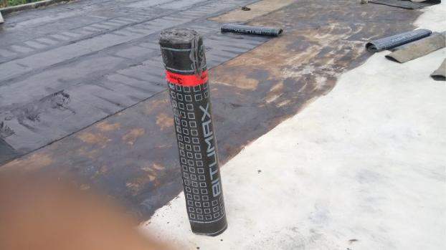

after the roof slabs has been primed, this was carried out by heating the primed surface and the felt together with the aid of gas.

EQUIPMENTS

The following are examples of various tools used in construction;

Trowel: This is a flat metal blade fixed to a short handle used for the application, jointing, smoothing and shaping of mortar in masonry. It is also used in the trimming of block/bricks. Trowel sizes ranges from 225-350mm measuring from the blade.

Spirit Level: This is a Hand-tool used for indicating true horizontal and vertical of a work, by means of an air bubble sealed in a marked, liquid-filled glass tube mounted in a frame; the tube is horizontal when the bubble

7

.

lOMoARcPSD|53486042

is between two marks. Spirit levels are of various length ranging from about 225mm to 1.2m.

Straight Edge: The kind of straight edge that was used on the construction site is an Aluminum frame of about 2m in length. The straight edge is used to check the fairness of the newly laid piece of a wall and to ensure that all the blocks are laid to the same level of each course.

Iron Square: This is a hand tool of angle 90 which measures 600mm by 450mm long. It is used for setting out walls at right angles to check for square nature of a section of work.

MACHINERIES
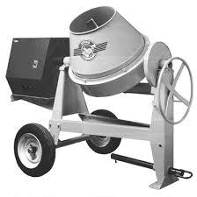

The machineries that were used on site were brought into considerations so as to promote high standards required particularly in the context of structural engineering works. Machineries are used on site to eliminate heavy manual work thus reducing fatigue and as a consequence increasing productivity. Such machineries that were used include;

Tilting Drum Concrete Mixer: This is a type of concrete mixer with a rotating hinged drum in which the constituent materials are mixed thoroughly and can be tilted to enable emptying. Choice of Mixer ~ the factors to be taken into consideration when selecting the type of concrete mixer required are …

8

.

lOMoARcPSD|53486042

- Maximum output required (m3/ hour).

- Total output required (m3).

- Type or method of transporting the mixed concrete.

- Discharge height of mixer (compatibility with transporting method).

Poker Vibrator: This consist of a hollow steel tube casing in which is a rotating impellor which generates vibrations as its head comes into contact with the casing. It is immersed in fresh concrete to provide compaction through gentle agitation.
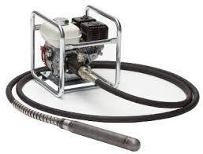

Pic; poker vibrator

Block moulding machine: The block moulding machine has a demountable mould which determines the size of the blocks to be moulded. It is either powered by a diesel engine or electricity. The engine enables the machine

9

.

lOMoARcPSD|53486042

to induce the desired vibra琀椀on to the mix placed in the mould in order to

enhance the strength of the blocks.
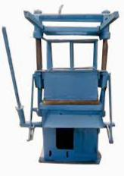

pic; Block moulding machine

3.2 CONCRETING

This is generally referred to as Casting. It is a process of working with freshly mixed concrete especially the placing of concrete. Before the establishment of the second floor some procedures where undertaken. Such procedures include;

10

.

lOMoARcPSD|53486042

- Material Supply and Storage: This is the receiving on site of the basic materials namely cement, fine aggregate and coarse aggregate and storing them under satisfactory conditions.

Cement is supplied in bags form and was stored on racks to prevent moisture penetration from the ground in a dry store free from draughts which can introduce moist air and cause air set of the material. Cement should not be stored on the site for long period of time on site; therefore provision should be made for rotational use so that the material being used comes from older stock.

Aggregates were stored in Bays on a clean firm base to ensure that foreign matter is not included when extracting materials from the base of the stock pile.

- Batching: Before mixing was carried out, the ingredients have to be measured in their correct proportion to enhance the quality of the concrete. Volume batching was used in this process with the aid of a head pan with a ratio of 1:2:4 and 1:3:6 and this was supervised by the site engineer.

- Mixing: The purpose of mixing is to coat the surfaces of Aggregate particles with cement paste and to make it a uniform mass. The quality of mixture depends on the accuracy of proportioning of the materials and the method of mixing. The method of mixing was carried out mechanically through the use of a Tilting Drum concrete mixer.

- Transportation: This involves the means of conveying concrete from the point of mixing to the point of placement. The choice of transportation depends on the size and complexity of the site, weather condition and the

height of the placement of the concrete. The mode of transportation used

11

.

lOMoARcPSD|53486042

was the manual method with the use of head pans and labour. A mason’s ladder made of both bamboo and timber was constructed to enhance vertical/inclined movements.

- Placing: Before the concrete was placed in the formwork, the inside of the formwork is thoroughly cleaned and a release agent (lubricant) was applied after the formwork was blown off of dust. The concrete was placed at a reasonable height of not more than 1m so as to avoid the segregation of its component materials.

- Compacting: The Compacting of freshly placed concrete is to make it a unit mass by eliminating voids within it. The method and the type of compaction given to concrete depend on the nature of work. Poker Vibrator was used for the

compacting of concrete during the construction of the floors of the new Polytechnic hostel while the

concretes of small works were compacted using tapping rod.

- Curing: After the placing and compacting of the concrete it is allowed to sufficiently harden for a day then the curing process comes in which involves the prevention of the evaporation of moisture in the concrete. The concrete was watered for 7days with use of a hose pipe connected to a tank. This was done to avoid shrinkage of the concrete and cause a more permanent and durable material produced.
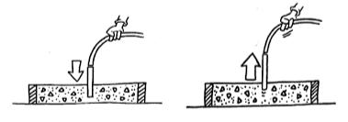

After 21 days the formwork are removed completely to enhance the full setting of the reinforced concrete floor.

Hence, concreting was carried out on almost all the construction work during my period of attachment.

12

.

lOMoARcPSD|53486042

3.3 SETTING OUT

Refers to the act of measuring and marking out a full size plan of a building or element of a building on site. This is accomplished by transferring the architectural details from paper to the ground.

3.4 FOUNDATION WORKS

Foundation consist of firm strata to prevent differential settlement of the structure and it provides stability to the structure. It transfers the weight of the structure (live, dead, and other loads) to the earth.

13

.

lOMoARcPSD|53486042

3.4 BLOCKWORK

The walling system was mostly carried out using sandcrete hollow blocks. The sizes of blocks were used in respect to their functions. The 6 inches blocks were used mostly for internal walls while the 9 inches blocks were used in load bearing areas and external walling. The bonding process used in the union of these block is Stretcher Bond; which is when the stretcher faces of the blocks appear on the front or rear elevation of the wall.
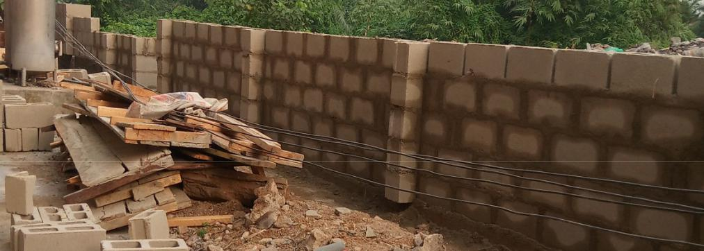

3.5 LINTELS

Lintel is referred to as the beam above an opening in a building, which supports the weight above it and transmits such weight of the imposed materials to the vertical sides of the wall opening. The lintel used for the opening in the constructed fence was Precast Reinforced Concrete Lintel that was constructed on site by using a wooden mould while the cast in-situ lintel was used for the construction of the new Polytechnic hostel. The precast lintel was transported and placed manually. One of the advantages of precast lintel is that it quickens production.

14

.

lOMoARcPSD|53486042

3.6 GROUND BEAM

Ground beam is a beam of reinforced concrete at or near ground level supporting a wall, and either resting directly on the ground or transferring its load to piles or piers in the manner of a lintel.
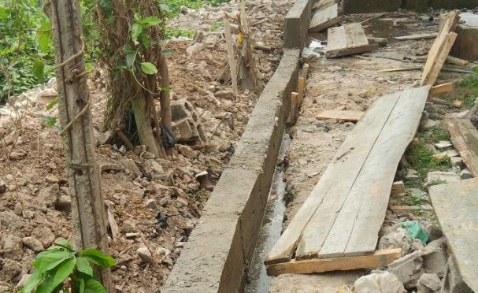

Pic; ground beam

3.9 MAINTENANCE AND REPAIR OF ROOFS

15

.

lOMoARcPSD|53486042

CHAPTER FOUR

4.0 PROBLEMS ENCOUNTERED DURING ATTACHMENT

- Access Road: The access road to the site is extremely poor due to the lack of drainages and constant passage of heavy vehicles such as trailer and Lorries.

- Land Pollution: The soil and water of the land is polluted as a result of oil spillage from trailers and lorries that where formerly abandoned on the land. The borehole that was sunk by the company was producing water of brownish color.

- Nature of Soil: The area of the site appears to be water logged thereby providing ponds of water in excavated trenches.

- Site Accommodations: The site accommodation is quite poor. The lack of provision of sleeping materials like beds and mosquito treated nets. Laborers sleep on plywood and use only bed covers to protect themselves against mosquitoes and other harmful insects.

4.1 RECOMMENDATION

The following Recommendation is referred to the Establishment I undertook my SIWES program, my college, Industrial Training Fund and the Government; in order to improve and enhance the expected results of the Student Industrial Work Experience Scheme;

- The Federal Government should establish and promote laws and agencies that regulate land use to prevent pollution.

- The Federal Government should provide and construct adequate roads in less developed areas.

17

.

lOMoARcPSD|53486042

- The Federal Government should provide industries and organizations with incentives to encourage and solicit for their cooperation and contribution to the programme

- The management of Fast Approach Konstruction Ltd can create and organise a special forum for students on attachment, this will help in discovering students’ potentials and to appropriately use them effectively.

- The management of Fast Approach Konstruction Ltd should provide adequate social amenities for their workers and enhance the welfare of their workers.

- The management of Fast Approach Konstruction Ltd should try to encourage workers initiatives and contributions to projects so at to enhance their esteem and contributions to such projects.

- The Industrial Training Fund should provide a network in which Establishments and Students could communicate better so promotes easier means of finding placements.

REFERENCES.

Dictionary of Architecture and Building construction by Nikolas Davies and Erkki Jokiniemi.

Building Construction Handbook by Roy Chudley and Roger Greeno.

Construction Illustrated by Francis D.K Ching (4th edition).

Essential Elements of Block-work Construction by Udoh Christopher Timothy (vol.1).

The Construction of Buildings by Barry R. vol.1 & 2 (1971). Encyclopedia Britannica; Ultimate reference suite (2014).

Oxford English dictionary.

.

