

A TECHNICAL REPORT ON
STUDENTS INDUSTRIAL WORK EXPERIENCE SCHEME (SIWES) UNDERTAKEN
AT
LAGOS STATE DEVELOPMENT AND PROPERTY COPERATION
BY

ND/23/ARC/FT/0003
Ayoola faruq ajibola

SUBMITTEDTO

DEPARTMENT OF ARCHITECTURAL TECHNOLOGY AND INSTITUTE OF ENVIRONMENTAL STUDIES, KWARA STATE POLYTECHNIC,
ILORIN, KWARA STATE, NIGERIA

In partial fulfillment for the award of national diploma in architectural technology

MARCH, 2025.

CERTIFICATION
I, hereby certify that this SIWES report was carried out by Ayoola faruq ajibola, with Matriculation Number ND/23/ARC/FT/0003 of Department of Architectural Technology of Kwara State Polytechnic, Ilorin Kwara State, after undergoing industrial training at The Capital Planning Consultant And Association.

___________________________ __________________________
INDUSTRIAL SUPERVISOR SIGNATURE AND DATE

___________________________ __________________________
INSTITUTION SUPERVISOR SIGNATURE AND DATE

___________________________ __________________________
STUDENT SIGNATURE AND DATE

DEDICATION
This is dedicated to God Almighty, who has guided me through my industrial training, to my parents who has been there from the beginning of my education, alsoto everyone who has contributed to my upliftmenttill today.

ACKNOWLEDGEMENT
I thank God almighty, who has preserved my life to attain this greater height of education. Providing me a suitable and correlated placement to my course of study and for granting me enough wisdom, knowledge and understanding and also saw me through the period of the SIWES.
Alongside, I thank the Managing Director and the entire staffs of LAGOS STATE DEVELOPMENT AND PROPERTY COPERATION, who had made it possible for me to understand and learn.
I would like to highly appreciate my parents Mr. & Mrs. OLADIPO for their support throughout the whole period sponsoring me financially and materially to make this industrial training period a success.
Also to the SIWES coordinator, the Head of Department, and all the Architects who have made the gradual molding of young students into future architects their mandate, may God strengthen you all.

ABSTRACT
This technical report is a detailed write-up comprising of my4months’ students’ industrial work experience scheme undertaken at; LAGOS STATE DEVELOPMENT AND PROPERTY COPERATION situated at block C 2/4 Town Planning Way, Ilupeju, Lagos State.
Experiences gained during the industrial training period were essential for the exposure of practical skills in the construction industry in Nigeria.
As an architect in training, a 4-year program of study without an industrial work experience would have been incomplete.
A personal assessment of knowledge prior to the commencement of my industrial work and after the three months showed a vivid difference as a result of being exposed to various aspects in the architectural profession.

TABLE OF CONTENT
Dedication
Acknowledgement
Abstract

Chapter One…………………………………………………...1
  - Introduction to SIWES
  - Aim and Objectives of SIWES
  - preface
Chapter Two………………………………………………….
2.1 Brief introduction and historical background of the firm
2.2 Past works
2.3 Flow chart
Chapter Three………………………………………………
3.1 Scope of the work done
3.2 Office/ design experience
3.3 Site experience Gained
Chapter Four……………………...........................................
4.1 Problems Encountered
4.2 Conclusions and Recommendations
4.3 Reference

CHAPTER 1
1.1 INTRODUCTION TO SIWES
Students’ Industrial Work Experience Scheme (SIWES) was designed with the responsibility of promoting and encouraging the acquisition of skills in industry and commerce with the view of generating a pool of trained indigenous man power sufficient to meet the needs of the economy. The most important asset of any industrial organization depends on the technical competence of its manpower for the operation and maintenance of its non-human assets and resources, hence, the need for SIWES.
SIWES was established by ITF in 1973 to solve the problem of lack of adequate practical skills preparatory for employment in industries by Nigerian graduates of tertiary institutions. The Scheme exposes students to industry based skills necessary for a smooth transition from the classroom to the world of work. It affords students of tertiary institutions the opportunity of being familiarized and exposed to the needed experience in handling machinery and equipment which are usually not available in the educational institutions.
Participation in SIWES has become a necessary pre- condition for the award of Diploma and Degree certificates in specific disciplines in most institutions of higher learning in the country, in accordance with the education policy of government. Operators – The ITF, the coordinating agencies (NUC, NCCE, NBTE), employers of labour and the institutions. Funding – The Federal Government of Nigeria.
Beneficiaries – Undergraduate students of the following: Agriculture, Engineering, Technology, Environmental, Science, Education, Medical Science and Pure and Applied Sciences.
1.2 AIM AND OBJECTIVES OF SIWES
The operational standards and guides for the program is such that students are posted to an organized establishment, either private or public, where activities of such organization are relevant to the student’s course of study. At various levels, the students are meant to undergo this period of training to enable them relate the theoretical knowledge taught in school to the practicality outside there.
This report is aimed at providing detailed records of activities carried out during the industrial training with a view to assessing the relevance of SIWES tofield. The aim of SIWES is to expose student to the working environment that are peculiar to each of their different professions outside the lecture rooms in order that they may acquire practical experience that would be of immense benefit to them in the nearest future when they begin to practice these professions.
Objectives
- To examine the correlation between the theoretical and practical aspects of the profession.
- To provide the opportunities for students to apply their theoretical knowledge in real work practice
- To prepare students for industrial work situations after graduation.
- To expose students to work methods and techniques in handling equipment.
- To bridge the gap between the classroom work and the real world.
- To examine the contributions of the student to the development of the unit and the organization as a whole.

1.3 PREFACE
I was opportune to start my industrial attachment training in the month of August 2017 with LSDPC. The firm works hand in hand with other construction and engineering bodies, an example of which is MOTAK CONSTRUCTORS which deals with the labor force on site. The proposed project is awarded to the contractors of which the time frame to be met is also considered.
The firm is headed by the M.DJIDE SANWOLU and the projects department is headed by the DGM. Architect Har YUSUPH and the architectural services is headed by the AGM. Architect AINBI, they also head their own Architecture firms. LSDPC is an architectural firm that is dedicated to design in excellence which integrates function, aesthetics, sustainability and affordability and also ensures every project comes out unique with exquisite designs features. We also carryout structural, mechanical, electrical and quantity survey at the cooperation. Our designs have exceptional attributes where every detail counts. Our Core values Integrity, Timeliness, Fairness, Competence, Openness, and Efficiency.

Chapter two
2.1 BRIEF INTRODUCTION AND HISTORICAL BACKGROUND OF THE FIRM
The provision of modern housing schemes and the transformation of the slums and ghettos in Lagos dates back to 1928 when the Lagos Executive Development Board (L.E.D.B.) was inaugurated. Amongst other things, the L.E.D.B. was charged primarily with the task of getting rid of the filth and unhealthy living conditions which existed then in Lagos. The Board was also to transform the slum areas and ghettos into a planned and habitable environment.
Although, the Board was the sole executive authority for planning and development both in central Lagos and its environs, the maintenance of its constructed roads, drains and open spaces was the responsibility of the Lagos City Council. The vetting of building plans was also shared with the City Council, an awkward arrangement which often resulted in the delay of approval of building plans. The attendant frustration of private developers often times led to contravention of planning regulations by developers.
However, subsequent expansion of the city necessitated the involvement of the Ikeja Area Planning Authority (I.A.P.A) in the control of development and provision of public housing outside the city. The (I.A.P.A) on one hand had full powers to vet building plans and control private development in its area of jurisdiction but such plans had to be forwarded to relevant local council for health approval. With the creation of Lagos State in 1967, the need to stem the lack of proper coordination between the existing planning authorities involved and the unnecessary dissipation of energy without meaningful results necessitated the formation of a central body to be charged with the duties of the different bodies. Consequently, in 1972, the Lagos Executive Development Board (L.E.D.B.), Ikeja Area Planning Authority (I.A.P.A.), and Epe Town Planning Authority (E.T.P.A.), metamorphosed into what is now known as Lagos State Development and Property Corporation (L.S.D.P.C). The L.S.D.P.C. Edict No. 1 of 1972 bestowed legality on this metamorphosis.
Upon its creation in 1972, L.S.D.P.C. which inherited the liabilities and assets of its three predecessors was completely divested of all their development control powers. These were transferred to the Lagos state Ministry of Works and Planning (L.S.M.W.P.), which became responsible for planning and development control throughout the State. But after much persuasion, the power to control development on its estates was transferred back to L.S.D.P.C. in 1978.
Under the present arrangement; the Corporation has a fully commercialized status with a Managing Director/Chief Executive Officer at the helm of affairs. The functions of the new L.S.D.P.C, amongst others, include:
1. To develop land or any estate or interest in land
2. To acquire, develop and maintain dwelling houses, shopping centers, offices, industrial buildings that are necessary, or desirable for the performance of the functions of the Corporation
3. To acquire, develop, maintain or repair any work plant or apparatus necessary or desirable for the provision of electrical, water, or sanitary services or in connection with any building owned, developed or managed by the Corporation
4. To sell, let or lease any building owned developed or presently managed by the corporation by virtue of this law upon such terms and conditions as the corporation deem fit.

2.2 PAST WORKS
Here listed are some of the past projects executed by the organization with their visual descriptions:
- A. The blocks of flat at Ebute Meta
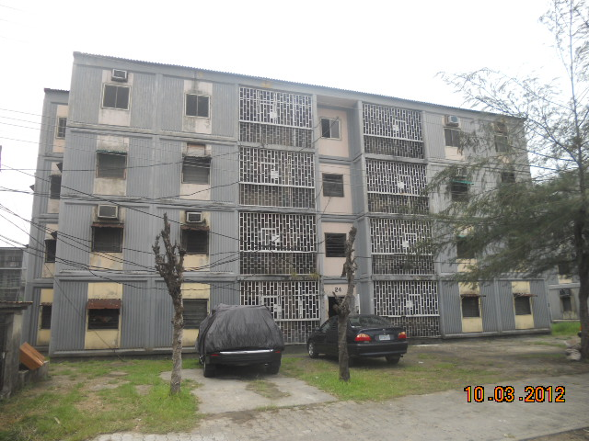
- B. Courtland villa at Igbokusu-Lekki
Features; 4 Bedroom mansionette with maids room, swimming pool, club house, gym multi-purpose game court and so on.
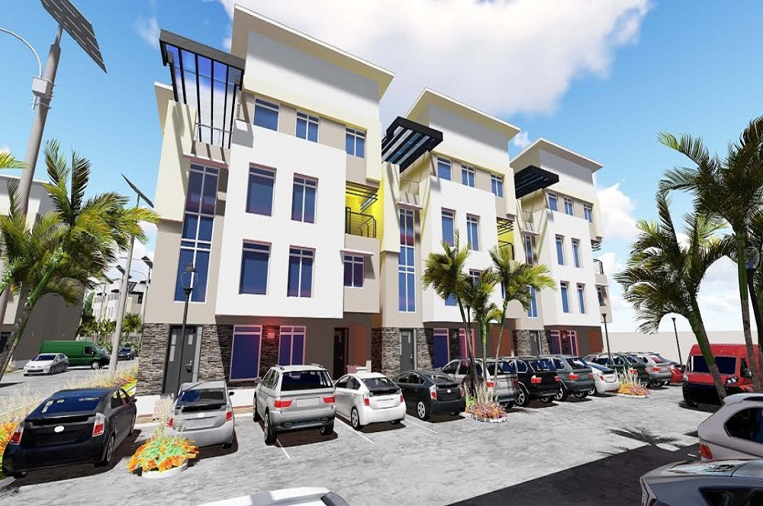
- C. Jakande Estate
Feature; Three-bedroom apartment with maid’s room
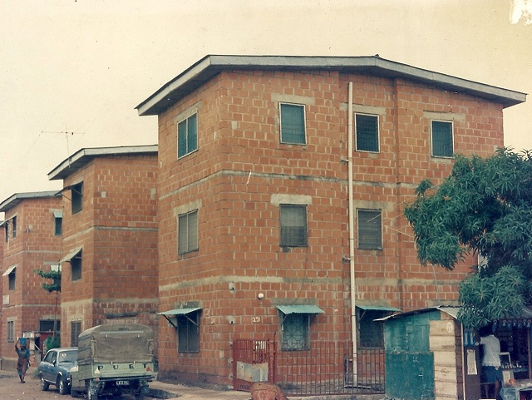
- D. Amuwo
Features; Three bedroom flats 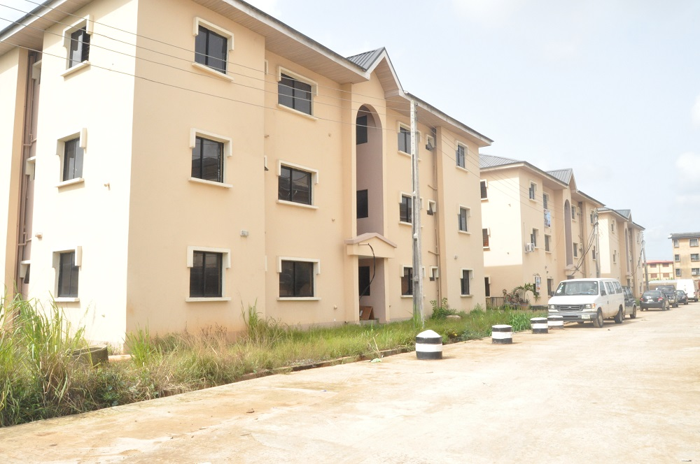
- E. Early Gate Estate IkotaLekki
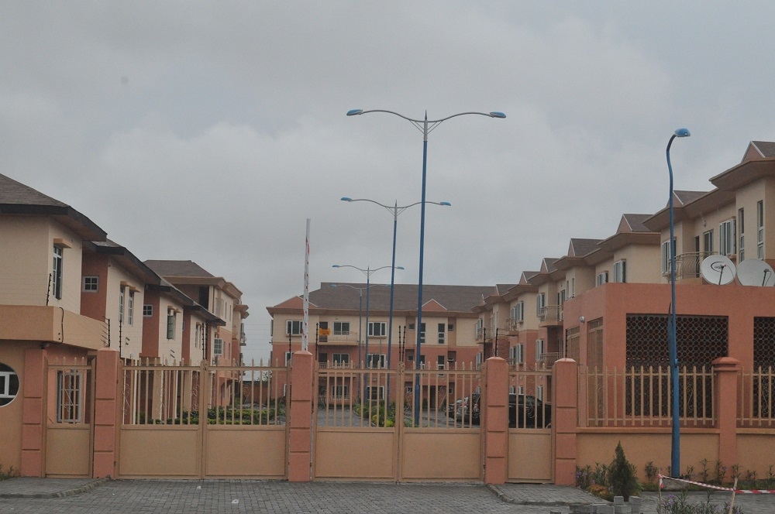

- F. Alapere Estate
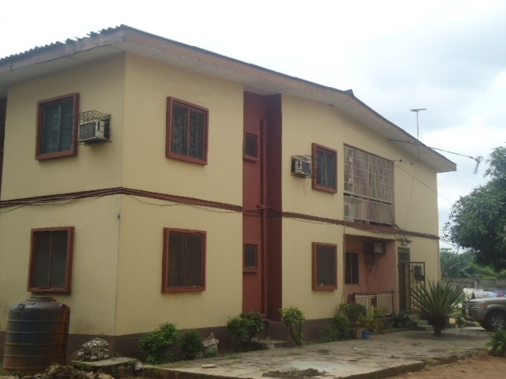

2.3 FLOW CHART
THE MANAGINIG DIRECTOR

THE GENERAL MANAGER

DEPUTY-GENEREAL MANAGER ASSISTANT GENERAL MANAGER

ARCHITECTURAL SERVICES
WORKS DEP. PROJECT DEP.

SITE INSPECTORS SITE TECHNICIANS

GRADUATE ARCHITECTS

SECRETARY / RECEPTIONIST / STAFFS

NYSC MEMBERS

I.T STUDENTS

CHAPTER 3
3.1 SCOPE OF THE WORKDONE
This chapter is basically based on what I experienced and Gained during my industrial training and it is divided into two parts:
- OFFICE/ DESIGN EXPERIENCE
- SITE EXPERIENCE
3.2 OFFICE EXPERIENCE
This part is a summary of lessons learnt in the office and on different projects carried out during my SIWES training.
In the office basically, I was able to work on different projects and designs that were sketched by my Supervising Architects, before being given to me to draft on the computer, while the ones revised are already on the system which had been previously worked on by a staff of the firm.

3.2.1 EXPOSURE TO AUTOCAD
My Student Industrial work experience scheme at LSDPC. I learnt how to draft and model designs at a more advanced level considering cost, aesthetics and the clients brief. I learnt how to present a detailed working drawing on this software.

3.2.2 EXPOSURE TO REVIT SOFTWARE
My Student Industrial work experience scheme at LSDPC. Architects exposed me to REVIT. REVIT provides a more accurate and detailed design thereby adding a variety of different tools and characters, to produce a self-explanatory plan, section, model and elevations.

3.2.3 ARCHITECTURAL WORKS
I discovered that there was no room for mistakes no matter the cost because a minor mistake in design stage could or would lead to a major disaster during or after the construction stage so all possible errors in the design stage must be eliminated. I also learnt that there were regulations and laws guiding every aspect of a building design and its construction, which I summarized in the following:
- The minimum set back from the road to the building line is 6 meters; while from the center of the road to the building line is 9 meters.
- Architectural works must be interactive and necessary specifications mustalso reflect in the designs apart from the schedules.
- The structural stability of a design at the inception stage.

The architect must take into consideration the structural aspect of the building, which gives the structural engineer a framework to work with and at the end of the project.
Real life architectural works must be self-explanatory with all the necessary dimensions shown to precision in all the design stages which includes the following:
- The site plan
- The floor plans
- The roof plan
- The sections
- The elevation
- The models

3.2.4 PRODUCING A COMPLETE SET OF DRAWINGS FOR GOVERNMENT APPROVAL
As part of my Student Industrial Work Experience Scheme, I have been exposed to Producing a complete set of drawings for Government approval which follows a sequential order as:
- The location map
- The site plan
- The floor plans
- The roof plans
- The sections
- The elevations
- The septic tank details
- The windows and door schedule
- The Structural drawings and others specification
Structural drawings by the structural engineers are always required by the townplanning authority along with the set of drawings listed above (4 copies); the moment a building design is having another floor aside from the ground floor plan.

3.2.5 DESIGN EXPERIENCE
PROJECT.1
A ONE BEDROOM-QUIN SEMI-DETACHED
I was asked to design a one bedroom-quin semi-detached building containing sixteen units in total. The features of the design are terrace, living room, kitchen, lobby, bedroom, toilet and stairway.

GROUND FLOOR PLANS
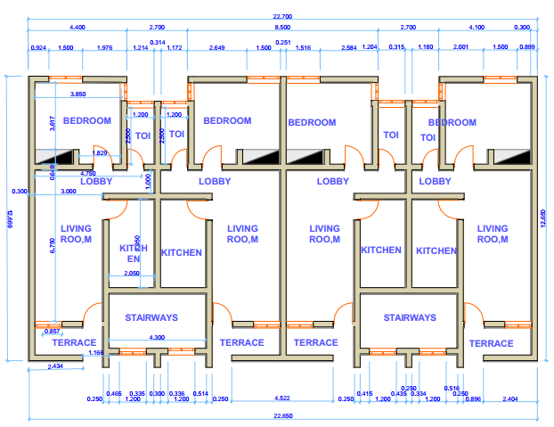
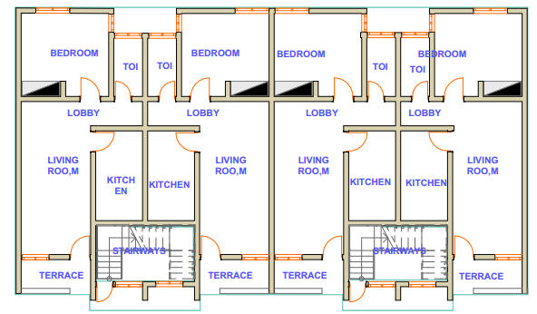

FIRST,SECOND AND THIRD FLOOR PLANS
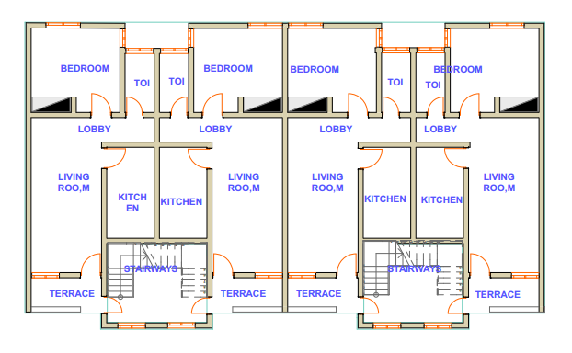

RIGHT SIDE ELEVATION
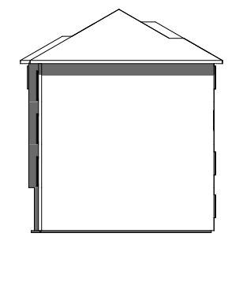
REAR ELEVATION
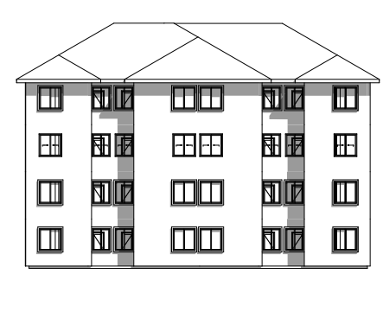
SECTIONS
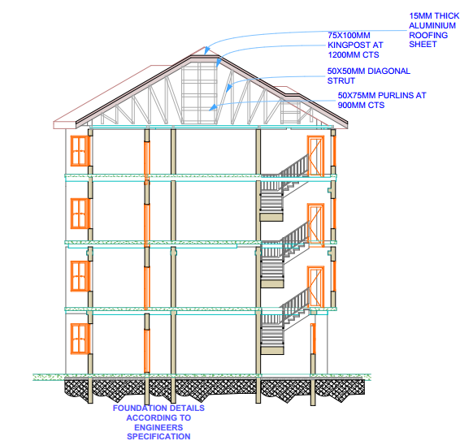
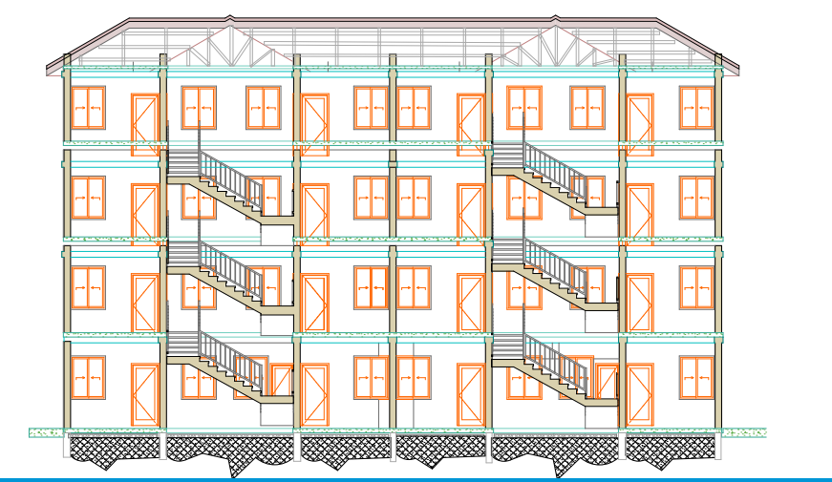
Lesson Learnt: I was able to manage spaces due to the small portion of land, and made sure the spaces were well accessible and I made sure that the windows size was 1200x1500mm because of their orientation and ventilation.
PROJECT.2
CONTEMPOARY TWO BEDROOM DESIGN
I designed a two bed room apartment considering contemporary features and this is visible in its aesthetics. The features of the design are entrance porch, main lounge, mini-bar, dining, kitchen, store, master’s bedroom and an extra bedroom.
GROUND FLOOR PLAN
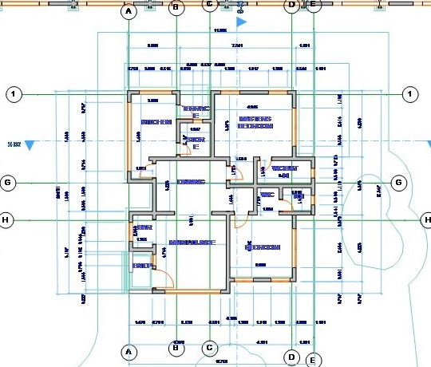

ROOF PLAN
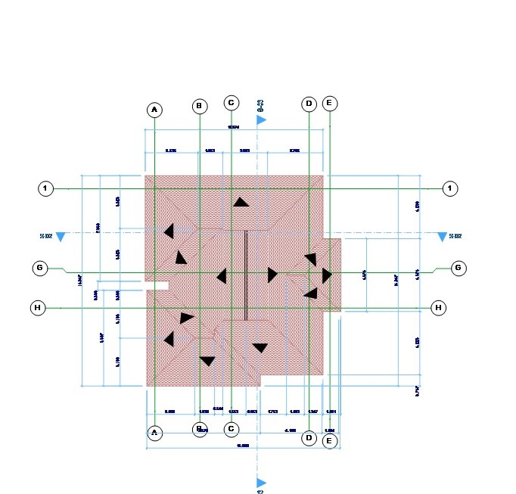
APPROACH ELEVATION
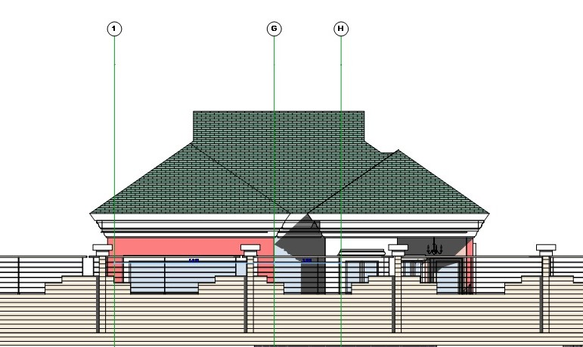

LEFT SIDE ELEVATION
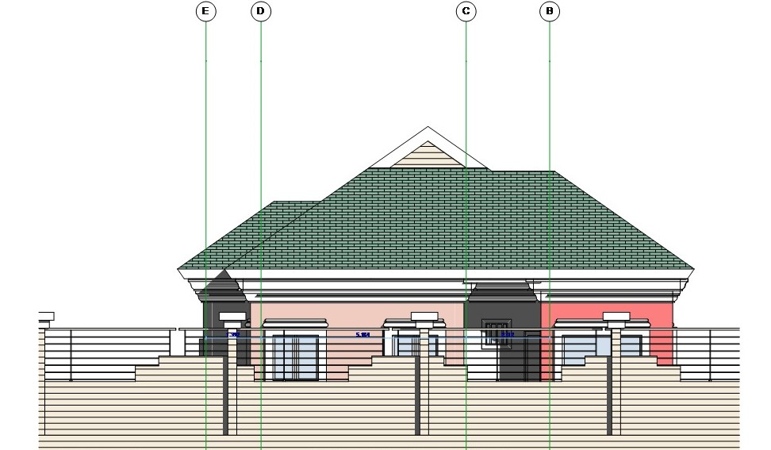
RIGHT SIDE ELEVATION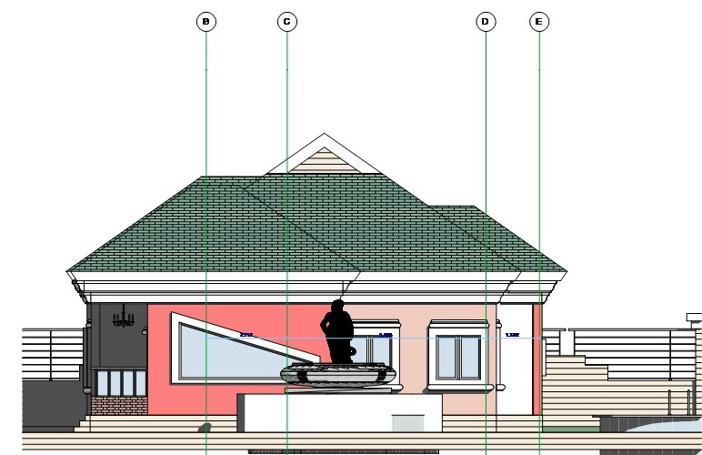
3D(PERSPECTIVE)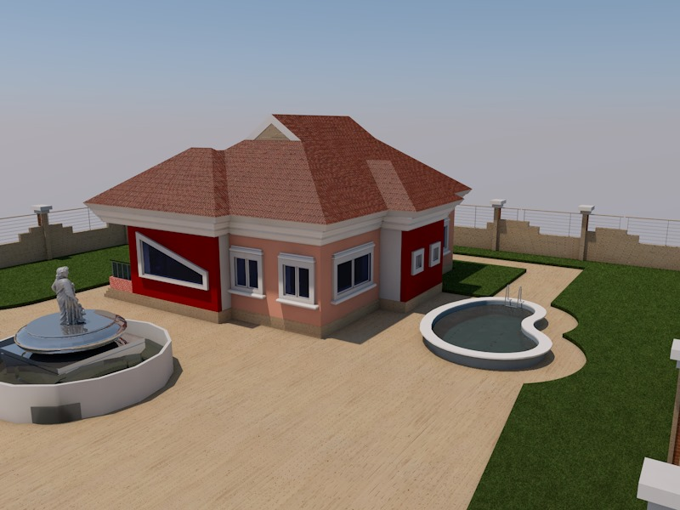
Lesson Learnt: I was able to take advantage of the land provided and to give an aesthetic look to the design which impressed the supervisor in charge. I also learnt how to use colored elevation while presenting.

PROJECT.3
A FOUR BEDROOM SEMI-DETACHED DUPLEX
I designed a seven-bedroom semi-detached duplex as sketched by my supervisor which had four units. The following features are present: a master’s bedroom, three other bedrooms, a kitchen, main lounge, yard, and a lightning lobby.
GROUND FLOOR PLAN
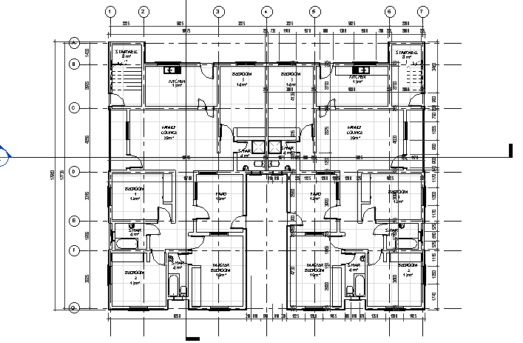

FIRST FLOOR PLAN
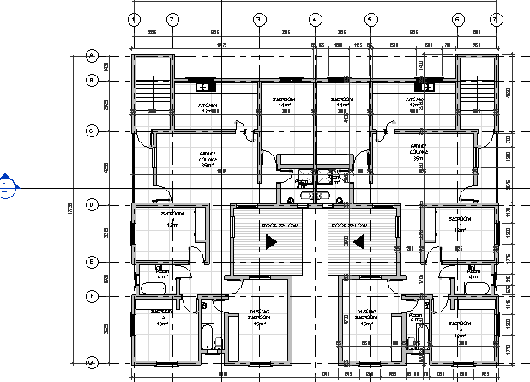
ROOF PLAN
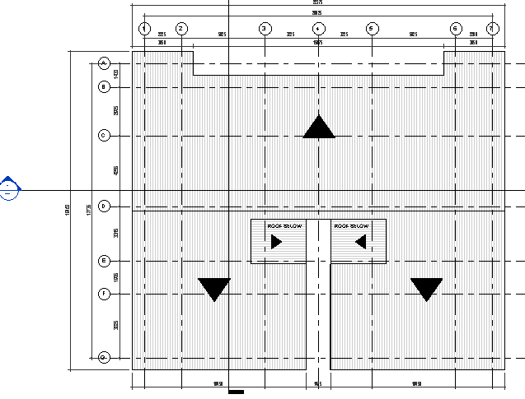
APPROACH ELEVATION
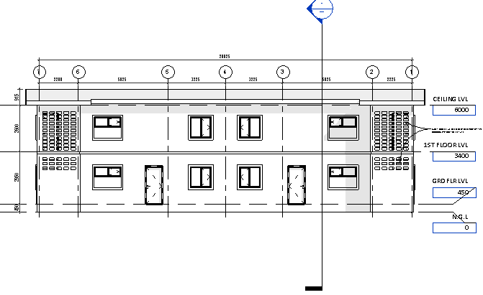
LEFT SIDE ELEVATION
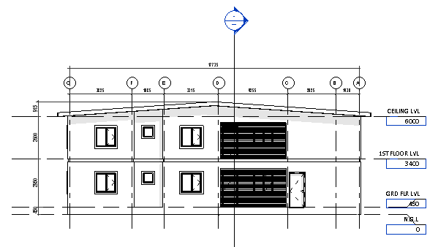

SECTIONS
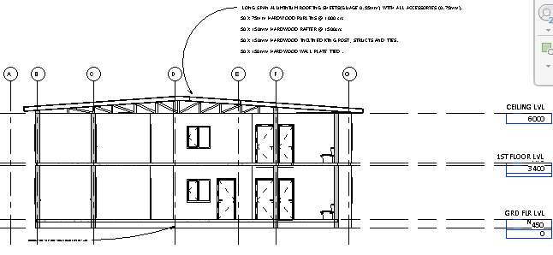

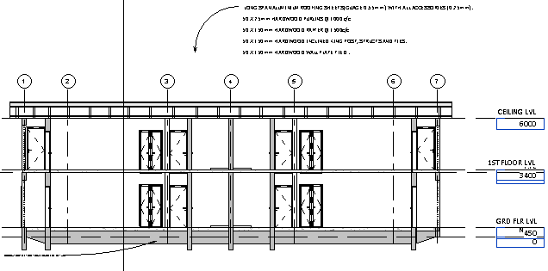

3D(PERSPECTIVE)
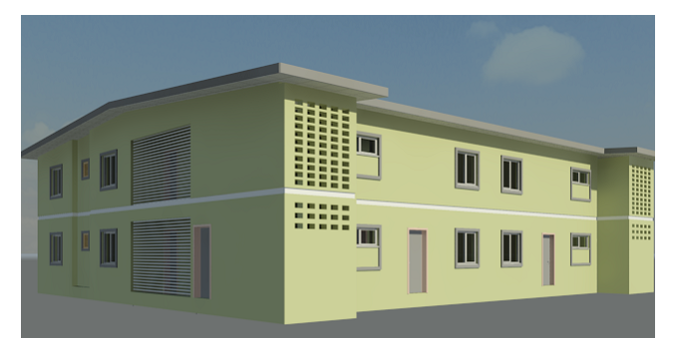

Lesson Learnt: I was able to manage spaces due to the size of the land, and made sure the spaces were well accessible and ventilated. And also putting more effort to meet the client need.

USEFUL EXPERIENCE AND LESSON LEARNT:
3.2.6 ARCHICAD AND REVIT
Working thoughtfully on the elevations and sections to produce aesthetically pleasing views.
- Adequate ventilation and illumination.
- Foresight of elevation from the planning stage.
- The use of grid lines in the plans with respect to the alignment and positioning of structural elements like columns beams and walls etc.
- Placement of conveniences with an evenly distributed grid on the plans.
- The use of varying stepped levels in the section to achieve interesting effects for the intended users of the facility.
- Thoughtful arrangement of the plan to produce aesthetically pleasing elevations.
- The arrangement of the final site layout with respect of the individual buildings to another and the building to the boundaries in accordance to government rules and regulations
PROGRAMING AND CLIENT BRIEFINGPROGRAMMING
Programming is the process of understanding and setting forth in writing the client's requirements for a given project. Steps in this process includes:
- Establishing goals
- Considering a budget
- Collecting
- Organizing and analyzing data
- Identifying and developing concepts
- And determining particular needs.

WORKING DRAWINGS/CONSTRUCTION DOCUMENTS
The working drawings phases of construction documents describe in graphic form, all of the essentials of the work to be done: location, size, arrangement and details of the project. Since the successful and timelyexecution of these documents can be equated closely with an office’s financial success, Architects constantly search for more efficient ways to produce construction documents. Regardless of the method of preparation, it is extremely important that the documents be accurate, consistent, complete and understandable. This requires thorough quality control including constant review and cross-checking of all documents. In addition, effective coordination of consultants’ drawings is essential to avoid conflicts and interference in the construction of the Architect's designs and documents the integrated result.
3.3 SITE EXPERIENCE
This part deals with the knowledge gained by me from the construction sites visited during my SIWES program where I was exposed to various projects. I spent my industrial training with LSDPC. The company is focused on civil, electrical mechanical and survey building engineering projects with several engineers handling different projects across the country.
Architect Ipeayida, Architect Kofo, Architect Funso, Architect Adeleke, and Architect Anibi(DGM)were my site supervisors. From time to time assigned me to different activities like preparing door and window schedules, supervision of block-setting and excavation, store recording and keeping, movement of building materials, taking measurements, setting out, etc. and they also put me through all diverse ways of things I knew nothing about. Decisions on work follow-ups were easily taken as there was ease in getting information and drawings through to and from the design architects to the engineers.
Also site inspections are done regularly to make sure the building is going on well and corrections are made on site to the contractor, which I was always present during inspections.
Also a technical meeting is also held once in a week involving the consultants, contractors, also the sub-contractors, of which I was always attending with my boss, issues and the growth of the project are being discussed.
Also monthly site meetings are done once in a month, involving client representatives, consultants, contractor’s representatives. Where the client comes to check the progress of work done and issues affecting the progress of the work.
3.3.1 PHYSICAL MEASUREMENT OF BUILDING COMPONENTS AND EXTERNAL WORKS
The major work I did during my industrial attachment was measurement of building works and external works. The building components can be found in the main building, generator house, gate posts, gate house, sewage treatment house, underground water tank, sewage lift pit etc. The external works can be found in driveways and parking lots, entrance culverts, retaining walls etc.
3.3.2OBSERVING AND NOTING LABOUR
I observed and noted labor outputs for different trades which include: painting; wall and floor tiling; interlocking pavement stone application; steel grill and plaster board ceiling and lifting and installation of steel roof trusses above the third floor painting application, sandtex trowel speckled-tan, I observed and noted the following parameters: name of paint; number of drum used; time of paint application; time at the end of paint application; numbers of painters and square meter covered. In tiles laying, i.e. ceramic floor and wall tiles, I observed and noted the following parameters: name of tiles, number of tillers and laborers and the square meter covered per day.
I also supervised cement and sand mix for floor screeding which is done to prepare the floor for receiving tiles and to get all parts of the floor on the same level. The difference between this mix and mortar is that it has a low water to cement ratio. It serves as backing for floor tiles. The mix ratio for cement and sand adopted for floor screeding was 1:6 i.e. 1 head pan of cement to six head pans of sharp sand or one bag of cement to 12 head pans of sharp sand.

3.3.3 LIST OF VISITED SITES
- Lagoshoms project at Ibeshe I&II
- Lagoshoms project at Akerele Randle Close site
- Lagoshoms project at Amuwo-odofin
- Lagoshoms project at Lekki
- Adelabu duplex project at Adelabu Close Surulere
- Olufemi Duplex at OlufemiAjao road Surulere
- Eko Court at Ikoyi
- The managing Directors duplex Residence at Ikoyi

CHAPTER4
4.1 PROBLEMS, RECOMMENDATIONS AND CONCLUSION
4.1.1 PROBLEMS ENCOUNTERED
The problems or challenges encountered during my six (4) months’ work experience which could be constraints to future students who may want to observe their SIWES in LSDPC can be stated as follows.
4.1.2Rejection of Students
Some organizations reject students when approached for placement. This to a large extent discourages students and kills their enthusiasm towards the SIWES program. Also, the process of entering the Corporation was politicalized, as you had to know somebody working in the Corporation before you can be accepted to work, this routine of recruitment had discouraged students.
4.1.3 Financial Problem
This was a major constraint because the allowance given to trainee was not encouraging. Finance are meant to be considered as a motivating factor for any intending trainee student. Financial aid is very important to help the students cover up the expenses of feeding, transportation and wears (i.e., official wears) among others.
4.1.4 Transportation Problem
Though, transport services were provided for the staffs to various routes but it was amazing that I.T. Students were not liable to any seat until all the staffs had conveniently seated and most times, we were inconveniently packed and bullied when in the bus. This act of discrimination is really disgusting because it makes trainees to feel inferior.

4.2 RECOMMENDATION
This SIWES program has being of immense benefit to me while undergoing the training However, the identified problems are affecting the efficiency of the scheme and reducing the level of its aimed potentiality. Thus to ameliorate the situations sprouting from the identified problems and make SIWES more beneficial, the following recommendations are suggested:
- The Federal Government should make it compulsory for all ministries, public parastatals and companies to offer placement to interested students as stated in the NUC job specification for SIWES.
- The payment of prompt ITF allowance in order to encourage them for efficient carriage of duties.
- Institutions that the students would be attached to should have the potentials of providing relevant information on planning activities, and possess sophisticated machinery so as to help the student to acquire the necessary skills that would be needed in the work.
In view of the earlier limitations/ challenges experienced by the firm, I recommend that the Federal Government of Nigeria should further intensify their effort in the area of funding of the SIWESprogram and enforcing students to participate actively in this program which will result to a future where Nigeria would be a better place.
4.3 CONCLUSION
In the past 4 months of my learning at LSDPC, I learnt a crucial aspect of Architecture, not only did I learn about building construction, I also learnt about office etiquette and operations. My ability and knowledge on computer aided designs have been explored and thus have being enlightened. The SIWES program has contributed immensely to the acquisition of practical experience and knowledge which are of paramount importance to my field of study. Its relevance therefore can never be overestimated. This training section has broadened my level of knowledge and as well paved way for diverse future opportunities.
Consequently, the SIWES program has made me to understand that the profession Architecture is Multifaceted. In that, it does not solely rely on Site work and drawings but also encompasses various forms of administrative duties which make it more captivating.
Thus, this report clearly indicates that the activities carried out during the period of my attachment have not only proved beneficial to me but also broadened my knowledge on professional ethics of Architecture.

REFERNCES
Hubbel G.S (1962): Writing term papers and reports. College outline series NO 37 (4th Ed) New york, Barms and Nobel.
Industrial Training Fund: Handbook on Basic Information for Students on Industrial Attachment.
Student industrial working experience logbook (2016/2017) session.
WWW.LSDPC.GOV.NG Email @ info@lsdpc.gov

