
TECHNICAL REPORT ON
STUDENT INDUSTRIAL WORK EXPERIENCE SCHEME (S.I.W.E.S) HELD AT

ILORIN MICRO-FINANCE BANK

WRITTEN BY
BABATUNDE SHUKURAT OPEYEMI
MATRIC NO: ND/23/BFN/PT/0076

SUBMITTED TO: DEPARTMENT OF BANKING AND FINANCE.
INSTITUTE OF FINANCE AND MANAGEMENT STUDIES KWARA STATE POLYTECHNIC, ILORIN.

MARCH 2025

DEDICATION
I dedication this report first and foremost to Almighty Allah who made it possible for me to go through this SIWES program safely and soundly and who has been there from the beginning to this very point also for the opportunity given to me to be in banking and finance department of this citadel of learning and to complete my 4mouth SIWES.

TO GOD BE THE GLORY.

ACKNOWLEDGEMENT
I deeper appreciation goes to Supreme God for granting me life, health, favor, wisdom knowledge and understanding all through the period of my SIWES program.
With a deep sense of appreciation, respect and gratitude, I want to say a big my parents, brothers, sisters and other relatives and non-relatives friends, for their caring attitude and support from the beginning of my ND program banking and finance to this point.
I will like to express my gratitude to my honourable (H.O.D) and my SIWES supervisor, and also the entire staff of the Department of banking and finance, Kwara State Polytechnic, Ilorin I say more grace to your elbow all. I can never forget the unalloyed cooperation of my beloved ones at Ilorin Micro- Finance Bank, and other General department management team.
My sincere appreciation also goes to everyone that has been by me all this while. ABIG THANKS TO ALL !!!

CHAPTER ONE

Introduction
SIWES was established by ITF in 1973 to solve the problems of lack of adequate practical skills preparatory for employment in industries by Nigeria graduate of tertiary institutions.
The student Industrial Working Experience Scheme (SIWES) was fund by the federal government of Nigeria beneficiaries undergraduate students of the following: agriculture engineering, technology engineering, environmental, science, education, medical science and pure and applied science the duration of four month programs for polytechnics and colleges of education and for six months for the universities and other related courses and it is controlled by a body known as NBTE (National Board for Technical Education), the headquarter is located in Kaduna state also with the Industrial Training Fund (ITF) in Jos.
However, this programme was introduce or established to enhance the student idea and learning, especially to expose students to industry based skills necessary for a smooth transition from the classroom to the world of work in their practical aspects, that is, to give the students of tertiary institutions the opportunity of being familiarized and exposed to the needed experience in handling machinery and equipment which are usually not available in the educational institutions participation in industrial training is a well know education strategy. classroom studies are integrated with learning through hand on work experience in a field related to the student's academic major and career goals. Successful internships foster an experiential but provides opportunities for leaners to develop skills necessary to becomes leaders in their chosen profession and them more knowledge to help them to put into practice the theories they already know i.e. banking and finance Engineering SIWES Training.

Definition of SIWES
SIWES is Student Industrial Work Experience Scheme, it can be said to be a training program design to give students practical skills in their field of study. It is design for the student in tertiary institution especially polytechnic student in their second year of study.

Goals and Objectives of SIWES
    - To make students integrated leadership development in to the experiential learning process.
    - To make students learn and develop basic non-profit leadership skills through a mentoring relationship with innovative non-profit leader.
    - To provide students the opportunity to test their interest in a particular career before permanent commitment are made.
    - To develop skills in the application of theory to practical work situations.
    - To develop skills and techniques directly applicable to their careers.
    - To make sure students gain practical experience in their field of study to increase a students sense of responsibility exposes student to employment opportunity and possibilities after graduation.
    - To make students to able to develop a draft agency or project budget and will be able to identify method of obtaining revenue to support the budget.
    - To help students to acquire good work habits.

CHAPTER TWO

  - BRIEF HISTORY OF THE ORGANIZATION

Ilorin Microfinance Bank is a licensed financial institution that provides financial services to small businesses, entrepreneurs, and low-income earners. The bank plays a crucial role in economic development by offering credit facilities, savings accounts, and financial advisory services to individuals and small businesses.
2.2 FUNCTIONS OF MICROFINANCE BANK
- Providing micro-loans to small business owners and individuals.
- Offering savings and investment opportunities to low-income earners.
- Facilitating financial inclusion by granting access to banking services.
- Encouraging entrepreneurship through financial literacy programs.
- Enabling money transfers and payment services for customers.

2.3 ORGANIZATIONAL STRUCTURE/CHART
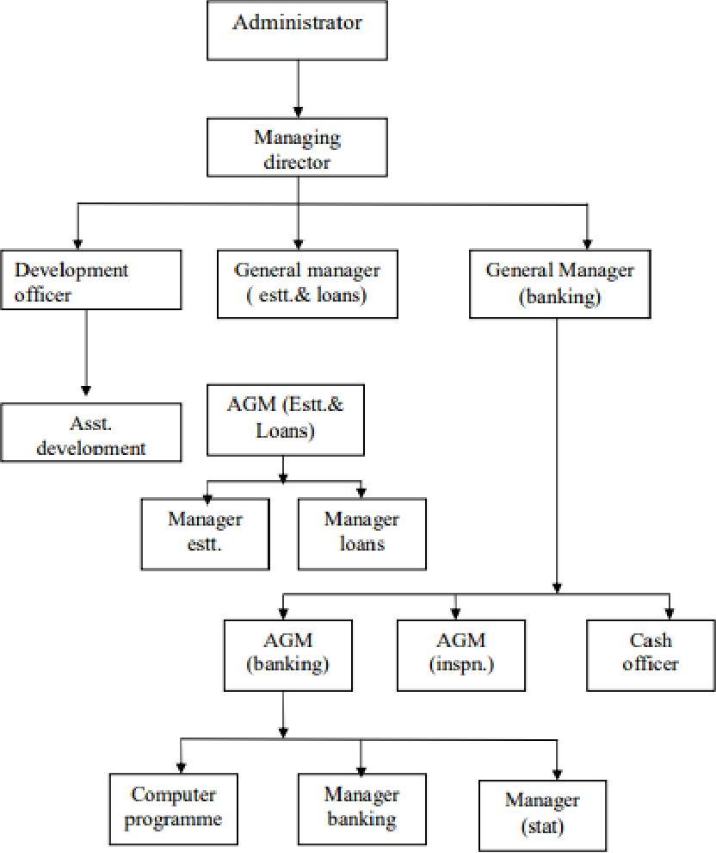

2.4 DEPARTMENTS AND THEIR FUNCTIONS
During my SIWES at Ilorin Microfinance Bank, I had the opportunity to work in different departments and learn about their various responsibilities. The key departments include:
Customer Service Department
- Welcoming and assisting customers.
- Opening new customer accounts.
- Addressing customer inquiries and complaints.
- Educating customers on financial products and services.
Credit and Loans Department
- Processing loan applications.
- Conducting creditworthiness assessments.
- Monitoring loan repayments and following up on defaulters.
- Advising customers on loan options and repayment plans.
Accounts and Finance Department
- Managing the bank’s financial transactions.
- Preparing financial statements and reports.
- Recording daily financial operations.
- Assisting with budgeting and financial planning.
Risk Management and Compliance Department
- Ensuring the bank follows regulatory guidelines.
- Conducting internal audits to prevent fraud.
- Implementing risk mitigation strategies.
- Monitoring compliance with banking laws and policies.

CHAPTER THREE

EXPERIENCE GAINED
3.1 Customer Interaction and Service Delivery
- Learned how to communicate professionally with customers.
- Assisted in opening new customer accounts.
- Handled inquiries about banking services and transactions.
3.2 Loan Processing and Credit Analysis
- Observed how loan applications are reviewed and approved.
- Learned about credit assessment techniques.
- Assisted in document verification for loan applicants.
3.3 Cash Handling and Accounting Procedures
- Gained exposure to cash management and deposit processing.
- Assisted in basic bookkeeping tasks.
- Observed how daily financial reports are prepared.
3.4 Banking Software and Technology Usage
- Learned to use banking software for account management.
- Assisted in updating customer records on the bank’s database.
- Gained insight into cybersecurity practices in banking.

CHAPTER FOUR
4.1 CHALLENGES FACED
The challenges I faced during my siwes are as follows:
- Limited access to certain banking operations due to confidentiality policies.
- Initial difficulty in understanding financial terminologies.
- High customer turnout, leading to increased workload.
- Technical issues with banking systems causing delays in transactions.

CHAPTER FIVE
5.1 CONCLUSION
My SIWES experience at Ilorin Microfinance Bank was highly educational and rewarding. It gave me practical exposure to banking operations, customer service, and financial management. The experience has enhanced my knowledge in the field of accounting and finance and prepared me for future career opportunities in the banking sector.

This report provides an overview of my learning experience, challenges faced, and recommendations for improving future internship programs. I am grateful for the opportunity to have worked with professionals in the banking industry and gained valuable skills that will benefit my career development

5.2 RECOMMENDATION
The Student Industrial Work Experience Scheme (SIWES) is very interesting and planned. This programme gives me more practical experience of what we have been taught in class because it deals with practical aspect of the field in which I specialized. Moreover, am using this medium to advice government to establish more company and pass the student to this company on their own.
Finally, industrial experience should be given priority by the government.

