

A TECHNICAL REPORT ON
STUDENT INDUSTRIAL WORKING EXPERIENCE SCHEME
(SIWES)

HELD AT
LEGIT VENTURES
OFF AFON JUNCTION, GANMO, KWARA STATE

WRITTEN BY
BELLO TOHEEB OLAWALE
ND/23/BAM/PT/0721

SUBMITTED TO

DEPARTMENT OF BUSINESS ADMINISTRATION
INSTITUTE OF FINANCIAL MANAGEMENT STUDIES
KWARA STATE POLYTECHNIC, ILORIN

INPARTIAL FULFILLMENT OF THE AWARD OF THE REQUIREMENT OF THE AWARD OF NATIONAL DIPLOMA IN BUSINESS ADMINISTRATION

SEPTEMBER – NOVEMBER. 2024
DEDICATION
I dedicate this technical report to the Almighty God, the giver of knowledge, wisdom and who is rich in mercy.

ACKNOWLEDGEMENT
I would like to begin by expressing my heartfelt gratitude to the Creator of heaven and earth, the One who knows the beginning and the end, the Alpha and the Omega, the Almighty Allah for His guidance and blessings throughout this journey.
I am deeply grateful to my beloved parents, Mr. and Mrs. Bello, whose unwavering support and prayers have been my foundation. To my brothers and dear friends, your encouragement and companionship have meant the world to me.
My special thanks go to my SIWES supervisor, for her guidance, mentorship, and invaluable insights during this program. I also extend my profound appreciation to everyone who supported me during my SIWES experience. May the Almighty God bless, protect, sustain, and guide you through all of life’s journeys.
Lastly, I wish to express my sincere regards to the school’s Board of Trustees and the entire staff of the business administration department for their dedication and support. Once again, a big thank you to everyone who contributed to making this experience a memorable and successful one.

TABLE OF CONTENT
Title page i
Table of content ii
Dedication iii
Acknowledgements iv
TABLE OF CONTENTS

CHAPTER ONE
  - Background of SIWES 1
  - Objectives of SIWES 2

CHAPTER TWO
2.1. Organizational Background 3
2.2. Departments in Legit Ventures 3

CHAPTER THREE
3.0 Key Projects and Assignments 5

CHAPTER FOUR
4.0 Key Knowledge Gained from the Siwes Training Programme 7
CHAPTER FIVE
5.1 Challenges 11
5.2 Conclusion 11
5.2 Recommendation 12
CHAPTER ONE
INTRODUCTION
1.1 Industrial Training Fund (ITF) and SIWES
SIWES was founded by ITF in 1973 to address the issue of Nigerian tertiary school graduates lacking sufficient practical skills to prepare them for employment in industries. The program exposes students to industry-based skills that are essential for a seamless transition from the classroom to the workplace. It gives tertiary institution students the chance to become acquainted with and exposed to the necessary experience in operating machinery and equipment, which is typically not available in educational institutions.
Participation in industrial training is a well-known educational strategy. Classroom studies are integrated with learning through hands-on work experiences in a field related to the students’ academic major and career goals. Successful internships foster an experiential learning process that not only promotes career preparation, but provides opportunities for learning to develop skills necessary to become leaders in their chosen professions.
One of the primary goals of the SIWES is to help students integrate leadership development into the experiential learning process. Students are expected to learn and develop basic non-profit leadership skills through a mentoring relationship with innovative non-profit leaders. By integrating leadership development activities into the industrial training experience, we hope to encourage students to actively engage in non-profit managements as professional career objectives. However, the effectiveness of the SIWES experience will have varying outcomes based upon the individual student, the work assignment, and the supervisor/mentor requirements. It is vital that each internship position description includes specific, written learning objectivities to ensure leadership skill development is incorporated.
Participation in SIWES has become a necessary pre-condition for the award of diplona and degrees certificates in specific practical-oriented disciplines in most institutions of higher learning in the country, in accordance with the education
policy of government operators-the ITF, the coordinating agencies (NUC, NCCE and NBTE), employers of labor and the institutions.
1.2 Objectives of the Students Industrial Work Experience Scheme (SIWES)
1. To provide students the opportunity to test their interest in a particular career before permanent commitments are made.
2. To provide an avenue for students in institutions of higher learning, acquire industrial skills and experience in their course of study.
3. To provide and prepare students for the industrial work situation they are to meet after school.
4. To aid students in adjusting from college to full-time employments
5. To provide students the opportunity to develop attitudes conducive to effective interpersonal relationships.
6. To increase students’ sense of responsibility.
7. To make students acquire good work habits.
8. To provide students with an opportunity to apply their knowledge in real work situation thereby bridging the gap between theory and practice.

CHAPTER TWO
INTRODUCTION
  - BRIEF HISTORY OF THE ORGANIZATION (LEGIT VENTURE)
LEGIT VENTURE was established to provide essential digital and business support services to students, professionals, and business owners. The organization is well known for its efficiency in handling online registrations, photocopying, typesetting, and other computer-related services.
The professions been taken or taught in the organization are such as ICT center, computer training institute, café generally.

DEPARTMENTS AND THEIR FUNCTIONS

Online Registration Department
      - Handles applications for JAMB, WAEC, NECO, NABTEB, and recruitment exercises.
      - Assists students with school portal logins, result checking, and admission processing.
      - Guides clients on how to complete government and corporate online applications.

Typesetting and Document Processing Department
      - Engages in the formatting and editing of official, academic, and business documents.
      - Ensures proper document structuring, proofreading, and printing services.

Graphics Design and Printing Department
      - Designs business cards, flyers, posters, and customized materials for customers.
      - Utilizes CorelDRAW and Adobe Photoshop for branding and marketing materials.

Photocopying and General Business Services
      - Provides high-quality photocopying, scanning, and laminating services.
      - Assists in binding and compiling large documents.

Customer Service and Consultancy Department
      - Engages in handling customer inquiries and complaints.
      - Advises clients on the best digital solutions for their needs.

CHAPTER THREE
MAIN WORK DONE DURING SIWES

Internet Services

During my SIWES at Legit Venture, one of the major tasks I handled was internet services. Many students and job seekers came to the center for help with their online registrations and result checking. My work involved guiding customers on how to access different websites, fill out forms correctly, and submit their applications without errors. I also helped them retrieve lost login details and reset passwords when necessary. This experience helped me understand how online platforms work and how to assist people who are not familiar with using the internet.
One of the most common services I provided was assisting students with the Kwara Polytechnic portal. Many students had issues logging in, checking their results, or making school payments. I helped them reset their passwords, check their semester results, and complete their course registration. Some students also needed assistance with printing their admission letters and payment receipts, which I was able to help with. This process required patience because some students were not familiar with how the school portal worked.
Another important task I performed was checking WAEC, NECO, and NABTEB results for students. Some customers bought result-checking cards but did not know how to use them. I assisted them in entering their details correctly, checking their results, and printing them out. Sometimes, we faced network issues, which delayed the process, but I learned how to handle such problems by refreshing the system and trying again later. I also advised students on how to keep their result details safe for future use.
Apart from academic registrations, I also helped with recruitment registrations for different government jobs, such as the Nigeria Immigration Service, Police Force, and Civil Defence. Many job seekers found it difficult to navigate these websites and upload their documents. My job was to help them fill in their personal information, scan and upload required documents, and submit their applications successfully. I also guided them on how to check for updates on their applications. This part of my work taught me the importance of accuracy because a small mistake could lead to an applicant being disqualified.
Overall, working in the internet services section exposed me to real-life challenges that people face when using technology. I learned how to be patient with customers, solve internet- related issues, and ensure that online applications were completed successfully. It was a great experience that improved my computer skills and taught me how to assist different types of customers professionally.

Photocopying Services
One of my main responsibilities was operating the photocopying machine. I learned how to load paper correctly, adjust the settings for different document sizes, and ensure that copies were clear and readable. Some customers needed black-and-white copies, while others requested colored copies. I had to make sure the machine settings were adjusted properly before printing to avoid wasting paper and ink.
Another important aspect of photocopying services was handling large-volume requests. Some customers came with a single document to copy, while others needed multiple pages copied in bulk. I had to ensure that all copies were correctly arranged and that no pages were missing. For large jobs, I learned to be patient and work quickly to avoid keeping customers waiting too long.
Sometimes, I encountered technical issues with the photocopy machine. At times, the machine jammed, or the prints came out too light or too dark. I was taught how to fix minor problems, such as clearing paper jams, refilling toner, and cleaning the scanner glass to improve copy quality. This experience helped me understand how to troubleshoot common photocopying errors without always relying on a technician.
I also learned about customer service in photocopying. Some customers were in a hurry and needed urgent copies, while others were not familiar with how many copies they needed. I had to be polite and patient, guiding them to ensure they got exactly what they wanted. I also made sure to count the copies properly before handing them over to avoid mistakes.

Typesetting, Document Formatting, and a Little Graphic Design at Legit Venture
One of my main tasks was typing and formatting different kinds of documents. Customers brought handwritten notes, CVs, reports, and assignments that needed to be typed and printed. I used Microsoft Word to type these documents, checking for spelling mistakes and ensuring proper arrangement. Some customers wanted their work bold, underlined, or in a special font, so I had to adjust the settings to meet their needs.
I also learned about document formatting, which involves making a document look neat and professional. Some customers wanted tables, bullet points, page numbers, and proper spacing in their work. I adjusted margins, aligned text properly, and used the right font size. For school projects and business proposals, I added headings and subheadings to make them easy to read.
Another important part of my job was proofreading. After typing and formatting, I checked the document for errors before printing. Some customers made mistakes in their writing, so I had to correct grammar, spelling, and punctuation errors. This helped in producing high-quality documents that looked professional and error-free.
Aside from typesetting, I also learned basic graphic design. Customers often needed simple designs for business cards, posters, and flyers. I used CorelDRAW and Canva to create attractive designs. For example, a customer requested a poster for a church program, and I helped in selecting the right colors, fonts, and images to make it stand out.
I also worked on document resizing and layout adjustments. Some customers needed their documents resized to fit a specific paper size before printing. For example, some wanted A4, A3, or half-page prints. I learned how to adjust layouts to ensure that the printed document came out correctly without cutting off any important details.

Customer Service
One of the key things I learned was how to communicate with customers politely and professionally. Some customers were in a hurry, while others needed help understanding how certain services worked. I had to explain things in a simple way, answer their questions, and sometimes guide them step by step. Being patient and respectful helped me build good relationships with customers and made them feel comfortable.
I also handled customer complaints and challenges. Sometimes, the photocopy machine would jam, or an online registration process would fail due to a network issue. Some customers would get angry or frustrated. I learned how to stay calm, apologize when necessary, and find quick solutions. If the problem was beyond my control, I would call my supervisor for assistance. This experience taught me how to handle pressure and difficult situations.
Another important part of customer service is keeping the workspace organized and making sure customers are attended to on time. I made sure that files, printed documents, and registration forms were arranged properly so that we could find them easily. I also learned to manage time well so that no customer had to wait too long before getting their service.

CHAPTER FOUR

4.1 KEY KNOWLEDGE GAINED FROM THE SIWES TRAINING PROGRAMME
During my Student Industrial Work Experience Scheme (SIWES) at Legit Ventures, I gained practical knowledge and hands-on experience in various aspects of Office Equipment, business administration, inventory management, customer service, and fashion retail operations. Key experience gained included:
- Identification Of Office Equipment and Their Functions

I get to know more about Various office equipment utilized to enhance administrative efficiency, record-keeping, customer service, and sales processing. These devices play crucial roles in streamlining business operations, ensuring smooth communication, and improving overall workflow. Below are list of Office Equipment and Their Functions:
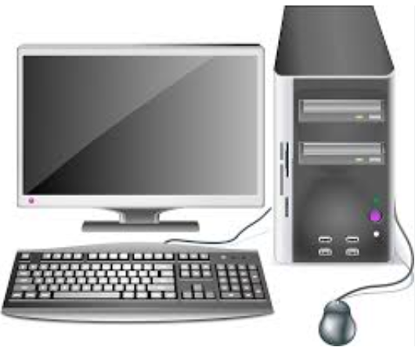
Computer: Used for processing business data, managing inventory using Microsoft Excel, writing invoices, scanning and storing documents, and handling payroll records.

Printer: Used to produce hard copies of invoices, receipts, payroll documents, and other business records required for customer and administrative use.
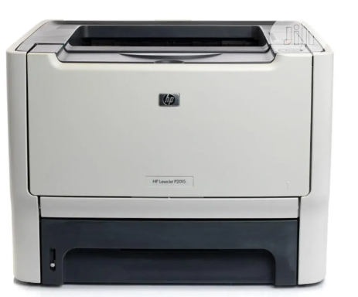

Photocopier Machine: Duplicates essential business documents such as receipts, invoices, staff records, and sales reports for record-keeping.
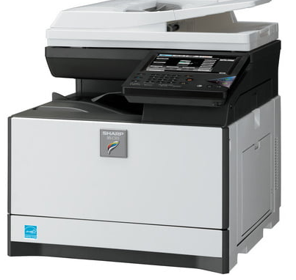


Point-of-Sale (POS): Machine Processes customer transactions, allowing for secure and efficient payment via credit/debit cards, reducing reliance on cash payments.

Scanner: Converts physical documents into digital files for secure storage, record-keeping, and easy retrieval.
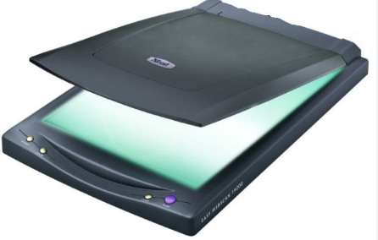


Telephone (Landline and Mobile): Facilitates communication with customers, suppliers, and employees, ensuring seamless business operations.

Binding Machine: Used to assemble and organize hard copies of business reports, invoices, and other important documents for easy reference.
Laminating Machine: Protects important documents (e.g., business licenses, certifications, and ID cards) by sealing them in a plastic covering to prevent damage.
Cash Register: Records sales transactions, providing printed receipts and keeping track of daily revenue.

4. Customer Relations and Front Desk Operations
Customer relations refers to the strategies and processes a business uses to interact with and satisfy its customers. Front desk operations involve handling inquiries, issuing invoices, processing transactions, and addressing customer concerns. Interacting with customers taught me effective communication, problem-solving, and the importance of professionalism. I learned how to process transactions, issue invoices, and address customer concerns politely and efficiently. Good customer relations increase customer retention, enhance brand loyalty, and drive business growth. Front desk operations ensure efficient service delivery, professional communication, and streamlined business transactions.

5. Digital Record-Keeping and Administrative Efficiency
Digital record-keeping involves scanning, storing, and managing business records electronically for quick access and long-term storage. It replaces manual filing systems with computerized data management tools. I was trained in scanning, organizing, and securing digital business records, reducing reliance on manual filing systems. I also learned how to retrieve and manage customer and financial records digitally. Digital documentation improves accuracy, enhances security, and allows easy retrieval of important business records. It reduces paperwork, saves time, and ensures compliance with data protection regulations.
In one word, My SIWES experience at Legit Ventures provided me with comprehensive exposure to business administration functions. I developed practical skills in inventory management, financial documentation, customer relations, digital operations, and supply chain management. These competencies are essential for ensuring business efficiency, optimizing resources, and driving sustainable growth.
This training has equipped me with the ability to analyze business challenges, propose effective solutions, and implement best practices for operational success. The hands-on experience has bridged the gap between theoretical knowledge and real-world business applications, making me better prepared for a future career in business administration.

CHAPTER FIVE

CHALLENGES, RECOMMENDATIONS, AND CONCLUSION

5.1 Challenges
During my Student Industrial Work Experience Scheme (SIWES) at Legit Ventures, I encountered several challenges that tested my ability to adapt, learn, and apply my knowledge of business administration in a real-world setting. These challenges, while demanding, significantly contributed to my professional growth.
Limited Initial Experience in Business Administrative Processes: At the start of my internship, I faced difficulties understanding core business administration tasks such as inventory management, payroll processing, and financial documentation. However, through continuous practice and guidance from my supervisor, I developed proficiency in these essential business functions.
Lack of Financial Incentives for SIWES Students: While SIWES provided invaluable practical knowledge, the lack of financial compensation posed a challenge, especially for students who had to cover transportation and other expenses. A small stipend for interns could serve as motivation and enhance productivity.
Technical Challenges with Office Equipment: The photocopier, scanner, POS machine, and other office equipment occasionally developed technical faults, causing delays in administrative processes. Learning basic troubleshooting and maintenance techniques became necessary to ensure smooth workflow and prevent operational inefficiencies.

5.2 Conclusion
The Student Industrial Work Experience Scheme (SIWES) at Legit Ventures provided me with invaluable hands-on experience in business administration, enhancing my understanding of key administrative functions such as inventory management, financial documentation, payroll processing, and customer relations. Through practical engagement in these tasks, I developed essential workplace skills, including effective communication, problem-solving, multitasking, and digital proficiency in business tools like Microsoft Excel.
Despite the challenges encountered, such as handling customer complaints, managing high workloads, and adapting to technical and inventory-related issues, these obstacles ultimately contributed to my professional growth, resilience, and adaptability in a real-world business environment. Additionally, my exposure to various administrative duties deepened my knowledge of business operations, stock control, and financial record-keeping, which are vital components of any successful organization.
The insights gained from this experience have reinforced my passion for business administration and have equipped me with the necessary skills to navigate the corporate world with confidence. Moving forward, I believe that implementing the recommendations proposed—such as structured departmental exposure, investment in modern business tools, financial support for interns, and digital skills training—will further enhance the SIWES program, ensuring that future students gain even greater practical knowledge and professional competence.
Overall, this experience has been a significant stepping stone in my academic and career journey, preparing me for future roles in business administration and corporate management. The lessons learned will remain invaluable as I continue to develop my expertise and contribute meaningfully to any organization I become a part of.
5.3 Recommendations
Based on my industrial work experience, I propose the following recommendations to improve the SIWES program and enhance its benefits for future students:
- Comprehensive Departmental Exposure: All students undergoing SIWES, especially in business-related organizations, should be given the opportunity to work across various departments, such as inventory management, financial records, sales, and customer service. This will ensure a holistic learning experience and allow students to discover areas where they excel.
- Investment in Modern Business Tools and Equipment: Private organizations should invest in modern office equipment to facilitate administrative efficiency. Upgraded computers, payroll software, efficient POS systems, and stock management applications will help streamline operations, reduce errors, and enhance productivity.
- Provision of Financial Support for SIWES Students: Given that students actively contribute to business operations, organizations should consider offering stipends or transportation allowances. This will motivate students, enhance commitment, and reduce financial strain, particularly for those who live far from their place of primary assignment (PPA).
- Incorporation of Digital Skills Training: Business organizations should provide training on digital tools such as Microsoft Excel, accounting software, and customer management systems. These digital skills are essential in modern business administration and will significantly benefit students beyond their internship period.
- Structured Feedback and Evaluation: Companies should implement structured feedback sessions for SIWES students, allowing them to identify their strengths and areas for improvement. Regular evaluations from supervisors will help students develop professional competencies and enhance their future career prospects.

