A

TECHNICAL REPORT ON

STUDENT INDUSTRIAL WORK EXPERENCE
SCHEME (S.I.W.E.S)

UNDERTAKEN
AT
WORKS DEPARTMENT
KWARA STATE POLYTECHNIC, ILORIN KWARA STATE
BY
ISIAKA SAOBAN OLAMILEKAN
ND/23/BLD/PT/0014

DEPARTMENT OF BUILDING TECHNOLOGY INSTITUTE OF ENVIRONMENTAL STUDIES KWARA STATE POLYTECHNIC, ILORIN

IN PARTIAL FULFILLMENT OF THE REQUIREMENT FOR THE AWARD OF NATIONAL DIPLOMA (ND) IN BUILDING TECHNOLOGY
KWARA STATE POLYTECHNICS

PREFACE
The industrial training experience is organized to introduce student to the practical aspect of their chosen course of study in their profession.
This programme is of immense importance to engineer student because it will give them a foresight of what will be encounter in their various investment in future, it is the moral aspect, creativity, level of attitude to work, relationship with other student, industrial work experience take care of all these.
This piece of work comprehensive report of such aim is carried out at PETIM CONSULTS

DEDICATION
I dedication this report to Almighty God for inspiring me to write the report at the time I never dream of. also dedicated it to my lovely parent Mr&Mrs Adedayo. and also to my friends and well wishers. Who has been supporting me from the beginning of my ND program, thanks for your love and cares.

ACKNOWLEDGMENT
I will like to give my profound appreciation and gratitude goes to Almighty God for his special love mercy over me, also the strength, power and prosperity given to me throughout the period of this training.
I will also extent my greeting to my industrial based supervisor and host of all staff in Building department and for the help of training given to me during the course of my training God bless you all (Amen).
I pray for almighty God to give you long life in order for me to be beneficent to you in future. (Amen)

TABLE OF CONTENTS

Title Page I
Preface II
Dedication III
Acknowledgement IV
Table of Contents V
CHAPTER ONE
1.0 Introduction 1
1.1 Definition of Siwes 2
1.2 History of Siwes 2
1.3 Aims and Objectives of Siwes 2 - 3

CHAPTER TWO
2.0 Company Profile 4
2.1 Company Objective & Aims 5
2.2 company Organizational chart 6

CHAPTER THREE
3.0 Report on One Particular Unit of Building 7-12

CHAPTER FOUR
4.0 Images Showing Practical Work and Steps on Site 13-14
4.1 Impression about the organization 15
4.2 Personal relationship with the organization 15

CHAPTER FIVE
5.0 Conclusion 16
5.1 Recommendation 16

CHAPTER ONE
1.0 INTRODUCTION
This report is a conscious attempt in partial fulfillment of the requirement for the award of the National diploma. The aim is to know good material to be used for any construction project and the normal scale for any Building Technology drawing.
It will tell us more about project execution and the material to be used, this will automatically make us to know whether to rely totally or partially on any executing project years ago, constructed building are easily and quickly goes out of existence (loose it standard) many structures collapse due to the fact that poor/bad materials used workmanship, earth movement of settlement of foundation.
The problems were said to have been caused by things, but the major cause of this problems is due to bad materials used and workmanship.
It has been discovered that this problems facing most of construction on project can be solve if our Engineers/constrictors can used quality not quantity of materials and supervised the workmanship very effective. It affords student of tertiary institutions the opportunity of being familiarized and exposed to the needed experience in handling machinery and equipment which are not available in the educational sector.
The industrial Training Fund (ITF) was set up under act No 47 of 1971 (as amended up to date) to promote and encourage the acquisition of the skills in industrial of the commerce with a view to generate a pool of indigenenous trained manpower sufficient to meet of the economy.
Participation of SIWES has become a mandatory precondition for the award of diploma and degree certificates in specific disciplines in most Institutions with the education policy of government operator. The ITF, the coordinating agencies (NUC, NCCE,NBTE). Employers of labour and the institutions
- Funding: The Federal Government of Nigeria.
- Benefiaries: Under graduate students of the following Agriculture, Engineering, Technology, and Environment Scheme. Education, Medical Science and pure and applied Science
  - DEFINITION OF SIWES
Students Industrial Work Experience Scheme (SIWES) can be defined as the practical experience of student in order to have quality control and satisfactory performance, when in the field. ‘SIWES’ can be interest in a particular subject which is connected with the people and activities involves in producing a particular. Thing (industrial) by involving in a hard physical work rather than office work (work) in order to gain knowledge and skill through the job undergo for a period of time (Experience) under a system of organizing things (scheme).
  - HISTORY OF SIWES
Student industrial work experience established by industrial Training Fund (ITF) in 1993 to solve the problem the lack of adequate practical skills preparatory for employment on Nigeria industries.
The scheme exposes student to industrial based skill necessary for a smooth transition from classroom to the word of work.
Duration: Four months for polytechnic colleges of education and six month engineering students of the University.
  - OBJECTIVE OF SIWES
- To improve the technology development of the country.
- To help students to put into practice what they have learnt theoretically in school.
- The scheme exposes students to industrial based skill necessary for a smooth transition from the classroom to the world of work.
- To exposes the students and broaden their knowledge on the practical aspect of the course they are pursing in their various schools
- To promote and encourage the acquisition of skills in industries and commerce with a view to generate a poor of indigenous trained manpower, sufficient to meet the needs of the economy.
- To help to solve the problem of lack of adequate practical skill preparatory for employment in industries by Nigeria graduates of tertiary institutions.

CHAPTER TWO

2.0 HISTORY OF KWARA STATE POLYTECHNIC, ILORIN
Kwara State Polytechnic, located in Ilorin, Nigeria, is one of the leading institutions of higher education in the country, particularly focused on providing practical, hands-on education in technical and vocational disciplines. Below is a historical overview of the Polytechnic, with a specific focus on the Department of Works.
Establishment Kwara State Polytechnic was established in 1977 by the Kwara State Government. The goal of the institution was to provide educational opportunities in the field of technology, business, and vocational education. The Polytechnic is located in Ilorin, the capital city of Kwara State, which serves as an important educational and administrative center.
The Polytechnic began its academic activities by offering National Diploma (ND) and Higher National Diploma (HND) programs in various technical and professional fields. Over the years, the Polytechnic expanded its academic programs, infrastructure, and student population.
Growth and Development Over the years, Kwara State Polytechnic has grown into one of the leading polytechnics in Nigeria, with a wide array of programs in fields such as Engineering, Science, Business, and Social Sciences. The institution is known for its focus on technical education, aiming to equip students with the skills necessary to thrive in industries such as construction, manufacturing, and information technology.
Accreditation and Recognition Kwara State Polytechnic is accredited by the National Board for Technical Education (NBTE), ensuring that the programs offered meet national standards for higher education in Nigeria. The Polytechnic has built a reputation for producing skilled graduates who contribute to Nigeria's socio-economic development.

2.1 Department of Works (Engineering Works)
Overview of the Department The Department of Works is one of the important departments at Kwara State Polytechnic. It is primarily focused on the training of students in the field of building and construction, with special emphasis on developing practical skills related to civil engineering, building construction, and infrastructure development.
Programmes and Courses The Department of Works offers various academic programs, including:
- National Diploma (ND) in Building Technology: This program covers the basic principles of construction, building materials, structural engineering, and project management, among others. It aims to provide students with a solid foundation in the technical aspects of construction.
- Higher National Diploma (HND) in Building Technology: Building on the ND program, the HND in Building Technology allows students to develop advanced knowledge in construction techniques, design, and management of construction projects.
Objectives The primary objectives of the Department of Works include:
- Training students to become proficient in the practical aspects of construction and building technology.
- Providing students with the necessary technical skills to work in the construction industry or pursue entrepreneurial ventures.
- Preparing students for further studies or research in related fields such as civil engineering, urban planning, and construction management.
Facilities and Infrastructure The Department of Works is equipped with modern laboratories and workshops, where students can engage in practical learning. These facilities include workshops for construction materials, surveying, and computer-aided design (CAD) software used in architectural and structural design. The department also has strong ties with local industries, allowing students to gain practical experience through internships and industrial attachments.
Contribution to National Development The Department of Works plays a significant role in Nigeria's development, as the construction and building sectors are crucial to the nation’s infrastructure growth. Graduates from this department often go on to work in various construction companies, government agencies, or set up their own businesses in the construction sector. Additionally, the Department of Works has contributed to the building of both private and public infrastructures in Kwara State and beyond.

SKILLS ACQUIRED
The following skills were acquired during the SIWES program:
- Practical Construction Skills: Gained hands-on experience in construction techniques and methods.
- Material Management: Acquired knowledge of how to manage building materials efficiently and cost-effectively.
- Surveying Skills: Improved surveying and site layout skills using professional equipment.
- Project Management Skills: Learned how to manage time, resources, and personnel to ensure a project is completed on time and within budget.
- Problem-Solving and Adaptability: Developed the ability to think critically and adapt to changing conditions at the construction site.

CHAPTER THREE

3. ACTIVITIES CARRIED OUT
During my attachment at Kwara State Polytechnic’s Works Department, I participated in a wide range of activities that allowed me to apply my academic knowledge in real-world situations. These included:

3.1 Site Supervision and Project Monitoring
- Description: I was involved in supervising the construction of various building projects, ensuring that the work followed the approved architectural drawings and specifications.
- Experience: I learned how to inspect and monitor the quality of work at construction sites, ensuring that workers adhered to the schedule and safety protocols. Additionally, I observed how site engineers and supervisors handled construction challenges, and I assisted in solving minor on-site problems.

3.2 Quantity Surveying and Estimating
- Description: I participated in the preparation of Bill of Quantities (BOQ) for ongoing projects, including estimating the quantities of materials required.
- Experience: I gained practical experience in material take-offs, preparing cost estimates, and understanding how construction costs are calculated. I also learned about the procurement process and how to select cost-effective materials without compromising quality.

3.3 Material Testing and Quality Control
- Description: I was involved in the testing of construction materials like concrete, sand, and cement to ensure they met required standards.
- Experience: I learned how to conduct various field tests such as slump tests for concrete, sieve analysis for aggregates, and moisture content determination for sand. This experience helped me understand the importance of using quality materials for the durability and safety of buildings.

3.4 Surveying and Site Layout
- Description: I was introduced to basic surveying techniques used in site layout and setting out building foundations.
- Experience: I learned how to use surveying tools like the leveling instrument, total station, and theodolite. I also participated in the marking of boundaries, setting up lines, and ensuring that building elements were accurately aligned with the design specifications.

3.5 Health, Safety, and Environmental Practices
- Description: I was educated on the importance of safety and health measures at construction sites.
- Experience: I attended safety briefings and learned the safety protocols necessary to avoid accidents. I participated in ensuring that all workers adhered to safety guidelines, such as wearing protective gear and maintaining a clean and organized work environment.

CHAPTER FOUR
4.0 Images Showing Practical Work and Steps on Site
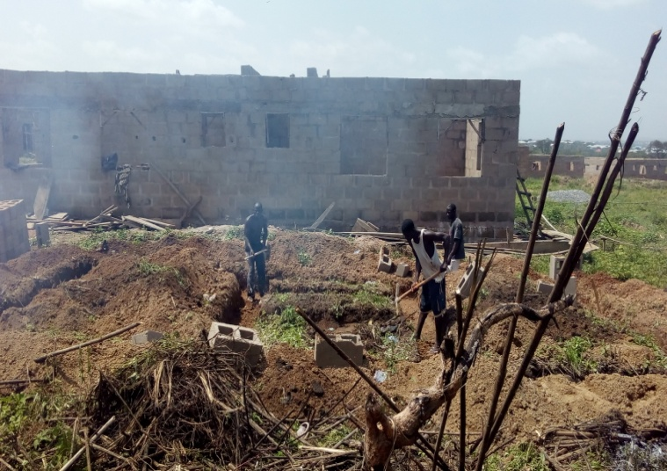
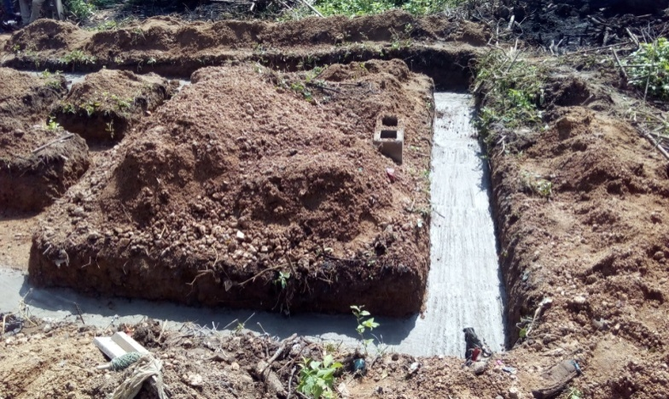
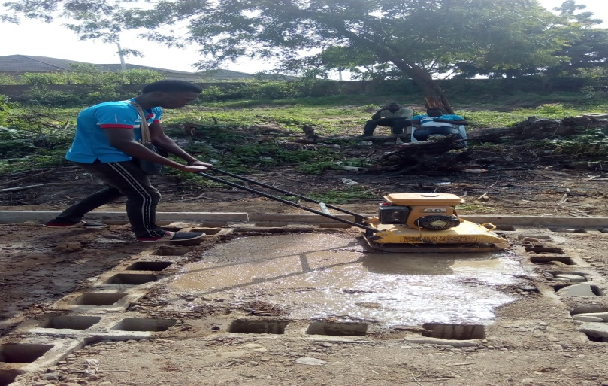
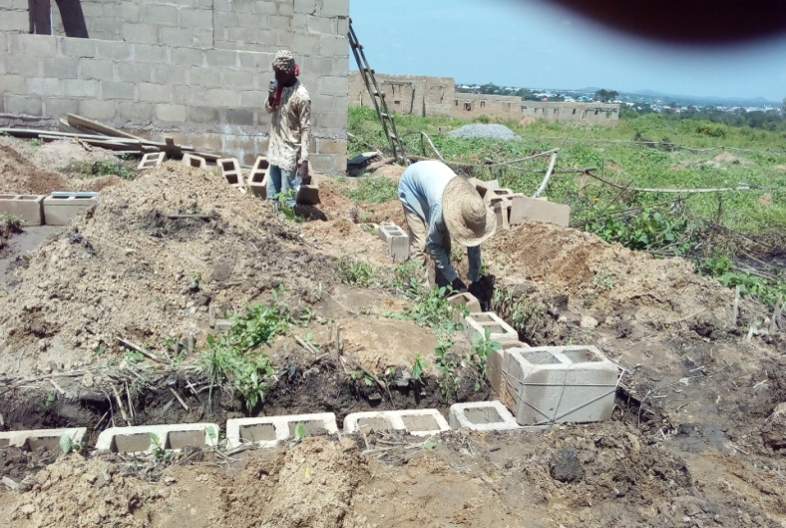
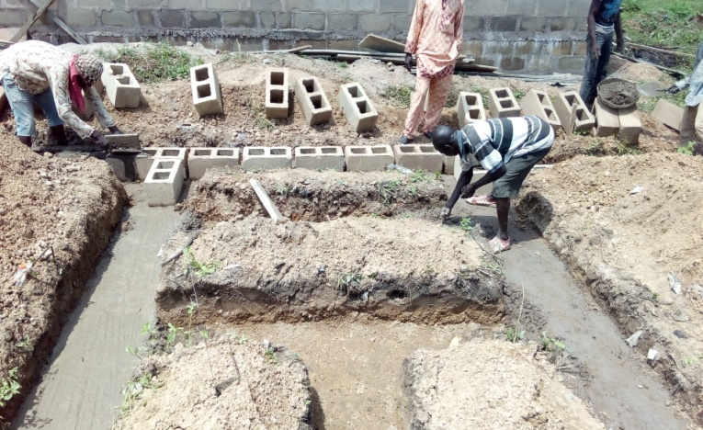
Image 4 showing block work in foundation Image 5: showing compaction of soil by manual compacting machine
Image 1 showing trench excavation
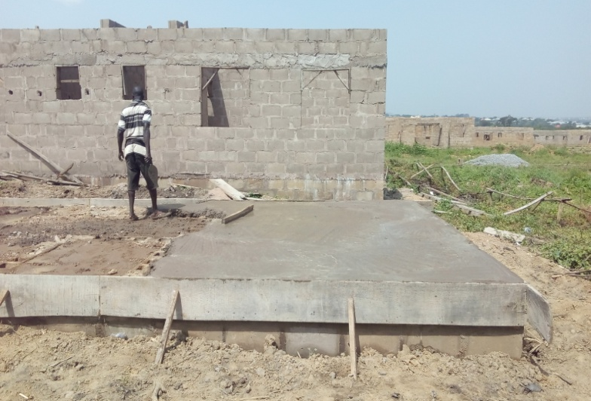
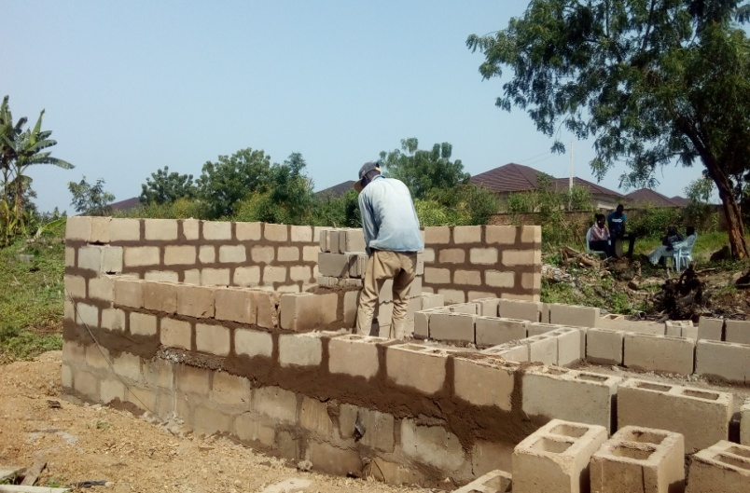
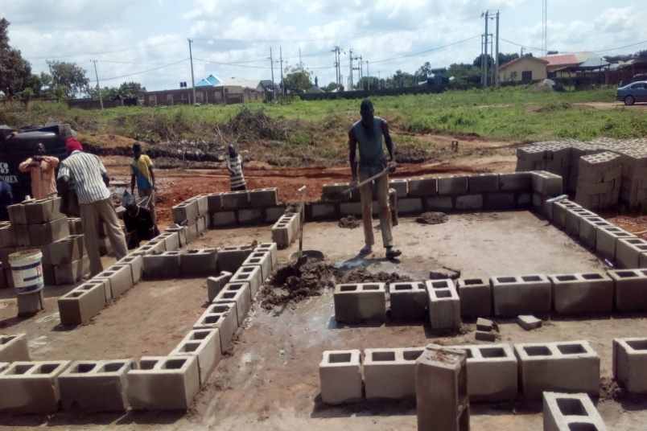
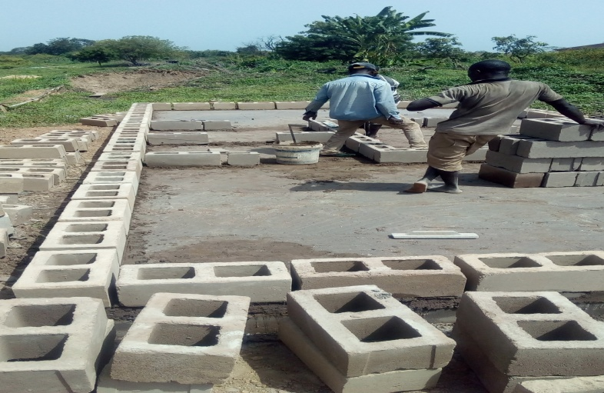
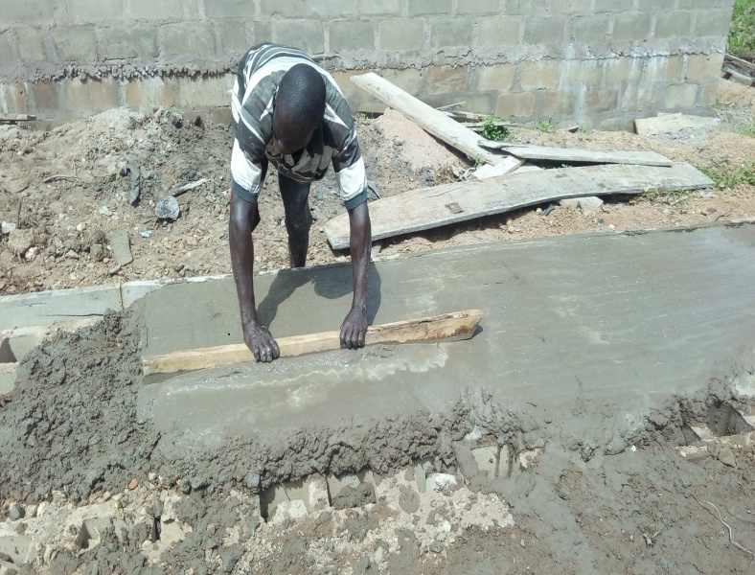
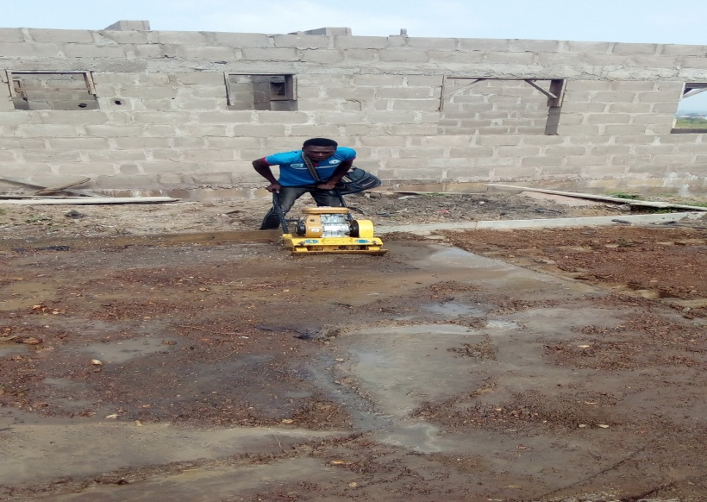
Image 10: showing block forming after DPC Image 9: showing block work in superstructure

Image 8: showing DPC Image 9: showing block forming after DPC

Image 6: showing compaction of soil by Image 7: showing DPC
manual compacting machine

4.1 Impression about the organization
Impression about the industrial training base on four months programs (siwes) was the acceptance of my siwes letter in their organization and also for provision of a construction site to enlighten and show all siwes student the practical work style of a professional builder on a construction site.

4.2 Personal relationship with the organization
The personal relationship with the company in highly correlating, because company accepts the training of the siwes students as their personal assignment, by showing us different technique in building construction.
The welfare and care giving to us in company was highly impressive because the company attached each and every one of the siwes student to different supervisor in which we are free to ask question about every unclear aspect during field work on site

CHAPTER FIVE
5.0 CONCLUSION
This program has brought improvement to my field of study. The experience gained through this program is majorly based on substructure and superstructure works on a four bedroom- bungalow, this program has inspired me to have technical knowledge and practical aspect of what I have learnt in school.
I hereby forward my appreciation to the Rector and Director of the Institute, HOD of my Department, and Professional Lectures in my department including my colleague in training, friends and every member of my family for their support both moral and financial.
My prayer to you all is for God in his infinity mercy bless you and reward every of your endeavor abundantly in Jesus name. AMEN

5.1 RECOMMENDATION
As a result of difficulties experience during the Four months SIWES program, I will like to recommend the following changes;
- The Industrial Training Fund should make monthly allowance available for students, so as to put end to financial difficulties that may arise as a result of transportation problems.
- The Institution must confirm that each student partake in the Industrial Training program, by making sure that they pay every student a visit before the end of the program.
- The Institution and Industrial Training Fund should help the student to get the place of attachment, so that the program will commence as planned.
- Students on SIWES program should be posted or deployed to the Organizations, Department or Firms that are relevant to their Course of study, so that the sole aim of SIWES can be achieved.

