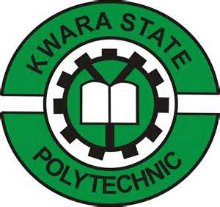

A TECHNICAL REPORT ON
STUDENT INDUSTRIAL WORK EXPERIENCE SCHEME
(SIWES)

HELD AT:
NATIONAL MUSEUM
ALESHINLOYE IBADAN OYO STATE

WRITTEN BY
ADEDEJI MARY OYINDAMOLA
ND/23/TMT/FT/0052

SUBMITTED TO
DEPARTMENT OF TOURISM MANAGEMENT TECHNOLOGY,
INSTITUTE OF APPLIED SCIENCE (I.AS),
KWARA STATE POLYTECHNIC, ILORIN

IN PARTIAL FULFILLMENT OF THE REQUIREMENTS FOR THE
AWARD OF NATIONAL DIPLOMA (ND) IN TOURISM MANAGEMENT TECHNOLOGY.

AUGUST –NOVEMBER, 2024

DEDICATION
This report is dedicated foremost to Almighty God for his favour may and grace upon my life especially during my 4 months Siwes programme.
I would also like to dedicate it to my lovely parent and siblings for their love and support and everyone else that contribute towards making my Siwes training fun and successful one

ACKNOWLEDGEMENT
My profound gratitude to Almighty God for keeping me alive, the giver and taker of lives and also extend my gratitude to my parent for their supports and prayers toward my every step in life. I pray my parent live long to eat the fruit of their labour
My sincere appreciation also goes to my parent Mr. and Mrs. Adedeji for their spiritual, moral and financially support towards the success of my SIWES programme.
I sincerely appreciate the management and staff of the National Museum for their support, guidance, and knowledge shared during my SIWES. I also extend my gratitude to my supervisors and lecturers for their continuous encouragement and constructive feedback throughout the program.

TABLE OF CONTENTS
Title Page i
Dedication ii
Acknowledgement iii
Table of Contents vi
CHAPTER ONE
1.0 Introduction To Training Programme 1
1.1 objective of the programme to student 2
CHAPTER TWO
2.1 ORGANIZATIONAL STRUCTURE OF THE NATIONAL MUSEUM 3
2.2 ORGANNOGRAM 4
CHAPTER THREE

3.0 DESCRIPTION OF ACTIVITIES 5

3.1 SKILLS ACQUIRED 7
CHAPTER FOUR

4.1 Challenges Faced 10

4.2 Solutions to Challenges 11
CHAPTER FIVE
5.1 Conclusion 15

5.2 Recommendations 15

CHAPTER ONE
1.0 INTRODUCTION TO TRAINING PROGRAMME
The students Industrial Work Experience Scheme (SIWES) was initiated in 1973 by the Industrial Training Fund (ITF). This was to update practical knowledge of students in the Universities, Polytechnics and College of Technology. It was aimed at bridging the gap between the theoretical knowledge acquired in classes and technical knowledge in the industries by providing students with opportunities to apply their educational knowledge in real work situations.
Over the years, SIWES has contributed immensely to building the common pool of technical and allied skills available to the Nigerian economy which are needed for the nation’s industrial development.
Furthermore, the place and relevance of SIWES is underscored by the fact that the scheme contributes to improving the quality of technical skills generally available in the pool from which employers’ source technical manpower.
The Student Industrial Work Experience Scheme (SIWES) is a program designed to bridge the gap between theoretical knowledge and practical experience by exposing students to real-world work environments. This report details my internship at the National Museum, highlighting the activities undertaken, skills acquired, and recommendations for improvement.
The National Museum serves as a custodian of cultural heritage, preserving and exhibiting artifacts of historical, artistic, and scientific significance. The museum plays a vital role in research, education, and the conservation of Nigeria’s rich cultural heritage.
1.1 OBJECTIVE OF THE PROGRAMME TO STUDENT
Industrial Training (I.T) provides an avenue for student in an institution higher learning to acquire industrials skills and experience in their course of study.
- To expose students to practical applications of their academic knowledge.
- To develop skills and competencies required in the industry.
- To understand the operational structure and functions of the National Museum.
- To gain hands-on experience in museum management, artifact preservation, and historical documentation.
- To foster a deeper appreciation of cultural heritage and its significance in national development.

CHAPTER TWO
2.1 ORGANIZATIONAL STRUCTURE OF THE NATIONAL MUSEUM
The National Museum operates under the National Commission for Museums and Monuments (NCMM). It consists of various departments such as:
- Curatorial Department (Responsible for artifact collection, preservation, and research)
- Education and Research Department (Focuses on research, public engagement, and educational outreach)
- Exhibition and Display Unit (Handles museum exhibits, display arrangements, and artistic presentations)
- Conservation Department (Responsible for restoring and maintaining cultural artifacts)
- Administrative Department (Manages personnel, finances, and logistics)
- Library and Documentation Unit (Maintains archival records and research materials)

2.2 ORGANNOGRAM
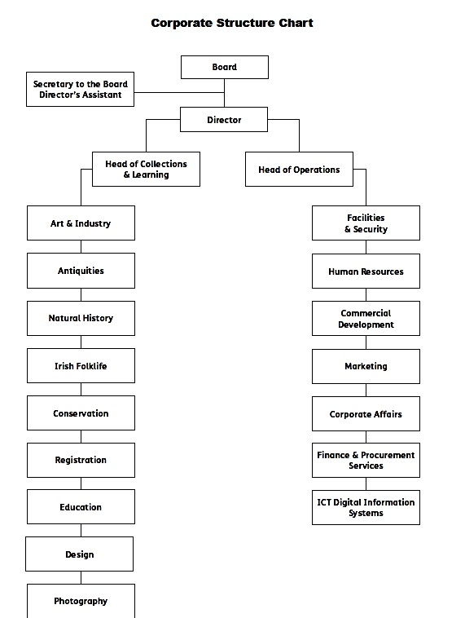
CHAPTER THREE

3.0 DESCRIPTION OF ACTIVITIES
During my SIWES, I was actively involved in various museum-related activities that enhanced my practical skills and understanding of heritage management. These activities included:

1. Artifact Documentation
I played a crucial role in cataloging and maintaining detailed records of artifacts in the museum's collection. This involved:
- Labeling and tagging items for easy identification.
- Updating digital and physical inventory records.
- Assisting in database management to ensure accurate documentation.
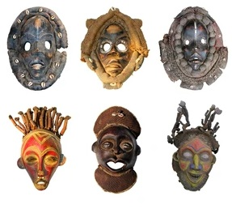

2. Preservation and Conservation
To safeguard the museum’s collection, I assisted in preservation efforts, which included:
- Carefully cleaning and restoring historical objects under supervision.
- Learning and applying conservation techniques to prevent deterioration.
- Monitoring storage conditions to ensure the longevity of artifacts.

3. Museum Tours and Public Engagement
As part of the museum’s outreach and educational efforts, I:
- Guided visitors, including school groups and researchers, on informative tours.
- Explained the historical and cultural significance of exhibits.
- Assisted in organizing interactive sessions to enhance visitor engagement.
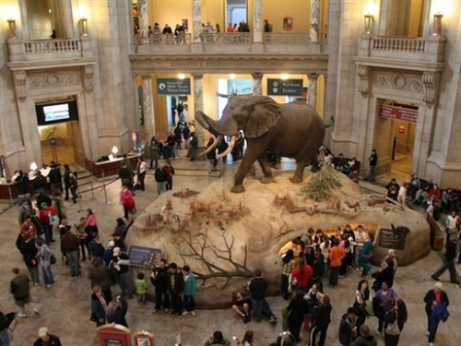

4. Research and Archival Work
My research responsibilities included:
- Investigating the historical background and provenance of artifacts.
- Compiling detailed reports and summaries of museum items.
- Assisting in the digitization of archival materials for long-term preservation.

5. Exhibition and Display Setup
I contributed to the planning and arrangement of exhibitions by:
- Assisting in the setup of both permanent and temporary exhibits.
- Ensuring proper placement and labeling of artifacts for maximum visual impact.
- Working closely with curators to maintain the aesthetic and educational value of displays.

6. Administrative Support
To support the museum’s daily operations, I:
- Assisted with data entry and record-keeping.
- Helped organize museum events and special programs.
- Coordinated communication between different departments.

3.1 SKILLS ACQUIRED
During my SIWES, I developed a range of valuable skills that enhanced my professional and academic growth. These include:

1. Artifact Handling and Preservation
- Gained hands-on experience in the proper handling, cleaning, and storage of historical and cultural artifacts.
- Learned conservation techniques to prevent deterioration and extend the lifespan of museum collections.
- Understood the significance of environmental conditions (temperature, humidity, and lighting) in artifact preservation.

2. Documentation and Archiving
- Mastered cataloging techniques, including labeling and inventory management of artifacts.
- Acquired proficiency in digital record-keeping and database management for museum collections.
- Assisted in digitizing archival materials for better accessibility and long-term preservation.

3. Communication and Interpersonal Skills
- Enhanced my ability to engage with diverse audiences, including visitors, researchers, and school groups.
- Developed professional communication skills through guiding museum tours and assisting in public engagement programs.
- Strengthened teamwork and collaboration by working closely with museum staff and fellow interns.

4. Research and Analytical Skills
- Conducted in-depth research on artifacts, including their historical, cultural, and artistic significance.
- Developed analytical skills in evaluating the authenticity and provenance of historical objects.
- Compiled detailed reports and contributed to the museum’s knowledge base.

5. Event Management and Coordination
- Gained experience in planning, organizing, and executing museum exhibitions and cultural events.
- Assisted in setting up displays, ensuring proper placement, and maintaining aesthetic appeal.
- Coordinated logistics for museum programs, including guest management and scheduling.

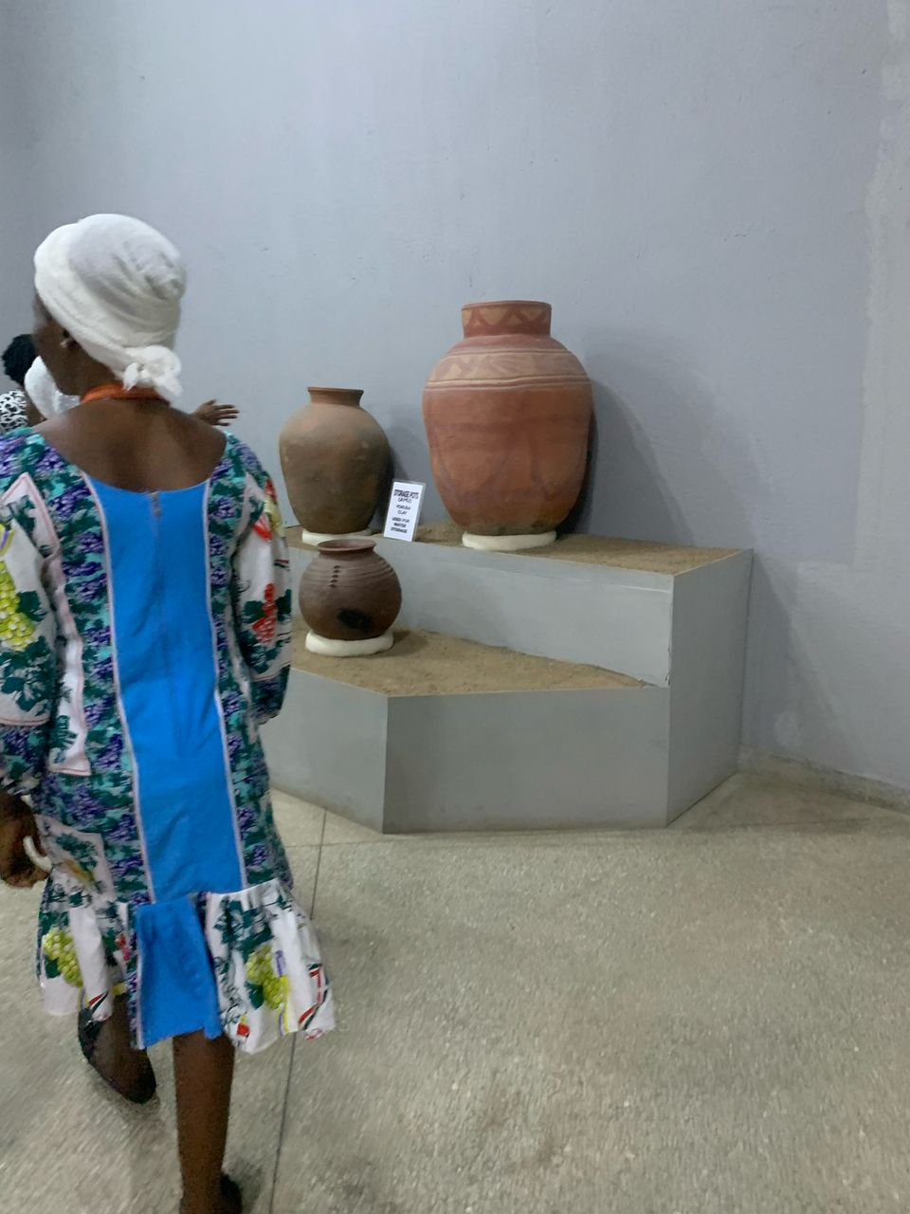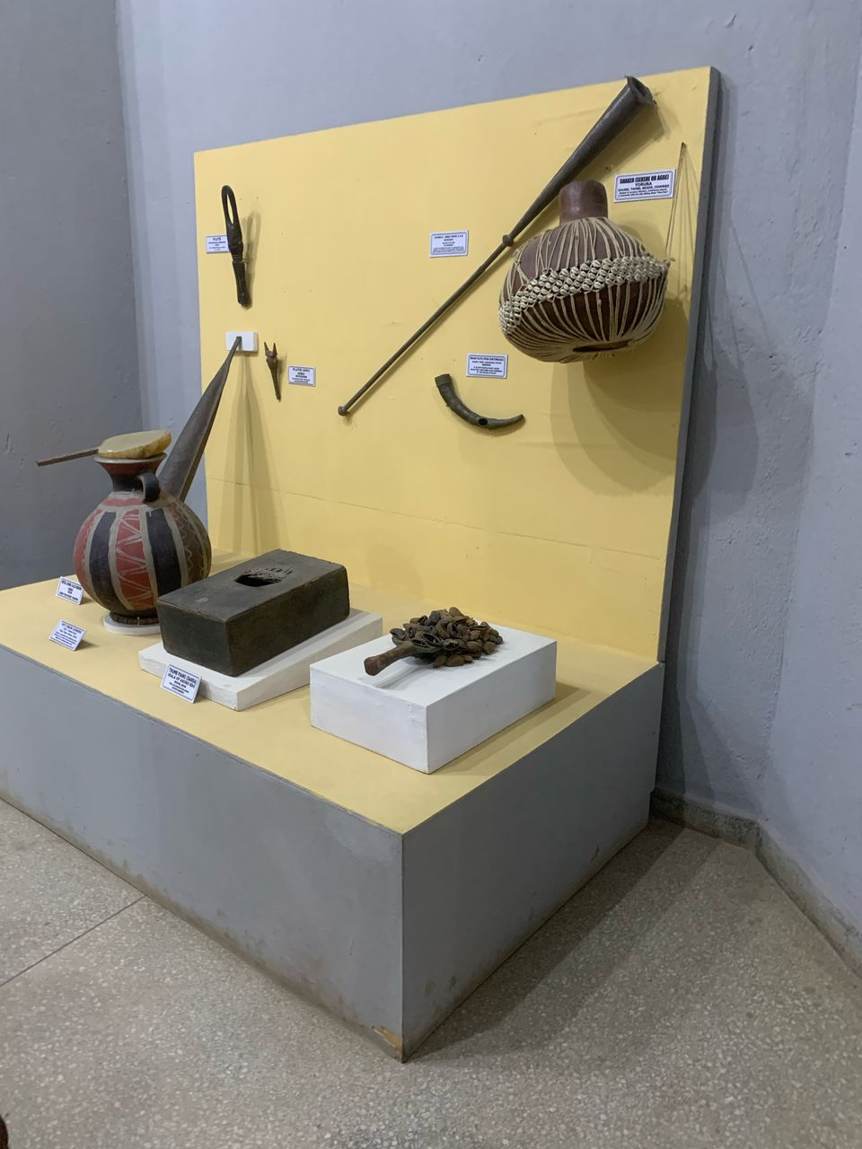
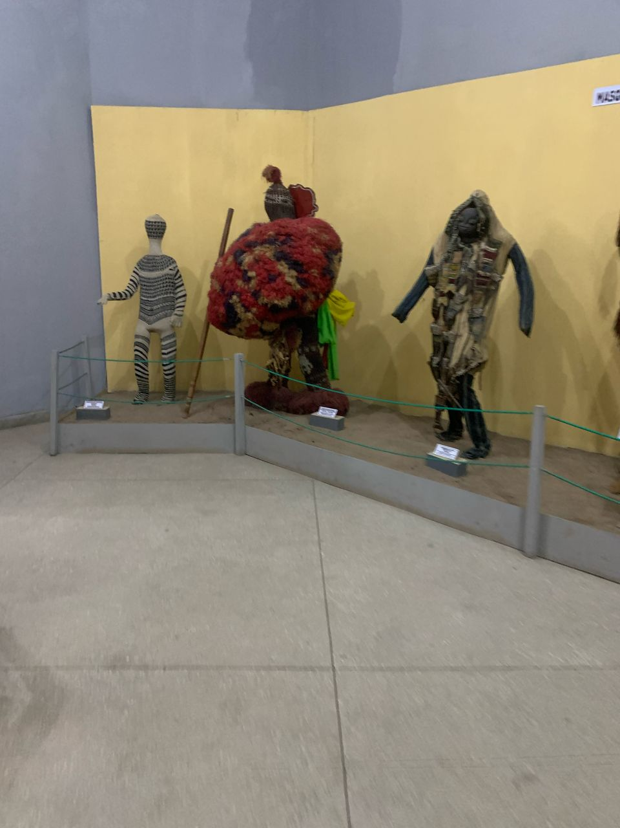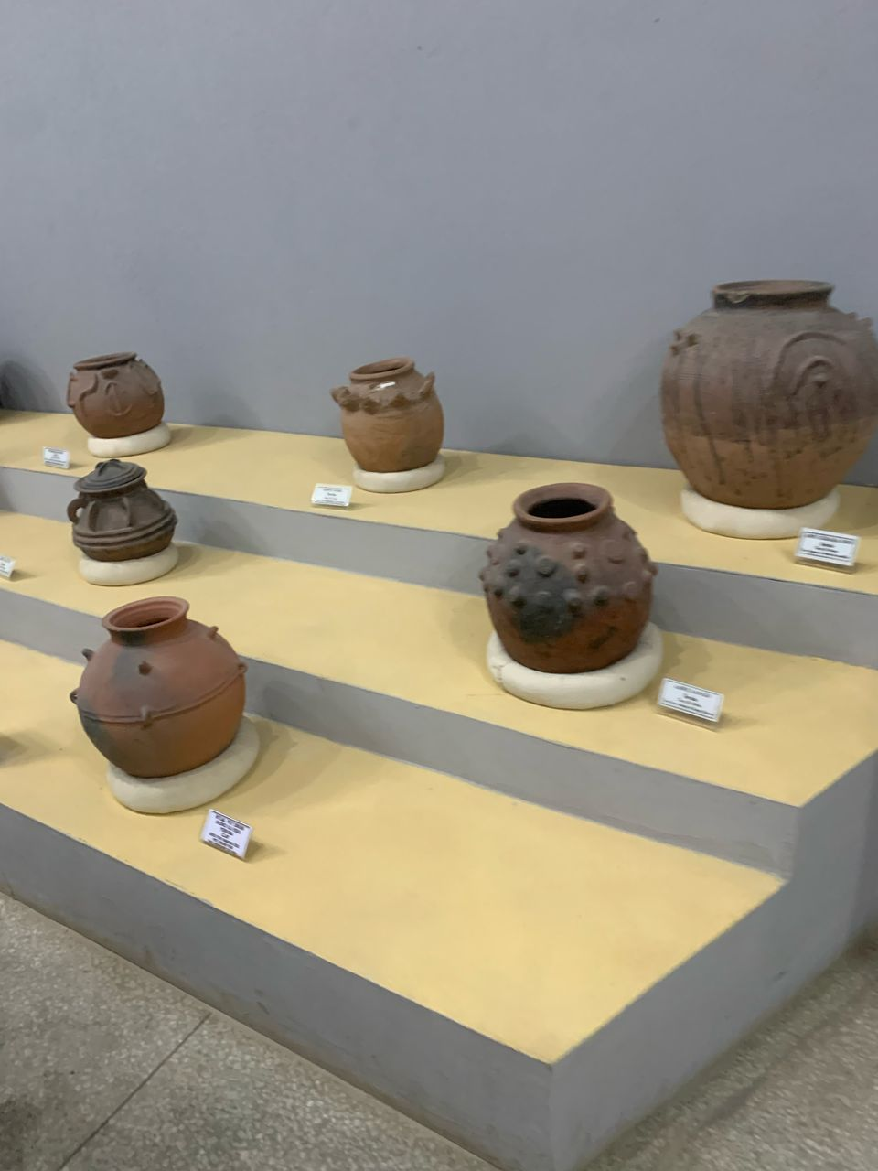

CHAPTER FOUR

4.1 CHALLENGES FACED
During my internship, I encountered several challenges that tested my adaptability, problem-solving skills, and resilience. These included:

1. Handling Fragile Artifacts
- Some artifacts required delicate handling and specific preservation techniques.
- The fear of damaging valuable items made the process stressful, but with guidance, I improved my confidence and precision in handling them.

2. Managing Large Volumes of Documentation
- Cataloging and updating inventory records was time-consuming and required keen attention to detail.
- Adapting to the museum’s documentation system and ensuring accuracy in data entry posed initial difficulties, but I developed efficiency over time.

3. Adapting to Research and Analytical Work
- Conducting historical research on artifacts required thorough investigation and verification of sources.
- Limited access to some archival materials made research more challenging, requiring creative approaches to gather relevant information.

4. Public Engagement and Communication Barriers
- Guiding diverse groups of visitors, including children, researchers, and tourists, required varying communication styles.
- Overcoming language barriers and ensuring visitor engagement was initially challenging, but I improved my adaptability and presentation skills.

5. Exhibition Setup Under Time Constraints
- Assisting in exhibition planning and setup demanded attention to detail and efficient time management.
- Working under tight deadlines to arrange displays and ensure proper presentation was challenging, but teamwork and coordination helped achieve success.

6. Balancing Multiple Responsibilities
- Managing administrative duties alongside research, conservation, and public engagement required effective time management.
- Learning to prioritize tasks and seek support when needed helped me navigate this challenge effectively.

4.2 SOLUTIONS TO CHALLENGES FACED
Throughout my internship, I encountered several challenges, but I was able to overcome them through strategic approaches, guidance from supervisors, and personal improvement efforts. Below are the solutions I applied to address each challenge:

1. Handling Fragile Artifacts
Solution:
- Received proper training on handling delicate artifacts, including using gloves and specialized tools.
- Closely followed conservation guidelines and sought assistance from experienced staff when dealing with particularly fragile items.
- Practiced careful and steady handling techniques to build confidence and precision.

2. Managing Large Volumes of Documentation
Solution:
- Adopted a systematic approach to cataloging artifacts, prioritizing accuracy over speed.
- Used digital record-keeping tools to streamline data entry and minimize errors.
- Regularly cross-checked records with supervisors to ensure consistency and accuracy.

3. Adapting to Research and Analytical Work
Solution:
- Improved my research skills by consulting multiple sources, including museum archives, books, and expert interviews.
- Learned to analyze artifacts more critically by understanding historical contexts and cultural significance.
- Developed better organization strategies for compiling and presenting research findings effectively.

4. Public Engagement and Communication Barriers
Solution:
- Practiced different communication techniques to engage diverse audiences, adjusting my approach based on visitor demographics.
- Used simple language and visual aids when explaining complex historical concepts to younger or non-specialist visitors.
- Observed experienced tour guides to refine my presentation and storytelling skills.

5. Exhibition Setup Under Time Constraints
Solution:
- Improved time management by creating a step-by-step plan for setting up displays efficiently.
- Worked closely with team members to divide tasks and ensure all aspects of the exhibition were completed on time.
- Learned to adapt quickly to last-minute changes by staying flexible and focusing on problem-solving.

6. Balancing Multiple Responsibilities
Solution:
- Developed prioritization skills by identifying urgent and important tasks.
- Maintained a daily planner to track deadlines and ensure all duties were completed efficiently.
- Sought support from colleagues when necessary and learned to delegate tasks when appropriate.

CHAPTER FIVE
5.1 Conclusion
The SIWES at the National Museum provided invaluable hands-on experience in museum operations, artifact preservation, and historical documentation. It enhanced my practical knowledge and skills, preparing me for future career opportunities in cultural heritage, historical research, and museum studies. The experience also deepened my appreciation for Nigeria’s rich cultural heritage and its significance in national identity and development.

5.2 Recommendations
- Increase Access to Resources: Provide interns with access to more sections of the museum to enhance learning.
- Adopt Modern Conservation Techniques: Introduce advanced digital tools for artifact preservation and restoration.
- Enhance Training for Interns: Conduct more structured workshops and practical sessions to improve technical skills.
- Improve Public Engagement Strategies: Use digital platforms and interactive technologies to enhance visitor experience.
- Proper awareness should be created on the relevance of SIWES in the various institutions around the nation.
- Students’ performances during the industrial attachment should be rewarded in order to motivate them to do more.

