

KWARA STATE POLYTECHNIC, ILORIN
TECHNICAL REPORT
ON
STUDENT INDUSTRIAL WORK EXPERIENCE SCHEME (SIWES)

HELD AT

MINISTRY OF WORKS AND TRANSPORT
AHMADU BELLO G.R.A P.M.B 1384 ILORIN KWARA STATE

PRESENTED BY
IBRAHIM ADAM ISHOLA
ND/23/CEC/PT/0013

SUBMITTED TO
THE DEPARTMENT OF CIVIL ENGINEERING, INSTITUTE OF TECHNOLOGY, KWARA STATE POLYTECHNIC ILORIN

AUGUST 2024-DECEMBER 2024

DEDICATION
This report is dedicated to Almighty Allah, the creation of all universe, the one only to be worship, for giving me this privilege and understanding knowledge and protection.
I also give thank to my adorable parents Mr and Mrs Ibrahim for their support in my financial activities in my studies.

ACKNOWLEDGMENT
My adoration goes to Almighty Allah of all human and every one in heaven and earth. All glory and praise unto Him. I would like to express my special thanks of gratitude to my parent for their abundant effort and uncountable support as well as my lecturers and my student of industrial works experience.
I also thank the entire staff of my department of Civil engineering , Kwara State Polytechnic, Ilorin.
My appreciation also goes to my brothers and my sisters of the same blood for their financial support, may God Almighty always bless you all.
There will be no significant effect in the treatment if I refuse to appreciate all my friends and colleague in my department, I thank you, all pray goals shall not be jeopardized.
To all I say a big thanks to you.

PREFACE
The introduction of the student industrial work experience scheme (SIWES) is to prepare student to have practical experience of what has been taught in school. The report activity took place at attachment with the reference of the SIWES log book. The period of attachment is four (4) month.

TABLE OF CONTENT
Title page
Dedication
Acknowledgement
Preface
CHAPTER ONE
1.1 Introduction
1.1 definition of Siwes
1.2 Function of SIWES Unit
1.3 Aims and objectives of SIWES
CHAPTER TWO
2.0 Historical Background Of The Organization Attachment
2.1 Organization Chart Of The Organization
CHAPTER THREE

3.1 Casting of precast slab

3.2 Casting of dam

3.3 Binding of dam

3.4 Grading machine

3.5 Concrete base
CHAPTER FOUR
Experiences gained during Siwes 14
CHAPTER FIVE
Conclusion
Recommendation
CHAPTER ONE
- INTRODUCTION
The student industrial works experience scheme (SIWES) was established by the industrial training fund (I.T.F) in 1973 and control by the national board for technical education (NBTE). The aims and objectives is to develop student skill and to expose students in the school of engineering, technology, environment, science and agriculture and medical science to the working experience in which they will found themselves in future.
It is integral part of degree and National Diploma programme institute of higher learning in Nigeria. This privilege programme would definitely broaden student chance of learning and would empower his/her academic efficiency.
During my four months Industrial Working Experience Scheme (SIWES) at Federal Ministry of Agricultural and Rural Development, the usefulness of maintenance in Tractor was proved and lot of experience was gained.
1.1 Definition of Siwes
Student industrial Working Experience (SIWES) is a skill acquisition training programme set up by the Federal and State government across the Nation in collaboration with the body known as Industrial Training Fund (I.T.F) for student to have a working experience and a feel of what it takes to be genius in one discipline before challenges ahead.

1.2 Function of SIWES Unit

By the directive of National Universities Commission (NUC) and IndustrialTraining Fund (ITF), the Unit is mandated to carry out the following functions.
i. Supervision of the students placed in the industries located within our ITFzone.
ii. Processing of students’ logbooks, ITF forms and industrial
attachment reports upon which is based on the Federal Government fundingof supervision and
students’ allowances.
iii. Fostering of close links between the university and industries participating inSIWES programme.
iv.Provision of advisory guidance to participating students on careeremployment opportunities.
v. Monitoring of compliance with the requirements of SIWES on the part ofstudents in eligible disciplines as a condition for graduation.

1.3 AIMS AND OBJECTIVES OF SIWES
1. It exposes the prepare students of higher institution for the industrial working situation they can likely to meet in the future.
2. It enables student to apply what they have learn theoretically in class into practice in the real world.
3. It makes student to understand the technical implication of their profession.
4. It helps student to express their initiatives, competence and standard in task they have chosen.
5. It enable student to be technically and morally oriented
6. It helps to make transition from school to the working environment easier and to enhance students contact for later job placement.

CHAPTER TWO
2.0 HISTORICAL BACKGROUND OF THE ORGANIZATION ATTACHMENT
The Ministry of Works and Transport in Nigeria is responsible for the construction and maintenance of highways, as well as ensuring road safety. In Ilorin, the ministry has installed signage along Ahmadu Bello Way to notify the public of restrictions on certain vehicle. Summary ; DescriptionAhmadu Bello Way, Ilorin6.jpg. English: Ahmadu Bello Way, Ilorin ; Date, 25 February 2015, 18:07:32 ; Source, Own work ; Author, Jamie Tubers.
The Kwara State Ministry of Works and Transport, located on Ahmadu Bello Way in the Government Reservation Area (G.R.A.) of Ilorin, is a pivotal agency within the Kwara State Government. It is responsible for the planning, development, and maintenance of the state's infrastructure, including roads, bridges, and transportation systems.
While specific historical details about the ministry's establishment are not readily available, its role has been integral to the state's development efforts. The ministry oversees various projects aimed at enhancing infrastructure and transportation within Kwara State.
The ministry has also been proactive in implementing policies to ensure the safety and efficiency of the state's road networks. For instance, in November 2024, it issued a restriction notice banning certain categories of vehicles, including motorcycles, tricycles, commercial vehicles, and heavy-duty vehicles, from plying Ahmadu Bello Way. This measure was taken to enhance safety and security along this critical road network that links to the Government House.

2.1 ORGANIZATION CHART OF THE ORGANIZATION
Manager
Engineers
Apprentice
Surface Finishing & Dressing
Casting Section
Moulding Section

CHAPTER THREE

3.1 CASTING OF PRECAST SLAB
The casting of a precast slab involves manufacturing concrete slabs in a controlled environment before transporting and installing them on-site. This method is widely used in construction due to its efficiency, high quality, and reduced on-site labor.

1. Preparation of Molds and Reinforcement
- Mold Setup: Steel or wooden molds are cleaned and coated with a release agent to prevent concrete from sticking.
- Reinforcement Placement: Steel reinforcement bars (rebar) or wire mesh are placed inside the mold to enhance strength and load-bearing capacity.

2. Concrete Mixing and Pouring
- Concrete Mix Design: A suitable concrete mix with high strength and durability is prepared.
- Pouring and Compaction: The concrete is poured into the mold and compacted using vibrators to eliminate air pockets.

3. Curing Process
- The slab is left to cure under controlled conditions for a specified period, usually 7–28 days, to achieve the desired strength.
- Steam curing may be used to speed up the process.

4. Removal and Finishing
- Once cured, the precast slab is carefully removed from the mold.
- Surface finishing, such as polishing or coating, is applied if required.

5. Transportation and Installation
- The slabs are transported to the construction site and installed using cranes.
- Joints are sealed to ensure structural integrity.
Precast slabs offer faster construction, reduced waste, and improved quality control compared to traditional on-site casting.
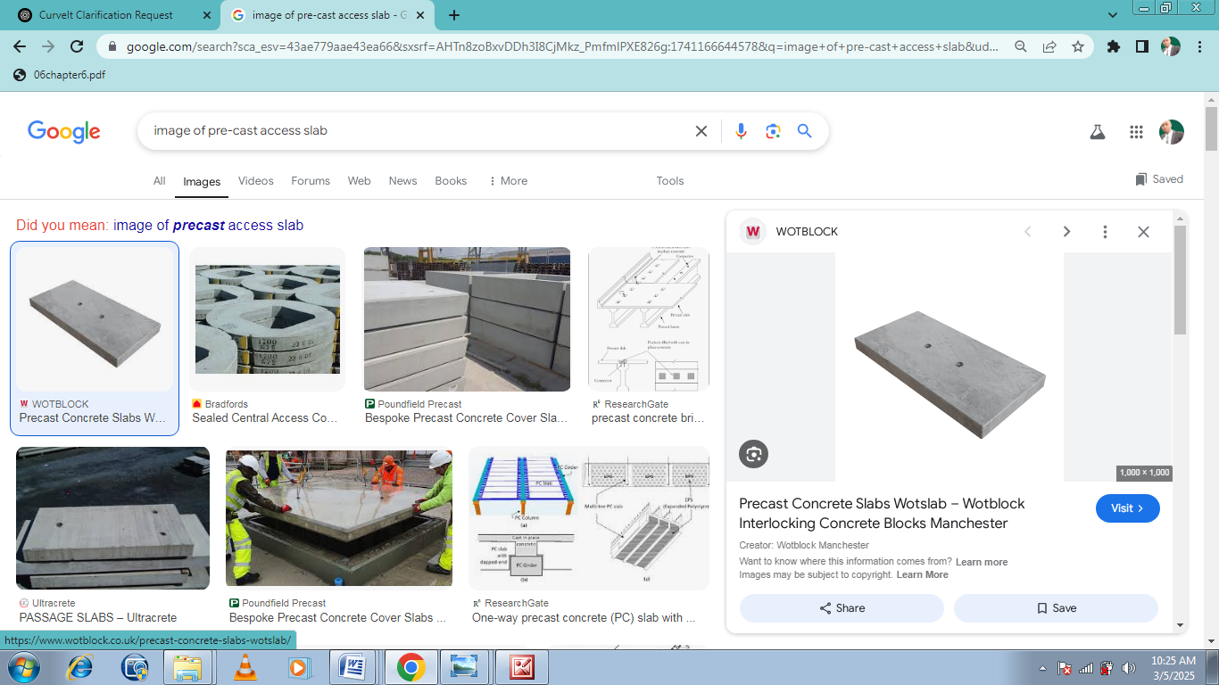
Pre-cast access slap

3.2 CASTING OF DAM
Casting of a dam refers to the process of placing and curing concrete to form the structural components of a dam. This method is primarily used in concrete dams, such as gravity dams, arch dams, and buttress dams. The casting process involves several critical steps to ensure strength, durability, and water resistance.

1. Site Preparation and Foundation Treatment
Before casting begins, the foundation is prepared by clearing debris, leveling the surface, and sealing cracks to prevent seepage. In some cases, grouting is done to improve foundation stability.

2. Concrete Mixing and Placement
Concrete used for dams is typically a special high-strength mix designed for long-term durability. It is prepared in batching plants near the construction site and transported via conveyor belts or trucks. Concrete is placed in layers (called lifts), usually 1.5–3 meters thick, and compacted using vibrators to remove air pockets.

3. Curing and Cooling
Due to the large volume of concrete, the heat generated during hydration must be controlled. Cooling pipes embedded in the structure help dissipate heat, preventing cracks. Curing is done by keeping the surface moist for several weeks.

4. Finishing and Inspection
Once the casting is complete, engineers inspect for defects, apply waterproofing treatments, and conduct stress tests before the dam becomes operational.


Mixer machine

3.3 BINDING OF DAM
The binding of a dam refers to the process of ensuring that different construction materials, especially concrete and reinforcement elements, adhere properly to create a strong and stable structure. Binding plays a crucial role in the durability and water-tightness of a dam.

1. Use of Binding Materials
- Cementitious Binders: Cement acts as the primary binding material in concrete dams, holding aggregates and sand together to form a solid structure.
- Reinforcement Steel: In reinforced concrete dams, steel bars (rebar) are used to enhance tensile strength, ensuring a strong bond between concrete and reinforcement.
- Admixtures: Special chemical admixtures, such as plasticizers and waterproofing agents, improve bonding, workability, and durability.

2. Proper Layer Bonding
- Cold Joint Treatment: When concrete is poured in layers, proper surface roughening and bonding agents prevent weak joints.
- Curing Process: Continuous curing prevents cracks and enhances the strength of binding materials.
- Compaction: Vibrators help eliminate air pockets, ensuring concrete layers bind effectively.

3. Structural Stability
A well-bound dam resists water pressure, reduces seepage, and ensures long-term stability against external forces like earthquakes and hydrostatic pressure. Proper binding techniques are essential to prevent structural failures and leakage.

3.4 GRADING MACHINE
A grading machine is a type of construction equipment used to level and smooth surfaces, typically for roads, landscaping, and site preparation. It ensures a uniform slope and proper drainage before paving or further construction.

Types of Grading Machines
- Motor Grader – A large machine with a long adjustable blade used for fine grading and leveling roads.
- Laser Grader – Uses laser technology for precise grading, common in sports fields and industrial sites.
- Box Grader – A tractor attachment used for light grading, mainly in landscaping.
- Dozer (Bulldozer) – Used for rough grading with a heavy front blade.

Functions of a Grading Machine
- Levels surfaces for roads, runways, and building foundations.
- Creates proper drainage slopes to prevent water accumulation.
- Prepares land for agriculture or landscaping.
- Helps in maintaining gravel roads and removing irregularities.

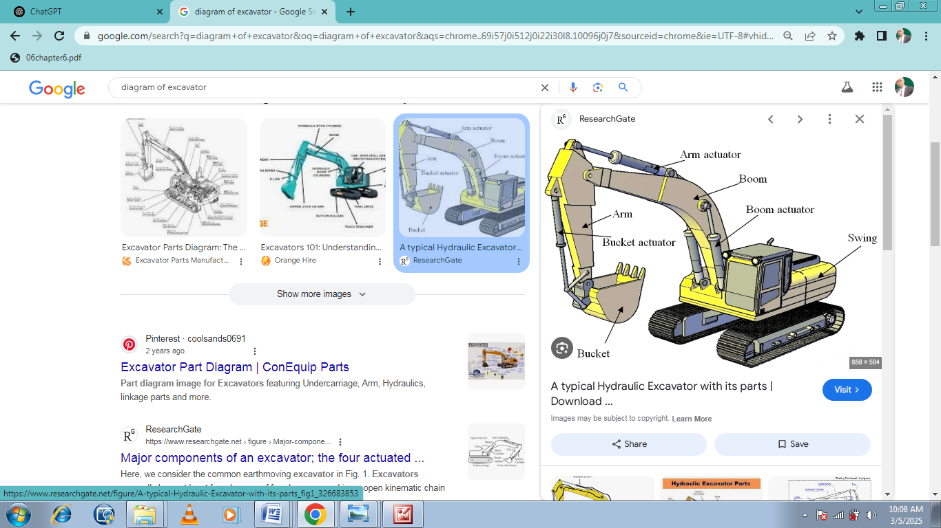
Excavator

3.5 CONCRETE BASE
A concrete base is a solid foundation made of concrete that provides structural support for various constructions, such as buildings, roads, and machinery. It ensures stability, load distribution, and durability.

Types of Concrete Bases
- Slab Base – A flat concrete slab used for floors, driveways, and patios.
- Raft Foundation – A thick concrete base that spreads loads over a large area, ideal for weak soils.
- Strip Foundation – Narrow concrete strips supporting walls, common in small buildings.
- Pile Foundation Base – Used in deep foundations, where concrete bases rest on piles driven into the ground.

Steps for Constructing a Concrete Base
- Site Preparation – Clear and level the ground.
- Formwork Installation – Wooden or metal frames hold the concrete in place.
- Reinforcement Placement – Steel rebar or mesh improves strength.
- Concrete Pouring – High-quality concrete is poured and spread evenly.
- Compaction & Leveling – Vibrators remove air pockets, and the surface is leveled.
- Curing – The base is kept moist for 7–28 days to gain strength.
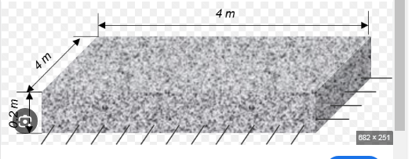

Section of reinforce concrete base

CHAPTER FOUR
4.1 EXPERIENCES GAINED DURING MY SIWES PROGRAMME
I leant how o cast slab for pre-cast and demolition of existing failed box culvert also leant construction of form work for the culvert
I also leant gained the removal of work for the culvelt box and the pre-cast access slab also gained how to using grading machine to do the grinding work
My experience gained also include clearing / packaging of scarfied old the road and gained the replacing of unsuitable material with a suitable material.
My experience gained was also include site investigating and mensuring was taken by ministry engineer at on going road coonstruiction at Abdul azeez Atah road.
Setting out for excavation drainage brech begin from chu 1 +100 to chin 1 + 0 + zoom byrerm of surveyor using survey also how have experience on casting of binding of the dam begin at R.H.S using 1:3:6 concurve mix desigh. pi

CHAPTER FIVE
5.0 CONCLUSION
The SIWES programe is an efficient an effective program which has bring much improvement to my field of study. I have gained a lot of experience from the various works done on field such as construction of sliding gate, solar street light and production of a particular project. It is a programe that bridges the gap between theory and practical aspect, so therefore it has made me to have technical knowledge about what I have learnt theoretically in class.
My three months SIWES program has equipped me the knowledge of metallurgical engineering design in terms of fabrication and production of a project. I here appreciate the effort to the Federal Government and Industrial Training Fund (I.T.F) for improving the technological development of this country.
5.1 RECOMMENDATION TO THE ORGANIZATION CONCERNING THE SIWES PROGRAMME
I would recommend that the organization should appeal to the federal government to make provision for necessary equipment for the effectiveness of the programme.
I will like to implore the organization to continue in their well accommodative standard.
I would recommend that the organization should provide transport facilities for SIWES students so as to move/carry them from the office to the site off construction.

