

STUDENT INDUSTRIAL WORK EXPERIENCE SCHEME [SIWES] INDUSTRIAL TRAINING REPORT

HELD AT

LASUCO SUGAR COMPANY LIMITED

WRITTEN BY

ABDULGANIYU MUBARAK

MATRIC NO; ND/23/EEE/PT/0016

PRESENTED TO

THE DEPARTMENT OF ELECTRICAL ELECTRONICS ENGINEERING, INSTITUTE OF TECHNOLOGY [IOT] KWARA STATE POLYTECHNIC, ILORIN P.M.B 1375 KWARA, NIGERIA

IN PARTIAL FULFILLMENT TO THE AWARD OF THE NATIONAL DIPLOMAL [ND] IN ELECTRICAL AND ELECTRONICS ENGINEERING

MARCH 2024

DEDICATION
This report is dedicated to Almighty Allah the creator and the finisher of our faith, the one who strengthen and spare my life to complete my SIWES programme. May his name be glorified forever? And to my lovely parent in person of Mr and Mrs Abdulganiyu for their spiritual moral and financial support towards the completion of the programme.
ACKNOWLEDGEMENT
My gratitude and sincere appreciation goes to Almighty Allah for his guidance and protection over my family, also for the strength and wisdom granted to me throughout my SIWES programme.
I wish to express my profound gratitude to my SIWES supervisor and other lecturers in the Electrical and Electronics department.
I also give thanks to the Adam crew, starting from the owner of the company, Engineer Adam and my other colleagues.
I also appreciate the effort of my parent of Mr and Mrs Abdulganiyu over me. I pray God will keep blessing them.

CHAPTER ONE
INTRODUCTION

1.0 BRIEF HISTORY OF STUDENTS WORK EXPERIENCE SCHEME (SIWES)
SIWES is the accepted skill training programme which forms part of the approved minimum academic standards in the various degree programmes for all the Nigerian universities. It is an effort to bridge the gap existing between theory and practical of engineering and technology, science, agriculture, media management and other professional education programme in the Nigerian tertiary institutions.
The Students Industrial Work Experience Scheme (SIWES) was initiated in 1973 by the Industrial Training Fund (ITF). This was in response to the mandate given to the ITF through decree 47 of 1971, charging it with the responsibility of promoting and encouraging the acquisition of skills in the industry and commerce with the view to generating a pool of trained indigenous manpower sufficient to meet the need of the nation’s economy. The Industrial Fund (ITF) introduced the scheme for employers to be involved in the entire educational process of preparing student for employment in our various industries with the vision "To be the foremost skills training and development organization in Nigeria and one of the best in the world" and mission "To set and regulate training standards and offer direct training interventions in industrial and commercial skills training and development, using a corps of highly competent professional staff, modern techniques and technology".The scheme is a tripartite programme involving the students, the universities and industries (employers of labor). It is funded by the Federal government of Nigeria and jointly coordinated by the industrial training fund (ITF) and the National Universities Commission (NUC)

1.1 AIMS AND OBJECTIVES OF SIWES:
The aim of SIWES is to put students through the labour market for them to apply and incorporate their classroom knowledge into the working practice of engineering and technology and other fields.
The objectives of SIWES programme include:
- The opportunity of being familiarized and exposed to the mode of work, handling of
- To impact practical method of performing professional functions to undergraduate of the tertiary institutions
- Provision of an enabling environment where student can develop personal attributes such as critical thinking, creativity, leadership, time management, presentation skills and interpersonal skill and other.
- It make student appreciate the roles of their professions which enable them be a creators of change and contribute to grow of the economy and national development.
- It make student to be aware of the work related problems and enable them to see how they can solve the difficulties them all them selves

1.2 BENEFITS AND CHALLENGES OF SIWES
- It’s gives opportunity for student to be in direct contract with junior, immediate and senior professional staff in the industry.
- There are several benefits derived from SIWES, some of which are:
- Its gives student opportunity of getting employment if such student if such student prove himself worthy of getting employed, and for the industries to evaluate the prospective employers.
- Successful SIWES operation provides the government the opportunity of reducing the importation of expatriate Engineers and professional personnel.

CHALLENGES OF THE SCHEME
- Inadequate funding for the maintenance of the scheme by the Federal Government of Nigeria.
- Inadequate and ineffective supervision of students on attachment by staff of institutions and ITF either due to lack of mobility or delays in payment of supervision allowance to both the staff and students.
- Growing number of Higher Institutions increases the number of eligible courses and hence students while the relevant industries are either shutting down or lack the capacity to accept such numbers.
- Acceptance of students to institution only based on vacancy.

CHAPTER TWO

2.0 HISTORICAL BACKGROUND OF THE ORGANIZATION

BUA Foods is a Nigerian food manufacturing company that includes LASUCO Sugar Company. BUA Foods is one of Nigeria's largest food conglomerates. The company was founded in 1988 by Abdul Samad Rabiu. Located at The address for LASUCO Sugar Company Limited is Puta Road, Lafiagi, Kwara State.
2.1 UNIT OF THE ORGANIZATION AND THEIR SPECIFICATION
i. Electrical installation
ii. Air conditional
iii. solar installation
2.2 TOOLS USED IN ELECTRICAL INSTALLATION AND THERE USES

FIXING TAPE: It is used to pull standard or solid wire through mutual PVC conduit
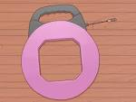

TAPE MEASURE: it is used to measure height for switches and outlets.


HAMMER: it is used to secure boxes equipped with nail on brackets studs in a home. Its also used to clip down wires in surface wiring.


VOLTMETER: it is used to check voltages and verify that circuits are indeed “live”
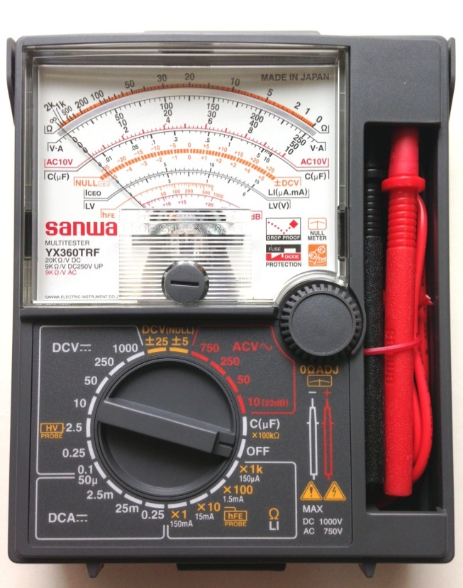

GLOVES: it is used to guide against electrical and mechanical damages to the body.


ALLEN KEYS SETS: it is used to lighted Allen headed screws in electrical works.

BLADE/KNIFE: it is used to cut the installation off the insulated wire.

STAR SCREWDRIVER OR (PHILLIPS SCREWDRIVER): it has a blade for installing star head screw. The tips look like a plus sign.
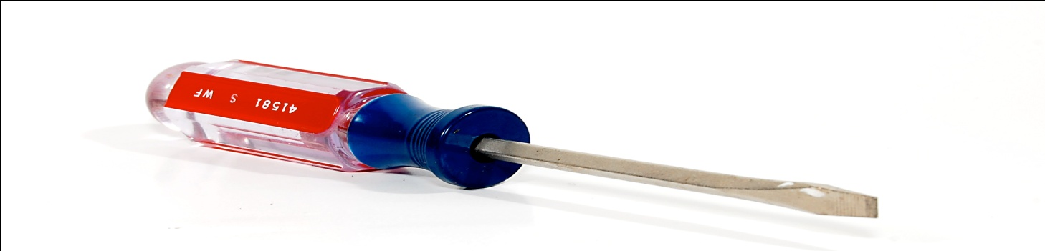

TESTER: it is a tool used to detect the flow of current in the system or in a cable and it comprises of three components inside which are the bulb, insulators and lead.
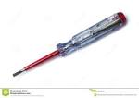

SOLDERING IRON: it is used for soldering of a panel with the use of the soldering bit.

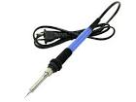

PLIER: it is used for cutting, disconnecting or for remover of installation material like rubber from the conductor, it can also be used to hold material firmly in order to couple the material together. There are various types of pliers which are the Long Nose Pliers and Cutting Pliers.
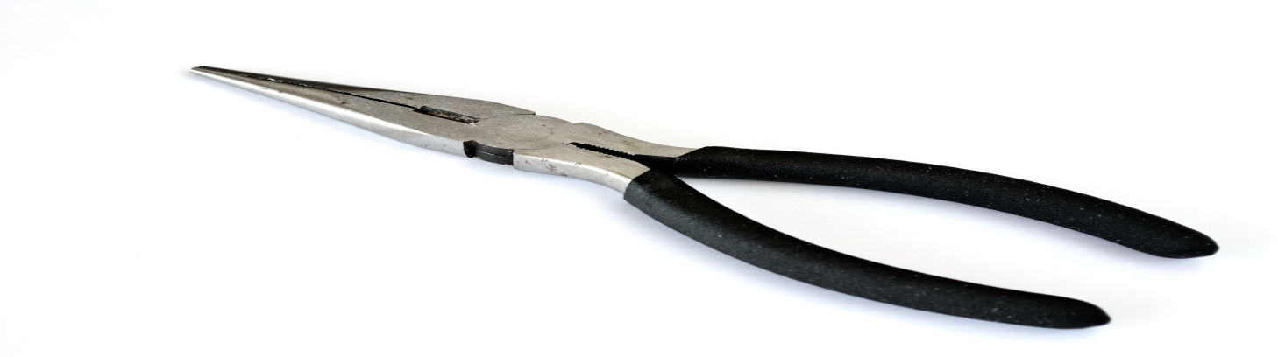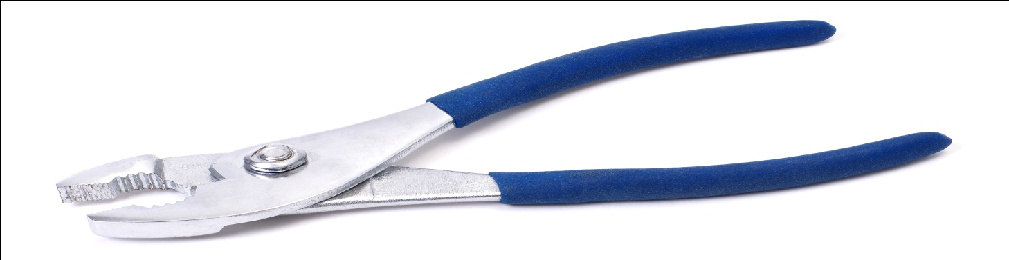2.3 ACCESSORIES USED IN ELECTRICAL INSTALLATION

Accessory is any device other than a lighting fitting associated with the wiring and current using appliance of an installation

SWITCH: it’s a device other than a fuse or circuit breaker for closing and opening a circuit. They are various types of switch they are one gang way switch, two gang one way switch, three gang one way switch, two gang two way switches etc.
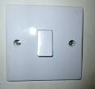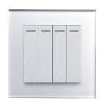

LIGHTING FITTING: It is a device that contains a lamp or lamps together with any holder, shade or reflector, for example wall bracket fitting, lamp holder, a fluorescent.

JOINT BOX: it is a box connecting two or more length of conduit duct and trunking example T joint, U joint, Through box, etc.

CIRCUIT BREAKRS: It is a mechanical device for making and breaking a circuit both under normal and abnormal condition, such as those of a short circuit, the circuit being broken automatically.
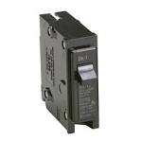

JUNCTION BOX: It is a forming part of a wiring of an installation (usually surface) provided to contain joints in the conductor.
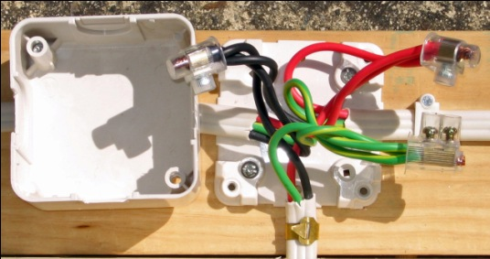

DISTRIBUTION BOARD: It is a device that all breakers switches are inside or device where all mains from each destination are being taped into.
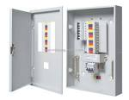

SOCKET: It is a device that connect a plug or electronics device to electric circuit examples are, 13 amp socket, 15 amp socket etc.
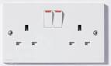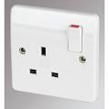

CHANGE OVER SWITCH: It is a device that changes electrical supply from one main to other.
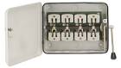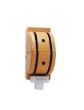

2.4 CABLES USED IN ELECTRICAL INSTALLATION

It is a length of insulated single conductor (solid or stranded) or two or more such conductor, each provided with its own insulation which are laid up together. The insulated conductor may or may not be provided with all overall covering for mechanical protections.
1.5mm (3029) wire: - this is used for lighting
2.5mm wire: - it is used for 13amp socket outlet
4mm wire: - it is used for AC and cooker socket outlet
10mm wire: - it is used for connection of meter or change over to distribution board
16mm wire: - it is used for connection of power supply from the electric pole to the meter.

CHAPTER THREE
EXPERIENCE GAINED
3.1 TO REPLACE A DRILLING MACHINE'S CARBON BRUSHES
To replace a drilling machine's carbon brushes, you need to: unplug the drill, open the housing, locate the carbon brushes, carefully remove the old brushes, insert the new brushes in the correct position, and reassemble the housing; always ensure to check for proper fit and functionality before using the drill again.
Detailed steps:
- Safety first: Unplug the drill from the power source.
- Open the housing: Using a screwdriver, remove the screws securing the drill's casing, typically located on the back of the drill.
- Locate the carbon brushes: Identify the brush holders, usually near the motor.
- Remove old brushes:
  - Depending on the design, you might need to unclip or unscrew the brushes to detach them from their holders.
  - Take note of how the brushes are positioned for proper reinstallation.
- Insert new brushes:
  - Carefully slide the new brushes into the brush holders, making sure they fit snugly.
  - Ensure the brushes are aligned correctly with the commutator.
- Reassemble the housing:
  - Securely tighten the screws on the drill casing.
- Test functionality: Plug the drill back in and test its operation, listening for any unusual sounds or vibrations.
Important considerations:

- Check for wear:
Before replacing, inspect the old carbon brushes for signs of excessive wear like significant shortening or crumbling.
- Correct replacement parts:
Always use carbon brushes specifically designed for your drill model.
- Cleaning:
Clean any dust or debris from the motor compartment while the housing is open.
- Consult manual:
If unsure about any steps, refer to your drill's user manual for specific instructions.

3.2 TO REPLACE A WASHING MACHINE CAPACITOR
To replace a washing machine capacitor, you need to:
- Disconnect power:
Unplug the washing machine from the power outlet.
- Access the capacitor:
Remove any panels or covers necessary to access the capacitor, usually located near the motor.
- Locate the capacitor:
Identify the capacitor, which is a cylindrical component with wires attached.
- Discharge the capacitor:
Use a screwdriver with an insulated handle to touch both capacitor terminals together, releasing any stored electrical charge.
- Remove old capacitor:
Loosen and remove the screws holding the capacitor in place, disconnect the wires attached to it, and carefully remove the old capacitor.

- Note wire connections:
Before removing the wires completely, carefully note the position of each wire on the old capacitor to ensure proper reconnection.
- Select new capacitor:
Choose a replacement capacitor with the same microfarad (uF) rating and voltage as the old one.
- Connect new capacitor:
Attach the wires to the new capacitor according to the noted positions from the old one, ensuring correct polarity.
- Secure mounting:
Mount the new capacitor in the same position as the old one, tightening the screws securely.
- Reassemble and test:
Reattach any panels removed, plug the washing machine back in, and test its functionality.
Important considerations:
- Safety first:
Always discharge the capacitor before handling it to avoid electrical shock.
- Match specifications:
Ensure the new capacitor has the same microfarad rating and voltage as the old one.
- Professional help:
If you are unsure about replacing the capacitor, consider seeking assistance from a qualified appliance repair technician
3.3 HOW TO REPAIR STREET LIGHT
To repair a street light, a technician would typically: identify the issue causing the outage (like a faulty bulb, damaged wiring, or a malfunctioning fixture), access the light fixture safely, replace the damaged component, secure all connections, and test the light to ensure it's functioning properly; this usually involves using specialized tools like ladders, insulated gloves, and sometimes a bucket truck depending on the height of the light pole.
Key steps in street light repair:
- Assess the problem:
  - Check if the bulb is burnt out.
  - Inspect the wiring for any damage or loose connections.
  - Examine the fixture for signs of wear or malfunctioning components.
- Access the light fixture:
  - Use a ladder or bucket truck to reach the light fixture safely.
  - Secure the ladder properly and follow safety protocols.
- Replace faulty components:
  - If the bulb is the issue, carefully remove the old bulb and install a new one.
  - If wiring is damaged, cut out the damaged section and splice in new wire, ensuring proper insulation.
  - If the fixture itself is malfunctioning, depending on the severity, it may need to be repaired or replaced.

- Secure connections:
  - Tighten all wire connections to prevent loose wires or potential sparking.
  - Ensure all connections are properly insulated.
- Test the light:
  - Turn on the power to the street light and check if it is functioning correctly.
  - Look for any flickering or dimness, which might indicate a problem that needs further attention.
Important considerations:
- Safety first:
Always wear appropriate safety gear like insulated gloves, safety glasses, and high-visibility clothing.

- Proper training:
Street light repair should be performed by qualified technicians with proper training and knowledge of electrical systems.
- Local regulations:
Adhere to any local regulations or permitting requirements for street light maintenance

3.4 TO REPLACE AN ELECTRIC POLE
To replace an electric pole, the primary steps include: obtaining necessary permits, safely de-energizing the lines, removing the old pole, installing the new pole, reattaching electrical equipment, restoring power, and conducting a final inspection; all while ensuring proper safety protocols are followed throughout the process.

Detailed steps:
- Planning and Permitting:
  - Contact the utility company to coordinate the replacement and obtain any required permits.
  - Assess the condition of the existing pole and determine the need for replacement.
  - Choose a qualified electrician or utility crew to perform the work.
- Preparation and Safety:
  - Mark the location of the new pole to ensure proper placement.
  - Set up safety barriers and warning signs to isolate the work area.
  - De-energize the power lines by shutting off the circuit at the appropriate switch.
- Removing the Old Pole:
  - Carefully disconnect all electrical equipment attached to the old pole, including wires, transformers, and insulators.
  - Use appropriate equipment to safely remove the old pole from the ground, ensuring no damage to surrounding structures.
  - Properly dispose of the old pole according to local regulations.
- Installing the New Pole:
  - Position the new pole in the designated location.
  - Securely set the pole in the ground using concrete or other appropriate anchoring methods.
  - Ensure the pole is properly aligned and level.
- Reattaching Electrical Equipment:
  - Carefully reattach all previously removed electrical equipment to the new pole, ensuring correct placement and connections.
  - Install new hardware or components as needed.
- Final Inspection and Power Restoration:
  - Conduct a thorough inspection of the new pole and all connections to verify proper installation and safety compliance.
  - Energize the power lines and restore electricity to the affected area.
  - Document the work completed and any necessary details.
Important Considerations:
- Weather conditions: Avoid replacing poles during severe weather conditions.
- Traffic management: Implement necessary traffic control measures if the replacement is near a road.
- Local regulations: Always follow all local electrical codes and permitting requirements.
- Professional expertise: Only qualified personnel should perform electric pole replacement work.

3.5 TO REPAIR A STANDING FAN
- Disconnect power:
Unplug the fan from the power source.
- Disassemble the fan:
  - Remove the front fan guard by loosening screws.
  - Access the motor housing by removing screws holding the plastic cover.
  - Carefully detach the fan blades from the motor shaft.
- Inspect components:
  - Visually check for any damage to the blades, motor housing, or wiring.
  - Check the motor shaft for wear and tear.
  - Examine the capacitor for any bulging or leaks.
- Clean and lubricate parts:
  - Use a damp cloth to clean the blades and motor housing.
  - Apply a small amount of lubricating oil to the motor shaft bearings.
- Check for faulty components:
  - Motor: Test if the motor spins freely by hand. If not, it may need replacement.
  - Capacitor: Check if the capacitor is functioning properly by testing its capacitance with a multimeter.
  - Switch: Verify that the power switch is working correctly.
- Replace faulty parts:
  - If any components are damaged or malfunctioning, replace them with new ones of the same specifications.
- Reassemble the fan:
  - Attach the fan blades back to the motor shaft.
  - Securely reattach the motor housing cover with screws.
  - Reinstall the front fan guard.
- Test functionality:
  - Plug the fan back in and test if it operates properly at different speed settings.
Important considerations:
- Safety first: Always disconnect power before working on the fan.
- Refer to manual: Consult the user manual for specific instructions regarding your fan model.
- Professional help: If you are not comfortable repairing the fan yourself, consider seeking assistance from a qualified appliance technician

CHAPTER FOUR

4.1 HOW SOLAR PANELS ARE INSTALLED
Solar panels are typically installed on the roof, which means that the shape and orientation of the latter should be studied beforehand. Just as important will be the observation of the surroundings, to ensure that there won’t be any shadings to impact negatively on the performance levels of the system. In fact, that is one of the most valuable tips one can give you before proceeding with the work: to carefully inspect the environment around you and check if there is any element that may be (or become in the future) a problem for your panels. In case shading is expected to be an issue, then optimisers should be added in order to get the best out of the system.
Then, there’s quite an extensive process involved in ensuring everything is done efficiently and safely. Most installation projects will follow a similar beat, which usually consists of eight different stages.

Step 1 – Scaffolding
If your installation is going to take place on the roof, scaffolding needs to be erected in order to safely access where the panels are going to be fitted. This usually takes the best part of a day, and accounts for roughly half of the time you can expect the project to last.

Step 2 – Mounts
The mount is what your solar panels are going to sit on. This is the first thing that’ll be attached to your roof or wall, and will serve as the support for the base of your array.
The mounting structure will need to be titled in order to maximise the amount of sunlight that your panels receive. This should be anywhere from 18 to 36 degrees, depending on the slant of your roof.

Step 3 – The solar panels
Next, and arguably most importantly, come the solar panels. Once your mounts are securely in place, these will be attached and tightly screwed on to ensure the panels remain stable at all times. At this point, your solar array will be looking the part – but not quite operational.

Step 4 – Wiring
Just like with batteries and inverters, solar panels can be wired either in series or in parallel. The most crucial difference between those two types of wiring configurations is related to their output voltages and currents. If you install solar panels in parallel, their output voltages will remain the same and their output current will be a sum of all parts. By contrast, if you install solar panels in series, their output current won’t change, though their voltages will be a sum of all parts. A professional installer will be able to assess which one is right for you. This is a very technical step, and one which should only be carried out by someone with a detailed knowledge of how to wire an electrical circuit which uses AC and DC currents.

Step 5 – The solar inverter
Once your panels are wired, a solar inverter will need to be connected to the system. This is the device which turns the solar energy that’s been absorbed throughout the day into the electricity which will power your home.
This is most often installed near to the main panel, and can be kept either outside or inside the building. As they tend to work more efficiently when kept in a cool place, it’s recommended to keep them inside (such as a garage, or any room which gets regular ventilation).
If you do decide to have yours installed on the outside of the building, try to have it facing away from a spot where it’ll get hit by the midday sun (when temperatures are at their hottest).

Step 6 – Bond inverter and battery
If you’re adding a solar battery to the project, the inverter can be connected to it at this point. There are many advantages to adding a solar battery to your array, such as using stored energy as a backup on darker days, as well as potentially lowering the solar battery storage system costs.
But how does it work to install solar panels with a battery? To begin with, you ought to know you need a hybrid inverter capable of managing the charging and discharging of the batteries, as these are the most expensive and delicate element of the entire system. Their storage capacity will vary according to the size of your system and your standard energy spending.
Depending on the voltage and capacity needed, there is more than one way to do it. The batteries can be connected in parallel, in series or in series and in parallel. In the case of parallel connections, the capacity of the batteries doubles, but the voltage remains the same. As for the batteries connected in series, the obtained results are the opposite: their capacity stays the same, but the voltage doubles. Finally, if a series and parallel connection is preferred, both the capacity and the voltage double.

Step 7 – Connect the inverter
The converter has been installed, but it’s at this stage that it gets connected to the consumer unit (the appliance which controls the distribution of solar energy throughout your home).
You might also want to consider adding a generation meter at this stage, as it will allow you to monitor the performance of each individual solar panel. This can help to give you better insight into what time of day is best to run home appliances like a washing machine, dryer, or oven.

Step 8 – Test the solar panels
At this point, the hard graft will be over. But you’ll still need to make sure the panels are working properly. Flick the power on and discover if the installation process has been a success. If it has, you’re all set up and ready to go.

