

A SIWES REPORT OF THE STUDENT INDUSTRIAL WORK EXPERIENCE SCHEME (SIWES)
HELD AT

M.R AJEE PLANNING TEAM

OLD JEBBA ROAD OPPOSITE KWARA TELEVISION OYUN AREA ILORIN KWARA STATE

BY
AJIBOLA KAMOLI ABIONA
ND/23/ARC/FT/0041

SUBMITTED TO:
DEPARTMENT OF ARCHITECTURAL TECHNOLOGY INSTITUTE OF ENVIRONMENTAL STUDIES (IAS)
KWARA STATE POLYTECHNIC ILORIN
SUBMITTED IN PARTIAL FULFILLMENT OF THE AWARD OF NATIONAL DIPLOMA (ND) IN ARCHITECTURAL TECHNOLOGY

AUGUST-NOVEMBER, 2024
DEDICATION
I would like to dedicate this work to the Almighty Allah, whose overflowing love and infinite mercy protected me and gave the grace, favor and strength to pass through the hurdles of the SIWES programme successfully despite the challenges. I also dedicate this report to my parents, Mr. and Mrs. Ajibola, who supported me during the programme.
ACKNOWLEDGMENT
I place on record my deep sense of gratitude to God for His love, mercy, favor, and protection during the Siwes Training. I would like to acknowledge Mr. Ajetunmobi Sikirullahi, who is the Managing Director/C.E.O of the company and other staffs of M.R Planning Team who have taken great pain and effort to guide me in the principles and practice of my discipline. I would recognize the key roles of my industry-based Supervisor, Mr. Ajetunmobi Sikirullahi for the knowledge impacted and the guidance given. I appreciate my parent, Mr and Mrs. Ajibola, and my siblings for their financial, physical, and spiritual support. I also want to thank them for the words of advice and encouragement given to me towards the industrial training. I thank the H.O.D of the department of Architecture, Mrs JM Tomori,
Lastly, I also use this medium to appreciate my fellow interns at M.R AJEE Planning Team –under the tutelage of Arc. Ajetunmobi Sikirullahi for his guidance during the period of my Siwes Program and also to all my friends for their cooperation and all who in one way or the other contributed to the success of my Industrial Training.
PERFACE
The student industrial work experience scheme (SIWES) comprises of knowledge I gained during the training programme. The programme is enhanced from Higher Industrial of training to expose the student to the practical aspect of their field.
However, this programme makes student to have good orientation on their course of study improve them practical through the experience gained.
More so, more companies and industries should be asset to create room for those that are unable to get a place to attach themselves for the training because it will promote the technological activities in the country.

TABLE OF CONTENT
Page
Title page....................................................................................................................................I

Certification................................................................................................................................II

Dedication...................................................................................................................................III

Acknowledgment........................................................................................................................IV

Table of contents ........................................................................................................................V
CHAPTER ONE

- INTRODUCTION……………………………………………………………
  - Aims and Objectives
  - Benefits
  - SIWES Guidelines
  - Architecture as a profession
  - The architect
  - Architects’ duties

CHAPTER TWO

- Firm’s profile…………………………………………………………………
2.1 D L C M Project unit.
2.2 Macro Plan II and Architects.

CHAPTER THREE
3.0 Office work and experience.

CHAPTER FOUR
4.0 Technical and site meetings.

CHAPTER FIVE
5.0 Construction and site experience.

5.1 General description of the construction site.
5.2 Materials used on site
5.3 Work done on site.
5.4 Machines used on site.

CHAPTER SIX

6.0 Conclusion and Recommendation…………………………………………

CHAPTER ONE
- INTRODUCTION.
The ‘Students Industrial Work Experience Scheme’ (SIWES) established by Industrial Training Fund in 1973 under the Industrial Training Fund to solve the problem of lack of adequate practical skills preparatory for employment in industries by Nigerian graduates of tertiary institutions.
The Scheme exposes students to industry based skills necessary for a smooth transition from the classroom to the world of work. It affords students of tertiary institutions the opportunity of being familiarized and exposed to the needed experience in handling machinery and equipment which are usually not available in the educational institutions.
The concept of SIWES conveys is so explicit that, it is non esoteric and fundamentally important that it has gone a long way of assisting students in their various professions. It is in this view that work taught theoretically in the classrooms will be seen and praticalized by students, which would in turn help them to broaden their knowledge. The SIWES Unit is responsible for the coordination of the Students Industrial Work Experience Scheme (SIWES) in the University.
The objective of the Unit is to ensure that students in Science and Technology-based disciplines are made to acquire sufficient practical knowledge so that when they get employed on graduation they become immediately productive with little or no further training in their fields of specialization.
The Unit accomplishes this through the placement of students who are in their penultimate year in the relevant industrial environments for on-the-job training for a period of four to six months. In collaboration with the Industrial Training Fund, the Unit monitors and controls the industrial training programme through the use of industry and institution-based Supervisors. Students, at the end of the training programme, do present reports on their practical experiences at a departmental interactive forum where faculty members jointly access individual student’s performance on the programme as is required by the SIWES curriculum.
The Industrial experience shall be discussed in Chapter three, while Chapter four shall discuss the Recommendations and Conclusions.

1.1 AIM AND OBJECTIVES OF SIWES PROGRAMME
The aims and objectives of SIWES are spelt out below to ascertain the reason for which it was instituted.
- It’s an opportunity for students to understand the technicalities and realities used in the business world that relate to their various field of study thus exposing them to practical levels and advanced level of learning.
- Its helps to build better professional personnel in all fields.
- The scheme provides the opportunity of being familiarized and exposed to the mode of work, handling of relevant machinery and equipments available in their discipline.
- Its gives students the opportunity to relate with their immediate and experienced professionals in their field of study.
- The scheme improves the technical know –how of students in the tertiary institutions.
- Relatively, it provides a means of communication between the industrialized sector and the potential workers.

1.2 BENEFITS OF THE STUDENT’S INDUSTRIAL WORK SCHEME (SIWES)
There are several benefits derived from SIWES, some of which are
- The successful operations of the SIWES provide an opportunity for the government to reduce the importation of expatriate Engineers, Technologist and other Professional Personnel.
- It’s also an opportunity for students to be in direct contact with junior, immediate and senior professional staff in the industry.
- The scheme also provides opportunity for industries to evaluate the prospective employers and give healthy feed back to Institutions.
- Many students also have been gainfully employed through this method as students with exceptional good skills and experience could be recalled to take on employment through the scheme which in turn reduces the number of unemployed graduates in the country.

1.3 SIWES GUIDELINES
The occupational guidelines for SIWES issued by the Federal Government of Nigeria through the Industrial Training Fund (ITF) lists the qualities that a selected work station should have in which I had followed
This includes.
- Provide satisfactory good working environment
- Provides experience which is in line with the students course of study
- Provides supervision by the employer.
- Provides opportunity to gain experience in various ways.
- Use modern facilities, equipments appropriate for the various works.
All these were listed based on the fact that I went to several registered Architectural and construction Firms.

1.4 ARCHITECTURE AS A PROFESSION.
Architecture is both the process and product of planning, designing and construction. Architectural works, in the material form of buildings, are often perceived as cultural symbols and as works of art. Historical civilizations are often identified with their surviving architectural achievements.
"Architecture" can mean:
- The art and science of design and erecting buildings and other physical structures.
- A general term to describe buildings and other infrastructures.
- A style and method of design and construction of buildings and other physical structures.
- The practice of an architect, where architecture means to offer or render professional services in connection with the design and construction of a building, or group of buildings and the space within the site surrounding the buildings, that have as their principal purpose human occupancy or use.
- Design activity, from the macro-level (urban design, landscape architecture) to the micro-level (construction details and furniture).
- The term "architecture" has been adopted to describe the activity of designing any kind of system, and is commonly used in describing information technology.
In relation to buildings, architecture has to do with the planning, designing and constructing form, space and ambience that reflect functional, technical, social, environmental, and aesthetic considerations. It requires the creative manipulation and coordination of material, technology, light and shadow. Architecture also encompasses the pragmatic aspects of realizing buildings and structures, including scheduling, cost estimating and construction administration. As documentation produced by architects, typically drawings, plans and technical specifications, architecture defines the structure and/or behavior of a building or any other kind of system that is to be or has been constructed.
1.5 THE ARCHITECT.
A picture speaks a thousand words, and before a building is constructed or converted it is an architect's job to transform the words of a specification into a design. They may do this themselves or with assistance from an architectural technologist or technician. These individuals have highly specialized skills but are less comprehensively trained than architects.
An architect is involved in the planning and drawing of this design, as well as overseeing its construction. This involves taking into consideration not only environmental and economic needs, but also the concerns of the construction team, which include materials and safety. The design has to be functional, thus an architect needs to have knowledge of the builder's requirements, such as which planning and building codes the construction must abide by. Ultimately the employer wants a design that is going to be most economically effective for them, giving the architect a further task to draw upon their knowledge to meet these requirements.
It is clear why the term 'architect' is only applied to people who have laboriously undertaken seven or six years of learning and training to give them the ability to combine all of the above factors. The title of architect is solely reserved for people who have taken the correct exams and have the appropriate experience to be on the national register of architects. This is held by a government organization - the Architects Registration Board.
1.6 ARCHITECTS DUTIES.

- STATUTORY DUTIES
An architect is expected to have a reasonable working knowledge of laws and legislation which affects him in the discharge of his duties as an architect.
- CONTRACTUAL DUTIES
Express Terms
The architects’ duties to his client depend on the express terms of his contract with the client.
The contract may be a standard form contract like the SIA Conditions of Appointment and Scale of Professional Charges which sets out the terms and conditions of appointment and governs the
rights duties and obligations of the architect and the client.

Implied Terms
Not all contracts however, are required to be in writing. Where there is no written contract, the
terms of the contract will have to be implied. A term can be implied by law or from the facts.
Degree of Skill
An architect who offers professional architectural services warrants that he will use “reasonable
care & skill”. The degree of skill required is that of an ordinarily competent architect professing to have that special skill. Contracts for supply of professional architectural services do not normally give any implied warranty beyond reasonable care and skill.
Delegation of Duties
The appointment of an architect, as with most professional persons is personal to himself. He
cannot delegate his duty to be performed by someone else. In practice however, due to the
complexities of some projects an architect will usually delegate a substantial proportion of the
technical aspects of design to other skilled professionals like mechanical & electrical engineers,
Civil & structural engineers, quantity surveyors, etc. Where an architect undertakes the design and supervision of a building project under an “umbrella” arrangement, he should let the client know that he is delegating other aspects of the design like the mechanical & electrical design work and structural design work to other professionals.
Design responsibilities
Quite apart from the aesthetic designs of a building, the design responsibilities of an architect can
extend to specifications, selection of finishes choice of construction techniques. He must exercise
skill and care in the execution of his designs and in the choice and specification of materials.
Design and Build
In traditional employer/architect relationships, an architect is only required to use reasonable care and skill in the execution of his design services. He does not normally warrant the suitability of his design for an intended purpose. In design and build contracts however, there may be an implied term that his design is suitable for the intended purpose. He has a higher duty of care to his employer to ensure that his design is suitable for the purpose made known to him where his is employed under a design and build contract

DETAILED DUTIES
- Site Investigation
- Feasibility Studies
- Cost Estimates
- Knowledge of legislation, regulations and bye-laws etc.
- Recommending builders
- Recommending form of contract
- Administration of contract
- Plans, drawings, specifications
- Supervision

CHAPTER TWO
  - Background of study
The opportunity of having a firsthand experience on the job is of a great significance that its importance cannot be over de-emphasized. First, it offers the trainee the ample choice to co-relate the theoretical knowledge with the practical or field experience and second, it present a wide choice again within the spectrum of professional background to the protégée to diversify or acquire special skills of specialization for future expertise on the job. Narrowing to the context of discursion without necessarily opting for the above broad overview, it will be no longer strange to see it only necessary to consider a choice place that support the core value of the scheme but also an enabling environment that has an array of opportunity that will drive the inspiration for the study background. It is worthy to note that this study carried out bearing in mind not only the need for the purpose of course work documentation but to expand the trainee horizon in the vast area spectrum of science and art of learning and therefore mobilized his inapt ability of cognitive skills for the all round success of the study.

- COMPANY PROFILE.
  - GRIDS ASSOCIATES
Grids associates is a commercial construction institution, headed by a registered and experienced architect with
over thirty years of experience. The firm came together in the year 1983 with three registered architects. Grids associates is a registered architectural firm; the firm was duly registered by the professional body of architects in Nigeria (Nigeria institute of architects). The principal partner at the firm is Arc. Oluseun Odeyale. The firm is located at No 22, Akindelu Street, off Folawiyo Bankole, Ikate, Surulere, Lagos state.

Softwares used in the firm include the following:-
AutoCAD, ArchiCAD, Sketch up, Revit, and Microsoft Project. Below is the organization structure of this unit.

2.11 Organization structure.

Managing Director and Consulting Architect

Professionals’ Administrative staff

Architect
Accountant
Planner

Foremen Receptionist

Labourers Drivers

The firm is affiliated with Tedley ventures and co limited; a construction firm with great reputation in the construction industry. As a result of the affiliation with Tedley ventures and co. limited, the firm (Grids associates), in a way, doubles as a “design and build” firm, they do designs and then Tedley ventures and co. limited does the construction works with little or no supervision.
The partner has the requisite academic and professional background to cope effectively with the high intellectual demand of their noble professional. They are well trained, experienced, and committed to the ideas of the profession which is to ensure that their client get value for money on their respective project and development. The main objective of the firm is to carry on business as design and project managers, achieving client’s objective in all types of capital projects and developments from conception to commissioning and maintenance in all sectors of the economy for the attainment of sustainable national development in Nigeria.
The firm recognizes and appreciates the importance of appropriate information management systems in the construction industry. Some of the software packages in use at the firm are; MS offices (Microsoft word, Microsoft excel, Microsoft access and Microsoft project), Corel draw, sketch up, AutoCAD and AutoCAD 3D.
Consequently, the internship experience I had with Grids associates afforded me full and supportive opportunities and exposure to the use of software packages, architectural (designing) and construction works.
OUR VISION: To be a globally recognized firm with up to date technology and management techniques, meeting global standards and commanding high acceptance in the international circles, while providing employment and investment opportunities and also bringing up the younger generation of Architects so as to maintain the high level of standard and discipline in the Architecture of today.
STRATEGY: Top Edge, through proof approach, is the premise on which our organization functions. This further strengthens our capacity to attracts and retain well seasoned professionals as well as best people inan allies in related industries. Ensure high team spirit of the work force develop and create high level of performance and integrity in all output.

CHAPTER THREE
During the period of my attachment, my experiences constituted of the following
i. Office activities,
ii. Site and technical meetings,
iii. Construction and site activities.
which are in details below.
OFFICE ACTIVITIES
I was exposed to some office and secretariat works and computer works during the course of my attachment. Due
to the development and scientific advancements in our time which has also affected Architecture in a large way.
One of such areas is in the creation of architectural design software such as autoCAD, archiCAD, revit, 3 – D max,
and many more.

3:2 INTRODUCTION TO AUTOCAD

AutoCAD is computer software which aid designs. It comprises of wide range of computer based tools that assist

Engineers, Architects and other professionals in the design industries.

The software has taken design beyond the conventional and old use of drawing boards. It offers unmatchable

precision, power and set leading standards for technical design.

The AutoCAD tools offer a standard for technical design. AutoCAD provides solid modeling systems, which gives

the flexibility to conceptualize and construct realistic and accurate two dimensional drawings and three

dimensional models. This application is not recommended for only architects but also engineers, planners among

others.

3:2:1 THE ADVANTAGES OF AUTOCAD

- Consistence and precision: precision and consistence is very necessary in any design, with the used of AutoCADthis is achieved to a high degree, having errors, at barest minimal level.
- Neatness and clarity of design: with AutoCAD designs neatness and clarity of work is far above that of manual designs.
- Storage and retrieval: since the designs are stored of the computer memory, it can be easily reprinted at a very short notices and making adjustment very easily done.
- Speed production: with designers, time is of paramount importance in most cases and AutoCAD have assist in producing designs at a faster rate than manual design. This is because work can be done anywhere other than the design studio.

3:2:2 Disadvantages of AutoCAD usage

1. Makes lesser number of staffs required for a given task leading to redundancy.

2. AutoCAD can be addictive, users may adopt non-stop design sections of many hours, muscular fatigue, eye strain and headaches can result from the extended use of badly placed AutoCAD equipment.

3. If the system has a mechanical fault all of a sudden, and one does not have another copy elsewhere, that will means starting the designs all over.

3.1 SITE AND TECHNICAL MEETINGS.
The site meeting was a meeting set up to bring the consultant(s), contractor(s), and the sub-contractor(s) together to discuss matter arising as regards to work ongoing on site, sometimes, in this meetings technical issues are discussed and long lasting solutions are brought up, during the period of attachment site and technical meetings were held fortnightly, and on monthly basis, contractors and consultants go round the site to take cognizance of the progress of work and the quality of the ongoing work. A general work summary is being taken and there is a comparison between this work summary and the program or progress of work. Site meetings also create an avenue for the professionals to settle some lapses during the course of the construction which may or may not alter the architectural drawing, that’s why the Architect presence is very important on site. For example during the course of my I.T, after the reinforcement and casting of a beam, it was later discovered that it was in a wrong position, so as not to destroy the other structural components and not also alter the functionality of the building, the architect has to alter it in the original plan.
The site meetings also settle long standing dispute among contractors and professionals.

3.2 CONSTRUCTION EXPERIENCE.
Construction is the ground and physical development of an already conceived design, most constructions in Nigeria
involves the use of materials such as steel, wood, different aggregate sizes, cement, glass etc.
The materials used on this site, during my period of attachment, were not any different.
GENERAL DESCRIPTION OF THE CONSTRUCTION SITE.
The ongoing construction sites in which I was privileged to be present were:
- A mixed- use building in Lekki, Lagos
- A five – unit terraced building, Lekki, Lagos
- A four – unit terraced building, Ikoyi, Lagos
- The conversion of a residential building to an office building, Surulere, Lagos.
The mixed - use building is a three storey building and a pent floor having multiple entrances and exits, two
common stair halls and an elevator at the rear of the building. Theground floor is an open office which may be
partitioned later, the first and the second floor are malls while the other parts of the buildings are guest houses.
The four and five unit terraced building were at the roofing stage when I arrived, the carcassing are being placed
already. A stone – coat roof is being used.
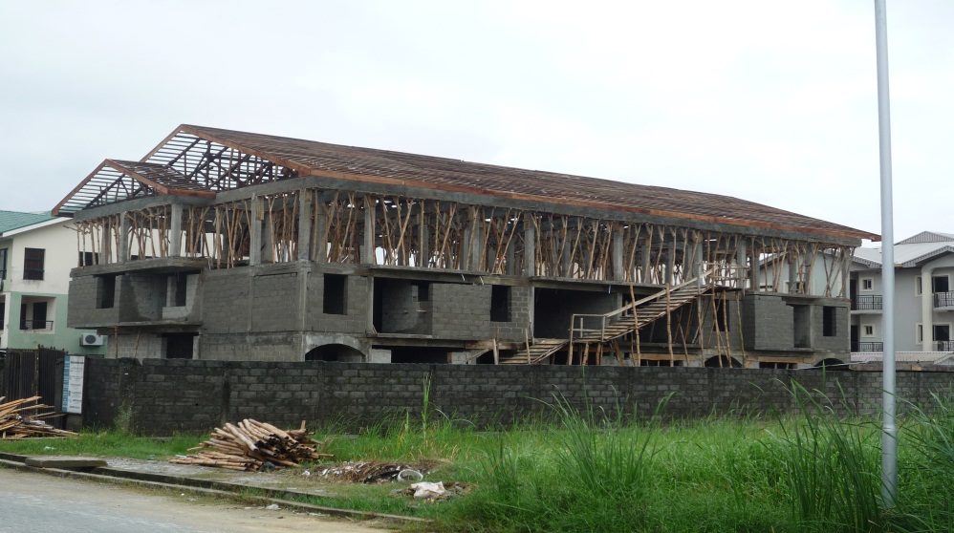

5.2 MATERIALS USED ON SITE.
These are the materials used on site.
225mm block; all external walls were done with 225mm blocks.
215mm blocks; partition walls, some toilet walls were done with this 215mm blocks
100mm blocks, toilet walls and duct walls were done with 100mm blocks.
-Perforated blocks; the fancy perforated are to be used on both sides of the walkways and stairways.
-Stones; stones of 20mm to 50mm are mixed with sand and cement to form concrete.
-Stone dust; usually 0 to 10mm thickness is mixed with plaster sand and cement for the finishing plaster.
-Sharp sand; for block binding mortar.
-Plaster sand.
-Galvanized steel pipes for dwarf walls.
-Gypsum ceiling of 600mm x 600mm.
-Floor tiles of 600mmx 600mm.
-Aluminum ceiling runners
-Galvanized steel sub-frames.
-Galvanized and finished door and window frames
-Glasses.
-Steel trusses coated with red-oxide to prevent corrosion.
-Stone coat roofing tiles.
Wall facing bricks
Pop plaster board
Acco bond
Wall paper
Laminated floor
And so much more
5.3 WORKS ON SITE.
The works stated below were works I was personally involved in, within my period of involvement on site.

-Block work: The forming of the block works both external (225walls) and internal walls (150 walls) were done as close to the floor plan design as possible, using the most popular bonding type (stretcher bond), block works were ranged and leveled with the plumb as the work progressed to prevent warping or slanting walls and ensure vertical and horizontal evenness.

-Plastering: Plaster sand, stone dust and cement mixed with water to form an almost smooth plastic paste known as the plaster, it is used to finish the block walls to an evenness of 15mm to 25mm, using the range to range the work so that the plaster is evenly spread and having equal thickness all over.
The ratio of cement and plaster sand as 1:6 respectively or a bag of cement to 12 head pans of plaster sand, but when stone dust or sharp sand is added, the ratio changes to 1:2:4 of cement, sharp sand and plaster sand respectively, or 2:4:8 which is a bag of cement to four head pans of sharp sand and eight head pans of plaster sand.
TILING WORK:
DEMOLITION: the residential house that was at Victoria Island in Lagos was totally demolished so that Blocks of flats can be built on the site. The demolition was done manually (that is with man labour) and this was due to the facts that there are buildings surrounding the site already, so if big machines like bulldozer were to be used it may affect t the structural components of the surrounding building
CASTING:
CEILING:
PAINTING
The firm also offers pre-contract and post-contract services as in the following
- consultancy
- Architectural designing
- interior designing
- Project procurement and management.

CONSULTANCY

ARCHITECTURAL DESIGNING
This segment involved mainly through thorough design of working drawing such as the floor plans, roof plan,
sections, elevations, details, site plan, taking off and endorsement of design by authorized urban planning board.
Apart from the above, the provision required that the drawings are vetted and sealed by a certified registered
architect. The drawing are then passed to the various allied professional such as structural engineer, mechanical
and electrical engineer, quantity surveyor, etc. for the onward production of relevant engineering drawing detail
and building services design like mechanical, electrical fire protection services, etc. the drawing is supervised by
the architect who is the head of the design team to make sure that undue alteration of the building plan. Some
architectural drawings details are stated below to further illustrate.
Location map.
This map is usually taken from a well known or easily located center or spots close to the site, the details of the existing streets and access roads to the site are clearly drawn and stated. Obvious benchmarks are clearly indicated on this diagram. This is to facilitate the locating and Identification of the existing site.
Floor plan(s).
The floor plan(s) is expected to carry horizontal sectional details, such as types of doors and windows, sizes of walls, and ducts in the case where there are (storey building).
Roof plan.
The roof plan in this region were designed high to increase the slope in other to prevent leakage due to their high rain fall, it was also not too high to prevent excess investment of money into the roof, therefore in designing we were expected to use a maximum height ranging from 1.5m to 2.4m.
Sections.
Sections were usually cut across parts of the floor design that could constitute any confusion or controversy, the sections were more often cut across the x and y axes and also diagonally for clarity purposes, although they could multi sectioned on each axis, or cut across as many other axes as possible. Clear details are given and dimensions are most times in reference to the grid lines.
Elevations.
The elevations of any design are what present the aesthetics of the design although what was represented on the elevation must be a reflection of the floor design. Sometimes an elevation with much beauty due to recesses or cantilevered top floors (where they exist) could be forced into the floor plan, causing little or no change at all to the functionality of the design.
Details.
Drawings were usually bubbled out and blown or enlarged to a smaller scale (i.e. 1:200 to 1: 20) so that minute details can be indicated and every ambiguity eradicated, and all dimensions clearly stated, example is a staircase detail, showing the height of the riser, and width of the thread, the length and width of the landing, handrail and winder details (if there be any).
Site Plan.
The site plan basically shows the plan with respect to the site boundaries; it shows space management and allocation on site, it also shows the amount of air space and set back needed. The site plan also carries the details needed to setting out on ground, there several methods for this but the method used is the triangulation method.
Program of work.
This a schedule often designed using the Microsoft excel, it shows different stages of construction, their commencement dates and the date they are to be completed.
Costing and estimating.
The total costing of a project, this includes the cost of construction plus, the pre-contract (75%) and post-contract (25%) fees for the architect,
Structural engineer, electrical engineer, mechanical engineer and quantity surveyor.
The total estimated cost is gotten from the total area of the building (including sub-floor areas).
Doors and windows schedule
This entails the specification and possible suggestions by the architect on the choice of doors and windows, and possibly the manufacturer’s profile.
INTERIOR DESIGN: The firm involves in the designing of the interior, either taking full control or advising and directing the client.
PROJECT PROCUREMENT AND MANAGEMENT: The firm also involves in procuring contracts either directly from the client or bidding for the contract and they also manage the contract from conception to the handing over of the project in the stage of completion
3.2 PRE-CONTRACT SERVICES
TAKING OF BRIEF: after the contract is being awarded, the firm will formulate in conjunction with the client a formal brief stating the client’s requirements and possible taste (in the sense that the client may have a funny and impossible requirement). A guide line will be provided by the consulting Architect to assist the client in furnishing his / her desire with all information that is necessary and also agreeing on a realistic budget.
SIGNING OF AGREEMENT: An agreement will be drawn and signed by both the client and the consultant in which all the obligations of the two parties are agreed on. Such as date of conception and possible date of completion and other things.
PRELIMINARY DESIGN: A preliminary design will be submitted for the clients’ consideration consisting of floor plans, elevations, and three dimensional drawing for illustration and models to suitable scales
FINAL DESIGN: After preliminary design has been considered and accepted by the client, comment made in a general framework of approval for the initials design concept, a final design is done incorporating the comment of the client. A formal approval of the design will be requested and that will bring in a successful completion of stage one of the project execution. Payment of fees for stage one may then be requested.
2:5:2 POST-CONTRACT SERVICES

CONSTRUCTION SUPERVISION
- Administration of the handing over of the site for work to the contractors.
- Administration of the construction
- Updating the client on progress of work by monthly or fortnight report
- Issues of certificate to subcontractors
- Advising the clients in conjunction with quantity surveyor about financial position of the works in form of fortnight or monthly interim financial statement
- Arrangement for handing over of building on completion
- Assisting and advising in compilation of furniture and assisting in the award of furniture contract
- Depositing with the client “as built” copy negatives for purpose of maintenance only.
- Preparation of a final financial statement to prepare maintenance schedules. failure is inevitable when there is no planning. It is for this reason that a program of work is prepared to assess the progress of work on site .The program of work carries the
- project title
- Date of handing over site
- contract completion date
- nature of operation
- Duration of stated operation and a host of other information as needed by the persons involved.
5.4 MACHINES USED

Below are some of the machines used on site.

`
The generator
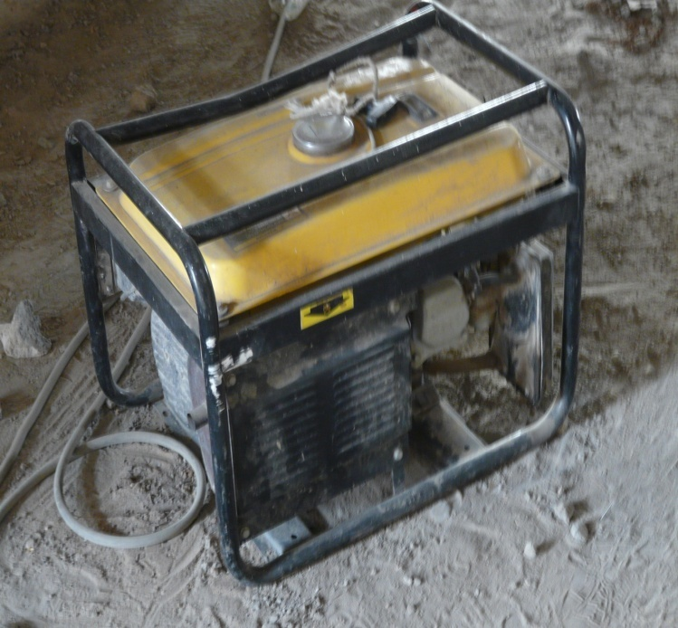
The concrete mixer
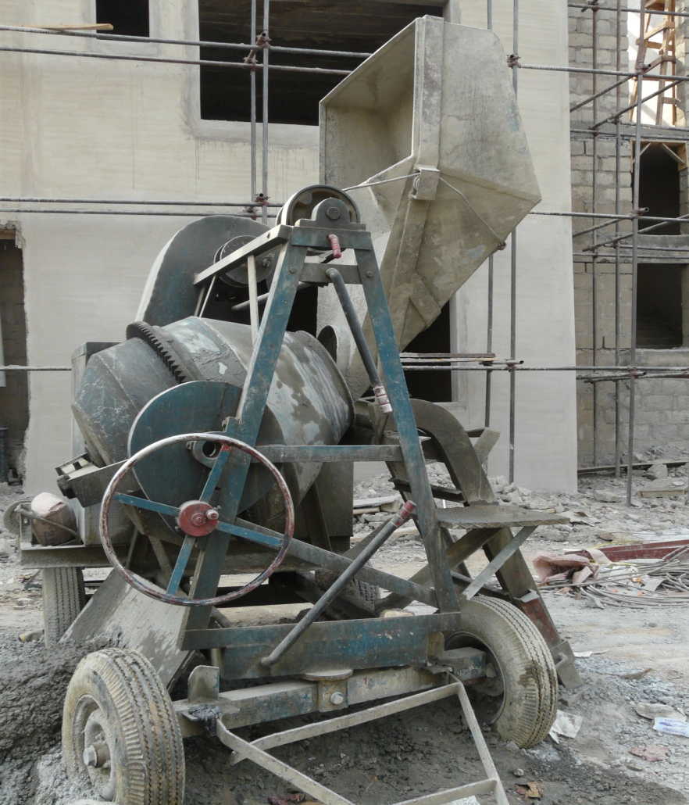

The welding machine and tong
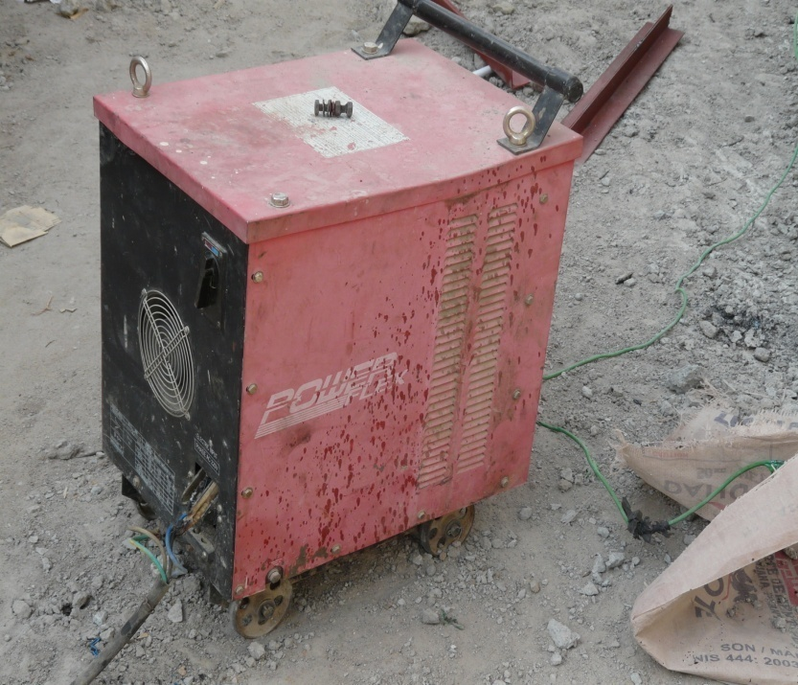

The cutter.
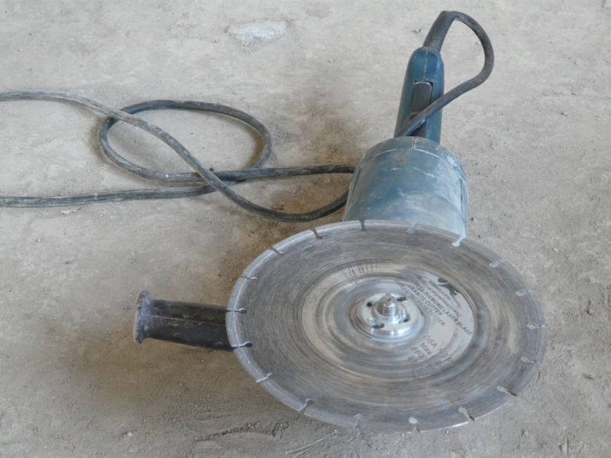

6.0 CONCLUSION
The period of my attachment was very challenging to me because of the distancea point of developing as much leadership skills as possible. Being a female in a male dominated environment, I was faced with the prejudice and the believe that I was not suppose to be in the field, and won’t be able to cope with its activities, had to face up to the challenge of supervising and ensuring that all job done were done as accurate as possible disregarding my gender, I had to cope with heights and extreme sunny weather on site. As a summary I developed my leadership is expected of an architect since he/she is the leader of the building/construction team.

