
TECHNICAL REPORT ON STUDENT INDUSTRIAL WORK EXPERIENCE SCHEME (SIWES)
HELD AT
ILORIN SOUTH LOCAL GOVERNMENT FUFU

BY
ABDULLAHI HAFSAT JIMBA
ND/23/BFN/PT/0021

SUBMITTED TO DEPARTMENT OF BANKING AND FINANCE, INSTITUTE OF FINANCE AND MANAGEMENT STUDIES, (IFMS) KWARA STATE POLYTECHNIC, ILORIN
IN PARTIAL FULFILMENT OF THE REQUIREMENT FOR THE AWARD OF NATIONAL DIPLOMA (ND) IN BANKING AND FINANCE
SEPTEMBER TO DECEMBER, 2024.
DEDICATION
This report is dedicated to Almighty Allah for his divine mercy on me and my family who has given me the strength, wisdom, knowledge and understanding in working toward my success, I also dedicate this report to my parent Mr. and Mrs. Abdullahi Jimba for their support and to my supervisor for the success of this report.

ACKNOWLEDGEMENT
To God who owns life, I wish to express my sincere appreciation and gratitude for seeing me throughout my duration in Kwara State Polytechnic and for making my vision come to reality, also for his Goodness, Mercy, Provision and Grace upon my life.
My profound gratitude goes to my Parent Mr. and Mrs. Abdullahi Jimba, may God be with you.
My special thanks go to the head of Department and the entire staff of BANKING AND FINANCE Department, Institute Of Finance and Management Studies, Kwara State Polytechnic for sharing wealth of experience with me in my course of study.
Furthermore, thanks goes to my honorable and diligent supervisor for his advice, guidance and adequate encouragement relish from him which has contribute in no small measure to the success of completion of this report.
Finally, my sincere gratitude also goes to my lovely friends both within and outside the institution,

TABLE OF CONTENT
Title page
Certification
Dedication
Acknowledgement
Table of contents
CHAPTER ONE
1.1 Introduction to Siwes
1.2 Brief history of Siwes
1.3 Importance and objective of Siwes
CHAPTER TWO
2.1 Organogram of the organization
2.2 Administrative and operational structure
2.3 Department in the organization
CHAPTER THREE
3.1 Technical training experience
3.2 Conclusion
3.3 Recommendations
CHAPTER ONE
1.1 INTRODUCTION
Siwes is an acronym for student industrial work experience scheme, Siwes is also an effective instrument used for exposing students to the realities of the work environment in Nigeria especially, and the world in general in the various professions so as to achieve the needed technological advancement of the alms of Siwes which are:
- To provide for the student opportunities to be involve in the practical aspect of their respective disciplines. Thus, bringing the gap between the theoretical aspect taught in the class to the real world situations.
- To expose students to latest developments and technological.
- To prepare students for industrial working environment that they are likely to meet after graduation.
1.2 BRIEF HISTORY OF SIWES
The student industrial experience scheme (SIWES) is a skill training programme designed to expose and prepare students of universities, polytechnics, college of technology and others, for the industrial work experience, they are likely to meet after graduation.
The scheme also afford student to the opportunity of familiarizing and exposing themselves to the needed experiences on handy equipment and machineries that are usually not available to their institution.
The industrial training fund (ITF) founded the scheme during its formative year in 1973-1974 as the financial involvement becomes unbearable to the fund, it withdraw from the scheme in 1978, the federal government handed over the scheme in 1979 to both the national board for technical education (NDTE) and the national universities commission (NUC). Later, the federal government in November 1999 inverts the management and implementation of the siwes programme to ITF and it was effectively taken over by the industrial training fund in July 1995 with the funding being solely borne by the federal government.
1.3 IMPORTANCE AND OBJECTIVES OF SIWES
In the regard to the handbook, the specific importance of the SIWES are:
- To provide an avenue for students in institution of higher learning to acquire industrials skills and experience in their cause of study.
- To prepare for the industrial work experience they undergo after graduation.
- To prepare students with an opportunity to apply for knowledge in real work situation thereby bringing the gap between theory and practice.
- To satisfy accreditation requirement set by NBTE.
- To provide students an opportunity to see the real world of their discipline and consequently bridge the gap between the classroom and real work situation.
- To enable students assess internet suitable for their chosen profession.

CHAPTER TWO

2.1 HISTORICAL BACKGROUND OF ILORIN SOUTH LOCAL GOVERNMENT FUFU, ILORIN
Ilorin South local government was created in 1996 with Headquarters at Fufu. It is made up of three districts and has 10 wards. It has an area of 174 km² and a population of 208,691 at the 2006 census. The major Towns: IIota, Fufu, Gaa-Akanbi, Kangie, Gaa Osibi, Omode.
Yoruba and Fulani are the major languages spoken. It also has some important markets, which include Cattle Market Sango, Gada Market, Ogidi Market. Ilorin South is popular for its maize, cereal and cassava farmers. Just like the other side of town, the Yawo Dancers festival is also a major one in Ilorin South Local Government Area. It’s main tourist attraction is the Kwara State Amusement Park.

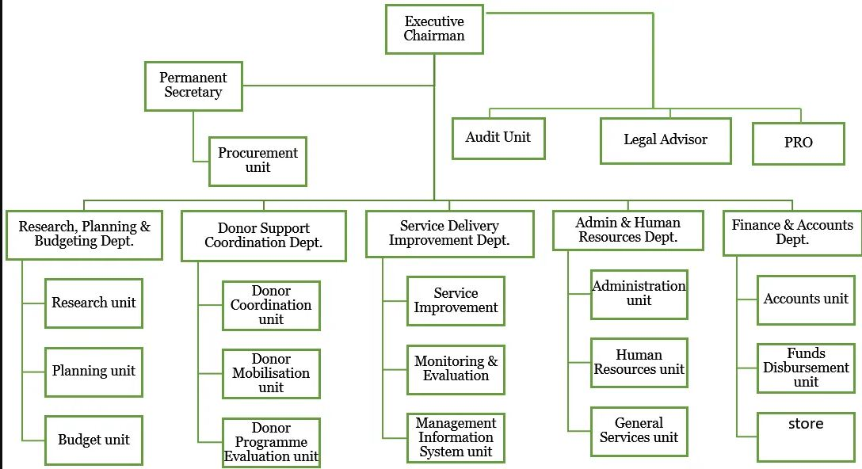
2.2 ORGANOGRAM OF THE ORGANIZATION

2.3 SECTIONS IN THE ORGANIZATION
Ilorin South LGA is one of sixteen local governments in Kwara state, it comprises 50 communities, it is situated between latitudes 8 0 26′-8 0 32′N and longitude 4 0 28′-4 0 40′E (Fig. 1), it was created in 1996, with its headquarters located in the town of Fufu (Muhammad-Lawal and Omotesho 2013). Ilorin South LGA has a projected population of 245,000 people in a 174 km 2 area, and an average population density of about 1200 inhabitants per square kilometre (Emeilu 2004; Daramola et al. 2015).

CHAPTER THREE
3.1 TECHNICAL TRANING EXPERIENCE
Week 1: I resume for my Siwes training today in Ilorin South Local Government and I was posted to the treasury department of the firms as an banking student
Week 2: They was thought to me today and explained the two types of payment vouchers (i) Salary payment voucher and (ii) payment voucher other charges
Week 3: They was explained today that payment voucher under charges is a document used in preparing other bills expenses or charges apart from staff monthly salary e.g financial assistance.
Week 4: Today we thought the vote book. Department of vote book: is a finance account or ledger used to track and manage expenditures for a specific unit or development.
Week 5: A bank statement is a document providing by a bank to it’s customers detailing their account transaction over a specific period.
Week 6: Pension: this is the money paid under given condition to a person following retirement
Week 7: I posted my Siwes today in Ilorin South Local Government Fufu to ensuring our service training program.
Week 8: I learned something on bank reconciliation statement from the local government cashier today.

CHAPTER FOUR
4.1 CONCLUSION
Siwes was established to provide opportunities for students to be involved in the practical aspect of their respective discipline in the industrial working environment. During the 2 months industrial training, I gained a wide range of experience from the various assignments undertake such as news writing and reporting, news alignment, news commentary and editing process, all the experience gained help me to fulfill the objectives of Siwes.
4.2 RECOMMENDATIONS
Going through some of the experience gained during the programme, I will recommend that there is need for some activities both in the organization where I served and the school.
The time duration for the programme should be extended for more than four months. The organization should create practical knowledge for the students for them to acquire more knowledge from their versatile staffs.

