A TECHNICAL REPORT

ON

STUDENT INDUSTRIAL WORK EXPERIENCE SCHEME (SIWES)

AT

KWARA STATE POLYTECHNIC, ILORIN, KWARA STATE

AND

BIG MUMMY FARM, ZONE B 14 , LAO ODOTA BY POWERLINE OFF AIRPORT ROAD, ILORIN

BY

JIMOH AHMAD OMOEKE
ND/23/AGT/PT/0194

DEPARTMENT OF AGRICULTURAL TECHNOLOGY
INSTITITUTE OF APPLIED SCIENCE
KWARA STATE POLYTECHNIC, ILORIN, KWARA STATE

IN PARTIAL FULFILMENT OF THE REQUIREMENTS FOR THE AWARD OF NATIONAL DIPLOMA IN AGRICULTURAL SCIEINCE
MARCH, 2025

CERTIFICATION
This is to certify that this report of the Student Industrial Work Experience Scheme (SIWES) was prepared and compiled by OLUWABITAN, JIMOH AHMAD OMOEKE MATRIC NO ND/23/AGT/PT/0194 of the department of AGRICULTURAL TECHNOLOGY, KWARA STATE POLYTECHNIC for the successful completion of my Industrial Training program undertaken at BIG MUMMY FARM, ZONE B 14 , LAO ODOTA BY POWERLINE OFF AIRPORT ROAD, ILORIN

__________________ __________________
Name of student Signature and date

__________________ __________________
Name of Supervisor Signature and date

DEDICATION
In great adoration and appreciation, I dedicate this report to The Almighty Allah, my help in ages past and in time to come for giving me the needed strength, vigor, good health and sustenance throughout the course of my SIWES programme. I would additionally dedicate this report to my mother Mrs. JIMOH, all who provided for my spiritual, financial and material needs.
I won’t forget to also dedicate this report to the staffs at Kwara State Polytechnic, Ilorin, Kwara State and Research Institute of Applied Science for taking their time to impart me with the needed knowledge in the agricultural sector and for also arousing further my interest in agriculture.

ACKNOWLEDGEMENT
I appreciate God Almighty for giving me the Grace, Opportunity and Strength to complete my industrial training successfully. I acknowledge my Mother; Mrs. JIMOH, for being there for me all the time and for providing the necessary support, I appreciate it a lot and I love you.
I acknowledge my siblings for their moral support.
I also thank the staffs of KWARA STATE POLYTECHNIC ILORIN KWARA STATE for their parental advise throughout the course of my training at the unit and also my thanks goes to the management and staffs of BIG MUMMY FARM, ZONE B 14 , LAO ODOTA BY POWERLINE OFF AIRPORT ROAD, ILORIN especially ( Farm Operator) for giving me the needed exposure, support and assistance during the course of my stay at the company. You are such wonderful and special people, who inspire and impact jubilance into the lives of others.

TABLE OF CONTENTS

TITLE PAGE ………….......…………………………………………..I

CERTIFICATION …...………………………………………….…… II

DEDICATION ………………..……………………………………… III

ACKNOWLEDGEMENT…..……………………………………..... IV

TABLE OF CONTENT….…………………………………………… 5

CHAPTER 1: INTRODUCTION

1.1 Background of Study
1.2 Brief history of SIWES
1.3 Aim of SIWES

1.4 Objectives of SIWES

1.5 Names of company/farm

1.5.1 Kwara Polytechnic and Research Farm

1.5.2 BIG MUMMY FARM, ZONE B 14 , LAO ODOTA BY POWERLINE OFF AIRPORT ROAD, ILORIN

1.6 Brief Summaryon the company/farm’s activities

    - BIG MUMMY FARM, ZONE B 14 , LAO ODOTA BY POWERLINE OFF AIRPORT ROAD, ILORIN and Research farm

    - BIG MUMMY FARM, ZONE B 14 , LAO ODOTA BY POWERLINE OFF AIRPORT ROAD, ILORIN
CHAPTER 2: UNIT BY UNIT REPORT WITH ROUTINE MANAGEMENT

2.1 BIG MUMMY FARM, ZONE B 14 , LAO ODOTA BY POWERLINE OFF AIRPORT ROAD, ILORIN and Research farm units

2.1.1 Poultry Unit

2.1.2 Cattle, Sheep and Goat unit

2.1.3 Piggery Unit

2.1.4 Garri Processing Unit

2.1.5 Crop Type Collection unit

2.1.6 Apiary Unit

2.2 BIG MUMMY FARM, ZONE B 14 , LAO ODOTA BY POWERLINE OFF AIRPORT ROAD, ILORIN

2.2.1 Screen house

2.2.2 Nursery

CHAPTER 3: OPERATIONS AND PROCEDURES CARRIED OUT

3.1 BIG MUMMY FARM, ZONE B 14 , LAO ODOTA BY POWERLINE OFF AIRPORT ROAD, ILORIN

3.1.1 Yam Mini-setting

CHAPTER 4: CONCLUSION AND RECOMMENDATION

4.1 Conclusions

4.2 Recommendations

LISTS OF FIGURES

Fig 1; BIG MUMMY FARM, ZONE B 14 , LAO ODOTA BY POWERLINE OFF AIRPORT ROAD, ILORIN and Research Farm
Fig 2; Big Mummy Farm Farm
Fig 3; Kwara Poly Layers Unit
Fig 4; Cattle in the paddock
Fig 5; Pig in a pen
Fig 6; Cassava for Garri processing
Fig 7; Frying of Garri
Fig 8; Vegetable Bed
Fig 9; Earthen Fish Pond
Fig 10; Screen House
Fig 11; Aeroponics System
Fig 12; Nutrient Tank
Fig 13; Nursery Unit
Fig 14; Seed Yams
Fig 15; Minisetts in Treatment solution

CHAPTER ONE
INTRODUCTION
1.1 Background of Study
Student Industrial Work Experience Scheme (SIWES) is one of the Industrial Training Fund (ITF) programs which were introduced in 1974 due to the inability of students in Nigeria universities and polytechnics to meet the practical aspects of their training. That is, the needs to enable students match their theoretical school knowledge with the practical aspect of their training in industry.
The program was designed for students of tertiary institutions with the aim of exposing students that have acquired theoretical knowledge in the classrooms to the practical exposure and experience. The scheme is a tripartite program, involving the student, the university and the industry (Employer of labor). It is funded by the Federal Government of Nigeria and jointly coordinated by the Industrial Training Fund (ITF) and the National Universities Commission (NUC).
1.2 Brief history of SIWES
In recognition of the shortcomings and weakness in the formation of graduates, particularly with respect to acquisition of relevant production skills (RPSs), the Industrial Training Fund (which was itself established in 1971 by decree 47) initiated the Students’ Industrial Work-experience Scheme (SIWES) in 1973. The scheme was designed to expose students to the industrial environment and enable them develop occupational competencies so that they can readily contribute their quota to national economic and technological development after graduation. Consequently, SIWES is a planned and structured program based on stated and specific career objectives which are geared toward developing the occupational competencies of participants. Participation in SIWES has become a necessary condition for the award of degrees and diplomas
The main thrust of ITF program and services is to stimulate human performance, improve productivity, and induce value-added production in industry and commerce. Through its SIWES and Vocational and Apprentice Training Program, the Fund also builds capacity for graduates and youth self-employment, in the context of Small Scale Industrialization, in the economy.

1.3 AIMS AND OBJECTIVES OF SIWES
The program was specially designed to carry out the following;
- Bridge the gap between theory and practical thereby giving students the opportunity to apply their knowledge accurately.
- Expose students to what their professions entail.
- Improve inter-personal relationship skills of the students.
- Develop skills on practical knowledge
1.4 NAME OF ESTABLISHMENT
- KWARA STATE POLYTECHINC (LAUTECH) TEACHING AND RESEARCH FARM
- BIG MUMMY FARM, ZONE B 14 , LAO ODOTA BY POWERLINE OFF AIRPORT ROAD, ILORIN
1.4.1 BIG MUMMY FARM, ZONE B 14 , LAO ODOTA BY POWERLINE OFF AIRPORT ROAD, ILORIN AND RESAERCH FARM
The BIG MUMMY FARM, ZONE B 14 , LAO ODOTA BY POWERLINE OFF AIRPORT ROAD, ILORIN and research farm is located at the Kwara State Polytechnic, Ilorin, Kwara State Nigeria. It was established alongside the institution in 1990.
1.4.2 BIGG MUMMMY INTERNATIONAL LIMITED
Big Mummy, international limited whose Head office is located at LAO ODOTA BY POWERLINE OFF AIRPORT ROAD, ILORIN AND RESAERCH FARM
1.5 BRIEF INFORMATION OF THE ACTIVITIES OF THE ESTABLISHMENT
1.5.1 BIG MUMMY FARM, ZONE B 14 , LAO ODOTA BY POWERLINE OFF AIRPORT ROAD, ILORIN AND RESEARCH FARM
The farm was established in the year 1990 with the aim of exposing the students of the faculty of agricultural science to practical field work and application of theoretical knowledge acquired so far in the class. BIG MUMMY FARM, ZONE B 14 , LAO ODOTA BY POWERLINE OFF AIRPORT ROAD, ILORIN and research farm has over 50 hectares of land which is engaged in the production of sales of farm produce such as garri, chicken, pork, vegetables, fruits and also for planting and for research works.
The farm consist of 12 different units which includes; poultry unit, feed mill/pasture unit, farm mechanization/ crop processing unit, arable unit, crop type collection (CTC), piggery unit, cattle-sheep & goat unit, permanent crops unit, fishery unit, apiary unit, garri processing unit, rabbitry unit.The farm is headed by the farm manager Mr. Oyebode. The staff strength of the farm is above 30.
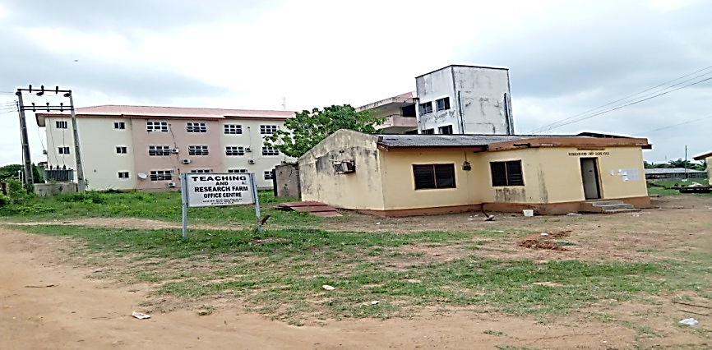
Fig 1; BIG MUMMY FARM, ZONE B 14 , LAO ODOTA BY POWERLINE OFF AIRPORT ROAD, ILORIN and Research Farm
1.5.2 BIG MUMMY FARM, ZONE B 14 , LAO ODOTA BY POWERLINE OFF AIRPORT ROAD, ILORIN
PS. Nutraceutical international limited is an agric-tech company that is focused on food production with climate smart technology, with the inclusion of artificial intelligence and soilless farming.
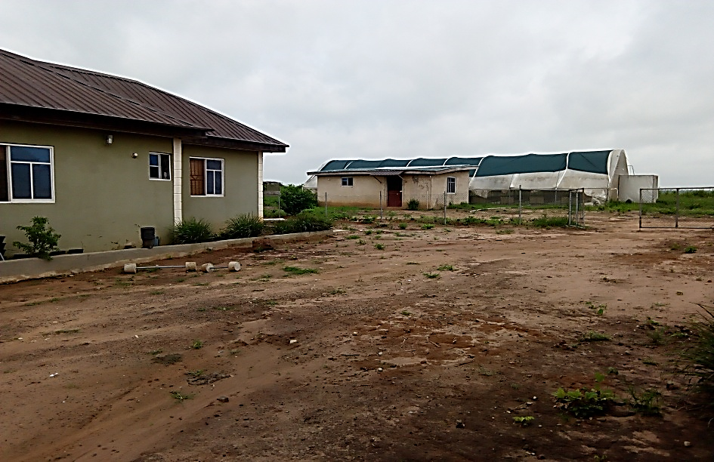
Fig 2; MHSS ATOLAGBE GOBIR FARM Limited Farm

CHATPER TWO
2.1 UNIT BY UNIT REPORT WITH ROUTINE MANAGEMENT PRACTICES
This is a detailed description of work done by me in the establishments where I observed my industrial training.
2.1 BIG MUMMY FARM, ZONE B 14 , LAO ODOTA BY POWERLINE OFF AIRPORT ROAD, ILORIN AND RESEARCH FARM UNITS
2.1.1 POULTRY UNIT
The poultry unit has the brooding house (which is operated on a deep litter system) where birds are been raised from day old chicks to point of lay or point of sale as the case may be. There is also the layers pen where birds are kept in battery cages for the egg production.
Routine management
- Fetching of water
- Feed formulation
- Packing of poultry waste
- Daily picking of eggs
- Feeding of Birds

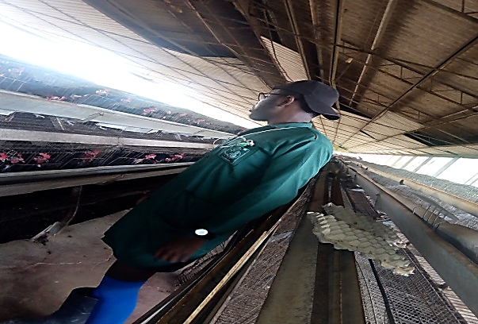
Fig 3; Mhss Atolagbe Gobir Farm Layer Unit

2.1.2 CATTLE, SHEEP AND GOAT UNIT
This unit is involved in rearing of ruminant animals like cattle, sheep and goat. The goat and sheep is small ruminant animal which posses the ability to chew and regurgitate cuds and are known for their complex stomach structure. This unit deals with rearing, breeding, mating and managing of both small and large ruminant animals under intensive system.
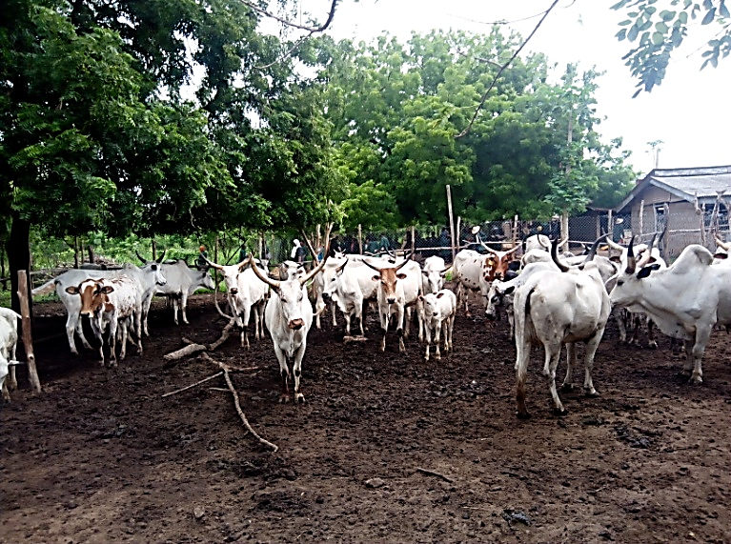
Fig 4; Cattles in the paddock
Routine management
- General lectures on cattle, sheep and goat
- Clearing of the unit surroundings
- Feeding of the animals with pasture grass (panicum maximum)
- Taking the cattle to the field for proper grazing
- Cleaning of the pen and paddock
Some of the facilities present in the unit
- Pen
- Paddock
- Kraal
Economics Importance of Ruminant Animals
- Production of hides and skin as raw materials for textiles industries
- Sources of food
- Sources of income
2.1.3 PIGGERY UNIT
Piggery unit deals with the rearing and breeding of pigs under intensive system of management. The unit houses a boar, three sows, five gilts, onesire, four growers and two in-soar.
The act of parturition in pigs is called FARROWING. Pigs are highly prolific and have a gestation period of 114days (3months, 3weeks, 3days) .
This unit is headed by Mr. Micheal Akinwale.
Routine management
- Clearing of the bushy areas surrounding the unit
- Feeding of pigs with Cassava peel, vegetables and pig feed
- Cleaning of the pen
Economics Importance of Pigs
- Sources of food
- Sources of income
- Research and scientific purpose
- Useful in medical and nutritional studies
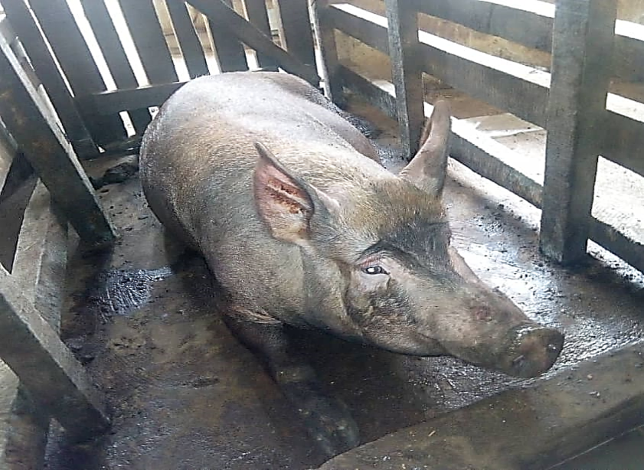
Fig 5; Pig in a pen
2.1.4 GARRI PROCESSING UNIT
This unit is involved in the processing of raw cassava into a dry granulated substance called garri. This is carried out by the various stages involved in the processing of cassava into garri ranging from peeling of the cassava to frying of the cassava flour.
This unit is coordinated by Mr. Alabi Samson.
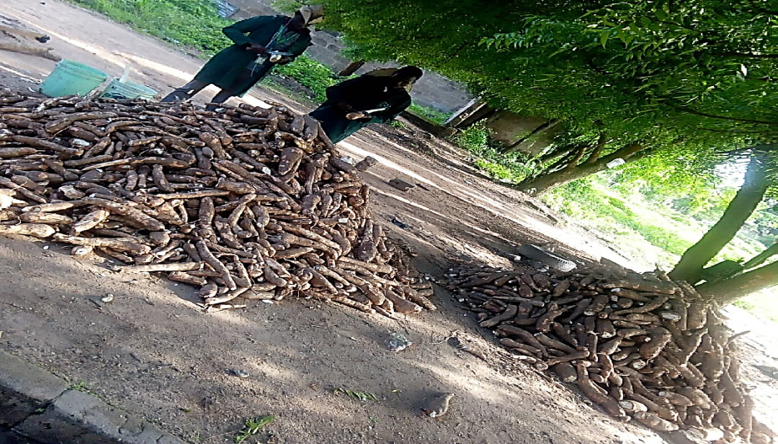
Fig 6; Cassava for Garri processing
Routine management
- Introduction to garri unit, terminologies and aspect of garri unit
- General cleaning of the processing unit and it surroundings
- Introduction to the processing machines
- Pulling of cassava, frying of garri and sieving of fermented cassava
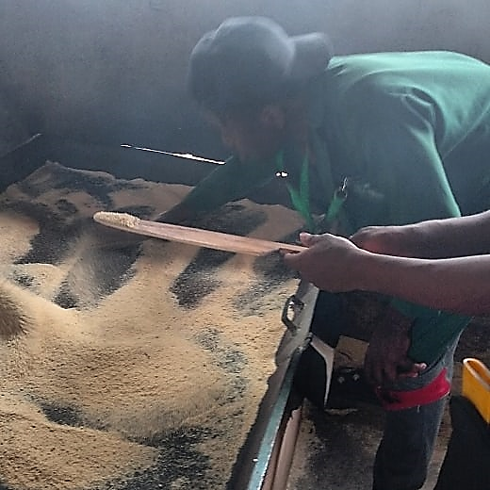
Fig 7; Frying of Garri
2.1.5 CROP TYPE COLLECTION UNIT
This unit is mostly concerned with growing of vegetables and species. It involves pre-planting to post planting operations. The land was cleared and tilled; beds are also made which are incorporated with organic manure to increase fertility before sowing of seeds.
Some of the vegetables planted at this unit are Amaranthus, Cucumber, Lettuce, Celosia spp. and pepper.
The unit headed by Dr S.O Akintaro.
Routine management
- Sowing of vegetables
- Regular wetting of the seedlings
- Making of vegetable bed
- Clearing of bush
- Rouging of weed from vegetable bed
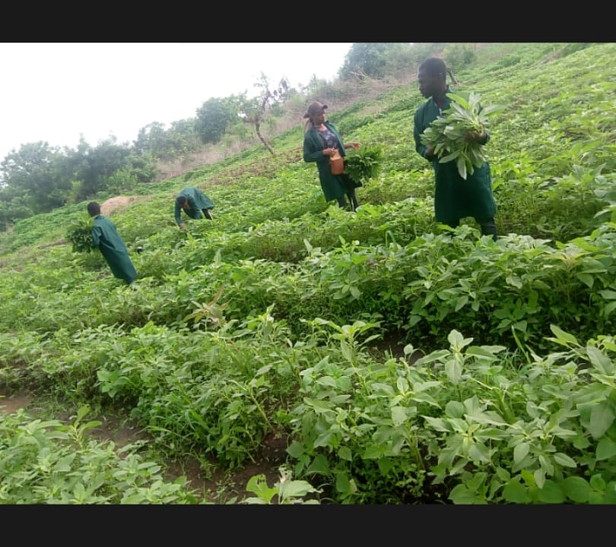
Fig 8; Vegetable Bed
2.1.6 FISHERY UNIT
The unit basically deals with rearing of fish in a conducive and confined environment, mainly in water body. Water body can classify into;
- Saline water
- Brackish water
- Fresh water
Importance of Fish
- Sources of food for man and animals
- Sources of income
- Source of protein
Routine practices carried out in this unit;
- Introduction to fishery unit, terminologies aspect of fishery
- Weeding of unwanted plant in cassava
- Making ridges around the fishery unit
- Feeding of fingerlings in the Earthen pond

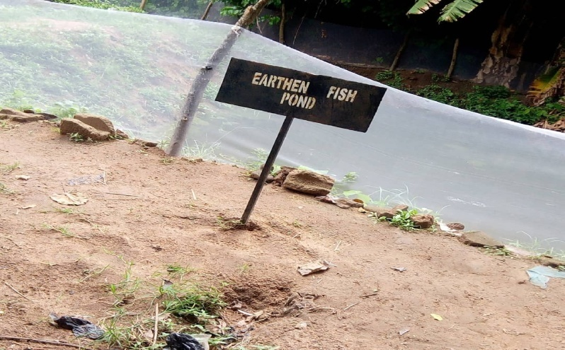
Fig 9; Earthen Fish Pond
2.2 BIG MUMMY FARM, ZONE B 14 , LAO ODOTA BY POWERLINE OFF AIRPORT ROAD, ILORIN
2.2.1 SCREEN HOUSE AEROPONIC UNIT
The Screen house is an erected structure with walls made from screen and shade canopy in which plants can be grown in a controlled environment. This unit houses the Aeroponics system which is used for the cultivation of seed yams.
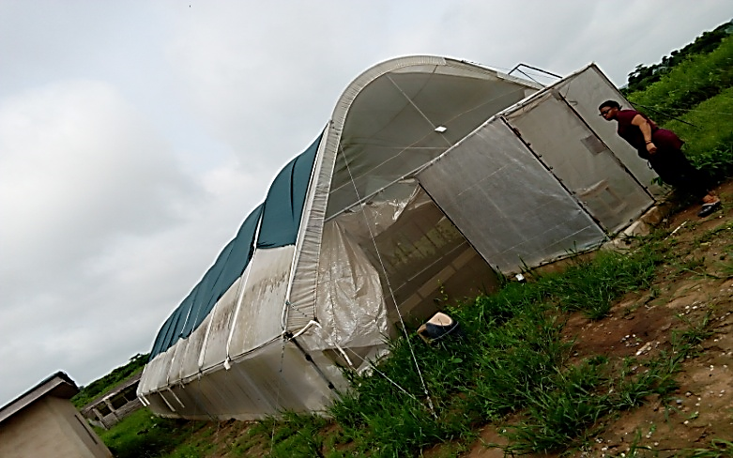
Fig 10; Screen House
Aeroponics is a process of growing plants or crops in an air or mist environment without the use of soil or an aggregate medium (geoponics). Water is used in Aeroponics to transmit nutrients to plants.
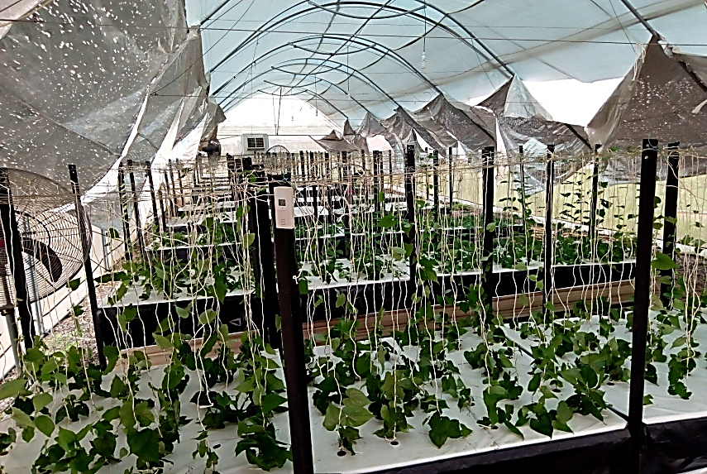
Fig 11; Aeroponics System
METHOD USED
In Aeroponics system, the plants root size suspended inside an environment where the roots are exposed to anatomized nutrient solution. The top of the plant, leaves and crown (canopy) is extended above the wet zone. The root and canopy of the plant are separated by the plant structure.
The last part of the plants support system and root system are sprayed or misted for intermitted duration with a hydro-atomized mist of pure water and nutrients enriched solution.
FEATURES OF THE SCREEN HOUSE
- Misters
- Air pump
- Nutrient Tank
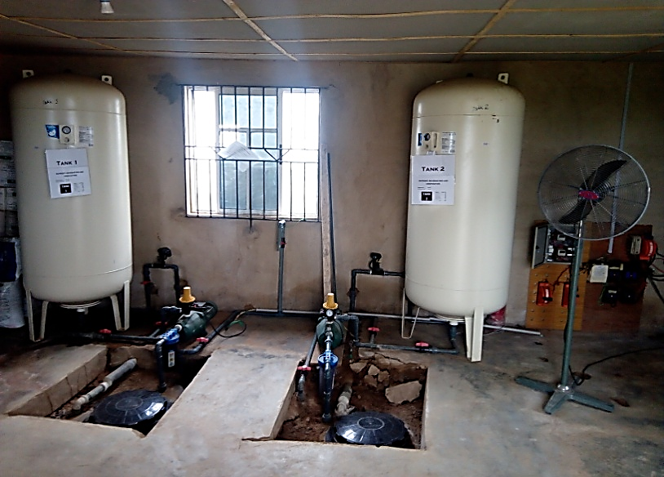
Fig 12; Nutrient Tank
Advantage of Screen House Aeroponics
- Eliminate crops exposure to disease
- Increase nutritional value of crops
- Increase yields of produce
- Requires less labour
Routine practices carried out in this unit;
- Checking of the nutrient level in the nutrient tank
- Pumping of Nutrients from the reservoir to the nutrient tank
- Staking of the plantlets

2.2.2 NUESERY UNIT
This unit is purposely for growing of yam leaf vines collected from the screen house Aeroponics system for a period of one month before it is transplant to the field to produce seed yam after a period of three month in the soil.
A Nursery is a place where plants are propagated, grown and allowed to mature until they are ready for permanent planting.
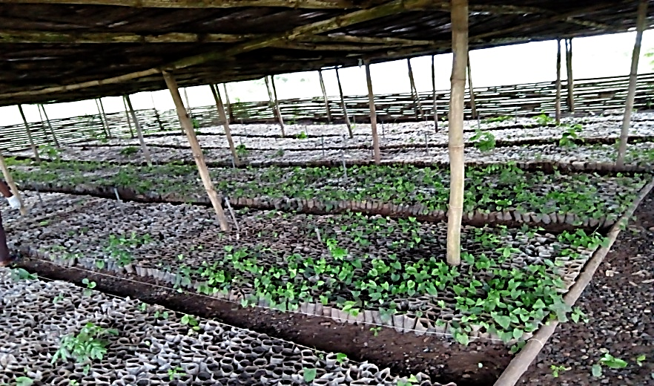
Fig 13; Nursery Unit
Routine practices carried out in this unit;
- Weed Control
- Irrigation
- Potting seedlings
- Transplanting
Benefits of Nursery unit
- Easy weed control
- Higher Yield
- Improved crop uniformity
- More accurate prediction of harvest date

CHAPTER THREE
3. OPERATIONS AND PROCEDURE CARRIED OUT
Contains series of special operations and procedures were out during the course of the industrial training program. These operations alongside their procedure are discussed in this chapter.
3.1 BIG MUMMY FARM, ZONE B 14 , LAO ODOTA BY POWERLINE OFF AIRPORT ROAD, ILORIN
3.1.1 Seed Yam Mini-sets
Seed yams are the planting materials used in the field production of ware or table yam consumed as food. The technique used in getting these Seed yams is the “minisetts technique” which was developed in the late 1970s for the production of seed tubers separated from the production of ware yam. The technique utilizes a small (20-50g) part of a whole non-dormant tuber containing periderm and some cortex parenchyma. The minisett is sown and the resulting tuber is sufficiently large to serve as a seed tuber that is suitable for the production of food tubers.

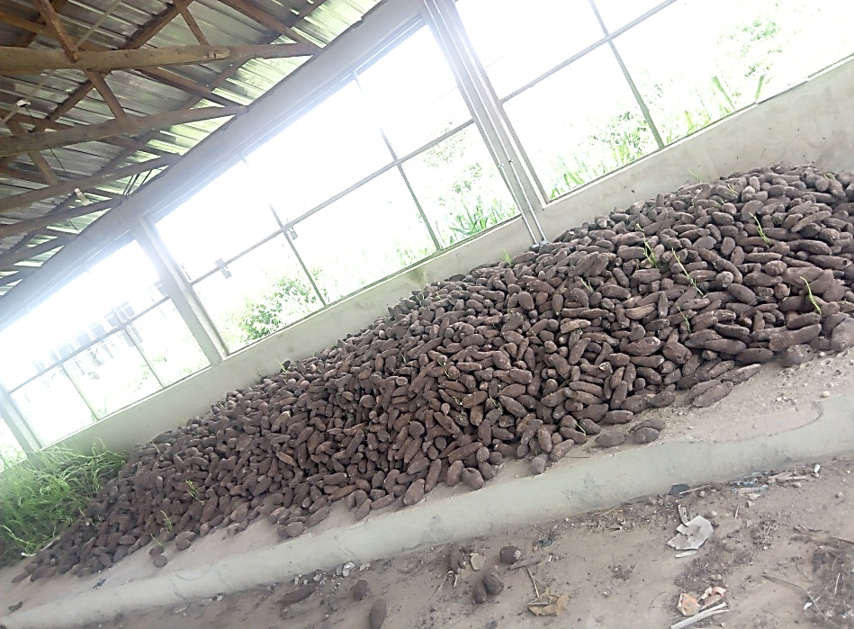
Fig 14; Seed Yams

The minisett technique involves cutting a yam tuber into 2 cm thick quadrants weighing approximately 25g and planting them after treatment in a treatment solution of Macozeb (a Fungicide) and Cypermethrin (an insecticide).
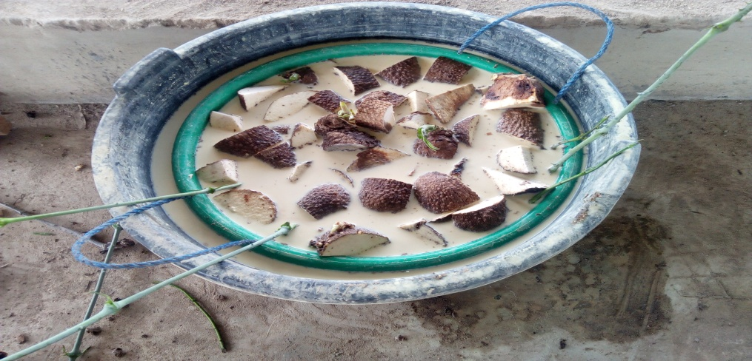
Fig 15; Minisetts in treatment solution
CULTURAL MANAGEMENT OF MINISETTS
- Seed Dressing
This is done to protect the cut surface of the minisetts from possible entry of rot causing oragnism
- Seedbed Preparation
Seed yams can be planted on ridges, mounds or flats.
- Planting Minisetts
Seed yams are planted with spacing of 10-15 cm below the surface of mounds or ridges.
- Staking
A Support for grown yam vines on stakes which help to increase the tuber yields

CHATPER FOUR
4.0 RECOMMENDATION AND CONCLUSION
4.1 CONCLUSION
The industrial attachment which lasted for three months has been able to help me to differentiate between theoretical work and practical. During this period I fully participated in poultry production, horticulture, cattle sheep and goat, feed mill, mechanization, fishery and piggery. Entrepreneurship in animal sciences were also carried out in poultry production this includes; transportation of old day chicks, installation of battery cages, house design
4.2 RECOMMENDATION
It is well known that the university system cannot provide all the technical knowledge and work experience needed by its students hence the opportunity provided through the SIWES. Nigeria students in higher institution should be encouraged to take the SIWES serious so as to enhance the opportunity of later job employment as well as self employment. Visitations should be made by supervisors from the institutions and representative from industrial training fund (ITF) in order to ensure students are getting the required and relevant training and exposure at their place of assignment.
I will also recommend prompt payment of Stipends by the establishments and payment of SIWES ALLOWANCE by the Industrial Training Fund (I. T. F.)during the period of attachment rather than after the program, so has to help the students solve minor needs such as feeding and transportation fare.

