

TECHNICAL REPORT ON
STUDENTS INDUSTRIAL WORKS EXPERIENCE SCHEMES (SIWES)

HELD AT

IFENIKOKO M.C.U LTD
no.7 oorelope area odota Ilorin kwara state

PRESENTED BY:

OLAJIDE JULIUS OPEYEMI

ND/23/ACC/PT/0171

SUBMITTED TO:

THE DEPARTMENT OF ACCOUNTANCY, INSTITUTE OF FINANCE AND MANAGEMENT STUDY, KWARA STATE POLYTECHNIC, ILORIN.
IN PARTIAL FULFILMENT OF THE REQUIREMENT FOR THE
AWARD OF NATIONAL DIPLOMA (ND) IN ACCOUNTANCY.

SEPTEMBER - NOVERMBER 2024

DEDICATION
I am delight to dedicate this report to Almighty God who gave me the grace and opportunity to complete this programme.

ACKNOWLEDGEMENT
I thank God Almighty for his mercy and grace that kept me all through my SIWES period.
I am greatly indebted to my parents, Mr. & Mrs. OLAJIDE for their morally, spiritually and financially, word of encouragement and prayer given to me, who make my SIWES programme successful and also my relatives and siblings.
I also want to thank my friend and everyone that contributed to the success of my SIWES program my Industrial supervisors, my colleagues and co-workers for the tremendous moral assistance throughout the period of my attachment.

REPORT OVERVIEW
The report comprises the background of SIWES, the description of the organization, its aims and objectives, the experiences gained as an industrial training student and the summary, conclusions and recommendations.
It has a total of 5 chapters with sub-chapters. It also has the preliminary pages, such as the title page, report overview and table of contents and recommendations on the improvement of scheme.

TABLE OF CONTENTS
1. Title Page
2. Dedication
3. Acknowledgment
4. Abstract
5. Chapter One: Introduction
• 1.1 Background of SIWES
• 1.2 Objectives of SIWES
• 1.3 Significance of SIWES
• 1.4 Scope of the Report
6. Chapter Two: Organizational Profile
• 2.1 History of the Cooperative Office
• 2.2 Organizational Structure
• 2.3 Functions of the Cooperative Office
• 2.4 Services Rendered
7. Chapter Three: Training Activities
• 3.1 Job Description and Responsibilities
• 3.2 Tasks Performed
• 3.3 Practical Experiences Gained
• 3.4 Challenges Encountered
• 3.5 Solutions and Lessons Learned
8. Chapter Four: Observations and Contributions
• 4.1 Observations About the Cooperative Office
• 4.2 Contributions Made During the Training
• 4.3 Skills Acquired
9. Chapter Five: Summary, Conclusion, and Recommendations
• 5.1 Summary of Industrial Training
• 5.2 Conclusion
• 5.3 Recommendations for Future Interns and the Organization

CHAPTER ONE
INTRODUCTION
1.1 Background of SIWES
The Student Industrial Work Experience Scheme (SIWES) was established by the Industrial Training Fund (ITF) in 1973 to bridge the gap between theoretical knowledge and practical experience. It enables students to acquire hands-on skills in their respective fields before graduation.
1.2 Objectives of SIWES
• To expose students to real-world work environments.
• To provide students with practical knowledge of cooperative office operations.
• To develop students’ problem-solving and teamwork skills.
• To enable students to apply classroom knowledge in professional settings.

1.3 Significance of SIWES
SIWES is an essential program that enhances employability by equipping students with relevant skills and experiences that are highly valued in the labor market.
1.4 Scope of the Report
This report covers my experience at the Cooperative Office, detailing my job responsibilities, tasks performed, skills acquired, and recommendations for improvement.

CHAPTER TWO
ORGANIZATIONAL PROFILE
2.1 History of the Cooperative Office
The cooperative office is a financial institution that provides financial assistance, savings, and credit facilities to its members. It was established to promote economic empowerment among workers and small-scale business owners.
2.2 Organizational Structure
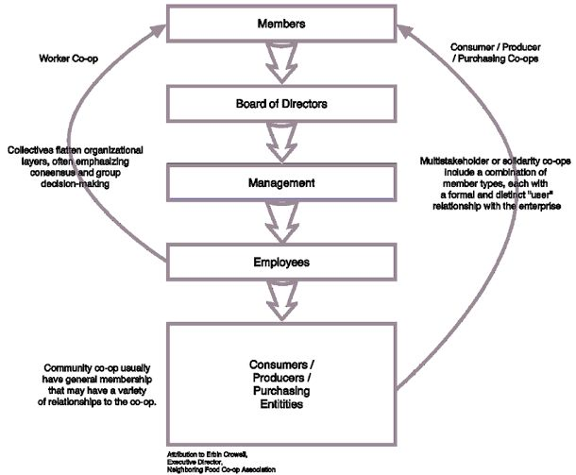

2.3 Functions of the Cooperative Office
• Providing financial assistance to members.
• Encouraging savings and thrift among members.
• Offering business development support.
2.4 Services Rendered
• Savings & Loan Services – Members save money and access loans at low-interest rates.
• Business Support – Financial education and investment advice.
• Welfare Support – Emergency financial assistance for members.

CHAPTER THREE
TRAINING ACTIVITIES
3.1 Job Description and Responsibilities
During my industrial training, I was assigned to the accounts and customer service departments, where I handled records, attended to customers, and processed loan applications.
3.2 Tasks Performed
• Data entry and record-keeping.
• Processing loan applications.
• Assisting customers with account inquiries.
• Attending cooperative meetings and taking minutes.
3.3 Practical Experiences Gained
• Understanding financial documentation.
• Learning how loans are processed and managed.
• Enhancing communication and customer service skills.

3.4 Challenges Encountered
• Managing large volumes of financial records.
• Handling difficult customers.
• Understanding financial terms and calculations.
3.5 Solutions and Lessons Learned
• Improved time management and multitasking.
• Gained problem-solving skills in customer service.
• Developed attention to detail in financial record-keeping.

CHAPTER FOUR
OBSERVATIONS AND CONTRIBUTIONS
4.1 Observations About the Cooperative Office
• The cooperative society plays a vital role in financial inclusion.
• There is a need for better technology adoption to improve efficiency.
4.2 Contributions Made During the Training
• Assisted in improving financial record organization.
• Helped with customer engagement and query resolution.
• Suggested digital solutions to improve loan processing speed.
4.3 Skills Acquired
• Financial record management.
• Teamwork and collaboration.
• Customer service and communication skills.

CHAPTER FIVE
SUMMARY, CONCLUSION, AND RECOMMENDATIONS
5.1 Summary of Industrial Training
My SIWES experience at the cooperative office was valuable in enhancing my practical knowledge of financial management, customer service, and office operations.
5.2 Conclusion
The cooperative office serves as a crucial financial institution, supporting economic growth through savings and loan services. My training exposed me to real-world challenges and equipped me with relevant professional skills.
5.3 Recommendations
• The cooperative office should adopt digital record-keeping systems.
• Future interns should be given structured training programs.
• More financial literacy programs should be introduced for members.

