

A TECHNICAL REPORT
STUDENT INDUSTRIAL WORKING EXPERIENCE SCHEME
(SIWES)

Held at

GIGABYTE COMPUTER SOLUTION, ILORIN KWARA STATE
Prepared by:
AIPHONSUS SILAS UCHE
ND/23/BFN/PT/0092

SUBMITTED TO

DEPARTMENT OF BANKING AND FINANCE
INSTITUTE OF FINANCE AND MANAGEMENT STUDIES
KWARA STATE POLYTECHNIC, ILORIN

INPARTIAL FULFILLMENT OF THE AWARD OF THE REQUIREMENT OF THE AWARD OF NATIONAL DIPLOMA IN BANKING AND FINANCE

DEDICATION
I dedicate this technical report to the Almighty GOD, the giver of knowledge, wisdom and who is rich in mercy.

ACKNOWLEDGEMENT
I take this opportunity to express my profound gratitude and deep regards to the creator of heaven and earth, the one who knows the beginning and the end, the alpha and the omega, the Almighty God and also to my parents MR & MRS ALPHONSUS, I pray God will bless you and perfect everything that concerns you.

TABLE OF CONTENT
Title page i
Table of content ii
Dedication iii
Acknowledgements iv
TABLE OF CONTENTS
CHAPTER ONE
  - Background of SIWES 1
  - History of SIWES 1
  - Objectives of SIWES 2
  - Objectives of Establishment 3
CHAPTER TWO
2.1. INTRODUCTION TO THE COMPANY 4
2.2 CASH BOOK 4
2.3 PAYMENT VOUCHER
CHAPTER THREE
3.1 EXPENDITURE LEDGER 6
3.2 HOW TO FORMAT A HARD DISK 6
3.3 SOFTWARE INSTALLATION
3.4 HOW TO DIAGNOSE SYSTEM
CHAPTER FOUR
4.0 CONCLUSION AND RECOMMENDATIONS
4.1 CONCLUSION
4.2 RECOMMENDATIONS
CHAPTER ONE
  - INTRODUCTION TO SIWES
Students Industrial Work Experience Scheme (SIWES) is a Skills Training Program designed to prepare and expose Students of Universities, Polytechnics, Colleges of Technology, Colleges of Agriculture and Colleges of Education for the Industrial Work situation they are likely to meet after graduation. The Scheme affords Students the opportunity of familiarizing and exposing themselves handling equipment and machinery that are usually not available in their institutions.

1.2 HISTORY OF SIWES
The Students’ Industrial Work Experience Scheme (SIWES) was initiated in 1973 by the Federal Government of Nigeria under the Industrial Training Fund (ITF) to bridge the gap between theory and practice among products of our tertiary Institutions. It was designed to provide practical training that will expose and prepare students of Universities, Polytechnics, and Colleges of Education for work situation they are likely to meet after graduation.
Before the establishment of the scheme, there was a growing concern among the industrialists that graduates of institutions of higher learning lacked adequate practical background studies preparatory for employment in industries. Thus the employers were of the opinion that the theoretical education going on in higher institutions was not responsive to the needs of the employers of labour.
As a result of the increasing number of students’ enrolment in higher institutions of learning, the administration of this function of funding the scheme became enormous, hence ITF withdrew from the scheme in 1978 and was taken over by the Federal Government and handed to National Universities commission (NUC), National Board for Technical Education (NBTE) and National Commission for Colleges of Education (NCCE). In 1984, the Federal Government reverted back to ITF which took over the scheme officially in 1985 with funding provided by the Federal Government.

1.3 OBJECTIVES OF THE PROGRAMME
The specific objectives of SIWES are to:
- Provide placements in industries for students of higher institutions of learning approved by relevant regulatory authorities (NUC, NBTE, NCCE) to acquire work experience and skills relevant to their course of study
- Prepare students for real work situation they will meet after graduation.
- Expose students to work methods and techniques in the handling of equipment and machinery that may not be available in schools.
- Make transition from school to the labour market smooth and enhance students’ conduct for later job placement
- Provide students with the opportunity to apply their knowledge in real life work situation thereby bridging the gap between theory and practice
- Strengthen employer involvement in the entire educational process and prepare students for employment in industry
Promote the desired technological knowhow required for the advancement of the nation.
1.4 OBJECTIVES OF ESTABLISHMENT
To provide innovative and effective solutions
➢ To deliver exceptional customer service
➢ To drive business growth and expansion
➢ To build a strong brand reputation
➢ To develop and maintain a skilled workforce
➢ To promote a culture of innovation and continuous improvement
➢ To maintain high-quality standards and best practices
➢ To foster strategic partnerships and collaborations

CHAPTER TWO
2.1. INTRODUCTION TO THE COMPANY
- I was introduce to each department in gigabyte computer solution and some other departments
- I was introduced to organization structure, office and their functions
An organizational structure is a system that defines how a company operates, including how employees are grouped, their roles, and how they communicate. It also outlines how tasks are delegated to achieve the company's goals.
Organization Structure
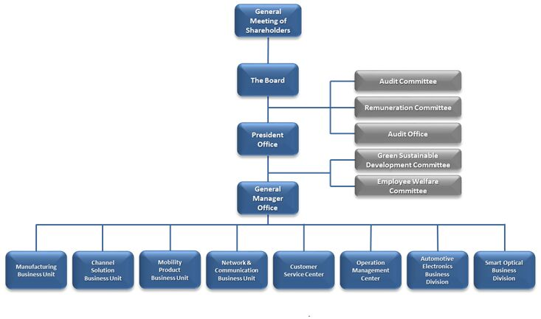

2.2 CASH BOOK
Cash book is a special type of book that is only concerned with the recording of cash transactions of an organisation. It performs the dual role of both journal and a ledger for all the cash transactions taking place in a business organisation.
A cash book records all the cash receipts on the debit side and all the cash payments of the organisation on the credit side.

Features of Cash Book
Cash book has the following features:
- Acts as both a journal and a ledger.
- Can be used as an alternative to a cash account for recording transactions.
- It follows the dual entry system of accounting (i,e. Debit and credit side in cash book).
- The debit side should be identical to the credit side.
- Cash book should always have a debit balance.

Types of Cash Book
There are four types of cash books used for accounting purposes. Let us have a look at the types of cash books.
1.Single column cash book
2.Double column cash book
3.Triple column cash book
4. Petty cash book
Single column cash book: Single column cash book is also called a simple cash book. It presents entries for cash received (receipts) on the left side or debit side and cash payments on the right hand side or credit side.
The bank transactions and the discounts that are given for transactions will be featured in separate ledger accounts in case of single-column cash books.
Cash books are updated on a daily basis in some business firms. The most striking feature of a cash book is that it can never have a credit balance. It should always show a debit balance.
Double Column cash book: In a double column cash book, there is an additional column that is reserved for the discounts. Therefore, in a double-column cash book, also known as two-column cash book, the cash receipts and transactions are recorded in one column while the second column records discounts received and discounts provided.
Discount being a nominal account the discount provided is placed on the debit side of the cash book while discount received is placed on the credit side of the cash book.
At the end of the accounting period, both the columns are balanced, and the closing balances are transferred appropriately.
Triple column cash book: In a triple column cash book, the two columns are similar to the double column cash book. While the additional column is for bank transactions.
Due to the advances in the banking industry, most firms deal in cheques and therefore, the presence of a bank column in a cash book is helpful in understanding the transactions properly.
Petty cash book: Petty cash book, as the name suggests, is for very small transactions that take place in an organisation. Such transactions can occur in a day and are repetitive in nature, which can put undue load on the general cash book. For this reason, it is maintained separately.
Examples of such transactions are: stationery, postage, food bills, etc.

Advantages of Cash Book
Cash book offers the following advantages:
1.It offers easy verification of cash by matching the balance in the cash book with actual cash in hand and is therefore helpful in identifying mistakes in the entry.
2.It helps in creating a regular record of transactions date wise for the convenience of accounting personnel.
3. As it is maintained date wise, any cash payments or the transaction can be correctly traced back in the cash book.
4. It is helpful in detecting any cash frauds in the organisation.
5.It helps in saving time and labour by reducing the workload
2.3 PAYMENT VOUCHER
A payment voucher is a record of payments made by a business to suppliers for various purchase orders. Payment vouchers consist of a purchase order, shipping receipt, and invoice. They are prepared by the accounting department, which matches a supplier's invoice with an order of purchase and the receiving report.

CHAPTER THREE
3.1 EXPENDITURE LEDGER
An expenditure ledger, also known as a nominal ledger, is a specific type of ledger in accounting that records expenses, income, depreciation, and insurance, providing a detailed view of a company's financial transactions related to these items.
Here's a more detailed explanation:
- What it is:
An expenditure ledger is a book or file where financial transactions related to expenses, income, depreciation, insurance, and other similar items are recorded.
- Purpose:
It helps track and manage a company's financial data related to expenses and income, which is essential for preparing financial statements like the income statement and balance sheet.
- Relationship to other ledgers:
It's one type of ledger, alongside the general ledger, which contains information on all accounts, and subsidiary ledgers, which provide detailed information for specific general ledger accounts.
- How it works:
Financial transactions are sorted into specific account types within the expenditure ledger, making it easier to track and understand the financial picture of the business.
- Examples of accounts:
Common accounts in an expenditure ledger include expenses, income, depreciation, insurance, and other nominal accounts.
- Importance:
The expenditure ledger, along with other ledgers, is a crucial tool for tracking and managing an organization's financial data.

3.2 HOW TO FORMAT A HARD DISK
To format a hard disk in Windows, open Disk Management (by pressing Windows key + R, typing diskmgmt.msc, and clicking OK), right-click the partition, select "Format," choose a file system (like NTFS), and click "Start".
Here's a more detailed breakdown:
1. Access Disk Management:
- Press Windows key + R: to open the Run dialog box.
- Type diskmgmt.msc: and click "OK".
- Alternatively, right-click the Start button and select "Disk Management".
2. Identify the Drive:
- In Disk Management, locate the hard drive or partition you want to format.
3. Format the Drive:
- Right-click: the partition and select "Format".
- Choose a file system: NTFS is generally recommended for Windows PCs.
- Give the drive a name: (optional).
- Click "Start": to begin the formatting process.
- Confirm the warning: and click "OK".
4. Additional Notes:
- Backup important data: Formatting erases all data on the drive, so make sure to back up any important files before proceeding.
- Quick Format: Consider using a quick format (check the box) for faster formatting, but it might not be as thorough as a full format.
- Allocation unit size: Leave this as "Default".
- Enable file and folder compression: Uncheck this option.
- Corrupted drives: If you're formatting a corrupted drive, ensure you choose a full format (uncheck "Quick Format").
- Command Prompt: You can also use the format command in Command Prompt to format a drive.

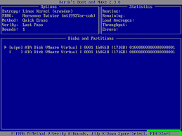

3.3 SOFTWARE INSTALLATION
Software installation is the process of making a computer program ready for execution by copying, configuring, and registering its files and components on a computer system or network.
Here's a more detailed explanation:
- The Goal:
The primary purpose of software installation is to make a program usable on a specific computer or system.
- The Process:
  - Copying Files: Installation involves copying the program's files (executable files, libraries, etc.) from the installation media (like a CD, USB drive, or downloaded file) to the computer's hard drive.
  - Creating Directories: Installers often create necessary folders or directories to store the program's files.
  - Registering Components: The installation process might also involve registering the program's components with the operating system, such as adding entries to the Windows Registry.
  - Configuration: Installers may also configure the software's initial settings, such as default paths, user preferences, or network settings.
- Installers:
Many programs come with a specialized program called an "installer" that automates the installation process. Installers handle tasks like copying files, creating directories, and registering components.
- Types of Installation:
  - Local Installation: Installing software from a physical or virtual media source like a CD-ROM, USB drive, or ISO file.
  - Remote Installation: Installing software over a network or internet connection, such as through a download link, FTP server, or cloud service.
- Uninstallation:
Since installation often involves copying and registering components in multiple locations,
uninstallation typically involves more than just deleting the program folder; it might also require modifying or deleting registry entries and other system files.

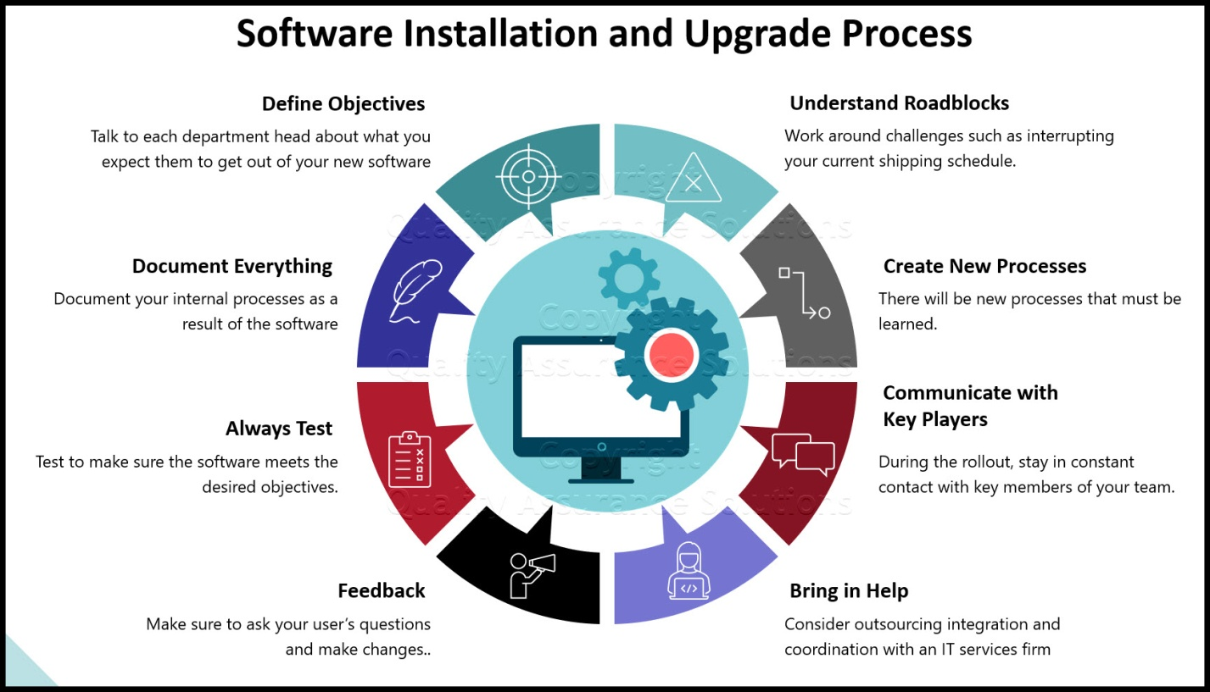
3.4 HOW TO DIAGNOSE SYSTEM
To diagnose a system, start by identifying the problem, then use tools like system event logs, performance monitoring, and error messages, and consider hardware diagnostics, software updates, and virus scans to pinpoint the issue and find solutions.
Here's a more detailed breakdown of the process:
1. Identify the Problem:
- Observe Symptoms:
Carefully note what's happening when the system malfunctions. What error messages are displayed? Are there any unusual noises or behaviors?
- Document the Issue:
Write down the specific steps that lead to the problem, including the time, date, and any relevant details.
2. Gather Information:
- System Event Logs:
Windows Event Viewer can provide valuable insights into system events, errors, and warnings.
- Performance Monitoring:
Monitor CPU usage, memory consumption, and disk activity to identify bottlenecks or resource limitations.
- Error Messages:
Pay close attention to error messages and codes, as they can point to the root cause of the problem.
- Hardware Diagnostics:
Use tools like HP PC Hardware Diagnostics or Device Manager to test hardware components and identify potential failures.
- Check Function:
Check if the system is functioning as expected by performing basic tasks and checking for any unusual behavior.
- System Diagnostics Report:
Use the Windows System Diagnostic Report to gather troubleshooting information while the problem is occurring.
- CrystalDiskInfo:
Monitor drive health and S.M.A.R.T. values.
3. Analyze the Information:
- Correlate Symptoms and Logs:
Analyze the collected information to identify patterns and relationships between symptoms, logs, and error messages.
- Research Potential Causes:
Use the gathered information to research potential causes of the problem, such as driver issues, software conflicts, or hardware failures.
4. Test and Implement Solutions:
- Software Updates:
Ensure that the operating system, drivers, and software are up to date, as updates often include bug fixes and performance improvements.
- Hardware Diagnostics:
Run diagnostic tests on hardware components to identify potential failures.
- Virus Scan:
Perform a thorough virus scan to rule out malware as a cause of the problem.
- Check Function:
Check if the system is functioning as expected by performing basic tasks and checking for any unusual behavior.
- Device Manager:
Use Device Manager to check the status of devices and troubleshoot potential issues.
- Event Viewer:
Use Event Viewer to view detailed information about significant system events.
- Test the Solutions:
After implementing potential solutions, carefully test the system to ensure that the problem has been resolved.
- Document the Process:
Keep a record of the diagnostic process, including the symptoms, the steps taken, and the solutions implemented.
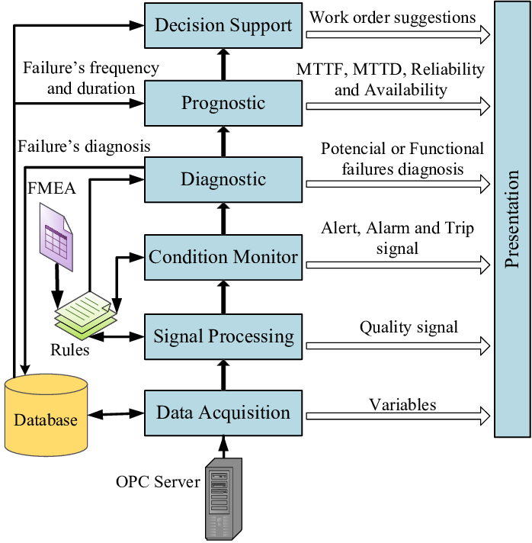

CHAPTER FOUR
4.1 CONCLUSION
The Student Industrial Work Experience Scheme (SIWES) plays a significant role in human resource development, it helps students develop new skills and enlightens them of what the present society holds for them after graduation and helps them adapt accordingly. As a result of the programme, I am now more confident to build my future, My four (4) months industrial attachment with Radio Kwara has been one of the most interesting, productive and instructive experience in my life. Through this training, I have gained new insight and more comprehensive understanding.

4.2 RECOMMENDATION
The following are the suggested recommendation for the program
i. The company should remain friendly and accommodating to future IT student.
ii. The SIWES coordinator and school should where organized enlightenment program for IT student in order to know the important of SIWES.
iii. The school (Polytechnics) should consider the four months mandatory SIWES while drafting the calendar for a successive session in a way that will affect the returning IT Student.
.

