

TECHNICAL REPORT

ON

STUDENT INDUSTRIAL WORK EXPERIENCE
SCHEME (SIWES)

HELD AT

TINKEY GLOBAL LIMITED
NO. 158 ALIMI ROAD, OLOJE, ILORIN

BY

POPOOLA BELSSING AYOMIDE
ND/23/PSM/PT/0008

SUBMITTED TO

THE DEPARTMENT OF PROCUREMENT AND SUPPLY CHAIN MANAGEMENT
INSTITUTE OF FINANCE AND MANAGEMENT STUDIES (IFMS)
KWARA STATE POLYTECHNIC, ILORIN
IN PARTIAL FULFILMENT OF THE REQUIREMENTS FOR THE AWARD OF NATIONAL DIPLOMA IN PROCUREMENT AND SUPPLY CHAIN MANAGEMENT

JANUARY, 2025
CERTIFICATION
This is to certify that the bearer has successfully completed the Student Industrial Work Experience (SIWES).

_________________________ ___________
Department Cordinator Date

________________________ ____________
SIWES Director Date

DEDICATION
This report is dedicated to the almighty God, the giver and sustainer of life, for His unconditional love and mercy granted to me throughout the period of my Industrial Training.
ACKNOWLEDGMENT
I am deeply grateful to Almighty God for granting me the strength and wisdom throughout my SIWES program.
My profound appreciation goes to Kwara State Polytechnic , my Department, and the Industrial Training Fund (ITF) for providing the opportunity to undergo this experience. I also extend my gratitude to the management and staff of TINKEY GLOBAL LIMITED, especially my industry-based supervisor, for their guidance and mentorship. Lastly, I thank my family and friends for their unwavering support.

TABLE OF CONTENTS
CHAPTER ONE: INTRODUCTION
Background of the Study
Objectives of SIWES
Scope of Training
Significance of Training
Company Overview
CHAPTER TWO: COMPANY PROFILE
History of Tinkey Global Limited
Organizational Structure
Services and Operations
Major Projects
CHAPTER THREE: TRAINING ACTIVITIES
Departments Worked In
Tasks Performed
Tools and Equipment Used
Safety Measures and Regulations
Challenges Encountered
CHAPTER FOUR: PRACTICAL EXPERIENCE AND OBSERVATIONS
Technical Skills Acquired
Problem-Solving and Decision-Making
Work Environment and Teamwork
Project Execution and Management
CHAPTER FIVE: CONCLUSION AND RECOMMENDATIONS
Summary of Experience
Recommendations for Future Interns
Contributions to Career Development

CHAPTER ONE

INTRODUCTION

1.1 Background of the Study
The Student Industrial Work Experience Scheme (SIWES) is a program designed to expose students to real-world applications of their theoretical knowledge. It enables students to gain practical experience in their field of study, equipping them with relevant industry skills.

1.2 Objectives of SIWES
- To provide students with hands-on experience in construction-related activities.
- To bridge the gap between academic learning and industrial applications.
- To expose students to professional ethics and standards in the construction industry.

1.3 Scope of Training
The training covered multiple areas within the construction field, including:
- Site preparation and surveying
- Concrete mixing and reinforcement
- Structural analysis and design implementation
- Supervision and project management

1.4 Significance of Training
This training is crucial in preparing students for future careers by providing technical skills, teamwork experience, and problem-solving techniques applicable to real-world scenarios.

1.5 Company Overview
Tinkey Global Limited is a well-established construction company located at No. 158 Alimi Road, Oloje, Ilorin. The company specializes in building construction, road construction, and infrastructure development.

CHAPTER TWO

COMPANY PROFILE

2.1 History of Tinkey Global Limited
Tinkey Global Limited was established in [year] with the aim of delivering high-quality construction services. Over the years, it has grown into a reputable firm known for its excellence in building and civil engineering works.

2.2 Organizational Structure
The company operates under a hierarchical structure that includes:
- Managing Director
- Project Managers
- Engineers and Supervisors
- Field Workers and Technicians
- Administrative Staff

2.3 Services and Operations
- Residential and commercial building construction
- Road construction and maintenance
- Structural engineering consultancy

2.4 Major Projects
Some of the notable projects handled by the company include:
- Construction of commercial buildings in Ilorin
- Road expansion projects
- Bridge construction and drainage systems

CHAPTER THREE

TRAINING ACTIVITIES

3.1 Departments Worked In
During my training, I worked in the following departments:
- Store assistant
- Structural Engineering
- Site Supervision
- Materials Testing and Quality Control

3.2 Tasks Performed
- Assisting in site surveying
- Mixing concrete and monitoring curing processes
- Observing and assisting in reinforcement placement
- Reviewing engineering drawings and blueprints

3.3 Tools and Equipment Used
- Measuring tapes and leveling instruments
- Concrete mixers and vibrators
- Safety helmets, gloves, and boots

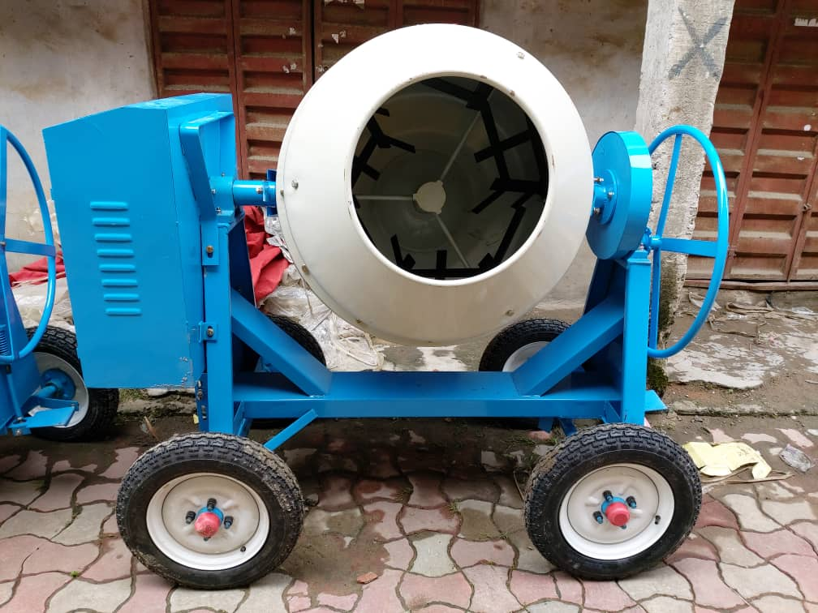
CONCRETE MIXERS AND VIBRATORS


MEASURING TAPES AND LEVELING INSTRUMENTS


HEAD PAN

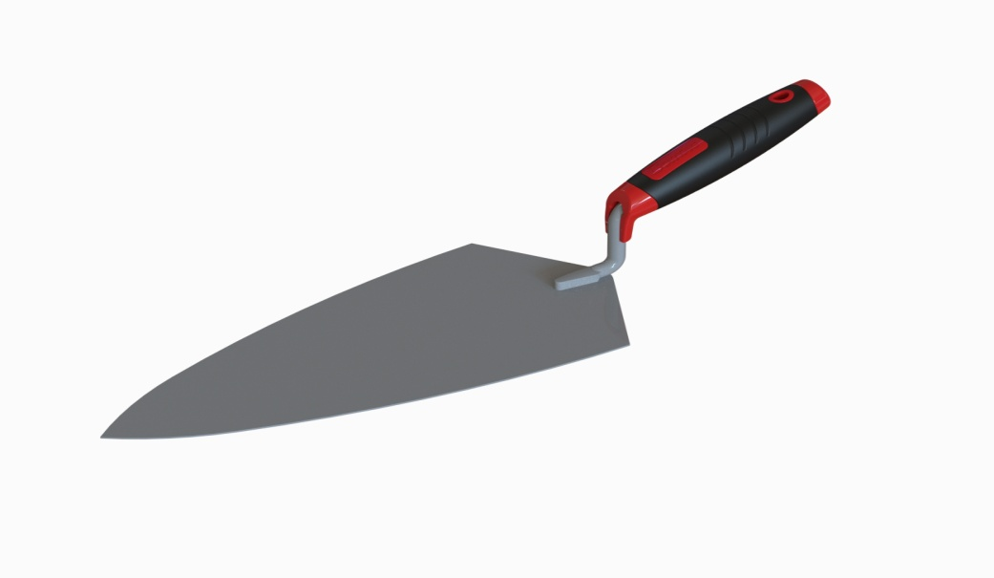
Brick trowel


SAFETY HELMETS, GLOVES, AND BOOTS

3.4 Safety Measures and Regulations
- Wearing personal protective equipment (PPE)
- Following construction site guidelines
- Ensuring proper use of machinery and tools

3.5 Challenges Encountered
- Adapting to harsh weather conditions on site
- Understanding complex engineering drawings
- Time management in a fast-paced environment

CHAPTER FOUR

PRACTICAL EXPERIENCE AND OBSERVATIONS

4.1 Technical Skills Acquired
- Basic knowledge of structural analysis
- Construction material handling and testing
- Interpretation of engineering blueprints

4.2 Problem-Solving and Decision-Making
- Quick adaptation to site challenges
- Effective communication with site supervisors
- Developing solutions for minor site errors

4.3 Work Environment and Teamwork
The training helped me understand the importance of teamwork in achieving project goals, enhancing my ability to collaborate with professionals on-site.

4.4 Project Execution and Management
Exposure to project planning and execution provided insight into how projects are managed from start to completion.

CHAPTER FIVE

CONCLUSION AND RECOMMENDATIONS

5.1 Summary of Experience
My training at Tinkey Global Limited was an eye-opening experience that provided me with practical knowledge and industry exposure. I gained valuable technical and professional skills that will be beneficial for my career development.

5.2 Recommendations for Future Interns
- Future interns should familiarize themselves with construction basics before training.
- They should actively participate in field activities to gain hands-on experience.
- Interns should be open to learning from experienced professionals.

5.3 Contributions to Career Development
The experience gained from this industrial training has reinforced my passion for construction engineering. It has provided me with the necessary skills to bridge the gap between theoretical knowledge and real-world applications.

