A REPORT ON

STUDENTS INDUSTRIAL WORK EXPERIENCE SCHEME

(S.I.W.E.S)

AT

BUA LASUCO COMPANY LAFIAGI

BY

MOHAMMED SALIHU

ND/23/BLD/PT/032

DEPARTMENT OF BUILDING TECHNOLOGY

KWARA STATE POLYTECHNIC, ILORIN

DECEMBER,2024
DEDICATION
This report is dedicated to my interest I have for the higher value of education.
Another dedication to my humble parent for their financial support during my programmed and also to the entire staff of Edu local Government secretariat staffs, especially those in Treasury/ Main account department, may all mighty God be with you all every time (amen).
ACKNOWLEDGMENT
I seize this glorious opportunity to express my gratitude unto Almighty God who is the beginner of every life and who made it possible for me to live to this day by his mercy, enable me to successfully see through this concluded academic work. I at this point expressed my warmest appreciation to a number of people who have contributed to the success of this report work in one way or the other.
I express my profound gratitude to my able and capable supervisor, in person of Mr. AY who render fatherly assistance and also spare his time to go through this script. May Almighty God continue to show his infinity mercy on him(Amen?〕
I also appreciate the effort of the co-staff of BUA Company in Building department. As well as my college supervisor.May Almighty God to bless you all (Amen)
At the end, my biggest thanks and honour goes to almighty God once more for sparing my life and grant s me ability to go through the program and also gave me the strength to finish my program successfully and for his protection throughout the program
CHAPTER ONE

INTRODUCTION

The Students Industrial Work Experience Scheme (SIWES) is a skills training programme designed to expose and prepare students of universities and other tertiary institutions for the Industrial Work situation they are likely to meet after graduation. It is also a planned and structured programme based on stated and specific career objectives which are geared towards developing the occupational competencies of participants (Mafe, 2009). Consequently, the SIWES programme is a compulsory graduation requirement for all Nigerian university students offering certain courses.
1. To provide an avenue for students in the Nigerian universities to acquire industrial skills and experience during their course of study;
2. To prepare students for the work situation they are likely to meet after graduation;
3. To expose the students to work methods and techniques in handling equipment and machinery that may not be available in their universities;
4. To allow the transition phase from school to the world of working environment
1.1BRIEF HISTORY OF SIWES
SIWES was established by ITF (Industrial Training Funds) in the year 1973 to solve the problem of lack of adequate proper skills for employment of tertiary institution graduates by Nigerian Industries. The Students' Industrial Work Experience Scheme (SIWES) was founded to be a skill training programme to help expose and prepare students of universities, polytechnics and colleges of education for the industrial work situation to be met after graduation. This scheme serves as a smooth transition from the classroom to the world of work and furthe
helps in the application of knowledge. The scheme provides students with the opportunity of acquainting and exposing themselves to the experience required in handling and managing of equipment and machinery that are usually not made available in their institutions.
1.2 AIMS AND OBJECTIVE
SIWES is strategized for skill acquisition. It is in fact designed to prepare and expose students of universities, polytechnics and colleges of education to the real-life work situation they would be engaged in after graduation. Therefore, SIWES is a key factor required to inject and help keep alive industrialization and economic development in the nation through the introduction and practical teaching of scientific and technological skills to students. (Culled from Detailed Manual on SIWES Guidelines and Operations for Tertiary Institutions).Objectives of the Students Industrial Work Experience Scheme include:
a. Provide an avenue for students to acquire industrial skills for experience during their course of study
b. Expose students to work methods and techniques that may not be available during their course of study.
c. Bridging the gap between theory and practice by providing a platform to apply knowledge learnt in school to real work situations
d. Enabling the easier and smoother transition from school by equipping students' with better contact for future work placement
e. Introduce students to real work atmosphere so that they know what they would most likely meet once they graduate.
1.3 BENEFIT TO THE STUDENT
1. The following are the benefits of siwes to students;
a. Learn to assume responsibility.
b. Gain knowledge and attitudes necessary for successful programme.
c. Acquire good work habits.
d. Learn how to get along with fellow workers and employers.
e. Develop personality and poise.
f. Realize the connection between the job production and wages.
g. Earn necessary funds.
h. Discover the relationship between education and job success.
i. Broaden their knowledge for the occupational world.
1.4 BENEFIT TO THE SCHOOL
Siwes is of benefit to the school in the following ways;
a. Provides an opportunity to relate academic training to job requirements.
b. Utilize many community facilities and resources of training purposes.
c. Increase the school ability to hold students in school for a longer period of time.
d. Provides assistance in occupational guidance.
e. Enable the school to keep abreast of development in the business and industrial world.
f. Provides a direct avenue through which the school can meet community needs.
1.5 BENEFIT TO THE EMPLOYER
Siwes is benefitted to the employer in the following ways
a. Provides a fulltime worker from which to select permanent employees at later date.
b. Provides an opportunity for the employer to refined and validate the company's own training method.
c. Provides the employer with employees who are receiving an additionaI training through related instruction at training but not warranted or possible on the job,
d. Serves a training programme for prospective employees of small business or industries.
e. study.
f. It also gives students the broad knowledge of what to expect in the labour market after graduation from the school.
CHAPTER TWO

2.0 BRIEF HISTORY AND BACKGROUNG OF THE COMPANY
Time, cost and quality consult commenced Construction Activities since 20178 but were incorporated in Nigeria on the 7th day of May, 2020. They are fully involved in construction of building projects from inception to completion. Below are the scope of activities that the company is mostly specialized on;
Pre-contract services.
Contract execution
Post contract services.
The under listed activities could be handled from any stage or as turnkey project by TIME, COST AND QUALITY CONSUL.
  - Constructions of new Buildings/structures.
  - Renovations/Rehabilitation of existing structures /Buildings.
  - Automated architectural designs for speed, accuracy and flexibility.
  - Construction of earth rural/tarred roads.
  - Construction of concretes drains.
  - Civil engineering works such as earth retaining structures.
2.1 LOCATION AND ADDRESS OF THE COMPANY
The company Bua Sugar, Lafiagi Construction Department located in Edu Local Government Area of Kwara State.
2.2 THE COMPANY AND ITS DIVISION
The company is comprises of three departments where each department is headed by a director.
Vision: to attain a safe livable, orderly, sustainable and aesthetically balance urban environment through the culture of professionalism, ethics and effective service delivery.
Mission: to conceive and execute projects that shall lead to the realization of safe, livable, orderly and conducive urban environment capable of transforming the entire country at large/
2.3 DEPARTMENTS IN COMPANY
i. Administrative Department
ii. Accounting Department
iii. Project Department
ADMINISTRATIVE DEPARTMENT
The department is responsible to ensure the efficient performance of all the departments in the company. They are act as a connecting link between the senior management and employees. They provide motivation to the work force and make them realize the goals of the company.
ACCOUNTING DEPARTMENT
The department is responsible for recording and reporting the cash flow transactions of a company. This department has some key roles and responsibilities, including accounts receivable, accounts payable, payroll, financial reporting, and maintaining financial controls of the company.
PROJECT DEPARTMENT
This department is responsible for the managing the production of the required deliverables. Planning and monitoring the project. Adopting any delegation and use of project assurance roles within agreed reporting structures. Preparing and maintaining project, stage and exception plans as required. The department comprises of subsections which are:
i. Construction department
ii. Planning department
iii. Procurement department
iv. Maintenance department
2.4 ORGANIZATIONAL CHART
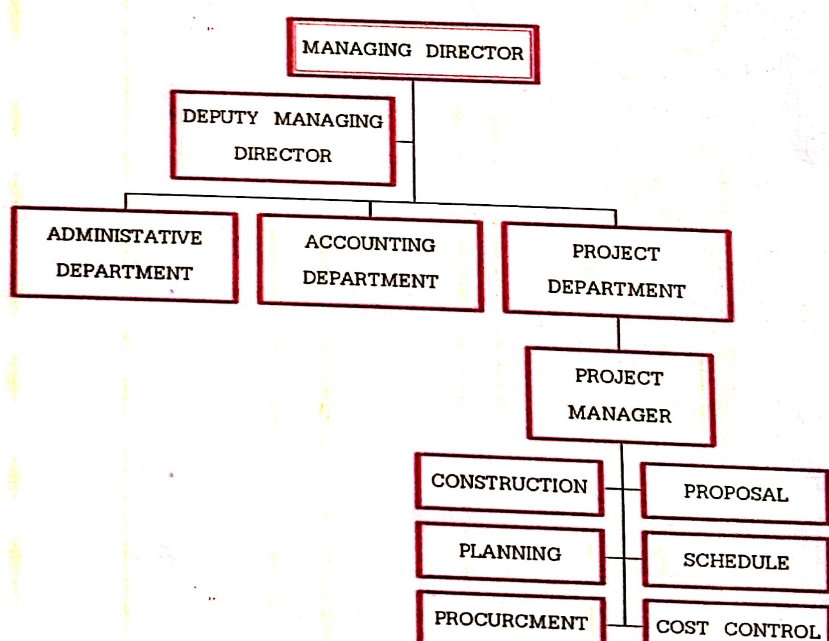

CONSTRUCTION CO.,LTD

CHAPTER THREE

3.0 DEPARTMENT OF PLACEMENT
I reported for work on 2nd of August 2024 which was my first day at work. I was introduced to the all the staff of the company and they all welcome me. I works in almost three difference sites my siwes program and each one of them gained me a lot of experience. One of the sites Is a renovation work and the other two is a fresh site. The first work I did at the site I was go to one of the site in Clinic Construction site for BUA Quarters. The title of the project is PROPOSED CLINICAL SITE FOR STAFF. Which comprises of 30 wards semi detach of two story building. The first thing we carried out at the site is clearing the site where there is a little bushes existing fence have been demolished.
ways to keep your construction safe:
1.Start with safety training
All workers must hold a current white card before they commence work on-site. Site-specific induction training should also be completed by each worker, to point out any highrisk areas and provide instructions for emergency management.
2. Minimise and manage risk
Due to the nature of construction work, it's impossible to eliminate all safety risks. However, many common safety issues can be avoided by conducting regular safety audits and having procedures in place to report, assess and address potential risks.
3.Site security
Restricted site access should not only be put in place to simply protect equipment from damage or theft. Security in and outside of work hours is integral to protect
pedestrians from potential construction hazards. This includes supervision or authorised site visitors. Strict security and safety protocols will also protect contractors from liability and negligence in the case of a safety incident or security breach.
4.Safe work method assessment
A safe work method statement (SWMS) must be prepared for all high risk construction projects, before work commences. The SWMS should outline the scope of work involved, any potential safety issues, and how risks will be prevented and managed. By law, construction work must not commence until SWMS standards are met.
5.Use clear signage throughout the site
The site SWMS should be clearly displayed at the construction site, so that all safety protocols are readily available - including a 24 hour emergency contact number and a map or directions to the site office. Visible signage should also indicate site amenities (such as toilets), entry and exit points, and first aid.or emergency fire equipment.
6.Entry and exit points
Separate entry and exit points should be established for heavy machinery/vehicle access, to strengthen pedestrian safety at high traffic points.
7.Compliant chemical storage
Chemicals need to be stored very carefully to minimise fires, explosions, asphyxiation, chemical injury and pollution on worksites. Use high quality,
compliant outdoor storage solutions such as explosive storage cabinets to segregate chemicals and reduce spillage.
8. Environmental conditions
Extreme weather conditions can cause serious safety hazards. Your on-site emergency plan should provide clear guidelines for workers who need to stop work in the event of natural disaster, severe environmental conditions or other emergency circumstances.
9.First aid
For the construction industry, it's best practice to provide one first aid officer per 25 workers. First aid kits and equipment must be placed in an easily accessible area on site.
10.Provide personal protective (PPS) equipment
3In many situations an employer is obligated to provide PPS such as high vis vests, safety goggles and safety harnesses to construction site workers. To find what PPS you are required to provide for a specific project, contact Safe Work Australia.
11.Dropped objects
It is your responsibility to secure objects onsite and minimise the risk of them falling. This video explains the risks and how they can be avoided by putting preventative safety measures in place.
3.1 SITE LAY OUT CONSIDERATION
1.Site Access Considerations
It is necessary to examine roads on and off the construction site. The suitability of the roads to transport all requirements for the suggested construction site and also for general circulation should be examined.
2.Considerations for Offices and Accommodation
The accommodation considerations include the type and expected numbers of staff at the construction site, determine the location for offices to provide quick and easy access for visitors, and also to give a good view of the construction site.
3.Storage Considerations
When storages are set at the construction site, many factors need to be considered, for instance, quantity and type of materials, suitable weather and security protections, provision of sufficient storage space and working area around the storage.
4.Considerations for Temporary Services
Consider the type of temporary services, location of the required services, and the time in which the given services are needed. The coordination between various services conducting at the site is fundamental.
The very first thing we started with in Bua Clinic site is clearing of site which is has small grasses and existing structure we demolished it which has been dóne manually by the use of cutlass, axe, hoe etc.
A site clearance is the removal of all the shrubs and other unwanted materials away from the site. Equipment use in site clearance includes: hand saw, hoe, rakes, shovels and pick axes hammer.
3.2 SETTING OUT OF 30 WARDS ROOM SEMI DETACH.
After site has been cleared we did sitting out of main building which has dimension of 18.04m by 14.09m the way it is in the drawing. Setting out is a transfer of information from architectural drawing to the actual ground level with high degree of accuracy.
EQUIPMENT USE IN SETTING OUT INCLUDE THE FOLLOWING.
I. Profile board
II. Nails
III. Builder square
IV. Measuring tape
V. Lime powder
VI. Hammer
VII. Line
VIII. Spirit level.
Trench excavation has been done with depth of 0.3m deep and thickness of 0.69m by manually using implement such as digger, hoe, shovel etc.
3.3 EXCAVATION WORK
We marked the areas to be excavated using lines as a guide to the laborers 'the depth of the trench was 0.3m and thickness of 0.69m because the of the type of foundation we were doing is a raft foundation and we all known that raft foundation no need to much deep on like pad and other types of foundation and
nature of the site is a water logging. Excavation has done manually include the use of implement shovel digger hoe et c.
Raft foundation is a type of shallow foundation that is provided in areas where the soil have a low bearing capacity, or where high superstructure load is anticipated such that individual, pad foundation will overlap.
3.4 BLINDING
We casted blinding which normally called(weak concrete) usually around 50mm (2 inches) mechanical plant (concrete mixer)has been used with the ratio of 1:3:4and manual method of placement it is casted all in one day and allowed for drying.
3.5 BENDING REINFORCEMENT
Bending reinforcement before putting them into the pits to serve as wall,10mm size were used as links, 16mm were used for top and bottom to overcome problem of tension and compression and 12mm were use as intermediate (neutral).
3.6 ARRANGEMENT OF RAFT FOOTING REINFORCEMENT
Arrangement of raft footing reinforcement inside the trench after concrete blinding has been drying the perimeter contained a base while internal were anchor to the perimeter, the height of raft reinforcement is 1.2m from the foundation to floor level.
3.7 FORMWORK
form work (boarding) on the reinforcement before casting the concrete to serve as support, marine boards of different sizes were used with support at different positions to serve as form work.
TOOLS USE IN FORMWORK INCLUDE
i. Saw
ii. Hammer
iii. Nails
iv. Line
v. Measuring tape etc.
RAFT FOOTING FORMWORK
3.8 CASTING OF CONCRETE RAFT
We casted concrete raft footing after we have been successful through with formwork which done by using mechanical concrete mixer with ratio of 1:2:2which include the use of tools shovel, bucket trowel,
3.9 FILLING
The foundation was filled with filling sand and allowed to be beating by rain fall in order to achieve proper consolidation, the filling was later ramped with poker vibrator to gain even level
3.10 STARTER BAR FOR STAIRCASE
Staircase starter bar were anchor with the concrete wall by the use of 12mm reinforcement steel had a space of 200mm c/c.
3.11 MECHANICAL WORK
Installation of mechanical (plumbing) work which include poly vinyl chloride pipe (PVC) of different sizes for both discharging and supplying of water into and outside the building premises
3.12 DPM
Polyethene was used to prevent dampness (DPM) which was applied all over the rooms before. The concrete slab with a blinding of 50mm thick on top.
3.13 FORMWORK FOR CONCRETE DPC FLOOR
A form work was applied at the edge of the external walls to serve as support to the concrete slab; planks were used to serve as form work with support at different positions.
3.14 CASTING OF CONCRETE SLAB
A form work was applied at the edge of the external walls to serve as support to the concrete slab, planks were used to serve as form work with support at different positions.
3.15 CONSTRUCTION OF ROOF FRAME
After we had been successful done with casting of roof beam we started construct roof frame which done by the use of following planks.2x3,2x4,1x3,1x12.
RAFTER
One big aspect of a roof's frame is the rafters. Rafters are a series of sloped structural Rafters are a series of sloped structural beams that extend from the peak of the roof to the edge of the roof. They provide the main support for the roof load, and if done incorrectly, it can lead to dipped or collapsed roofs.
PURLINS
Another large aspect of a roof comes from purlins-additional support for the roof load. Where rafters are vertical beams, purlins are horizontal beams laid on top of the principal rafters.
PITCH
You will also notice the roof's pitch right from the get-go. The pitch is, quite simply, the slope of the roof. It is expressed as the ratio between the rise and horizontal span of the roof or in terms of the angle of inclination.
Roof Covering:
The next section we'll discuss is the roof's covering. There are tons of elements to this part of the roofing process, so we'll delve into the main components.
UNDERLAYMENT
Your home has its entire structure and bones laid out. Next, is the roof's covering, and that begins with the underlayment. This acts as the last barrier for your home and is a water-resistant material installed directly onto your room
SHINGLES
Shingles can be made from many different materials, but many popular roofing materials such as asphalt shingles are chosen because of their price, not their longevity
FLASHING
One of the most vital parts of your entire roofing system is flashing, which is a type of resistant molding that prevents water from infiltrating the roof.
Roof's Edge:
Our final section is about the edge of the roof and what it takes to complete and finalize your roof. These aspects are just as important as the others, as it works to keep water and other elements from leaking into your home.
DRIP EDGE
Simply put, this is a molding that covers theedge of the roof and reduces any risk of water infiltration from any nooks and crannies in the roof. Though not necessarily required by Code, it is highly recommended by roofers and manufacturers. It will attach directly to the decking along the bottom of the roof slope and above the underlayment.
FASCIA
This is a vertical component of the exterior part of the roof where it meets the edge of the home. It is basically a band under a roof's edge, and it's the most visible part of the edge to an observer. Gutters are attached to the fascia.
ROOF GUTTER AND DOWNSPOUT
The last parts of the roof you should know about are the gutters and downspouts. Gutters are the metal troughs that take water away from the roof's edge, and they connect to downspouts, which bring the water down and away from the roof's foundation.
CHAPTER FOUR

4.0 INTRNODUCTION
This report will describes the activites of SIWES as well as serving as documentation for six month IT. It serves as an answer necessary to questions of student's achievement or otherwise.
During this six month of industrial training the student come into physical contact with tools, machines, and terms he views theoretically in class.
4.1 EXPERIENCE GAINED
Experiences gained during my SIWES program include:
Use of measuring tape: This is an important task on site as it enables correct positioning of items/features. When taking measurements, the tape must not be in a slopping direction, which can alter the readings (either by increasing or reducing the actual reading) and can lead to problems during construction.
Setting out: setting out simply refers to transferring the working drawing on paper onto a natural ground and marking the possible excavation spots using either nails and lines or ash powder some times.
Different types of foundation: I am exposed to different types, of foundation during my IT programme which includes pad foundation,raft foundation and strip foundation.
Laying and bending of reinforcement bars: I learnt how to identify different sizes of bars and their area of application.
  - Columns
  - Beams
  - Slabs
Formwork: formwork is the term used for temporary timber, plywood, metal or other boarding material used to support and form wet concrete until it has gained the sufficient strength. Formwork should be sufficiently rigid to prevent undue reflection.
Construction of floor slabs: I learnt how to construct slabs using a proper mix ratio.
Concreting: The quality of a good concrete depends on a good mix ratio, mixing method, method of placement, compaction and curing afterwards.
Block laying: This requires skilled labour to carry out. The tools involved for the job include trowel, plump, line, range and choking board. A block is the first set in place, properly plumbed and another is done in the same at the opposite corner, before a line is drawn from the top and sides of both set blocks to one another, to enable the placement of the remaining blocks.
Curing: This is the process of preventing rapid loss of water from the concrete to enable it develops strength and prevents crack formation. This is very important as it enables the concrete to achieve its final strength.
Laying soil pipes: This requires the pipes to be properly slopped to ensure the smooth running of waste in them. Also the connection of the two pipes must be done in the correct order by always connecting the end of one of the pipe to the head of the other pipe in the flow direction to prevent gradual collection of waste particles at that joint/connection.
4.2 APPLICATION IN MY FUTURE CAREER
The whole experience I gained during my training would have a profound impact on me in the future as a builder. When practicing I would be able to understand better and appreciate situation both in the office setting and on site.
The communication skills I developed would also help me in the future when practicing, what I learnt is a very important tool in the labour market.
4.3 PROBLEMS FACED DURING THE TRAINING
All in all problems encountered were minimal compare to the achievement covered during the period. Some difficulties faced during my SIWES training include the following;
Transportation of materials from company to site
  - Weather condition.
  - Time factor
  - Change of environment
  - Theft
  - Rain beating at the site
- ·Expensive life
4.4 SUMMARY
The objective of this report is to enable the institution to know the knowledge/experience acquire by a student during their SIWES programme.
I acquire much during my SIWES programme, I understand how to interpret drawings and building services. The experience I gained during this period will help me in understanding my course of study and life as it has improve my communication skills.
4.5 CONCLUSION
These industrial training will remain as an adventure event to happened during my life time of study as I learnt a lot in both academics and also in my personal life by meeting new people from different part of the country, being me from
north region but due to IT I was opportune to visit the southern part and see how they go about their buildings and there life style where I interact with different buildings such as high rise buildings (sky scrapers), modern buildings, etc.
I.T gave me an opportunity to relate with practical aspect of the theory I am been taught in class.
I was also opportune to relate with different student from other universities and well other professionals in the building industry such as masons, carpenters, iron benders, plumbers, etc.
It also availed me with the much needed experience in handling machinery and equipment that otherwise I would not have learnt.
The amount of knowledge I have accumulated during my six month attachment at Time, cost and Quality consult is quite immense. I am very proud that I cannot only read (drawings) and write (building terms) I can also take incharge as a site supervisor from inception to completion of many projects.
4.6 RECOMMENDATION
I really must commend the ITF (industrial training fund) and all the stakeholders involved in establishing SIWES programme in order to solve the problems of lack of professional skills among the Nigerian Students. {S.I.W.E.S} was established in 1973 by ITF to solve the problems of inadequate practical skills which are preconditions for employment of graduates in Nigeria's industries or organization. And I want to thanks Time, cost and quality consult for all the efforts they put through my six months (SIWES) of questions and answers especially the G.M of company in person of Ahmed Zakari for all he did to ensure we acquire what we were there for.
REFERENCE
The construction of buildings Vol.1 by R. Barry Fourth edition

Building construction handbook sixth edition by R. Chudley and R. Greeno.

