
A REPORT ON

STUDENTS INDUSTRIAL WORK EXPERIENCE SCHEME (SIWES)

HELD AT

FAMOUS HOSPITAL

OPPOSITE LEKKI FREE ZONE GATE, TIYE IBEJU,
LEKKI LAGOS

BY

OLAREWAJU BARAKAT OMOLARA

ND/23/SLT/FT/0059

SUBMITTED TO

THE DEPARTMENT OF SCIENCE LABORATORY TECHNOLOGY, INSTITUTE OF APPLIED SCIENCE, KWARA STATE POLYTECHNIC, ILORIN.

IN PARTIAL FULFILMENT OF THE REQUIREMENT FOR THE AWARD OF NATIONAL DIPLOMA (ND) IN SCIENCE LABORATORY TECHNOLOGY.

AUGUST, 2025

TABLE OF CONTENTS

Title Page
Table of Contents |  | 1
Chapter One: Introduction
1.1 | General Introduction | 2
1.2 | Objectives of SIWES | 2
Chapter Two
2.0 | Rules and regulations in the laboratory | 4
2.1 | Laboratory equipments and their functions | 4
Chapter Three
3.0 | Procedures for tests | 5
3.1 | Pack cell volume | 5
3.2 | Fasting and Random Blood Sugar | 5
3.3 | Semen Pregnancy test | 6
3.4 | Full blood count | 6
3.5 | Human Immune Deficiency test | 7
3.6 | Urine analysis | 8
Chapter Four
4.0 | Blood grouping | 9
4.1 | Genotype | 10
4.2 | Hepatitis B | 11
4.3 | Widal test | 11
4.4 | High Vaginal Swab | 12
4.5 | Semen Analysis | 12
4.6 | Malaria parasite | 12
Chapter Five
5.1 | Summary | 14
5.2 | Conclusion | 14
5.3 | Problem encountered during the program | 14
5.4 | Recommendations | 14

1

CHAPTER ONE

1.0 General Introduction

The student industrial work experience scheme placement was carried out by polytechnic as per-requisite for award of diploma certificate to produce skilled manpower for speedy development of national economy. In science laboratory and technology is categorized into two aspects. The medical and industrial sections with hematology section which deal with the study of different forms of blood affecting or causing disease.

It is aimed in exposing students to machines and equipment and the way to blend with industrial activities and the safety guarding and effective work in a particular working area. The scheme is a tripartite program involving the student, the polytechnics and the industry.

1.1 Objective of SIWES

My main objective of doing my SIWES attachment is to be able to:

- To gain practical experience in addition to theoretical knowledge in school.

- To introduce me to work methods and techniques for handling equipment and machinery that are not available at school.

- To give me the opportunity to apply my theoretical knowledge in a real-world situation.

1.2 Objective of Establishment

1. to provide patients with personalized care.

2

- To develop an understanding of patients' privacy and dignity needs..

- To maintain good relationship with patient, relationship and the community through health education.

- To carry out diagnosis and intervention.

- To provide training for students.

- To maintain sufficient hospital supply of equipment and promote their utilization and maintenance.

- To treat and control disease.

3

CHAPTER TWO

2.0 Rules and Regulation of the Laboratory

- Do not eat inside the laboratory.

- Always put on your laboratory coat in the laboratory.

- Do not talk when performing test.

- Always wear hand gloves when carrying lout test.

- Do not use any equipment unless you are trained and approved as a user by the technologies in charger.

- Keep the work area clear of all materials except those needed for your work.

- Do not engage in childish antics such as horseplay or pranks.

- Clean up your area before leaving the laboratory.

- Cover up your wound because infection.

- Wash hands before leaving the laboratory and before eating.

2.1 Laboratory Equipment’s, Materials and Functions

- Centrifuge: for separation of sampling e.g. blood from the serum.

- Incubator: it is used to culture micro-organism.

- Glucometer: it is used for knowing the level of blood sugar present in the body.

- Glucose strip: it is used for laboratory blood.

- Electrophori machine: it is also known as genotype machine.

- Microscope: it is used for magnifying very small object.

- Heamatocrit reader: it is used for reading the level of blood of percentage of blood present in the body.

- Syringe and needle: for taking sample from patient body.

- Tourniquet: it is tied tightly round a limb to stop the flow of blood before taken sample.

4

CHAPTER THREE

3.0 Procedure of Test

3.1 Packed Cell Volume (PCV)

Apparatus: spirit swab, lancet blade, capillary tube, plasticize, centrifuge, heamatocrit reader.

Procedure:

- Clean the thumb of the patient with swab, allow to dry.

- Pierce the patient thumb with lancet blade.

- Use capillary tube to collect the blood the end with plasticine.

- Separate using centrifuge.

- Then read with heamatocrit reader.

Percentage of blood in female ranges between 35%-45%

Percentage of blood in male ranges between 39%-54%

3.2 Fasting Blood Sugar and Random Blood Sugar (FBS AND RBS)

Materials needed: spirit swab, lancet blade, glucometer glucose strip.

Procedure:

- Insert glucose strip into glucometer

- Clean the thumb of the patient, allow to dry

- Pierce the patient thumb with lancet blade

- Collect the blood with glucometer strip

- Then take readings

Normal value for FBS is 2.5 – 5.0

Normal value for FBS is 5.0 – 10.0. the unit is mmolil both for FBS and RBS.

5

3.3 Serum Pregnancy Test (SPT)

Apparatus: syringe and needle, spirit swab, tourniquet, centrifuge, pregnancy strip.

Procedure:

- Collect the patient blood sample

- Separate the blood with centrifuge or allow to settle

- Insert pregnancy strip into the serum, if two lines show i.e. control and test line. It means the patient is positive but if a line shows it means is negative.

3.4 Full Blood Count (FBC)

It is divided into three (3) parts, namely:

- Packed cell volume

- White blood cell

- Different count

White blood cell (WBC)

Apparatus and reagents: EDTA bottle, turk’s solution, neubauer chamber, cover slip.

Procedure:

- Put a drop of patient’s blood in a sterile EDTA bottle

- Add about 6 drop of turk’s solution

- Allow to stand for few minutes

- Charge the neubauer chamber with the solution

- Mount cover slip on the chamber

- Disperse a drop each to both end of the cover slip on the chamber

- View under microscope using x10 objective

6

Different count (thin film)

Material and reagents: slide, leishman stain, water, oil

Procedure:

- Make a thin film

- Allow to air-dry

- Flood with leishman stain for 20minutes

- Counter-stain with water

- Leave for another 8 minutes

- Rinse with water

- Allow to air-dry

- View under the microscope using oil immersion

3.5 Human Immune Deficiency Virus Test (HIV)

Apparatus: syringe and needle, spirit swab, tourniquet, centrifuge, HIV strip

Procedure:

- Collect the patient blood sample

- Separate the blood with centrifuge or allow to settle

- Insert HIV strip into serum, if two lines show i.e. control and test line, it means the patient is positive but if line shows it means the patient is negative

7

3.6 Urinalysis

Material needed: urinalysis strip

Procedure:

- Collect urine sample into universal bottle

- Label the sample with patient name, age, sex, cardio, date, nature of sample and investigation required.

- Pour the urine on the urinalysis strip and make sure the urine circulates to all the colours in the strip

- Observe your results immediately within 60 seconds.

- Compare the test result (colour change) with the colours on the urinalysis container

- Start the readings for glucose, specific gravity, protein, leukocyte, PH etc.

8

CHAPTER FOUR

4.0 Blood Grouping

Apparatus and reagents: anti-reagents, tile

Procedure:

- Place a drop of blood in three (3) places on a tile

- Add anti-sera reagents on the blood i.e. anti-sera A, B & D

- Stir and rock until agglutinations occur

There are eight (8) types of blood group namely:

A+, B+, AB+, D+, A-, B-, AB-, O-

Interpretation of a result was shown on the table below:
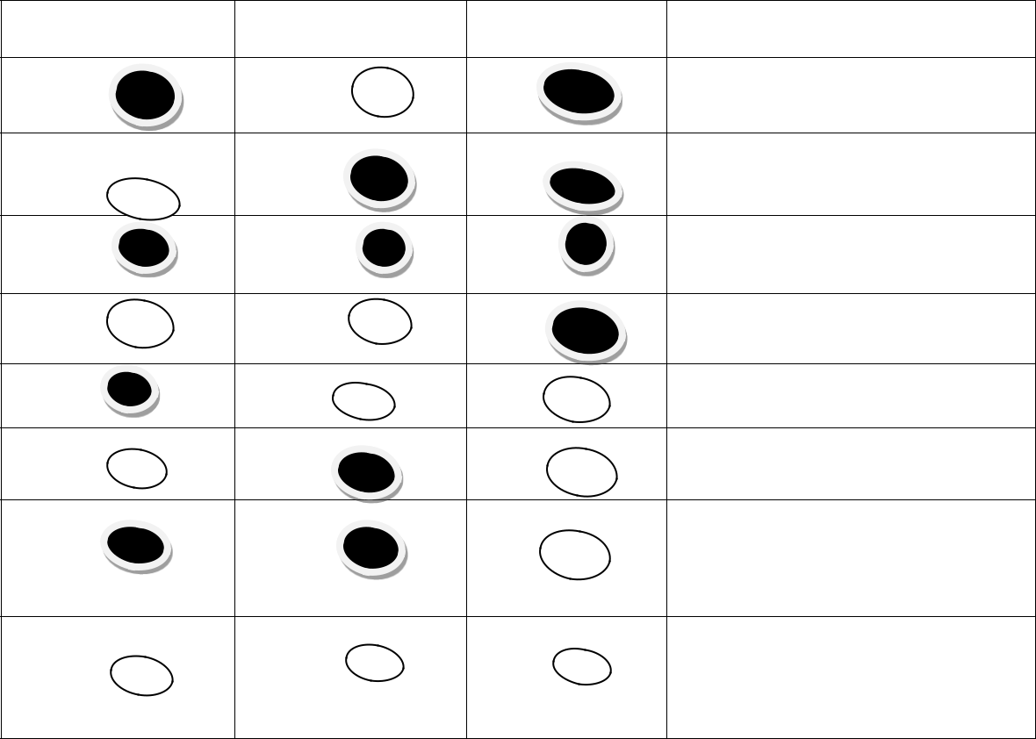

ANTI A | ANTI B | ANTI D | RESULT
 |  |  | ‘A’ Rh ‘D’ Positive (A + ve)
 |  |  | ‘B’ Rh ‘D’ Positive (B + ve)
 |  |  | ‘AB’ Rh ‘D’ Positive (AB + ve)
 |  |  | ‘O’ Rh ‘D’ Positive (O + ve)
 |  |  | ‘A’ Rh ‘D’ Negative (A - ve)
 |  |  | ‘B’ Rh ‘D’ Positive (B -ve)
 |  |  | ‘AB’ Rh ‘D’ Positive (AB - ve)

‘O’ Rh ‘D’ Positive (O - ve)

9

The agglutinations on the tiles shows the blood group of a patient Agglutinations on sera A & D ------------------------- Blood group A+ve Agglutinations on sera B & D ------------------------- Blood group B+ve Agglutinations on sera AB & D ------------------------- Blood group O+ve Agglutinations on sera D only ------------------------- Blood group A-ve Agglutinations on sera A only ------------------------- Blood group B-ve Agglutinations on sera B only ------------------------- Blood group AB-ve Agglutinations on sera AB only ------------------------- Blood group D-ve No Agglutinations occur ------------------------- Blood group O-ve

Agglutinations on sera D determines the Rhesus factor as positive and no agglutinations determines the Rhesus factors negative.

4.1 Genotype

Genotype or haemoglobin electrophoresis is used to separate and identify the different haemoglobins by their migration within an electric field. Haemoglobin variants separate at different rates due to different in their surface electric charges as determined by their amino acid structure .the predominant Genotype are AA and AS ,SS while AC ,SC etc

Aim :to detect ones genotype.

Apparatus: sterile swap, 2m1 syringe ,harid glove ,Tris buffer cellulose acetate membrane, clean and dry tile ,application ,a positive and negative control i.e. AS and. AA ,water, pasture’s pipettes, electrophoresis machine.

Procedure:

After blood collection using pasture’s pipette

The blood is placed using on a clean tile also your control placed at a different division.

Using another pasture’s pipette ,pipette small volume of water and add to the respective blood samples..then mix separate using an application to make the mixture light for easy separate of the samples.

10

Using respectively applicators place the sample on a cellulose acetate member respectively .

Pour l00mis of this EDTA borate buffer ip each of the electrophoresis chamber.

Put the cellulose acetate member in an electrophoresis machine placed side down.

Cover the tank and correct to power supply leave for 25 minutes to separate.

RESULT: if the result is AA when there are two lines when the S migrate to the positive electrode and then A to the negative electrode then is AS. When A migrate only to the negative electrode then it is AA and when the S riigrate to positive electrode and another S migrate to the positive electrode then it is SS.

4.2 Hepatitis B

Apparatus: syringe and needle, spirit swab, tourniquet, centrifuge, hepatitis B strip

Procedure:

- Collect patient blood sample

- Separate using centrifuge of allow to settle

- Insert hepatitis B strip into the serum, if two lines show, it means the patients is positive but if a line shows it means the patients is negative.

4.3 Widal test

Apparatus: widal reagents, tile

Procedure:

- Collect blood sample from the patient

- Separate serum from blood using centrifuge

- Use a dropper to draw serum and drop in eight different places on a clean tile

- Add widal reagent (salmonella thyphy H and parathyphy D) to the serum

- Stir and rock for some minutes

- Check the reaction and rate it

11

4.4 High Virginal Swab (HVS)

Procedure:

- Use a swab stick to collect the patient virginal fluid

- Drop a saline on a slide and take the swab stick to stir the saline a tittle

- Place a cover slide on it, it must not have air bubble i.e. the saline

- View under microscope

- After viewing it likely diagram will be the diagram of epithelial cell, bacteria, pulse cells etc

4.5 Semen Analysis Test

Procedure:

- Collect semen by given the patient universal bottle the time of examination should not exceed 20 minutes and production should be better taken in the morning.

- Records the time produced, time examined, volume colour, viscosity, PH

- To know the motility of the semen which is active cells, sluggish and dead cells.

- Put a drop of semen on a slide, it must not have all bubbles.

- Place a cover slip on it.

- Then view under microscope.

4.6 Malaria Parasite Stain (thick film)

Procedure:

- Make a blood semen of the patient’s blood.

- Allow to air-dry.

- Stain with giemsa stain.

- Leave for about 10 minutes.

- Counter stain by adding water.

- Leave for about 8 minutes.

12

- Rinse with water.

- Allow to air-dry.

- View under microscope using oil immersion.

13

CHAPTER FIVE

5.1 CONCLUSION

Without a doubt, the Student Industrial Work Experience Scheme (SIWES) has really helped to close the gap between the theoretical work done in the school and the practical experience gained in this organization, and it has exposed me to the latest development and technological innovation in this profession of mine. Therefore, meeting he aims and objectives of the SIWES program.

5.2 SUMMARY OF THE ATTACHMENT

My Industrial Training held at Health Centre has really helped me to handle some laboratory tests, machines and materials which are not used in my school. More so, I have been carried along all with all the important aspects of carrying out different types of tests with detailed experiment.

5.3 PROBLEMS ENCOUNTERED DURING THE PROGRAMME

- Inadequate machines and materials needed for carrying out some important tests;

- None availability of financial support from the organization.

5.4 SUGGESTIONS FOR IMPROVEMENT OF THE SCHEME AND

RECOMMENDATIONS

- Visiting the students in their various places of attachment regularly to confirm if the training being undergone is in accordance with the aim and objectives of

SIWES programme. If not, correction can be made by liaising with the organization;

14

- The coordinator of the SIWES programme at the National Level should try and encourage organizations to pay student a little token of amount to help reimburse

their expenses especially transportation expenses.

- The coordinator of the SIWES programme at the National Level should try and to encourage organizations to allow students to participate more in the practical

work, though with supervision to widen and give confirmation to what is being passed to them.

15

