A
TECHNICAL REPORT
OF
STUDENT INDUSTRIAL WORK EXPERIENCE SCHEME (SIWES)
HELD AT
NETWORK OPERATING CENTER (NOC), KWARA STATE POLYTECHNIC ILORIN, ILORIN KWARA STATE, NIGERIA.
WRITTEN BY:
SULYMAN JAMIU YUSUF
ND/23/COM/PT/0180
SUBMITTED TO:
DEPARTMENT OF COMPUTER SCIENCE,
IN PARTIAL FULFILMENT FOR THE AWARD OF NATIONAL DIPLOMA OF SCIENCE (COMPUTER SCIENCE)

DECLARATION
I, SULYMAN JAMIU YUSUF with matriculation number ND/23/COM/PT/0180 hereby declare that I undergo four full months of Industrial Training Programme at Network Operations Center (NOC) Kwara state polytechnic, Ilorin, Kwara State and that this report is written by me to the best of the practical knowledge I gained during the course of the training programme.

CERTIFICATION
This is to certify that SULYMAN JAMIU YUSUF with matriculation number ND/23/COM/PT/0180 of the department of COMPUTER SCIENCE, has completed his three months industrial training at NETWORK OPERATION CENTER (NOC), ILORIN NIGERIA and this reports contains the experience obtained by the above-named student during his four months Student Industrial Work Experience Scheme (SIWES) in partial fulfilment of the requirement for the award National Diploma (ND) degree in Computer Science.

SIWES SUPERVISOR DATE

HEAD OF DEPARTMENT DATE

SIWES COORDINATOR DATE

DEDICATION
I dedicate this report to Allah (SWT) who gave me the grace and strength to finish my SIWES program successfully and also for providing all the necessary resources.

ACKNOWLEDGEMENT
I am grateful to GOD Almighty, who granted me the grace, strength and knowledge to go through my period of Industrial attachment successfully. My sincere appreciation and heartfelt gratitude goes to my supervisor MR. OLALERE KOREDE and All our Directors in NOC MR. TAYO and MR AYO and for their precious advice during our Siwes program and MR TESLEEM who also put us through some useful knowledge . My appreciation also goes to all my departmental HOD and our amiable lecturers who have been of help all through.

TABLE OF CONTENT
DECLARATION
CERTIFICATION
DEDICATION
ACKNOWLEDGEMENT
CHAPTER ONE: INTRODUCTION
1:0 Introduction 5
1.1 Background of SIWES 5
1.2 Objectives of SIWES 5
1.3 Description of the establishment of attachment. 6
1.4 Objectives of establishment 7
1.5 Organisational structure 9
1.6 Departments/units in the establishment and their functions 10
CHAPTER TWO : WORK EXPERIENCE
2.0 Networking 11
2.1 Network Topology 11
2.2 Transmission Media 13
2.3 Network Equipment 17
2.4 IP Addressing 20
2.5 Troubleshooting skills 22
CHAPTER THREE : CHALLENGES AND SOLUTION PROFFERED
3.1 Challenges 23
3.2 Solutions Proffered 23

CHAPTER FOUR : SUMMARY, CONCLUSION AND RECOMMENDATION
4.0 Summary and recommendation 24
4.1 Summary of attachment activities 24
4.2 Conclusions 25
Reference
List of figures
CHAPTER ONE
1.0 INTRODUCTION
These reports provide details of the experience and challenges I had during my four months of the Student Industrial Working Experience Scheme (SIWES) acquired at Network operation Center, Ilorin, Kwara State.
1.1 BACKGROUND OF SIWES
The Industrial Training fund established by decree 43 was introduced in 1971, vis-à-vis the birth of the Students Industrial Work Experience Scheme (SIWES) the same year by the Federal Government of Nigeria (FGN).
It is an integral part of the requirements for the award of Certificates, Diplomas and Degrees in institutions of higher learning, e.g, Colleges of Education, Polytechnics, Universities, etc.
Student Industrial Work Experience Scheme (SIWES) exposes students to industry based skills necessary for a smooth transition from the classroom to work environments. It accords students of tertiary institutions the opportunity of being familiarised and exposed to the needed experience in handling machinery and equipment which are more often than not, found in such an educational institutions.
My four months Industrial Training was observed at Network Operations Centre, Kwara state Polytechnic Ilorin, Kwara State, Nigeria.
1.2 OBJECTIVES OF SIWES
- To provide students with relevant practical experience.
- To satisfy accreditation requirements set by the Nigerian Polytechnic Commission (NPC)
- To familiarise students with typical environments in which they are likely to function professionally after graduation.
- To provide student an opportunity to see the real world of their discipline and consequently bridge the gap between the University work and actual practice.
- To change the orientation of students towards labour market when seeking for job.
- To help students access area of interest and suitability for their chosen profession.
- To enhance students contact for future employment
- To provide access to equipment and other facilities that would not normally be available in the University workshop’
- Summarily the objective of the Student Industrial Work Experience Scheme.
- To solve the problem of inadequate practical skills, preparatory for employment in industries by Nigerian graduates of tertiary institutions.
- To promote and encourage the acquisition of skills in industry and commerce, with a view of generating a pool of indigenous trained manpower sufficient to meet the needs of the economy.

1.3 DESCRIPTION OF THE ESTABLISHMENT OF ATTACHMENT
LOCATION AND BRIEF HISTORY OF ESTABLISHMENT
The network operating centre (NOC) is located at the Kwara state polytechnic Ilorin main campus opposite the Rector Admin Building.
The present day Network Operating Centre evolved from the defunct VSAT office which was being managed by a contractor before the university administrators constituted a board that was responsible for the management and maintenance of the internet infrastructure and improvement in network services both on and off the university campuses.
The Network Operating Centre (NOC) is the unit responsible for the provision of network services (intranet and internet), carry out installations and render support services on activities she renders in all its campuses.

1.4 OBJECTIVES OF ESTABLISHMENT
The following are the objectives of the establishment:
- To provide quality internet service to both members of staff and students of the institution.
- To make research easy for members of staff and students.
- To ensure adequate interaction between lecturers and students through online teaching and forums.
- To also provide wireless dimension to ensure location flexibility to all the university community.
- To provide security through installation and monitoring of surveillance cameras.
1.5 ORGANISATIONAL STRUCTURE.
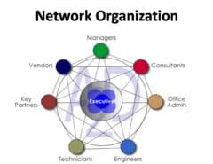

1.6 UNITS IN THE ESTABLISHMENT AND THEIR FUNCTIONS
Following units exist in NOC:
Network administration department
This department is saddled with the responsibility of designing the entire network; provide network service to clients of data, voice and video. Staff in this unit includes network engineers and system analysts.
Technical department
The technical department carries out all forms of technical activities which include amongst other things; uninterrupted power supply to the unit, mounting of radios on mast and site inspection of where installations can be carried out. Staff in this unit includes technical officers, riggers and students on IT.
Help desk
This section is charged with the duty of receiving clients and their complaints. It also does data entry activities, monitors the network performance and bandwidth utilization (using the PRTG software). Those working in this area include data entry staff and students on IT.

CHAPTER TWO
WORK EXPERIENCE
2.0 NETWORKING
Network are component involve in connecting computer and application across small and large distance.
Each computer on the network has access to the files and peripheral devices (such as printers or modems) on all the other computers on the network.
A computer network is a digital telecommunications network which allows nodes to share resources. In computer networks, computing devices exchange data with each other using connections (data links) between nodes. These data links are established over cable media such as wires or optic cables, or wireless media such as Wi-fi
Network computer devices that originate, route and terminate the data are called network nodes. Nodes are generally identified by network addresses, and can include hosts such as personal computers, phones, and servers, as well as networking hardware such as routers and switches.
2.1 NETWORK TOPOLOGY
Common topology found in networking includes mesh topology, star topology, bus topology, ring topology, and others.
Network topology refers to the layout of the transmission medium and devices on a network. Topologies use either a point to point or multipoint connection scheme.

A connection scheme indicates how many devices are connected to a transmission media segment or an individual cable.
An example of point-to-point connection scheme is a modem/ printer connected to computer, direct cable connection between two computers.
An example of a multi point connection scheme is a star or bus topology network.

Star Topology
This is a local area network topology where all the nodes are connected individually to a central connecting device called a hub or switch. Signals travel from the nodes to the hub which then sends signals to other nodes on the network. A star topology network is scalable –i.e. it can be design and redesigned easily.

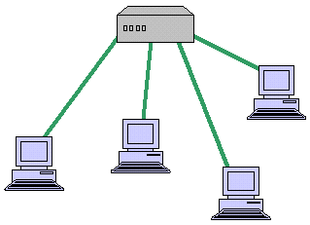
fig:1: star topology
Bus Topology
A LAN topology where each node is connected to a single main bus cable, is transmits data to all the nodes on the network. The bus is actually a series of cable segments running from one node to the other. Break or faulty piece of cable anywhere on the segment prevents all the computers on the segment from being able to communicate.
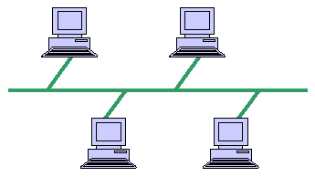
fig:2: bus topology
Mesh Topology
This is a network topology where every node on the network has a separate wire connecting it to every other node on the network. It provides each device with a point-to-point connection to every other device in the network. This type of network has a high fault tolerance because failure of one node does not affect data transmission between other nodes.
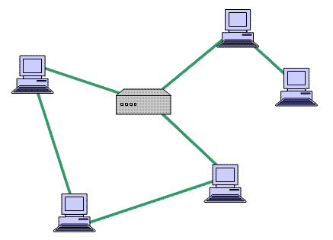fig:3 : mesh topology
At NOC the topology adopted is the mesh topology.

2.2 TRANSMISSION MEDIA
• Wired media
• Wireless media
Wired Media
These are media which require the use of wires, lines and cables to transmit communication signals. During my industrial training at NOC, I encountered majorly three different types of wired network media namely:
Coaxial cable
A coaxial cable is an alternative for protecting data from noise. Coaxial cables do not produce external electric and magnetic fields and are not affected by them. This makes them ideally suited, although more expensive, for transmitting signals.
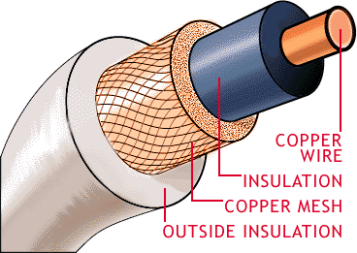fig:4: coaxial cable

Twisted pair cable
In a twisted pair there are eight copper wire that are coated with different colours; the colours are mix/orange, orange, mix/blue, blue, mix/green, green, mix/brown and brown.
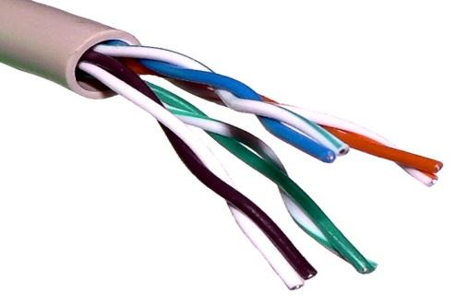 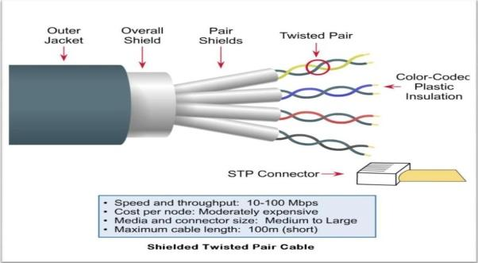fig:5: twisted pair
These colours are very important when terminating cables. The two most common ways of terminating Ethernet cables are:
- Straight-through method
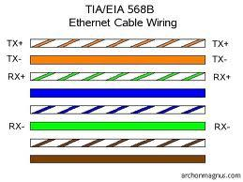 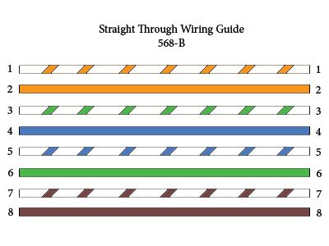fig:6: Straight-through method
- cross-over method
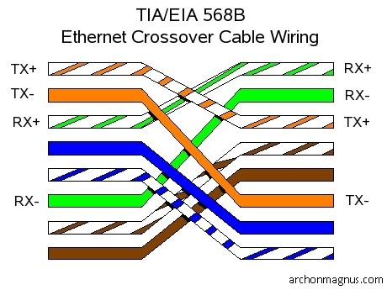
fig:7: cross over cable
In straight-through method, in any way you put in your cable, the colour adopted at both ends must be the same.
In a cross-over method all you need to do is to terminate one end with a straight rule method and the other end would be that pin ‘1’ goes to pin ‘3’ and vice-versa, the pin ‘2’ then goes to pin ‘6’ and also vice-versa.
I got to know that a cross-over cable is used to connect two similar devices like a PC to a PC while a straight through cable is used to connect different devices e.g. a PC to a router.

Fibre optic cable
At NOC the backbone upon which the network is built is fibre optic.
It is made of glass fibres instead of wire; it consists of a centre glass core surrounded by several layers of protective material. The outer insulating jacket is made of Teflon or PVC. The fibre optic cables transmit light rather than electronic signals, thereby eliminating the problem of electrical interference.
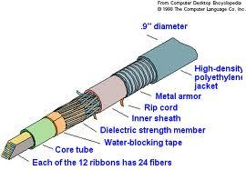
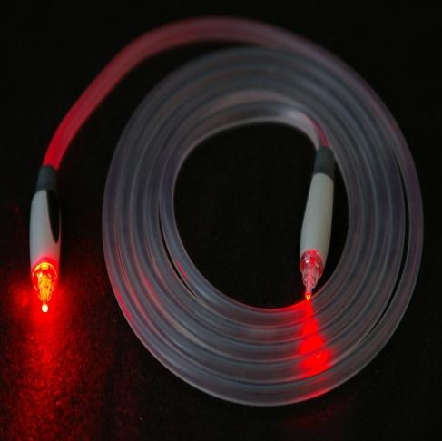
fig:8: fibre optics cable
Optical fibres come in two types:
• Single-mode fibres
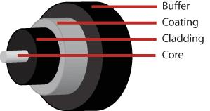fig:9 : single mode fibres
• Multi-mode fibres
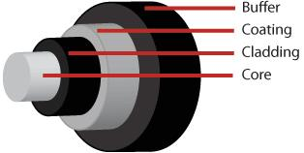fig:10: multi mode fibres
Single-mode fibres have small cores while
Multi-mode fibres have larger cores. Used for short-distance communication links.

Wireless Media
To fully explore the wireless added dimension, Communication system designers have sought to use wireless media to reduce infrastructure cost and complexity, when compared to wired communication systems. There is no need to construct miles of telephone line poles or cable trenches.
During my stay at NOC I was able to interact with the following devices:
2.3 NETWORK EQUIPMENT
Some network equipment:
Ethernet Radio
Is a device that sends and receive packets from one network to the other.

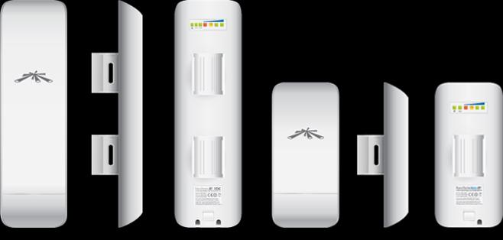
fig:11: ethernet radio
Router
A router is a device that forwards data packets between computer networks, creating an overlay internetwork. A router is connected to two or more data lines from different networks. When a data packet comes in one of the lines, the router reads the address information in the packet to determine its ultimate destination. Then, using information in its routing table or routing policy, it directs the packet to the next network on its journey.
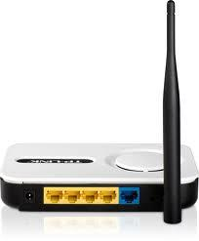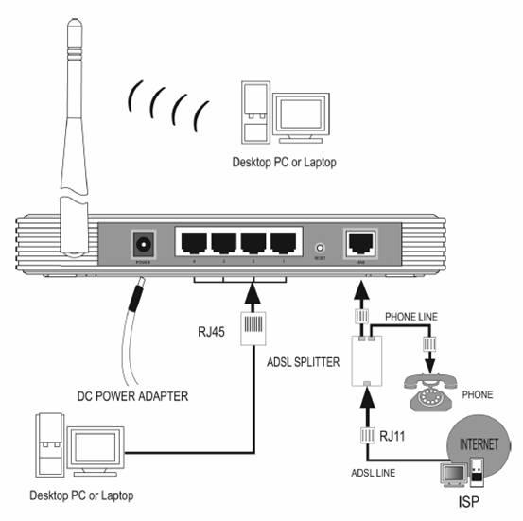
fig:12 : router
Switch
A network switch is a computer networking device that connects network segments or network devices. It serves mainly for extension.

Antenna
It’s a device that aid and enhances the signal strength and quality. Antennas are not used alone; they are always attached to something mostly to an antennas. An antenna is of two types in terms of direction Directional and Omni-directional. Directional beams signal in one direction while Omni- directional beams signals in all direction. Antennas are better propagated horizontally.
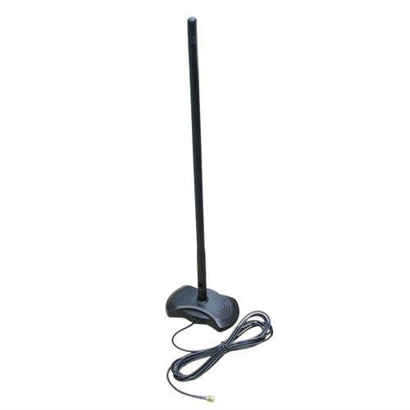Unidirectional antenna 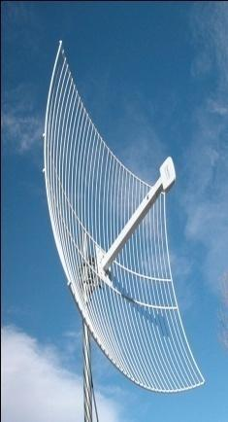 parabolic grid antenna
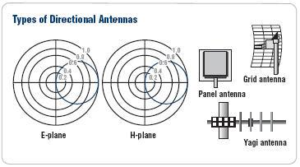fig:13: antenna

Twisted pair Cable
Twisted pair is the ordinary copper wire that connects home and many business computers to the telephone company. To reduce crosstalk or electromagnetic induction between pairs of wires, two insulated copper wires are twisted around each other. Each connection on twisted pair requires both wires. Since some telephone sets or desktop locations require multiple connections, twisted pair is sometimes installed in two or more pairs, all within a single cable.

Connectors
Rj-45 plug is the common name for an 8P8C modular connector using 8 conductors which pin down wires in a twisted pair cable.
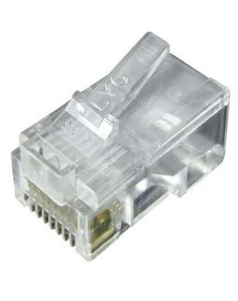 fig:14: RJ-45 connector
Crimping tool
Is a tool used to terminate category cables such as CAT1-CAT6 using an RJ-45 connector; it can also be used to cut cable to a desired length.
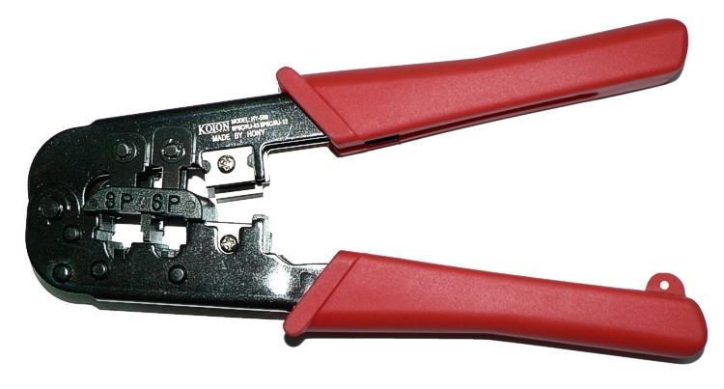fig:15: crimping tool
LAN cable tester
This is used to test if a category cable has been well terminated, or develop a fault.
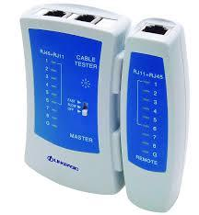
fig:16: Cable tester
2.4 IP ADDRESSING
An IP address is a unique identifier that is assigned to a host on a network. It is also a unique identifier for a host or a node on a network. We have IPv4 and IPv6. The most used being IPv4 (with 32bits).

Functions of IP Addressing
- For location of a device on the network
- It is assigned to allow hosts on one network to communicate to hosts on another network
- IPv4 address is 32 bits divided into four octets or bytes using dot ’.’

Classes of IPv4 Addresses
IPv4 which is 32bits has class ranges from class A-E
Class A
This Class address can only be between 0 and 127. All 0’s reserved for default route and ‘127’ is reserved for troubleshooting –loopback, therefore in reality Class A valid address range that can be assigned to host on a network is 10-126
Class B
Class B address can only be between 172 – 191
Class C
Class address can only be between 192 – 223
Class A-C is used for uncast.
Class D and E
Class D (224-239) used for multicasting
- Class E (240-255) for research purposes
Broadcast Address
This is the address used to send data to all hosts on a broadcast domain.
When all the host bits are on (‘1’) this is a broadcast address for all hosts
255 are reserved for sending broadcast message.
Subnet ting
The basic function of subnetting is to define the class boundary.
To create subnets you take bits from the host portion of the IP address and reserve them to define the subnet address.

Subnet Mask
The subnet mask for class A ranges from 255.0.0.0
The subnet mask for class B ranges from 255.255.0.0
The subnet mask for class C ranges from 255.255.255.0
The first octet determines the class.
The ‘255’ above represent the network portion and the zeros represent the host portion.

Private IP address ranges
The ranges and the amount of usable IP's are as follows:
10.0.0.0 - 10.255.255.255
Addresses: 16,777,216
172.16.0.0 - 172.31.255.255
Addresses: 1, 048, 5
2.5 TROUBLESHOOTING SKILLS
Troubleshooting is the process of finding problems and solving them.
Should a client unable to browse or unable to make calls via the IP phone, the check begins with the cable being used if client is connected via LAN cable, this is done using the LAN-cable tester, check the face plates to know if it is working, check the patched panel and switches on the distribution rack where they are kept. Ping the systems Ethernet port, ping the server etc.

CHAPTER THREE
CHALLENGES AND SOLUTIONS PROFFERED
3.1 Challenges
There are challenges that were encountered during the industrial training. These challenges are time demanding and thereby consume a lot of time and effort but to my optimum satisfaction I was able to overcome those challenges which really exposed me to some technical problems that can occur and how to tackle or solve these problems.
- The intense traffic on my way home was a serious challenge and I have to get up early the next morning.
- The problem of time management was inevitable, a lot of activities needed to be completed in a limited time.
- Inability of the tertiary institutions to provide a more suitable office or workshop for SIWES students
- Problems of accommodation for SIWES students.
3.2 Solutions Proffered
Here are some solutions I employed in the approach of solving each of the difficulties faced.
- Changing of routine so that I don’t get tired waking early in the morning.
- Planning of daily activities.
- ITF should make provisions of workshop for SIWES students.

CHAPTER FOUR
4.0 SUMMARY OF ATTACHMENT ACTIVITIES
The gains of this exercise are immense; that it was worth the while is grossly an understatement. Being accorded another opportunity in life to be exposed to the rudiments of work places outside the classroom teaching is an experience of a lifetime.
Furthermore, the exposure to practical tools, software and hardware had engendered better understanding of lessons thought in the class room and charted a course for career development in networking.
4.1 RECOMMENDATIONS & SUGGESTION FOR IMPROVEMENT OF THE SCHEME
I put forward the following suggestions and recommendations for future improvement of the scheme;
- Organizing workshops, seminars and symposium for students in various faculties in other to keep the student abreast of new technologies and innovations.
- Posting of students for SIWES should be done by the scheme to ensure conformity with course of study.
- A mass enlightenment campaign should be carried out, to enable industries and establishments to know the importance of SIWES to the future of the student and the society at large.
- The scheme should also try to enforce the act guiding the establishment of the scheme, to serve as a deterrent to those establishments who reject student for IT.
- School Curriculum should be organized in such a way that the SIWES exercise be carried out at a stretch of six months and not the intermittent arrangement of three months twice.

4.2 CONCLUSION
The Student Industrial Work Experience Scheme (SIWES) plays a significant role in human resource development, it helps students develop new skills and enlightens them of what the present society holds for them after graduation and helps them adapt accordingly.

REFERENCE
- "Computer Networking: A Top-Down Approach" by James F. Kurose and Keith W. Ross - First published in 1996, with subsequent editions released, the latest being in 2021.
- "Goleniewski, L. (2006) Telecommunications Essentials, Addison Wesley Professional. (Order from amazon , order from Barnes and Noble , compare at bigwords , compare at CampusBooks4Less , order from Chegg , or search eFollett )
- Ogletree, T.W. and M.E. Soper (2006) Upgrading and Repairing Networks, Que. (Order from amazon , order from Barnes and Noble , compare at bigwords , compare at CampusBooks4Less , order from Chegg , or search eFollett )

List of Figures
fig:1: star topology
fig:2: bus topology
fig:3 : mesh topology
fig:4: coaxial cable
fig:5: twisted pair
fig:6: Straight-through method
fig:7: Cross over method
fig:8: fibre optics cable
fig:9 : single mode fibres
fig:10: multi mode fibres
fig:11: ethernet radio
fig:12 : router
fig:13: antenna
fig:14: RJ-45 connector
fig:15: crimping tool
fig:16: Cable tester

Important Shortcuts Keys For Computer
CTRL+A. . . . . . . . . . . . . . . . . Select All CTRL+C. . . . . . . . . . . . . . . . . Copy
CTRL+X. . . . . . . . . . . . . . . . . Cut
CTRL+V. . . . . . . . . . . . . . . . . Paste
CTRL+Z. . . . . . . . . . . . . . . . . Undo
CTRL+B. . . . . . . . . . . . . . . . . Bold
CTRL+U. . . . . . . . . . . . . . . . . Underline
CTRL+I . . . . . . . . . . . . . . . . . Italic
F1 . . . . . . . . . . . . . . . . . . . . . . Help
F2 . . . . . . . . . . . . . . . . . . . . . Rename selected object
F3 . . . . . . . . . . . . . . . . . . . . . Find all files
F4 . . . . . . . . . . . . . . . . . . . . . Opens file list drop-down in dialogs
F5 . . . . . . . . . . . . . . . . . . . . . Refresh current window
F6 . . . . . . . . . . . . . . . . . . . . . Shifts focus in Windows Explorer
F10 . . . . . . . . . . . . . . . . . . . . Activates menu bar options
ALT+TAB . . . . . . . . . . . . . . . . Cycles between open applications
ALT+F4 . . . . . . . . . . . . . . . . . Quit program, close current window
ALT+F6 . . . . . . . . . . . . . . . . . Switch between current program windows
ALT+ENTER. . . . . . . . . . . . . . Opens properties dialog
ALT+SPACE . . . . . . . . . . . . . . System menu for current window
ALT+¢ . . . . . . . . . . . . . . . . . . opens drop-down lists in dialog boxes
BACKSPACE . . . . . . . . . . . . . Switch to parent folder
CTRL+ESC . . . . . . . . . . . . . . Opens Start menu
CTRL+ALT+DEL . . . . . . . . . . Opens task manager, reboots the computer
CTRL+TAB . . . . . . . . . . . . . . Move through property tabs
CTRL+SHIFT+DRAG . . . . . . . Create shortcut (also right-click, drag)
CTRL+DRAG . . . . . . . . . . . . . Copy File
ESC . . . . . . . . . . . . . . . . . . . Cancel last function
SHIFT . . . . . . . . . . . . . . . . . . Press/hold SHIFT, insert CD-ROM to bypass auto-play
SHIFT+DRAG . . . . . . . . . . . . Move file
SHIFT+F10. . . . . . . . . . . . . . . Opens context menu (same as right-click)
SHIFT+DELETE . . . . . . . . . . . Full wipe delete (bypasses Recycle Bin)
ALT+underlined letter . . . . Opens the corresponding menu
PC Keyboard Shortcuts
Document Cursor Controls
HOME . . . . . . . . . . . . . . to beginning of line or far left of field or screen
END . . . . . . . . . . . . . . . . to end of line, or far right of field or screen
CTRL+HOME . . . . . . . . to the top
CTRL+END . . . . . . . . . . to the bottom
PAGE UP . . . . . . . . . . . . moves document or dialog box up one page
PAGE DOWN . . . . . . . . moves document or dialog down one page
ARROW KEYS . . . . . . . move focus in documents, dialogs, etc.
CTRL+ > . . . . . . . . . . . . next word
CTRL+SHIFT+ > . . . . . . selects word
Windows Explorer Tree Control
Numeric Keypad * . . . Expand all under current selection
Numeric Keypad + . . . Expands current selection
Numeric Keypad – . . . Collapses current selection
¦ . . . . . . . . . . . . . . . . . . . Expand current selection or go to first child
‰ . . . . . . . . . . . . . . . . . . Collapse current selection or go to parent
Special Characters
‘ Opening single quote . . . alt 0145
’ Closing single quote . . . . alt 0146
“ Opening double quote . . . alt 0147
“ Closing double quote. . . . alt 0148
– En dash. . . . . . . . . . . . . . . alt 0150
— Em dash . . . . . . . . . . . . . . alt 0151
… Ellipsis. . . . . . . . . . . . . . . . alt 0133
• Bullet . . . . . . . . . . . . . . . . alt 0149
• Registration Mark . . . . . . . alt 0174
• Copyright . . . . . . . . . . . . . alt 0169
• Trademark . . . . . . . . . . . . alt 0153
• ° Degree symbol. . . . . . . . . alt 0176
• ¢ Cent sign . . . . . . . . . . . . . alt 0162
• 1⁄4 . . . . . . . . . . . . . . . . . . . . . alt 0188
• 1⁄2 . . . . . . . . . . . . . . . . . . . . . alt 0189
• 3⁄4 . . . . . . . . . . . . . . . . . . . . . alt 0190
• PC Keyboard Shortcuts
• Creating unique images in a uniform world! Creating unique images in a uniform world!
• é . . . . . . . . . . . . . . . alt 0233
• É . . . . . . . . . . . . . . . alt 0201
• ñ . . . . . . . . . . . . . . . alt 0241
• ÷ . . . . . . . . . . . . . . . alt 0247
• File menu options in current program
• Alt + E Edit options in current program
• F1 Universal help (for all programs)
• Ctrl + A Select all text
• Ctrl + X Cut selected item
• Shift + Del Cut selected item
• Ctrl + C Copy selected item
• Ctrl + Ins Copy selected item
• Ctrl + V Paste
• Shift + Ins Paste
• Home Go to beginning of current line
• Ctrl + Home Go to beginning of document
• End Go to end of current line
• Ctrl + End Go to end of document
• Shift + Home Highlight from current position to beginning of line
• Shift + End Highlight from current position to end of line
• Ctrl + f Move one word to the left at a time
• Ctrl + g Move one word to the right at a time
• MICROSOFT WINDOWS® SHORTCUT KEYS
• Alt + Tab Switch between open applications
• Alt +
• Shift + Tab
• Switch backwards between open
• applications
• Alt + Print
• Screen
• Create screen shot for current program
• Ctrl + Alt + Del Reboot/Windows task manager
• Ctrl + Esc Bring up start menu
• Alt + Esc Switch between applications on taskbar
• F2 Rename selected icon
• F3 Start find from desktop
• F4 Open the drive selection when browsing
• F5 Refresh contents
• Alt + F4 Close current open program
• Ctrl + F4 Close window in program
• Ctrl + Plus
• Key
• Automatically adjust widths of all columns
• in Windows Explorer
• Alt + Enter Open properties window of selected icon
• or program
• Shift + F10 Simulate right-click on selected item
• Shift + Del Delete programs/files permanently
• Holding Shift
• During Bootup
• Boot safe mode or bypass system files
• Holding Shift
• During Bootup
• When putting in an audio CD, will prevent
• CD Player from playing
• WINKEY SHORTCUTS
• WINKEY + D Bring desktop to the top of other windows
• WINKEY + M Minimize all windows
• WINKEY +
• SHIFT + M
• Undo the minimize done by WINKEY + M
• and WINKEY + D
• WINKEY + E Open Microsoft Explorer
• WINKEY + Tab Cycle through open programs on taskbar
• WINKEY + F Display the Windows Search/Find feature
• WINKEY +
• CTRL + F
• Display the search for computers window
• WINKEY + F1 Display the Microsoft Windows help
• WINKEY + R Open the run window
• WINKEY +
• Pause /Break
• Open the system properties window
• WINKEY + U Open utility manager
• WINKEY + L Lock the computer (Windows XP & later)
• OUTLOOK SHORTCUT KEYS
• Alt + S Send the email
• Ctrl + C Copy selected text
• Ctrl + X Cut selected text
• Ctrl + P Open print dialog box
• Ctrl + K Complete name/email typed in address bar
• Ctrl + B Bold highlighted selection
• Ctrl + I Italicize highlighted selection
• Ctrl + U Underline highlighted selection
• Ctrl + R Reply to an email
• Ctrl + F Forward an email
• Ctrl + N Create a new email
• Ctrl + Shift + A Create a new appointment to your calendar
• Ctrl + Shift + O Open the outbox
• Ctrl + Shift + I Open the inbox
• Ctrl + Shift + K Add a new task
• Ctrl + Shift + C Create a new contact
• Ctrl + Shift+ J Create a new journal entry
• WORD SHORTCUT KEYS
• Ctrl + A Select all contents of the page
• Ctrl + B Bold highlighted selection
• Ctrl + C Copy selected text
• Ctrl + X Cut selected text
• Ctrl + N Open new/blank document
• Ctrl + O Open options
• Ctrl + P Open the print window
• Ctrl + F Open find box
• Ctrl + I Italicize highlighted selection
• Ctrl + K Insert link
• Ctrl + U Underline highlighted selection
• Ctrl + V Paste
• Ctrl + Y Redo the last action performed
• Ctrl + Z Undo last action
• Ctrl + G Find and replace options
• Ctrl + H Find and replace options
• Ctrl + J Justify paragraph alignment
• Ctrl + L Align selected text or line to the left
• Ctrl + Q Align selected paragraph to the left
• Ctrl + E Align selected

