

TECHNICAL REPORT ON

STUDENT INDUSTRIAL WORK EXPERIENCE SCHEME (SIWES)

HELD AT

MUZAHIMU FINANCIAL STRATEGIES (MFS)
(BESIDE IKINFIN HEALTH FACILITY, OTUN-AIYEGBAJU ROAD, IREE, OSUN STATE)

BY:

AFOLABI MUHAMMED OLAWALE
ND/23/BAM/PT/0366

SUBMITTED TO:

THE DEPARTMENT OF BUSINESS ADMINISTRATION AND MANAGEMENT,
INSTITUTE OF FINANCE AND MANAGEMENT STUDIES (IFMS)
KWARA STATE POLYTECHNIC, ILORIN.

IN PARTIAL FULFILMENT FOR THE AWARD OF NATIONAL DIPLOMA (ND) IN BUSINESS ADMINISTRATION AND MANAGEMENT, KWARA STATE POLYTECHNIC, ILORIN

2024/2025 SESSION

DEDICATION
This report is dedicated to God Almighty for His blessings, and mercies bestowed on me right from womb till this very moment and for always been there for me and got my back always and ever. and special thanks to my parent and departmental lecturers as well.

ACKNOWLEDGEMENT
I really thank God Almighty for making this vision a reality. The foundation of everything in life is of utmost importance. Therefore, I give credit and kudos to all Muzahimu financial strategies. I also thank the Director of the center for his leadership attitude which provides a conducive and uninterrupted academic Centre for which students can acquire knowledge in different kind of field of study.
Special thanks to the supervisor from the school management for checking up on me and special thanks to my industrial base siwes coordinator.

PREFACE
The Student Industrial Work Experience Scheme (SIWES) was established by the Industrial Training Fund (ITF) to enable student of tertiary institution to have basic technical knowledge of industrial work basic on their courses of study before the completion of their program in their various institutions.
In the early stage, students are graduating into institution without any technical knowledge of working experience, this make them to undergo further training after servicing an employment with the reason.
I did my SIWES programme at Muzahimu financial strategies, located beside Ikinfin Health Facility, Otun-Aiyegbaju Road, Iree, Osun state.

TABLE OF CONTENTS
Title page
Dedication ii
Acknowledgement iii
Preface iv
Table of Contents v
Chapter One 1
Background of Siwes 1
1.1 Introduction 1
1.2 History of Siwes 1
1.2 Aims and Objectives of Siwes 1
Chapter Two 3
2.0 Overview of Place of Attachment 3
2.1 Historical Background of The Organization 3
2.2 Majoractivities of The Organization 3
Chapter Three 5
Work Done and Experience Gained 5
3.1 Familiarization With Financial Management 5
3.2 Why Should One Study FM? 5
3.2.1 Definitions 5
3.3 Major Areas & Concepts of Financial Management 6
3.4 Investment Decisions & Capital Budgeting: 7
3.5 Risk & Return 8
3.6 Corporate Financing & Capital Structure 8
3.7 Internal and External Business Environment 10
3.8 Financial Markets 11
Chapter Four 13
4.0 General Knowledge Acquired 13
4.1 Objectives of Financial Management, Financial Assets and Analysis of Financial Statements 13
4.2 Real Assets and Financial Assets (Securities) 14
4.2.1 Different Types and Characteristics of Financial Assets and The Similarities and Differences Among Them 14
4.3 Analysis of Financial Statements 16
Chapter Five 22
5.1 Summary of The Attachment 22
5.2 Challenges and Problem Encountered 23
5.3 Conclusion/Recommendation 23

CHAPTER ONE

BACKGROUND OF SIWES

1.1 INTRODUCTION
This program called (SIWES) student industrial work experience scheme is compulsory to all ND1 student who offer science course or any other practicable course. It enables student to have the experience of the aspect which have been taught in school. It is a program that takes up to four months in which student are expected to be able practices what they are taught.

1.2 HISTORY OF SIWES
The student work experience scheme {SIWES} came into establishment of the industrial training fund[ITF] under degree No 47 of 8 October, 1971, in a bid to boost indigenous capacity for the nation’s industrial need, the fund in its policy statement No. 1 published in 1973 inserted a clause dealing with the issue of practical skills which states that “the seek will seek to work out cooperative machinery with industry, where student in institution of higher learning may acquire training in industry or mid-career attached by contributing to the allowance payable to the student”.
The fund identified a great gap between theory and practice of engineering and technology of higher learning and has come to an effort to eliminate this gap. The fund initiated work experience scheme {SIWES} in 1973. SIWES therefore is a skill training program designed to expose and prepared students of universities, polytechnics and college of education to real life work situation including environmental, technical and business student in higher institution of training in Nigeria.

1.2 AIMS AND OBJECTIVES OF SIWES
The student industrial work experience scheme (SIWES) can be define as a technical skills and acquisition of knowledge from the organization, industrial sector. It is also serving as the complement the learning which student have acquired in the classroom or theoretically.
The objective of the student industrial work experience scheme is as follow;
- It enables the student to practically different test from what they learnt theoretically in the classroom.
- It also enlightens students to various s division of industrial or organization of work in which the course of study can be radicalized.
- To provide student with an opportunity to applied their theoretical knowledge in real work situation thereby bridging the gap between theories and practical
- To provide avenue for students for institutions in higher learning to acquire industrial skills and experience in their course of study while in school.
- To expose students to work methods and techniques in handling equipment and machineries that may not be available in some educational institutions.
- It relate the student to the labor market and how it being operated.
- To enable student to defend his or her self in anywhere he or she found itself.

CHAPTER TWO

2.0 OVERVIEW OF PLACE OF ATTACHMENT

2.1 HISTORICAL BACKGROUND OF THE ORGANIZATION
The name of the organization is Muzahimu Financial Strategies. It is located beside Ikinfin Health Facility, Otun-Aiyegbaju Road, Iree, Osun State.
The organization specializes in providing financial consulting, investment advisory, business development, and accounting services. Its aims and objectives include:
- offering quality financial advisory services to businesses and individuals.
- Training both SIWES students and business professionals on financial management and strategic investment planning.
- Providing business consultancy services to help clients improve their financial performance.
- Helping individuals and companies gain a deeper understanding of financial management to enhance business growth.

2.2 MAJORACTIVITIES OF THE ORGANIZATION
The core activities of Muzahimu Financial Strategies revolve around financial planning, investment advisory, and business consulting. The organization also accommodates SIWES students for industrial training in financial management and business administration.
Other major activities of the organization include:
- Financial Advisory & Business Consulting
  - Providing professional advice on investment opportunities and financial growth strategies.
  - Helping clients with budgeting, tax planning, and loan acquisition guidance.
- Accounting & Bookkeeping Services
  - Recording financial transactions, preparing income statements, and managing business accounts.
  - Teaching SIWES students how to use accounting software (e.g., QuickBooks, Excel) for financial record-keeping.
- Customer Service & Financial Report Preparation
  - Assisting businesses in preparing financial statements, cash flow reports, and budget forecasts.
  - Ensuring proper documentation of financial transactions to maintain accuracy and accountability.
- Business Training & SIWES Student Development
  - Providing training on entrepreneurship, business strategy, and financial decision-making.
  - Teaching students the fundamentals of financial reporting, risk analysis, and business administration.

CHAPTER THREE

WORK DONE AND EXPERIENCE GAINED

3.1 Familiarization with financial management
Financial Management is the management of financial resources – how to best find and use investments and financing opportunities in an ever-changing and increasingly complex environment.

3.2 Why should One study FM?
First of all, financial management is a core life skill; almost everyone needs to understand some concepts of finance to manage his/her business & personal finances.
It is generally and quite rightfully said, “Money makes the world go round”. Finance is like a life-blood for a company. Even the best of the companies and CEOs go out of the business because of poor financial management policies.
Management Information Systems (MIS) and Information Technology (IT) are just a part of the overall corporate strategy which runs on finances, the major resource. So the computer sciences professionals need to have an understanding of the financial concepts to understand and contribute to the overall corporate strategy.
Financial Engineering is an upcoming field that requires people with CS, math/science, and finance background. Financial engineering is the application of engineering methods to finance. One important area of study is the design, analysis, and construction of financial contracts to meet the needs of enterprises. This field is experiencing an increased demand for professionals, especially those who are trained in both the underlying mathematics/computer technologies and finance.

3.2.1 Definitions
Finance:
Finance is the science of managing financial resources in an optimal pattern i.e. the best use of available financial sources. Finance consists of three interrelated areas:
- Money & Capital markets, which deals with securities markets & financial institutions.
- Investments, which focuses on the decisions of both individual and institutional investors as they choose assets for their investment portfolios.
- Financial Management, or business finance which involves the actual management of firms.

3.3 Major Areas & Concepts of Financial Management
Following are some of the important areas and concepts of financial management, which would be discussed in detail in the lectures to come.
Analysis of Financial Statements:
Analysis of financial statement is one of the most common techniques of financial analysis, in the financial performance and financial health of a company is analyzed based on its past performance.
The following financial statements are used in the analysis process.
- Profit & Loss Statement or Income Statement
Income statement reflects the operating efficiency or profitability of a company as a result of its operations along with the net profit available to the shareholders for a given year (usually one accounting period). This statement provides the analyst with some insight into the financial performance of the company.
- Balance Sheet
Balance Sheet is a snap-shot of an organization’s financial health at a particular time. It shows what assets are owned by the business and the sources of acquiring these assets. Balance Sheet – An FM Perspective (Fig.1)
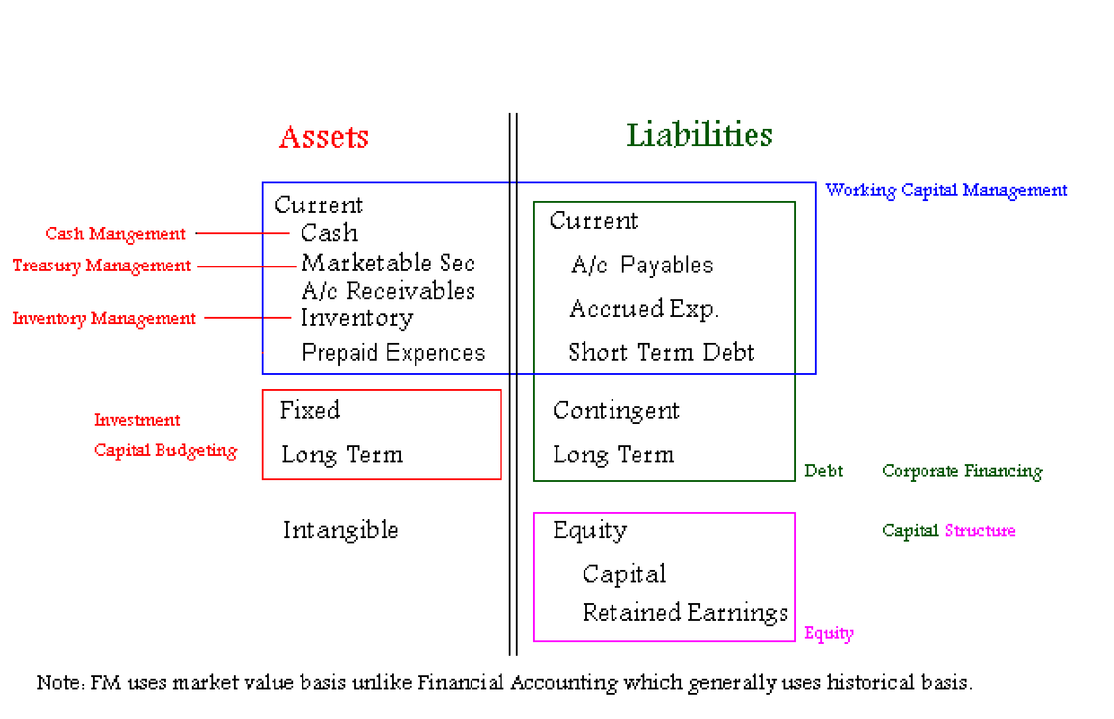
Fig. 1
- Statement of Shareholders’ equity
Statement of shareholders’ equity provides the share of the owners in the business.
- Statement of Cash Flows
Statement of cash flows explicitly reflects the cash movement (inflows and outflows) during the operations in an accounting period.
Taken together, these statements give an accounting picture of the firm’s operations and financial position. Financial statements report what has actually happened to the assets, earnings, and dividends over the years. The analysis of the information contained in these statements help management of the organization to evaluate the performance and activities of the concern; it also helps the investors and creditors to have an idea of the profitability potential and creditworthiness of the business.

3.4 Investment Decisions & Capital Budgeting:
Investment decisions are the most critical as they usually involve huge sums of money and these decisions are likely to bring prosperity or doom to a business. A company’s future income depends on how much investment is made, in what type of assets, and how these assets add to the overall value of the company.
Capital budgeting is a term strictly related to investment in fixed assets; here, the term capital refers to the fixed assets that are used in production, while budget is a plan which details projected cash inflows and outflows over some future period. The following concepts and techniques are employed while analyzing investment decisions.
- Interest rate formulas
- Time Value of Money
- Discounted Cash Flows
- Net Present Value
- Internal Rate of Return

3.5 Risk & Return
Investors, individual or institutional, invest their money with the expectations of earning a return on their investment. While investors wish and attempt to earn maximum return, they are constrained by risk. How the risks and returns are related and how do investors make a choice of their portfolios is important for investment decision making. Following concepts and theories would be discussed while discussing the risk-return choices of the investor:
- Uncertainty
- Risk
- Portfolio Theory
- Capital Asset Pricing Model

3.6 Corporate Financing & Capital Structure
When a firm plans to expand, it needs capital or funds. Acquisition of funds is considered to be a primary responsibility of a finance department in an organization. There are numerous ways to acquire funds, i.e., finances can be raised in the form of debt or equity. The proportion of debt and equity constitutes the capital structure of the firm. Financial experts attempt to find a combination of debt and equity that could increase the overall value of the company, i.e., they try to find the optimal capital structure. The following concepts would be used to understand how an optimal capital structure could be attained.
- Cost of Capital
- Leverage
- Dividend Policy
- Debt Instruments
Valuation:
Asset or company valuation is important not only for financial managers, but also for creditors and investors. It is important to know the value of the company or its assets to make important financing and investment choices. Different valuation techniques and factors that influence the value of a company or its financial instruments would be discussed in this section.
- Share
- Bond
- Option
- Corporate
Working Capital & Inventory Management: Working capital and inventory management pertains to the effective management of current assets. As we will see, an optimal and effective utilization of working capital and inventory increases the operating efficiency of the firm.
International Finance & Foreign Exchange: With the increasing importance of international trade and global markets, the role of international finance has increased manifold. In a global environment, the finance managers have more choices pertaining to investing and financing than ever before. However, it is important to understand the implications of working in a global environment, since fluctuations in the currency rates can convert a good financing or investment decision into a bad one. This section of the course would discuss the international financial environment and the financial implications of working in a global environment.

3.7 Internal and External Business Environment
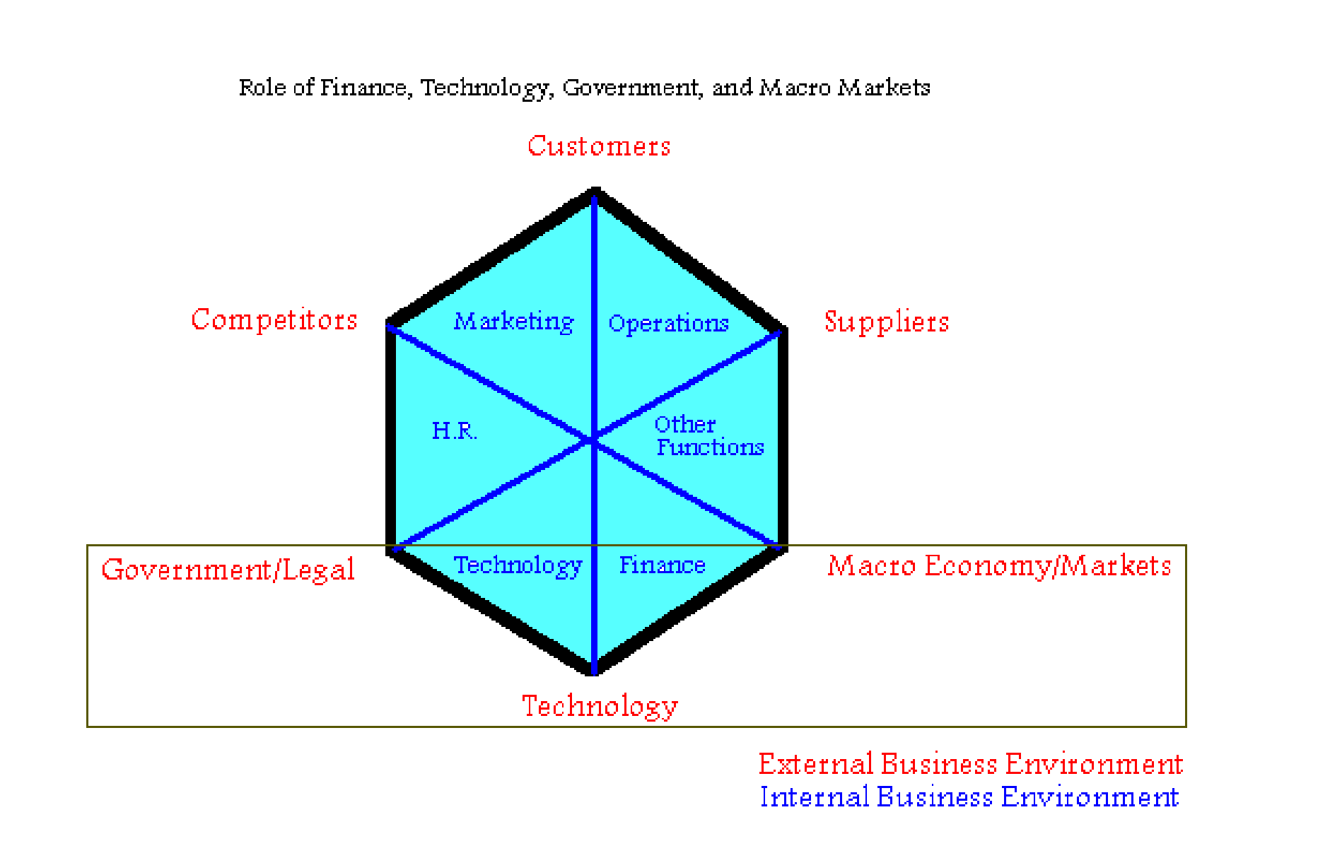
Fig.2
Internal Business Environment:
Internal environment of business normally consists of the following:
- Finance
- Marketing
- Human Resources
- Operations (Production, Manufacturing)
- Technology
- Other Functions (Logistics, Communications)
External Business Environment:
The following business environment factors outside an organization have a profound effect on the functions and operations of an organization.
- Customers
- Suppliers
- Competitors
- Government/Legal Agencies & Regulations
- Macro Economy/Markets
- Technological Revolution

An analysis which is used in a business is called SWOT Analysis. SWOT is an acronym where
S stands for Strengths
W stands for Weaknesses
O stands for Opportunities
T stands for Threats
Strengths and weaknesses are within an organization, i.e., they pertain to the internal environment of the organization.
Opportunities and threats, on the other hand, pertain to the external environment, i.e., outside the organization.

3.8 Financial Markets
Capital Markets:
These are the markets for the long term debt & corporate stocks.
Stock Exchange:
A stock exchange is a place where the listed shares, Term finance certificates (TFC) and national investment trust units (NIT) are exchanged and traded between buyers and sellers.
Long term bonds:
Long term government & corporate bonds are also traded in capital markets.
Money Markets
Money market generally is a market where there is buying and selling of short term liquid debt instruments. (Short term means one year or less). Liquid means something which is easily encashable; an instrument that can be easily exchanged for cash. Following financial instruments are traded in money markets.
Short term Bonds
- Government of Pakistan: Federal Investment Bonds (FIB), Treasury-Bills (TBills)
- Private Sector: Corporate Bonds, Debentures
- Call Money, Inter-bank short-term and overnight lending & borrowing
- Loans, Leases, Insurance policies, Certificate of Deposits (CD’s)
- Badlah (money lending against shares), Road-side money lenders
Real Assets or Physical Asset Markets
Following are the active markets of real and physical assets in Pakistan
- Cotton Exchange, Gold Market, Kapra Market
- Property (land, house, apartment, warehouse)
- Computer hardware, Used Cars, Wheat, Sugar, Vegetables, etc

CHAPTER FOUR

4.0 GENERAL KNOWLEDGE ACQUIRED

4.1 OBJECTIVES OF FINANCIAL MANAGEMENT, FINANCIAL ASSETS AND ANALYSIS OF FINANCIAL STATEMENTS
In this aspect, I would like to discuss the differences that exist among Financial Management, Economics & Financial Accounting disciplines.
- Objective of Economics:
The objective of economics, as a subject, is profit maximization; however, the scope of economic profit maximization is vast and loosely defined. In economics, we can talk about profit maximization for an individual, the whole society, or a particular class or group. We can also talk about profit maximization for the whole world in global terms. In social economics, we may study the social profit maximization for the societies, whereas, in capitalistic economics we may study individual or company’s profit.
- Objective of Financial Management (FM)
In comparison, financial management is more focused. The objective of financial management, specifically, is to maximize the shareholders wealth in the present terms.
Financial practitioners usually use the discounting and the net present value techniques while calculating the increase in the wealth of shareholders.
- Objective of Financial Accounting (FA)
The objective of financial accounting is to collect accurate, systematic, and timely financial data and other financial information, and to compile and consolidate it in an organized and systematic way, according to the principles and rules of accounting, for reporting purpose. The financial managers use these reports to assess the financial position of the company through various financial management tools and then the financial position can be compared to, or benchmarked against, the industry norms. The four different financial statements used for the purpose of reporting and analysis are;
- Balance Sheet
- P/L or Income Statement
- Cash Flow Statement
- Statement of Retained Earnings (or Shareholders’ Equity Statement)
In financial accounting, assets are recorded on the basis of historical costs in the balance sheet, i.e., the assets are recorded at their original purchase price. of course, the depreciation on the asset is duly subtracted from its original value as the asset remains in use of the business. However, in financial management, book value is seldom used and financial managers consider the market value and the intrinsic value of assets.
Market value may be defined as the value currently prevailing in the market or the value at which the sellers are ready to sell, and buyers are ready to buy a particular asset.
Intrinsic value or the fair value is calculated by summing up the discounted future cash flows. In Financial accounting, we followed the principle of accrual accounting in which expenses & incomes are rerecorded when they incur. In Financial management, we will primarily be interested in cash & cash flows. In Financial management, we will use cash as primary source for calculating value, although the accrual data would also be useful for analyzing a firm’s financial position.
Before getting into details, it is important to understand a few concepts that would be frequently used throughout the course.

4.2 REAL ASSETS AND FINANCIAL ASSETS (SECURITIES)
Real Assets:
Real assets are tangible assets that have physical characteristics. For instance, land, house, equipment, car, wheat, fruits, cotton, computers, etc., are different kinds of real assets.
Securities:
Security, also known as a financial asset, is a piece of paper representing a claim on an asset. Securities can be classified into two categories.

4.2.1 DIFFERENT TYPES AND CHARACTERISTICS OF FINANCIAL ASSETS AND THE SIMILARITIES AND DIFFERENCES AMONG THEM
Securities:
Security, also known as a financial asset, is a piece of paper representing a claim on an asset. Securities can be classified into two categories.
Direct Securities: Direct securities include stocks and bonds. While valuing direct securities we take into account the cash flows generated by the underlying assets.
Discounted Cash Flow (DCF) technique is often used to determine the value of a stock or bond.
Indirect Securities: Indirect securities include derivatives, Futures and Options.
The securities do not generate any cash flow; however, its value depends on the value of the underlying asset.
Bonds:
Bonds represent debt. The important features of bonds are given as under.
Internationally, bonds are the most common way for companies to raise funds.
- A bond is a long-term debt contract (on paper) issued by the borrower (Issuer of the Bond i.e., a company that wishes to raise funds) to the lenders (bondholders or Investors which may include banks, financial institutions, and private investors).
- Bonds issued by a company are usually shown on the liabilities side of the Balance Sheet. A Bond requires the borrower to pay a pre-determined amount of interest regularly to the lender (bondholder). The interest rate or the rate of return on a bond can be Fixed or Floating. If an investor purchases a bond which is offering a rate of 10 % for the life of the bond, the rate would be fixed at 10 percent. However, if the interest rate on the bond is tied to the market interest rates, the rate of interest would be floating. The floating rate implies that the interest rate would fluctuate with any change in the market interest rate.
Types of Bonds:
- Debentures: Unsecured – no asset backing
- Mortgage Bond: Secured by real property i.e. Land, house
- Others: Eurobond, Zeros, Junk, etc.
The details on these different types of bonds would be discussed in later lectures.
Stocks (or Shares):
Stocks (or Shares) are paper certificates representing ownership in a business. Therefore, if a company has issued 1 million shares and an investor owns 1 share only, he is a part owner (or shareholder) of the company. Stocks or shares are represented in the equity section of the balance sheet. A stock certificate is perpetuity, i.e., it lasts as long as the company does. Shareholders have a residual claim (last claim) on whatever net income (or profit) and assets are left over after the bondholders have been fully paid off. It is the most common source of raising funds under Islamic Shariah. Shares are traded in Stock market e.g. Karachi Stock
Exchange (KSE), Lahore Stock
Exchange (LSE) & Islamabad Stock Exchange (ISE).
Difference between Shares & Bonds:
The main difference between shares and bonds is that shares are representation of ownership in a company while bonds are not representative of ownership.
The second difference is that shares last as long as the company lasts where as bonds have limited life.
Another difference is that the return on a bond is predetermined, i.e., the investor knows in advance how much return he would get from a bond. However, a stockholder cannot be certain about the return on a stock investment, since the dividends may or may not be paid in a certain year or the percentage of dividends announced may vary.

4.3 ANALYSIS OF FINANCIAL STATEMENTS
A company’s financial statements need to be studied for signs of financial strengths and weaknesses and then compared to (or benchmarked against) the industry. Before getting into the details of the financial management techniques, we would briefly revise some of the accounting concepts, which are going to help us in comprehending those analysis techniques.
Basic Financial Statements:
There are four basic financial statements that are prepared by the financial accountants for the use of the managers, creditors and investors of the company. These statements are
- Balance Sheet
- P/L or Income Statement
- Cash Flow Statement
- Statement of Retained Earnings (or Shareholders’ Equity Statement)
The concepts that we are going to discuss here in reviewing financial accounting concepts are Fundamental Accounting Equation and Double Entry Principle.
Assets +Expense = Liabilities + Shareholders’ Equity + Revenue
(Note: Expense & Revenue are Temporary P/L accounts – the others are Permanent Balance Sheet Accounts)
Left Hand Items increase when debited. Right Hand items increase when credited
For every journal entry, the Sum of Debits = the Sum of Credits
Balance Sheet:
The following facts about balance sheet are also going to help us in understanding the financial statements analysis process.
- A balance sheet is a ‘static snapshot’ at one point in time (therefore the consolidated data available is vulnerable to inventory and cash swings, i.e., if the balance sheet of a firm is showing low inventory and high cash position at the year ending when the balance sheet is prepared, the company may buy excessive inventory against cash the very next day. The balance sheet prepared a day earlier would not report the new transaction and the latest financial position of the company would not be known to the analyst, unless the company updates him on that.)
- Balance sheet items or accounts are ‘permanent accounts’ that continue to accumulate from one accounting cycle to the next.
- Balance sheet items are recorded on historical cost basis, i.e., the balance sheet neglects any increase in value of assets resulting from inflation and reports assets and liabilities at their book value. It is a big limitation for financial analysts, since a useful analysis could only be made by considering the assets and liabilities at their market value rather than book value. Nevertheless, there are some approaches by which we can solve this problem. Constant rupee approach is one such remedy.
- Constant Rupee Approach: In constant rupee approach, two balance sheets of the same company for different times are compared at a specific time and inflationary adjustments are made.

• Assets (Left Hand Side):
Having revised certain concepts and limitations of financial accounting process and financial statements, we would now have a brief overview of the items that appear on the left-hand side of the balance sheet, known as assets.
- Assets are economic and business resources that are used in generating revenue for the organization: They can be tangible (inventory) or intangible (patent, brand value, license).
Some assets are classified as current (cash, accounts receivable) and others are fixed
(machinery, land, and building). There are also long-term assets (property, loan) and contingent assets, the value of which can only be assessed in future (legal claim pending, option).
- Current Assets = Cash + Marketable Securities + Accounts Receivable + PrePaid Expenses + Inventory
- The accounts receivable aging schedule is a listing of the customers making up total accounts receivable balance. Most businesses prepare an accounts receivable aging schedule at the end of each month. Analyzing your accounts receivable aging schedule may help you identify potential cash flow problems.
- Inventory value (at any instant in time) is a very controversial figure which depends on inventory valuation methodology (i.e. FIFO, LIFO, and Average Cost) and Depreciation Method (i.e. Straight Line, Double Declining, and Accelerated). Companies have the flexibility that they can use one methodology for preparing the financial statements & the different methodology for tax purposes.
Liabilities (Right Hand Side):
The right hand side of the balance sheet represents liabilities.
– Liabilities are sources which are use to acquire the resources or liabilities are obligations of two types:
- Obligations to outside creditors and
- Obligations to shareholders known as Equity.
- Liabilities can be short term debts, long term debt, equity, retained earnings, contingent, unrealized gain on holding of marketable securities
- Current Liabilities = Account Payables + Short Term Loans + Accrued Expenses
- Net Working Capital = Current Assets – Current Liabilities
- Total Equity = Common Equity + Paid In Capital + Retained Earnings (Retained
Earnings is NOT cash always)
- Total Equity represents the residual excess value of Assets over Liabilities: Assets –
Liabilities = Equity = Net Worth
- Only cash account represents real cash which can be used to pay your bills!!
Profit & Loss account or Income Statement:
- An income statement is a “flow statement” over a period of time matching the operating cycleof the business, which reports the income of the firm.
- Generally, Revenue – Expense = Income
- Right hand side receipts (revenues) are added. Left hand side payments (expenses) are subtracted.
- P/L Items or Accounts are ‘temporary’ accounts that need to be closed at the end of the accounting cycle.
- Sales revenue – Cost of Goods Sold = Gross Profit (Revenue)
- Cost of Goods Sold is a very controversial figure that varies depending on Inventory
Valuation Method (i.e., FIFO, LIFO, Average Cost) and Depreciation Method (Straight Line, Double Declining, Accelerated). Depreciation is treated as an expense (although it is noncash)
- Gross Revenue – Admin & Operating Expenses = Operating Revenue
- Operating Revenue – Other Expenses + Other Revenue = EBIT
- EBIT – Financial Charges & Interest = EBT Note: Leasing Treatment
- EBT – Tax = Net Income
- Net Income – Dividends = Retained Earnings
- Net Income is NOT cash (it can’t pay for bills)

P/L Statement of Company XYZ
(Year Ending June 30th 2024)
(‘000 Rs) (‘000 Rs) (‘000 Rs)
Net Sales 1000
Cost of Goods Sold (500)
Gross Profit 500
Administration Expenses (200)
Depreciation Expense (0)
Operating Profit 300
Other Expenses (180)
Other Income (interest) (180)
EBIT 120
Tax (20)
Net Income 100

Cash Flow Statement: A cash flow statement shows the cash position of the firm and the way cash has been acquired or utilized in an accounting period.
A cash flow statement separates the activities of the firm into three categories, which are operating activities, investing activities and financing activities.
• Operating Cash Flow Statement can be obtained by using two approaches:
1) Direct
2) Indirect.
A cash flow statement can be derived from P/L or Income Statement and two consecutive year Balance Sheets.
- A cash flow statement is not prepared on accrual basis but rather on cash basis: Actual cash receipts and cash payments.
- The net income is obtained from the Income Statement of a period of time matching the operating cycle of the business. Generally:
Revenue – Expense = Income
In order to arrive as the cash flows resulting from operating activities Increases in current assets are cash payments (-), i.e., cash outflow
Increases in current liabilities are cash receipts (+), i.e., cash inflow Right Hand Side Receipts are added.
Left Hand Side payments are subtracted
Statement of Retained Earnings or Shareholders’ Equity Statement
Total Equity = Common Par Stock Issued + Paid In Capital + Retained Earnings
(Retained Earnings is the cumulative income that is not given out as Dividend

XYZ
Cash Flow Statement
(June 30th 2023 – June 30th 2024)
(‘000 Rs) (‘000 Rs) (‘000 Rs)
Net Income 400
Add Depreciation Expense 100
Subtract Increase in Current Assets:
Increase in Cash (400)
Increase in Inventory (700)
(1100)
Add Increase in Current Liabilities:
Increase in A/c Payable 500
Cash Flow from Operations (100)
Cash Flow from Investments 0
Cash Flow from Financing 500
Net Cash Flow from All Activities 400
Note
- Indirect Cash Flow Approach using Income Statement and two consecutive Balance Sheets
- Final Net Cash Flow from All Activities should match the difference in the difference in the closing balances in the Balance Sheets from June 30th 2023 and June 30th 2024.
- Investments include all cash sale and purchases of non-current assets and marketable services
- Financing includes all cash changes in loans, leasing, and equity.

CHAPTER FIVE

5.1 SUMMARY OF THE ATTACHMENT
My SIWES at Muzahimu financial strategies was highly successful having being exposed to practical applications of what I have learnt while in school. As a result of my stay with this organization, I can boldly say that I have been furnished and equipped with essential and substantial information and experience as regards practicing in the field of my study.
Part of the knowledge I acquired includes;
- Familiarize with company culture and financial product and we attended orientation session where we learned about the company mission and services
- Gain foundational knowledge in financial terminology and we attended a workshop on key financial terms we also Participated in group discussions on financial products
- Develop financial report writing skills and we Attended a training session on financial reporting and we Drafted a sample financial report
- Understand financial analysis techniques Analyzed financial statements from previous projects Discussed findings with the finance team
- I understand the investment strategies and we Attended a seminar on different types of investment vehicles
- Gain insights into strategic planning processes Participated in a strategic planning meeting Analyzed a competitor’s strategic approach
- client relationship management Attended a workshop on effective client communication Role-played client scenarios with peers
- Understand corporate finance fundamentals Reviewed corporate financial strategies in a workshop Analyzed a case study of a corporate merger
- Learn about budgeting and financial planning attended a budgeting workshop Participated in budget simulation exercises
- Understand the role of technology in finance Participated in a seminar on fintech innovations Discussed how technology is changing financial services
- Participate in a financial planning workshop Attended a workshop focused on client financial planning Worked on creating personalized financial plans
- Participated in financial strategy development and we Conducted SWOT analysis and presented findings dynamic team and we improved with open communication
- we Understand the role of financial technology and we Engaged well in discussions about future trends
- Explore risk management practices and Reviewed case studies on risk assessment we Shadowed a risk management team member
- Study the impact of economic factors on financial strategy Attended a workshop on macroeconomic indicators Discussed how these indicators affect investment decisions.

5.2 CHALLENGES AND PROBLEM ENCOUNTERED
It is not uncommon to hear students on their Student Industrial Work Experience Scheme (SIWES) or internship lament over their unpleasant experiences, especially the challenges encountered in the process of finding a firm to accommodate and support them.
- Distance to my living place
- Inadequate of Practical
- Some of the projects I executed took me few days to debug at early stage of working.

5.3 CONCLUSION/RECOMMENDATION
The SIWES program is a very fascinating program for National Diploma (ND) students; it is a four-month program at the middle of the first and second section.
TO THE DEPARTMENT
I strongly recommend that the department should see to it that a strong link exists between them and this organization so that the progress of the students can be properly enhanced.
TO THE POLYTECHNIC
The polytechnic should form a strong link with the industrial via the departments to solve the problem of student’s placement. I also recommend a review of the duration of SIWES training because it is evident that the scheduled time is in-sufficient to acquire all necessary practical knowledge before student graduation.
TO THE INDUSTRIAL TRAINING FUND (ITF)
I strongly recommend that the industrial training fund and the Federation Government of Nigeria organize and sponsor exhibition of technological discoveries among undergraduates in the Nigeria Polytechnic. In addition, the industrial training fund (ITF) and the federal government should see to a better structure for paying the stipulate amount to the students immediately after training.
I will like to recommend special dedication to SIWES program by the institution management and proper orientation should be based on this program. The lacks of proper oriented students make the students to look down to this program. The duration of the program must be strictly abided to and properly followed accordingly by the students.

