

A TECHNICAL REPORT
ON
STUDENT INDUSTRIAL WORK EXPERIENCE SCHEME
(SIWES)

HELD AT
GUFH-LAND GLOBAL INVESTMENT LIMITED
NO 3, SAPHO COUNTRY ROAD, GWAZUNU-SULEJA, NIGER STATE

BY
HABIBAT ADERINTO
ND/23/ABE/PT/0049

SUBMITTED TO:
THE DEPARTMENT OF AGRICULTURAL ENGINEERING
(INSTITUTE OF TECHNOLOGY) KWARA STATE POLYTECHNIC
IN PARTIAL FULFILMENT OF THE REQUIREMENT FOR THE AWARD OF NATIONAL DIPLOMA (ND) IN AGRICULTURAL ENGINEERING

AUGUST - DECEMBER 2024
DEDICATION
This Siwes is dedicated to Almighty God for his protection, kindness, strength over my life and also to my parents for their financial support and moral care towards me. Also to my lecturers for the academic advice they often gives to me.
May Almighty God shield them from the peril of this world and bless their entire endeavor Amen.

ACKNOWLEDGEMENT
I acknowledge with gratitude to Almighty GOD for the successful completion of this Siwes.
My Appreciation goes to all staffs and H.O.D of Agric Engineering department who has contributed in one way or the other to the completion of this Siwes.
I also appreciate the effort of my parent in person of Mr. and Mrs. Aderinto for their morally, spiritually and financially support, i pray that almighty God should be with them.

PREFACE
The student industrial work experience scheme (SIWES) helps in exposing students to the practical application of their course and to get used to equipment and machines used in the factory. The SIWES was established to promote student skills in industrial practice and pre-expose them to working experience in industrial setting.
The SIWES program covered a period of four months from August to December 2024 and it is a partial fulfilment of a two years academic program to obtain an OND certification in Engineering. The report explains the description of the work done.

TABLE OF CONTENTS
Title Page
Dedication i
Acknowledgements ii
Table of contents iii
CHAPTER ONE: INTRODUCTION ON STUDENTS INDUSTRIAL WORK EXPERIENCE SCHEME (SIWES)
  - Background on SIWES
  - Aim and Objectives of SIWES
CHAPTER TWO: DESCRIPTION OF THE ESTABLISHMENT OF ATTACHMENT
2.1 Location and brief history of establishment
2.2 Objectives of establishment
2.3 Organization structure (including organogram)
2.4 The various departments/unit in the establishment and their functions
CHAPTER THREE: WORK DONE AND EXPERIENCE GAINED AT THE PLACE OF ATTACHMENT
3.1 Brief introduction on the Greenhouse at GLGI
3.2 Operation of a plough machine
3.3 Making of Plant Beds in the Greenhouse kits
3.4 Installation of Trunk and Drip Lines for Irrigation
3.5 Staking of plants in the Greenhouse kits
CHAPTER FOUR: WORK DONE AND EXPERIENCE GAINED AT THE PLACE OF ATTACHMENT
4.1 Operation of Knapsack sprayer
4.2 Pre Nursery and Nursery Operations
4.3 Harvesting Operations
4.4 Post Harvest Operations
CHAPTER FIVE: SUMMARY, CONCLUSION AND RECOMMENDATION
5.1 Summary of attachment activities
5.2 Problems encountered during the program
5.3 Conclusion
5.4 Recommendation

CHAPTER 1
1.0 INTRODUCTION
1.1 BACKGROUND ON SIWES
The student industrial scheme (SIWES) is a skill training programme designed to prepare and expose student of tertiary institution to the industrial work situation they are likely to meet after graduation. The scheme afford students the opportunity to familiarizing and exposing themselves to handling equipment and machinery that are usually not available in the institutions.
It’s to this effect that the industrial training fund (ITF) initiated , designed and introduced SIWES scheme in 1973 to acquaint student with the skills of handling industrial equipment and machinery. The ITF solely funded the scheme during its
formative years. But as the financial involvement became unbearable to the fund, it withdrew from the scheme in 1978. The federal government handed over the scheme in
1979 to both the National Universities Commission (NUC) and the National Board for Technical Education (NBTE). Later, the federal government in November 1984 reverted the management and implementation of the scheme to ITF and it was effectively taken over by the Industrial Training Fund (ITF) in July 1985 with the funding being solely borne by the federal government.

1.2 AIM AND OBJECTIVES OF SIWES
- It orients student practically
- It helps to be self employed
- .It helps students to be self confidence
- It prepare students for the work situated they are likely to meet after graduation
- To expose student to working methods and techniques in handling equipment and machinery that may not be available in schools.

CHAPTER 2
2.0 Description of the establishment of attachment
2.1 Location and brief history of establishment
Gufh-Land Global Investment Limited the Greenhouse Section is a fast growing Agricultural company located at No 3, Sapho Country Road, Gwazunu-Suleja, Niger State
Since its implementation in 2017, the farm currently have over twenty five [25] greenhouse structures with over seventeen [17] out of the 25 being cultivated and actively used in planting as at December 2021.
2.2 Objectives of the Establishment
The main objectives of the establishment among many are:
- Improving Food security.
- Ensure access to fresh and healthy vegetables all year round.
- To create employment opportunities.
2.3 Organogram
SECURITIES
FA
FS
DDS
FASS
GHM
GOM
MD

2.3.1 Organogram Terms Definition
MD: Managing Director
GOM: Group Operation Manager (that is, supervises Greenhouse and other GLGI farms)
GHM: Greenhouse Manager
FASS: Financial and Sales Supervisor
DDS: Data and Documentation Secretary
FS: Farm Supervisor
FA: Farm Attendants
2.4 The various departments/units in the establishment and their functions
- Operation Unit
This unit specializes in the agronomical aspect, planning, planting sequence and general production of various vegetables [Tomatoes, Bell Pepper, Habanero, Cucumber etc.]. This unit is headed by the FS [Farm Supervisor].
- Financial and Sales Unit
They specializes in the management of Farm running funds, expenditures and sales revenue funds, manage customer base, price surveys, quotations and materials purchases etc. This unit is headed by the FASS [Financial and Sales Supervisors].
- Documentation Unit
This unit keeps track of all forms of document and data, receipt and way bills, inventories, daily farm watch etc. This unit is headed by the DDS [Data and Documentation Secretary].

CHAPTER 3
3.0 EXPERIENCE GAINED
3.1 BRIEF INTRODUCTION ON THE GREENHOUSE AT GLGI
The typical greenhouse at the GLGI farm is an enclosed structure made up of waterproof materials. I was told the greenhouse materials are Ultraviolet treated enabling the structure to absorbed high intensity of heat needed for Plant growth.
The type of greenhouse used at the farm is the conventional type [i.e. having the shape of a house]. The size of the kind of greenhouse used at GLGI is 8m by 48m. The greenhouse makes use of artificial irrigation granting the plant to full access of water at all seasons thereby causing all year round planting and harvesting of vegetable crops.
The Irrigation materials that are attached to each greenhouse structures are:
- A pair of Storex tank
- Trunk lines Pipes
- Drip line Pipes
- Tank stand
All these equipment’s are what makes up a complete greenhouse structure and keeps the greenhouse system running.
After the construction of a greenhouse structure and before the installation of the irrigation equipment into the greenhouse, the land preparation in each greenhouse kits needs to be done first and this is carried out by the Plough Machine.
3.2.0 Operation of a Plough Machine
Description: The typical plough machine used at GLGI is automated operated, uses Petrol and has the grinding machine engine. The plough is chiseled with very sharp edges.
3.2.1 My Experience in Operation:
- To start the Machine:
I started the machine by drawing the starting rope. This is done after I had switch on the start button and shifted the choke
- To move the Machine forward:
I pressed my hand on the clutch lever which is below the left handle of the machine and simultaneously shifted the gear lever in the gear box to the far right hand side [this I done without releasing the clutch]. After, I pushed forward the throttle lever and then then the machine began to move forward at an average speed with me providing the direction through the Horizontal steering [Handles].
- To halt the Movement of the Machine:
I pulled the throttle lever backwards and then the machine stopped moving.
- To move the Machine Backward:
I pressed my hand on the clutch lever which is below the left handle of the machine and simultaneously shifted the gear lever in the gear box to the far left hand side [this I done without releasing the clutch]. After, I pushed forward the throttle lever and then then the machine began to move backward at a slow speed with me providing the direction through the Horizontal steering [Handles].

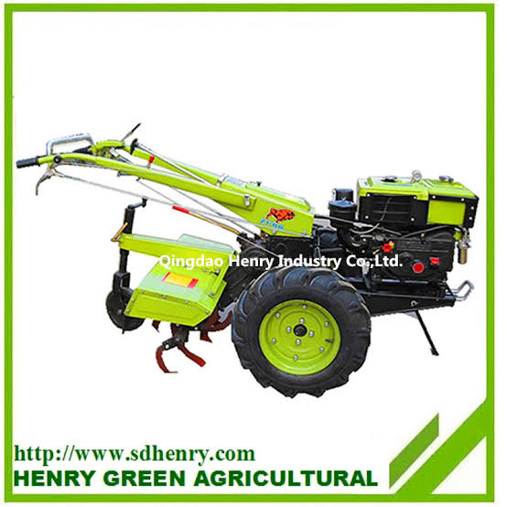
A background picture of the Plough machine used at GLGI
3.3.0 Making of Plant Beds in the Greenhouse kits
After the operation of the plough machine, beds needs to be make in the GH kits to aid planting and since the ground has been tilled and soften by the operation of the plough what is needed is for attendants to go to the farm store to gather the equipment needed for the bed making.
3.3.1 My Experience in making Plant beds
The method of making beds employed at GLGI is the manual method carried out by the use of shovels or spades. Below are my experiences in this:
- The bed widths and length are determined by the farm supervisor and he does this by fixing a pair of iron, one on one side of the bed and the other on the other side after which he ties a rope to both irons stretching it down to the designated end of the bed and tying it to the other pair of iron. This way, a space has been created between the two ropes showing the length and the width of the bed
- Each GH kits contain 12 beds, six beds at the upward part i.e. first half of the kit [divided by the trunk lines] while the other six are at the downward part i.e. at the second half of the kit.
- We are each handed a shovel and positioned at the middle of two plant beds where we can lift the soil with the shovel into the space that has been created by the ropes on both plant beds thus, the beds are formed.
3.4.0 Installing Trunk line and Drip line pipes in the Greenhouse Kits to enhance Irrigation
As mentioned earlier that each greenhouse kits has a pair of storex tanks to enable irrigation. The storex tank pipes are connected to the underground boreholes which had been dug in different places in the farm.
3.4.1 The Trunk Lines
Description: These are rubber pipes with big diameter connected from the storex tank outside the greenhouse kits into the greenhouse. It is the major pipe that supplies the drip line pipe with water. They are passed [fixed] through the Middle and through the end in the greenhouse.
3.4.2 The Drip Lines
Description: These are long rubber pipes with little diameter connected [fixed] to the trunk lines in the greenhouse kits. The drip lines had holes bored around its body to supply water to each plant stands. The Drip lines are laid in pairs on each plant beds, one on the right and the other on the left.
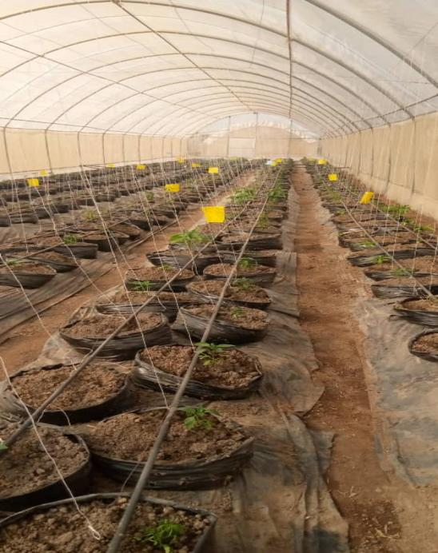
A picture showing Drip lines laid on the plant soil in a GH kit
3.4.3 My Experience in Installation:
- I collected all the Materials needed for the installation from the farm supervisor.
Note: Installation is done by three or more people with the farm supervisor leading the operation.
- Moderate size holes are bored into the left and right side of the greenhouse covering [Net] at the middle and at the end of the greenhouse kit to allow the passage of the trunk line pipe in the GH kit.
- The trunk lines are passed into the bored holes from the tank side to the other side of which accurate measurement of the trunk line are taken and cut to avoid excesses.
- The end of the trunk line are covered to prevent the flowing out of water while the other end are connected [fixed] to the storex tank
- Holes are bored on the trunk line inside the GH kit with a plastic G-clamp to allow the connection of each drip line pipes.
- One end of the drip lines are connected to the bored holes through a small tap switch which is fixed to the trunk line serving as intermediary between the drip and trunk lines
- The other end of the drip line is tightly covered to avoid the flowing out of water.
- After all these, the water can now be switched on from the storex to allow the irrigation of the Plants.
3.5 My experience in Staking of Crop Plants in the Greenhouse Kits [E.g. Green Pepper & Habanero pepper].
There are two categories of staking we carried out on the Crop plant.
- Primary staking
This is done after 2-3 weeks of transplanting the crop plant from the nursery kit to the intended GH kit to be used for the crop. The method involved in this staking is to tie a strong –thin leather rope (recommended) from the upper plant support to the downward plant support. These plant supports had previously been constructed immediately after the after the construction of the greenhouse kits. These ropes are tied beside individual plant stands.
- Secondary Staking
This is carried out when the crop plant has start producing fruits of which the plant will start to bend and the fruits will start touching the ground as a result of the weight of the fruits hence, causing a reduction in the quality of fruit [over ripening].
To carry out this staking, more staking ropes are measured, cut and joined to the initial staking rope [Primary] then spin round the plant crop to lift the fallen stems and fruits from the ground.

CHAPTER 4
4.0 EXPERIENCED GAINED
4.1 My Experiences with the Knapsack Sprayer and various Insecticides, Pesticides and Fungicides.
The sprayer used at GLGI is the knapsack sprayer of different brand and quality. They are majorly used for the application of pesticides, fungicides and insecticides in the GH kits. They are also used for the fumigation of the GH kit before it commences its planting operation. It is as well used in irrigation application in the nursery kit.
Irrigating and spraying of farm chemicals are majorly done in the cool of the day i.e. in the early morning hour [between 7am &10am] and in the evening hour [from 4pm downward]. The intended chemicals (which are mostly in liquid form) to be used are gotten from the Farm supervisor with the instruction on the dosage measurement [usually between 6oml & 65ml per knapsack].
Typical chemicals used in the spraying are:
Insecticides: ballistic, abamentin, lancergold, didicorn and furadan
Fungicides: skywalk, hexacal, ridomilgold etc.
After the measured dosage had been added into the knapsack, little quantity of water is added into the knapsack after which the knapsack is then shaken to allow the mixture of the chemical with the water. After this, the knapsack is topped to the brim with water then mounted on the back to begin operation.
4.2 Experiences gained in the Pre-nursery and Nursery planting operation
Not all vegetable crops are planted directly into their designated kit. In fact, most greenhouse crops are planted first in the nursery before their transplanting to their designated kit. Crop plant in this category are the tomatoes, red and yellow habanero, green and yellow pepper, bell pepper etc. cucumbers| are not planted in the nursery rather they are directly planted in their designated kits.
The seeds planted in the nursery are improved and treated seeds. They germinate faster and have high yield of productivity. Examples of this seeds are:
Green pepper: falkor f1, golden sun, red flame
Tomatoes: zara and Eva f1
Habanero: caribean red and yellow
In GLGI, there is a customized GH kit for nursery planting operation. The materials needed for the nursery are:
- Planting crates: a strong rubberlike crates containing over planting holes.
- Planting medium: it is a saw-dust like particles with a light weight which serves the function of a Soil.
- Water: needed to mix the planting medium to make it wet.
- Seeds
- Knapsack sprayer: for irrigation of the nursery
- Yellow sticker: it is a glued sticker which is tied above the nursery crates.
The yellow color of the sticker attracts insects present in the GH kit and glued them to it leading to their death.
The planting medium is emptied from its sack into a large bowl. Hands are rubbed on them to disintegrate those that are knotted into powdered form. Water is added to the planting medium to moisturize and not to turn it to a solution. They are stirred with the hand to allow for uniform moisturization of the medium. The now moisture medium are spread upon the crates and then little holes are made with the hand to allow the putting in of the seeds on the crates.
Note: The holes mustn’t be deep because the deeper the holes, the more time it will take for sprouting to commence.
After the holes had been made, the seeds are carefully put in each hole. A seed per hole, a crop type per crate. Caution has to be taken not to not to mix two different crop in a crate. After the crate is filled with seeds, it must be lightly covered with the planting medium and labeled according to the kind of seed planted.
After the whole crates had been filled, it must be carefully arranged and irrigated with water.
Note: To know whether a crate is well irrigated, the water must be coming out from the bottom of each hole.
Irrigation is carried out every day in the cool of the day.
4.3 Experience gained from harvesting of vegetables fruit from the GH kits.
Harvesting is an operation that is carried out almost every day in the GH kits as a result of frequent demands and exports of the fruits. Harvesting is done manually at GLGI with the use of the hands and harvesting basket as there has not yet been a purchase for a harvester. Moreover, the limited spacing capacity in the GH kits and the sensitivity of the crops to external handling may not allow the operation of a harvester.
4.3.1 Factors we put into consideration when harvesting Green pepper in the GH kits and the activity carried out are:
- Touch the flesh of the pepper to check whether it is soft or hard. If hard then it is ripe and meant to be harvested.
- Only the hard big green peppers are meant to be harvested as the medium and small sizes ones are left to grow big (within 3 days after, they would have grown big).
- Only the green peppers with fully bright green color are harvested. Those with reddish black spot are left to ripen into the red pepper [tatase] while those with infected part are left alone to be disposed later.
- The peppers are to be harvested with its top stalk.
- They are to be carefully placed not thrown in the basket to avoid the breaking of fleshly part of the fruit.
4.3.2 Factors we put into consideration when harvesting both Red and Yellow habanero pepper (they are the hottest rhodo pepper on earth) in the GH kits
- We are each given a pair of gloves to be worn on the hand to prevent the pepper from causing itching on our hand due to its pepperish state.
- Only the hard bright yellow or red peppers are harvested.
- The peppers are to be harvested with its stalk
- The green habanero peppers are left behind to ripen while the semi red or semi yellow ones are harvested together with the ripened ones cos the ripening of the semi ripe ones to fully ripe ones is between 24 hours.
4.4 Experiences gained in Post-harvest operation (e.g. sorting and packaging)
After the peppers are harvested, they are carried to the sorting room where they are sorted before weighing and packaging.
4.4.1 Factors to check out for when sorting are:
- Check the fleshly part of the pepper to separate the hard ones from the soft ones.
- Remove the peppers without the top stalk from the ones with the top stalk.
- Separate those with the black spot disease from the fresh ones.
- Separate the big peppers from the smaller ones.
After all these, the separated good peppers are cleaned with a dry clean cloth and placed back into the harvesting basket for weighing.
To weigh, first place an empty basket on the scale to determine the basket weight then tare it to ensure accurate determination of the weight of the peppers. Place the basket containing the peppers on the scale to determine its weight. The usual weight of pepper to be contained in each basket at GLGI is between 10kg and 12kg.
After weighing, the peppers are poured into bag sacks (the bags must be designed in such a way as to allow the passage of air) readied to be delivered for transportation.
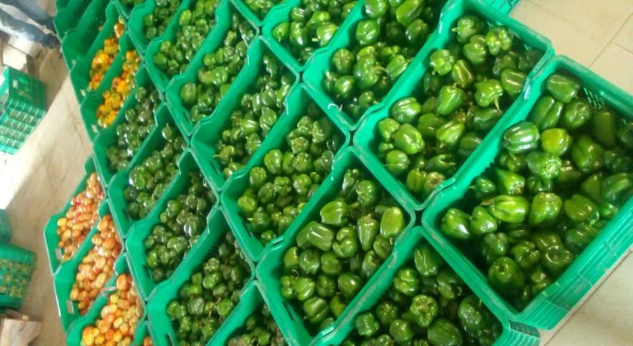
A picture of a sorted and weighed green peppers and tomatoes at GLGI

CHAPTER 5
5.0 Summary, Conclusion and Recommendation
5.1 Summary of attachment activities
The farm as stated in chapter two is greenhouse based and involved the growing of vegetable crops such as cucumbers, tomatoes, green and yellow pepper, chili pepper and habanero pepper. The method of growing all these aside from cucumber is through the nursery, that is, treated seeds that have been worked upon are bought and are planted in a crate[nursery bed] containing planting medium.
The nursery are watered and monitored for 2-3 weeks before transplanting to the intended GH kit which had earlier been cultivated. The method of cultivating the GH kit in GLGI is through the use of automated plough machine. As stated in the preceding chapters, the plough machine is made up of a petrol engine and contains a sharp chiseled mouth at the bottom of the machine for breaking the soil structure and turning the soil.it has a big strong tire which also help in turning the soil.
After the first round of breaking the soil with the plough machine, large quantities of farmyard manures [8 bag sacks per kit] are then spread on the soil for the plough machine to mix together when ploughed again for the second time. Then the farm beds are made employing the use of Shovels.
5.2 Problems encountered during the program
The major problems encountered during my stay at the greenhouse farm are the longevity of working hours, working from 8am to 5pm with only one hour rest. Also, the lack of storage and processing facilities is a major setback for the farm leading to an average decrease in the spoilage and preservation of peppers.
5.3 Conclusion
Greenhouse system of Farming is a modern farming system that enhance the all year round production of vegetable crops using artificial irrigations and improved seedlings as well as the use of chemicals such as pesticides, insecticides, fungicides and Bonus to control and improve the growth rate of crops.
5.4 Recommendation
The greenhouse farming is a lucrative farming system needed in this country to improve and stabilize the economy and to improve consistent supply of food production in the country. Therefore I recommend this report to anyone who is willing to learn the basicity of greenhouse farming.

