A TECHNICAL REPORT ON
STUDENT’S INDUSTRIAL WORK EXPERIENCE SCHEME
(SIWES)

HELD AT
DANGOTE SUGAR REFINERY PLC
APAPA, LAGOS STATE

PREPARED BY:
LATEEF FATHIA OMOLARA
ND/23/BAM/PT/0124

SUBMITTED TO:
DEPARTMENT OF BUSINESS ADMINISTRATION AND MANAGEMENT,
INSTITUTE OF INANCE AND MANAGEMENT STUDIES,
KWARA STATE POLYTECHNIC, ILORIN.

IN PARTIAL FULFILMENT OF PART OF THE REQUIREMENT FOR THE AWARD OF NATIONAL DIPLOMA (ND) IN BUSINESS ADMINISTRATION AND MANAGEMENT

NOVEMBER, 2024
TABLE OF CONTENT
Title page i
Table of content ii
Dedication iii
Acknowledgements iv
TABLE OF CONTENTS
CHAPTER ONE
- Introduction 1
  - History of SIWES 2-3
1.2 Aims and Objectives of SIWES 3-4
1.3 Relevance and Justification of SIWES 4
CHAPTER TWO
2.1 Description of Organization 5-6
2.2 Location of organization 6
2.3 Objective of Organization 6-7
2.4 Organizational Structure of Dangote Sugar Refinery 8
2.5 Departments and Functions 8-10
CHAPTER THREE
3.1 Work Carried out during SIWES 11-15
CHAPTER FOUR
4.1 Work Done and Experience Gained 16-17
CHAPTER FIVE
5.1 Summary 18
5.2 Conclusion 18
5.3 Recommendations 18-19

DEDICATION
I dedicate this technical report to the Almighty Allah, the giver of knowledge, wisdom and who is rich in mercy.

ACKNOWLEDGEMENT
I use this opportunity to express my profound gratitude and deep regards to the creator of heaven and earth, the one who knows the beginning and the end, the alpha and the omega, the Almighty Allah. Thank You for seeing me through this SIWES programme.
Also, to my parents MR. and MRS. LATEEF for their blessings, help and guidance given by them, time to time has carry me so far and shall carry on the journey of life on which I am about to embark. I, also take this opportunity to express a deep sense of gratitude to compliment my mentor for his cordial support valuable information and guidance which helped me in completing my SIWES through various stages.

CHAPTER ONE
- INTRODUCTION
SIWES stands for Students Industrial Work Experience Scheme. It is the accepted skills training program, which forms part of the approved minimum Academic standards in the various degree program for all Nigerian tertiary Universities (N.U.C 1996). SIWES goes a long way inputting to test the level of knowledge a student has acquired during the industrial training program.
The student industrial work experience scheme {SIWES} is an appreciable skills/training which is included as part of the minimum academic standard in Nigeria tertiary institution. The scheme is a participatory program involving universities, polytechnics and technical colleges for student of various institutions in Nigeria. It is run jointly by the Industrial Training Fund (I.T.F). The SIWES was established as a result of realization by the Federal Government in 1971, of the need to introduce a new dimension to the quality and standard of education obtained in the country in order to achieve the much-needed technology advancement, because it has been shown that a correlation exist a country level of economic, technological development and its level of investment in manpower (oniyide; 2000).
SIWES goes a long way inputting to test the level of knowledge a student has acquired during the industrial training program. It is an effort to bridge the gap existing between theory and other practice of architecture, engineering and technology, sciences, agriculture and other professional educational programs in the Nigerian tertiary institutions. It is aimed at exposing students to machines and equipment and professional work methods in industries and other organizations. The scheme is a tripartite program, involving the students, the universities and the industries (employers of labor). It affords students the opportunity to familiarize and expose themselves to the knowledge and experience needed in handling equipment that is not readily available in their various institutions. Before the establishment of this scheme, employers believed that the theoretical education in tertiary institutions were not adequate enough to meet most of the needs of employers of labor.
  - HISTORY AND BACKGROUND OF SIWES
In the early stages of education development in Nigeria, there was a problem with the gap between students' theory and practical skills. Therefore, there was a need to allow students to get real work experience. The program was created to give students experience in addition to theoretical learning. The industrial training policy was introduced by the Federal Government of Nigeria in 1973. Therefore, this project was necessary to improve the practical skills of students.
SIWES was established by ITF (Industrial Training Funds) in the year 1973 to solve the problem of lack of adequate proper skills for employment of tertiary institution graduates by Nigerian Industries. The Students’ Industrial Work Experience Scheme (SIWES) was founded to be a skill training programme to help expose and prepare students of universities, polytechnics and colleges of education for the industrial work situation to be met after graduation. This scheme serves as a smooth transition from the classroom to the world of work and further helps in the application of knowledge. The scheme provides students with the opportunity of acquainting and exposing themselves to the experience required in handling and managing of equipment and machinery that are usually not made available in their institutions. Before this scheme was established, there was a growing concern and trend noticed by industrialists that graduates of higher institutions lacked sufficient practical background for employment. It used to be that students who got into Nigerian institutions to study science and technology were not trained in the practical know-how of their various fields of study. As a result, they could not easily find jobs due to the lack of working experience.
Therefore, the employers thought that theoretical education going on in higher institutions was not responsive to the needs of the employers of labour. This was a huge problem for thousands of Nigerians until 1973. It is against this background that the fundamental reason for initiating and designing the scheme by the fund in 1973/74 was introduced.
The ITF organization (Industrial Training Fund) made a decision to help all interested Nigerian students and established the SIWES program. It was officially approved and presented by the Federal Government in 1974. The scheme was solely funded by the ITF during its formative years but as the financial involvement became unbearable to the fund, it withdrew from the scheme in 1978. In 1979, the federal government handed over the management of the scheme to both the National Universities Commission (NUC) and the National Board for Technical Education (NBTE).Later, in November 1984, the federal government reverted the management and implementation of the scheme to ITF. In July 1985, it was taken over by the Industrial Training Fund (ITF) while the funding was solely borne by the federal government. (Culled from Job Specifications on Students Industrial Work Experience Scheme).

  - AIMS AND OBJECTIVES OF SIWES
In the early stages of education development in Nigeria, there was a problem with the gap between students' theory and practical skills. Therefore, there was a need to allow students to get real work experience. The program was created to give students experience in addition to theoretical learning. The industrial training policy was introduced by the Federal Government of Nigeria in 1973. Therefore, this project was necessary to improve the practical skills of students.
- To provide an avenue for students in the Nigerian Universities to acquire industrial skills and experience in their various field of study.
- To prepare students for the work situation they are likely to meet after graduation.
- To expose students to work methods and techniques in handling equipment and machinery that may not be readily available in the universities.
- To make transition from the university to the world of work and thus enhance student’s contacts for future job placements.
- To provide students with the opportunity to apply the theoretical knowledge they had gain in school to real-life work situation, thereby bridging the gap between university work and actual practice.
- To enlist and strengthen employers’ involvement in the entire education process of preparing university undergraduate for employment in the industry.
- To provide students with an opportunity to apply their theoretical knowledge in real work situation, thereby bridging the gap between university work and actual practice.
- To serve as opportunity for self- actualization for students thus making positive and commendable contribution within the scope of his/her knowledge.

  - RELEVANCE AND JUSTIFICATION OF SIWES
One of the significant features of advanced industrial societies is the degree to which they have achieved progress in the field of science and technology. This had enabled the citizens to enjoy a good standard of living, which exceeds that of the developing Countries. Thus, formal education comprising of field or industrial work is vital for the production of graduates with increasingly specialized skill.
Therefore, Students Industrial Work Experience Scheme (SIWES) is relevant for;
- Improvement of science and technological education
- Skilled manpower development
- Creation of a community with increased standard of living
- Development of critical and scientific approach to problems and their solutions.
New innovations in the field of science and technology. As a matter of fact, the student industrial work experience scheme (SIWES) is a promotion for the growth of science and technology, Engineering, Agriculture, Medical, Management, and other professional program in the Nigerian tertiary Institution.

CHAPTER TWO
  - DESCRIPTION OF DANGOTE SUGAR REFINERY
Dangote Sugar Refinery Plc, is an integral part of the Federal Government of Nigeria’s National Sugar Development Master Plan. In 2012, Dangote Sugar committed to becoming an integrated sugar business, serving local and export markets from integrated sugarcane plantations and factories across Nigeria, over the next 10 years.
Our goal is to achieve the capacity to produce 1.5 million tonnes of refined sugar annually from sugarcane plantations covering more than 150,000 hectares of land across a number of sites in Nigeria. This step will move Dangote Sugar from a port-based refining to fully integrated sugar production within Nigeria, thereby helping Nigeria to achieve self-sufficiency in sugar production, and create over 100,000 new employment opportunities.
The first phase of the project is at an advanced stage with the rehabilitation and expansion of Dangote Sugar, integrated sugar estate at Numan, in Adamawa State; reintroduction of a robust out-growers scheme and the charting of a sustainable community relations and development initiatives guided by consultations and engagements with the local communities.
In addition, acquisition of other integrated sites at other locations close to suitable land with good irrigation, and our key markets have begun and the engagement of the required technical competence for the project is ongoing.
Dangote Sugar is Nigeria’s largest producer of household and commercial sugar with 1.44 million tonnes of refining capacity, with the ability to supply most of the country through an extensive network of distributors. Our refinery at Apapa imports raw sugar from Brazil and refines it into white, Vitamin A fortified sugar suitable for household and industrial uses. Our Savannah cane sugar factory located near Numan, in Adamawa State has an installed factory capacity of 50,000 tonnes. Covering 32,000 hectares in extent, the Savannah estate has considerable opportunity for expansion which is underway. Our strategy is to become a global force in sugar production, working within Nigeria’s National Sugar Master Plan to end importation and sell more than 1.5 million metric tonnes of locally produced sugar in Nigeria and neighbouring countries. As part of this plan we acquired Savannah Sugar in December 2012 and are currently improving its farm acreage and upgrading its production facilities. We intend to augment Savannah’s 32,000 hectares in Adamawa state by acquiring and planting a further 150,000 hectares across Nigeria, supporting the new plantations with modern production facilities that are located closer to the consumer. Dangote Sugar Refinery was spun out of Dangote Industries in 2006 and was listed on the Nigerian Stock Exchange in March 2007.

  - LOCATION AND OBJECTIVE OF DANGOTE SUGAR REFINERY PLC
Dangote Sugar Refinery Plc, a major player in Nigeria's sugar industry, is located at Shed 20, NPA Wharf Port Complex, Apapa, Lagos. The main refinery, which was the first sugar refinery built in Nigeria, is situated at Shed 20, NPA Apapa Wharf Complex. The corporate head office is located at the same address: 3rd Floor, GDNL Building Terminal E, Shed 20, NPA Wharf Port Complex, Apapa, Lagos.
2.3 OBJECTIVES OF DANGOTE SUGAR REFINERY PLC
The objectives of Dangote Sugar Refinery Plc can be summarized as follows:
- To be the leading sugar refining company in Nigeria and West Africa: Dangote Sugar Refinery aims to maintain its position as the largest sugar refinery in Nigeria and expand its market share in West Africa.
- To produce high-quality sugar products: The company is committed to producing sugar products that meet international standards, thereby ensuring customer satisfaction and loyalty.
- To increase efficiency and reduce costs: Dangote Sugar Refinery aims to optimize its production processes, reduce waste, and minimize costs in order to remain competitive in the market.
- To expand its product portfolio: The company plans to diversify its product offerings to include other sugar-related products, such as ethanol, molasses, and other by-products.
- To increase local sugar production and reduce reliance on imports: Dangote Sugar Refinery aims to increase its local sugar production capacity, thereby reducing Nigeria's reliance on imported sugar and contributing to the country's economic development.
- To create value for shareholders: The company is committed to generating returns on investment for its shareholders through efficient operations, strategic investments, and sustainable growth.
- To contribute to the socio-economic development of Nigeria: Dangote Sugar Refinery aims to contribute to the country's economic growth, provide employment opportunities, and support local communities through its corporate social responsibility initiatives.
- To maintain high standards of environmental sustainability and social responsibility: The company is committed to minimizing its environmental footprint, promoting sustainable practices, and upholding the highest standards of social responsibility in its operations.
- To develop and implement innovative technologies: Dangote Sugar Refinery aims to stay ahead of the competition by investing in research and development, adopting new technologies, and improving its manufacturing processes.
- To maintain a strong and disciplined organizational culture: The company is committed to upholding a culture of excellence, integrity, and transparency, and to ensuring that its operations are guided by the highest standards of ethics and governance.
These objectives are aligned with the company's vision and mission statements, which emphasize its commitment to becoming a world-class sugar refining company, creating value for its stakeholders, and contributing to the socio-economic development of Nigeria.
MISSION/VISION STATEMENT
Dangote Group continues to grow its focus of becoming the leading provider of essential needs in Food and Shelter in Sub-Saharan Africa. Our vision is to be a world-class enterprise that is passionate about the quality of life of the general populace and high returns to stakeholders. Our mission is to touch the lives of people by providing their basic needs. We continue to sustain and improve on our market leadership in Cement Manufacturing, Sugar Milling, Sugar Refining, Port Operations, Packaging Material Production and Salt Refining.

2.4 ORGANIZATIONAL STRUCTURE OF DANGOTE SUGAR REFINERY
EXECUTIVE DIRECTOR, COMMERCIAL OPERATIONS

CHIEFF EXECUTIVE
OFFICER (CEO)

EXECUTIVE DIRECTOR, LOGISTICS AND DISTRIBUTION

VICE PRESIDENT, DANGOTE INDUSTRIES LIMITED

CHIEF RISK OFFICER
EXECUTIVE DIRECTOR, COMMERCIAL OPERATIONS

EXECUTIVE DIRECTOR
NON-EXECUTIVE DIRECTOR

2.5 DEPARTMENTS AND THEIR FUNCTIONS
Dangote Sugar Refinery is a leading sugar refining company in Nigeria, and it has several departments that work together to ensure the smooth operation of the refinery. Here are some of the departments in Dangote Sugar Refinery and their functions:
- Production Department: This department is responsible for the day-to-day production of sugar at the refinery. They oversee the processing of sugarcane or sugar beets into refined sugar, ensuring that the production process is efficient and meets the required quality standards.
- Quality Control Department: The Quality Control Department is responsible for ensuring that the sugar produced meets the required quality standards. They conduct regular tests and inspections to ensure that the sugar is pure, safe, and meets the regulatory requirements.
- Engineering Department: The Engineering Department is responsible for the maintenance and upkeep of the refinery's equipment and machinery. They ensure that all equipment is in good working condition, and they carry out repairs and maintenance as needed.
- Procurement Department: The Procurement Department is responsible for sourcing and purchasing raw materials, equipment, and supplies needed for the production process. They negotiate with suppliers, manage inventory, and ensure that all purchases are made in accordance with company policies and procedures.
- Finance Department: The Finance Department is responsible for managing the refinery's financial affairs, including budgeting, forecasting, and financial reporting. They also oversee the payment of salaries, taxes, and other expenses.
- Human Resources Department: The Human Resources Department is responsible for managing the refinery's workforce, including recruitment, training, and employee relations. They ensure that all employees are properly trained and equipped to perform their jobs safely and efficiently.
- Safety, Health, and Environment (SHE) Department: The SHE Department is responsible for ensuring that the refinery operates in a safe and healthy environment. They develop and implement safety policies and procedures, conduct regular safety audits, and ensure that all employees are trained in safety procedures.
- Logistics and Supply Chain Department: The Logistics and Supply Chain Department is responsible for managing the movement of raw materials and finished goods in and out of the refinery. They ensure that all shipments are delivered on time, and that inventory levels are properly managed.
- Research and Development (R&D) Department: The R&D Department is responsible for developing new products and improving existing ones. They conduct research and testing to identify new business opportunities and improve the refinery's operations.
- Marketing and Sales Department: The Marketing and Sales Department is responsible for promoting and selling the refinery's products. They develop marketing campaigns, manage customer relationships, and ensure that the refinery's products are competitive in the market.
- Information Technology (IT) Department: The IT Department is responsible for managing the refinery's computer systems, software, and networks. They ensure that all systems are secure, efficient, and meet the refinery's operational needs.
- Warehouse and Store Department: The Warehouse and Store Department is responsible for storing and managing the refinery's inventory of raw materials and finished goods. They ensure that all inventory is properly stored, and that stock levels are accurately recorded.
- Security Department: The Security Department is responsible for ensuring the safety and security of the refinery, its employees, and its assets. They provide 24/7 security coverage, and respond to any security incidents or threats.
- Administrative Department: The Administrative Department is responsible for providing administrative support to the refinery's operations. They manage the refinery's facilities, provide reception and telephone services, and perform other administrative tasks as needed.
These departments work together to ensure that Dangote Sugar Refinery operates efficiently and effectively, producing high-quality sugar products for the Nigerian market.

CHAPTER THREE
  - WORK CARRID OUT DURING THE SIWES
At the start of my SIWES programme, the organization gave me orientations and induction process. I attended the orientation session by the HR department and receive overview of local government structure. I was also introduced to the various staff in the organization and learnt goals for internship such as learning about policy analysis and development.
I attended the training session on policy analysis and development and learned about the importance of stakeholders’ engagement in policy-making. I assisted in researching data for a report on community development initiatives. I was put through skills development such as data analysis and report writing. I was stationed at the office where I received and dispatch mails for the organization. I was also put through the process of filling numeric and alphabetic order. Also, I learnt about the employment, deployment and posting of staff across various departments and offices in the organization.


COMPUTER
As the Clearing and Forwarding Department in Dangote Sugar Refinery, I play a crucial role in ensuring that all imports and exports are cleared through customs and other regulatory agencies in a timely and efficient manner. My day begins with pre-clearance, where I review and verify all relevant documents, such as commercial invoices, bills of lading, and certificates of origin, to ensure that they are complete and accurate. This involves scrutinizing every detail, from the value and quantity of the goods to the country of origin, to ensure that they comply with customs regulations and are in good condition.
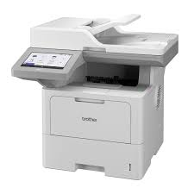
PRINTER
Once I have verified all the documents, I proceed to customs clearance, where I prepare and submit customs declarations, pay duties and taxes, and obtain clearance certificates from the relevant authorities. This requires a thorough understanding of customs procedures and regulations, as well as the ability to communicate effectively with customs officials and other stakeholders. I also arrange for cargo inspection, where I ensure that the goods are in good condition and comply with customs regulations. This involves coordinating with freight forwarders, customs brokers, and other parties to ensure that the cargo is inspected and cleared in a timely and efficient manner.

SCANNER LABEL PRINTER
In addition to clearance and inspection, I am also responsible for document preparation, where I prepare and submit all necessary documents, such as commercial invoices, packing lists, and bills of lading, to the relevant authorities. This requires attention to detail and a thorough understanding of documentary requirements, as any errors or omissions can lead to delays or even rejection of the cargo. I also arrange for freight forwarding, where I coordinate with freight forwarders and other parties to ensure that the cargo is transported from the port of arrival to the refinery's warehouse or other designated locations.
Before I can begin the clearance process, I require a range of documents, including commercial invoices, bills of lading, certificates of origin, and packing lists. I also need customs declaration forms, import licenses, phytosanitary certificates, and certificates of conformity, depending on the type of cargo being imported. In Nigeria, I also require additional documents, such as Form M, Pre-Arrival Assessment Report (PAAR), Single Goods Declaration (SGD), and Nigerian Customs Service (NCS) Declaration Form. These documents provide detailed information about the goods being imported and are used to declare the goods to customs, determine the applicable duties and taxes, and ensure that the goods comply with regulatory requirements.
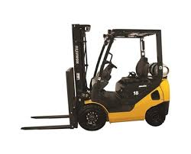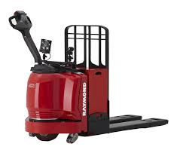
FORKLIFT PALLET JACK
As I navigate the complex world of customs clearance and forwarding, I must be meticulous and thorough in my work. I must ensure that all documents are complete and accurate, and that all procedures are followed to the letter. I must also be able to communicate effectively with stakeholders, including customs officials, freight forwarders, and other parties, to ensure that the clearance process is smooth and efficient. By doing so, I can ensure that the refinery receives its imports in a timely and cost-effective manner, and that all regulatory requirements are met. Ultimately, my goal is to provide a seamless and efficient clearance and forwarding service that supports the refinery's operations and contributes to its success.
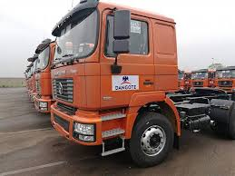
CCTV DANGOTE TRUCK
Import refers to the good brought into a country from overseas for personal use
Type of imports
Visible
Invisible
Clearing also known as customs clearance is the process of complying with custom regulations and obtaining clearance for imported goods to enter the country
Step involved in clearing
Pre clearance
Submission of documents
Inspection and verification
Duty and tax calculation
Release of goods
Documents required for clearing
- Commercial invoice
- Bill of lading: it is the title of the goods
- Certificate of origin
- Custom declaration
- Permits
- License
- certificate of compliance
Benefit of efficient clearing
Reduced delays
Cost saving
Improved compliance
Increased customer satisfaction
Type of clearing
Express clearing
Standard clearing
Bonded clearing
(LC) letter of credit transactions: is a financial instrument used in international trade to facilitate Payment between a buyer & seller
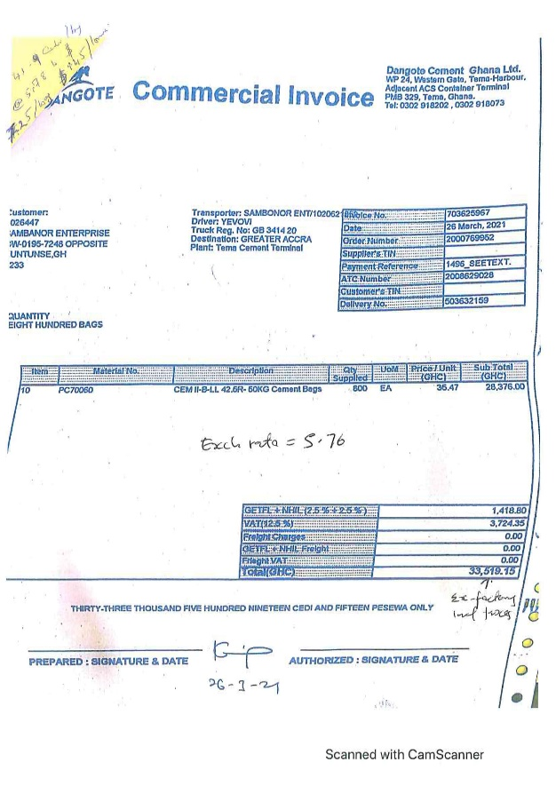
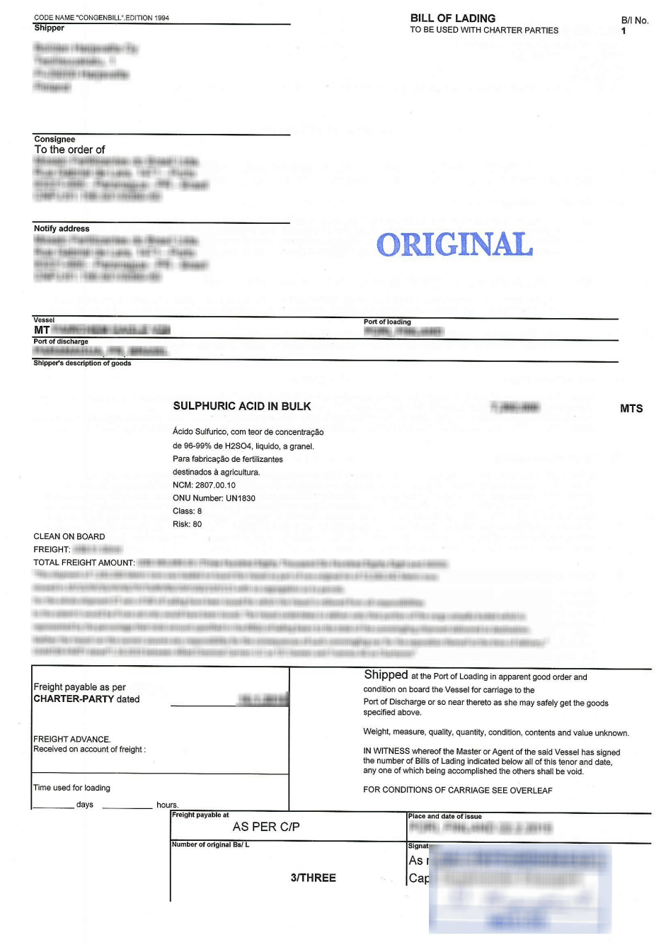
COMMERCIAL INVOICE BILL OF LANDING

CHAPTER FOUR
  - DESCRIPTION OF WORK DONE AND EXPERIENCE GAINED
During my Student's Industrial Work Experience Scheme (SIWES) program at Dangote Sugar Refinery Plc, Apapa, Lagos State, I gained a plethora of experiences that have significantly contributed to my personal and professional development. One of the most significant experiences I gained was practical knowledge of sugar production. I was able to witness firsthand the production process of sugar, from raw material handling to finished product packaging. This hands-on experience not only deepened my understanding of the theoretical concepts I learned in the classroom but also gave me a unique perspective on the intricacies of sugar production. I was able to see how different units and departments in the refinery, including the raw sugar warehouse, melting and filtration, crystallization, centrifugation, and packaging, work together to produce high-quality sugar products.
I also became familiar with various industrial equipment and machinery used in the sugar refinery, such as boilers, turbines, pumps, and conveyor belts. This exposure helped me to appreciate the importance of equipment maintenance and troubleshooting in ensuring the smooth operation of the refinery. Furthermore, I learned about the importance of quality control and assurance in the sugar industry, including testing and analysis of raw materials and finished products. I was able to participate in quality control activities, such as sampling and testing, and gained a deeper understanding of the measures that are taken to ensure that the sugar products meet the required standards. Additionally, I was trained on safety and health procedures in the refinery, including personal protective equipment, emergency response plans, and hazard identification and mitigation. This training not only taught me the importance of safety in the workplace but also equipped me with the skills to identify and mitigate potential hazards.
My experience at Dangote Sugar Refinery Plc also taught me the value of teamwork and communication in a fast-paced industrial environment. I worked with colleagues from different departments and levels of management, and I learned the importance of effective communication, collaboration, and problem-solving in achieving organizational goals. I was able to develop my problem-solving and troubleshooting skills, including identifying and resolving issues related to equipment, processes, and production. I also learned to prioritize tasks, manage time effectively, and maintain a high level of organization in a dynamic and demanding work environment. Moreover, I developed adaptability and flexibility skills, including adjusting to changing schedules, priorities, and deadlines. Through my experience, I gained valuable insights into the sugar industry and developed professional skills, including networking, etiquette, and ethics.
Throughout my SIWES program, I was able to engage in various activities that contributed to my growth and development. I conducted routine inspections and maintenance of equipment, assisted in the operation of various units and departments, and participated in quality control and assurance activities. I also developed and implemented safety and health procedures, collaborated with colleagues on projects and tasks, and analyzed data to identify areas for improvement. I presented my findings and recommendations to management and colleagues, and I participated in training and development programs to enhance my knowledge and skills. Overall, my experience at Dangote Sugar Refinery Plc was invaluable, and I am grateful for the opportunity to have worked with such a dedicated and professional team. The skills and knowledge I gained during my SIWES program have prepared me for a career in the sugar industry or related fields, and I am confident that I will be able to make a positive contribution to any organization I join in the future.

CHAPTER FIVE
- SUMMARY, CONCLUSION AND RECOMMENDATIONS
  - SUMMARY OF ATTACHMENT ACTIVITIES
In summary, the Student's Industrial Work Experience Scheme (SIWES) program held at Dangote Sugar Refinery Plc, Apapa, Lagos State, provided a valuable opportunity for me to gain practical skills and experience in my field of study. Throughout the program, I was exposed to the inner workings of a major sugar refinery and gained hands-on experience in various aspects of the business, including production, quality control, and management. The program helped to bridge the gap between theory and practice, allowing me to apply the concepts and principles learned in the classroom to real-world situations. Overall, the SIWES program was a highly beneficial experience that helped to prepare me for the workforce and provided me with a competitive edge in the job market.
5.2 CONCLUSION
In conclusion, the SIWES program at Dangote Sugar Refinery Plc was a resounding success, providing me with a unique opportunity to gain practical skills and experience in a real-world setting. The program helped to equip me with the skills and knowledge necessary to succeed in my chosen field, and I am grateful for the experience and exposure gained. The program also highlighted the importance of industrial training in preparing students for the workforce, and I believe that it should be a mandatory requirement for all students in tertiary institutions. Overall, I am confident that the skills and experience gained during the SIWES program will serve me well in my future career, and I am thankful for the opportunity to have been a part of it.
5.3 RECOMMENDATIONS
Based on my experience during the SIWES program, I recommend that students in tertiary institutions take full advantage of the program to gain practical skills and experience in their field of study. I also recommend that companies and organizations provide more opportunities for students to participate in the SIWES program, as it provides a win-win situation for both the students and the organizations. Furthermore, I recommend that the Industrial Training Fund (ITF) and other relevant stakeholders continue to support and fund the SIWES program, as it plays a critical role in preparing students for the workforce and addressing the skills gap in Nigeria. Additionally, I recommend that the curriculum of tertiary institutions be reviewed to include more practical and industry-relevant courses, to ensure that students are better prepared for the workforce upon graduation. Overall, I believe that the SIWES program has the potential to make a significant impact on the development of Nigeria's workforce, and I recommend that it be given the necessary support and resources to achieve its full potential.

