A TECHNICAL REPORT ON

STUDENT INDUSTRIAL WORK EXPERIENCE
SCHEME (S.I.W.E.S)

UNDERTAKEN AT

DEE JAY CAPABLE TRENDS
SHOP 36 DANSIKI MARKET BESIDE UBA HEAD OFFICE , MARINA LAGOS
BY

ZAKARIYAH HADEEZAH OMOWUMI
ND/23/BFN/FT/0045

DEPARTMENT OF BANKING AND FINANCE
INSTITUTE OF FINANCE AND MANAGEMENT STUDIES (IFMS)
KWARA STATE POLYTECHNIC, ILORIN.

IN PARTIAL FULFILMENT OF THE REQUIREMENTS FOR THE AWARD OF NATIONAL DIPLOMA (ND) IN BANKING AND FINANCE

2024 – 2025
DEDICATION
This SIWES report is dedicated to the Glory of Almighty God and my parents, Mr. and Mrs. zakariyah.

ACKNOWLEDGEMENT
All praise and adoration to the Almighty God for providing me wisdom, knowledge and understanding in making this SIWES work a successful one and also for making my dreams come to reality.
In the course of putting this report together I am indebted to my school KWARA STATE POLYTECHNIC for the admission and enabling environment to partake in the SIWES programme.
My sincere gratitude goes to my parents, Mr. and Mrs. Zakariyah for their financial support and prayer.

TABLE OF CONTENTS
TITLE PAGE i
DEDICATION ii
ACKNOWLEDGEMENT iii
TABLE OF CONTENTS iv
INTRODUCTION
History of SIWES
Operators of SIWES
Objectives of SIWES
Historical Background of the Organization
Organisational Chart
Major Activities of the Organization
Section/Unit of the Organization and Their Specific Function
CHAPTER TWO MICROSOFT WORDS
What is Microsoft Word?
How to Open Microsoft Word?
Understanding the Design and Daily Analysis
Understanding the calculation base on consumer request
How to texture and color different clotting
CHAPTER THREE FABRIC BRANDING/CLOTHING BRANDING
How to Open Computer to calculate Fabric Branding/Clothing Branding
Skills Acquired on native dressing

CHAPTER FOUR CHALLENGES, CONCLUSION AND RECOMMENDATION
Challenges Encountered During My SIWES Programme
Conclusion
Recommendations

CHAPTER ONE
INTRODUCTION

1.1 HISTORY OF SIWES
SIWES (Student Industrial Working Experience Scheme) was established by ITF in 1973 to solve the problem of lack of adequate practical skills preparatory for employment in industries by Nigerian graduates of tertiary institutions.
The Scheme exposes students to industry based skills necessary for a smooth transition from the classroom to the world of work. It affords students of tertiary institutions the opportunity of being familiarized and exposed to the needed experience in handling machinery and equipment which are usually not available in the educational institutions. Participation in Industrial Training is a well-known educational strategy. Classroom studies are integrated with learning through hands-on work experiences in a field related to the student’s academic major and career goals.
Successful internships foster an experiential learning process that not only promotes career preparation but provides opportunities for learners to develop skills necessary to become leaders in their chosen professions.
One of the primary goals of the SIWES is to help students integrate leadership development into the experiential learning process. Students are expected to learn and develop basic non-profit leadership skills through a mentoring relationship with innovative non-profit leaders.
By integrating leadership development activities into the Industrial Training experience, we hope to encourage students to actively engage in non-profit management as a professional career objective. However, the effectiveness of the SIWES experience will have varying outcomes based upon the individual student, the work assignment, and the supervisor/mentor requirements.
It is vital that each internship position description includes specific, written learning objectives to ensure leadership skill development is incorporated.
Participation in SIWES has become a necessary pre-condition for the award of Diploma and Degree certificates in specific disciplines in most institutions of higher learning in the country, in accordance with the education policy of government.

1.2 OPERATORS OF SIWES
Operators - The ITF, the coordinating agencies (NUC, NCCE, NBTE), employers of labor and the institutions.
Funding - The Federal Government of Nigeria
Beneficiaries - Undergraduate students of the following: Agriculture, Engineering, Technology, Environmental, Science, Education, Medical Science and Pure and Applied Sciences.
Duration - Four months for Polytechnics and Colleges of Education, and Six months for the Universities.

1.3 OBJECTIVES OF SIWES
1. SIWES will provide students the opportunity to test their interest in a particular career before permanent commitments are made.
2. SIWES students will develop skills in the application of theory to practical work situations.
3. SIWES will provide students the opportunity to test their aptitude for a particular career before permanent commitments are made.
4. SIWES students will develop skills and techniques directly applicable to their careers.
5. SIWES will aid students in adjusting from college to full-time employment.
1.4 HISTORICAL BACKGROUND OF THE ORGANIZATION
Dee Jay Capable Trends is a clothing business based in the Dansiki Market, Marina, Lagos. The business specializes in the production and sale of traditional native wear, such as Adire, Agbada, Dansiki, and Kanpala. Dee Jay Capable Trends has become known for its quality craftsmanship and innovative designs, tailoring native dresses to suit the modern fashion trends while maintaining the authenticity of Nigerian cultural attire. Over the years, the company has grown into a leading fashion brand in the Lagos region, servicing both local and international clients.

1.5 ORGANISATIONAL CHART
Manager
Secretary
Designers
Tailors and Seamstresses
Administrative Staff
Sales and Marketing Team

1.6 MAJOR ACTIVITIES OF THE ORGANIZATION
Dee Jay Capable Trends engages in the following major activities:
- Designing traditional wear such as Agbada, Adire, Dansiki, and Kanpala.
- Fabric sourcing and management, ensuring the highest quality materials for their outfits.
- Custom tailoring for individuals and corporate clients seeking bespoke native wear.
- Sales and marketing, promoting native attire both locally and online.
- Research and development of new designs to meet the evolving demands of customers.

Section/Unit of the Organization and Their Specific Functions
- Design Department
  - Responsible for conceptualizing and sketching designs for native attire. The team focuses on blending traditional styles with contemporary fashion.
- Production/Manufacturing Unit
  - This department focuses on the actual production of the garments, ensuring quality stitching, finishing, and packaging of the native wear.
- Sales and Customer Relations
  - Handles the direct sales of garments, customer service, and marketing efforts.
- Accounts and Administration
  - Manages financial records, transactions, and daily administrative tasks necessary for business operations.

CHAPTER TWO

MICROSOFT WORDS

2.1 What is Microsoft Word?
Microsoft Word is a versatile word processing application developed by Microsoft, widely used for creating, editing, and formatting text documents. It is part of the Microsoft Office suite, which includes programs like Excel, PowerPoint, and Outlook. Since its inception in the 1980s, Microsoft Word has become one of the most widely used software programs globally for personal, academic, and professional purposes.
In the context of my Industrial Training (SIWES) at Dee Jay Capable Trends, Microsoft Word plays a significant role in helping manage daily operations and documentation. It allows for the creation of various documents such as reports, business letters, client communications, and internal memos. Additionally, it offers a wide range of features, including text formatting, page layout design, and the ability to insert images and tables, making it an essential tool for streamlining the business's administrative functions.

2.2 HOW TO OPEN MICROSOFT WORD?
To open Microsoft Word on a computer, follow these steps:
- Click on the Start Menu: In Windows, click on the Start Menu located at the bottom left of the screen.
- Search for Microsoft Word: Type “Microsoft Word” into the search bar. If you are using a Mac, you can open the Spotlight by pressing Command + Space, then type “Word” to search for the application.
- Select Microsoft Word: From the search results, click on Microsoft Word to open the program. Alternatively, you can select the Word shortcut on your desktop or taskbar if you have it pinned.
Once the program is open, you can begin creating a new document, working on an existing one, or using various templates provided by the software to help you start quickly.

2.3 UNDERSTANDING THE DESIGN AND DAILY ANALYSIS
Microsoft Word is not just for writing; it also provides tools for analyzing and organizing data, especially in the day-to-day activities of Dee Jay Capable Trends. For example:
- Daily Activity Logging: Every business, regardless of industry, requires detailed record-keeping. At Dee Jay Capable Trends, I used Microsoft Word to maintain a daily log of activities and transactions. This includes tracking customer orders, logging fabric usage, recording payments, and noting any issues that arise during production. These records help the business track progress, identify recurring problems, and monitor customer satisfaction.
- Design Documentation: The design process is critical in any clothing business. Microsoft Word is an essential tool in documenting the design process, from initial sketches to finalized designs. For example, after designers at Dee Jay Capable Trends come up with new designs for Agbada or Dansiki, the details of these designs, including the fabrics used, color schemes, and any customer customization, are documented in Word for future reference. This documentation is often shared with other departments, such as the production or sales teams, to ensure everyone is on the same page.
- Production Scheduling: In any production-based business, proper scheduling is key. Using Microsoft Word, I learned how to develop daily, weekly, or monthly schedules for various production activities. These schedules include when certain designs are to be started, deadlines for completion, and any adjustments to be made based on customer requests. Scheduling helps streamline the workflow, ensuring that the business operates efficiently.
- Analysis of Sales and Customer Preferences: At Dee Jay Capable Trends, keeping track of customer orders, preferences, and buying patterns is important for making informed decisions about production. This analysis can be done in Microsoft Word by creating detailed reports based on customer feedback, sales history, and market trends. For example, when certain colors or designs are in high demand, the company can focus on producing more of those styles, while reducing focus on less popular ones. Word documents are also used to generate sales summaries, which are then reviewed to track business performance.

2.4 UNDERSTANDING THE CALCULATION BASED ON CONSUMER REQUEST
While Microsoft Word itself does not have the same advanced features as Excel for complex calculations, it can still serve as a useful tool for organizing and documenting calculations related to consumer requests. At Dee Jay Capable Trends, I was involved in documenting and calculating pricing for customers orders and fabrics. These calculations often include:
- Material Costs: When a customer places an order, the first step is to determine the materials required. This includes measuring the amount of fabric needed for a design like Agbada or Dansiki. By calculating the quantity of fabric (e.g., meters or yards) and the cost per meter, the total cost of the material can be determined. This information is then recorded in a Word document and attached to the customer’s order for reference.
- Labor Costs: After determining the material costs, the next calculation involves labor. Tailors and designers at Dee Jay Capable Trends are paid according to the complexity of the design and the time required to complete each order. I learned to estimate labor costs based on the hours worked for each specific garment. These labor costs are added to the total cost of the garment, ensuring that the pricing structure is accurate.
- Custom Pricing: Many of the orders at Dee Jay Capable Trends are custom, meaning the client requests a specific design, color, or modification to an existing pattern. Based on these custom requests, pricing is adjusted. For example, if a customer wants a specific color combination for an Agbada, there may be an additional cost for sourcing that particular fabric. All these changes are documented in Microsoft Word, where I could keep track of customer preferences and adjust pricing accordingly.

2.5 HOW TO TEXTURE AND COLOR DIFFERENT CLOTHING
Microsoft Word is not designed for creating intricate fabric designs or rendering textures and colors. However, it can be used for documentation of design elements such as color and texture. When working with native wear like Adire (a traditional dyed fabric), Agbada, or Dansiki, I would document:
- Color Schemes: Different colors represent different meanings in traditional attire. For instance, royal blue and gold are often associated with high status, while earthy tones are linked to cultural heritage. In Word, we can track these color preferences in the context of specific customer orders and record how these colors are incorporated into the garment.
- Fabric Textures: Textures refer to the feel and appearance of the fabric, such as rough, smooth, shiny, or matte. In Word, a designer might describe the texture of the material used in the garment, especially when custom materials like silk, cotton, or Adire are involved. This documentation helps ensure consistency in future orders and allows for easy reference if the same material needs to be sourced again.
Microsoft Word is an invaluable tool for managing the business processes at Dee Jay Capable Trends. From documenting design ideas and customer preferences to managing daily logs and calculating costs, it plays a central role in ensuring the smooth operation of the business. While it may not be a specialized tool for advanced design or production calculations, Word remains essential for business documentation, reporting, and communication.
Through the use of this software, I gained insight into how administrative tasks are managed in the fashion industry, which has proven invaluable during my SIWES program. The ability to organize and analyze business data, communicate effectively, and track production processes has been crucial in understanding the real-world application of my academic knowledge.
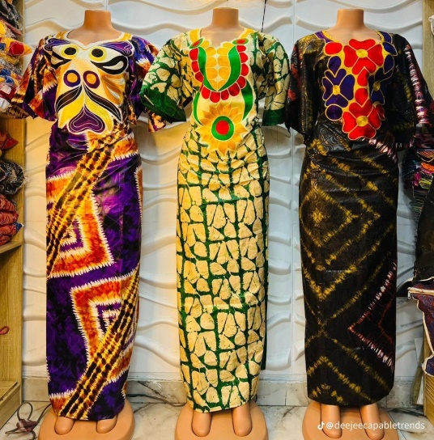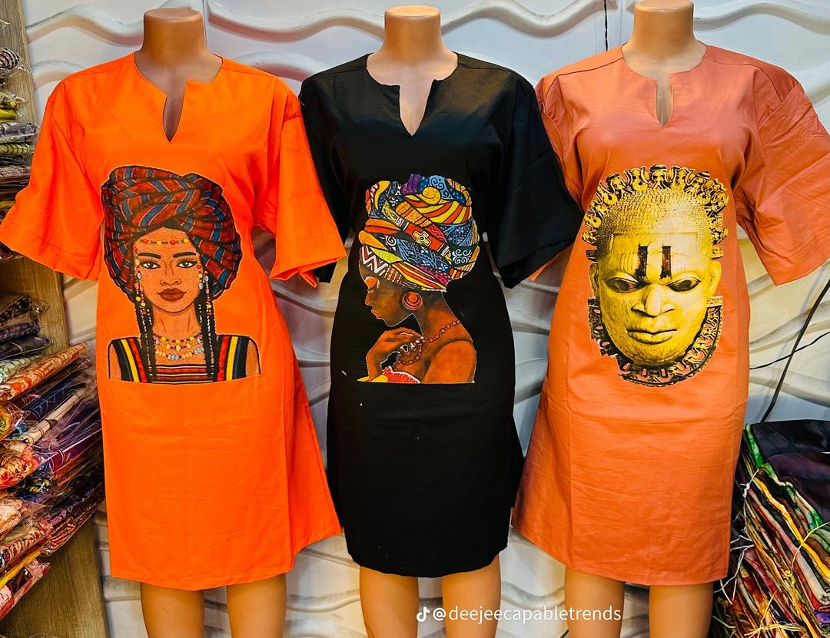
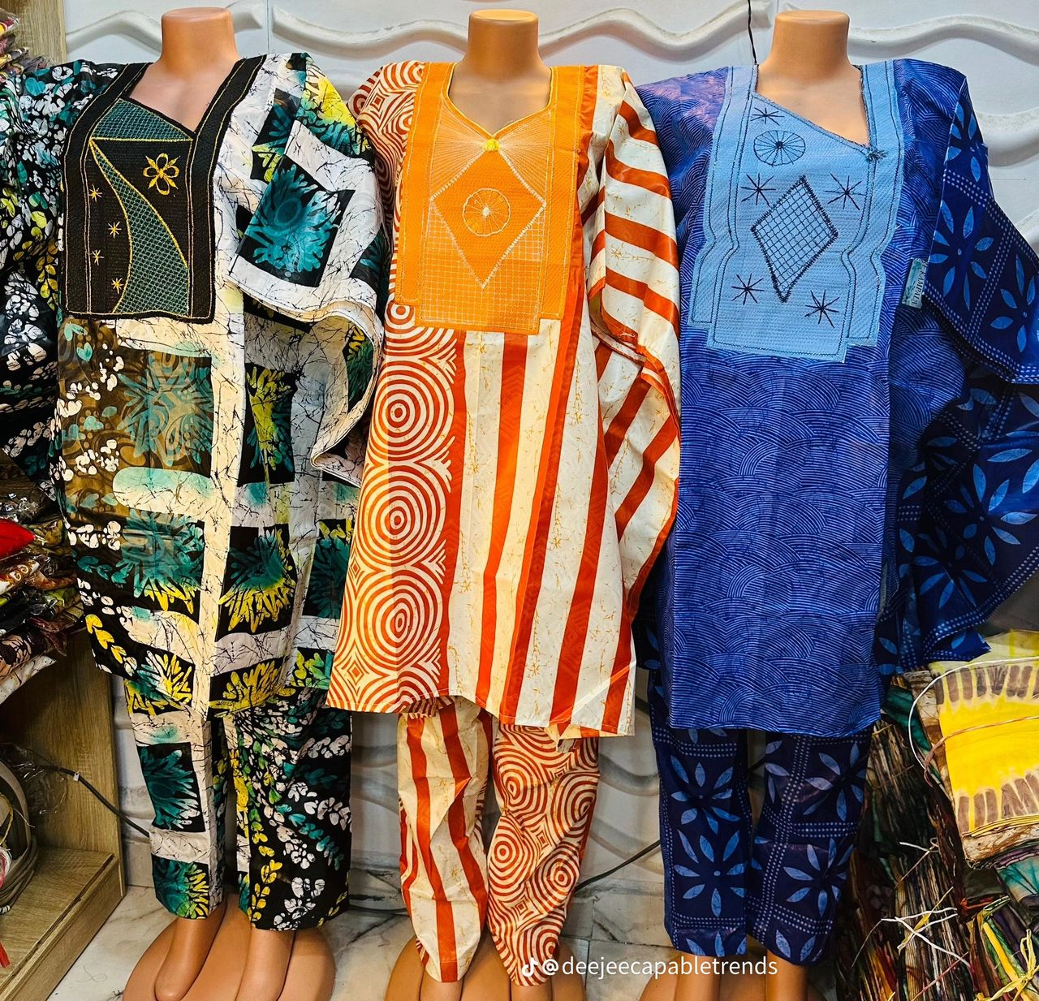
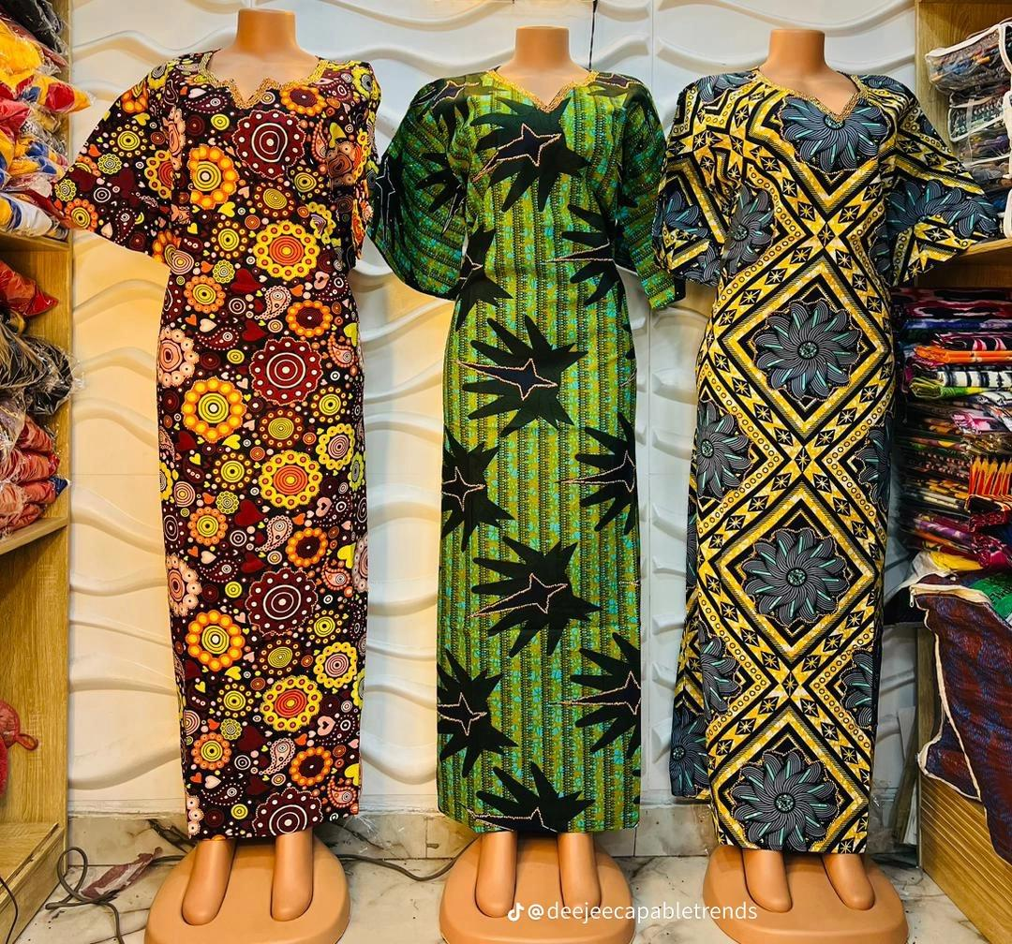

CHAPTER THREE

3.1 How to Open Computer to Calculate Fabric Branding/Clothing Branding
Branding is a crucial component of any business, especially in the fashion industry. At Dee Jay Capable Trends, fabric branding and clothing branding are essential for creating a distinct identity and gaining customer recognition. The process of branding includes the creation of logos, labels, tags, and the design of patterns that reflect the company's image and values. To manage and calculate fabric branding and clothing branding effectively, it is important to understand how to utilize basic computer tools.
The first step is to open the computer, which is typically done by:
- Pressing the Power Button: Turn on the computer by pressing the power button on the CPU or laptop.
- Logging In: Enter the necessary login credentials (username and password) to access the computer.
- Opening the Design Software: The main tools for fabric and clothing branding are design software programs such as Adobe Illustrator, CorelDRAW, or simpler tools like Microsoft Paint or Canva. Once the computer is powered up and logged in, open the relevant software used for creating designs and branding materials.
Once the software is open, the next step is to start working on fabric branding, which involves creating the visuals that will be associated with the clothing brand. The branding process typically starts by conceptualizing the elements that will represent the brand's identity.

3.2 Skills Acquired in Fabric Branding/Clothing Branding
During my time at Dee Jay Capable Trends, I was able to acquire several valuable skills in fabric branding and clothing branding. These skills are crucial for creating designs that resonate with consumers and stand out in a competitive market. Here are some of the key skills I gained:
- Designing Logos and Patterns: One of the most important aspects of clothing branding is designing a memorable logo. A logo serves as the face of the brand and is often used on clothing tags, labels, and promotional materials. During my SIWES program, I learned how to create logos that are simple, scalable, and memorable. The process involves choosing the right colors, shapes, and fonts to represent the brand’s identity. The logos are then incorporated into fabric patterns, which are either hand-painted or printed onto the fabric, creating a unique aesthetic for the clothing line.
- Using Design Software: I became proficient in using various design tools, particularly CorelDRAW and Adobe Illustrator, which are essential in fabric and clothing branding. These software programs offer a range of features such as vector drawing tools, color palettes, text manipulation, and the ability to create intricate patterns. With these tools, I learned to design everything from basic brand logos to complex patterns that would later be printed on fabrics like Adire, Agbada, or Dansiki.
- Selecting Fabric for Branding: Understanding how fabric type influences branding was a crucial skill I learned. Each fabric has its own characteristics, such as texture, thickness, and how well it holds dye or ink. Some fabrics, like cotton, are excellent for screen printing because they absorb ink easily, while other fabrics like silk or polyester require different techniques to ensure the branding remains intact. I learned to select the appropriate fabric type for different branding techniques, ensuring that the final product is durable and aesthetically pleasing.
- Digital Fabric Printing: One of the most exciting aspects of fabric branding is the digital fabric printing process. This involves transferring a digital design onto fabric through specialized printers. At Dee Jay Capable Trends, I was exposed to the process of preparing digital files for printing, ensuring that the resolution of the image was high enough for a clear print. This required attention to detail to ensure the design was not distorted when printed on fabric, which could affect the overall branding quality.
- Understanding Color Theory: Color plays a pivotal role in clothing branding because it helps evoke specific emotions and associations. I learned the importance of color psychology, which involves choosing colors that communicate the right message to customers. For instance, red can signify passion or energy, while blue is associated with calmness and trust. In branding, selecting the right combination of colors for the fabric, the logo, and any other design elements ensures that the clothing line has a cohesive and appealing look.

3.3 SKILLS ACQUIRED ON NATIVE DRESSING
The process of native dressing is an art form, particularly for traditional African garments like Agbada, Dansiki, and Kanpala. Native dresses carry cultural significance, and creating garments that are both fashionable and culturally respectful requires expertise. During my SIWES placement, I acquired essential skills related to native dressmaking, which included both the technical aspects of clothing design and the cultural understanding of various fabrics and garments.
- Understanding Traditional Fabrics: Native dresses like Agbada and Dansiki are often made from specific traditional fabrics like Adire (a hand-dyed cotton fabric), Aso-Oke (a handwoven fabric), or Shantung silk. I learned how to handle these fabrics and understood the importance of preserving their integrity during the designing and branding process. Each fabric carries its own unique cultural value, and knowing how to work with them effectively allows for a more authentic product.
- Designing Traditional Garments: Native dresses require a different design approach compared to Western-style clothing. For example, Agbada is a wide, flowing robe worn by men, often with elaborate embroidery, while Dansiki is a traditional garment worn by both men and women, characterized by its loose fit and flowing design. I learned how to create patterns for these garments that respect traditional elements while incorporating modern style preferences. This involves understanding how to cut, sew, and finish the garments, ensuring they fit well and are comfortable for the wearer.
- Incorporating Cultural Symbolism: Native dressing is deeply tied to cultural symbolism. I learned how certain colors, patterns, and styles can signify different things in various cultures. For example, in some Nigerian ethnic groups, the color white represents purity, while gold is associated with royalty. The embroidery and design choices made in Agbada or Dansiki are often influenced by these cultural symbols. I was involved in learning how to incorporate these elements into the designs, making sure that the final product is not only stylish but also culturally relevant.
- Techniques for Finishing Native Dresses: Native garments are often hand-finished with embroidery, beadwork, or appliqué. I gained skills in hand-finishing these garments, ensuring that the stitching was neat, strong, and aesthetically pleasing. The finishing techniques are essential because they contribute to the overall quality and durability of the garments.
- Customizing Orders: One of the key skills I acquired was the ability to customize native dresses according to customer specifications. Whether it was adjusting the fit of an Agbada or incorporating a specific color or pattern requested by the customer, I learned to make necessary adjustments to ensure customer satisfaction. This skill also involved understanding the specific measurements and preferences of the client, which is vital in the creation of bespoke native garments.
Fabric branding and clothing branding are integral parts of the fashion industry, and the skills I developed during my SIWES program at Dee Jay Capable Trends have provided me with a strong foundation in these areas. From learning how to create logos and designs to understanding the intricacies of traditional African garments, this experience has greatly enhanced my knowledge of clothing branding.
Furthermore, the ability to understand and work with native fabrics like Adire and Aso-Oke has given me a deeper appreciation for the cultural significance behind native dresses. By combining traditional techniques with modern branding strategies, Dee Jay Capable Trends ensures that its products stand out in the competitive fashion market.
The hands-on experience gained in this chapter has not only strengthened my technical skills but also my creative problem-solving abilities, which are essential in the world of fashion design and branding.

CHAPTER FOUR
CHALLENGES, CONCLUSION AND RECOMMENDATION
4.1 CHALLENGES ENCOUNTERED DURING MY SIWES PROGRAMME
- Distance from my home to my place of attachment.
- Lack of payment from the ITF.
- Lack of Transport Fare.
- Traffic Congestion
- Discrimination between Polytechnic Students and University.
4.2 CONCLUSION
I give God all the glory for his grace for making me to finish the SIWES programmed without any problem and also thanks go to the Statistics Department of Kwara State Polytechnic, Ilorin. Also, I am not ungrateful to the contribution of Dee jay Capable Trends. So I thank God for his wonderful knowledge and wisdom given to me.
Finally my appreciation goes to ITF office for organizing this programme.
4.3 RECOMMENDATIONS
I will suggest that the ITF should keep the SIWES program going so that students in the higher institution of learning can gain more practical experience which will prepare them ahead of the labour market demands.
I will also like to recommend Dee jay Capable Trends to student for SIWES programme. They are just not training student only on computer, but to grace the challenges out there and also their career, for them to know what Information Technology (IT) is all about. They give the right IT skill.

REFERENCES
Dee Jay Trends Enterprise Handout/Lecture Notes
SIWES Logbook
Wikipedia

