TECHNICAL REPORT
ON

STUDENTS INDUSTRIAL WORK EXPERIENCE SCHEME (SIWES)
UNDERTAKEN AT

SAYO AND ASSOCIATES
Suite 38 ore ofe jesu complex opposite bite more monatan iwo-road Ibadan

COMPILED AND SUBMITTED
BY
Oladayo olabode Quyum
ND/23/ARC/FT/0010

SUBMITTED TO
THE DEPARTMENT OF ARCHITECTURE,
KWARA STATE POLYTECHNIC, ILORIN

IN PARTIAL FULFILLMENT OF THE REQUIREMENT FOR THE AWARD OF
NATIONAL DIPLOMA IN ARCHITECTURE

Janurary, 2025

DEDICATION
I dedicate this industrial attachment technical report to the Almighty God for his grace and love for me, and also to my family for their love and constant words of encouragement to me at the times when I needed it the most.

ACKNOWLEDGEMENT
All glory and honour be to God for whom he has made me today, without him, I am nothing. My profound gratitude and unreserved thanks to my parents, Mr. and Mrs. Ademola Apelehin, for their continual shower of love, words of insight and affection right from my birth till this moment. My gratitude to my siblings for their encouragement, support and love. Also worthy of mention is the entire staff of SAYO AND ASSOCIATES, where I did my Industrial Training. I found in them a set of dedicated people who were always there for me throughout the industrial training period.

ABSTRACT
This students industrial work experience scheme (SIWES) report is an account of my six (6) months Industrial Attachment Training undertaken at Lagos State Ministry of Housing in the Department of Architectural and Building Services situated at Block 3, Lagos State Secretariat, Alausa-Ikeja, Lagos State, from the month of July to December 2018 where I learnt a lot about design, construction and site supervision. This helped me to improve on my design and it also helped me to have a more practical knowledge in the field of construction. During my six months of internship with the Lagos State Ministry of Housing, I was attached to the MASS HOUSING and LANDSCAPING PROJECTS undertaken by the company, and as a result I was very fortunate to be involved directly with various project designs and implementation.

TABLE OF CONTENTS
DEDICATION ii
ACKNOWLEDGEMENT iii
ABSTRACT iv
CHAPTER ONE 1
1.0 INTRODUCTION 1
1.1 BACKGROUND 1
1.2 SCOPE OF SIWES 1
1.3 AIM AND OBJECTIVES OF SIWES 2
CHAPTER TWO 6
2.0 PROFILE OF LAGOS STATE MINISTRY OF HOUSING 6
2.1 RANGE OF SERVICES OFFERED BY THE DEPARTMENT OF ARCHITECTURAL AND BUILDING SERVICES (ABS) 6
2.2 KEY PERSONNEL AT THE DEPARTMENT OF ARCHITECTURAL AND BUILDING SERVICES (ABS) 7
2.3 COMPANY’S ORGANOGRAM 8
2.4 ARCHITECTURAL PRACTICE IN THE DEPARTMENT OF ARCHITECTURAL AND BUILDING SERVICES (ABS) 8
2.4.1 Client: 8
2.4.2 Funding: 9
2.4.3 Organizational Structure: 9
2.4.4 Project Management: 10
2.5 USE OF CAD, BIM AND OTHER SOFTWARE EMPLOYED IN THE DEPARTMENT OF ARCHITECTURAL AND BUILDING SERVICES (ABS) 10
2.5.1 AUTOCAD 11
2.5.2 REVIT ARCHITECTURE 11
2.5.3 3D STUDIO MAX 12
2.5.4 SKETCHUP 13
2.5.5 CORELDRAW 14
2.5.6 MICROSOFT OFFICE 14
CHAPTER THREE 17
3.0 WORK EXPERIENCE 17
3.1 TECHNICAL EXPERIENCE 17
3.1.1 DESIGN-STUDIO EXPERIENCE 17
3.1.2 DRAFT 18
3.2 ADMINISTRATIVE EXPERIENCE 18
3.2.1 RECORDS AND FILING 19
3.3 FIELD EXPERIENCE 19
3.3.1 SITE MEETINGS AND INSPECTION 19
3.3.2 CONSTRUCTION WORK 20
3.4 GENERAL SITE SAFETY PRECAUTIONS 21
CHAPTER FOUR 22
4.0 DETAILS OF SELECTED PROJECTS UNDERTAKEN 22
4.1 ODO-ONOSA HOUSING ESTATE, AGBOWA-IKOSI, LAGOS STATE. 22
4.2 PROBLEMS ENCOUNTERED ON SITE 25
4.3 RENDERING OF AN OFFICE SPACE 28
4.4 DESIGN OF A COMMUNITY GATEHOUSE 29
4.5 DESIGN OF A BUILDING PROTOTYPE FOR AN ESTATE 31
4.6 DESIGN FOR AN ART GALLERY 34
CHAPTER FIVE 36
5.0 CONCLUSION 36
5.1 RECOMMENDATIONS 36

CHAPTER ONE

1.0 INTRODUCTION
This was introduced in Nigeria by the decree No.46 of 1971 for students in institutions of Higher Learning. The Students Industrial Work Experience Scheme (SIWES) was conceived as a tool to expose the students to the practical aspect of their various disciplines which the academic environment is not in a position to offer.
It is aimed at exposing the students to the outside world to experience and appreciate the deference inherent in professional practice and the theory that is imparted to them in their various institutions. The scheme is an important tool in creating a well-rounded education as it not only improves academic knowledge. It equips the students with the necessary skills and technical know-how along with human relationship and the professional ethics in his or her chosen career which in turn generates manpower development in the nation as a whole.

1.1 BACKGROUND
The Students Industrial Work Experience Scheme (SIWES) is a technical programme required in partial fulfillment of the Award of Bachelor of Technology to students in the School of Science, Agricultural, Engineering, Management, and Environmental Technology.
The Federal University of Technology, Akure actively engages her eligible 400level Students on the scheme for a period of 6 months preparatory to the final session in the university. This is the period students are expected to have full Industrial Training Experience.

1.2 SCOPE OF SIWES
SIWES as conducted by the Industrial Training Fund (ITF) and their representative unit in the various institutions is designed to acquaint students in tertiary institutions in Nigeria with the necessary practical/industrial rudiments needed to corroborate the required theoretical knowledge.
The student industrial experience not only exposes students to practical knowledge of the course of study but also perfects their knowledge thereby making them competent professionals.

1.3 AIM AND OBJECTIVES OF SIWES
SIWES brings about a hand-on-the-job training in the industries. It bridges the gap between the level knowledge acquired in tertiary institutions and the practical application of such in the field of work.
The scheme came about through the ITF policy statements No.1 of 1973 with the following objectives:
- To prepare students for the work situations they are to meet after graduation.
- To provide an avenue for students in institution of higher learning to acquire industrial skills and experience in the course of their study.
- To provide students an opportunity to apply his knowledge in real work situation thereby bridging the gap between college work and actual practice.
- To expose students to work methods and techniques in handling equipment and machinery that may not be in educational institutions.
- To make transition from school to the World of work easier and enhance students contact for later job placements.
- To enlist and strengthen employers involvement in the entire educational process for preparing students for employment industry.

CHAPTER TWO

2.0 PROFILE OF LAGOS STATE MINISTRY OF HOUSING
The Lagos State Ministry of Housing was created in 1999 at the inception of the Administration of His Excellency Asiwaju Bola Ahmed Tinubu in Lagos State. The Ministry is a government parastatal which comprises a team of reputable professionals in the building industry from architects, builders, estate valuers to quantity surveyors.
The Ministry comprises of different departments which are responsible for its success and they include; Administrative and H.R, Architectural and Building Services, Accounts, Quantity Surveying, Physical Planning and Surveying, ICT, Estate, Engineering Services, Legal Services, Public Affairs, Planning and Budget, Internal Audit and Mortgage Unit Departments.
The Ministry also partners with consultants and contractors on different housing projects in order to meet with the ever increasing housing needs of the citizens.
The Ministry is concerned with the provision of affordable housing for the citizenry and it does it so effectively by creating several housing scheme all over the state and is funded through partnership with private industries. A major notable scheme worthy of mention through which the Ministry employs in creating housing is the LAGOSHOMS (Lagos State Home Ownership Mortgage Scheme) and through this scheme has provided numerous families with affordable housing since its launch in February 2014.

2.1 RANGE OF SERVICES OFFERED BY THE DEPARTMENT OF ARCHITECTURAL AND BUILDING SERVICES (ABS)
- Lagos State Ministry of Housing provides architectural drawings (working and presentation) to be used in the development of the several housing schemes.

- They also hold design defense from several consultants and contractors who come with different designs to be approved for development.

- The Ministry also offers consultancy services for new innovations in building such as new affordable building material or new building technique.

- The Ministry also undertakes the utilization and landscaping of public spaces around the state.

- The Ministry acts as project managers and supervisors on projects not handled directly by them. The most notable responsibility of the Ministry is the management and supervision of the LAGOSHOMS Project.
The Lagos Home Ownership Mortgage Scheme (Lagos HOMS) is a government initiative created to encourage and support home ownership of First - Time Buyer (FTB) residents of Lagos Sate to purchase decent and affordable homes through the provision of accessible mortgage finance. Lagos HOMS is administered by the Lagos State Mortgage Board (LMB). Lagos HOMS is the product of a Public-Private Partnership between the Government and private companies. The LAGOSHOMS Project is distributed at various parts throughout the state including; Gbagada, Ilupeju, Ikorodu, Igbogbo, Badagry etc.
During my internship with the Ministry, I was attached to the LAGOSHOMS Project in Igbogbo.

2.2 KEY PERSONNEL AT THE DEPARTMENT OF ARCHITECTURAL AND BUILDING SERVICES (ABS)
NAMES POSITION
- ARC. R.B. IBITOYE DIRECTOR
- ARC. B.M. OLUKAREH ASST. DIRECTOR
- BLDR. OLUSEGUN AKINSANYA ASST. CHIEF BUILDING OFFICER

2.3 COMPANY’S ORGANOGRAM
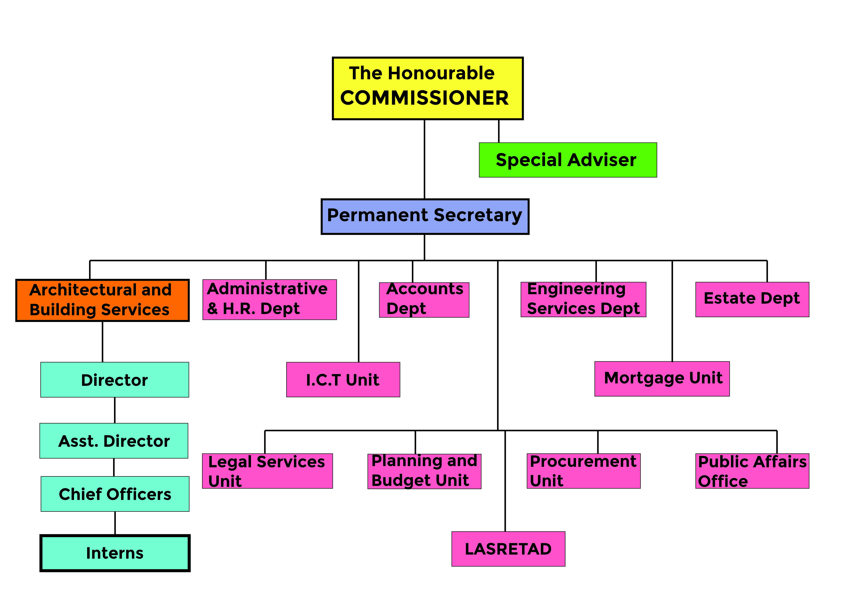
Figure 1: An image showing the organogram of the Ministry of Housing.

2.4 ARCHITECTURAL PRACTICE IN THE DEPARTMENT OF ARCHITECTURAL AND BUILDING SERVICES (ABS)
In almost all 21st century architectural firms, the way they practice architecture however unique may not be so different but the Lagos State Ministry of Housing where I did my internship is quite different from most architectural firms in several ways for example; the primary client of the Ministry are the citizens of the state.
Consequently, I will be explaining the mode of architectural practice in the Ministry under the following headings:

2.4.1 Client:
For every architectural firm, there’s always a client with a project that needs to be executed by professionals. The magnitude of every project may differ due to the financial capacity of the client.
In the department of Lagos State Ministry of Housing, the primary client are the citizens of the state and so every construction project the Ministry undertakes, it is towards the betterment of the lives of the general populace.

2.4.2 Funding:
In Nigeria, we practice a democratic system of government and so every project the Ministry executes is funded by taxpayers money and in some cases as I’ve experienced during my internship, the Ministry partners with companies in the private sector in what is known as a PPP (Public-Private Partnership) venture and what this entails is that the government provides the site for construction and the private company provides the funding for the project and then a plan for repayment is formulated. This method of funding is what the Ministry predominantly uses because they don’t necessarily have to dip into their generated revenue and they still get to provide quality infrastructure for the masses.

2.4.3 Organizational Structure:
Every architectural firm has a principal who is responsible for the practice and is also its sole proprietor or two if it’s a partnership and if the firm is a large one – it will consist of different departments.
Similarly, at the Ministry (even though it is not a private firm) the organizational structure is almost the same as I will explain in the following paragraphs.
The Ministry of Housing consists of different departments, the architectural department is just one of the several departments and the head of all the departments is the Honourable Commissioner, the head of the architectural department is the Director (which is the same things as a Principal in the private firms). In the architectural department, there are licensed architects who produce designs, there are also builders who also assist the architects on site and there are also office clerks who sort out the records and files.

2.4.4 Project Management:
In the Ministry of Housing, the construction projects are supervised and coordinated by architects who work with builders and surveyors on site

2.5 USE OF CAD, BIM AND OTHER SOFTWARE EMPLOYED IN THE DEPARTMENT OF ARCHITECTURAL AND BUILDING SERVICES (ABS)
The letters CAD stands for computer-aided design. BIM is an acronym for Building Information Modeling. These applications are the software tools of architects, drafters, engineers, and builders. Various types of software can create plans, construction drawings, and precise lists of building materials, and even instructions on how and when to put together the parts. For constructing and designing things, CAD and BIM are more efficient than paper and pencil because the application records lines as vectors based on mathematical equations.
The idea of designing with the help of computers began in the 1960s with the growth of automobile and aerospace companies. The CAD industry became firmly established in the 1970s with software and hardware sold together in very expensive, dedicated machines. It wasn’t until the 1980s that personal computing (PC) was possible and affordable, with the goal of having a PC on every desk in the office. The growth and evolution of CAD is traceable to the global advancement of science and technology and the need to evolve a faster, more accurate and a more flexible approach to design problems. The desire and necessity to overcome the limitations of manual drafting techniques has led to subsequent improvement on CAD (Computer-aided Design) applications and the development of new ones.
With CAD, a designer could switch between two-dimensional (2D) and three-dimensional (3D) views; zoom in and out for close-up and distant views; rotate images to view them from different perspectives; manipulate the shape of images; and change the scale of images – when one value changed, related values automatically adjust.
There are more than seventy different CAD applications software in use today. Only about twenty of these are in wide spread use for Architectural jobs in Nigeria presently. Just as Microsoft Office is the most popular word processor, AutoCAD is equally the most wide spread CAD application in use in the world today.

2.5.1 AUTOCAD
AutoCAD is a 2D and 3D computer-aided drafting software application used in architecture, construction, and manufacturing to assist in the preparation of blueprints. It is mostly used for its 2D aspect of drafting and its interface is easy to use and understand.
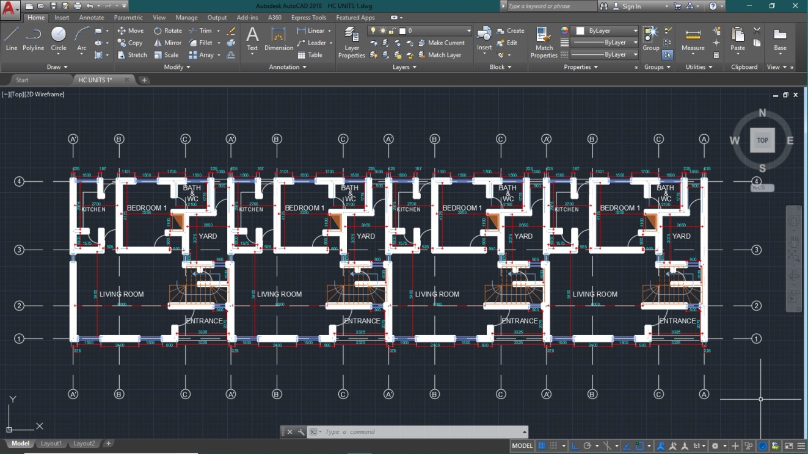
Figure 2: An image showing the user interface of AutoCAD 2018

2.5.2 REVIT ARCHITECTURE
This is another similar CAD tool to AutoCAD. It can as well be used to produce 2- and 3- dimensional drawings. Its advantage over AutoCAD is that it is faster to use and helps in specifying for components. It is also quite flexible in that files worked on in Revit can also be exported and worked on in other applications.
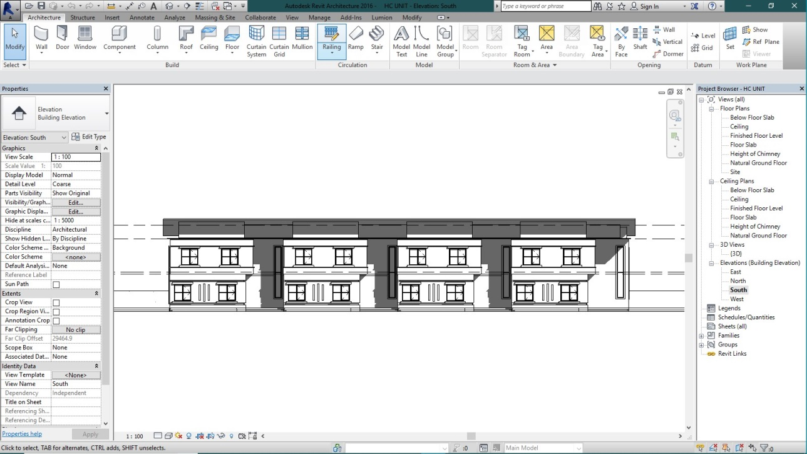
Figure 3: An image showing the user interface of Revit 2016

2.5.3 3D STUDIO MAX
3D studio max is one of the most popular realistic rendering software. It was developed by Autodesk, the same company that developed the AutoCAD software mainly to overcome the limitations of AutoCAD. It is mainly a presentation package used to produce 3D drawings. It is not used to produce 2D drawings, it has three main features
- Creation of 3D models
- Rendering of 3D models
- Animations
3D studio max is not limited to architectural models only; it can be used to model a wide range of objects, from tea kettles to helicopters. It is used in the film making industry to produce cartoons and games. It produces photo-real images and it is very easy to use. It has tens of thousands of commands but only a few of these are needed to produce architectural models and renderings.
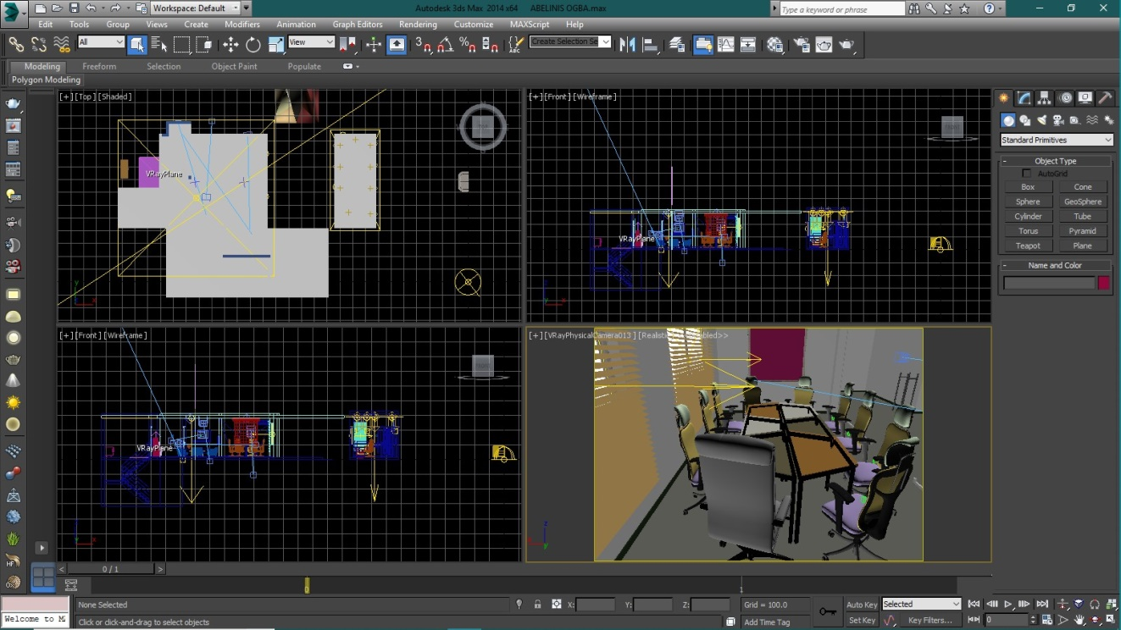
Figure 4: An image showing the user interface of 3ds Max Studio 2014

2.5.4 SKETCHUP
SketchUp is very flexible, a CAD software developed by Google, which is capable of drafting, modeling and rendering. The application is so versatile that it can be used in other professions such as; Civil Engineering, Building etc.
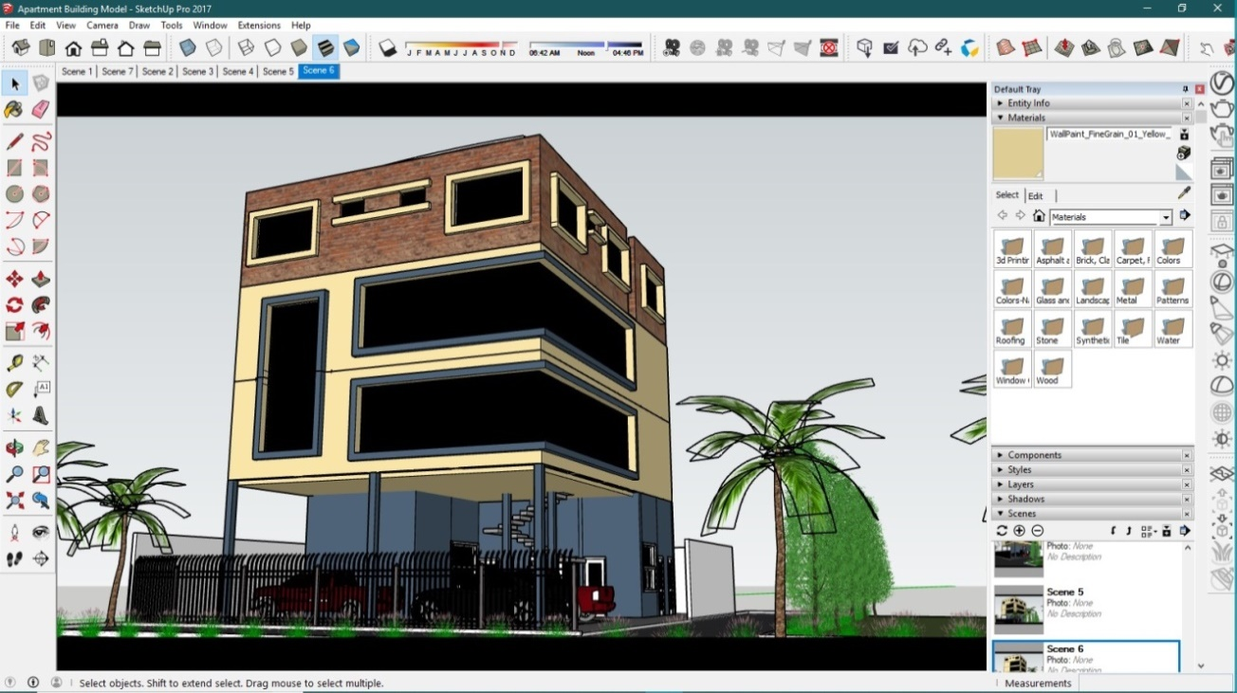
Figure 5: An image showing the user interface of SketchUp 2017

2.5.5 CORELDRAW
CorelDRAW is a vector graphics editor. The software is a robust graphics suite, providing many features for users to edit graphics. These features include contrast adjustment, color balancing, adding special effects like borders to images, and it is capable of working with multiple layers and multiple pages.
CorelDRAW was originally released in January 1989. Today, the software is still used by many people, with the latest version, X8, being released on March 15, 2016.
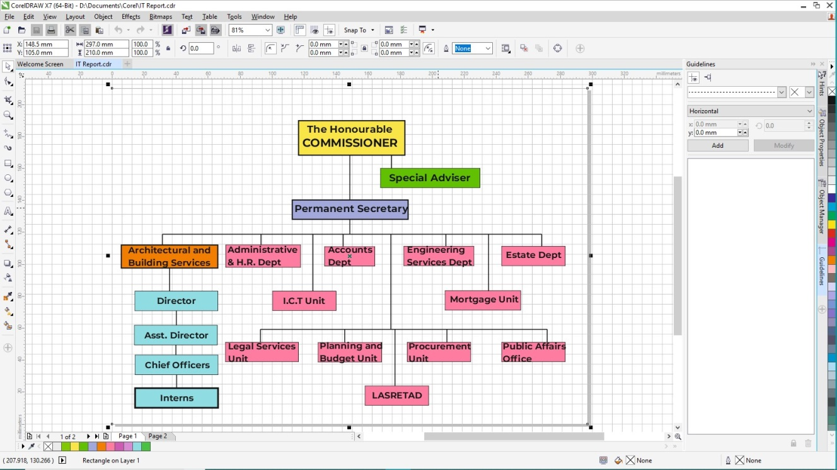
Figure 6: An image showing the user interface of Corel Draw X7

2.5.6 MICROSOFT OFFICE
Suite of products developed by Microsoft Corporation that includes; Microsoft Word, Excel, Access, Publisher, PowerPoint, and Outlook. Each program serves a different purpose and is compatible with other programs included in the package. Microsoft Office can be used to type letters and envelopes, create spreadsheets, make labels, and produce presentations. Microsoft Office is the most common form of software used in the western world. Of all these products, the two I used frequently throughout my internship period at the Ministry was Excel and Word.

2.5.6.1 EXCEL
Microsoft Excel is a spreadsheet program used for calculations, making charts and recording data about all sorts of business processes. That means it is used to create grids of texts, numbers and formulas specifying calculation. This function is extremely valuable for many businesses, which use it to record expenditures and income, plan budgets, charts data and succinctly present fiscal results.
Like Microsoft Word, Excel has become a de facto standard in the business world, with Excel spreadsheets frequently emailed and otherwise shared to exchange data and perform various calculations.
Excel also contains fairly powerful programming capabilities for those who wish to use them that can be used to develop relatively sophisticated financial and scientific computation capabilities.
During my internship, I used Excel to prepare monthly project progress reports.
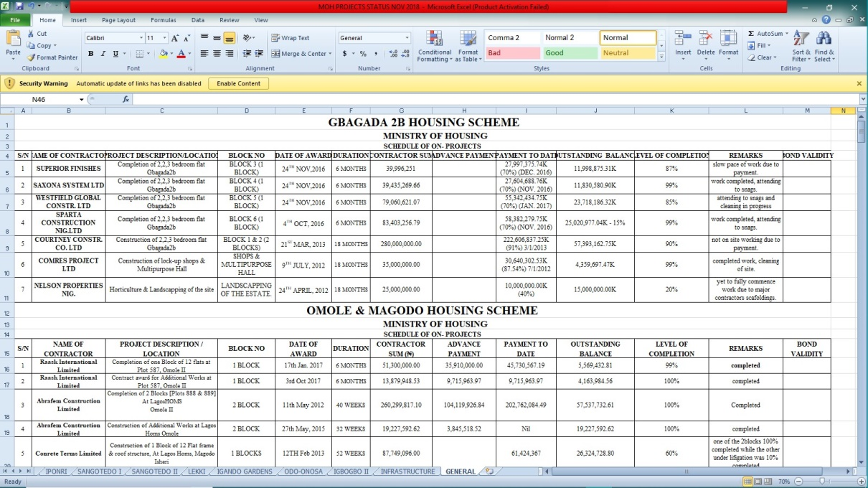
Figure 7: An image showing the user interface of Microsoft Excel 2010

2.5.6.2 WORD
Microsoft Word is a word processing program used for writing letters, memos, reports and paper presentations. Microsoft Word is also designed to make it possible to create a variety of documents that will look the same between different computers and similar on the screen to how they appear on paper.
It is used by businesses and individuals to write personal and professional letters, reports for work and school and to take notes on conversations and in seminars and classes. Because it is so widely used, many businesses appreciate that it’s possible to send documents created in Word to clients, employees and other business associates without worrying about whether or not they will be able to open them.
During my internship at the Ministry, I used Word to type memos, site reports, letters etc.
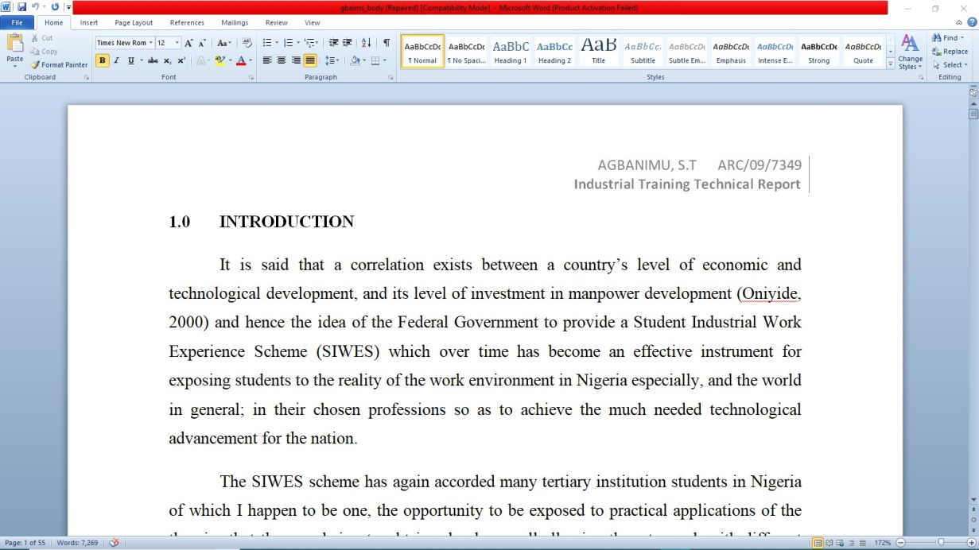
Figure 8: An image showing the user interface of Microsoft Word 2010

CHAPTER THREE

3.0 WORK EXPERIENCE
During the course of my internship at the Ministry of Housing, I was exposed to a lot of practical realities in the discipline of Architecture. I was assigned to my supervisor by the name Arc. B.M. Olukareh while in the office, and Bldr. O.A. Akinsanya while on site, which I was always accountable to. The official working hours was between 8am and 4pm but occasionally, I have had to close later than the official time due to some inexcusable reasons. My internship experience at the Ministry of Housing was highlighted by the various duties:
- Provision of Design Solutions.
- Preparation of Design Sketches.
- Preparation of Working and Presentation Drawings.
- Preparation of Details.
- Attending Site Inspection and Meetings.
My work experience is divided into various parts for easy understanding.
- Technical Experience – This explains the administrative and design & studio aspect
- Field Experience - This explains the aspect of work related to construction work, site meetings and so on.

3.1 TECHNICAL EXPERIENCE
Throughout the course of my learning experience at the Ministry of Housing, I was able to learn the fundamental technicalities needed for an Architect to be relevant in the present day practice. These technicalities are categorized below:

3.1.1 DESIGN-STUDIO EXPERIENCE
The studio is a place where architectural drawings are made. The way the factory is to the manufacturer that is the way a studio is to the architect. During my internship at the Ministry of Housing, the office space was also the studio and each person worked in his/her computer. Working in the office or studio as it were also exposed me to the use of a number of computer aided design (CAD) software which over time has replaced the use of manual drafting that once dominated the profession. As I got more comfortable with the demands of the job my techniques and proficiency in the use of numerous software improved.

3.1.2 DRAFT
Drafting is a means for the architect to express himself/herself. It is a formidable tool in the profession because it is what the Architect uses in generating or preparing drawings needed for construction. As earlier said, AutoCAD remains the most popular drafting software due to its versatility and functions. It also happens to be the primary drafting software employed at the Ministry of Housing. The use of AutoCAD constituted part of my Working Experience in the office as I made use of it in the preparation of drawings, details, specifications etc.

3.1.2.1 USE OF COMPUTERS IN ARCHITECTURAL PRACTICE
The use of computers in architectural practices has increased so much in this decade that all the leading architectural firms in Nigeria are fully computerized. A careful observation will reveal that the firms that are not computerized do not normally get large commissions and projects. Furthermore, only the firms that are computerized are in most cases called to bid for new projects through design competitions. The smaller firms not computerized never win or get the upper hand when invited for such competitions. Furthermore, these architectural firms not yet computerized are now training their staffs in the use of Computer Aided Design. If this new development continues, no graduate of architecture will get a good job without being computer literate.

3.2 ADMINISTRATIVE EXPERIENCE
Part of the aims of the SIWES Programme is to make students have a feel of the labour market so as to understand what it takes to assume responsibility in the employment world. This was largely experienced at my place of industrial attachment as a lot of responsibilities were entrusted into my care.

3.2.1 RECORDS AND FILING
Careful filing is most important as much time can be lost searching for documents when the need arises. Therefore a proper filing of these records or document in a way in which they can easily be retrieved is highly necessary. Documents in the case of large jobs can be sub-divided into several files, e.g. architects, contractors, subcontractors, supplies, reports etc.
My training also permitted me to take records, keep files, and produce progress report of projects directly and indirectly. Such files are presented to my principal or senior colleagues at the close of work for assessment and remarks. My secretariat qualities were called to actions at those times.
My industrial training exposure was all encompassing as no area of administration was left untouched. My training also permitted me to take records, keep files, and produce progress report of projects directly and indirectly. Such files are presented to the boss at the close of work for the week for assessment and remarks. My secretariat qualities were called to actions at those times.

3.3 FIELD EXPERIENCE
Every building erected today is sitting on a site. Sites vary from one place to the other and have various complexities. It is important to note that every site is unique. During my internship period, I have had the privilege to experience firsthand some difficult situations on site and with the tutelage of my supervisor, learnt to overcome them.

3.3.1 SITE MEETINGS AND INSPECTION
Opportunity was given to me to visit a number of sites while working at Lagos State Ministry of Housing. I was allowed to go see some of the details I draw in the office on site. Although some site were ongoing before the commencement of my SIWES programme but I was still able to catch up with some of them.
During my internship at the Lagos State Ministry of Housing, I was attached to one major site namely ODO ONOSA/ODOAYANDELU HOUSING SCHEME, AGBOWA-IKOSI in Lagos state. Site meetings were held once every month at the site due to the magnitude of the project. The meetings were usually anchored by my supervisors. In this particular case, the project was a Public-Private Partnership and so consultants were also present at the meeting. Usually present at the monthly meeting are the following;
- PROJECT CONSULTANTS
- ARCHITECT
- CONTRACTOR
- STRUCTURAL ENGINEER
- ELECTRICAL/MECHANICAL ENGINEER

3.3.2 CONSTRUCTION WORK
Below is brief but detailed description of some of the construction processes witnessed on site:
- Painting
I witnessed the painting of the exterior walls of some of the blocks in the project I supervised. Some of the buildings needed more than a coat of paint before finishing.
- Installation of Kitchen Cabinet
The installation of the kitchen cabinet was just an assembly of the different parts of the cabinet given in the specified materials in the bill of quantities so that all the cabinets in the block were the same.
- Installation of Doors
I witnessed the installation of doors and the grouting involved after installation in order to have a smooth finish
- Installation of Electrical Fixtures
I also oversaw the installation of some wall brackets
- Installation of sanitary wares
I witnessed the installation of sanitary wares such as; the water closet, wash-hand basin etc.
- Tiling
I was accustomed to the several processes involved in the installation of floor tiles

3.4 GENERAL SITE SAFETY PRECAUTIONS
My visits to site married my prior knowledge of safety precautions needed on site and the various possible sources of injuries. Below are some of the site safety precautions:
- Always wear a helmet when on site, this helps prevent the risk of sustaining injuries on the head when tools or materials drop from a height.
- Safety shoes must be worn on site at all times to prevent penetration of sharp objects into the shoe and also impacts from dropping tools or materials.
- A safety mesh must be provided round the exterior of the building to prevent materials from rolling down from upper floors thereby injuring the workmen or others.
- Workmen must never carry loads that will obstruct their view so as to avoid collisions which might lead to injuries.
- When renovations are being carried out, naked wires must be avoided to prevent the risk of electric shock.
- Do not operate machines you are not familiar with to avoid damaging it and inflicting danger on yourself.
- A first aid box should be provided close to the hub of construction activities to give temporary relief in cases of injuries

CHAPTER FOUR

4.0 DETAILS OF SELECTED PROJECTS UNDERTAKEN

4.1 ODO-ONOSA HOUSING ESTATE, AGBOWA-IKOSI, LAGOS STATE.
The ODO-ONOSA Housing Estate is a 660 unit dwelling situated in the outskirts of Ikorodu town. The project is a product of a Public-Private Partnership involving the Government through the Ministry of Housing and a host of private firms.
During my internship at the Ministry of Housing, my supervisor and I oversaw and supervised the development of construction work on site.
SITE LOCATION: Agbowa-Ikosi, Lagos State.
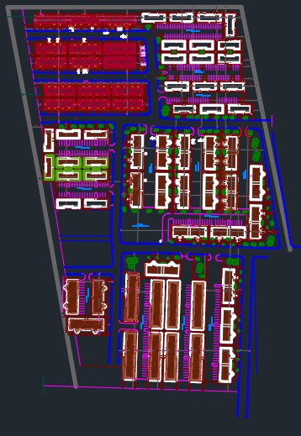
Figure 9: An image showing the layout of the estate

DESIGN DESCRIPTION:
- DOORS:
I supervised the installation of a few 900mm door in different units. The frames were first installed after which a horizontal wooden post was nailed to the frame in the middle to hold in in place before the door was finally installed.
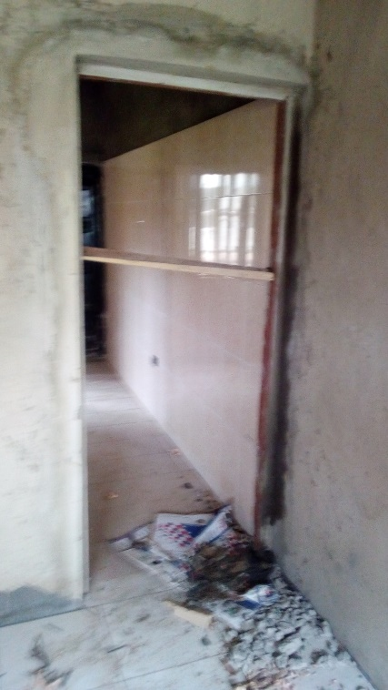
Figure 10: An image showing the installation of the door frame
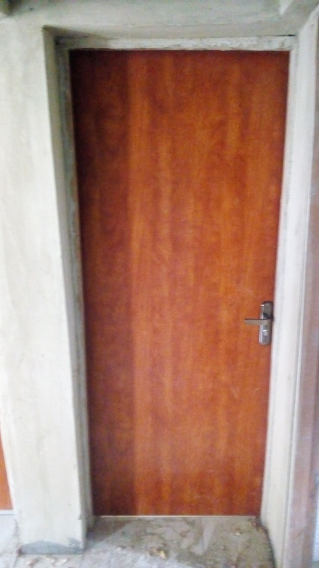
Figure 11: An image showing the installed door

- TILING:
I supervised the installation of the tiling of a room using vitrified 600 x 600mm tiles bounded by mortar

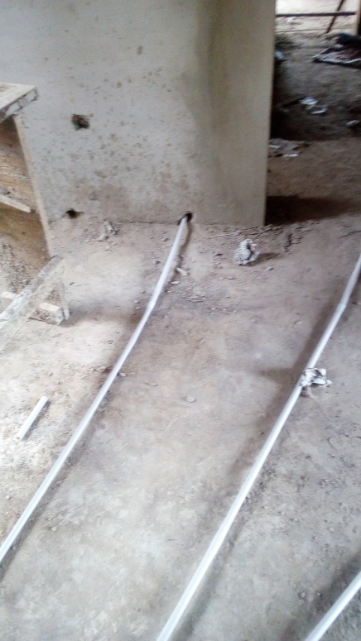
Figure 12: An image showing the state of the floor before it was tiled
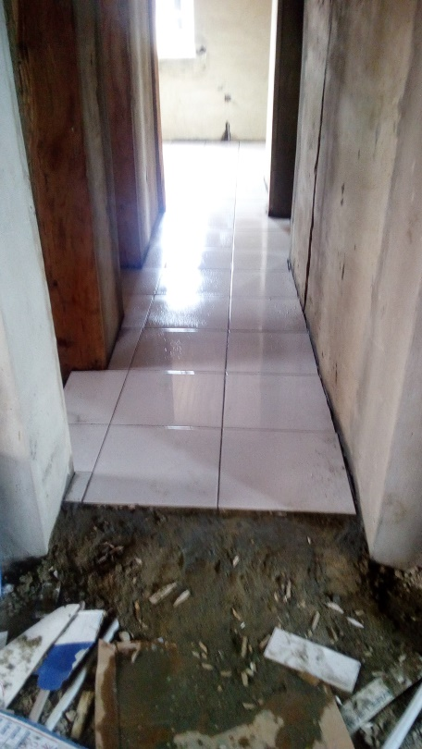
Figure 13: An image showing the state of the floor during tiling
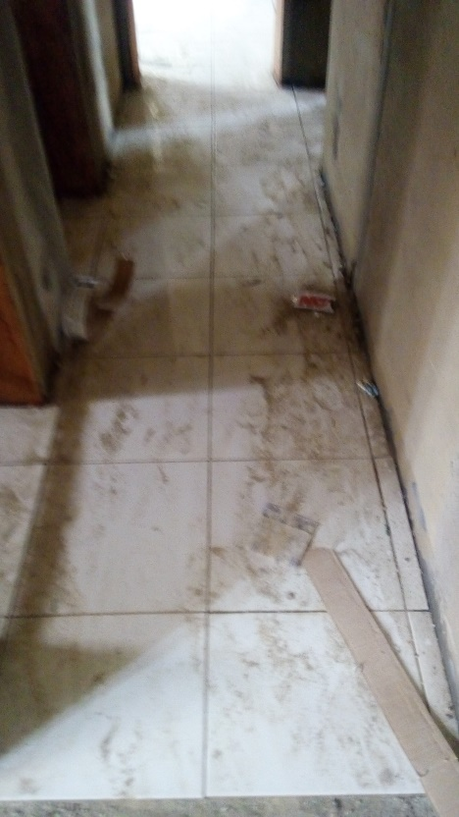
Figure 14: An image showing the state of the floor after tiling

4.2 PROBLEMS ENCOUNTERED ON SITE
During the course of my supervision on site, the construction work encountered a few stumbling blocks and it put the affected parties in a dilemma. While the landscapers were excavating at the middle of the night and leveling the ground surface for the parking lot, the operator of the bulldozer uprooted some sewage pipes and some parts of some building foundation and due to this catastrophe and its cost implications, work had to stop and the architect-in-charge (my supervisors) had to step in to do some conflict resolution in order for work to continue smoothly on site.
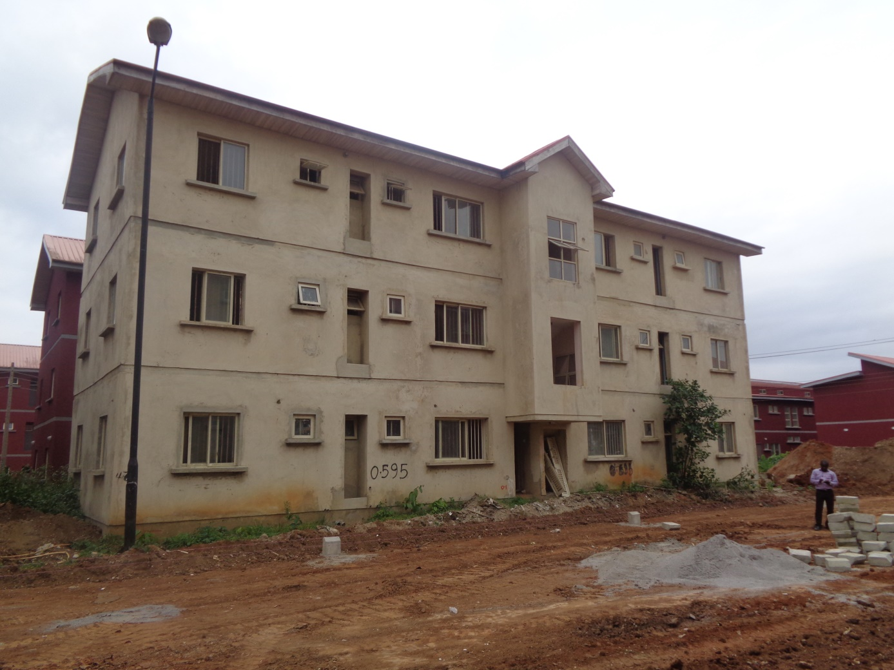
Figure 15: An image showing an overview of the leveled surface
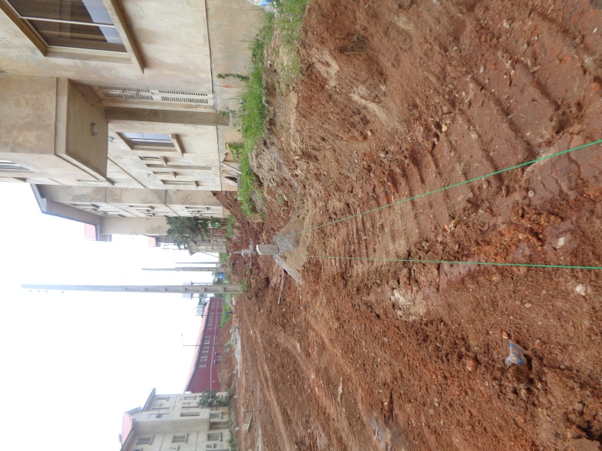
Figure 16: An image showing the extent of damage caused by the excavation team.
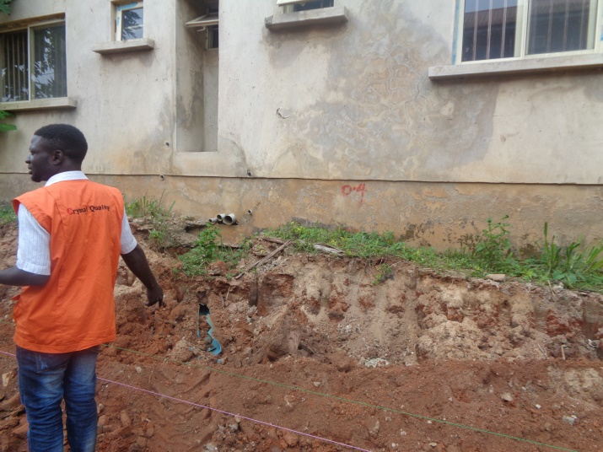
Figure 17: Another image showing the sewage pipes ruined by the excavation team
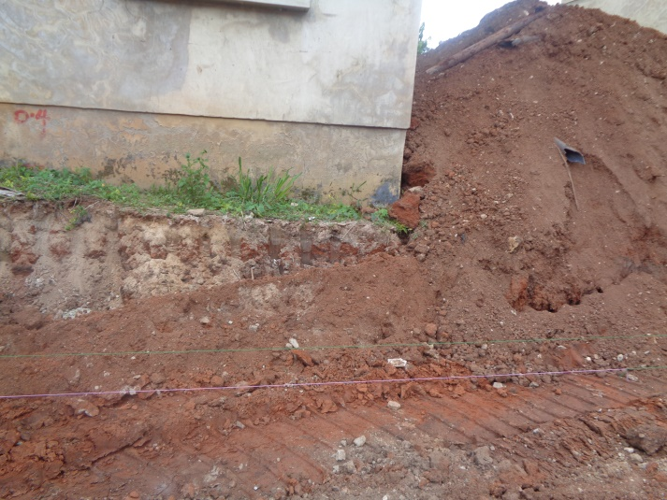
Figure 18: An image showing the parts of the foundation exposed by the excavation team
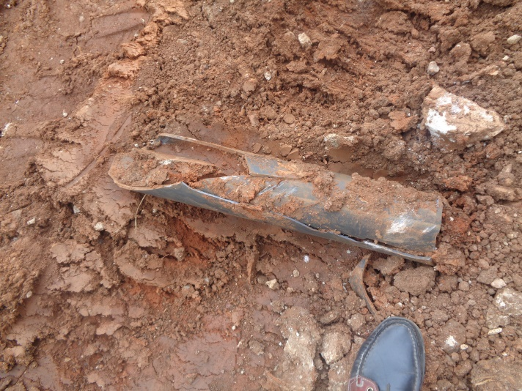
Figure 19: An image showing one of the sewage pipes damaged by the excavation team

4.3 RENDERING OF AN OFFICE SPACE
I was given the brief to design and render a functional and aesthetically pleasing office space by my supervisor. The spatial requirements included a reception and a meeting room. My supervisor gave me this project in order to test my CAD skills and proficiency.
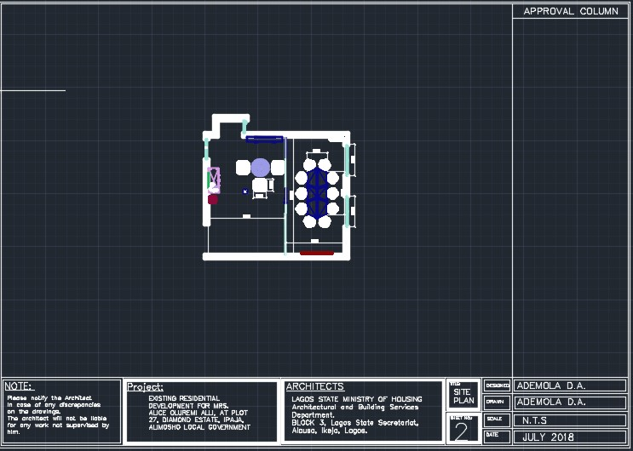
Figure 20: An image showing the floor plan of the design.
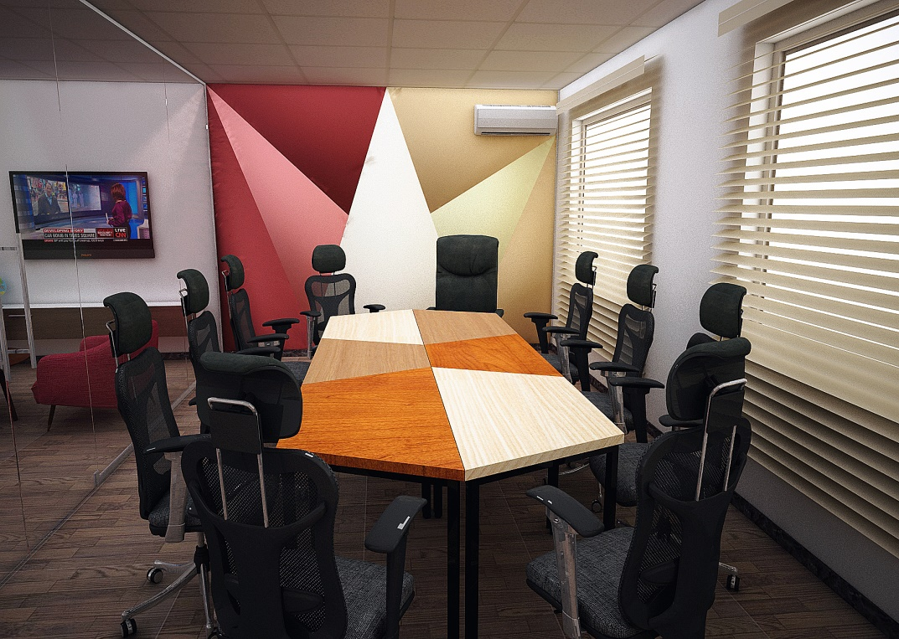
Figure 21: An image showing the meeting room

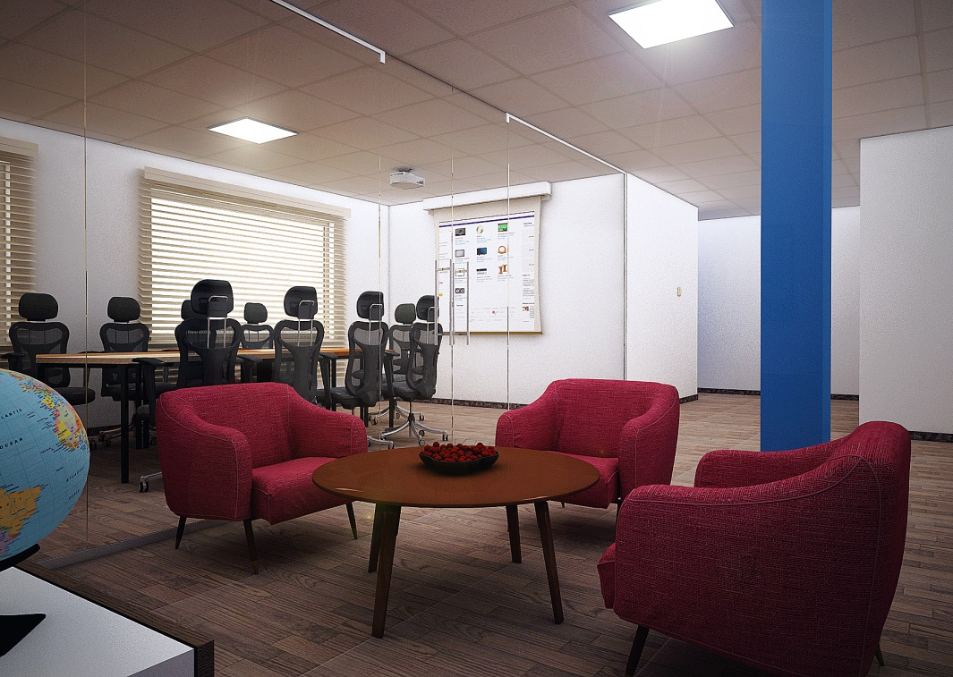
Figure 22: An image showing the reception and the meeting room

4.4 DESIGN OF A COMMUNITY GATEHOUSE
My supervisor gave me a brief to design a gatehouse for a community. The design requirements allowed a creative freedom. The design philosophy is that of minimalism.
`````````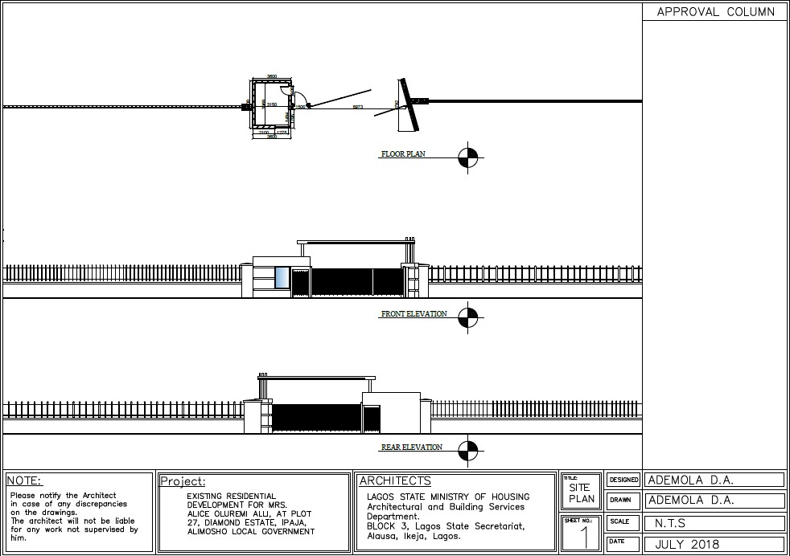
Figure 23: An image showing the floor plan, front and rear elevations of the gatehouse.
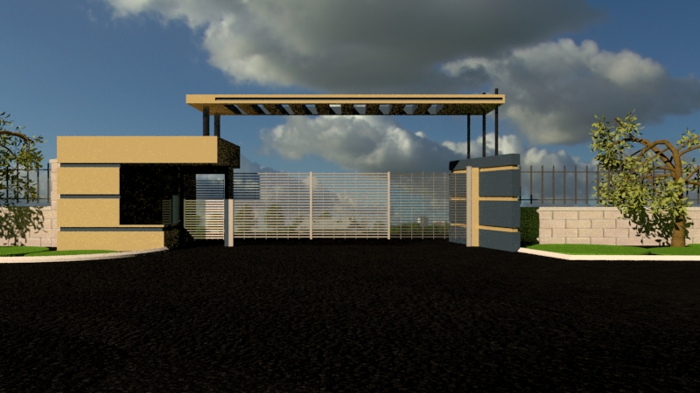
Figure 24: An image showing the front elevation of the gatehouse
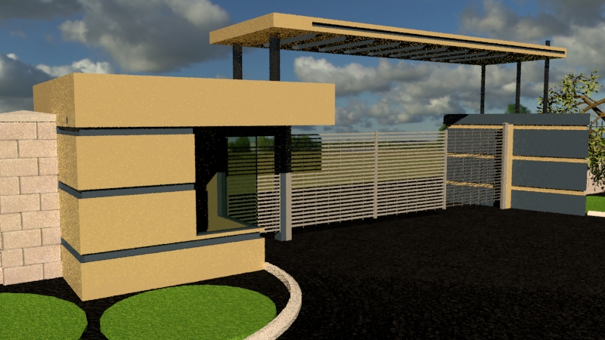
Figure 25: An image showing the perspective view of the gatehouse
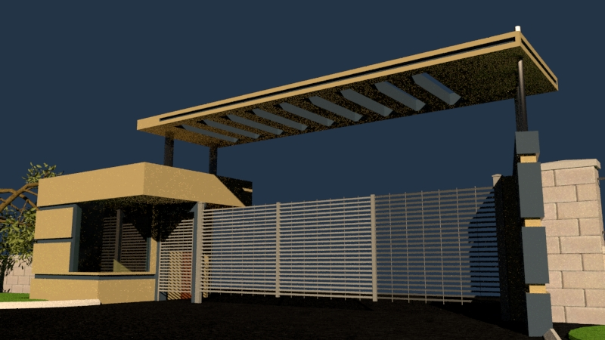
Figure 26: An image showing the perspective view of the gatehouse

4.5 DESIGN OF A BUILDING PROTOTYPE FOR AN ESTATE
My supervisor gave me a brief to design a building type that was to be constructed in an estate. The design requirements include:
- 4 Bedrooms with 2 en-suite including a guest bedroom
- 1 Box Room
- A Courtyard
- A Visitor’s Toilet
- A spatial restriction of 10,000mm x 10,000mm
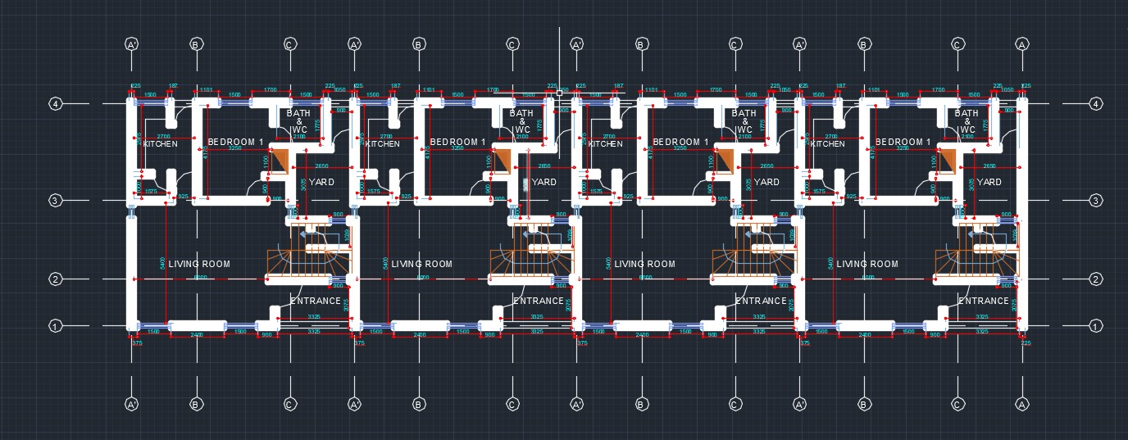
Figure 27: An image showing the ground floor plan of a terraced 4 bedroom duplex
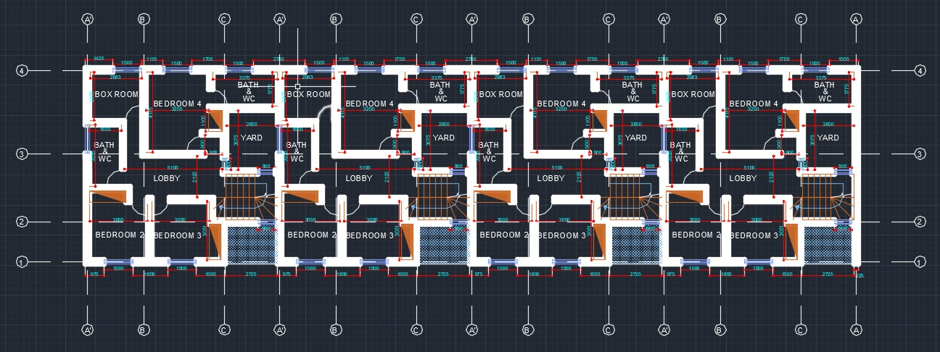
Figure 28: An image showing the first floor plan of a terraced 4 bedroom duplex

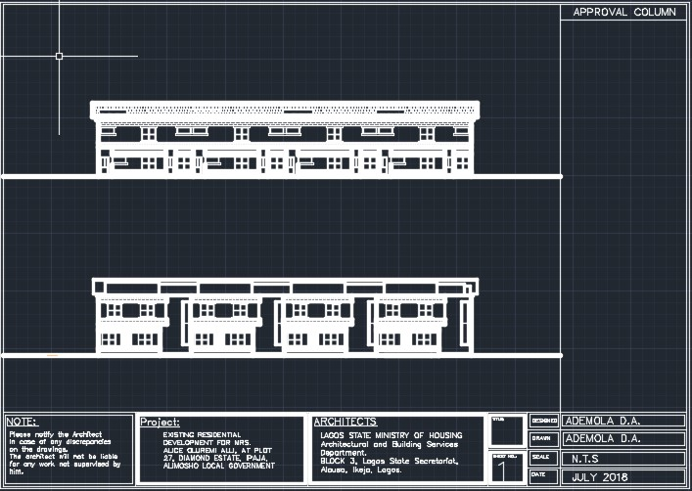
Figure 29: An image showing the front and rear elevations

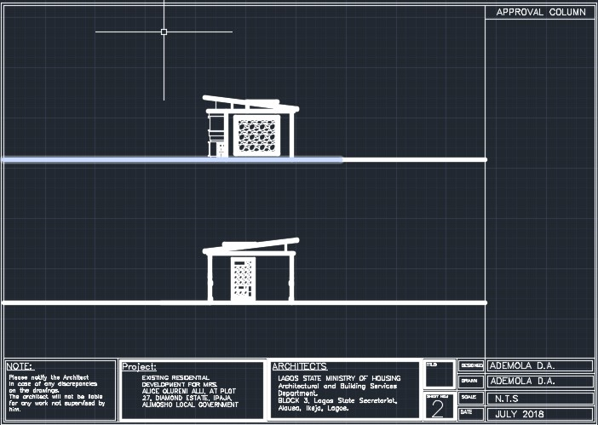
Figure 30: An image showing the two side elevations

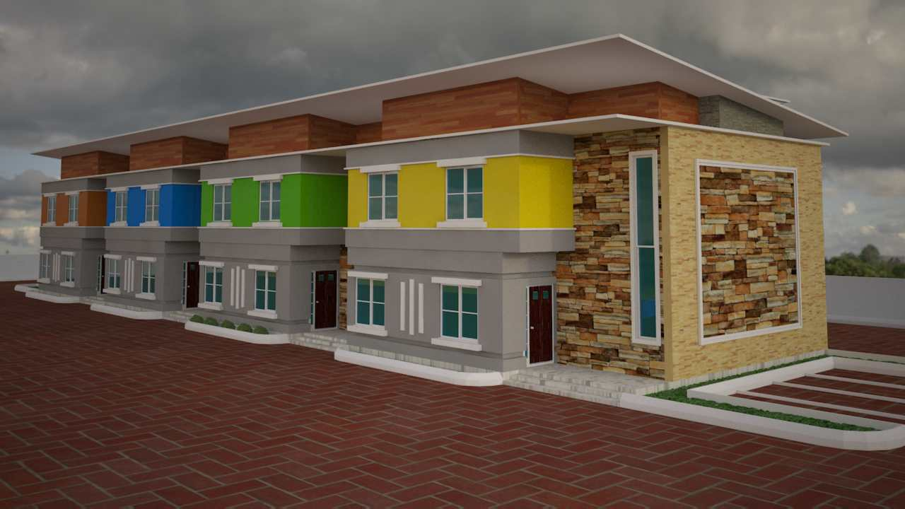
Figure 31: An image showing a rendered view of the terraced 4 bedroom duplex

4.6 DESIGN FOR AN ART GALLERY
My supervisor gave me and a colleague the brief to design an art gallery. My supervisor was particularly interested with the aesthetical value of the interior and also the flow of movement within the gallery.
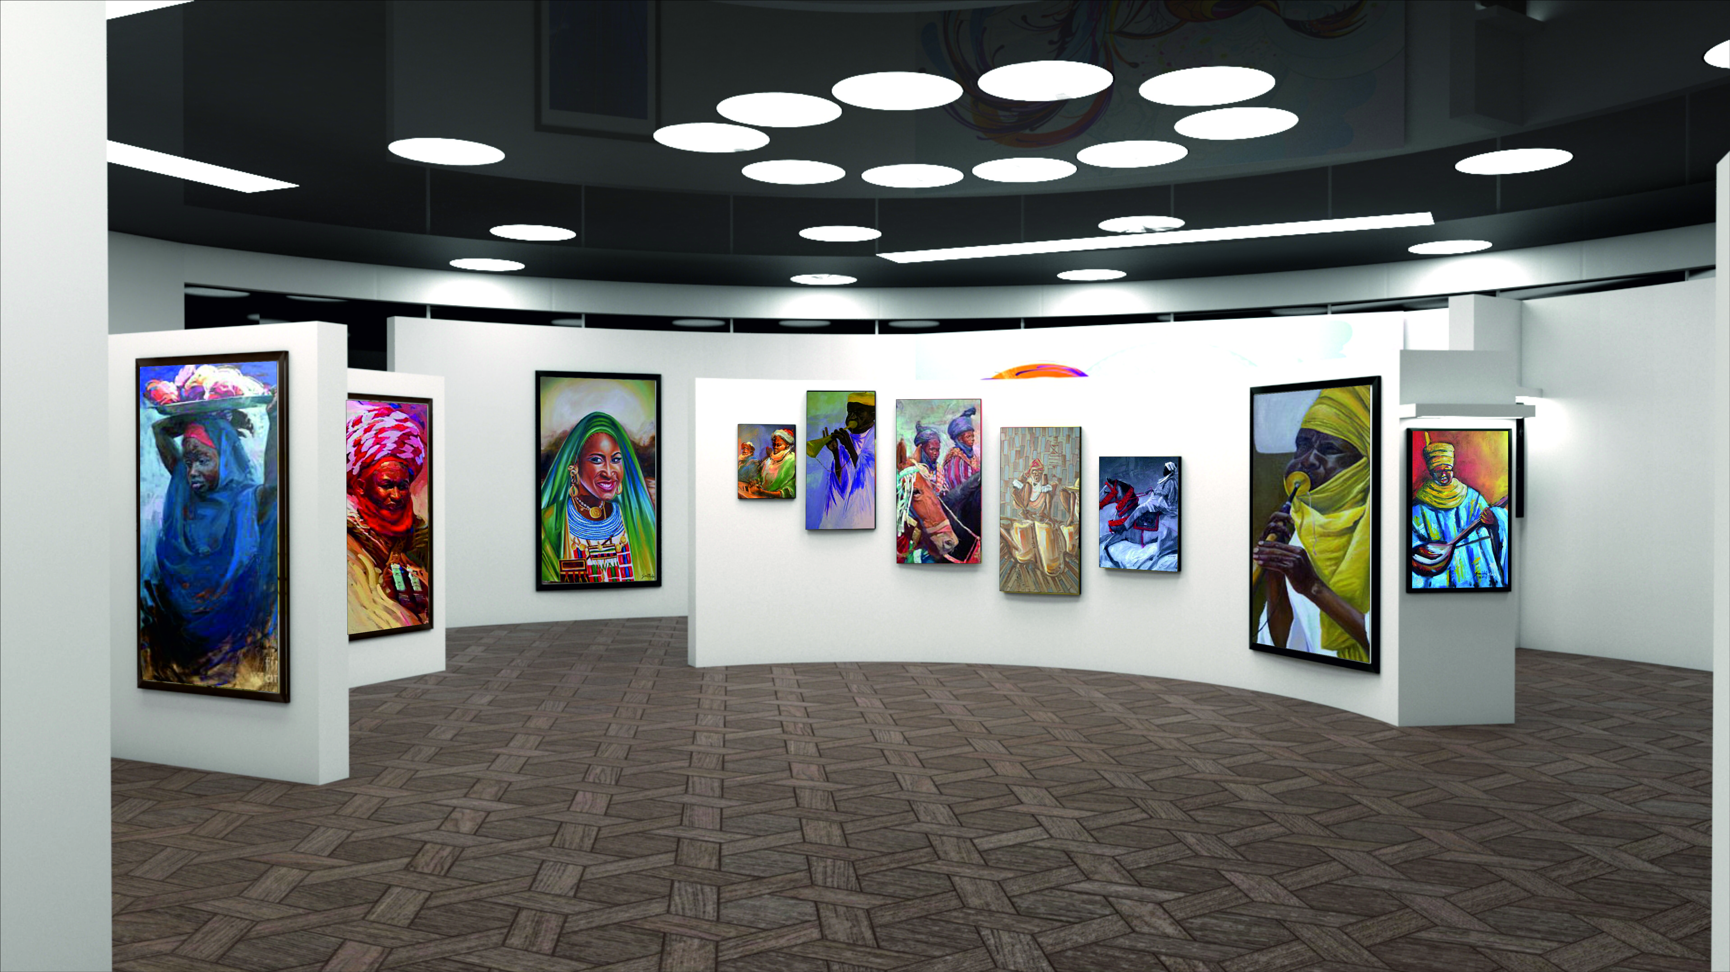
Figure 32: An image showing the interior of an art gallery
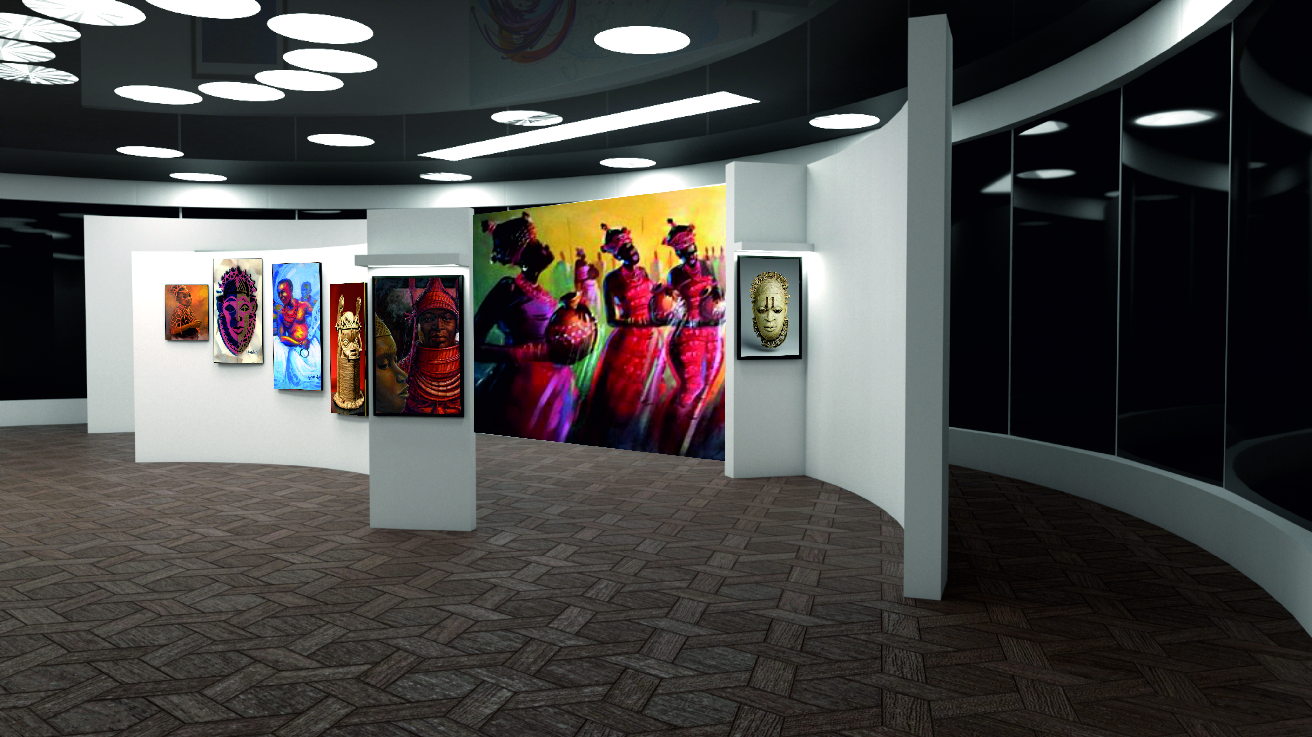
Figure 33: An image showing the interior of another art gallery
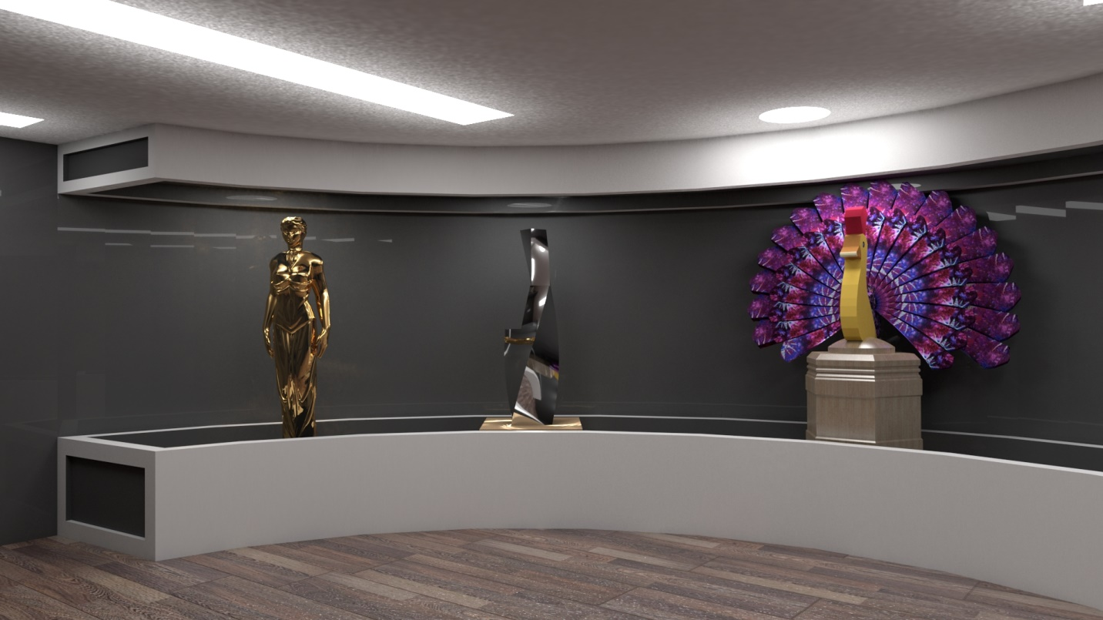
Figure 34: An image showing the interior of a sculpture gallery

CHAPTER FIVE

5.0 CONCLUSION
In this report I have attempted to give an overview of all the activities I carried out and the experience I gained during the six (6) months Industrial Training at the Lagos State Ministry of Housing. The knowledge I gained cannot be underestimated it greatly complimented all I learned during my course of study so far in FUTA.
I therefore conclude that, the SIWES programme was a success because I was equipped with basic technical skills to become a successful Architect and at the same time, the experience gathered during the training will last for a life time.

5.1 RECOMMENDATIONS
The SIWES program is a wonderful one; it enables students gain experience as well as skills required in their fields of study. As one who has benefited from this scheme, I would like to make a few suggestions, to improve the quality of experience gained by students:
- Students should be encouraged to develop themselves in the use of CAD and related software, and this can be done by incorporating CAD into the school curriculum since it is a major criterion for admission into architectural firms.
- Students should be sent specifically to establishments where the aims and objectives of SIWES would be achieved.
- The professional body (NIA) should provide some form of incentive for firms and organizations who take on students for Industrial Training attachment, as this would encourage firms to accept more students for their SIWES programme.
- The institution and ITF should assist students in getting placements thus enabling their SIWES program commence as planned.

