A TECHNICAL REPORT ON STUDENT INDUSTRIAL TRAINING WORK EXPERIENCE
SCHEME [SIWES]

UNDERTAKEN AT:
KWARA STATE GEOGRAPHIC INFORMATION SERVICE [KW-GIS]:
COMMISSIONER’S LODGE WAY, GRA, ILORIN, KWARA STATE.
PRESENTED
ONIMAGO AFISAT IDOWU
ND/23/SGI/FT/0013

SUBMITTED TO THE DEPARTMENT OF SURVEYING AND GEO- INFORMATICS
FACULTY OF ENVIRONMENTAL STUDIES, KWARA STATE POLYTECHNIC, ILORIN KWARA STATE.

IN PARTIAL FULFILMENT OF THE REQUIREMENT FOR THE AWARD OF ORDINARY NATIONAL DIPLOMA (OND) IN SURVEYING AND GEO- INFORMATICS

ACKNOWLEDGEMENT
I would like to express my sincere gratitude to KWARA STATE GEOGRAPHIC INFORMATION SERVICE [KW-GIS] for providing me with the opportunity to undertake my industrial training at their esteemed organization. I am particularly indebted to my boss for their invaluable guidance, support, and mentorship throughout my training period. I am grateful to my HOD and SIWES coordinator for their support and guidance throughout the SIWES program. I would like to express my heartfelt appreciation to my family for their unwavering support and encouragement throughout my academic journey and this industrial training experience.
Finally, I would like to thank my sectional head, head of field and Carto- section in Person of Surv. owolabi Sunday, for all his trust, support and advice during my SIWES programme at the Company words cannot express all the knowledge he impacted in me. May God Almighty Allah bless you and your home.

DEDICATION
This report is dedicated to KWARA STATE POLYTECHNIC for their commitment to providing quality education and fostering practical learning experiences for students in the field of Information Technology.

TABLE OF CONTENTS
TITLE PAGE
ACKNOWLEDGEMENT
DEDICATION

CHAPTER ONE
1.0 INTRODUCTION
1.1 HISTORY OF SIWES
1.2& 1.3 AIM AND OBJECTIVES OF THE SIWES
1.4 ROLES OF BODIES INVOLVED IN THE MANAGEMENT OF SIWES PROGRAMME

CHAPTER TWO
2.0 BRIEF HISTORY
CHAPTER THREE
3.0 DESCRIPTION OF OF WORK UNDERTAKEN
3.1. PLOTTING AND PROCESSING USING AUTOCAD
3.1.1CADASTRAL
3.1.2 PROPERT SURVEY & SETTING OUT
3.1.3 DATA CAPTURING WITH DGPS
3.1.4 HOW TO USE THE DIFFERENTIAL DGPS

CHAPTER 4
4.0 SUMMARY
4.1 CONCLUSSION

4.2 RECOMMENDATION

CHAPTER ONE
1.0 Introduction
1.1 History of SIWES and Meaning of SIWES
The early phase of science and technology in Nigeria was characterized by the theoretical lectures in polytechnics and universities which have proven to be an ill method of teaching. Students in Universities and Polytechnics graduate with little or no technical experience in their course of study.
In the same vein, students’ inability to contribute to the society is hampering the growth and development of our country. It was in this view that SIWES was introduced to the Industrial and Educational sector.
SIWES is an acronym for Student’s Industrial Work Experience Scheme. SIWES was established in the year 1973 in order to improve the standard of education in Nigeria in order to achieve the needed technological advancement.
Economists being able to evaluate the role technology plays in a country’s economy concluded that for an economy to grow and develop there be advancement in the technology. SIWES was solely funded by ITF (Industrial Training Funds) during it early stage not until it was difficult to continue for economic stress: then the responsibility was shared between Industrial Training Funds (ITF) and the Federal Government.
The Federal Government took over the funding of the scheme and Industrial Training Funds took over the managerial position by managing the funds given to them by the Federal Government in order to sustain the scheme.
The effective management of Student’s Industrial Work Experience Scheme (SIWES) has been as a result of the cooperation and well played roles of the Federal Government, ITF, Supervising agencies.

Roles of the Federal Government
Federal Government being the major party in the establishment off SIWES; has ever since been involved in the management of SIWES. Some of the roles played are:

- To make it mandatory for all ministries, companies and parastatals to offer places of attachment for students in accordance with the provision decree of No 47 of 1971 as amended in 1990.
- To provide necessary and adequate funds to ITF through the Federal ministries of industries.
Roles of ITF (Industrial Training Fund)
- Provide logistics and materials needed to administer the scheme
- Supervise students through it Area offices.
ITF VISION:
To be the foremost skills training and development organization in Nigeria and one of the best in the world.
ITF MISSION:
To set and regulate training standards and offer direct training intervention in industrial and commercial skill training and development using a corps of highly competent professional staff, modern techniques and technology.
1.2 Objectives of SIWES
- To expose students to work methods and technique.
- To provide an avenue for students to acquire industrial skill.
- Enhancing students’ contacts with potential employers while on training
iv. To help students appreciate the role their professions play in the society.
- Enlist and strengthen employer’s involvement in the entire educational process and prepare students for employment in Industry and Commerce (Information and Guideline for SIWES, 2002).
1.3 Roles of Students
    - Attend SIWES orientation program before going on attachment.
    - Comply with the establishment’s rules and regulations.
    - Record all training activities done and other assignments in the log book.

1.4 BODIES INVOLVED IN THE MANAGEMENT OF SIWES PROGRAMME AND THEIR ROLES
  - The Federal Government of Nigeria
  - The Industrial Training Fund (ITF)
  - National Universities Commission (NUC)
  - National Board for Technical Education (NBTE)
  - National Commission for Colleges of Education (NCCE)
  - Institutions of Higher Learning
  - The Employers of Labour The bodies have specific roles assigned to them in the administration and management of SIWES.

CHAPTER TWO
2.0 Brief Description of Place of Industrial Training
Location and Brief History of the Establishment
Name: KWARA STATE GEOGRAPHIC INFORMATION SERVICE [KW-GIS]
Office Address: Commissional Lodge Way, G.R.A, Ilorin, Kwara State
Industrial Based Supervisor: SURV. OWOLABI SUNDAY MICHEAL
The office of the Surveyor General of Kwara State is a multi-disciplinary establishment, comprising of professionals and technical staff in surveying, geo-information, photogrammetry, cartography, printing, photography, carpentry and electrical work. It is responsible formulation and execution of policies and project of the state on issues relating to surveying, mapping, geo-spatial information and general land administration and management.
It was upgraded and restructured into and extra-ministerial department consisting of four [4] department namely, mapping and boundaries, cadastral and special surveys, geo-spatial information system and administration finance in October 2009.
The staff strength of the office is seventy made up of:
- Registered Professionals
- Survey Office
- Technical Officers
- Technical Assistants
- Foremen (Chairman)
- Administration and Finance Personal
Structure of the office of Surveyor General of Kwara State:
The head of the organization is the Surveyor General office (SG), then the next in the chain of command are the head of department. In each department, there is a Supervisor that oversees and checks all the works been done in that department, then followed by the trainees or interns (SIWES student).
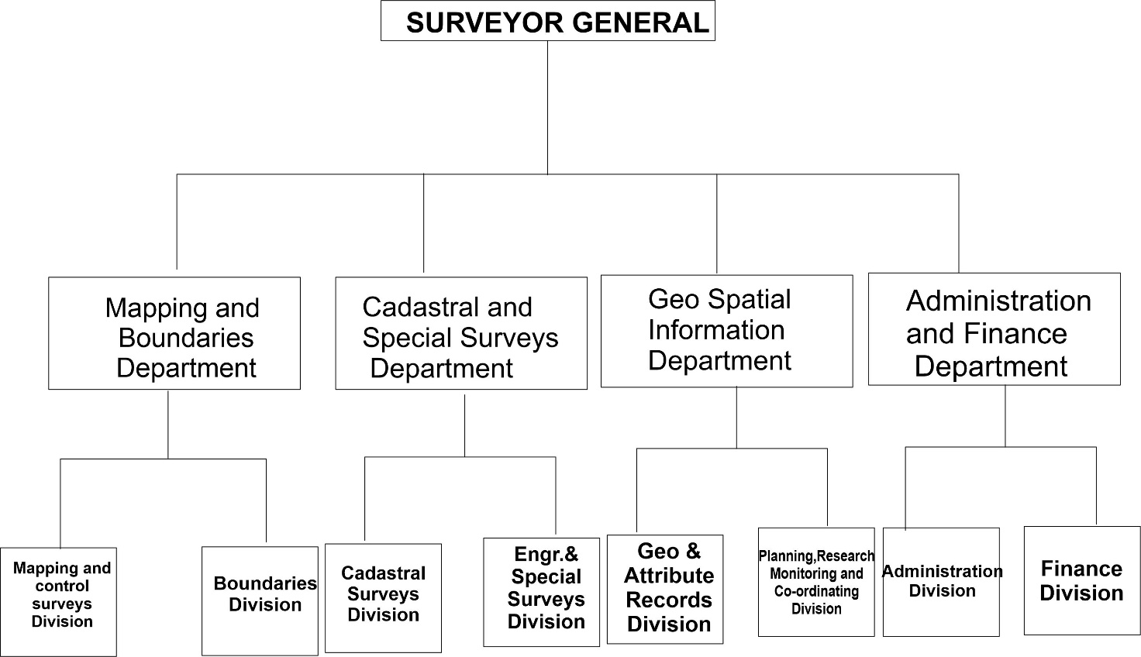

Departments in the office of Surveyor General:
The departments in the office of Surveyor General are:
i . Cartography department
- Record department
- GIS [Global information system] department
- Field operation department
- Land registration department

CHAPTER THREE
3.0 Introduction to the Department
I resumed to limited Kwara State Geographic Information service [KW-GIS] on the 5th of August, 2024. At first I was attached to the GIS department of the organization; Then as time went on, I was made to work in all the departments of the organization. This helped me to gain bulk of experience from all the departments in the organization.
Supervisor
I was supervised by Surv.Sunday Owolabi Micheal who is the chief assistant surveyor, Heading the department of cartography through whom I gained of the experience and from other staff inclusive.
The Nature of Workdone :
On my first week at Kwara State Geographic information Service [KW-GIS], I worked closely with the GIS department of the organization. Then as time went on, I was made to work in all the departments of the organization. This helped me to gain bulk of experience from all the departments in the organization. I was able to gain both in how to plot and field operation during my consultancy period. Some of the equipment and components used during my SIWES period are classified and listed below:
Digital Equipment
- Global positioning system [GPS]
- Total Station
- Digital theodolite
- Computer
- Plotter and Printer
Analogue Equipment
- Theodolite
- Levels
- Compass
- Steel Tape
- Ranging pole
- Levelling staff
- Survey umbrella
- Walkie Talkie
This gives detailed explanation of all activities carried out during my industrial training exercise at the office of Surveyor General. The office has their specialty in handling cartography surveying, Cadastral survey and all reletaed activities ranging from boundary demarcation, monumentation, setting out e.t.c.

3.1 PLOTTING AND PROCESSING USING AUTO CAD
AutoCAD is a powerful computer-aided design (CAD) software application developed by Autodesk. It's a cornerstone tool for professionals across a wide range of industries, enabling them to create precise 2D and 3D drawings and models. AutoCAD was first released in 1982 by Autodesk inc, and has since become one of the most widely used CAD software in various industries.
USE OF AUTO CAD TO A SURVEYOR Data Processing and Visualization:
- Importing Survey Data:
- Creating Topographic Maps:
- Boundary and Cadastral Surveying:
- Plotting Legal Descriptions
- Creating Cadastral Maps
- Setting Out
- Site Planning:
- Subdivision Design:

STEPS TO PLOT ON AUTO CAD
- OPEN THE SOFTWARE
- UNIT SETUP
- TYPE IN CORDINATES ON NOTE PAD
- RUN SCRIPT OR PASTE ON COMMAND P-LINE
- CONTROL C (TO CLOSE TRAVERSE)
- CONTROL E (EXTEND VIEW)
- CONTROL Z (ZOOM IN)
- CALCULATE ITS BEARING AND DISTANCE BY ENGAGING DISTANCE COMMAND

PROCEDURE FOR PLOTTING AUTOCAD
STEP 1: HOW TO SET PRIMARY SETTING
- Go to format
- Click on unit
- Lenth - decimal
- Precision - 3 decimal places
- Unit of scale - METER
- Angle type - deg/min/sec
- Precision - 0°00'00"
- Then click on clockwise
- Click direction - NORTH
- Click "OK"
STEP 2: HOW TO SET BEACON SIZE
- Go to format
- Click on point style
- Point scale/style
- Scale - 1:500 = 1.2
1: 1000= 2.4
- Invalid input: click on "set size in absolute unit"
STEP 3: HOW TO SET TEXT STYLE SETTING
- Go to format
- Click on text style
- Click on Font name : Time New Roman
- Click on Font style: Regular
- Click on height: 1.2
- N.B: the height depends on the scale you see
- Click on Apply * Then close
TYPES OF AUTOCAD
1. AUTOCAD (FULL VERSION): The standard, Full featured version of autocad suitable for most user. 2. AUTOCAD CIVIL 3D: A specialized version for civil engineers with features for infrastructure design, analysis and simulation.
- AUTOCAD MAP 3D: A version for geographic information systems (GIS) and mapping professionals
- AUTOCAD PLANT 3D: A version for plant design and engineering, with features for 3D plants design and documentation.
- AUTOCAD ARCHITECTURE: A version designed for architecture with features for building design documentation and visualization.

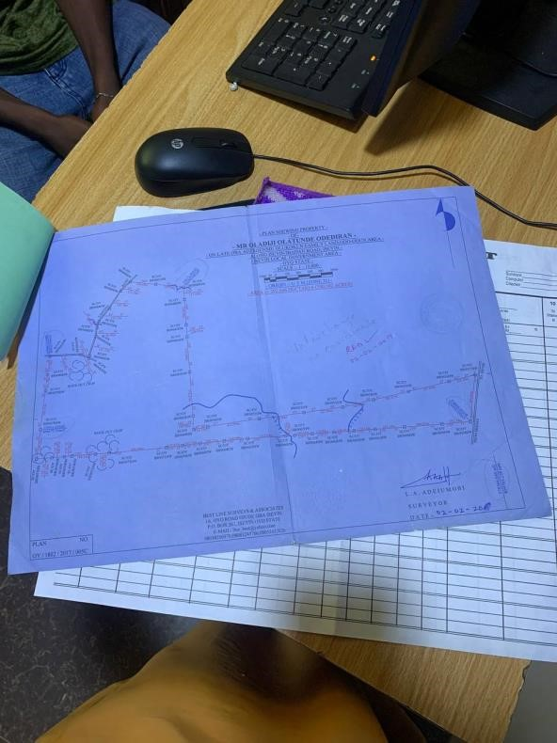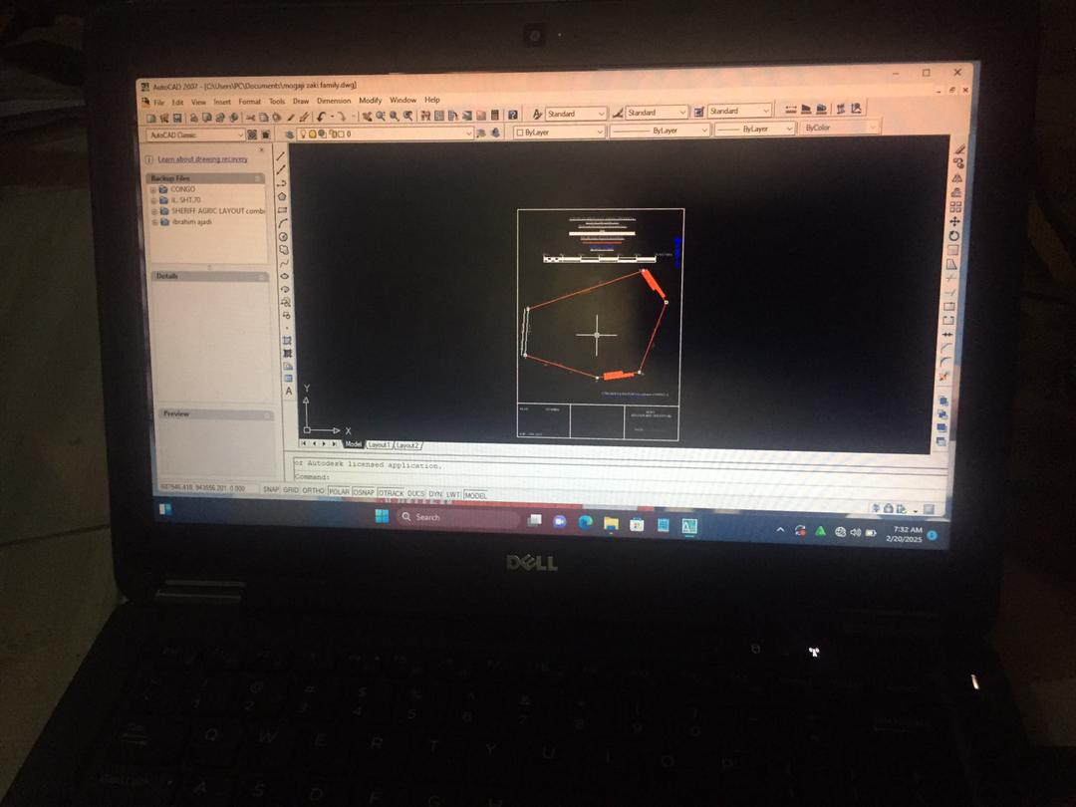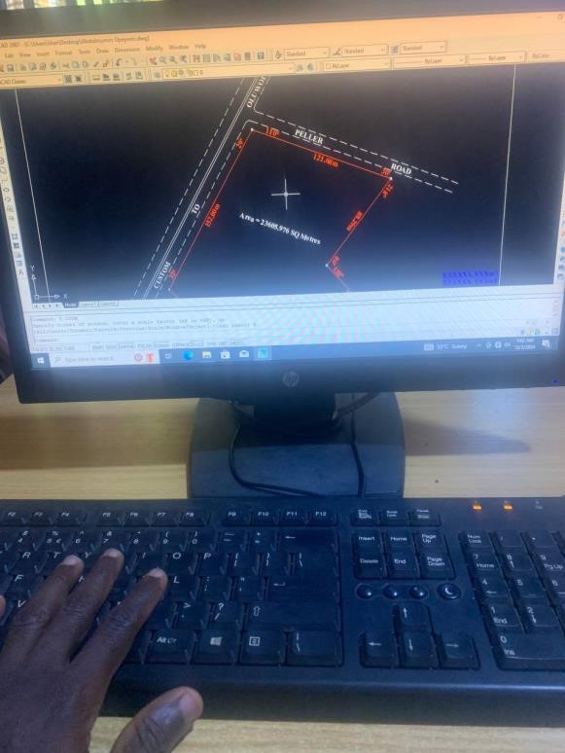

FIG 3.1.

AUTO CAD & PLAN PROCESSING

    - CADASTRAL SURVEYING
Is the discipline of land surveying that relates to the definition or re-establishment of land parcel boundaries. This information is recorded for use on plans, maps and other documentation. Accurately recording the information is an important part of the cadastral surveying discipline.
Cadastral surveying also involves the physical delineation of property boundaries and the determination of dimensions, areas and certain rights associated with properties. This is regardless of whether they are land or water, or defined by natural or artificial on features.
    - PROPERTY SURVEY & SETTING OUT
A property survey is a detailed legal document that defines the boundaries of a piece of land. It's a crucial step in any real estate transaction, construction project, or land dispute. Here's a breakdown of what you need to know about property surveys:
SETTING OUT: Setting out in land surveying refers to the process of transferring known points on paper from paper onto the actual ground, essentially marking out the exact location of proposed structures or features on a construction site using surveying instruments, allowing construction crews to build precisely according to the design specifications; it involves establishing reference points and lines to define the position and levels of elements in three dimensions, effectively "laying out" the project on the land.
Purpose of a Property Survey learned
- Define Property Boundaries: The primary purpose is to accurately establish the legal boundaries of a property. This prevents disputes with neighbors and ensures you know exactly what you own.
- Identify Easements and Restrictions: Surveys reveal any easements (rights of way) or restrictions on the property, such as utility lines or shared driveways.
- Verify Legal Descriptions: Surveys confirm the accuracy of the legal description of the property, which is essential for property deeds and titles.
- Assist with Construction Planning: Surveys provide crucial information for building new structures, additions, or fences, ensuring they are within property lines and comply with local regulations.
- Obtain Financing: Lenders often require a survey to ensure the property's value and that there are no boundary issues that could affect the loan.
STEPS INVOLVED IN CARRYING OUT A PROPERTY SURVEY
- Schedule a Site Visit
- Mark out the boundaries has shown by the property owners
- Put in to considerations the necessary set backs
- Demarcated point with markers or pegs
- Set a concrete monument on demarcated pegs
- Inscribe beacon numbers and id

3.1.3 DATA CAPTURING WITH DGPS:
Data capturing with DGPS (Differential Global Positioning System) is a technique used to obtain highly accurate location data for various applications. It builds upon the basic principles of GPS but incorporates additional technology to significantly improve precision.
3.1.4 HOW TO USE THE DIFFERENTAL GPS
Using Differential GPS (DGPS) involves a few key steps, whether you're using a real-time or postprocessing method. Here's a general guide:
1. Base station setup (for real-time DGPS):
    - Open a working folder:
    - Clear sky view :
    - Power supply:
    - Proper fix of cables
2. Equipment Setup:
- Base station setup (setting by average):
    - Mount the base station antenna securely over a stable ground
    - Connect the antenna to the base station receiver.
    - Turn on the base station and configure it to transmit correction signals.
- Rover setup:
    - Mount the rover antenna on a survey pole or vehicle, ensuring it's stable and level.
    - Connect the antenna to the rover receiver.
    - Turn on the rover receiver.
- Data collector: Connect the rover receiver to a data collector (e.g., ruggedized tablet) to record data.
- Data Collection:
  - Real-time DGPS:
        - Establish communication between the base station and rover (e.g., via radio link or cellular modem).
        - The rover receiver will automatically receive and apply corrections from the base station in real-time.
        - Collect data points as needed for your project.
- Data Processing:
  - Post-processed DGPS:
        - Download data from both the rover and the base station.
        - Use DGPS processing software to apply corrections from the base station data to the rover data.
        - This will improve the accuracy of the rover's position data.
  - Analyze the corrected data using appropriate software.
  - Use the data for your intended application [e.g., creating maps, setting out construction sites, precision farming].

CHAPTER FOUR

4.0 CONCLUSION
4.1 Summary of the Attachment Activities
During the period of attachment at KWARA STATE GEOGRAPHIC INFORMATION
SERVICE [KW-GIS], I worked closely with my supervisor, my practical experience to provide solution to real-world survey tasks have been improved. He gave me several tasks to do which he directly supervised.
More so, I am also exposed to industry trends and best practices like software skill development
during my industrial training. I gained a deep understanding of the processes involved in cadastral survey . I developed proficiency in using AUTO CAD, DGPS e.t.c and learned the importance of accuracy and attention to detail in this field.
And lastly, the SIWES program really broaden my scope and knowledge about electronics and the different aspect of the field and have gained a lot of experience and I now have deep insight about working in a company relating to my course of study

Problems Encountered During the Program (Challenges)
The challenges I encountered, developed and prepared me for the real-life scenario and some of them includes:
- Early hours traffic while transiting to my Industrial training organization.
- High rate of transport fees.
- Poor road network in some distant areas.
- Inadequate and insufficient stipend allowances that could cover for my transportation.

Work Experiences Gained
During the course of my 4 months SIWES at my place of attachment (KW-GIS), I learnt a lot of things ranging from discipline, integrity, respect for senior staff, work ethics, timeliness, procedures to follow when carrying out a task for a staff and how to address a superior in the organization.

4.2 RECOMMENDATION
I recommend that educational institutions offering surveying programs incorporate more practical, hands-on training in cadastral surveying techniques. Exposure to real-world case studies and the use of industry-standard software would better prepare students for the demands of the profession.
For students interested in pursuing a career in cadastral surveying, I highly recommend seeking SIWES opportunities at reputable survey firms. Active participation in fieldwork and a willingness to learn from experienced professionals are crucial for gaining practical skills and building a strong foundation in this field.

