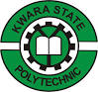
A REPORT ON
STUDENTS INDUSTRIAL WORK EXPERIENCE SCHEME
(SIWES)
UNDERTAKEN AT
OLAIYA METAL WORKS NIGERIA LIMITED
NO. 4, ORILOWO AVENUE BEHINDE BRAVO FILLING STATION SANGO ILORIN KWARA STATE.

BY
YUNUS ABDULAFEEZ KEHINDE
ND/23/MET/FT/0023

SUBMITTED TO
THE DEPARTMENT OF METALLURGICAL ENGINEERING, INSTITUTE OF TECHNOLOGY, KWARA STATE POLYTECHNIC, ILORIN.
IN PARTIAL FULFILMENT OF THE REQUIREMENT FOR THE AWARD OF NATIONAL DIPLOMA (ND) IN METALLURGICAL ENGINEERING.

ACKNOWLEDGMENT
All praise and adoration is due to Almighty Allah, who has keep me alive till this present moment.

TABLE OF CONTENT
Title page
Acknowledgment
Table of content
CHAPTER ONE: INTRODUCTION
  - Introduction
  - Definition of siwes
1.2 Aims and Objectives of Siwes
CHAPTER TWO
2.0 Location and Brief History of Olaiya Metal
2.1 Objective of Olaiya Metal
2.2 Responsibility of Olaiya Metal
CHAPTER THREE:
3.1 Measurement
3.2 Metallic Piping
3.3 Radial Circuit
CHAPTER FOUR:
4.1 Challenges Encounter
4.2 Recommendation
4.3 Conclusion

CHAPTER ONE
1.1 INTRODUCTION
The Industrial Training is a training Scheme by which a student can undergo practical training within an approved Industrial undertaking having specific amount of fixed assets or turnover of paid up share capital. The scheme is a participatory program involving Universities, Polytechnics and Technical Colleges and students of carious Institutions of Nigeria.
The Student Industrial Work Experience Scheme (SIWES) is funded jointly by Industrial Training Fund (ITF). The Scheme completes part of the academics requirement standards in pursing the award of the National Diploma in Office Technology Management. The training lasts for six months. The theory and the practical aspect are being joined together in the programme in order to find out how things are being done. In theory, we are to read electronic guidance, books, novels which concern deeply with sense of belonging especially in course of concern them in practical we have to know how to do things by ourselves to enhance spirits of commitment in all we do. That is why, for efficient moving of this programme in conjunction with ministry of education has set a step that students should be going for these programme. Office Technology Management Departments has seen it as a step forward of progress by sending their student to embark on it.
  - DEFINITION OF SIWES
Student industrial working experience scheme (Siwes) is a program organized by industrial training fund (ITF) for National Diploma science student after their first year (ITF) for National Diploma science student after their first year on campus , to help them known more about the practical aspect of what they have been thought in the school, thou will do practical in the school but we still have some area where we have to know, that it will help us in future to be able to call ourself a computer operator , programmer a system analyst.

  - AIMS AND OBJECTIVE OF SIWES
- It promotes interaction between student in training and the company staffs.
- It helps us to gain moiré to what to customer.
- It help us to know how to relate to customer
- It help us to be perfect in our course of study
- It help us to know how the computer system is been operate
- It help us to know more about practical aspect of what we have being taught in the school

CHAPTER TWO
2.0 LOCATION AND BRIEF HISTORY OF OLAIYA METAL
Olaiya Metal Works, a prominent metal fabrication company based in Ilorin, Kwara State, Nigeria, has a rich history rooted in the local metalworking tradition, head office is located at no 4 orilowo avenue old jebba road sango Ilorin Kwara state branch show room at Olaiya plaza kilometer, with its origins likely dating back several decades, although precise founding details may be limited.
2.1 OBJECTIVE OF OLAIYA METAL
- Local Craftsmanship:
The company likely emerged from a lineage of skilled local metalworkers in the Olaiya area of Ilorin, known for their expertise in crafting metal items like household utensils, tools, and decorative pieces.
- Growth and Expansion:
Over time, as the demand for metal fabrication services increased in the region, Olaiya Metal Works expanded its operations, adopting more advanced techniques and machinery to cater to a wider range of projects.
2.2 RESPONSIBILITY OF OLAIYA METAL
- Reputation for Quality:
The company gained a reputation for producing high-quality metal products, contributing to its local prominence and attracting customers from surrounding areas.
- Modernization and Diversification:
In recent years, Olaiya Metal Works has likely focused on further modernization by integrating new technologies and diversifying its product line to include more complex metal fabrication services, potentially encompassing industrial applications.
Important factors to consider:
- Founder/Early Leadership:
While specific details about the founder or early leadership of Olaiya Metal Works may not be widely available, understanding the key individuals who contributed to its growth could provide valuable insight into its history.
- Community Impact:
The company likely played a significant role in the local economy by providing employment opportunities and contributing to the development of metalworking skills within the Olaiya community.

CHAPTER THREE
REPORT ON WORK ACTUALLY CARRIED OUT WITH CLEAR STATEMENT
3.1 MEASUREMENT
A tape measure or measuring tape is a long, flexible ruler used to measure length or distance.^{[1]} It usually consists of a ribbon of cloth, plastic, fibreglass, or metal strip with linear measurement markings.
On a standard tape measure, the biggest marking is the inch mark (which generally has the biggest number, if it has them). As the increments decrease, so does the length of the mark. For example, ½" has a bigger mark than ¼" which has a bigger mark than ⅛", and so on.
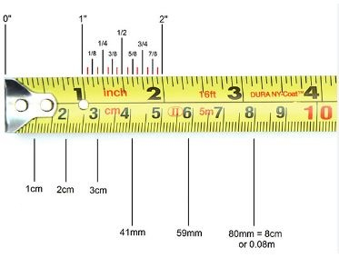
MEASURING TAPE
3.2 METALLIC PIPING
Metallic piping refers to a system of pipes and tubes used to transport various fluids, gases, or materials within industrial, commercial, and residential settings. The term metallic means the pipes are made from metals. Metallic pipes are constructed from various metallic materials such as carbon steel, stainless steel, alloy steel, copper, brass, aluminum alloy, nickel alloys, and more, depending on the specific requirements of the application.

Types of Metallic Piping
When it comes to metallic piping, there are several types of materials that are commonly used to meet different requirements based on factors like the fluid being transported, temperature and pressure, environmental conditions, and industry standards.
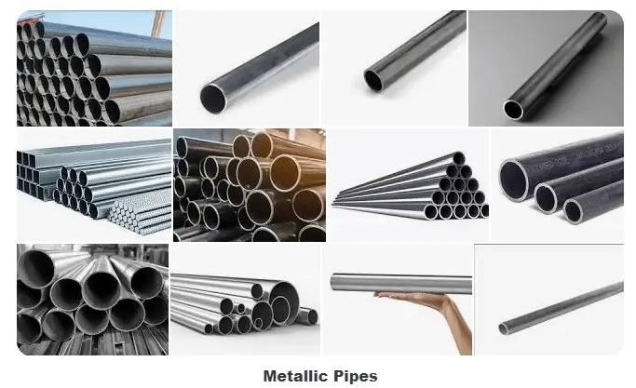

Carbon Steel Piping:
Carbon steel pipes are widely used due to their affordability and versatility. They are suitable for a range of applications including water, oil, and gas transportation. However, Carbon Steel pipes are susceptible to corrosion and may require protective coatings or linings. They are categorized into different grades and specifications based on their composition and properties. Here is a list of some common types of carbon steel pipe materials:

Stainless Steel Piping:
Stainless steel pipes are highly corrosion-resistant and come in various grades, each offering different levels of resistance to chemicals and extreme temperatures. They are commonly used in industries like food processing, pharmaceuticals, and petrochemicals.

Alloy Steel Piping:
Alloy steel pipes are designed to handle high temperatures and pressures. They are used in industries such as power generation, where pipes need to withstand the conditions of steam and high-pressure gases.

Copper Piping:
Copper pipes are known for their excellent thermal conductivity and corrosion resistance. They are often used in plumbing systems for residential and commercial buildings, as well as in HVAC systems

Brass Piping:
Brass pipes are a combination of copper and zinc, offering good corrosion resistance and aesthetic appeal. They are commonly used in plumbing, industrial applications, and decorative purposes.

Zirconium Piping:
Zirconium pipes are highly resistant to corrosion, even in hot, acidic, and alkaline environments. They are used in industries like nuclear power, chemical processing, and aerospace.

Aluminum Alloy Piping
Aluminum alloy pipes are chosen for their lightweight nature, excellent corrosion resistance, and versatility. These alloys are used in various industries, including aerospace, automotive, construction, and more.

Cast Iron Piping
Cast iron pipes have been historically used for their durability and strength in various applications, particularly in plumbing and sewage systems. Different types of cast iron pipes are used based on their composition and intended use.

Using Metallic Pipes for Window Frames and One Side Doors: Requirements
Metallic pipes offer a strong, modern aesthetic for window frames and doors, providing both durability and design flexibility. Below are the key requirements:

1. Materials Needed
- Metallic Pipes:
  - Common materials: Mild steel, stainless steel, or aluminum.
  - Pipe diameter: Typically 1 to 2 inches for residential or commercial uses.
  - Pipe thickness: Choose pipe thicknesses such as 16 or 18 gauge for structural integrity.
- Fasteners and Welding Materials:
  - Bolts, nuts, or screws (for pipe connections).
  - Welding rods (if welding is preferred over bolted joints).
- Glass or Mesh for the Window:
  - Standard clear glass or specialized glass depending on design.
  - Metal mesh or reinforced glass for security windows.
- Finish and Coatings:
  - Anti-rust primer (for steel).
  - Powder coating or anodizing (for aluminum).
  - Paint (for aesthetic or protective finishes).
- Hinge and Locking Mechanism (for Door):
  - Heavy-duty hinge for the door.
  - Lockset or handle for door functionality.
- Sealants:
  - Silicone or polyurethane sealant to seal gaps and prevent weather infiltration.

2. Tools Required
- Pipe cutter, hacksaw, or angle grinder for cutting pipes.
- Welding machine (if welding joints).
- Drill with metal bits (for screwing or bolting connections).
- Clamps and vices (for holding pipes while working).
- Level and measuring tape (to ensure the frame is square).
- Paint sprayer or brush (for applying finish coatings).

3. Design Considerations
- Window and Door Dimensions: Measure the opening where the frame and door will be installed to determine the correct size.
- Style and Functionality:
  - Window frame: Decide on fixed or operable window options (e.g., sliding or hinged).
  - Door: A one-side door is typically hinged, so ensure the hinge side is reinforced.
- Pipe Configuration: Use square or rectangular pipes for stability and appearance.
- Strength: Ensure the frame can support the weight of glass and door panels.
- Weatherproofing: Apply sealants around the frame and door edges to prevent drafts and water ingress.
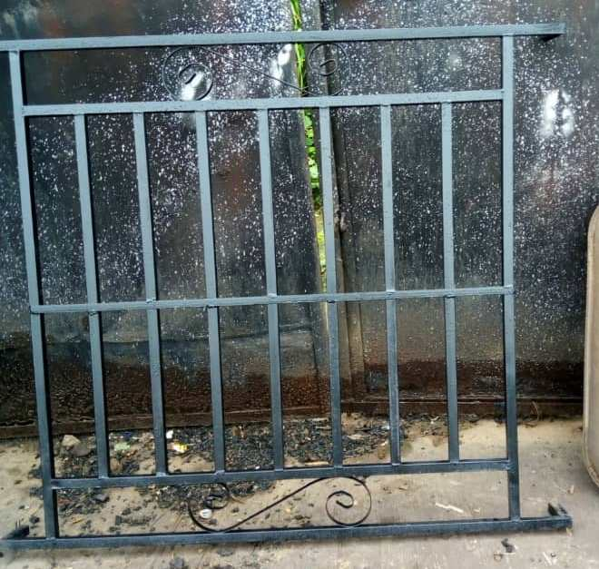
WINDOW FRAME
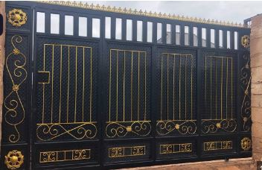
SLIDING GATE

CHAPTER FOUR
SUMMARY, RECOMMENDATION AND CONCLUSION
4.1 CHALENGES ENCOUNTERED
The programme was requiring more than usually expected, especially great patient effort and skills. The challenges was finance: owing to the fact that the organization does not give me any grant of financial support, transportation became a major source of expenditure. I never encounter any difficulties based on my programme, they monitor and taught me what I needed to know and I put them into practice. It wasn’t an easy task to undergo, only God in Heaven saw me through.
4.2 RECOMMENDATION
Early approved of Siwes report is the most important factor to be considered by the polytechnic authority because the siwes might need a huge amount of money which the students might not be able to get as once and also to avoid delayed of the siwes.
Unstable power supply is another major problem encountered during the construction of the siwes.
Finally, I will appeal to the polytechnic that school should before to use any of the technological tools during course of study. In as such that such tools can not cause damage to them.

4.2 CONCLUSION
My three month student industrial work experience scheme with Olaiya Metal Works has been one of the most interesting, productive and instructive experience in my life. Through this training. I have gained new insight and more comprehensive understanding about the real industrial working condition and practice; it has also improved my soft and functional skills. All these valuable experiences and knowledge’s that I have gained were not only acquired through the direct involvement in task but also through other aspects of the training such as: work observation, interaction with colleagues, superior and other people related to the field.

