

A TECHNICAL REPORT

ON

STUDENTS INDUSTRIAL WORK EXPERIENCE SCHEME (SIWES)
THE REPORT BASED ON THE EXPERIENCE GAINED AT

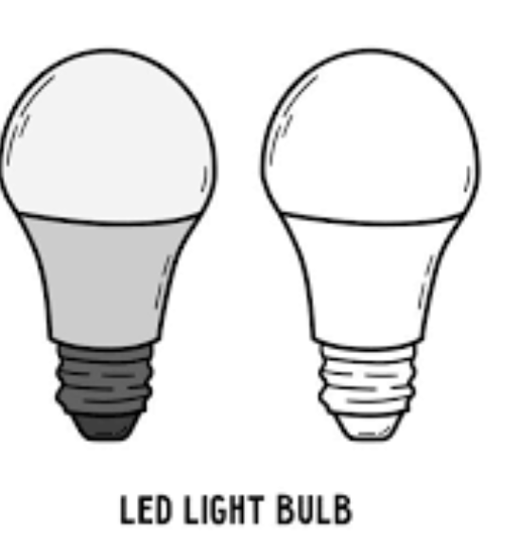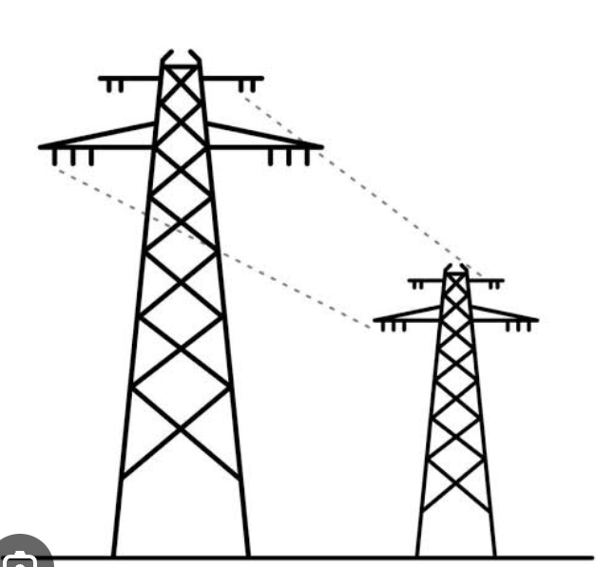

NIVICTAD NIGERIA ENTERPRISE

BY

AGBEDE EMMANUEL FRIDAY
ND/23/EEE/FT/0034

SUBMITTED TO
THE DEPARTMENT OF ELECTRICAL ELECTRONIC ENGINEERING, INSTITUTE OF TECHNOLOGY (IOT), KWARA STATE POLYTECHNIC, ILORIN.

IN PARTIAL FULFILLMENT OF THE REQUIREMENT FOR THE AWARD OF ORDINARY NATIONAL DIPLOMA (OND) IN ELECTRICAL ELECTRONIC ENGINEERING

Supervisor: IBISANKALE KOLA LUKMAN

August –November, 2024.
DEDICATION

This program Student Industrial Work Experience Scheme (SIWES) is dedicated to the Almighty God, the giver of wisdom, knowledge and understanding, The Almighty God who has given me the opportunity, strength and has spared my life throughout the program (SIWES).

My appreciation also goes to my precious parents in person of MR. & MRS. AGBEDE for their advice, supports, prayers and efforts morally and financially for the success of this work. May you live long to eat the fruit of your labour in God’s name (Amen).
iii

ACKNOWLEDGEMENT

First and Foremost, my deepest acknowledgement goes to Almighty God for his overwhelming love upon my life throughout the scheme. He Strengthen me not to give up. Without his support and miracles I would not have been able to be successful in this SIWES experience.
I appreciate my parents for their constant help and support, even when I could not give a reasonable report of expenditure.
My special thanks goes to my effective and amiable coordinator for inspiring me to be a practitioner.
I vigorously express my appreciation to MR. IBISANKALE KOLA LUKMAN (SIWES, Supervisor), and the entire Institute of Technology, SIWES coordinators for making this possible for me in the Navictad Nigeria Enterprise (Company).

iv

ABSTRACT

Student Industrial Work Experience Scheme (SIWES) is a compulsory skills acquisition training designed to give University, undergraduates in Nigeria appropriate practical knowledge, respective disciplines during their course of study and to understand the industrial application of the theoretical knowledge they acquire with the four walls of the lecture halls. The students are also expected to develop occupational competencies that would facilitate their fitting into the world of work after graduation. I was fortunate to serve four months SIWES program at Navictad Nigeria Enterprise, a well recognize company that offers both business and leisure activities. This report is a comprehensive summary of all that I learnt and was involved in throughout my SIWES Program.

v

TABLE OF CONTENTS

Title Page……………………….…………………….…………………………i
Dedication………………………………………………………………..……..ii
Acknowledgement………………………………..…………………..……..….iii
Abstract …………………………….…………………………..………..…..…iv
Table of Contents……………………………………………………….……....v
CHAPTER ONE
1.1 Introduction to SIWES
1.2 Meaning of SIWES
1.3 Background of the Program (SIWES)
1.4 Aims and Objectives of SIWES
1.5 Bodies involved in the Management of SIWES
CHAPTER TWO
  - Roles and Responsibilities of the Company
  - Navictad Nigeria Enterprise
  - The Company’s Organogram
  - Conclusion
CHAPTER THREE
  - Introduction
  - SIWES carried out
  - Supervisory works
CHAPTER FOUR
4.1 Conclusion, Problem Encountered and Problems Solved
CHAPTER FIVE
5.1 Summary, Recommendation and Conclusion.
vi

CHAPTER ONE

  - INTRODUCTION TO SIWES

The Student Industrial Work Experience Scheme (SIWES) is an accepted skills programme which forms part of the approved academic standards in the degree programme for Nigerian Universities. In 1974, the Federal Government of Nigeria introduced the national policy on Industrial training, called the Students, Industrial Work Experience Scheme (SIWES). This programme is under the umbrella of the Ministry of Education through the Industrial Training Fund (ITF), was designed to help students acquire the necessary practical education/experience in their fields of study and other related professions.

This is an effort which was created in order to bridge the existing gap between the theory taught in the classroom and practice of science, agriculture, medicine, engineering, technology and other professional programmes in the Nigerian tertiary institutions. This programme is aimed at exposing the students to the use of various machines and equipment’s, professional work methods and ways of safeguarding the work areas in industries as well as other organizations and parastatals. The programme was established basically to impact elaborate practical understanding to students with respect to their various disciplines. It is also intended that the student through a process of relation to academic knowledge and practical industrial application would understand the underlying principles and become better focused and acquire the practical applications towards excellence in his or her discipline.

The Students Industrial Work Experience Scheme (SIWES) programme involves the student, the Universities and the industries. This training is funded by the Federal Government of Nigeria and jointly coordinated by the Industrial Training Fund (ITF) and the National Universities Commission (NUC).

1.2 MEANING OF SIWES
SIWES means “Student Industrial Work Experience Scheme”. This was introduced a three-four months training program for students of science/medical laboratory technology not to have just the head-knowledge about the course but for them to be sound both theoretically and practically.

1.3 BACKGROUND OF SIWES
The student industrial work experience scheme (SIWES) is an accepted skill training scheme which form part of the approved minimum academic standards in various degree scheme for all Nigerian universities and polytechnics to acquire industrial skills and experience in their various course of study.
The SIWES program was established in 1973, the scheme is a scheme involving students, the university and the industry (employer). It is funded by the federal government of Nigeria and jointly coordinated by the Industrial Training Fund (ITF) and the National Universities commission (NUC). This training scheme is also an effort to bridge the gap existing between theory and practice of Engineering, science, agriculture, medicals, management and other professional education programs in the Nigerian Tertiary institution.

1.4 AIMS AND OBJECTIVES OF SIWES

The aims and objectives of the scheme are to:

- Preparing an avenue for students in institutions of higher learning to acquire adequate industrial skills and experience during their course of study.
- To make students understand the technical implication of their professions as well as teaching them competence, standard and professionalism.
- Enhance students’ opportunity for later job placements.
- Expose students to work methods and techniques in handling equipments and machineries that may not be available in institutions.
- Prepare students for industrial work situations that they are likely to meet after graduation.
- To provide opportunity for students to apply their knowledge in real work situation thereby, bridging the gap between theory and practical.

1.5 BODIES INVOLVED IN THE MANAGEMENT OF SIWES
- The Federal Government.
- The Industrial Training Fund (ITF)
- The Supervising Agency
- National Universities Commission
- NUC
CHAPTER TWO

2.1 ROLES AND RESPONSIBILITIES OF THE COMPANY

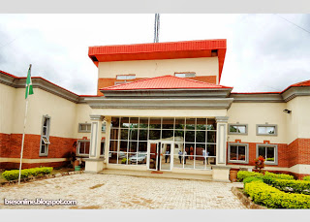
The Navictad Nigeria Enterprise (company) committees involves the Chairman, Secretary, Treasurer whereby they provides leadership and direction to the company, the chairman and the members attend meetings and participate in association-organized training, workshops and other events.
The Chairman, Vice Chairman, Secretary and Treasurer all adhere to the company’s code of conduct and ethics. The Treasurers manages the company’s finances, including dues, paying bills and maintaining financial record. The company are responsible for the welfare of members, including providing support during challenges.
2.2 NAVICTAD NIGERIA ENTERPRISE
The Navictad Nigeria Enterprise (Company), located at Opposite Omo Oro Ago Express, Ita-Alamu, Ilorin Kwara State, where a group of people in Ilorin, Kwara State, came together to form an informal association. The group aimed to promote the interests of cables, wires, sockets, meters, street lights, bulb, ceiling fan, electrical lights to use in Conversion, Replacement, Surface wiring, Rolling of cable, Installation, Repairing, disconnecting etc and provide a platform for them to share knowledge.
2.3 THE COMPANY’S ORGANOGRAM
Executive Chairman
Chairman, Vice Chairman, Secretary, Treasurer, Public Relations, Welfare and the Auditor
Committee

Welfare & Social Committee

Disciplinary Committee / Commerce Committee

Membership Committee

Chairman and Members (comprising experienced and respected members of the association

Advisory Board

CHAPTER THREE
3.1 INTRODUCTION
Installation: Installation refers to the process of setting up, configuring and deploying a system, product or service to make it operational and ready for use..
Wiring: refers to the process of connecting electrical devices, circuits and systems using conductive wires and cables.
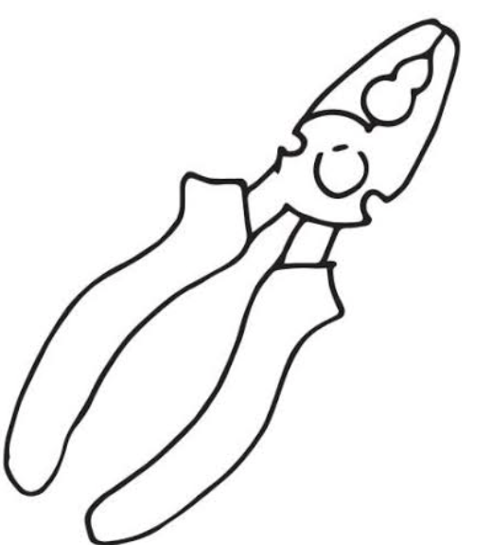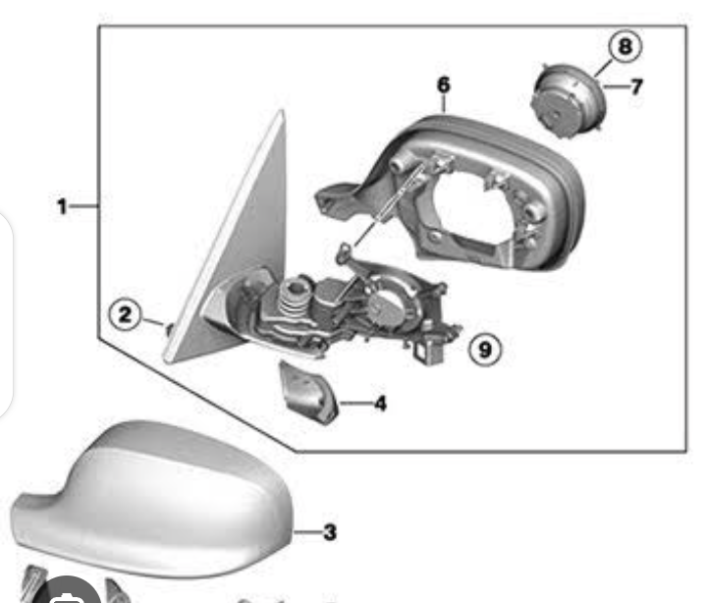
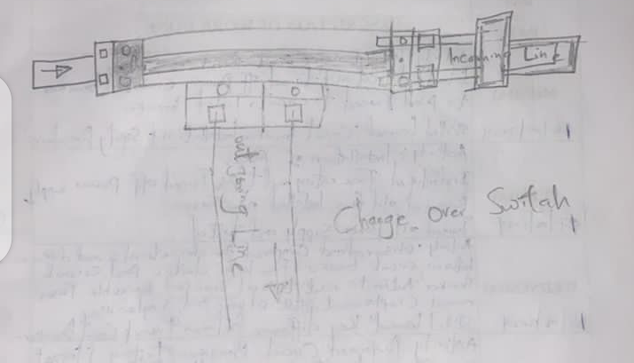

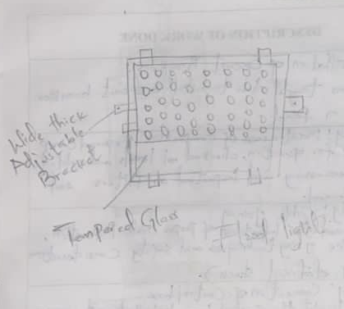
- 13 amp double socket
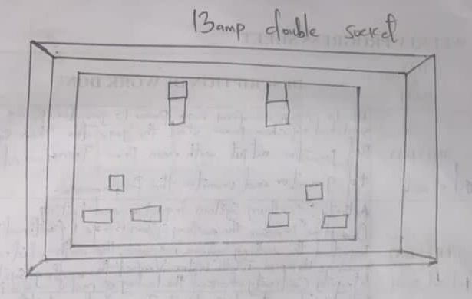
- Flood light
- Cable
- Electrical Tester
- Pop light
The above uses are:
- For measuring various physical parameters
- Fluorescent lighting is used in a variety of settings to lightening up.
- An electrical tester is a handy tool used to measure and detect various electrical parameters, ensuring safety and efficiency in electrical work.
3.2 SIWES CARRIED OUT
I resumed for my Student Industrial Work Experience Scheme (SIWES) at Nivictad Nigeria Enterprise on 2nd August, 2024 with few of my colleagues, where I gained practical knowledge about types of switch, change over, Electrical safety & precautions in electrical engineering including personal protection equipment usage (insulted gloves). Skilled learned: Electrical safety awareness, Emergency response.
My 1st week, I was introduced to multi-meter measure Voltage current: I became familiar with electrical engineering equipment & tools, I participated in training sessions on the checking continuity of a wire using a multi-meter procedure. Wire testing and multi-meter usage.. I was introduced to learn how to start a generator then symbolic red generator output with main power. Earthing system inspection and testing. The inverter inspectors for factory lighting.
My 2nd week at Nivictad Nigeria Enterprise, I learnt practically about the significance of interlock in protecting personnel, equipment and the environment from potential harm and also the installation of limit switch i.e. how to install limit switch to prevent over travel.
The 3rd week, I learnt practically on the installation of circuit breaker. The installation of fuses. The key differences between fuses & circuit breakers was made known to me and also I was taught on the use of tester when connected to a particular power source. I was taught how to replace a bad socket, the reconnection of flood light using appropriate wire and connections.
I learnt practically about installation of inverter, I was taught how to safely install and configure and the importance of proper sizing and selecting inverter for specific cords.
I learnt practically about installation of manual starter.
Towards the last week (16th week) of my program I learnt practically about safety protocols and we were explained to how we can install light bulb at Dr. Akanola’s house. Installation of a new ceiling fan, of led tubes, security lights, and 4ft led tube and fluorescent tube. There was a Public holiday on 8th December, 2024. While later on, I also learnt about installation of socket the completion of the installation of ceiling fans, tracing & repairs of electrical faults. I also learnt practically about the connection of industrial mixer to gear switch at heavy equipment unit and to ensure that tools and work spaces are clean and organized appropriately.
And the last day of the week I learned to always maintain a clean and organized work environment, which helps in preventing environmental hazards.
3.3 SUPERVISORY WORKS

- They manage the workflow and training going on in the company.
- They create schedules that keep everyone busy with deadlines met to prevent gaps or downtime while giving direction and feedback about what needs improvement.
- They monitors, listen to students who finds it difficult to understand.
- They are bold and ready to hear out.

CHAPTER FOUR

4.1 CONCLUSION/PROBLEM ENCOUNTERED/PROBLEM SOLVED

There is nothing on the earth that is free of challenge, despite the fact that Nivictad Nigeria Enterprise environment was conducive for learning, I still faced challenges when observing SIWES which I will highlighted in some points.

- During the industrial training I faced transportation challenges due to the economic situation.
- And during my stay at Nivictad Nigeria Enterprise environment I use to starve at times.
- Another challenges that I faced was that during the time of my stay at first it was a bit difficult, but as time goes by I find it very easy and great skills to learn and acquire.

Based on the experience I had during my SIWES program, I hereby recommend that this training should continue as it helps student in full knowledge of the course they are studying.

I also solicit that the amount of money that has been attached to this program should be paid immediately after the student program.

And I also suggest that SIWES student should not be embarrassed and insulted anyhow in the teaching hall and if there is any issue that might lead to abusing of any student, proper research and investigation should be done before reacting to such student.

CHAPTER FIVE

5.1 SUMMARY, RECOMMENDATION AND CONCLUSION

An adage says “seen is believing and experience is the best teacher” I have seen it and believe that practical is more encouraging than theory, when am expose to the real practical of a job, I realize that the program is of great use and privilege to the undergraduate as it has expose me to discipline and machinery and help me to have the practical experience that may not be available in education institution.

RECOMMENDATION
I recommend that SIWES should provide places or Industrial attachment for students and the company should provide more safety equipment to prevent further environmental hazards.
CONCLUSION
My four months industrial attachment with the Nivictad Nigeria Enterprise has been one of the most interesting, productive and instructive experience in my life, through this training, I have gained new insight and more comprehensive. it has also improved my soft and functional skills.
All these valuable experiences and knowledge that I have gained were not only acquired through other the direct involvement in task but also through other aspects of the training such as work observation, interactor with colleagues, supervisor and other people related to the field. And from what I undergone I am sure that Industrial Training Program has achieved its primary objective. As a result of the program I am now more confident to build my future career which I have already started.

