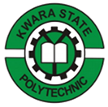

REPORT ON

STUDENTS’ INDUSTRIAL WORK EXPERIENCE SCHEME (SIWES)
Held at:

IREPODUN LOCAL GOVERNMENT HEALTH AUTHORITY
Anwo Junction, Ilobu Laro Area, Osun State

BY

HASSA HAMIDAT AJIKE
ND/23/SLT/PT/0051

IN PARTIAL FULFILLMENT FOR AWARD OF NATIONAL DIPLOMA (ND) IN THE DEPARTMENT OF ELECTRICAL/ELECTRONICS ENGINEERING,
INSTITUTE OF TECHNOLOGY,
KWARA STATE POLYTECHNIC, ILORIN

AUGUST – NOVEMBER, 2024

TABLE OFCONTENTS
Table of Contents 1
Chapter One: Introduction
What is SIWES 2
Brief History of SIWES 2
Aim and Objectives of SIWES 3
Various Department in the Laboratory 3
Laboratory Rules and Regulations 3
Laboratory Equipments and their Uses 4
Chapter Two: Hematology Tests
Blood Group 6
Genotype 7
Hemoglobin test 7
Pack cell volume test 8
White blood cell count 9
Chapter Three: Serology Tests
Pregnancy test 10
Widal test 10
Typhoid fever test 11
Hepatitis B Surface Antigentest 12
Chapter Four: Clinical Chemistry Tests
Urinanalysis 14
Urine Macroscopy 14
Urine Chemistry 14
Urine microscopy 15
Chapter Five: Parasitology Tests
Stool analysis 16
Stool macroscopy 16
Stool microscopy 16
Malarial parasite test 17
Chapter Six: Microbiology Tests
Culture media 18
Preparation of media 18
Stool culture 18
High Vagina Swabmicroscopy 19
Semen analysis 19
Measurement of volume 20
Measurement of pH 20
Percentage and Viable spermatozoa 20
Semenculture 20
Chapter Seven:Relevanceof SIWES 21

CHAPTERONE
INTRODUCTION

WHAT IS SIWES:
SIWES (students industrial work experience scheme) is a scheme designed by the federal ministry of education,theindustrialtrainingfundistheNationalboardfortechnicaleducationandinstitutionofhigh students in Nigeria.
SIWES (students industrial work experience scheme) is aimed at granting or exposing students to experience the nature of work they are to encounter when they finish their program in school depending on one discipline
The scheme also gives students opportunityto gain experience practicallywhat was not taught in school during their programme.
It also helps students to practicalize the theoryaspect of their lecture in school. It also gives the students the opportunity to be versatile .it makes the students popular, it also act as a medium of job opportunity when they finish their programme in school.
Itgives adetailed accountofallworkcarriedoutduringSIWESandaswellastheproblemsfaced.

BRIEFHISTORY OF SIWES
The student Industrial Work Experience Scheme (SIWES) was established in 1973/1974 session by the Industrial Training Fund (ITF). Prior to the establishment of this scheme, there was a growing concern among our industrialists that graduates of our institutions of higher learning lacked adequate practices backgroundstudiespreparatorytoemploymentintheindustries.Itisagainstthisbackgroundthattheaim of initiating and designing the scheme was hinged.
Consequently, the scheme affords students the opportunity of familiarizing and exposing themselves, to the needed experience in handling equipment and machinery that are usually not available in the institutions.
The ITF solely funded the scheme duringits formative years. It withdraws from the scheme in 1978 due to the financial problem. The federal government handed the scheme in 1979 to both the National University Commission (NUC) and the National Board of Technical Education (NBTE). Later, in November 1984, the federal government changed the management and implementation of the scheme to ITFanditwaseffectivelytakenoverbytheIndustrialTrainingFund(ITF)inJuly1985withthefunding being solely borne by the federal government.

AIMSANDOBJECTIVESOFSIWES
- Itactasmediumforjobopportunityfor students
- Itprovidesstudentswith experienceoutsidetheirprogrammein school
- Itgrantsstudentsopportunityto practicalizethetheoreticalaspect oftheircoursein school
- Exposestudent to the kind ofworkexperiencetheywill encounterwhen they graduate
- Exposestudentstoknowtheoperationandfunctionoftheinstrumentsinvolvedintheircourseofstudy.
- Itmakes studentsknowhowtomanagedifficultin workwhen theygraduate.

VARIOUSDEPARTMENTOFTHE LABORATORY.
- RECEPTIONIST/COLLECTIONSECTION:
Thisistheunitwherepatientsarereceivedandattendedtoregardingtothe investigationwrittenontheir laboratory request forms bythe doctor. Activities such as collection of clinical specimens and issuing of laboratory result forms are carried out in this section.
- SEROLOGYSECTION:Thissectionisconcernedwiththelaboratoryinvestigationwhichinvolved the formation of immune complex (agglutination) from antigen and antigen and antibodyreaction in the blood (serum). Clinical tests carried out in this section include Widal tests, hepatitis B surface Antigen (HBsAq)andVeneralDiseaseResearchLaboratory(HIV)TESTS.Blood,especiallyserumwhichisused
- PARASITOLOGY SECTION: This is the unit where clinical specimens are analyzed in search for parasitic organisms. The clinical specimens analyzed include stool, urine analysis.
- HEMATOLOGY:ThissectionisconcernedwithHemoglobin(bloodpenaltytest),FBC,malariatest, HB-genotype , ABO groups.
- CHEMISTRYSECTION:Thissectionisconcerned withcholesterol, FBSandRBS,
- MICROBIOLOGY: Deals with urine, stool, HVS ( urine Swab), urethral, P.T (Pregnancy tests), Sensitivity test etc.

LABORATORYRULESANDREGULATIONS
- Laboratorycoatand hand gloves shouldbe worn in thelaboratory
- Eating,drinking, smokingand dancingshouldbeavoidedin the laboratory
- Handsshould bewashed afterhandlingasample andwhen leavingthelaboratory
- Allbenches should becleanedbefore and after thedaywork.
- Avoidbeingbarefooted, cover shoes should beworn in thelaboratory
- Hairsshouldbe coveredwithHair net.
- Fingersand nailsshould becut short

- Labelingof sample should bedonewith care

LABORATORYEQUIPMENTSANDTHEIRUSES
MICROSCOPE: this equipment is used of the examination of samples and magnification of microorganismsthatcannotbeseenwiththenakedeyes,itspartsincludeobjectlenswhichhavel00x,40x, and l0x objective lenses other parts are fine and coarse adjustment knobs
AUTOCALVE: this is used in sterilization of glass wares and media used in the laboratory to avoid contamination. It consists of chambers on which the articles are placed and treated with steam At high pressure.
INCUBATOR:Itisusedforincubatingculturedplatefor24hours-48hoursatthetemperaturebetween 37oc-4000c so as to obtain proper growth of microorganisms.
LABORATORY OVEN: It is used for sterilization of meta wares and also for preservation. CENTRIFUGE: It is used for sedimentation of particles, is used in separating components of different densities in a liquid, using centrifugal force.
WEIGHING BALANCE: This is used for measuring mounts of substance required for analysis which measure in grams.
ELECTROPHORESISMACHINE:Itisusedforcarryingouttestongenotype.
REFRIGERATOR:Thisisforthepreservationof samples.
HAEMATOCRITECENTRIFUGE:Thisisusedforsamplingbloodwithmicrohaeamatocritcapillary tubes to know the blood percentage of an individual.
SYRINGE:Theyareusedtogiveinjectionandalsoforcollectionofbloodsamplethroughvenousblood collection in the lab for laboratory practical.

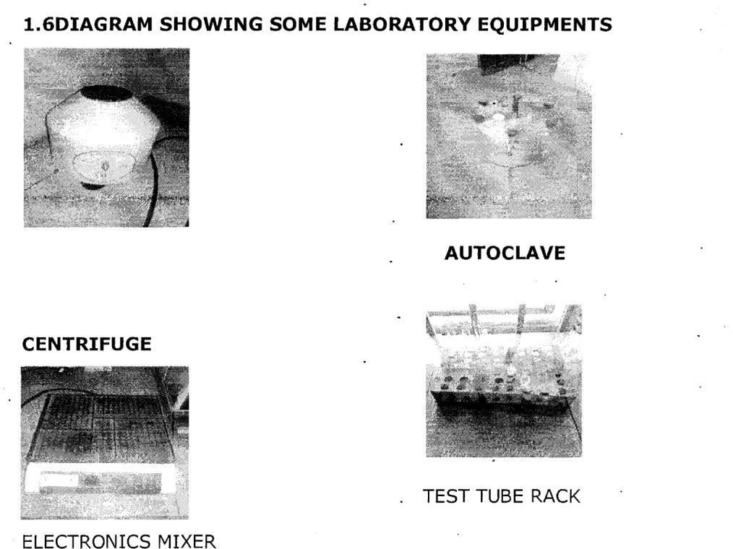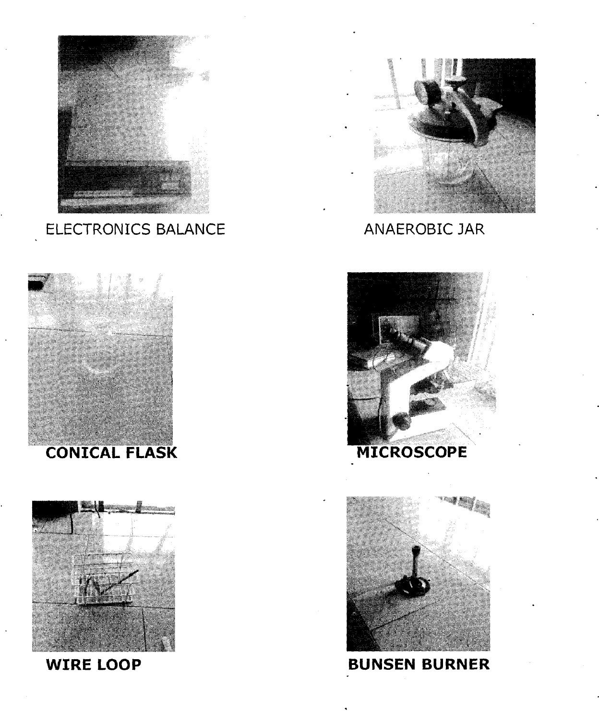

CHAPTERTWO
HAEMATOLOGYTEST

Thisisthetestusedincarryingouttheinvestigationofanemia,infectionandpyrexia9fever)ofunknown origin,investigationheamoglobinopathicsandmonitoringpatientsreceivingantiretroviraltherapy(ART).

BLOOD GROUP
This is all ABC blood group system are clinically the most important. blood group donors and patients must be grouped correctly to avoid the death of the patients when the ABC is incompatible . The ABC blood group w have: AB, AB, A, K, B+, B, O+,0

AIM:
Theaimistodeterminea patient’sbloodgroup

Apparatus:
AntiseraA,B, andC cleanand drytitleapplicators,sterilebloodlancet, sterileswapandhandglove.

TECHNIQUES:
After a patient thumb has being cleaned with sterile swap and allow to dry, a puncture is made with the lancet and the first drop of the blood is cleaned off.
Andthenpressedto getanotherdropofbloodwhichisdroopedatthreedivisiononatile. Add one volume of the respective anti-sera A B and 0 to the blood samples
Using applicators mix the anti —sera with the blood respectively Rock for 2-3 minutes and then record your result. -

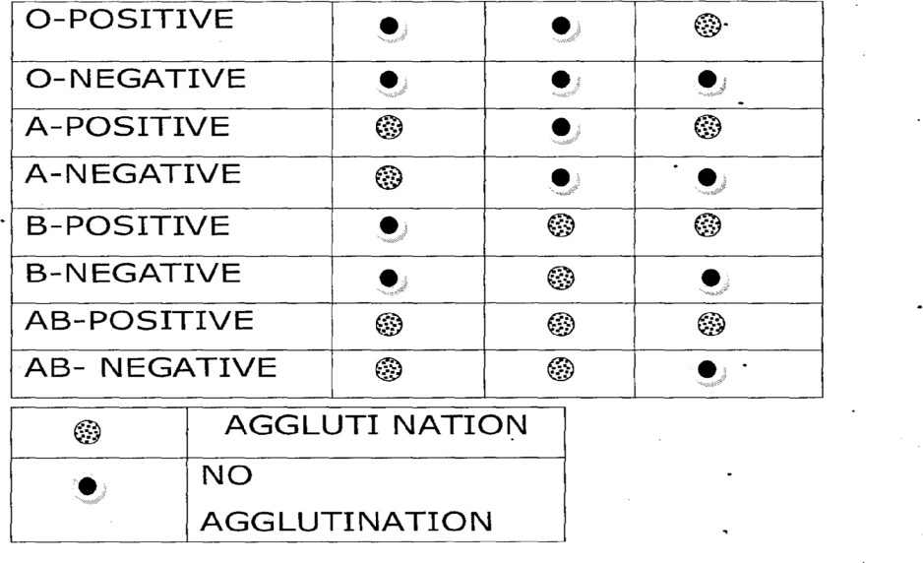
HOW TO READ YOUR RESULT BLOODTYPEANTI-AANTI-BANTI-D

GENOTYPE

Genotype or haemoglobin electrophoresis is used to separate and identifythe different haemoglobins by their migration within an electric field. Haemoglobin variants separate at different rates due to different in their surface electric charges as determined by their amino acid structure .the predominant Genotype are AA and AS ,SS while AC ,SC etc
Aim:to detect onesgenotype.
Apparatus: sterileswap,2m1syringe,haridglove ,Trisbuffer celluloseacetatemembrane, cleananddry tile,application,apositiveandnegativecontroli.e.ASand.AA,water,pasture’spipettes,electrophoresis machine.

PROCEDURE:
Afterbloodcollection usingpasture’spipette
Thebloodis placedusingonacleantilealsoyourcontrol placedat adifferent division.
Using another pasture’s pipette ,pipette small volume of water and add to the respective blood samples..thenmixseparateusinganapplicationtomakethemixturelightforeasyseparateofthesamples. Using respectively applicators place the sample on a cellulose acetate member respectively .
Pour l00mis of this EDTA borate buffer ip each of the electrophoresis chamber. Putthecelluloseacetatememberinanelectrophoresismachineplacedsidedown. Cover the tank and correct to power supply leave for 25 minutes to separate.
RESULT : if the result is AA when there are two lines when the S migrate to the positive electrode and then A to the negative electrodethen is AS. When A migrate onlyto the negative electrodethen it is AA and when theS riigrateto positive electrode and anotherS migrateto thepositive electrodethen it is SS.

HB(HAEMOGLOBIN)TEST
This test is measures to check anemia and its verity and also to monitor an anemic patient’s response to treatment. Also , when a patient’s is being treated with HIV.
AIM :the aim to detect the level of a patient haemoglobin level Apparatus :HB test tube HB pipette calibrated 2Ot, sterile blood lancet, hand glove, a clean tile, tissue paper, diluting fluid Hcl application, HB meter, sterile swap, tissue paper.

PROCEDURE:
Afterbloodcollectionbypunctureonthethumbandthencleanedandpressedtocollectanotherblood The blood is placed on a tile

Apatient’sthumbiscleanedwillsterileswapandallowedtodry,thenalancetisusedtopuncturedeeply to allow free flow of blood and the first blood deaned with swap,
Thenthethumbispressedandbloodiscollectedandplacedona clean tile.
The HB pipette is used to pipette 20 ml of blood exactlyand if it is over a tissue paper is used to wipe it off.
The Hb pipette blood is dispersed into a test tube containing a diluting fluid (HCL) of about 0.4ml andrimed there
TheHCLis used to dilute the blood until it looks exactlylike the control , the result is recorded with 5.1 unit g1d

Result: Hb(gIdi)
140 Newborninfants
110 6 months-6years
120 6years-14years
130 Adult males
120 Nonpregnantadultfemale
110 Pregnantadult females.

PCV(PACKEDCELLVOLUME)
Packed cell volume also known as haematocrit is used to screen for anemia when (haemoglobin) Hb is notmeasuredaccuratelyisalsousedtocheckdehydration,burnderuehaemorrhagicfeverandcythaemia e.t.c
Aim:thisis todetect packedcellvolumeintheblood
Apparatus:EDTAcontainingbloodcapillarytubes(2)microhaematocritreader,sealant,centurionmicro haemtocrit centrifuge.
Procedure: using the capillary tubes collected blood from well mixed Edta anti coagulated blood container, respectively in the capillary tubes.
Sealtheunfilled endofthe capillarytubes with asealant respectively.
Placecapillarytubes in thehaematocrit centrifugeand spinnedforfive(5)minutes.
Bringoutthecapillarytubes andplacein amicroheamatocritreaderand take your reading.

Result:

Childrenatbirth | 44-54%
Children2-5years | 34-40 %
Children6-12years | 35-45%

Adult men 40-54%
Adult women 36-46%

WHITEBLOODCELL(DIFFERENTIAL)(WBC)
Thisistheexaminationoftheirbloodfilmusedintheinvestigationandmanagementofanemia,infections and other conditions that produced change, in the appearance of blood cells, it’s is also used rapidly to report a patient’s condition.
AIM: it is aimed at detecting condition that can cause change, in the appearance of blood differential white cell.
APPARATUS: Hand glove, sterile lancet, sterile swap, clean grease free slide, a clean cover slip undiluted leishman’s stains, immersion oil.
PROCEDURE: Using a swap clean a patient thumb puncture with the lancet deeplyto enable free flow clean up the first flow of blood
Thenpresstobringoutanotherflowwhichisplacedatapointinacleanslide Using the cover slip a well made thin film on the slide is prepared.
Allowtodryandthenstainusingleishman’sfor2minutes Wash off and dilute with water for 8 minutes
Washoffwithtapwaterandthenallowtodryadropofoilimmersionandthen Add view using x l00 objective under the microscope.

RESULT:

Neutrophils | = | (40-75)%
Lymphocytes | = | (21-40)%
Monocytes | = | (2-10)
Eosinophils | = | (0-1)%
Children | = | (2-6)%
Neurophil | = | (20-4)%
Lymphocytes | = | (45-70)%
Monocytes | = | (2-10)%
Basophils | = | (0.1-1)%.
N/B:Inpreparationofathinfilm,adropofbloodismadeonaslide, thenthecoverslipisdrawnbackto touch the drop blood and allowed to extend the edge of the spreader holding the spreader at an angle of 300; the length of the thin film should be about (40-50)mm.

CHAPTERTHREE

SEROLOGYTESTS
Serology tests are tests that make use of the reaction between antigens and antibodies in serum. It is a studyof blood serum and other bodyfluids especiallywith regard to the response of the immune system to the pathogens. It is defined as the portion of blood that can be found in a veil of blood is left standing long enough to separate.

PREGNANCYTEST(P.T)
AIM:QualitativedeterminationofHumanChorionic Gonadotrophin (HCG) in serum or urine.
PRINCIPLE: The P.T strip membrane is pre-coated with HCG antibodies on the test line region of the strip. During testing, the serum or urine specimen reacts with the particle coated with a HCG antibody. The mixture migrates upwards on the membrane chromatographically by capillary action to react with anti-HCG antibodies.
SAMPLES:Serum/plasmaorurineof apregnantwoman.
MATERIAL:Pregnancytest-strip
PROCEDURE:Spinthebloodsampleinacentrifugesoastoseparatetheplasmaandtheblood.Remove the P.T strip from the pouch and dip the pregnancy test inside the available sample.
OBSERVATION:Twodistinctlines,oneatthecontrollineregionandtheotheratthetestlineregionor just a single line at the control line region might be seen.
RESULT/CONCLUSION: When two distinct line are seen the result is positive but if one line is seen, the sample is negative.

WIDALTEST
Widal test is atest used forthediagnosis oftyphoid fever,based on agglutination ofsalmonellatyphi by dilution of the patient serum. -
Aim: To detect the presence of antibodies against salmonella organism that causes paratyphoid (typhoid fever).
Principle: This is based on agglutination reaction between an antibody present in the serum, produced specificallyagainst salmonella antigen and the salmonella antigen suspension to form immune complex. Materials:Cromatestwidalkit,Pasteurpipette,Whitetilewitheight(8)depressions,blood(serum),Test tube, Glass rod, Centrifuge, Rocking machine.

Procedure:
- Thepatient’sblood iscollected •usingatourniquetand stringe.
- Thepatient’sbloodsamplewastransferredintoatesttubeandspunfor10minutesusingthecentrifuge to obtain the serum.
- Adropoftheserum wasplaced oneachof thedepressions onthewhite tile usingPasteurpipette.
- Equalamountofeachofthesalmonellaantigensuspension(salmonella‘0’and‘H’antigensuspensions) was dropped beside the already dropped serum.
- Thefluid was mixed homogenously.
- Thewhitetilewasrockedcontinuouslyforabout2minutesandthemixturewasobservedfor agglutination.

Result:
The result is graded according to the degree of agglutination on each fluid ranging from 1:20<1:80<1:160<1:320.Thediagnostictitrevalueofentericfeveris1:80.Hence,anytitrevalueequalor greater than 1:80 is diagnostic of enteric fever.
Thetablebelow is asampleof Widal test result:
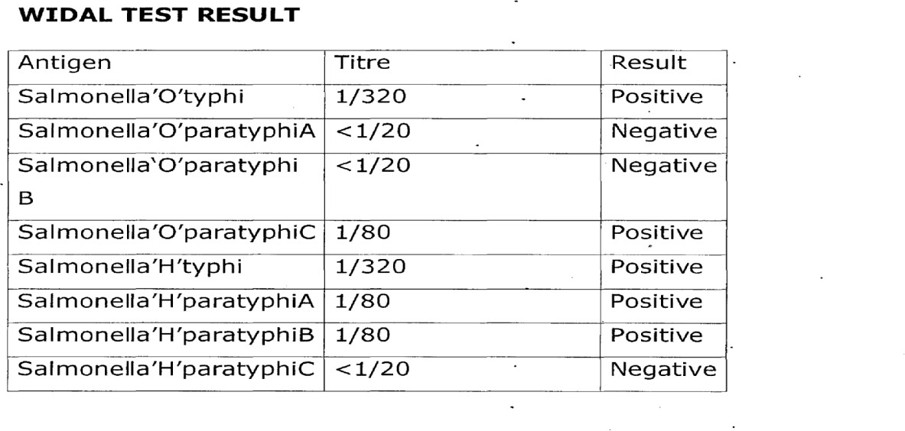

TYPHOIDFEVER

SymptomsofTyphoid Fever
The symptoms of typhoid fever usually develop one or two weeks after a person becomes injected with the salmonella typhi bacteria.
- Ahightemperaturewhichcanreachupto39-40°C(103- 104°F).
- Headache.

- Muscleache.
- Stomach pain.
- Feelingsick,weaknessandfatigue.
- Lossof appetite.
- ConstipationorDiarrhea(Adultstendtoconstipationandchildrentendtogetdiarrhea).
- Drycough.
- Weightloss
- Rashesmadeup ofsmall pink spots.

Causesof TyphoidFever
- Ingestionofcontaminatedwaterorfood.
- Eatingfoodortouchingyourmouthbefore washingyourhandsafter goingtothe toilet.
- Eatingseafoodfroma watersourcecontaminated byinfectedfaeces or urine.

PreventionofTyphoidFever
- Getvaccinatedagainsttyphoidfever.
- Eatfood that arethoroughlycooked-andarestillhot.
- Avoid raw vegetable and fruits that cannot be peeled. Vegetable like lettuce are easily contaminated and are very hard to wash well.
- Avoid food and beverages from street vendors because it is difficult for food to be kept clean on thestreet, and many travelers get sick from food brought from the street vendors.
- Sanitationandmaintenanceofgoodhygiene.

ControlofTyphoidFever
- Safedrinkingwater. -
- Improvedsanitationandadequatemedicalcare.
- Takingvaccinationagainsttyphoidfever.
- Avoidraw fruitsand vegetables.

HEPATITISBSURFACEANTIGEN(HSSAB)TEST
Thisisaserologicaltestcarriedouttoscreenapatientbloodfor thehepatitisBsurfaceantigen. It aids in the diagnosis of Hepatitis B viral infection.
AIM:Toscreenapatient’sbloodforHepatitisB surface.
PRINCIPLE:BasedontheagglutinationreactionbetweenanantibodyproducedinresponsetoHepatitis B viral infection and antigen embedded in the test strip.
MATERIAL:HBsAgteststrip, Pasteurpipette, test tube,centrifugeandblood (serum)sample

PROCEDURE:
- Thebloodsamplewastransferredintoatesttube
- Thesamplewas spundown bycentrifugationat3000 rpm for10minutes to obtain serum.
- UsingPasteurpipette, twodropsof serumwere placedontheabsorbentendofthetest strip.
- Theteststripwas allowedtostand for2minutesand theresultwas observed

RESULT:
POSITIVE:Twodistinctredlines,onelineshouldbeincontrol region(c)andanotherlineshouldbein the test region.
NEGATIVE:Oneredlineappearsinthecontrolregion(c)noapparentredlineappearsinthetestregion (C).
INVALID:ThisoccurswhenthecontrolLinefailstoappearduetoinsufficientspecimenvolumeor incorrect procedural techniques.

CHAPTERFOUR

CLINICCHEMISTRYTESTS
Inchemistry,achemicaltestisaqualitativeorquantitativeproceduredesignedtoprovetheexistenceof, or to quantify a chemical compound or chemical group with the aid of a specific reagent

URINALYSIS:
This is a non-specific test that was used to detect the presence of some metabolites in urines whose concentration was used to determine the health condition of a patient such as diabetes, metabolic abnormalities,liverdisease,binaryandhepaticobstructions,hemolyticdiseaseandurinarytractinfection. Routine urinalysis consists of three testing groups which include urine microscopy, urine chemistry and urine microscopy.

URINEMACROSCOPY:
This measured the colour and transparency of urine sample which were determined from the visual observation of the sample in a sterile transparent container the physical characteristics of urine sample were noted as
    - Paleamberandclear
    - Yellowand turbid
    - Paleamberandclouding
    - Yellowandclear
    - Bloody

URINECHEMISTRY
Thiswasbasedonthedippingofthemeditestcombi-9coloursectionsintotheurinesampletocheckfor the following parameters like pH, Glucose, Ascorbic acid, Protein, Nitrite, Ketone, Blood, Bilirubin and urobilinogen.
This test serves as a diagnostic tool which determines pathological changes in a patient’s urine in a standard urinalysis.
AIM:Todeterminepathologicalchangesinpatienturine
MATERIAL:Testtube,combi-9,urinalysisstrip,testtuberackandsamplecontainerwhichcontainsthe urine sample.

PROCEDURE
- A fresh urine sample of about l0mI was transferred from the transparent sample container into a test tube and fixed in the test tube rack.
- Thecombi-9 strip was dipped into the well-mixed urinesamplecontained in thetest tube.
- Thecombi-9 stripwasbroughtout fromurinesampleand theedgeofthestripthesupported overthe mouth of the test tube to remove excess urine.
- The result was read within 60 seconds by matching the colour changes with the standard chromatic scale provided by the manufacturer on the combi-9 container,

RESULT:
There may be colour changes. On the urinalysis strip indicating the presence of the parameters like PH, blood, Glucose, Bilirubin, Ketone, ascorbic acid, protein urobilinogen.

URINEMICROSCOPY
Urinewasexaminedunderamicroscopeinsearch ofcellularfragmentssuchaspuscells,epitheliacells, redbloodcells, yeastcells,casts,crystals,parasiteslikeflagellateoftrichomonasvaginalis,andbacteria. AIM: To check for cellular fragments in urine sample.
MATERIAL:Urineinasterilecontainer,cleangrease-freeglassslide,sterilecoverslip,centrifuge,test tube and microscope.

PROCEDURE
- Theurinesamplewasshakedto homogenize.
- Urinesampleof aboutl0mlwastransferredfrom thesamplecontainerintoatest tube.
- Theurinesamplein thetest tube was spun down bycentrifugation at 3000rpm for 10minutes.
- Thesupernatantfluidwasdecantedandthedepositwasmixedwiththelastdropthatdrainedbackinto tube,
- Adropofthe deposit was placed on the clean grease-free glass slide and covered. With asterile cover slip without entrapping air bubbles.
- Thepreparation was mounted onthemicroscopeand examinedwith xl0and x40 objective.

RESULT
Cellularfragments such as red blood, cells, pus cells, epithelial cells, yeast cells, crystals, bacterial cells, casts and trophozoite of trichomonas vaginalis ma’ be seen in urine deposit in microscopy view.

CHAPTERFIVE

PARASITOLOGYTEST
Parasitology test are test carried out indoor to diagnosis for parasite and is normally based upon the microscopic appearance of the parasite in the patients specimen.

STOOL ANALYSIS
Stool analysis involves the examination of faecal specimen collected from patients to investigate the presence of parasites. Two aspects of stool analysis are described below.

STOOL MACROSCOPY
In this aspect of stool analysis, the physical characteristics of stool specimen were investigated. These physical characteristics are the color, presence of blood, mucus or pus consistency of the stool (formed, semi-formed, unformed, watery etc)
AIM: To determine the physical appearance of stool samples. MATERIAL:Transparentsamplecontainercontainingthestoolsample. PROCEDURE
- Stoolsamplewasreceivedfromapatientsinatransparentsterile container,
- Thephysicalcharacteristicwereexaminedusingtheunaidedeye.

RESULT
Thestool samplemayappearbrown-formed withmucus etc.

STOOL MICROSCOPY
Here,thestoolsamplewasexaminedmicroscopicallytoinvestigatethepresenceofcystsandtrophozoites of protozoa, ova and larvae of helminthes, sometimes, pus cells and epithelial cells were also present in the stool.
AIM:Tocheckforentericparasitesinastoolsample
MATERIAL: Stool sample in a clean dry transparent container, applicator stick, clean grease-free microscope glass slide, sterile cover slip, normal saline, microscope and Pasteur pipette.

PROCEDURE
- AdropofnormalsalinewasplacedonthecleangreasefreemicroscopeglassslideusingPasteurpipette.
- Alittleportionofthestoolsamplewascollectedandemulsifiedinthenormalsalineontheglass slide using an applicator stick.
- Thepreparationonthe glassslidewascovered withasterilecoverslipwithoutentrappingair bubbles.

- Thepreparation was mountedand examined under themicroscopeusing xl0andx40 objectives.

RESULT
Cystsandtrophozoitesofprotozoasuchasentamoebahistolytica,gardialambiaetcaswellasovalarvae of helminthes eg Ascaris lumbricoides etc may be seen. Other include epithelia cells, pus cells etc

MALARIAPARASITETEST
Aim:toinvestigate thepresenceofmalariaparasite(plasmaodium)in the blood sample
PRINCIPLE: the thick blood film dictates the parasite present as Giemsa stain is used to stain the film which helps for easy identification with the addition of immerson oil.
SAMPLE:WholeBlood
MATERIALS: clean glass slide, cotton wool, spreader, staining rod, immersion oil, and microscope. . PROCEDURE:inversethebloodcontainerforthebloodtomixthenplace1-2dropsofbloodsampleon aclean,drygreasefreeslidemakeathickfilmorsmear.Allowtoair-dryandfloodtheslidewithGiemsa stain and allow for -10 minutes, then allow to air-dry. When completely dry, apply a drop of immersion oil to an area of the cover an area of the 10mm in diameter. Select the examiner for malaria parasite.
OBSERVATION/RESULT:TrophozoitesofplasmodiumfaecipariumandMonocytescontainingblack pigment was seen with x100 oil immersion. A thick red dot is found on these black pigments. If one red dot is seen, it is record as +, if two are seen, it is recorded as ++ etc.

CHAPTERSIX

MICROBIOLOGYTEST

CULTURE MEDIA
Aculturemediumisanynutrient,liquidorsolidmaterialthatcansupportthegrowthofmicroorganisms. The most important requirement of a culture medium is it’s ability to allow a detectable growth from a minute incubate within the shortest period of incubation.

PREPARATIONOF MEDIA
- Aweighingbalancewaskeptonafiattableanditsscalewas adjusted to zero. -
- Athinfoilwasplacedonthe balanceandit’sweightwasnoted.
- The agar base powder was collected and placed on the foil using a spatula until the required quantity was obtained.
- Thedehydratedagar medium wasthentranferred intoaclean drygraduatedconical flask
- Acorrespondingvolumeofdistilledwaterwasmeasuredusingthemeasuringcylinderandwas transferred into the conical flask containing each agar.
- Themixturewas stirred gentlyto mixusing
- Themouthof theconical flaskwascorked andplaced inanautoclave.
- Themixturewas sterilized at 121°cfor l5mins.
- Afterautoclaving,the mixturewallowedtocool

STOOL CULTURE
Thiswasusedforthediagnosisofintestinaltractinfectioncausedbyespeciallyentericpathogenssuchas salmonella enteritidis, shigella dysenteria.
AIM:To detectthepresenceofentericpathogens in stool sample.
MATERIALS: Wire loop, Bunsen burner, stool sample and agar plates (salmonella-shigella agar, bload agar and macConkey Agar plates) incubator.

PROCEDURE
- Thewireloopwas flamed tored hot inBunsenflame andallowed to cool.
- Usingtheflamesterilizedwireioop,stoolsamplewasintroducedontheagarplates(macConkeyagar, SS agar and blood agar).
- The wire loop was flamed again to red hot, allowed to cool and the inoculum was streaked out on the agar plates.

- Thecultureplates wereincubatedat 37°C for 24hours.
- Theincubatedplateswereinspectedforcolonialgrowthafter 24hours of incubation at 37°C

RESULTS
Bacteriasuchassalmonellaenteritidis,shigelladysenteriaeandEscherichiaCoilasinthecaseofinfantile gastroenteritis may be isolated. Sensitivity test was performed for the effective antibiotics to which the bacterial isolate was sensitive.

HIGHVAGINALSWAB(HVS)MICROSCOPY
AIM:Todetectthepresenceofyeast cellsandmotile organism.
METHOD:Directwetmount.
MATERIALS:Highvaginalswabsample,normalsaline,cleangreasefreeglassslide,sterilecoverslip, Pasteur pipette and microscope.

PROCEDURE:
- 3-5dropsof normalsalinewereintroduced intotheswab sticktomoistenit usingPasteurpipette.
- Adropofmoistenedspecimenwasplacedonacleangreasefree glassslide.
- Thepreparationwascoveredwith asterilecoverslip withoutentrappingair bubbles.
- Thepreparation was mountedunder themicroscopeandwasexamined withxl0 and x40 objective.

RESULT
AmotilemicroorganismlikeTrichomonasvaginalis,andyeastcells,puscellsandepithelialcellsmaybe seen.

SEMENANALYSIS
Semen analysis was carried out to investigate infertilityin a human male adult. The parameters assessed in semen analysis include:
- Measurementofvolume
- MeasurementofPH
- Examinationofwetpreparationtoestimatethepercentageofmotilespermatozoaandviableformsand look for cells and bacteria.
- Spermcount
- Examinationofstainedpreparationtoestimatethepercentageofspermatozoawithnormalmorphology. Theappearanceofsemen-canbeviscoidorhyperviscoid,butbecomesliquefiedwithin60minutesafter ejaculation due to the action of fibrinolysin in the fluid.

MEASUREMENTOFVOLUME
Normal semen has avolumeof2ml or. above in thelaboratory, it was measured usinga small graduated cylinder after liquefaction.

MEASUREMENTOFPH
- Adropofliquefied semenwasplacedon anarrowrangePH.
- After 30 seconds, the PH of the semen was recorded. The PH of normal semen should be PH 7.2 ormore within 1 hour of ejaculation.
WhenthePHisover7.8, thismaybeduetoinfection.WhenthePHisbelow7.0andthesemenisfound to contain no sperm, this may indicate dygensis of vas deferens, seminal vesicles or epididymis.

PERCENTAGEMOTILITYANDVIABLE SPERMATOZOA
- Adropofwell-mixedliquefiedsemenwasplacedonacleangreasefreeglassslideandcoveredwitha sterile cover slip.
- The specimen was focused on the microscope using the xl0 objective and the fields were examined to assess motility using x40 objective.
- A total of 100 spermatozoa was counted and the motile ones were noted out of the hundred. Then the percentage that were motile and non-motile were recorded. Normal motility is when over 50% of spermatozoaaremotilewithin60minutesofejaculation.Whenmorethan 6O%ofspermatozoaarenon- motile, eosin preparation is examined to assess whether the spermatozoa are viable or non viable.

SEMENCULTURE
Semenis sterile, as such, anymicroorganism found in it is said to bepathogenic. Pathogensmayinclude staphylococcus aureus, Neisseria gonorrhea etc.
Semenculturewascarriedoutwheninfectionwassuspectedinamale adult.
AIM:To detectthepresenceof pathogensin semen sample.
MATERIALS: SEMEN sample, wireloop, blood agar plate and macConkeyagar plate, Bunsen burner and incubator.

PROCEDURE
- Aninoculatingwirelop wasflammedtored hotonaBunsenflameandallowedto cool.
- The inoculum (semen sample) was inoculated into the agar plates (blood agar and macConkey agarplates) using a flame sterilized wire loop.
- Thewireloopwas sterilizedagain inaBunsenflametoredhot, allowed tocooland used tostreak the inoculate on the agar plates in a definite pattern.

- The culture plates were incubated at 37°c for 24hours. Culture plates were inspected far growth after the period of incubation 37°c.

RESULT:
Bacteria commonly isolated in semen culture include Escherichia coli, staphylococcus aureus etc. after isolationofbacteriagrowth,antibiogramwascarriedoutfortheeffectiveantibioticstowhichthebacteria isolate was sensitive.

CHAPTERSEVEN
RELEVANCEOFTHESIWES PROGRAMME
Ibenefitalot duringtheprogrammewhichIbelievedis stillrelevantin thefollowingareas:
Itexposedmetowork methods,techniquesinhandlingequipments thatare notavailablein school

ADVICETOTHE COMPANY/ORGANIZATION
Thereshouldbe formal trainingandorientationforthestudentsundertheircare.
Thereshouldbeappreciativemeasureonthepartofthecompanybecauseastudentwillworkwhenhe/she is appreciated even if not monetary.
Monthlydefenseof whatthe student has learnt should be done.

ADVICETOTHE INSTITUTIONS
- QualityorientationprogrammesshouldbeorganizedforallintendingI.T.studentsandshouldbemade compulsory (it should be on departmental/faculty levels due to the significance of each disciplines)
- ManyI.Tstudentsroamaboutbecauseoflackofplacement.Theinstitutionshouldliaise (departmentally) with some industries/organizations who will always be ready to assist.
- Each I.T students should be allowed tcr defend their reports of SIWES programme instead of groupdefense.
- Visitingof thestudents bythe institution should betaken with all seriousness.

ADVICETOTHE STUDENTS
- SIWESisnotmoney-makingventures.Studentsshouldlearnhowtoworknowtogetallnecessarypay in the future.
- Tothosewhorefrainfromactivework, goingaroundforpersonalbusinessesorselfishinterestshould stop it because the six months is not made for that but to acquire skills and knowledge.
- ToallwhoreallyparticipatedintheSIWES,pleasedon’tforgetallyouhavelearntandnevertradefor anything.

