
A TECHNICAL REPORT
STUDENT INDUSTRIAL WORKING EXPERIENCE SCHEME
(SIWES)

Held at
INTERSCAN PAINTS NIGERIA LIMITED
4, Ayorinde Street, Off Bishop Hudges, Ifako-Ijaye, Lagos State

Prepared by:
ABDULLAHI HUSSENAT OJONUGWA
ND/23/PSM/FT/0183

SUBMITTED TO:
DEPARTMENT OF PROCUREMENT AND SUPPLY CHAIN MANAGEMENT,
INSTITUTE OF FINANCE AND MANAGEMENT STUDIES,
KWARA STATE POLYTECHNIC, ILORIN

INPARTIAL FULFILLMENT OF THE AWARD OF THE REQUIREMENT OF THE AWARD OF NATIONAL DIPLOMA IN PROCUREMENT AND SUPPLY CHAIN MANAGEMENT.

Sept., – Dec., 2024

DEDICATION
This Siwes work is purely dedicated to Almighty Allah and my beloved parents, Mr. and Mrs. Abdullahi.

ACKNOWLEDGEMENTS
I am most grateful to Almighty Allah for giving me this opportunity and strength to complete this Siwes programme at this stage of my education career. I am greatly indebted to my family, and friends for their contribution towards my programme.
I want to extend my gratitude to the owner of the company I did my Siwes, who took his time to correct all my errors and mistakes in this work.
Lastly, my gratitude also goes to myself for not letting all my efforts go unsuccessfully.

TABLE OF CONTENTS
Title Page
Dedication
Acknowledgements
CHAPTER ONE
  - Introduction to SIWES

1.2 History of SIWES

1.3 Objectives of the Programme

CHAPTER TWO: DESCRIPTION OF THE ORGANIZATION, ORGANIZATION STRUCTURE AND FUNCTIONS
2.1 Description of the Organization

2.2 Organizational Structure

2.3 Roles and Responsibilities of the Store Department

2.4 Instruments and Materials in the Store Department
2.5 Role of the Store Keeper

CHAPTER THREE: SIWES ACTIVITIES AND EXPERIENCES

3.1 Tasks Performed During the SIWES Program

3.2 Challenges Encountered

3.3 Skills Acquired

CHAPTER FOUR: CONCLUSION AND RECOMMENDATIONS

4.1 Conclusion

4.2 Recommendations
CHAPTER ONE
  - Introduction to SIWES
Students Industrial Work Experience Scheme (SIWES) is a Skills Training Program designed to prepare and expose Students of Universities, Polytechnics, Colleges of Technology, Colleges of Agriculture and Colleges of Education for the Industrial Work situation they are likely to meet after graduation. The Scheme affords Students the opportunity of familiarizing and exposing themselves handling equipment and machinery that are usually not available in their institutions.

1.2 History of SIWES
The Students’ Industrial Work Experience Scheme (SIWES) was initiated in 1973 by the Federal Government of Nigeria under the Industrial Training Fund (ITF) to bridge the gap between theory and practice among products of our tertiary Institutions. It was designed to provide practical training that will expose and prepare students of Universities, Polytechnics, and Colleges of Education for work situation they are likely to meet after graduation.
Before the establishment of the scheme, there was a growing concern among the industrialists that graduates of institutions of higher learning lacked adequate practical background studies preparatory for employment in industries. Thus the employers were of the opinion that the theoretical education going on in higher institutions was not responsive to the needs of the employers of labour.
As a result of the increasing number of students’ enrolment in higher institutions of learning, the administration of this function of funding the scheme became enormous, hence ITF withdrew from the scheme in 1978 and was taken over by the Federal Government and handed to National Universities commission (NUC), National Board for Technical Education (NBTE) and National Commission for Colleges of Education (NCCE). In 1984, the Federal Government reverted back to ITF which took over the scheme officially in 1985 with funding provided by the Federal Government.

1.3 Objectives of the Programme
The specific objectives of SIWES are to:
- Provide placements in industries for students of higher institutions of learning approved by relevant regulatory authorities (NUC, NBTE, NCCE) to acquire work experience and skills relevant to their course of study.
- Prepare students for real work situation they will meet after graduation.
- Expose students to work methods and techniques in the handling of equipment and machinery that may not be available in schools.
- Make transition from school to the labour market smooth and enhance students’ conduct for later job placement.
- Provide students with the opportunity to apply their knowledge in real life work situation thereby bridging the gap between theory and practice.
- Strengthen employer involvement in the entire educational process and prepare students for employment in industry.
- Promote the desired technological knowhow required for the advancement of the nation.

CHAPTER TWO

DESCRIPTION OF THE ORGANIZATION, ORGANIZATION STRUCTURE AND FUNCTIONS
2.1 Description of the Organization
The SIWES program was undertaken at Interscan Paints Nigeria Limited, a well-established manufacturer and distributor of various types of paints, including emulsion, gloss, and oil-based paints. The company specializes in large-scale production, sales, and distribution of high-quality paint products. The store department plays a crucial role in inventory management, stock control, and supply chain activities to ensure seamless operations within the company.
I was assigned as a Store Keeper, responsible for managing stock, receiving and dispatching materials, and maintaining proper inventory records.

2.2 Organizational Structure
The store department in the paint company is structured into different units, including:
- Procurement Unit
- Inventory Control Unit
- Sales and Distribution Unit
- Logistics and Dispatch Unit

2.3 Roles and Responsibilities of the Store Department
The store department is responsible for:
- Receiving and inspecting raw materials and finished paint products.
- Managing stock levels and ensuring proper storage conditions.
- Processing customer and distributor orders.
- Coordinating with suppliers and logistics teams for timely delivery of materials and finished products.
- Keeping accurate records of stock movements and sales transactions.

2.4 Instruments and Materials in the Store Department
The store department is equipped with various instruments and materials essential for the paint industry, including:
- Paints (Emulsion, Gloss, Oil-Based, and Textured Paints)
- Paint Rollers – Used for applying paint evenly on surfaces.
- Hand Gloves – Protect hands from paint and chemicals.
- Brushes – Different sizes for various painting needs.
- Putty Knives – Used for smoothing surfaces before painting.
- Scrapers – For removing old paint from walls and surfaces.
- Sandpaper – For smoothing surfaces before painting.
- Measuring Containers – To ensure accurate mixing of paint components.
- Safety Goggles – For eye protection while handling chemicals.
- Masking Tape – Used to protect areas that should not be painted.
- Storage Racks – For organizing paint cans and materials.
- Ladders – Used to reach higher surfaces during painting tasks.
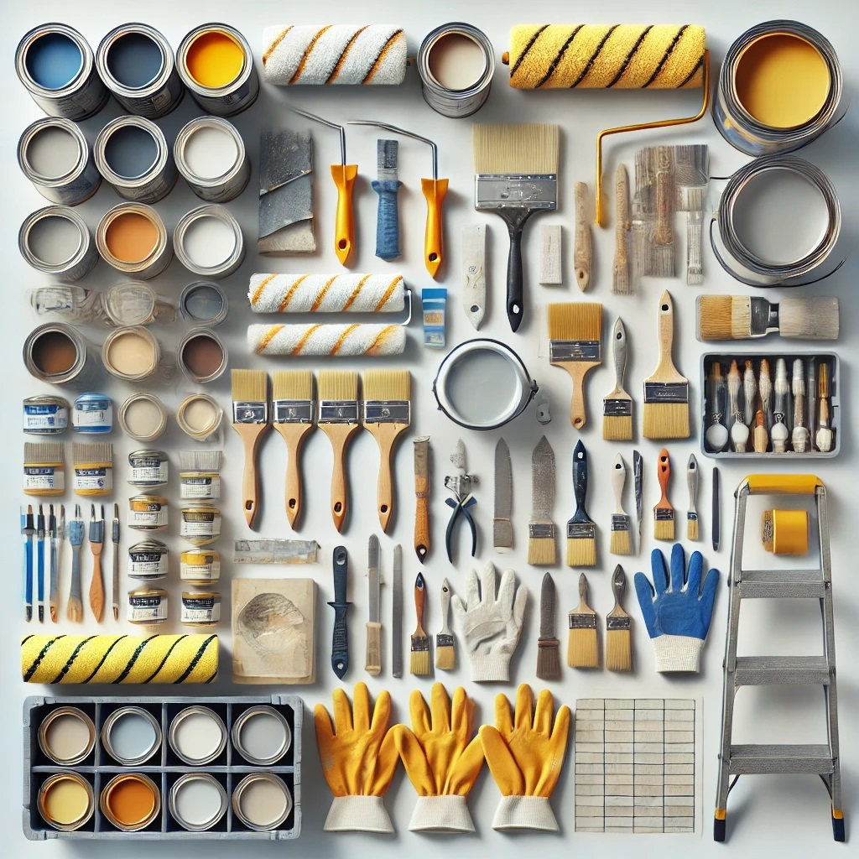
2.5 Role of the Store Keeper
As a Store Keeper, my key responsibilities included:
- Monitoring and maintaining stock levels to ensure sufficient supply of materials.
- Receiving and properly storing incoming materials such as paints, brushes, rollers, and safety equipment.
- Issuing materials to production and sales teams as required.
- Conducting regular stock audits to prevent discrepancies.
- Updating inventory records and generating reports for management.

CHAPTER THREE

SIWES ACTIVITIES AND EXPERIENCES

3.1 Tasks Performed During the SIWES Program
During the industrial training, I was actively involved in the following activities:
- Stock Management – Assisted in tracking inventory levels, updating stock records, and arranging storage facilities.
- Procurement Operations – Helped in sourcing and receiving raw materials such as pigments, binders, and solvents.
- Order Processing and Sales – Assisted in processing bulk and retail orders for distributors and direct customers.
- Logistics Coordination – Engaged in managing dispatch and delivery of finished products to various customers.
- Documentation and Record-Keeping – Maintained records of stock movements, purchase orders, supplier transactions, and sales records.

3.2 Challenges Encountered
Some challenges faced during the SIWES program included:
- Difficulty in handling large inventory volumes manually.
- Managing customer and distributor complaints regarding order delays and product availability.
- Ensuring accurate stock reconciliation with physical inventory counts.

3.3 Skills Acquired
Through the SIWES experience, I developed valuable skills such as:
- Inventory management and stock control techniques.
- Effective communication and customer service skills.
- Procurement and supply chain negotiation tactics.
- Use of inventory management software for record-keeping and tracking stock movements.

CHAPTER FOUR

CONCLUSION AND RECOMMENDATIONS

4.1 Conclusion
The SIWES training at the store department of a paint company provided practical exposure to procurement and supply chain management in a manufacturing setting. It enhanced my understanding of stock control, raw material procurement, order processing, and supplier coordination. The experience bridged the gap between theoretical knowledge and real-world business operations in the paint industry.

4.2 Recommendations
To improve the SIWES experience for future students, I recommend:
- Introducing an automated inventory management system to reduce manual errors.
- Enhancing training programs on procurement and supplier relationship management.
- Providing more hands-on opportunities in logistics planning and warehouse management.
- Organizing workshops on modern supply chain trends, especially in the paint manufacturing industry.

