

A TECHNICAL REPORT
STUDENT INDUSTRIAL WORKING EXPERIENCE SCHEME
(SIWES)

HELD AT BOLAD HUB

Prepared by:
AJIBOYE OLUWAFEMI DANIEL
ND/23/PAD/PT/0536

SUBMITTED TO

DEPARTMENT OF PUBLIC ADMINISTRATION
INSTITUTE OF FINANCE AND MANAGEMENT STUDIES
KWARA STATE POLYTECHNIC, ILORIN

IN PARTIAL FULFILLMENT OF THE AWARD OF THE REQUIREMENT OF THE AWARD OF NATIONAL DIPLOMA IN PUBLIC ADMINISTRATION

SEPTEMBER - NOVEMBER 2024

DEDICATION
I dedicate this technical report to the Almighty God, the giver of knowledge, wisdom and who is rich in mercy.

ACKNOWLEDGEMENT
I take this opportunity to express my profound gratitude and deep regards to the creator of heaven and earth, the one who knows the beginning and the end, the alpha and the omega, the Almighty God and also to my parents MR & MRS AJIBOYE, and to all those who has helped me during my SIWES programme. May Almighty God bless, protect, keep, nourish and guide you all.

ABSTRACTS
The Students Industrial Work Experience Scheme (SIWES) is an accepted skills acquisition programme which forms part of the approved academic standard in the degree programme for Nigeria University. In 1974, the federal government of Nigeria introduced the national policy on industrial training, called the Students Industrial Work Experience Scheme (SIWES).This programmes is under the umbrella of the ministry of education through the industrial training fund (ITF), was designed to help students acquire the necessary practical education/experience in their field of study and other related professions. This is an effort which was created on order to bridge the existing gap between the theory taught in the classroom and practice of science, agriculture, medicine, engineering, technology and other professional programmes in the Nigeria tertiary institution. The programme was established basically to impact elaborate practical understanding to students with respect to their various disciplines. This report is a summary of the experience I acquired during my Students' Industrial Work Experience Scheme (SIWES) in NTA. I served as an intern in the News Department of the organization.

TABLE OF CONTENT
Title page i
Dedication ii
Acknowledgements iii
Abstract iv
Table of content v-vi
TABLE OF CONTENTS
CHAPTER ONE
  - Background of SIWES 1
  - History of SIWES 1-2
  - Objectives of SIWES 2-3
  - Objectives of Establishment 3
CHAPTER TWO
2.1. Introduction to the Company 4
2.2. Open Registry 4-6
2.3 How to Fill Document 6-7
CHAPTER THREE
3.1 Mail Dispatching 8
3.2 Sending and Dispatching of Mails 6
3.3 Sources of Mail 10

CHAPTER FOUR
4.1 File Movement Register 11-12
4.2 Secret Registry 12-14
4.3 Record of Service 14-15
CHAPTER FIVE
5.1 Conclusion 16
5.2 Recommendation 16

CHAPTER ONE
  - INTRODUCTION TO SIWES
Students Industrial Work Experience Scheme (SIWES) is a Skills Training Program designed to prepare and expose Students of Universities, Polytechnics, Colleges of Technology, Colleges of Agriculture and Colleges of Education for the Industrial Work situation they are likely to meet after graduation. The Scheme affords Students the opportunity of familiarizing and exposing themselves handling equipment and machinery that are usually not available in their institutions.

1.2 HISTORY OF SIWES
The Students’ Industrial Work Experience Scheme (SIWES) was initiated in 1973 by the Federal Government of Nigeria under the Industrial Training Fund (ITF) to bridge the gap between theory and practice among products of our tertiary Institutions. It was designed to provide practical training that will expose and prepare students of Universities, Polytechnics, and Colleges of Education for work situation they are likely to meet after graduation.
Before the establishment of the scheme, there was a growing concern among the industrialists that graduates of institutions of higher learning lacked adequate practical background studies preparatory for employment in industries. Thus the employers were of the opinion that the theoretical education going on in higher institutions was not responsive to the needs of the employers of labour.
As a result of the increasing number of students’ enrolment in higher institutions of learning, the administration of this function of funding the scheme became enormous, hence ITF withdrew from the scheme in 1978 and was taken over by the Federal Government and handed to National Universities commission (NUC), National Board for Technical Education (NBTE) and National Commission for Colleges of Education (NCCE). In 1984, the Federal Government reverted back to ITF which took over the scheme officially in 1985 with funding provided by the Federal Government.

1.3 OBJECTIVES OF THE PROGRAMME
The specific objectives of SIWES are to:
- Provide placements in industries for students of higher institutions of learning approved by relevant regulatory authorities (NUC, NBTE, NCCE) to acquire work experience and skills relevant to their course of study
- Prepare students for real work situation they will meet after graduation.
- Expose students to work methods and techniques in the handling of equipment and machinery that may not be available in schools.
- Make transition from school to the labour market smooth and enhance students’ conduct for later job placement
- Provide students with the opportunity to apply their knowledge in real life work situation thereby bridging the gap between theory and practice
- Strengthen employer involvement in the entire educational process and prepare students for employment in industry
Promote the desired technological knowhow required for the advancement of the nation.
1.4 OBJECTIVES OF ESTABLISHMENT
- To provide innovative and effective solutions
- To deliver exceptional customer service
- To drive business growth and expansion
- To build a strong brand reputation
- To develop and maintain a skilled workforce
- To promote a culture of innovation and continuous improvement
- To maintain high-quality standards and best practices
- To foster strategic partnerships and collaborations

CHAPTER TWO
2.1. INTRODUCTION TO THE COMPANY
- I was introduce to the administrative department and some other departments
- I was introduced to organization structure, office and their functions
An organizational structure is a system that defines how a company operates, including how employees are grouped, their roles, and how they communicate. It also outlines how tasks are delegated to achieve the company's goals.
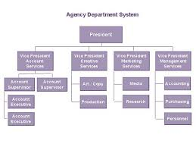
Organization Structure
2.2 OPEN REGISTRY
Open registry is all about information and record keeping and dispatching letters for smooth administration of the institute. This unit therefore generates and save records of each staff of the institute; serving and retired for reference purpose. These records are often referred to as mails which are saved in various categories of file and shelves or containers known as cabinets,
The records/file is often labeled using alphabetic and or alphanumeric style for easy identification and retrievals e.g. P2012/18. This section of Administrative Department is also in charge of preparation and procession of leaves of all kinds e.g.
- Maternity Leave
- Casual Leave
- Sick Leave
- Annual Leave
- Sabbatical Leave
- Study Leave
- Prorate Leave
- Compassionate leave
- Pre-retirement leave
Indeed, open registry is headed by a senior staff/officer and assisted by a supervisor and other office clerks. The head of the open registry performs the following functions:-
- - Management and Control of the unit staff.
- - Serves as Secretary to some committee as assigned by the management.
- - Discharge duties and functions as assigned by the HOD and the management.
- - Reports any area of needs of the section to the HOD for further necessary action.
- - Pass comments and checks staff files when the need arises/demanded.
- Other functions perform by this section includes the following:
- - Receipt of incoming mail
- - Indexing
- - Dispatch
- - File enclosure
- - File tracing
- - Receiving of mails before dispatch etc.
2.3 HOW TO FILL DOCUMENT
To fill out a document, open the document in a compatible program like Adobe Acrobat Reader (for PDFs), then navigate to the designated fields within the document and type in the required information; for most forms, simply click within a highlighted box to start typing your answer, and remember to save the document once completed.
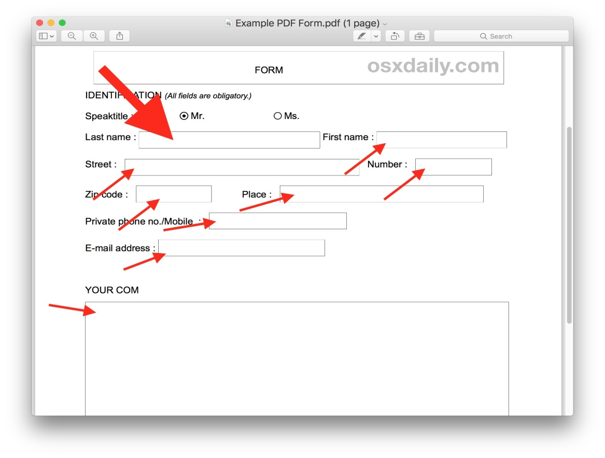

STEPS TO FILL DOCUMENT
- Open the document: Access the document on your computer or device using a suitable program like Adobe Acrobat Reader.
- Identify fillable fields: Look for highlighted boxes or designated areas within the document where you can enter text.
- Click and type: Click inside a field to activate it and start typing your information.
- Navigate through fields: Use the tab key to move between different fields on the form.
- Check for accuracy: Double-check all entered information for correctness before saving.

CHAPTER THREE
3.1 MAIL DISPATCHING
Mail dispatching is the process of sorting and sending mail to the right person or place. It can also refer to an email management model that directs emails to the best agent to handle them.

Points about mail sorting and categorization:
Sorting criteria
  - Sender: Group emails based on who sent them, helpful for identifying messages from specific contacts or companies.
  - Subject: Organize emails based on the topic discussed in the subject line, making it easy to find information related to specific projects.
  - Date: Arrange emails chronologically, allowing you to see the latest messages first.
  - Importance: Flag critical emails as high priority to ensure timely attention.

Categorization methods:
  - Predefined categories: Most email clients offer built-in categories like "Personal," "Work," "Promotions," or "Social".
  - Custom categories: Create your own categories based on your specific needs, like "Travel," "Finance," or "Health".
- Automation tools:
  - Filters: Set up rules to automatically sort emails into specific categories based on sender address, subject keywords, or other criteria.
  - Machine learning: Advanced email clients can leverage machine learning to automatically categorize emails based on content analysis, improving accuracy over time.

Example of email sorting and categorization
- Scenario: You receive an email from your bank regarding your monthly statement.
- Sorting: The email might be automatically sorted based on the sender "Bank Name".
- Categorization: Using a filter, this email would be categorized as "Finance" to easily access financial related messages.

3.2 sending and dispatching of mails

Sending and dispatching of mails" essentially means the process of preparing and physically sending out letters or packages through the postal service, including steps like addressing, sealing, stamping, and delivering them to the post office for distribution; essentially, the complete action of getting mail ready and sending it off to its intended recipient.

Points about sending and dispatching mails
- Preparation:
Writing the letter, including the recipient's address, sealing the envelope, and applying postage stamps.

- Sorting:
Categorizing mail based on destination, whether by zip code or geographic location.
- Delivery to Post Office:
Handing over the mail to a postal worker at the post office or dropping it in a mailbox.

Important considerations
- Registered mail:
For important documents, utilizing a registered mail service to get proof of delivery.
- Courier services:
Using a courier company for faster, more secure delivery, especially for urgent items.



3.3 SOURCES OF MAIL
Mail can come from a variety of sources, including the post office, email service providers, and other senders.

Mail sources
- The post office
The United States Postal Service (USPS) offers different classes of mail, including Priority Mail, Priority Mail Express, and First-Class Mail.
- Email service providers
Some popular email service providers include Gmail, Outlook, Yahoo, AOL, iCloud, and Neo.
- Other senders
Emails can come from businesses, individuals, and online retailers. For example, online retailers may send abandoned cart emails to customers who left items in their shopping cart.
Managing mail
- Companies may receive mail from multiple sources, including emails, letters, faxes, and packages.
- Digitization can help with managing mail flows.
Email basics
- An email's source code contains information such as the sender, the server that sent the message, and when it was received.
- Emails can be used for personal and professional communication.
- The five main parts of an email are the sender, subject line, salutations, body, and call to action.

CHAPTER FOUR
4.1 FILE MOVEMENT REGISTER
A "File Movement Register" is a record book or document used in an office setting to track the movement of important files between different departments or individuals within an organization, essentially noting where a file is located at any given time and who has access to it, helping to monitor file location and prevent misplacement.

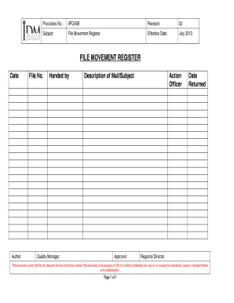

Points about a File Movement Register
- Purpose:
To maintain a clear record of where a file is currently located, who has it, and when it was transferred to another person or department.
- Information recorded:
Typically includes the file name, date of transfer, originating department, recipient's name and department, date returned (if applicable), and any relevant notes.
- Benefits:
  - Improved accountability: Helps identify who has access to a file at any given time.
  - Efficient retrieval: Makes it easier to locate a file when needed.
  - Audit trail: Provides a record of file movement for compliance purposes.
- Common practice:
Many offices maintain two File Movement Registers - one for outgoing files leaving a department and another for incoming files received.

HOW TO RETRIEVE FILE
You can retrieve files from the Recycle Bin, File History, or using file recovery software.

Recycle Bin
- Open the Recycle Bin icon on your desktop
- Find the file you want to restore
- Right-click on the file
- Select Restore

File History
- Open the folder that contained the deleted file
- Right-click on the folder
- Select Restore previous versions
- Choose a version to restore

File recovery software
- Install and run file recovery software
- Follow the on-screen instructions to scan for and recover your deleted files

Windows File Recovery
- Use the Windows File Recovery command-line tool to recover a file that seems to be permanently gone

Test Disk
- Use the Test Disk recovery tool to restore all files with their original names and folder structures

4.2 SECRET REGISTRY
A secret registry is a place that stores confidential or secret documents. These documents may include disciplinary files, queries, policy documents, and performance evaluation reports.

How secret registries are organized
- In large organizations, the secret registry is housed separately and has its own head.
- In small organizations, the secret registry and open registry are housed together.

What documents are kept in a secret registry? Disciplinary files, Queries, Policy documents, and Annual Performance Evaluation Report (APER) forms.

MORNING CENSUS
A morning census may refer to a census conducted in the morning or to a morning patrol as part of a census.



Explanation
- Census
A census is a count of people in a given area. The National Population Commission (NPC) is responsible for conducting censuses in Nigeria. The President of Nigeria issues the proclamation that sets the date for the census.
- Morning patrol
A morning patrol may be part of a census, such as when interns are involved in a census to identify tracks and nests.

Benefits of a census
- Census data can help identify services and facilities needed in rural communities.
- Census data can help develop market strategies and create more efficient production and distribution systems.

Census controversies
Census processes in Nigeria have been controversial, with frequent allegations of data manipulation for political purposes.
Census resources
For the latest updates on the census in Nigeria, you can visit the NPC's official website and follow their social media channels.

4.3 RECORD OF SERVICE
A record of service is a collection of documents that record a person's activities and accomplishments while serving in an organization. It can be a printed or electronic document.

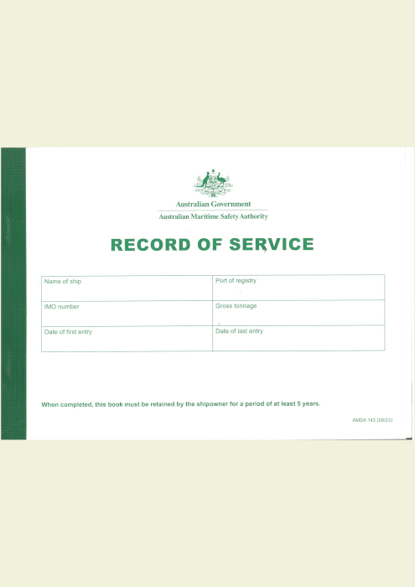

USES OF RECORD OF SERVICE
- Employment Verification:
Employers can use the record of service to verify an employee's past employment details when required for background checks, credit applications, or other external verification purposes.

- Benefits Administration:
Accurate records of service are essential for calculating employee benefits like vacation time, sick leave, retirement contributions, and severance pay based on their tenure with the company.
- Performance Management:
By reviewing past performance evaluations within the record of service, managers can assess an employee's career progression, identify areas for development, and make informed decisions regarding promotions or salary adjustments.
- Succession Planning:
A detailed record of service helps identify potential successors within an organization by highlighting employees with relevant experience and qualifications.
- Legal Compliance:
Maintaining comprehensive records of service is crucial for complying with labor laws, including requirements related to employee documentation, termination procedures, and wage and hour regulations.
- Internal Investigations:
In case of disciplinary actions or internal investigations, the record of service can serve as evidence to support decisions related to employee conduct.
- Historical Reference:
For an organization, the record of service can provide valuable historical information about employee contributions and company evolution over time.

CHAPTER FIVE
5.1 CONCLUSION
The Student Industrial Work Experience Scheme (SIWES) plays a significant role in human resource development, it helps students develop new skills and enlightens them of what the present society holds for them after graduation and helps them adapt accordingly.
5.2 RECOMMENDATIONS
I put forward the following recommendations for future improvement of the scheme;
- Organizing workshops, seminars and symposium for students in various faculties in other to keep the student abreast of new technologies and innovations.
- Posting of students for SIWES should be done by the scheme to ensure conformity with course of study.
- A mass enlightenment campaign should be carried out, to enable industries and establishments to know the importance of SIWES to the future of the student and the society at large.
- The scheme should also try to enforce the act guiding the establishment of the scheme, to serve as a deterrent to those establishments who reject student for IT.
- School Curriculum should be organized in such a way that the SIWES exercise be carried out at a stretch of six months and not the intermittent arrangement of three months twice.

