
TECHNICAL REPORT
ON
STUDENT INDUSTRIAL WORK EXPERIENCE
SCHEME (SIWES)

HELD AT

RAIDO KWARA (99.1)

BY
Emmanuel ayomide elizabeth
Nd/23/mac/pt/1196

SUBMITTED TO:
THE DEPARTMENT OF MASS COMMUNICATION, INSTITUTE OF INFORMATION AND COMMUNCATION TECHNOLOGY (IICT), KWARA STATE POLYTECHNIC, ILORIN.

IN PARTIAL FULFILMENT OF THE REQUIREMENTS FOR THE AWARD OF NATIONAL DIPLOMA (ND) IN MASS COMMUNICATION
CERTIFICATION
This is to certify that the bearer has successfully completed the Student Industrial Work Experience (SIWES).

Department Coordinator Date

SIWES Director Date

DEDICATION
This report is dedicated to the Almighty God, the giver and sustainer of life, for His unconditional love and mercy granted to me throughout the period of my Industrial Training.
ACKNOWLEDGEMENTS

I thank Almighty God for the glory, honor, adoration and mercy I received during the course of my study and when undergoing my Student Industrial Work Experience Scheme (SIWES)

My appreciation also goes to my supervisor, during my training who accessibility, untiring effort, patience and guidance and suggestions fabulously contributed to the completion of this report. Who do not just teach me but makes me understood all his teaching, may Almighty God continue to guide and protect him and his house hold.

My appreciation also goes to my parent for their support during my training. May Almighty God continue to guide and protect them.

TABLE OF CONTENT
Title Page
Certification
Dedication
Acknowledgement
Table of Contents
CHAPTER ONE: INTRODUCTION
1.1 Background to the Study
1.2 Objectives of SIWES
CHAPTER TWO: DESCRIPTION OF ESTABLISHMENT
2.1 Location and Brief History of Radio Kwara (99.1)
2.2 Objectives of Radio Kwara (99.1)
2.3 Organizational Structure of Radio Kwara (99.1)
2.4 The various Dept/Unit in Radio Kwara (99.1)
CHAPTER THREE:
3.1 Actual Work Done with Experience Gained
3.2 Equipment’s used at Radio Kwara (99.1)
3.3 Live Programs at Radio Kwara (99.1)
CHAPTER FOUR:
4.1 Summary and Conclusion
4.2 Challenges Encountered
4.3 Suggests for the Improvement

CHAPTER ONE
INTRODUCTION
  - Background
The S.I.W.E.S. was launched in 1973 by the Industrial Training Fund (I.T.F) as a programme designed to impart the undergraduate of the nation’s tertiary institutions studying various professional courses with the practical methods of performing professional functions to real life situations on site, in the office or even the factory and how they apply themselves mentally, intellectually and physically in relation to what they have been taught in the classrooms theoretically. It works with the following professional bodies to function effectively across the tertiary institutions nationwide. These are the Nigeria University Commission (N.U.C), National Board for Technical Education (N.B.T.E.) and the National Commission for Colleges of Education (N.C.C.E.). Thus, equipping the students with the necessary skills and technical knowledge to make them highly competitive and professional individuals in the Labour Market
The scheme as conducted by the Industrial Training Fund (I.T.F) through their representative liaison units and offices situated within the various institution and in major cities or towns in Nigeria with the necessary industrial rudiments needed to corroborate, practicalize and then actualize the required technical knowledge. The Industrial Training experience not only puts them in real life situations buts also exposes their practical knowledge of the course of study, consequently perfecting this knowledge thereby producing very competent and versatile professionals.
1.2 Aim and Objective of SIWES
The aim of S.I.W.E.S is to bridge the gap between the level of knowledge acquired in tertiary institutions and the practical application of such knowledge in the field of work.
The Objectives are:
- To provide an avenue for students in industries of higher learning to acquire industrial skills and experience in their course of study.
- To prepare students for the work situations they are to meet after graduation.
- To expose students to work methods and techniques in handling equipment and machinery that may not available in the educational institution.
- To make transition from school to the world of work easier and enhance students contact for later job placements.
- To improve student’s interpersonal relationship with others in their field.
- To prove students an opportunity to apply his/her knowledge in real work situation, thereby bridging the gap between college work and actual practice
CHAPTER TWO
DESCRIPTION OF THE ESTABLISHMENT OF ATTACHMENT
2.1 Location and Brief History of Radio Kwara (99.1)

LOCATION OF RADIO KWARA (99.1)
No 2 Police Road, GRA Ilorin, Kwara State.

A BRIEF HISTORY OF RADIO KWARA (99.1)
Radio Kwara (99.1), established in 1976, is a prominent state-owned radio station located in Ilorin, the capital city of Kwara State, Nigeria. It was created to serve as a medium for promoting the cultural heritage, values, and development of the state, while also providing information and entertainment to the public.
The station has grown over the years, evolving with the changing media landscape. Radio Kwara 99.1 FM offers a wide range of programs, including news, talk shows, music, sports, and educational content, catering to a diverse audience. Its goal has always been to inform, educate, and entertain listeners, while also fostering social development and unity within the community.
Radio Kwara has become an essential part of the media landscape in Kwara State, using its platform to address local issues, promote government policies, and offer a voice to the people. With its strategic programming and commitment to excellence, Radio Kwara continues to be a trusted source of information and entertainment in the region.
CURRENT STAFF STRENGTH = 90
Vision Statement
The station aims to unite and engage its audience by providing accurate news, insightful discussions, and reliable information, all while celebrating the rich culture and diversity of Ife and beyond.

Mission Statement
“The station strives to provide accurate news, insightful discussions, and reliable information, celebrating the rich culture and diversity of Ife and beyond”
ORGANIZATIONAL CHART OF RADIO KWARA 99.1 FM
- General Manager
  - Overall in charge of the station’s operations and management. Responsible for setting strategic direction and overseeing daily activities.
- Deputy General Manager
  - Assists the General Manager in overseeing station operations and may stand in during the GM's absence.

Departments and Key Roles:

Programmes Department
- Head of Programs
  - Oversees the planning and execution of all radio programs, ensuring they align with the station's mission.
- Program Presenters/Anchors
  - Hosts daily shows, news, talk shows, interviews, and other entertainment programs.
- Producers
  - Responsible for producing radio shows, selecting content, and ensuring smooth execution.

News and Current Affairs Department
- Head of News
  - Manages the newsroom and coordinates news gathering and reporting activities.
- Reporters/Correspondents
  - Report on current affairs, both locally and internationally, and provide live coverage of events.
- News Editors
  - Edit news stories, ensure accuracy, and coordinate the publication of news segments.

Technical/Engineering Department
- Chief Engineer
  - Oversees all technical aspects, including radio transmission, sound equipment, and IT infrastructure.
- Technicians
  - Maintain broadcasting equipment, monitor signal transmission, and manage sound quality.

Marketing and Public Relations Department
- Head of Marketing/PR
  - Responsible for promoting the station and building relationships with advertisers, partners, and listeners.
- Marketing Officers
  - Handle advertising sales, sponsorships, and promotional campaigns.
- Public Relations Officers
  - Manage the station's public image, communicate with the press, and coordinate community outreach.

Administration and Human Resources Department
- Head of Administration
  - Responsible for managing the station's daily operations, office staff, and logistics.
- HR Manager
  - Handles staff recruitment, training, and employee relations.

Finance Department
- Chief Accountant
  - Oversees the station's financial management, budgeting, and accounting.
- Accountants
  - Manage day-to-day financial transactions, payroll, and budgeting.

CHAPTER THREE
ACTUAL WORK DONE WITH EXPERIENCE GAINED
3.1 Introduction
This to initiates, coordinates, supervise, and control matters such as funding, hiring key personnel, contracting and arranging for distributors. This also is involved throughout all phases of the process from the development to completion of the production. The also include how to set-up live shows on the studio.

Granting of Interview
About 90 percent of everything in a news story is based on some form of interviewing - either in person, by telephone or occasionally by correspondence.

Types of Interviews
Interviews are as varied as the people who grant them, the journalists who conduct them and the news that suggests them. Rarely are interviews so mechanical that they can be reduced to standard formulas or categories. Several types, however, deserve special attention because they are the ones that occur most frequently. They are as follows:
News Interview: The news interview is based on "hard news," some event or development of current and immediate interest.
Telephone Interview: The telephone interview, a modified version of the news interview, has a number of obvious advantages, and at the same time, it has several limitations that challenge a resourceful journalist.
Casual Interview: An accidental encounter between a journalist and a news source on the street or at a social gathering can often result in a tip that arouses the curiosity of a writer.
Personality Interview: In the personality interview an effort is made to let the reader see the appearance, mannerisms, background and even the character of the subject.

Writing of News
The following are procedures on how to write and make a good news story:

1) Choose are cent, News worthy event or topic
There are a few points that we need to discuss when it comes to this step. The first of which is, of course, knowing when something is newsworthy and when something is not.
A newsworthy story is anything happening in your community that might interest readers. It should be unique, active, and impactful. For example, covering a business (if it isn’t new or offering any particular changes) isn’t particularly newsworthy, especially if it’s always been there. But covering a new business in the area is absolutely newsworthy, and will bring the company to the attention of your readers.

Conducttimely, In-Person Interviews with Witnesses
The hardest part about writing a news story is getting interviews with the right people. If there was a robbery at a local grocery store, you’d need to talk to the store manager and, if possible, the cashier or employee involved. You should not ask a family that shops at the store frequently (unless they were witnesses) or a random community member.

Construct Your Piece
Now that you have the materials that you need to continue, start putting your piece together. Start with the necessary information, and let the rest trickle down. You’ll start to get a feeling for this process as you continue to write journalistically.

Insert Quotations
Some writers choose to add quotations as they write. Others decide to add their quotations at specific points in the story, after it’s already been developed. Either way, place your quotes and be sure to identify key people in the story by their full name, occupation, and age.
3.2 Equipment’s used at Radio Kwara (99.1)
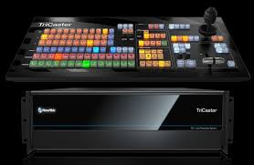
- Tricaster: Is also used to broadcast live program while the playout system is used for recorded programs. When there is no live show going on recorded program are being played through it.

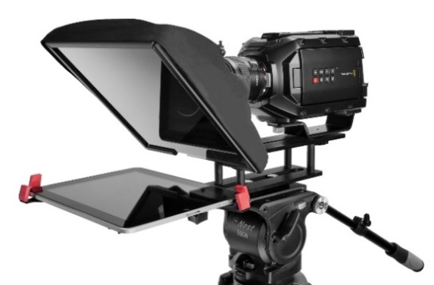
- Teleprompter: Is a display device that prompts the person speaking with an electronic visual text of a speech or script using a teleprompter is similar to using cue cards. I heard experiences on how weather forecast script to the teleprompter by highlighting all first then copy the document and clicking the teleprompter software, then add script and paste, then connect the teleprompter. A laptop was used to operate it to make it move fast and slow.

- Audio mixer: A mixer is an electronic device which is often used for changing the quality and the levels of audio signals. It is also known as a mixing console, an audio mixer, or a soundboard. Using a mixer is the most convenient way to route or combine various audio signals and even change the timbre and dynamics of the sound.
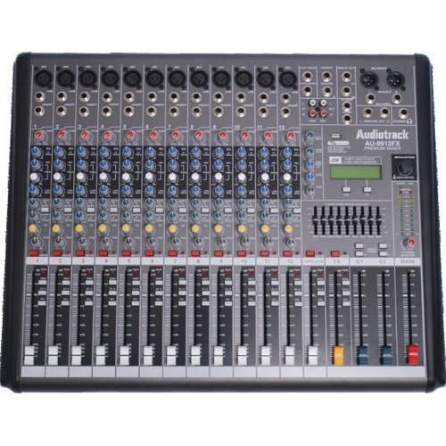

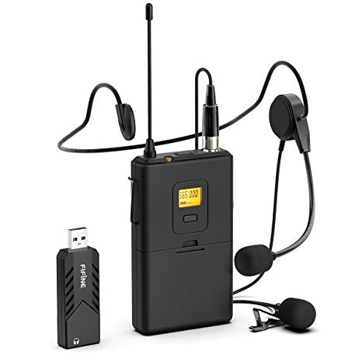
- Lapel microphone: Is a small microphone used for television, theatre, and public speaking, in order to allow for hands-free operation.

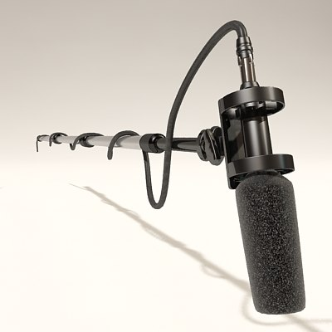
- Boom mic: is used to pick up sounds of the presenter and the guests, from ascending to decending order in all angels of the studio.

3.3 Programs at Radio Kwara (99.1)
- Educational Programs
- Music Shows
- Talk Shows
- News Segments and others

CHAPTER FOUR
SUMMARY CONCLUSION AND RECOMMENDATION

4.0 SUMMARY OF ATTACHMENT ACTIVITIES
This is a complete report of an industrial training program carried out during my SIWES (Aug – Nov, 2024) at Radio Kwara (99.1). Activities including field work such as news writing and report, different types of interview, news editing, Advertising and so on.
The experience gained has given me a sound knowledge on media house in general which has helped prepare me for the future journalism work.

4.1 CHALLENGES ENCOUNTERED
The success of my training is undisputed, but it was not devoid of rough edges. I experienced some challenges, among these are:
    - The issue of expensive transportation was the problem of transportation because my place of attachment was a little bit far from my.
    - The bureaucratic system is rigid and before things are done its takes so much time. This affected the conducive working environment for the members of staff in that whenever machines are bad and need repairs it takes so much time before it gets attended to. This system made work so tedious and cumbersome.
    - Lastly the issue of industrial base I was unable to get in touch with my survive till I ended my program which gave me a lot of worry and concern.

4.2 SUGGESTIONS FOR IMPROVEMENT OF THE SCHEME
    - Students should be paid their allowance on time to ensure motivation
    - Selection of placement should not be left to students. Polytechnics should make a means of allocating students to related companies
    - Visiting of students during the program should been sured by the ITF
    - Seminars should be organized for establishments to acquaint them with their roles towards students on training
    - Government should participate fully in the provision of equipment in the placement centers

4.3 CONCLUSION
The period has contributed immensely to my academic experience. Students Industrial Working Experience Scheme (SIWES) is an important program for all students. It helps in tackling the issue of unemployment amongst youth as it teaches us way to be independent. The exercise made me understood part of what is expected as a journalist in the practice. It helped groom my relationship skills especially in areas where team work are required and communicating with the staffs and students alike. It has exposed me to work ethics and routines.
The problems, if not tackled, will make it lose its usefulness and vitality notwithstanding the benefits of it.
Finally, I do hope the program will be improved so as to enhance manpower development and student’s skill in their respective field of study.

