
A REPORT ON COMPLETION OF STUDENT
INDUSTRIAL WORK EXPERIENCE SCHEME (S.I.W.E.S).

HEAD AT:
RSK & SON INTEGRATED, OSOGBO OSUN STATE

PRESENTED BY:
YUSUF SALAWU AKOLADE
ND/23/BAM/PT/0668

A SIWES REPORT SUBMITTED TO DEPARTMENT OF BUSINESS ADMINISTRATION OF KWARA STATE POLYTECHNIC, ILORIN

IN PARTIAL FULFILMENT OF THE REQUIREMENT FOR THE AWARD OF NATIONAL DIPLOMA (ND) IN THE DEPARTMENT OF BUSINESS ADMINISTRATION

MARCH, 2025

CERTIFICATION
This is to certify that YUSUF SALAWUDEEN AKOLADE with Matriculation number ND/23/BAM/PT/0668 of the Department of Business Administration, Kwara State Polytechnic Ilorin, Kwara State, has successfully completed his four months Student Industrial Work Experience Scheme (SIWES) at BD Investment Property and Development Company, Ilorin Kwara State.

YUSUF SALAWUDEEN AKOLADE
(Student) Signature/Date

DEDICATION
This work is foremost dedicated to Almighty God for His unquenchable love and gift of life during the pleasant course of my SIWES program, and my Parent MR. AND MRS. YUSUF for their financial support and unseasonal advice toward my academic pursuit.

ACKNOWLEDGEMENTS
With an immense gratitude, I want to acknowledge the Almighty God (most superior) for His continuous love, grace and faithfulness, and his providence throughout the period of my SIWES programme. I want to acknowledge the effectual effort of the BD Investment Property and Development Company for their amicable discharge of their duties.
I also acknowledge all the staffs of Admin Officers ALHAJI AZEEZ RASAQ for his cordial tutorship of all I need to know about the administration.
I say thank you to you all for the opportunity and privilege granted to me to serve under your amicable organization.

ABSTRACT
This report holds a review of the Student Industrial Work Experience Scheme (S.I.W.E.S), at the RSK & SON Integrated Company. The nature of this report spans the duration and findings during the program, including duties of an administrative office in the Secret Registry, daily activities and procedures through which files are received, record and documentation.

CONTENTS PAGE
Font page………………………………………………………………………..i
Certification………………………………………………………………..……ii
Dedication……………………………………………………………………….iii
Acknowledgements……………………………………………………………...iv
Abstract………………………………………………………………………….v
Contents Page……………………………………………………………………vi
CHAPTER ONE
1.1 Introduction…………………………………………..………………....……1
1.2 About Industrial Training Fund (ITF)……………………………….…….....2
1.3 Brief History SIWES………………………………………………………....2
1.4 Objectives of SIWES…………………………………………………………3
CHAPTER TWO
2.1 Overview of the Company..………………………….…...............................4
2.2 Components Units of Company…………………............................................5
2.3 Organogram of the Organization………………….………………………....6
CHAPTER THREE
3.1 Assignment carried out by the students …..…….……………………….…..8
3.2 Problem encountered………………………………………………………..9
3.3 Prospects……………………………………………………………………..9
CHAPTER FOUR
4.1 Knowledge acquires during the service …………………………..………..10
4.2 Problem encountered.………………….…………………………………...10
4.3 Proposed solution to encountered problems………………………………..11
CHAPTER FIVE
5.1 Recommendation..…………………………………………………………12
5.2 Conclusion………………………………………………………….……...12
References ………………………………………………………………...13

CHAPTER ONE
- . INTRODUCTION
This report was written in respect to the Industrial Training (IT) program undergone. It examines the activities carried out during the program as regard to the duties and responsibilities undertaken by my department.
This program was incorporated and funded by the Industrial Training Fund (ITF) jointly coordinated by Student Industrial Work Experience Scheme (SIWES), for the acquisition of skills and added values to students of various institutions.
In the course of the program, I was meant to understand the verse responsibilities and duties of the BD Consult and Property Investment Company with the flow of command which is majorly bureaucratic (a procedure of performing a task in consideration of the laid down rules and regulation). It also induce in me the knowledge of chain of command is important and to have someone under-checking your performance and coaching you on a more positive aspect of carrying out all paper works.
  - ABOUT INDUSTRIAL TRAINING FUND (ITF)
In October 1971, the Federal Government established the Industrial Training Fund (I.T.F). In its policy statement No.1 published in 1973, a clause was inserted dealing with the issue of practical skills among the locally trained professionals in the tertiary institutions especially the universities of technology, polytechnics, colleges of education and technical colleges.
Hence, Section 15 of the policy statement states clearly that “Great emphasis will be placed on assisting certain products of the post-secondary school system to adapt or orientate easily to their possible post-graduation job environments”, subsequently leading to the launch of a scheme known as Student’s Industrial Work Experience Scheme (SIWES).

  - BRIEF HISTORY OF S.I.W.E.S
SIWES (Student industrial work experience scheme) was established by ITF in 1973 to solve the problem of lack of adequate skills by graduating student in the industrial world. The scheme exposes students to industry based skills necessary for an easy transition from the classroom to the industrial world.
Participation in SIWES has become a necessary pre-condition for the award of diploma and degree certificates in specific disciplines in most institutions of the higher leaning in the country, in accordance with the education policy of government.
Operators of SIWES include: the ITF, the coordinating agencies; NUC, NCCE, NBTE, employers of labour and the various institutions. The SIWES program is funded by the Federal Government of Nigeria.
  - OBJECTIVES OF SIWES
- SIWES provides the avenue for students in institutions of higher learning to acquire industrial skills and experiences in their course of study.
- Prepare the students for the industrial work situation they’re likely to meet after graduation.
- Expose students to work method and techniques in handling equipment and machinery that may not be available in their institutions.
- Make the transition from school to the world of work easier and enhance students contact for later job placement.
- SIWES provides students with an opportunity to apply their knowledge in real work situations thereby bridging the gap between theory and practice.

CHAPTER TWO
- . OVERVIEW OF RSK & SON INTEGRATED
RSK & SON Integrated is a private limited company registered in Nigeria and has been active since 2012. We operate from Osogbo in Osun State.
INVESTMENT RATIONALE
We share the vision of the sustainable development agenda and place people and their environment at the centre of our business. We have been developing a business portfolio that targets access to product and services, and job creation through industrialization.
Achieving the industrialization goals requires massive resources that the public sector alone can’t mobilize. Engaging the private sector by attracting investment is therefore crucial. We see these challenges as an opportunity toward developing bankable projects with an attractive rate of return for private investors while contributing towards reducing poverty.
INDUSTRIALIZATION
RSK & SON Integrated have many advantages by providing quality goods and service to our customers.. They have been crucial in the industrial transformation of many states in Nigeria.
2.2 COMPONENT UNIT OF RSK & SON INTEGRATED COMPANY
The company different departments:
  - Administration
  - Finance
  - Purchasing
  - Sales
However, each department has its functions:-
- Administration department is in charge of the followings:
- Appropriations/ employments
- Confirmations
- Discipline
- Promotion and host of others
- Finance department is in charge of the followings:
- Monetary aspects of the company
- Issuance of receipts
- Collation of all payments and a host of others
- Purchasing is in charge of the followings:
    - Predict, manage, and avoid risk situations
    - Choose company-aligned clients
    - Track investments
    - Understand pricing
    - Evaluate digital risk factors
  - Sales department is in charge of the following:
    - Annual sales goals: The revenue or number of new customers you want to achieve in a year .
    - Individual goals: Specific goals for a sales rep to improve performance or motivation
    - Stretch goals: Challenging but attainable goals that encourage employees to exceed initial sales goals
    - Activity goals: Identifying activities that contribute to sales and optimizing them .
    - Customer relationship and retention goals: Improving customer satisfaction and retention rates.
    - Leadership and team development: Developing leadership and team management capabilities
2.3 ORGANOGRAM OF THE ORGANISATION
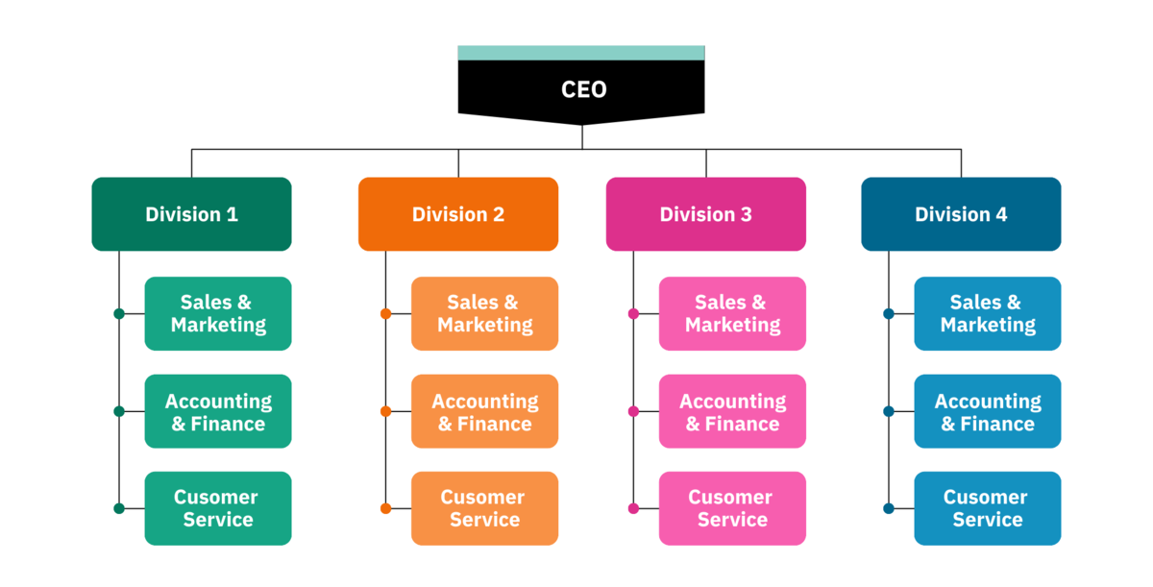

CHAPTER THREE
3.1 ASSIGNMENT CARRIED OUT BY THE STUDENT DURING THE INDUSTRIAL PERIOD
During my industrial attachment period, I was opportune to work in the department of general administration under the unit of RSK & SON Integrated Company. The department of general administration and supplies is a department which is set aside for administrative function as an administrator. These are some of the basic knowledge in which I acquired are;
- Prospecting: Identifying potential customers and building relationships with them.
- Needs analysis: Understanding a customer's specific requirements and how your product or service can address them.
- Presentation: Effectively communicating the value proposition of your product or service to the customer.
- Objection handling: Addressing concerns or doubts a customer may have.
- Closing the sale: Negotiating terms and securing the customer's commitment to purchase.
- Customer relationship management: Maintaining ongoing communication and support with customers to foster repeat business.
3.2 PROBLEMS ENCOUNTERED
The major problems encountered during my attachment are as follows:
Lack of allowance to enable me transports myself to the office during working days. The long distance between my place of attachment and home, made me to pay high for transportation. The high cost of living in this place of attachment
3.3 PROSPECTS
In-spite of the work of various department of the company, I have noticed critically the area of problems and possible solutions to be adopted by this department as regard the problem of how to deal with different customers.

CHAPTER FOUR
  - KNOWLEDGE ACQUIRED DURING SERVICE
The major knowledge acquired is that in RSK & SON Integrated Company is that hierarchy is duly recognized and there are strict rules and regulation in carrying out functions i.e it should be in accordance with the laid down rules of RSK & SON Integrated Company.
Secondly, Identifying potential customers and building relationships with them.
Lastly cordial communication of ideas improves the working and learning speed of each staffs.
  - PROBLEMS ENCOUNTERED
As this department play some essential to the organization, some of the problem adhere to it are as follows:
- The staff sees the company as a place concerned with their own personal business.
- Late coming of some staffs of the department
- Sleeping on duty
- Absence from duty without leave

  - PROPOSED SOLUTION TO ENCOUNTERED PROBLEMS
- All staffs should be treated equally and duly discipline.
- The organization should employed competent and ready minded staff
- Provision of constant seminar to staff to know how to form cordial relationship with customers.
- Office cabinet should be made available and damaged ones should be replaced

CHAPTER FIVE
  - RECOMMENDATIONS
The experience I had in RSK & SON Integrated Company has posed me to recommend the following should to implemented
- SIWES student should be given access to the organization history
- Proper orientation should be given to any SIWES student
- Supervision of the student in accordance of is been done and what he/she learn for that day
- SIWES student should be posted to the department base on their field of study
  - CONCLUSION
Purchasing and sales is the life wire of business organization just as the head perform crucial function in the body. It will ensures profitability and provide quality goods and services to customers.

REFERENCES
Formal students report book.
History of RSK & SON Integrated Company
Barbara E. Coyton, Peter Jenknis and Joan M (2004 to 200 five) design and construction by black well scientist.
District Secretariat practice in topical countries part 2 by Monica Cheesbrough

