
A REPORT ON COMPLETION OF STUDENT
INDUSTRIAL WORK EXPERIENCE SCHEME (S.I.W.E.S).
HEAD AT:
BD INVESTMENT AND PROPERTY DEVELOPMENT COMPANY, OKEFIA OSOGBO OSUN STATE

PRESENTED BY:
NURENI ZAINAB TITILAYO
ND/23/PAD/PT/0154

A SIWES REPORT SUBMITTED TO DEPARTMENT OF PUBLIC ADMINISTRATION OF KWARA STATE POLYTECHNIC, ILORIN

IN PARTIAL FULFILMENT OF THE REQUIREMENT FOR THE AWARD OF NATIONAL DIPLOMA (ND) IN THE DEPARTMENT OF PUBLIC ADMINISTRATION

MARCH, 2025
CERTIFICATION
This is to certify that NURENI ZAINAB TITILAYO with Matriculation number ND/23/PAD/PT/0154 of the Department of Public Administration, Kwara State Polytechnic Ilorin, Kwara State, has successfully completed his four months Student Industrial Work Experience Scheme (SIWES) at Harmony Investment Property and Development Company, Ilorin Kwara State.

NURENI ZAINAB TITILAYO
(Student) Signature/Date

DEDICATION
This work is foremost dedicated to Almighty God for His unquenchable love and gift of life during the pleasant course of my SIWES program, and my Parent MR. AND MRS. NURENI for their financial support and unseasonal advice toward my academic pursuit.

ACKNOWLEDGEMENTS
With an immense gratitude, I want to acknowledge the Almighty God (most superior) for His continuous love, grace and faithfulness, and his providence throughout the period of my SIWES programme. I want to acknowledge the effectual effort of the Harmony Investment Property and Development Company (HIPDC) for their amicable discharge of their duties.
I also acknowledge all the staffs of Admin Officers for his cordial tutorship of all I need to know about the administration.
I say thank you to you all for the opportunity and privilege granted to me to serve under your amicable organization.
Finally, this report will be incomplete if I failed to acknowledge my academic supervisor for their precious effort.

ABSTRACT
This report holds a review of the Student Industrial Work Experience Scheme (S.I.W.E.S), at the Harmony Investment Property and Development Company. The nature of this report spans the duration and findings during the program, including duties of an administrative office in the Secret Registry, daily activities and procedures through which files are received, record and documentation.

CONTENTS PAGE
Font page………………………………………………………………………..i
Certification………………………………………………………………..……ii
Dedication……………………………………………………………………….iii
Acknowledgements……………………………………………………………...iv
Abstract………………………………………………………………………….v
Contents Page……………………………………………………………………vi
CHAPTER ONE
1.1 Introduction…………………………………………..………………....……1
1.2 About Industrial Training Fund (ITF)……………………………….…….....2
1.3 Brief History SIWES………………………………………………………....2
1.4 Objectives of SIWES…………………………………………………………3
CHAPTER TWO
2.1 Overview of (HIPDC) ..………………………….….....................................4
2.2 Components Units of HIPDC…………………...............................................5
2.3 Organogram of the Organization………………….………………………...6
CHAPTER THREE
3.1 Assignment carried out by the students …..…….……………………….…..8
3.2 Problem encountered………………………………………………………..9
3.3 Prospects……………………………………………………………………..9
CHAPTER FOUR
4.1 Knowledge acquires during the service …………………………..………..10
4.2 Problem encountered.………………….…………………………………...10
4.3 Proposed solution to encountered problems………………………………..11
CHAPTER FIVE
5.1 Recommendation..…………………………………………………………12
5.2 Conclusion………………………………………………………….……...12
References ………………………………………………………………...13

CHAPTER ONE
- . INTRODUCTION
This report was written in respect to the Industrial Training (IT) program undergone. It examines the activities carried out during the program as regard to the duties and responsibilities undertaken by my department.
This program was incorporated and funded by the Industrial Training Fund (ITF) jointly coordinated by Student Industrial Work Experience Scheme (SIWES), for the acquisition of skills and added values to students of various institutions. In the course of the program, I was meant to understand the verse responsibilities and duties of the BD investment and property development company, okefia osogbo osun state with the flow of command which is majorly bureaucratic (a procedure of performing a task in consideration of the laid down rules and regulation). It also induce in me the knowledge of chain of command is important and to have someone under-checking your performance and coaching you on a more positive aspect of carrying out all paper works.

  - ABOUT INDUSTRIAL TRAINING FUND (ITF)
In October 1971, the Federal Government established the Industrial Training Fund (I.T.F). In its policy statement No.1 published in 1973, a clause was inserted dealing with the issue of practical skills among the locally trained professionals in the tertiary institutions especially the universities of technology, polytechnics, colleges of education and technical colleges.
Hence, Section 15 of the policy statement states clearly that “Great emphasis will be placed on assisting certain products of the post-secondary school system to adapt or orientate easily to their possible post-graduation job environments”, subsequently leading to the launch of a scheme known as Student’s Industrial Work Experience Scheme (SIWES).

  - BRIEF HISTORY OF S.I.W.E.S
SIWES (Student industrial work experience scheme) was established by ITF in 1973 to solve the problem of lack of adequate skills by graduating student in the industrial world. The scheme exposes students to industry based skills necessary for an easy transition from the classroom to the industrial world.
Participation in SIWES has become a necessary pre-condition for the award of diploma and degree certificates in specific disciplines in most institutions of the higher leaning in the country, in accordance with the education policy of government.
Operators of SIWES include: the ITF, the coordinating agencies; NUC, NCCE, NBTE, employers of labour and the various institutions. The SIWES program is funded by the Federal Government of Nigeria.
  - OBJECTIVES OF SIWES
- SIWES provides the avenue for students in institutions of higher learning to acquire industrial skills and experiences in their course of study.
- Prepare the students for the industrial work situation they’re likely to meet after graduation.
- Expose students to work method and techniques in handling equipment and machinery that may not be available in their institutions.
- Make the transition from school to the world of work easier and enhance students contact for later job placement.
- SIWES provides students with an opportunity to apply their knowledge in real work situations thereby bridging the gap between theory and practice.

CHAPTER TWO
- . OVERVIEW OF HARMONY INVESTMENT AND PROPERTY DEVELOPMENT COMPANY (HIPDC)
Kwara State Investment Corporation was established by Edict No 4 of October, 1971. This was to foster the rapid economic development of the state.
The Kwara State Investment Corporation had five (5) main division of which housing and property division was later excised to become the defunct Kwara State Housing Corporation which metamorphose into Estate Mangement Committee and later to Kwara State Property Development Corporation by Edict No 2 of 1991.
In July 1995, the Kwara State took a decision to establish Kwara Investment and Property Development Corporation as a state own. In view of this Edict No. 11 of 1995 was promulgated to establish Kwara Investment and Property Development corporation (KIDPC) which later on incorporated into Limited Liability Company with registration No. Rc 355148.
2.2. COMPONENT UNIT OF HARMONY INVESTMENT PROPERTY AND DEVELOPMENT COMPANY
The company different departments:
  - Administration
  - Finance
  - Estate
  - Works
  - Physical planning
  - Development
However, each department has its functions:-
- Administration department is in charge of the followings:
- Appropriations/ employments
- Confirmations
- Discipline
- Promotion and host of others
- Finance department is in charge of the followings:
- Monetary aspects of the company
- Issuance of receipts
- Collation of all payments and a host of others
- Estate Departemt is in charge of the followings:
- Acquisition of landed property
- Allocation of plots of land
- Issuance of allocation letters
- Renovation of undeveloped plots and a host of others
- Works department is in charge of the followings:
- drawing of building plans
- submission of estimate costs
- checking of building plans.
- Physical planning is in charge of the followings:
- Charting of measures areas
- Determine the area of buildings
- Issuance of site plans
2.3 ORGANOGRAM OF THE ORGANISATION
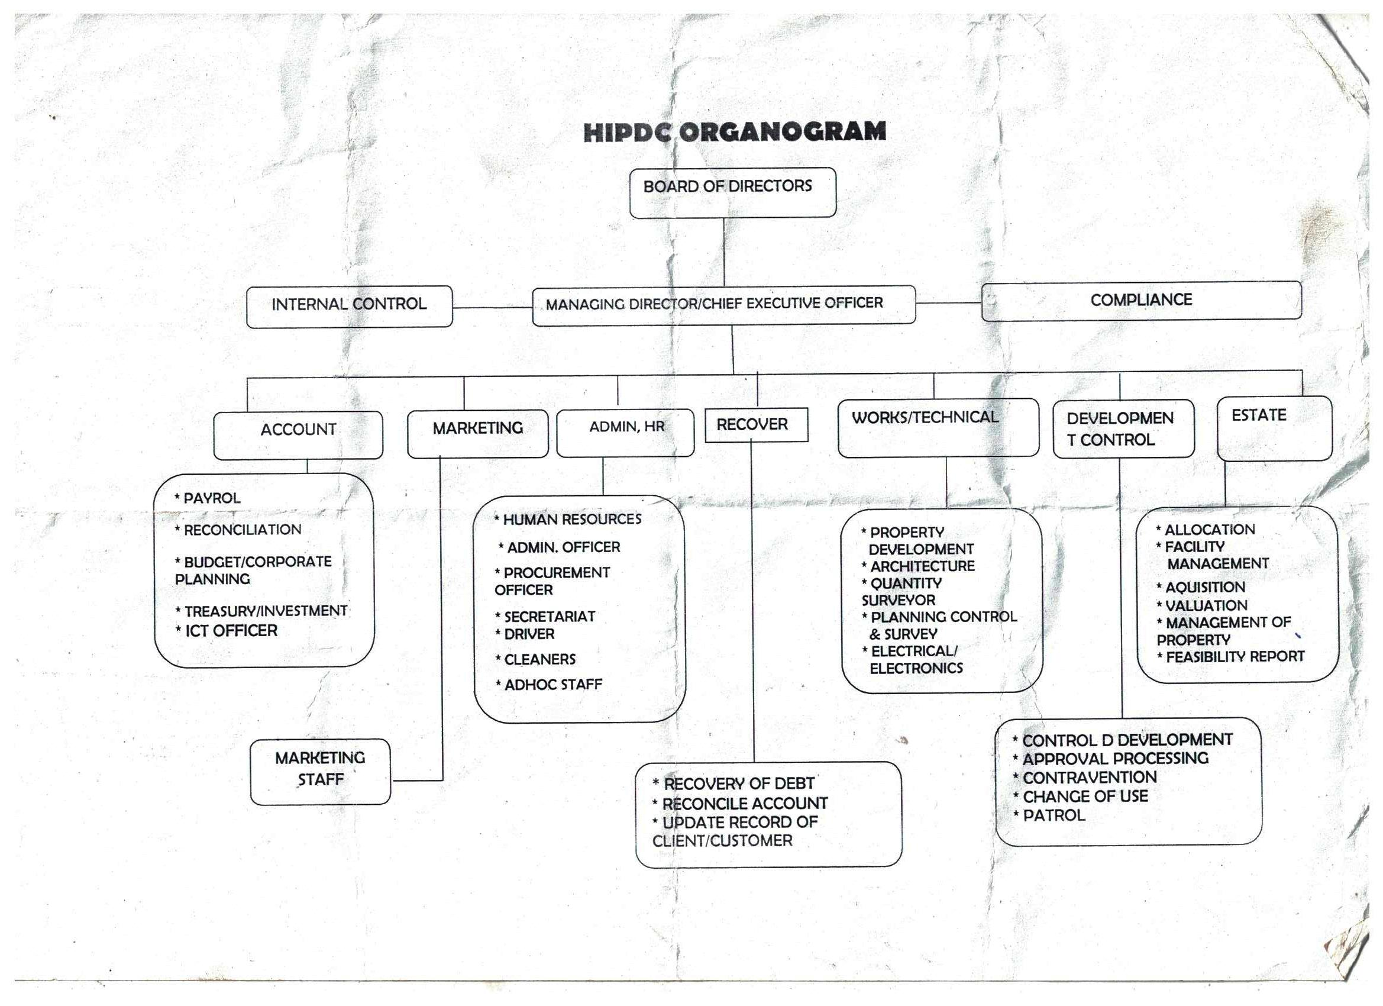

CHAPTER THREE
3.1 ASSIGNMENT CARRIED OUT BY THE STUDENT DURING THE INDUSTRIAL PERIOD
During my industrial attachment period, I was opportune to work in the department of general administration under the unit of Harmony Investment Property and Development Company (HIPDC). The department of general administration and supplies is a department which is set aside for administrative function as an administrator. These are some of the basic knowledge in which I acquired from the department of general administration as an administrator;
- Sorting of file
- Discipline
- Supervision of text
- Arrangement of file
- Location of map
- Orientation on how to carry out administrative functions effectively in an organization
- How to fill staff verification form
- How to differentiate between the two file which is open file and secrete file.
- How to trace a staff file.

3.2 PROBLEMS ENCOUNTERED
The major problems encountered during my attachment are as follows:
Lack of allowance to enable me transport myself to the office during working days. The long distance between my place of attachment and home, made me to pay high for transportation. The high cost of living in this place of attachment
3.3 PROSPECTS
In-spite of the work of various department of the company, I have noticed critically the area of problems and possible solutions to be adopted by these department as regard the problem of inadequate infrastructure facilities such as pipe bore water, electricity and other allowances should be paid accordingly. In addition, high cost of feeding and accommodation should be reduced in other to motivate the students on attachment.

CHAPTER FOUR
  - KNOWLEDGE ACQUIRED DURING SERVICE
The major knowledge acquired is that in Harmony Investment Property and Development Company is that hierarchy is duly recognized and there are strict rules and regulation in carrying out a function i.e it should be in accordance with the laid down rules of Public Service Rules (PSR)
Secondly, manual filing system is still appreciated in our society despite the technological advancement
Lastly cordial communication of ideas improves the working and learning speed of each staffs.
  - PROBLEMS ENCOUNTERED
As this department play some essential to the organization, some of the problem adhere to it are as follows:
- The department was over staffed which cause some of the officers to be idle
- The department now sees the commission as a place concerned with their own personal business neglecting the affairs of the government
- Late coming of some staffs of the department
- Lack of stationery to carried out the organization duties
- Sleeping on duty
- Absence from duty without leave
- Filing system which an essential part in the department was carelessly handed
- Misplacement of officers file
  - PROPOSED SOLUTION TO ENCOUNTERED PROBLEMS
- All officers should be treated equally and duly discipline should be given in accordance of the Public Services Rules
- The organization should employed competent and ready minded staff
- Provision of stationeries when required
- Office cabinet should be made available and damaged ones should be replaced

CHAPTER FIVE
  - RECOMMENDATIONS
The experience I had in Harmony Investment Property and Development Company (HIPDC) has posed me to recommend the following should to implemented
- SIWES student should be given access to the organization history
- Proper orientation should be given to any SIWES student
- Supervision of the student in accordance of is been done and what he/she learn for that day
- SIWES student should be posted to the department base on their field of study
  - CONCLUSION
A registry is the life wire of every organization just as the head perform crucial function in the body. It houses all the information and documents which are valuable for effective decision-making and references.

Besides senior officer should cooperate with all registry staff in discharging of their duties by avoiding unnecessary delay of files and removal of documents in interest of good service, document preservation, storage and retrieval.

REFERENCES
Formal students report book.
History of Harmony Investment Property And Development Company (HIPDC)
Barbara E. Coyton, Peter Jenknis and Joan M (2004 to 200 five) design and construction by black well scientist.
District Secretariat practice in topical countries part 2 by Monica Cheesbrough

