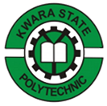

REPORT ON

STUDENTS’ INDUSTRIAL WORK EXPERIENCE SCHEME (SIWES)
Held at:

RAMFOY PROJECT & CONSTRUCTION COMPANY
ODU CUSCENT, BE SUM, IBADAN, OYO STATE

BY

RASHEED ABEEB ABIODUN
ND/23/EEE/PT/0039

IN PARTIAL FULFILLMENT FOR AWARD OF NATIONAL DIPLOMA (ND) IN THE DEPARTMENT OF ELECTRICAL/ELECTRONICS ENGINEERING,
INSTITUTE OF TECHNOLOGY,
KWARA STATE POLYTECHNIC, ILORIN

AUGUST – NOVEMBER, 2024

ABSTRACT
I was attached to RAMFOY PROJECT AND CONSTRUCTION COMPANY which had an on-going project; the electrical wiring and Installation. My duties were to observe and report the weekly installation activities, procedures and work progresses carried out on the site and make a weekly presentation to the office on the various installation stages, installation processes and knowledge obtained on the project. This report is therefore an illustration of the nature of works and activities carried out on the electrical installation site and the nature of works done during the course of the industrial programme. It also provides a detailed principle of building construction and some aspects of Health and Safety Environment in reference to building technology and how they are applied practically in the electrical installation on the buildings both conduct and surface procedure.

TABLE OF CONTENT
Title page
Acknowledgement
Abstract
Table of contents
CHAPTER ONE: INTRODUCTION
1.0 SIWES Background
1.1 Objectives of SIWES
1.2 Bodies involved in the management of SIWES
1.3 Background of Establishment.
CHAPTER TWO:
2.0 Historical Background of the Organization
2.1 Organizational Chart
CHAPTER THREE:
3.0 Work experience during attachment
3.1 Introduction to construction materials, equipments and their uses.

CHAPTER FOUR
4. 1 Knowledge gained during attachment
CHAPTER FIVE
5.1 Recommendation
5. 2 Conclusion
References

CHAPTER ONE

INTRODUCTION

STUDENT INDUSTRIAL WORK EXPERIENCE SCHEME (SIWES) BACKGROUND
In the earlier stage of science and technology education in Nigeria, students were graduating from their respective institutions without any technical knowledge or working experience. It was in this view that students undergoing science and technology related courses were mandated for students in different institution in view of widening their horizons so as to enable them have technical knowledge or working experience before graduating from their various institutions.
The Student Industrial Work Experience Scheme (SIWES) was established by the Industrial Training Fund (ITF) in 1973 to enable students of tertiary institution have technical knowledge of industrial work base on their course of study before the completion of their program in their respective institutions. The scheme was designed to expose students to industrial environment and enable them develop occupational competencies so that they can readily contribute their quota to national economic and technological development after graduation. The major background behind the embarkment of students in SIWES was to expose them to the industrial environment and enable them develop occupational competencies so that they can readily contribute their quota to national economic and technological development after graduation. The major benefit accruing to students who participate conscientiously in Students Industrial Work Experience Scheme (SIWES) are the skills and competencies they acquire. The relevant production skills remain a part of the recipients of industrial training as life-long assets which cannot be taken away from them. This is because the knowledge and skills acquired through training are internalized and become relevant when required to perform jobs or functions.

1.1 OBJECTIVES
The Industrial Training Funds policy Document No. 1 of 1973 which established SIWES outlined the objectives of the scheme. The objectives are to:
- Provide an avenue for students in higher institutions of learning to acquire industrial skills and experiences during their course of study.
- Prepare students for industrial work situations that they are likely to meet after graduation.
- Expose students to work methods and techniques in handling equipment and machinery that may not be available in their institutions.
- Make the transition from school to the world of work easier and enhance students’ contacts for later job placements.
- Provide students with the opportunities to apply their educational knowledge in real work situations, thereby bridging the gap between theory and practice.
- Enlist and strengthen employers’ involvement in the entire educational process and prepare students for employment in Industry and Commerce (Information and Guideline for SIWES, 2002).
1.2 BODIES INVOLVED IN THE MANAGEMENT OF SIWES
The bodies involved are:
- The Federal Government.
- Industrial Training Fund (ITF).
Other supervising agents are:
- National University Commission (NUC)
- National Board for Technical Education (NBTE)
- National Council for Colleges of Education (NCE)
1.3 The functions of these Agencies above include;
- Establish SIWES and accredit SIWES unit in the approved institutions.
- Formulate policies and guideline for participating bodies and institutions as well as appointing SIWES coordinators and supporting staff.
- Supervise students at their places of attachment and sign their lob-book and IT forms.
- Ensure payment of allowances for the students and supervisors.
- Ensure adequate funding of the scheme.
CHAPTER TWO
HISTORICAL BACKGROUND OF THE ORGANIZATION
2.1 BACKGROUND OF ESTABLISHMENT
RAMFOY PROJECT AND CONSTRUCTION COMPANY (RAMFOY PROJECT AND CONSTRUCTION COMPANY) Limited located at Odu Cuscent BeSum, Iadan, Oyo State was incorporated as a limited liability company in March 2003, the company which was formerly known as STANDARD FOCUS VENTURE started business in April 2000 and with the needs of expansion and bringing in more investors, the company became a limited liability company with the name RAMFOY PROJECT AND CONSTRUCTION COMPANY Limited.
The company was formed because of the realization that Nigerian construction professionals should take the bull by the horn and dictate the pace for the complete development of the construction and real estate sector of the economy. Because of the competitive nature of the terrain of business, the Organization is aware that for indigenous engineering companies to survive, a complete re-orientation of the erstwhile Nigeria approach to business must be embraced.
To this end, the organisation’s subscription to Total Quality Management is unsurpassed consequently therefore matters such as;
- Conducive business environment.
- Competitive pricing.
- Employees and Public safety.
- Commitment to ultimate quality.
- Staff welfare
- Commitment to project on-time delivery.
- Effective management techniques have become second nature to our organization.
RAMFOY PROJECT AND CONSTRUCTION COMPANY should provides and deploys the best in class project management techniques and procedures in executing all projects to the highest standard. Projects undertaken include Construction, Engineering and Architectural Design, Interior Decoration, Procurement and Consultancy to both private and corporate clients in Nigeria.

2.2 ORGANIZATIONAL CHART
Chairman
DPM
General Secretary
Vice Chairman
Accounting
Finance
Project
Staff
Store
Staff
Auditing
Supervisors
Staff
Maintenance
Parks
Security

CHAPTER THREE
3.0 WORK EXPERIENCED GAINED DURING ATTACHMENT

NEEDLE-NOSE PLIERS
Another essential specialty electrical tool is a pair of needle-nose pliers (also called long-nose pliers). It will be used for bending and twisting wires whenever you are making screw-terminal connections. The long, narrow tip makes this a great tool for detailed work. Most needle-nose pliers also include cutting jaws for trimming wires.

LINESMAN PLIERS
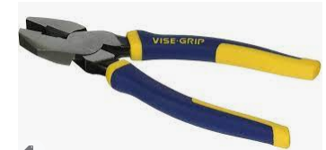
A pair of linesman pliers is an electrician's do-it-all tool. It has a squared-off end that is great for twisting wires together, a center cutting blade for trimming wire, and a grip area between the handles for pulling wire.
Casual DIYers may be able to get by without this tool, but anyone who does regular electrical work will want to own a pair of linesman pliers.

DIAGONAL CUTTING PLIERS
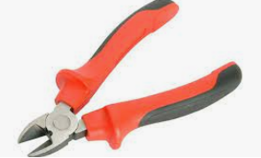
Diagonal cutting pliers, sometimes called side snips or dikes, are used to cut wires. They are specially designed with a cutting edge that goes down to the tip of the jaws, allowing you to get into tight areas to trim wires. Some types can also have a built-in voltage detector to sense live wires. You can also find combination tools that include wire-stripping slots built into the handles.
This is a second-tier specialty tool: Casual DIYers may not need it, but those who do regular electrical work will find it very useful.

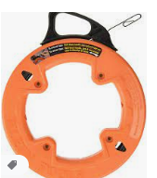
FISH TAPE
A fish tape is used to pull stranded or solid wire conductors through metal or PVC conduit. Cable lube is available to assist you in pulling the wires through the conduit. A fish tape can also be helpful when you are pulling NM cable through wall cavities.
This is a tool used when making wiring improvements, such as adding or extending circuits. Casual DIYers who are simply making electrical repairs or replacements rarely need a fish tape, but it is a good tool for more advanced DIYers to own.
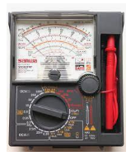
VOLTMETER OR MULTIMETER
A voltmeter is used to read voltage levels and verify that circuits are “live” or off. Unlike a circuit tester, this tool gives you reading on how much voltage is being carried. More sophisticated forms of the tool are known as multimeters, and they can not only read voltage levels but also amperage, resistance, and DC voltage and amperage. They do, however, require practice to learn how to use them properly.
This specialty tool is used mostly by advanced DIYers and professional electricians. Casual DIYers may not need to own this tool, but those who do a lot of electrical work on appliances and electronics may find it essential.

WIRE CRIMPERS
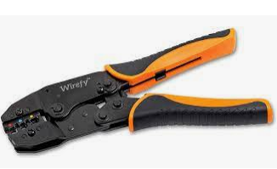
Wire crimpers are used to crimp lugs or connection terminals onto wires. This tool is not often used for routine circuit repairs, but it has many uses when working with appliances or electronics. Many types can also be used to strip wire insulation
CHAPTER FOUR
4.0 KNOWLEDGE GAINED DURING ATTACHMENT

The experience gained at the place of attachment is basically based on the electrical wiring circuit, both the conduct and surface and others electricity installation where necessary.

Types of Electrical Wiring
We know that electrical circuit is a closed path through which electricity flows from phase or hot wire to the device or apparatus and then back the source though neutral wire.
Along the way, the electricity path may consist of fixtures, switches, receptacles, junction boxes, etc. So, the wiring may be routed through these elements before actually making connections with apparatus or device.
Majorly, the wiring is divided into two types depending on the way the devices are powered or connected to the supply. They are:
- Parallel Wiring
- Series Wiring
In Parallel Wiring, several devices on the installation are powered on a single circuit. It is the most accepted wiring in homes and industries, in which devices are connected in parallel with the supply source as shown in figure.
In this, both phase (or hot) and neutral cables are routed through the electrical boxes (junction boxes) from which individual receptacles, fixtures, and devices are branched.
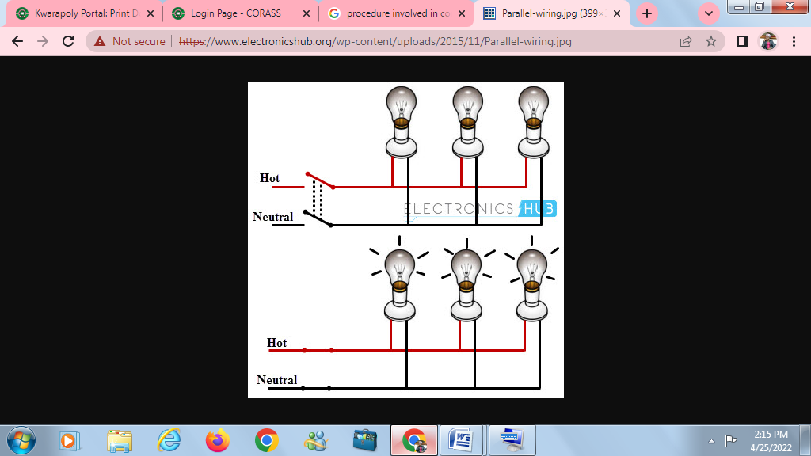
The Series Wiring is the rarely used wiring in which hot wire is routed through the several devices and then last device terminal is connected to the neutral wire. It is like an old Christmas lights or serial lights wiring in which one light burnout leads to the shutdown of the entire network.

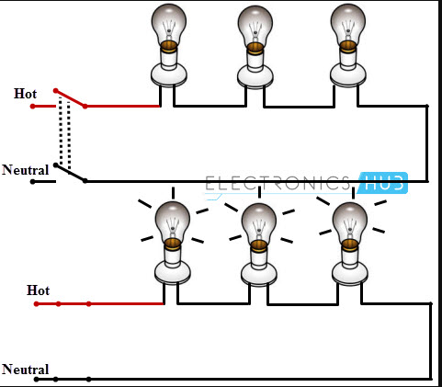

Examples of Electrical Wiring
For a better understanding of the wiring concept, here we are giving some examples of the wiring circuits, which are commonly used in our homes / offices.

Single Bulb (or any other load) Controlled by a One Way Switch
In this, hot wire is connected to the one terminal of the switch and other terminal of the switch is connected to the bulb positive terminal, then bulb negative terminal is connected to the neutral wire as shown in figure.
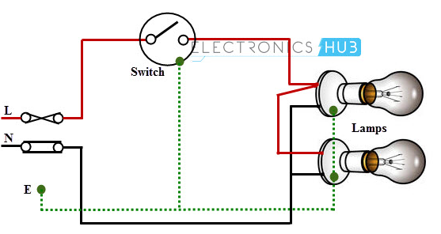

Two Blubs Controlled by a One Way Switch
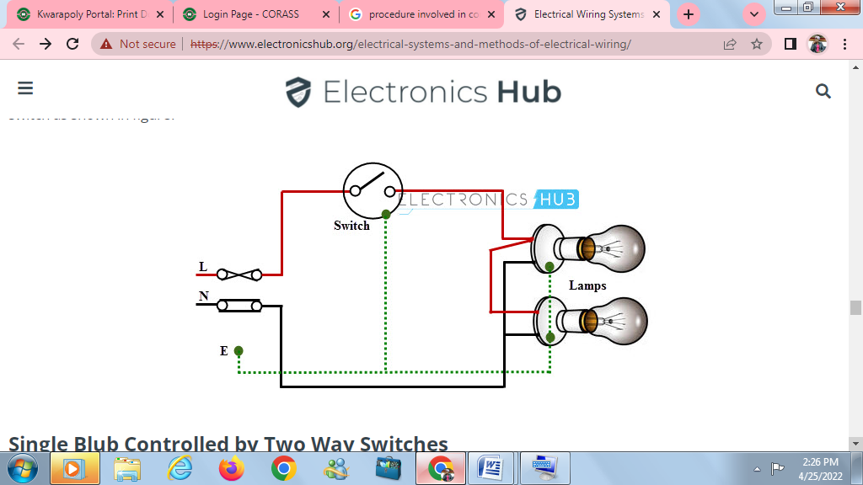
In this, two bulbs are connected in parallel with the supply wires (phase and neutrals), which are routed by single one-way switch as shown in figure.

Single Blub Controlled by Two Way Switches
This wiring is also called as Staircase Wiring. In this, a light bulb / lamp is controlled from two different places / sources by using two two-way switches. This type of wiring is used in bed rooms to switch ON/OFF the lamp from two sources (at the bed side and at switchboard). The connection of switches with the lamp is shown below.
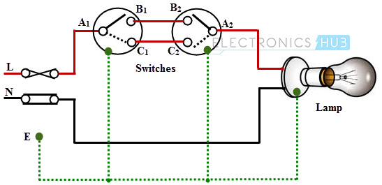

Warehouse Wiring
This type wiring is used in big god-owns, long passages, warehouses and tunnel like structures having many rooms or portions. It follows the linear sequence for switching the lights from one end to the other.
When a person leaves one room and enters the next, turning the light switch makes previous room’s lamp to be switched OFF, while the present room lamps to be switched ON. It turns OFF one lamp while switching ON the another. The schematic wiring diagram for warehouse wiring is shown in below.

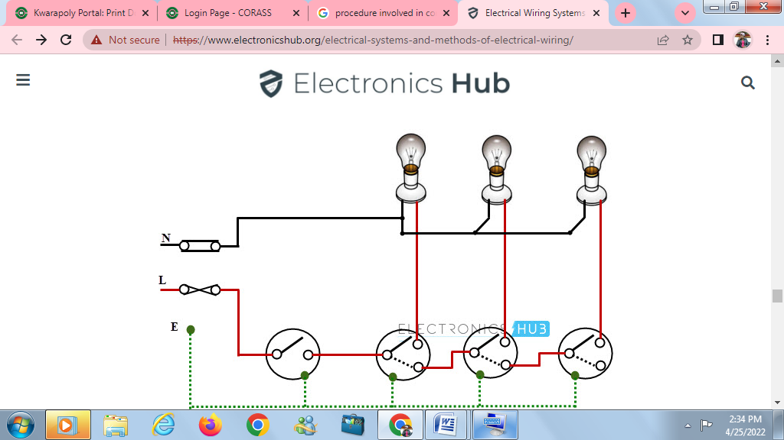

Fluorescent Lamp Controlled by a One-Way Switch
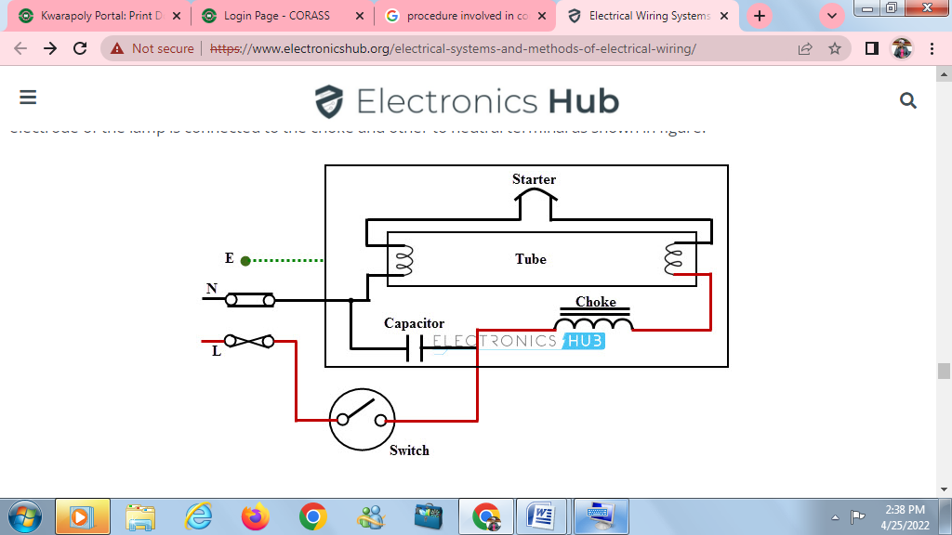
The switching of fluorescent lamp with single one-way switch through ballast and capacitor is shown in below figure. In this, phase wire is connected to the one end of the switch and another end of the switch is connected to the choke (or ballast). One electrode of the lamp is connected to the choke and other to neutral terminal as shown in figure.

Socket Outlet Wiring
The outlet holds a plug and passes the current through it when the power is routed to the socket through a switch. The single socket connection and radial socket connection are shown in below figure.
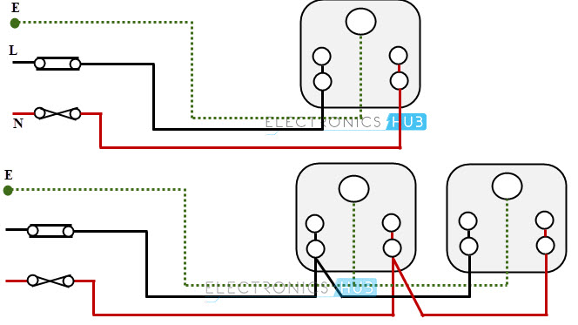

Control Switch Board Wiring
Is an electronic board that indicates the switch for a ceiling fan, a fluorescent lamp and a light bulb are controlled by appropriate switches.

CHAPTER FIVE
5.1 RECOMMENDATION AND CONCLUSION
The following Recommendation is referred to the Establishment I undertook my SIWES program, my college, Industrial Training Fund and the Government; in order to improved and enhance the expected results of the Student Industrial Work Experience Scheme;
- The Federal Government should establish and promote laws and agencies that regulate land use to prevent pollution.
- The Federal Government should provide and construct adequate roads in less developed areas.
- The Federal Government should provide industries and organizations with incentives to encourage and solicit for their cooperation and contribution to the programme
- The management of RAMFOY PROJECT AND CONSTRUCTION COMPANY can create and organise a special forum for students on attachment, this will help in discovering students’ potentials and to appropriately use them effectively.
- The management of RAMFOY PROJECT AND CONSTRUCTION COMPANY should provide adequate social amenities for their workers and enhance the welfare of their workers.
- The management of RAMFOY PROJECT AND CONSTRUCTION COMPANY should try to encourage workers initiatives and contributions to projects so at to enhance their esteem and contributions to such projects.

