

STUDENTS’ INDUSTRIAL WORK EXPERIENCE SCHEME (SIWES)

HELD AT

STATE HOSPITAL OTA
7, TAIWO RUFAI STREET, OFF ADIMULA ROAD, IYANA IYEJI, OTA, OGUN STATE

BY
AJIBODE OLATILEWA ROKEEBAT
ND/23/STA/FT/0027

SUBMITTED TO THE DEPARTMENT OF STATISTICS,
INSTITUTE OF APPLIED SCIENCES,
KWARA STATE POLYTECHNIC, ILORIN

2024/2025 ACADEMIC SESSION

Dedication
This seminar work is dedicated to Almighty God for its successful completion

Acknowledgements
Foremost, my appreciation goes to Almighty God for the successful completion of this SIWES report.
My sincere appreciation goes to Industrial Training and Management of kwara State polytechnic for the opportunities given in having practical idea of what’s learnt in the four wall of a class room.
Lastly, my appreciation goes to all those who were supportive in one way or the other in the success of this work.
Thanks to you all.

TABLE OF CONTENTS
Title page i
Dedication ii
Acknowledgments iii
Table of Contents iv
CHAPTER ONE: INTRODUCTION
1.1 Background of SIWES 1
1.2 Objectives of SIWES 2
1.3 Description of the Organization (State Hospital, Ota, Ogun State) 2
1.4 Organogram 4
CHAPTER TWO: WORK EXPERIENCE
2.1 Department of Attachment 5
2.2 Responsibilities and Work Done 6
CHAPTER THREE: LEARNING EXPERIENCE AND CHALLENGES
3.1 Knowledge Gained 8
3.2 Challenges Encountered 9
CHAPTER FOUR: CONCLUSION AND RECOMMENDATIONS
4.1 Conclusion 11
4.2 Recommendations 11

CHAPTER ONE
INTRODUCTION
1.1 Background of SIWES
The Student Industrial Work Experience Scheme (SIWES) was introduced to bridge the gap between classroom learning and real-world work experience. Many students graduate with strong theoretical knowledge but lack the practical skills needed to perform effectively in their respective industries. SIWES was created to solve this problem by exposing students to hands-on training in real work environments.
This program was established by the Industrial Training Fund (ITF) in 1973 to provide students in technical, vocational, and professional fields with the opportunity to gain industry experience. Over the years, SIWES has become an essential part of the academic curriculum for students in fields like engineering, statistics, medical sciences, and business administration. It helps students apply their classroom knowledge in practical settings, making them more prepared for future careers.
Through SIWES, students work with professionals in their chosen industries, learning how tasks are performed in real-life situations. They get the chance to observe, participate, and sometimes even contribute to important projects. This hands-on experience helps them understand industry standards, work ethics, and operational procedures that cannot be fully taught in a classroom.
Another important benefit of SIWES is that it builds confidence and improves problem-solving skills. Many students start their industrial training with little knowledge of workplace expectations, but by the end of the program, they become more familiar with how things are done professionally. They learn how to handle challenges, work under pressure, and collaborate with others to achieve common goals.
In addition to improving practical skills, SIWES also enhances students’ chances of employment after graduation. Employers often prefer candidates who have prior industry experience because they require less training and can adapt quickly to the work environment. Some students even get job offers from the organizations where they did their SIWES, making the program a valuable stepping stone into their careers.
Overall, SIWES is a vital part of a student’s educational journey. It serves as a bridge between theory and practice, helping students gain the necessary skills and experience needed for their professional growth. By participating in SIWES, students become better equipped to contribute effectively to their industries and the economy as a whole.
1.2 Objectives of SIWES
The objectives of the Student Industrial Work Experience Scheme (SIWES) include:
- To bridge the gap between theory and practical industry experience.
- To expose students to real workplace environments and professional ethics.
- To develop students' technical and practical skills for career readiness.
- To enhance problem-solving abilities through real-world challenges and tasks.
- To improve students' confidence, teamwork, and communication skills.
- To increase students’ employability through hands-on industry training.
- To encourage entrepreneurship by providing practical business and industry exposure.
- To introduce students to modern technology and industry trends.
- To strengthen collaboration between academic institutions and industries.
1.3 Description of the Organization (State Hospital, Ota, Ogun State)
State Hospital, Ota, is a government-owned healthcare facility established in August 2001 to provide quality medical services to the people of Ota and its surrounding communities. Over the years, the hospital has grown into a reputable institution known for its commitment to patient care, medical excellence, and efficient healthcare delivery. It plays a crucial role in addressing the healthcare needs of residents by offering a wide range of medical services.
The hospital has various departments, including General Medicine, Pediatrics, Surgery, Obstetrics and Gynecology, Laboratory Services, and the Medical Records Department. Each department is staffed with trained professionals who ensure patients receive proper diagnosis, treatment, and care. The hospital also offers emergency medical services, outpatient consultations, and maternal healthcare, making it an essential part of the community's healthcare system.
One of the critical units in the hospital is the Medical Records Department, where patients' information is documented, organized, and stored. This department ensures that all medical records are accurately maintained and easily accessible when needed. Proper documentation helps doctors and other healthcare professionals provide effective treatment and track patients' medical history. The department also plays a vital role in managing hospital data for administrative and research purposes.
State Hospital, Ota, is equipped with modern medical facilities to enhance healthcare delivery. The hospital has diagnostic tools, laboratory equipment, and a pharmacy that provides essential medications. Although some procedures still rely on manual record-keeping, efforts are being made to transition to digital healthcare systems for better efficiency and accuracy.
The hospital is known for its dedication to patient care and community health programs. It frequently organizes health awareness campaigns, vaccination programs, and free medical check-ups to promote public health. Additionally, it serves as a training center for medical students and interns, providing them with hands-on experience in various aspects of healthcare service delivery.
Overall, State Hospital, Ota, continues to play a vital role in the healthcare sector by offering affordable and accessible medical services to the people. With its well-structured departments, dedicated staff, and commitment to patient well-being, the hospital remains a key healthcare institution in Ogun State.
1.4 Organogram
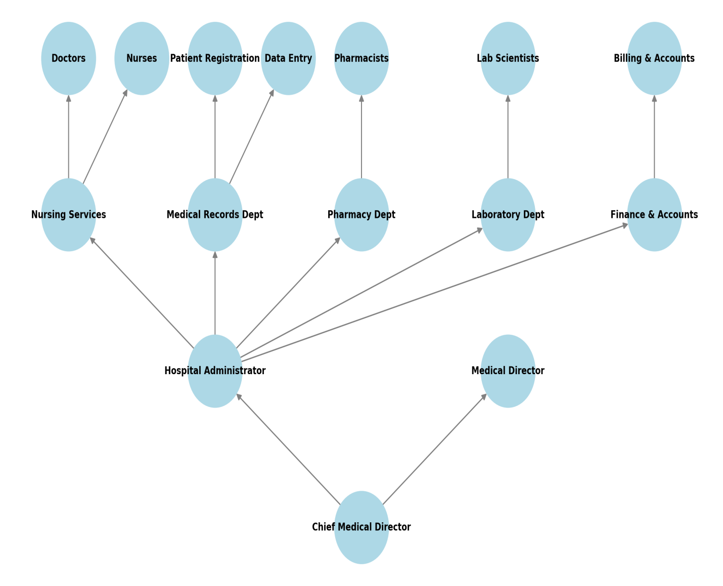

CHAPTER TWO
WORK EXPERIENCE
2.1 Department of Attachment
During my SIWES program at State Hospital, Ota, I was attached to the Medical Records Department. This department is responsible for managing, organizing, and maintaining patients' medical records, ensuring that doctors and healthcare professionals have accurate information for effective treatment. It plays a crucial role in the hospital’s operations by handling patient registration, data entry, and record retrieval.
The Medical Records Department is essential for proper documentation and storage of patient information. It ensures that all medical files are systematically arranged to allow easy access when needed. The department also assigns unique medical record numbers to patients, which helps in tracking their medical history efficiently.
One of the key functions of the department is to collect and verify patient information before it is documented. This includes recording patient demographics, medical history, and diagnoses. The department also ensures that patients’ case notes are filed correctly and retrieved when necessary, reducing delays in medical services.
Additionally, the department is responsible for data backup and recovery procedures to prevent the loss of important medical records. In cases of system failures or missing files, the department follows a structured recovery process to retrieve patient information. Proper data management is essential to maintain hospital efficiency and ensure compliance with medical record-keeping standards.
The department also conducts statistical analysis of patient records, which helps in tracking health trends, patient demographics, and disease occurrences. This information is useful for hospital management and government agencies in planning healthcare policies and improving medical services.
Overall, my attachment to the Medical Records Department provided valuable insights into hospital data management, record-keeping procedures, and the role of statistics in healthcare. The experience helped me develop practical skills in data organization, patient registration, and medical record analysis, which are relevant to my field of study.
2.2 Responsibilities and Work Done
During my SIWES training at State Hospital, Ota, I was actively involved in various tasks within the Medical Records Department. My responsibilities were focused on organizing patient information, assisting in data entry, and ensuring the smooth management of medical records. These tasks helped me gain practical experience in hospital record-keeping and statistical data management.
One of my key responsibilities was collecting patient information during registration. I assisted in documenting patient demographics, medical histories, and other necessary details. This information was crucial for creating and updating patient records, ensuring accuracy in hospital documentation.
I was also involved in filing and retrieving patient case notes for doctors and nurses. Since medical records must be properly stored and easily accessible, I helped organize files systematically. This process reduced delays and improved efficiency in patient care.
Additionally, I assisted in assigning unique medical record numbers to patients, which helped in tracking their medical history efficiently. This numbering system is essential for maintaining order in the hospital’s record-keeping process and ensuring that each patient’s file is easily identifiable.
Another important task I handled was data entry and documentation. I helped update patients’ medical records, ensuring that their diagnoses, treatments, and follow-up appointments were recorded correctly. I also participated in data backup and recovery procedures, which are important for preventing information loss.
Lastly, I was involved in statistical analysis and reporting on patient records. This included reviewing patient data to identify trends in hospital admissions, disease patterns, and medical cases. These reports were useful for hospital management in decision-making and planning healthcare services.
Through these responsibilities, I gained valuable experience in medical data management, improved my organizational skills, and learned the importance of accurate record-keeping in healthcare settings.

CHAPTER THREE
LEARNING EXPERIENCE AND CHALLENGES
3.1 Knowledge Gained
My SIWES experience at State Hospital, Ota provided me with valuable knowledge in medical records management and statistical data handling. I learned how to collect, organize, and maintain patient information, ensuring accurate documentation of medical histories, diagnoses, and treatments. This knowledge deepened my understanding of the role of proper data management in healthcare services.
I also gained hands-on experience in filing and retrieving patient case notes. I learned the importance of maintaining an organized record system to ensure that doctors and nurses can quickly access patient information when needed. Proper filing reduces errors, enhances workflow efficiency, and improves the quality of patient care.
Another important lesson was data entry and documentation techniques. I became familiar with hospital data management systems and how to accurately input patient details, medical conditions, and treatment updates. I also learned how to verify patient demographics, ensuring that all records were correctly documented and stored for future reference.
Through my involvement in data backup and recovery procedures, I understood the significance of securing medical records to prevent information loss. I learned how hospitals implement backup systems to safeguard critical patient data and ensure continuity of care in case of system failures or missing files.
Additionally, I acquired knowledge in statistical analysis of patient records. I observed how patient data is analyzed to track disease trends, admission rates, and hospital performance. This knowledge broadened my understanding of how statistics play a key role in healthcare planning and policy-making.
Overall, my SIWES training improved my skills in record-keeping, data management, and patient information analysis. The experience enhanced my ability to work in a structured environment, follow standard procedures, and contribute effectively to a professional healthcare setting.
3.2 Challenges Encountered
During my SIWES training at State Hospital, Ota, I encountered several challenges that affected my work experience. One of the major difficulties was managing large volumes of patient records. The hospital receives numerous patients daily, and keeping track of their medical records manually was sometimes overwhelming. The large workload required patience, accuracy, and attention to detail to avoid errors in documentation.
Another challenge was retrieving old patient case notes. Some records were misplaced or difficult to locate due to improper filing. Since the hospital still relies on a mix of manual and digital record-keeping systems, finding a patient's medical history could take time, delaying medical services. This experience made me understand the importance of an efficient filing system in healthcare settings.
I also faced technical challenges in data entry and backup procedures. Although I had basic computer skills, working with the hospital's record-keeping software required learning new procedures. At times, system errors or slow networks delayed the data entry process, making it difficult to update patient information quickly.
Communication was another challenge, especially when interacting with patients and medical staff. Some patients had difficulty providing clear information about their medical history, while doctors and nurses were often busy, leaving little time for record verification. I had to develop better communication skills to ensure accurate documentation and smooth workflow.
Additionally, adapting to the hospital's fast-paced environment was challenging at first. The medical records department required quick thinking and multitasking to handle patient registrations, record retrieval, and documentation all at once. With time, I learned how to work under pressure and manage tasks efficiently.
Despite these challenges, I gained valuable experience in handling real-world work situations. Overcoming these difficulties improved my problem-solving skills, patience, and ability to adapt to new environments. These lessons will be beneficial in my future career.

CHAPTER FOUR
CONCLUSION AND RECOMMENDATIONS
4.1 Conclusion
My SIWES experience at State Hospital, Ota was highly insightful and beneficial, providing me with practical knowledge in medical records management, data entry, patient information documentation, and statistical analysis. Despite challenges such as managing large volumes of patient records, retrieving misplaced files, and adapting to a fast-paced work environment, I gained valuable skills in record-keeping, communication, problem-solving, and teamwork. The training enhanced my understanding of the importance of accurate documentation and data management in the healthcare sector. Overall, the program bridged the gap between theory and practice, preparing me for future career opportunities and professional growth.
4.2 Recommendations
At the end of the study, the following recommendations are made:
- Management of the hospital should improve the filing system for easy retrieval of patient records.
- Management of the clinic should implement a fully digital medical record system for better efficiency.
- There should be provision of regular training for staff on data entry and record management.
- Management of clinic should ensure proper backup and recovery procedures for medical records security.
- Government through the ministry of health should increase staff strength to handle the high volume of patient records.

