A TECHNICAL REPORT
ON
STUDENT INDUSTRIAL WORKING EXPERIENCE SCHEME
(SIWES)

HELD AT
RIGHT TIME KITCHEN
Gaa's Compound Adjacent Answarudeen Central Mosque, Ejigbo Road Iwo Osun State

WRITTEN BY
OMOBORIOWO ROMOKE DASOLA
ND/23/HMT/PT/0013
SUBMITTED TO;
HOSPITALITY MANAGEMENT DEPARTMENT
INSTITUTE OF APPLIED SCIENCE

KWARA STATE POLYTECHNIC
PMB 1375, ILORIN KWARA STATE

IN PARTIAL FULFILLMENT OF THE REQUIREMENT FOR THE AWARD OF NATIONAL DIPLOMA (ND) IN THE DEPARTMENT OF HOSPITALITY MANAGEMENT

SEPTEMBER – DECEMBER 2024

CERTIFICATION
This is to certify that this report was compiled and written by OMOBORIOWO ROMOKE DASOLA with matriculation number ND/23/HMT/PT/0013 after the completion of SIWES program in partial fulfilment of the requirement for the award of national diploma (ND) in the department of Hospitality Management, Kwara State Polytechnic.

________________ ________________
SIWES SUPEVISOR DATE

_________________ _________________
SIWES CO-ORDINATOR DATE

DEDICATION
I dedicate this report to the Almighty God, the Incomparable king of kings, Omnipresent, Omnipotent, The Author and the finisher of the Universe, who is the pillar behind the success of this programme.
I also dedicate this to Amiable Mentor, Driver, Advocate, Motivator, and Incomparable loving and Darling Parent MR/MRS OMOBORIOWO for their Support and encouragement throughout the period.

ACKNOWLEDGEMENT
I give glory to God Almighty, the incomparable king of kings, the author and the finisher of all things. For the strength, grace and enablement given unto me to be partaker of this programme.
I also show my indebtedness to my able bloods for their irreplaceable and indefinable love, encouragement, advice, support, and financial back up during the course of this programme.
Finally, my profound gratitude goes to the officials and other staff of RIGHT TIME KITCHEN for their help, advice, encouragement and other forms of support rendered during the period of the SIWES programme.
I thank you all and God bless you abundantly.

TABLE OF CONTENTS
Title Page
Certification
Dedication
Acknowledgement
Table of Content
Chapter One
1.0 Introduction to Siwes
1.1 Brief History of Siwes
1.2 Aims and Objectives of Siwes
1.3 Importance of Siwes
Chapter Two
2.0 Brief History of the Organization
2.1 Organization Structure
2.2 Organization Mission
2.3 Organization Chart
Chapter Three
- Introduction to Activities Acquired in the Kitchen
  - Kitchen
3.1.1 Recipes and Method of Preparation of Amala, Gbegiri and Ewedu
    - Recipes and Method of Preparation of Fried Rice
    - Restaurant Department
3.1.4 Housekeeping Department
3.2 Challenges Face in the Kitchen
Chapter Four
4.0 Conclusion
4.1 Recommendation

CHAPTER ONE
- INTRODUCTION TO SIWES
The Student Industrial Work Experience Scheme (SIWES) is an academic support unit designed to provide avenue for student to acquire practical industrial exposure in their study. The SIWES serves as an accepted skill training programme which is part of the minimum academic standard in the various institutions.
Expert are of the opinion that, there is a yearning gap between the learning acquired by graduate of Nigerian institution and the skill application required in the work place. Clearly, academic learning and theoretical knowledge alone would not usually prepare an educated person for the world of work. Consequently, the capacity of Nigeria graduate in innovation and creativity determines the extent of their potential contribution to the growing economy and national development. However, the expected contribution cannot be made by graduates who are lacking in practical skills, hence; Student Industrial Work Experience Scheme (SIWES) was established. The technical report is based on the Student Industrial Work Experience Scheme (SIWES) which was commenced on 12th of December till 3th of March of the year 2022/2023.
The Student Industrial Work Experience Scheme (SIWES) is to let the student to have experience on works of their various field.
  - HISTORY OF SIWES
The Student Industrial Work Experience Scheme (SIWES) is a skill training programme designed to expose and prepare student of Universities, Polytechnic, Colleges of Technology, Colleges of agriculture and or meet after graduation. The scheme also afford students the opportunity of familiarizing and exposing themselves to the needed experience in handling equipment and machinery that are usually not available in their institutions.
Before the establishment of the scheme, there was a growing concern among industrialists that graduates of tertiary institutions lacked adequate practical background (studies) preparatory for employment in industry.
The ITF solely funded the scheme during its formative years. But as the financial involvement became unbearable to the fund, it withdrew from the scheme in 1978. The Federal Government handed over the scheme in 1979 to both the National Universities Commission (NUC) and the National Board for the Technical Education (NBTE), Later, the Federal Government in November 1978 reverted the management and implementation of the SIWES programme to ITF and it was effectively taken over by the Industrial Training Fund in July 1985 with the funding being solely borne by the Federal Government.
1.2 AIMS AND OBJECTIVES OF SIWES
Specifically, the objectives of the students work industrial scheme are to:
- Prepare students for the work situation they are likely to meet after graduation.
- Provide an avenue for student in the Nigerian polytechnics to acquire industrial skills and experience in their course of study
- Make the transition from the higher polytechnic to the world of work easier, and thus enhance student’s contacts for later job placement.
- Enlist and strengthen employer`s involvement in the entire educational process of preparing graduates for employment in the industry.
- Provide students with an opportunity to apply their theoretical knowledge in real work situation, thereby bridging the gap between polytechnic work and actual practice
- Exposed student to work methods and techniques in handling equipment and machinery that may not be available in the polytechnics.
- To provide student an opportunity to see the real world of their discipline and consequently bridge the gap between the classroom and real work situation
- To provide access to equipment and other facilities that would not normally be available in a Polytechnic Laboratory/Workshop.
- To enable student assess interest and suitability for their chosen profession.
1.3 IMPORTANT OF SIWES
The importance of SIWES is broad and complicated but the following are the extracted of some of its importance which are
- Practical soundness of student
- Self-reliance development
- Future employment
- Ability and capability of builder
- Economy growth and development

CHAPTER TWO
2.0 BRIEF HISTORY OF THE ORGANISATION
Right Time Kitchen is a well-established food service business located at Gaa's Compound, Adjacent Answarudeen Central Mosque, Ejigbo Road, Iwo, Osun State. The kitchen was founded with the mission of providing high-quality, affordable, and delicious meals to the local community and visitors in the area. Since its inception, Right Time Kitchen has earned a reputation for its commitment to preparing fresh, flavorful meals in a hygienic environment.
The establishment specializes in a variety of local and continental dishes, catering to different tastes and preferences. Over the years, it has become a popular spot for individuals and families looking for quality food. The restaurant prides itself on its prompt service, warm atmosphere, and the use of locally sourced ingredients to prepare its dishes.
Right Time Kitchen has grown steadily in terms of customer base, offering a mix of dine-in and takeout services, and has become an essential part of the local food scene. Through consistent focus on customer satisfaction and maintaining high standards of food quality, the business has built strong customer loyalty and continues to thrive in Iwo, Osun State.
2.1 ORGANISATION POLICY
RIGHT TIME KITCHEN is to provide comfortable appetizing and appealing meal and also quality food and beverages to customers, and they make sure they provide quality and efficient customer services to ensure happy and willing to return customers and also customers satisfaction while maximizing adequate profit and also staff satisfaction.

2.2 ORGANIZATION MISSION
To provide adequate, safe and well food and beverages with other service to customer who are willing and ready to pay, while ensuring the safety and protection of lives and properties of their guest.

2.3 ORGANIZATION CHART

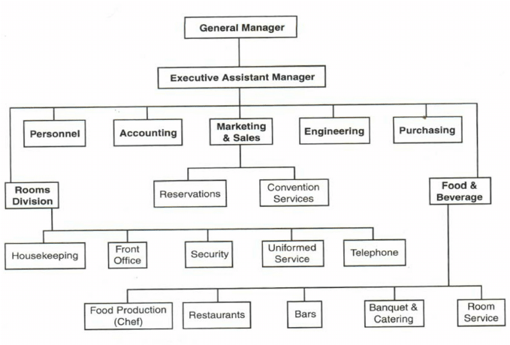

CHAPTER THREE
3.0 INTRODUCTION OF ACTIVITIES ACQUIRED IN THE KITCHEN
During the four (4) month period i used in my Student Industrial Work Experience Scheme (SIWES), they taught me on how to carry a large number of tasks in the kitchen.
3.1 KITCHEN
The place where food gets ordered, prepped, cooked, and plated before being served to customers. Whether it's spacious or tiny, if a kitchen is carefully designed, its staff can consistently deliver hundreds of meals in an evening. Defining the different sections of the kitchen helps to increase the ease and productivity to the safety of the kitchen staff, when it pertains to food production.
- The Receiving section
- The Storage section
- The preparation and production section
- The service section
- The dishes and cleaning section

WORK EXPERIENCE IN KITCHEN SECTION
- I was introduce to different types of equipment used in the kitchen
- I was taught how to Keep proper record of all food items in stock both frozen and dry foods.
- I was taught how to make the whole kitchen environment clean and tidy
- I was shown how to take guest order and preparing of customer dish and deliver it to their various rooms
- I was taught different dishes like Amala, gbegiri and Ewedu, semovita with ogbono soup, omelete and arabiata, white rice, fried plantain e.tc.
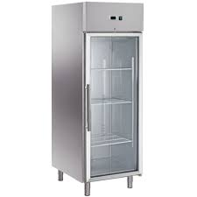
FRIDGE CHILLER

3.1.2.2 RECIPES AND METHOD OF PREPARATION OF FRIED RICE
RECIPES
- Rice
- Chicken stock and Chicken stock cube
- Onion
- Vegetable carrot
- Groundnut Oil
- Sweet corn and Sweet peas
- Beef Liver cubed
- Curry powder and Thyme
- Salt
- Scallions diced
- Cayenne pepper
- All Purpose Seasonings
- Water, As Needed

METHOD OF PREPARATION
1. Put some oil in a clean pot. Add the pepper, ginger, garlic and onions and allow to fry for about 3 minutes. Then, pour the stock water into the pot.
2. Add curry, thyme and stock cubes. Then add salt to taste.
3. Pour the parboiled rice into the mixture and mix. Add some warm water to just below the level of the rice.
4. Allow the rice to steam for 20-30 minutes on medium to low heat, checking on it at intervals.
5. When the rice is soft, add the chopped vegetables on top of the rice for them to steam.
6. When rice is done, turn off heat and stir. Allow to settle.

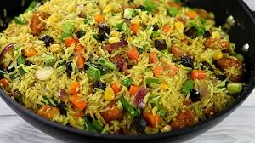
FRIED RICE
WORKS EXPERIENCE IN RESTAURANT DEPARTMENT
- I was shown the morning routines which are, cleaning of tables, chairs, sweeping and mopping of the floor, washing and sterilizing of the cutleries, opening of windows to allow fresh airs
- I was taught the procedure of serving food, i.e. when serving rice, wrap knife, fork, and spoon with a serviette. For spaghetti/noodles, wrap knife with fork and pin it with a toothpick
- I was taught different types of dishes/meals with beverages and their price
- I learn how to account for the sales of the day
- Making sure the food environment is clean and germ free
- I was taught how to take guest order
- I was taught how to input food and beverages on the system
- I was taught the process of writing requisition/ impress which will be approved by the director and the purchasing officer will purchase the items needed
- I learn how to receive and cross-checking of goods and checking of expiring date
- I learn how to keep a proper record of daily sales by using control sheet

TABLE SETTING WISKY CUP

3.1.5 HOUSEKEEPING DEPARTMENT: -
Housekeeping is the department that essentially deals with cleanliness and the ancillary service. Housekeeping may be defined as “a provision of Clean, comfortable and safe environment”, and one who does so is commonly known as Housekeeper.

WORK EXPERIENCE IN HOUSEKEEPING DEPARTMENT
- I was introduce to different equipment used in housekeeping department
- I was taught how to keep the environment clean like sweeping, picking of bottles on the ground and dispose them to the appropriate place
- I was taught how to do room dusting and learn different types of dusting
- I was shown the procedures of cleaning room
- I learn how to clean the rest room perfectly and put the necessary things in the appropriate place

MOPPING STICK AND BUCKET

3.2 CHALENGES FACE IN THE KITCHEN
- Change in marketing trends and dynamics.
- Operational issues.
- Housekeeping issues.
- Change in guest expectations.
- Irregular cash inflows.
- Data security challenges.

CHAPTER FOUR
4.0 CONCLUSION
In conclusion, I personally gained a lot of practical experience at RIGHT TIME KITCHEN, the industry has over the year brings a furtherance understanding and practical. The industrial training has a lot of advantages. It is therefore a must do for students because it has shown the difference between the theoretical knowledge and the practical aspect of analysis as a course, in which the government and the institution should emulate and maintain the continuity of this good act.

4.1 RECOMMENDATION
I hereby recommend that student on SIWES training programme should be much more focus throughout the SIWES training and they should pay more attention to the work that is been carried out, and student performance during the SIWES should be rewarded in order to motivate them to do more

