


A TECHNICAL REPORT ON

STUDENT INDUSTRIAL WORK EXPERIENCE SCHEME (SIWES)

HELD AT
WISDOM HOTEL HOSPITALITY SERVICES LIMITED
Along iresa-apa, Orogun Area, Ogbomoso, Oyo State

BY

AJIBADE AYOMIDE ND/23/HMT/PT/0086

SUBMITTED TO
DEPARTMENT OF HOSPITALITY MANAGEMENT INSTITUTE OF APPLIED SCIENCE (IAS)
IN PARTIAL FULFILLMENT OF THE REQUIREMENT FOR THE AWARD OF NATIONAL DIPLOMA (ND) IN HOSPITALITY MANAGEMENT

AUGUST – NOVEMBER 2024

DEDICATION
I dedicate this project to Almighty Allah, the author and finisher of my faith, for his protection over me during SIWES program.

ACKNOWLEDGEMENT
A report of this .magnitude definitely involved more than just my hand work alone. In consequence to that, it is important that effort of the people who contribute to success of this program be acknowledge. I acknowledge the effort the manager and staffs of Comfort Suites and Suites and also a big thank you to my parents who contributed immensely to the success of this SIWES program.

CHAPTER ONE
  - DEFINITION OF SIWES
Student industrial work experience which is a program established by I.T.F (Industrial Training Fund) in 1976 to bridge the gap between theory and practical aspect of learning in a tertiary institution in Nigeria.
SIWES was established in Nigeria to help student develop on the practical aspect of learning expose them to various technique in the industry and also help them to know the ways of handling equipment and machineries.
The program was established with various coordinating agencies respect to each tertiary institution in the country. These agencies are:
    - NBTE (National Broad for Technical Education)
    - NUC (National University Commission) for University.
    - NCCE (National Commission of College of Education) for colleges of education.
The objectives of Siwes among others include to:-
      - Provide an avenue for students in institution of higher learning to acquire Industrial skills and experience in their approved courses of study.
      - Prepare students for the industrial work Situation which they are likely to meet alter graduation.
      - Expose students to work methods and techniques in handling equipment and machinery not available in their institution.
      - Provide students which they are likely to meet after graduation.
      - Expose students to work methods and techniques in handling equipment and machinery not available in their various institutions.

BRIEF HISTORY OF SIWES
Student industrial work experience scheme (Siwes) was established by Industrial Training Fund (ITF) in 1973/1974 to solve the problem of lack of adequate practical skills preparatory for employment in industries by Nigerian graduate of tertiary institution.
Prior to the establishment of the schemes, there was a concern among our institution of higher learning lacked practical background studies preparation for employment in the industries.
The student industrial work experience scheme (Siwes) is a skill training program designed to expose and prepare student of agriculture technology, environmental science, medical science and pure & applied science for the industrial work situation one is likely to meet after graduation.

CHAPTER TWO
  - HISTORICAL BACKGROUND
Wisdom Hotel Hospitality was founded in the year 11 November 14, 2014 by Engr. Ayo, t he main purpose of this to provide travelers and quests with the experience away from home. Comfort Suites Lagos have 28 rooms in total, 16 standard rooms, 1 VP Suit, 3 Executive, 1 family suite and 6 deluxe. There's also a Banquet hall (capacity 120) and an event hall (capacity 300). The facilities include inside bar, a standard restaurant and Kitchen.
There's also well equipped gym and free wifi for the guest.
The staff of the hotel were all friendly and ready to teach. A lot was learnt during my Siwes experience and this report contain all of my experiences and all I learnt.
Comfort Suites comprises of the following departments
- Front office
- Restaurant
- Bar
- Kitchen
- House keeping
- Maintenance
- Laundry
  - Organization chart for Comfort Suites

Store
Receptionist Department
Security Department
House Keeping Department
Food & Beverage Department
General Manager
Cashier

COMFORT SUITES

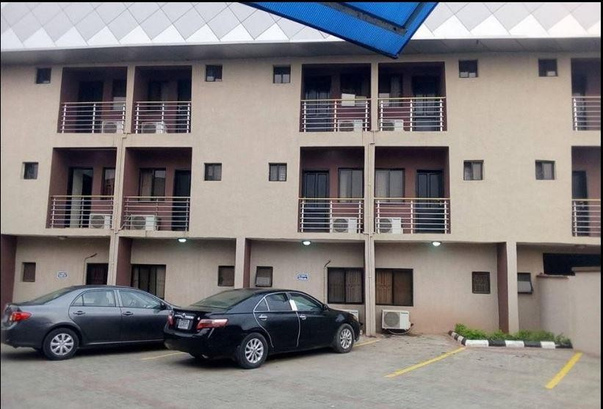

CHAPTER THREE
  - FOOD PRODUCTION (KITCHEN)
Paring knife Chef’s knife Cutting board
Measuring cups and spoons Kitchen shears
Colander Can opener Mixing bowl Blender Grater Whisk
Vegetable peeler Rolling pub
Food processor Food scale Spatula Saucepans Skillet
Baking sheet

OMELET WITH CHICKEN LIVERS INGREDIENTS
100G chicken livers
125ml jus-lie or demi-glare pt 25g butter chopped parsley 102 Steps
    - Allow 2-3 eggs per portion
    - Break the egg into a basin, season with salt and pepper
    - Beat well with a fork or whisk until the yoke and white are thoroughly combined and no streak of white can be seen.
    - Heat the omelet pan
    - Wipe thoroughly clean with a dry cloth
    - Add 25g (102) butter
    - Heat until foaming but wet brown
    - Cut the liver into neat scallop
    - Season and salt and pepper

    - Fry quickly with hot butter
    - Make an incision down the center
    - Draw and place in the hot jus-lie or demi-glare correct for seasoning
    - Place a spoonful of the mixture in the incision of each omelet, sprinkle a little chopped parsley on the liver
    - Then serve.

PLANTAIN PORRIDGE
The Ingredients for Plantain porridge includes
      - 4 medium sized Unripe plantain
      - Palm Oil (about 10cl
      - Fresh tomatoes (3-5 balls
      - All Fresh red pepper
      - 2 bulbs of medium sized onions
      - 2 cubes of magi
      - Meat of Choice
      - Fish of choice
      - Oil Crayfish (2-3 spoons)
      - vegetable

How to Make Plantain Porridge
- Add the sliced plantain, spray the sliced tomato/onions/fresh pepper at the top, add the fish and cover to cook for 15-20 minutes.
- Check to see if the water is dried and the plantain is properly cooked add vegetable if you like, lower the heat and allow to simmer for two to three minutes
- Stir all together and you just made a delicious plantain porridge. You can serve this meal with a chilled bottle of your favorite drink.

CHAPTER FOUR
  - BAR
Bar is an important part of the food and beverage department in a hotel. It provides alcoholic and non-alcoholic beverage to the customers. It is established independently with the separate license, or included with the hotel by obtaining legal permission from the civil authority.
A bar is a licensed place for selling all kinds of alcoholic beverages to the customers.
Various types of bars are found in hotels, resorts, clubs, casinos, and many such establishments and they can also be operated as independent units.

Following are some of the bar types, categorized either according to the kind of alcoholic drinks served or the place where it is served.

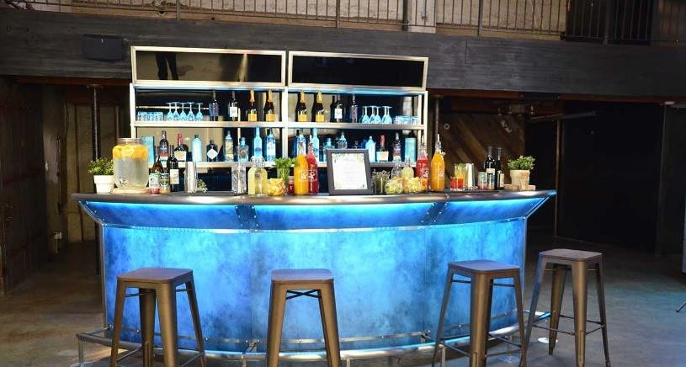

TYPES OF BAR IN HOTEL INDUSTRY
These are the different bar types in a hotel

PUBS
The pub is a word derived from a public house that is licensed to sell alcoholic beverages. Pubs mainly serve all kinds of beers along with other alcoholic drinks.

LOUNGE BAR
The lounge is an area meant for relaxing which is normally located near the reception

area. The drinks may be collected from the main bar and carried on a tray to the lounge and served. The lounge bar is often seen in Airports, Chubs, Casinos, Luxury hotels, Ships, etc

WINE BAR
This bar sells only wines of all kinds. mainly the most expensive wines. It has a good collection of a wide range of wines. The guests may buy bottles of wine for consumption later or drink in the wine bar itself

COCKTAIL BAR
This serves all kinds .of cocktails along with other alcoholic drinks It may be found in Airports, Casinos, Hotels, Ships, etc.

BANQUET BAR
This is a temporary bar set up in the banquet suits to serve alcoholic drinks during a specific function. The banquet bar collects the required stock either from the main bar or from the cellar.

DISPENSE BAR
It is the bar attached to a restaurant, serving alcoholic drinks to the guests n the restaurant during their mealtime. The stock may be either collected from the main bar or from the cellar.
The dispense bar has a minimum stock of drinks that may suitable for an appetitive, to accompany the dishes offered and digestives.

FUNCTIONS OF BAR IN HOTEL INDUSTRY
A bar is one of the key revenue generating areas of the food and beverage service department in the hotel industry. The main function of the bar is to serve the alcoholic drinks in the appropriate glassware according to the customer's preferences.
The other important requirements for bar operations are water supply, electric supply, lighting, and drainage. A Bar needs a continuous hot and cold water supply for many applications

BAR ORGAIZATION
The organization of a bar depends on the following factors:
- The types of bar
- Juices
- Wines
- Beers
- Minerals
- Spirit

Table Water
- Ragolis Water
- Eva Water

- Heritage Water
- Aquafina Water
- Visleri Water
- Spawwasser Water ctc.

Juice
- Dangote Juice
- Fruita Juice
- Fuman juice
- Boosta Juice
- Chivita Juice
- Five Alive

Wine
- Red Wine
- Red Label
- Rose Wine
- Blue Cocktail
- Champagne
- Bacchus
- Barleys

Beer
- Gulder
- Harp
- Small Stout
- Heineken
- Big Stout
- Star

Mineral
- Coke
- Gold sport
- Limca
- Pepsi
- Mirinda
- Maltina
- Schwepps

Spirit
- Campary
- Dry gin
- Chelsea
- Golden dry gin
- Ponche
- Bull

Equipments used in the bar
Creates of Drinks Table of Carpet
Deep freezer/refrigerator Glassware
Sink Straws
Show glass of snacks Ice cube machine Opener
Water jug Astray Disposable Cup Napkin

BAR STOCK BOOK
This book shows the numbers and quantity of all dinks that are available in the bar and it shows the number of drinks sold in bar daily, and the opening stock and closing stuck and it also shows the amount of each drink.

REASONS FOR DISPLAYING DRINKS IN THE BAR
- To promote sales and revenue of the hotel.
- To know what they have in the bar for the satisfaction of the guest e.g. wine is normally arrange on the shelf not inside the refrigerator.
- To show the image that surrounds and contribute the product and to identity types of drinks to guest e.g it’s a large hold and they have different product of refrigerator i.e.
maybe they have Guinness refrigerator, Guinness product such as hap will be stored inside.
- To make work easier for the barman or bar lady.
- It serves as an advertisement

CHAPTER PIVE
  - RECOMMENDATION
The experience and knowledge required could be possible if not for student industrial working experience scheme. I therefore explore the departments management board to allow my fellow students to their training n private firms where their knowledge will be exposed to field work and these will bring great opportunities and benefit to the country at large too.

SUGGESTIONS
SUGGESTION TO THE ORGAN1ZATION
The organization should organize seminar at least once in a month on practical training in which students have learned from various department so that there will be an opportunity of asking question and answer.
    - Organization should draw the attention of all student so that they will be able to
contribute to the progress of the organization by their suggestion.
    - Advising student and word of an encourage to all students in organizing during the SIWES programme.

SUGGESTION TO THE KWARA STATE POLYTECHNIC
- The polytechnic should base and specialized on how and where to be attached in relevant to their course are professional job.
- The polytechnic should choose supervisor from each Department lecture or lecturers from other polytechnic that relevant to the field of student for supervisor in order to put students through in their training.

CONCLUSION
The SIWES prograrmme was involved and interested task that made to know about Hospitality Management as a professional course, for without this programme being organized by the government in collaboration with the institution, student will have been a novice in their field of studies before the end of their National Diploma (ND) programme

