
TECHNICAL REPORT ON STUDENT INDUSTRIAL WORK EXPERIENCE SCHEME (SIWES)
HELD AT
NATIONAL MUSEUM, ILORIN
NO 14, ABDULKADRI ROAD, G.R.A, ILORIN KWARA STATE

BY
ADEWUYI FUNMILAYO RACHEAL
ND/23/ACC/PT/0107

SUBMITTED TO DEPARTMENT OF ACCOUNTANCY, INSTITUTE OF FINANCE AND MANAGEMENT STUDIES, (IFMS) KWARA STATE POLYTECHNIC, ILORIN
IN PARTIAL FULFILMENT OF THE REQUIREMENT FOR THE AWARD OF NATIONAL DIPLOMA (ND) IN ACCOUNTING
SEPTEMBER TO DECEMBER, 2024.
DEDICATION
This report is dedicated to Almighty Allah for his divine mercy on me and my family who has given me the strength, wisdom, knowledge and understanding in working toward my success, I also dedicate this report to my parent Mr. and Mrs. ADEWUYI for their support and to my supervisor for the success of this report.

ACKNOWLEDGEMENT
To God who owns life, I wish to express my sincere appreciation and gratitude for seeing me throughout my duration in Kwara State Polytechnic and for making my vision come to reality, also for his Goodness, Mercy, Provision and Grace upon my life.
My profound gratitude goes to my Parent Mr. and Mrs. ADEWUYI, may God be with you.
My special thanks go to the head of Department and the entire staff of ACCOUNTANCY Department, Institute Of Finance and Management Studies, Kwara State Polytechnic for sharing wealth of experience with me in my course of study.
Furthermore, thanks goes to my honorable and diligent supervisor for his advice, guidance and adequate encouragement relish from him which has contribute in no small measure to the success of completion of this report.
Finally, my sincere gratitude also goes to my lovely friends both within and outside the institution,

TABLE OF CONTENTS
Title page
Certification
Dedication
Acknowledgement
Table of contents
CHAPTER ONE
1.1 Introduction to Siwes
1.2 Brief history of Siwes
1.3 Importance and objective of Siwes
CHAPTER TWO
2.1 Historical background of National Museum, Ilorin
2.2 Organogram of the organization
2.3 Department in the organization
CHAPTER THREE
3.1 Technical training experience
3.2 Conclusion
3.3 Recommendations
CHAPTER ONE
1.1 INTRODUCTION
Siwes is an acronym for student industrial work experience scheme, Siwes is also an effective instrument used for exposing students to the realities of the work environment in Nigeria especially, and the world in general in the various professions so as to achieve the needed technological advancement of the alms of Siwes which are:
- To provide for the student opportunities to be involve in the practical aspect of their respective disciplines. Thus, bringing the gap between the theoretical aspect taught in the class to the real world situations.
- To expose students to latest developments and technological.
- To prepare students for industrial working environment that they are likely to meet after graduation.
1.2 BRIEF HISTORY OF SIWES
The student industrial experience scheme (SIWES) is a skill training programme designed to expose and prepare students of universities, polytechnics, college of technology and others, for the industrial work experience, they are likely to meet after graduation.
The scheme also afford student to the opportunity of familiarizing and exposing themselves to the needed experiences on handy equipment and machineries that are usually not available to their institution.
The industrial training fund (ITF) founded the scheme during its formative year in 1973-1974 as the financial involvement becomes unbearable to the fund, it withdraw from the scheme in 1978, the federal government handed over the scheme in 1979 to both the national board for technical education (NDTE) and the national universities commission (NUC). Later, the federal government in November 1999 inverts the management and implementation of the siwes programme to ITF and it was effectively taken over by the industrial training fund in July 1995 with the funding being solely borne by the federal government.
1.3 IMPORTANCE AND OBJECTIVES OF SIWES
In the regard to the handbook, the specific importance of the SIWES are:
- To provide an avenue for students in institution of higher learning to acquire industrials skills and experience in their cause of study.
- To prepare for the industrial work experience they undergo after graduation.
- To prepare students with an opportunity to apply for knowledge in real work situation thereby bringing the gap between theory and practice.
- To satisfy accreditation requirement set by NBTE.
- To provide students an opportunity to see the real world of their discipline and consequently bridge the gap between the classroom and real work situation.
- To enable students assess internet suitable for their chosen profession.

CHAPTER TWO
2.1 HISTORICAL BACKGROUND OF NATIONAL MUSEUM, ILORIN
The National Museum Ilorin has a rich historical background that dates back to 1945, making it one of the oldest museums in Nigeria Located in the heart of Ilorin, the capital city of Kwara State, the museum was established by the British colonial government to preserve the cultural heritage of the region.
The museum's collection is renowned for its impressive array of soapstone images, with over 800 pieces on display. These images were discovered in the 1930s by Mr. Ramsey, a Church Missionary Society Inspector of Schools, in Esie, a town about 60km southwest of Ilorin.
The National Museum Ilorin is not just a repository of historical artifacts but also a center for education, entertainment, and relaxation.
2.2 ORGANOGRAM OF THE ORGANIZATION
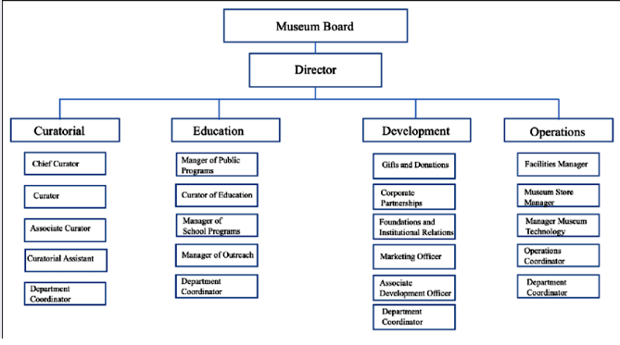

2.3 SECTIONS IN THE ORGANIZATION
The National Museum Ilorin is not just a repository of historical artifacts but also a center for education, entertainment, and relaxation. It features various sections, including:
- Archaeological Section: showcasing the region's rich cultural heritage
- Ethnographic Section: displaying artifacts that reflect the daily lives of the people
- Craft Shop: offering a variety of local handicrafts and artworks for sale
The museum has undergone significant developments over the years, with new galleries and exhibitions being added to its collection ³. Despite facing some challenges, the National Museum Ilorin remains a vital cultural institution in Nigeria, promoting the preservation and appreciation of the country's rich cultural heritage ³

CHAPTER THREE
3.1 TECHNICAL TRANING EXPERIENCE
Week 1: Payments vouchers are and passed to internal audit unit.
Week 2: filling of sorted documents into appropriates files
Week 3: photocopy of accounts documents.
Week 4: preparation of monthly pay slip for retiring officers.
Week 5: collection of revenue from museum visitors and updating revenue ledger
Week 6: updating pay slip to staff members.
Week 7: updating staff national housing funds pass books
Week 8: I was to generate the remitta referral reference code RRR for payment of (IGR) internally generated revenue.

CHAPTER FOUR
4.1 CONCLUSION
Siwes was established to provide opportunities for students to be involved in the practical aspect of their respective discipline in the industrial working environment. During the 2 months industrial training, I gained a wide range of experience from the various assignments undertake such as news writing and reporting, news alignment, news commentary and editing process, all the experience gained help me to fulfill the objectives of Siwes.
4.2 RECOMMENDATIONS
Going through some of the experience gained during the programme, I will recommend that there is need for some activities both in the organization where I served and the school.
The time duration for the programme should be extended for more than four months. The organization should create practical knowledge for the students for them to acquire more knowledge from their versatile staffs.

