

A TECHNICAL REPORT ON
STUDENT INDUSTRIAL WORK EXPERIENCE SCHEME
(SIWES)

HELD AT
OLUWASEUN SHOPPING MALL
Gaa-Akanbi, Roundabout, Ilorin, Kwara State

WRITTEN BY

ADETAYO CHRISTIANAH OLUWATOYIN
MATRIC NO: ND/23/PSM/FT/0159

SUBMITTED TO
DEPARTMENT OF PROCUREMENT AND SUPPLY CHAIN MANAGEMENT, INSTITUTE OF APPLIED SCIENCE,
ILORIN

IN PARTIAL FULFILLMENT OF THE REQUIREMENTS FOR THE
AWARD OF NATIONAL DIPLOMA (ND) IN APPLIED SCIENCE

AUGUST - NOVEMBER, 2024

PREFACE
This report contains all experience gained during the time of my student industrial work experience scheme (SIWES).Thus, it vividly gives a comprehensive summary report of the engaged and experience gained at OLUWASEUN SHOPPING MALL

DEDICATION
I dedicate this report to God, the source of my strength and ability. Also to my dearest parents Mr and Mrs Adetayo whom through their advices, love, care and financial assistance has made me to be where I am today. I pray to God will continue to keep and guide them for me. Amen.

ACKNOWLEDGEMENT
My sincere thanks and praises are to God, the uncreated creator who within His mercy I am able to begin and end this programme successfully. He is forever worthy of my appreciation “Halleluyah!!!” My gratitude also goes to my parents Mr and Mrs Adetayo for their care and passion into my future. May God keep you both to reap the good fruit of your labour, Amen
I have learnt a lot both in academic and life as a whole. May God keep protecting you and your families with lot of goodness and also to my supervisor Mr. Olorunnisola Benjamin, thank you so much
To everyone who has in one way contributed to the success of this programme, you are acknowledged. “God Bless you All”

ABSTRACT
This technical report is based on four months compressive industrial training exercise.
The report comprises of five chapters, chapter one: focuses on general introduction to work, chapter two; Developed and Implemented Process Improvement, chapter three and four explain the experience gain and gathered during the programme, chapter five gives the summary conclusion of the report and recommendation needed to the organization and to the polytechnic and development of students industrial work experience scheme (SIWES).
TABLE OF CONTENT
Title page i
Certification ii
Dedication iii
Acknowledgement iv
Abstract v
Table of content vi
CHAPTER ONE
1.0 Introduction 7
1.1 Background of SIWES 8
1.2 Aim and objective of SIWES 8
1.3 Benefit of SIWES 9
1.4 The Bodies involved in the management of SIWES 9
2.0 CHAPTER TWO
2.0 Arrangement of the Goods 10
2.1 Rearrangement of Goods 11
2.2 Cleanliness of the Environment 12
3.0 CHAPTER THREE
3.0 Explanation on the Stocks in the Company 14
3.1 Explanation about the Distributor 15
3.2 Delivery of Goods to Customer 16
4.0 CHAPTER FOUR
4.1 Experience gained during the SIWES training and their relevance to my course of study 16
4.2 Problems Encounter during the Programme 16
5.0 CHAPTER FIVE
5.0 Conclusion 17
5.1 Recommendations 18
5.1.1 Problems Facing During Siwes Program
CHAPTER ONE
1.0 INTRODUCTION
I had my four (4) months Student Industrial Work Experience Scheme at Oluwaseun Shopping Mall, and I partake on; the company is located at Gaa-Akanbi Roundabout, Ilorin Kwara State.
The period of my attachment was from August to November, 2024.
This report is a comprehensive summary of my four months training which was completed at the above mentioned organization and also contains information about the organization.
I officially started my SIWES training on 5th of August, 2024, and worked on both shopping mall and in the company. The task carried out on company include, supervision on how to attend to customer, we rearrange the goods in the drinks and biscuits department of work done to know the quantity of material used, checking the component made off company.
The office task and responsibilities include taking off, preparation of bill of quantities, estimation for the material used on site/Road, preparation of daily production report e.t.c. The task carried out, works observed and experiences gained are fully explained in the later chapters of this report.
I also took part in some Laboratory work which includes; Slump test, Aterberg limit test, and Concrete cube test.
1.1 Background of Students’ Industrial Work Experience Scheme (Siwes)
The Students Industrial Work Experience Scheme (SIEWS) is a Skills Training Programme designed to expose and prepare Students of Universities, Polytechnics and Colleges of Education for the Industrial Work situation they are likely to meet after graduation.
The Industrial Training Fund (ITF) solely funded the scheme during its formative years. However, due to financial constraints, the Fund withdrew from the scheme in 1978. The Federal Government, noting the significance of the skills training, handed the management of the Scheme to both National Board for Technical Education (NBTE) and National Universities Commission (NUC) in 1979.
1.2 Aim and Objectives of SIWES Programme
The aim is to provide an enabling environment for the practical application of theoretical knowledge in actual real work situation and also to enable practical establishment of theoretical facts that had been learnt is school.
Specifically, the objectives of the Students of the Industrial Work Experience Scheme (SIWES) are to:
a) Provide an avenue for Students in Institutions of higher learning to acquire industrial skills and experience in their course of study.
b) Prepare students for the industrial work situation they are to meet after graduation.
c) Expose students to work methods and techniques in handling equipment and machinery that may not be available in their institutions.
d) Make the transition from school to the world of work easier, and enhance students contact for later job placement.
1.3 Benefits of SIWES Programme
There are many benefits derived from SIWES, some of which are:
a) The opportunity for the students to boost the theoretical knowledge gained in the classroom with practical knowledge in the Industry.
b) The opportunity for the students to be in direct contact with Junior, intermediate and senior professional staff in the industry.
c) It provides opportunities for students to handle equipment and machine that they may not have access to in their academic institutes.
d) It serves as an avenue for students to understand the technicalities and realities used in the business world that relate to their various field of study thus exposing them to practical levels and advanced level of learning.
1.4 The Bodies involved in the Management of Siwes
In Nigeria, there are five bodies that are involved in the smooth operation of SIWES. They are:
i. Educational Institutions
ii. Employers
iii. Students
iv. National University Commissions (NUC)
v. Industrial Training Fund (ITF)
Employers
The employers are to work out relevant industrial attachment programmes with institutions; ensuring that attachment programme exposes students to real life working situations; and inspect and countersign students logbooks on weekly basis and make comments where necessary. They are to pay students allowances and when due for every month completed and submit to the ITF monthly returns of actual amounts disbursed, and complete the end of the programme evaluation form (ITF FORM 8) in respect of all students who served in the organization.
Students
Students on Industrial training are expected to keep logbooks (obtained from their respective schools) in which daily activities and other assignments are recorded. They must equally be present regularly at the respective organizations to which they have been attached.
Industrial Training Fund
The ITF was established upon promulgation of the ITF decree of 1971. It publishes the rules and guidelines for the Student Industrial Work Experience Scheme (SIWES), identifies and prepares list of suitable industries for placement and assist institutions of learning in facilitating placements for their students.
CHAPTER TWO
2.0 ARRANGEMENT OF THE GOODS
We dust the goods in the store, after that we make arrangement of goods and attend to the customers, then the supervisor address us and welcome the Siwes Students. We dust the mall and goods then, we receive goods that were ordered for (Toileteries). I confirm maybe it the total of that was order we clean and dust the goods, then started attending to the customers and make sales for the sales we dust the goods then started attending to the customers and make sales for the sales. We rearrange the good in the provisions and croceries department we attend to customers and make sales for the day the manager place an order for the goods needed in spices and stationeries department we attend to customers and check there goods before leaving the supermarket we dust and rearrange the good in the drinks and biscuits department and the manager place an order for the drinks needed and make sales for the day.
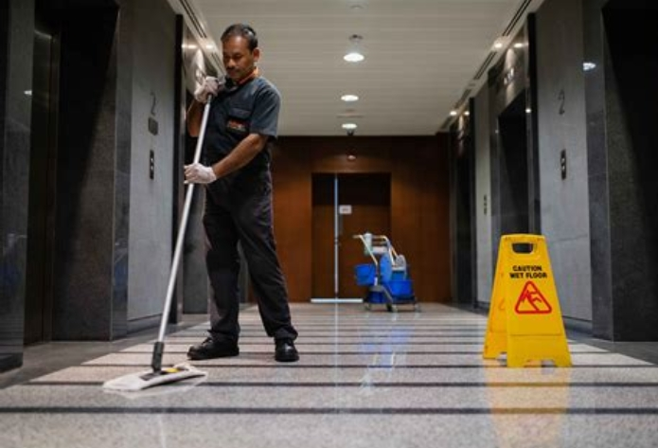
CLEANLINESS OF THE ENVIRONMENT
We clean and dust all the goods in the mall and rearrange the goods that was supply yesterday on the shelf we attend to the customers and shelf we attend to the customers and make sure the goods bought are in good condition we clean the mall and put the goods in order, then we attend to customers and make sales for the day. We dust the goods and arrange them, and the distributor supply the drinks that was order for and we counted it to confirm may be is complete we dust the goods and make sales for the day we clean the mall and rearrange the toiletries and electronics, then the manager list out the goods that is needed the department.
We clean the surrounding and dust the goods in the store, then the manager place and order for the day we dust the goods and attend to customers and make sales for the day we dust and rearrange goods in provisions and croceries department and we make sales for the day we dust and arrange the goods in shoes and bags department, including wears, then we attend to customers and make sales for the day the manager listed the items needed in the store and check the available goods we rearrange the goods and dust them then the manager place an order for the goods needed in provision and croceries department we clean and dust goods in the mall, the distributors came to supply the drinks and other goods that was ordered for and we count and check the goods before taking it to the store.
We dust the goods and arrange the new stocks before making sales for the day. We clean the mall and the distributor supply provisions and croceries that was order for and we make sales for the day we dust and arrange the goods in the mall, then we attend to the customers and make sales for the day we dust the goods and make sales for the day we stock in the store and shop then we arrange the goods needed outside the shelf.
We clean the surrounding and dust the goods in the store and make sales for the day we dust the goods in toiletries and electronics department and make sales for the day we arrange the goods in the store and listed out the goods that is needed to supply we dust the goods and the manager place an order for the goods needed we clean and dust the goods and make sales for the day we attend to the customers and make sales for the day the suppliers came to deliver some goods and we count and check the quantity and quality of the good supply the old goods was brought out for immediate sales and arrange the store the wall was clean and we dust the goods and make sales for the day we make sales for the day and make sure customers are well satisfy we dust the goods and attend to customers.
2.1 REARRANGEMENT OF THE GOODS
We dust and rearrange the goods and make sure they are in good condition an order was place on the wears department we dust and rearrange the goods in spices and stationeries department we rearrange the goods in drinks and biscuits department and attend to customers we dust and attend to customers and check there good before its been taken array we dust and attend to customers we arrange the goods and check if they are still in good condition we dust and arrange the goods then we attend to customers we dust and rearrange the items in toiletries and electronics department we dust and clean the store and rearrange the goods there the goods were check and make sure they are in good other we receive some good that was ordered for and confirm it maybe it is in good condition. We dust the goods and arrange it very well we brought some goods out of the store and displayed it on the shelf for sales we clean the mall and make sales for the day we dust the goods and arrange the store we check the goods and rearrange the position of the good, then we attend to customers we dust and attend to the customers and make sure the goods taking away are good condition we dust the good and make sales for the day the goods in provisions and croceries are rearrange and we attend to customers the goods in shoe and bags department rearranges and we make sales for the customers we dust the goods and make sales for the day.
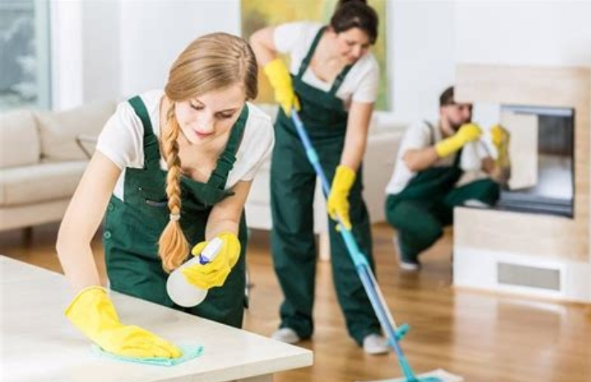
REARRANGEMENT OF THE ENVIRONMENT
2.2 CLEANLINESS OF THE ENVIRONMENT
We clean the environment and dust the goods on the shelf then we have sales for the days the mall are well kept to make sure the customers and satisfy we dust and attend to customers and make sales for the day there is cross check of goods in store and the one display on the shelf we dust the goods and make sales for the day we attend to the customers and make sure the goods bought are in good condition. There are some goods we did not have that are requested for by customers, the manager place an order for it we dust the mall and rearrange the good for customers attraction.

We dust the goods in the store check the expired data and arrange them properly we attend to customer and check the goods before taken it away the distributor came to delivered the goods that was order for and it was count and check before accepting them we display the new stock on the shelf, and make sales for the day we rearrange the goods in drinks and biscuits department, then we move to toiletries and electronics and dust the goods.


ARRANGEMENT OF THE GOODS
CHAPTER THREE
3.0 EXPLANATION ON THE STOCKS IN THE COMPANY
The manager place an order for biscuits and drinks we attend to customers and make sure their goods are in good condition the mall was kept clean and make sales for the day then we take the stock for the month there are more sales and the customers are well satisfied the goods were well arranged and the distributors came to deliver drinks and biscuits there is arrangement of the new stocks and we brought some sample out w dust the goods in mall and we rearrange the sessions of spices and stationeries we dust and attend to the customers we attend to customers and make sales for the day the manager place an order for the goods needed in the mall we clean and dust the goods we make sales for the day.
3.1 EXPLANATION ABOUT THE DISTRIBUTOR
The distributor came and deliver the goods and we count it and check the expiring data before caring it to the store we clean the mall and rearrange the good, then we attend to the customers we attended to customers and make sure the goods bought are in good condition the goods in shoe and bags session are rearrange and we make sales for the day we bought some goods from the store and arrange it on the shelf for sales we dust and arrange the goods and make sales for the day the mall was kept clean and we attend to customers the goods are well arrange and money was deposited to the bank the goods are well arrange and then we attend to customers we listed out the items that was needed in the mall and an order for it
3.2 DELIVERY OF GOODS TO CUSTOMER
We dust the goods and make sure we meet customers satisfaction we bought some items from the store to the shelf for customer to see we clean the surroundings and dust the goods and make sales for the day.
We dust the goods and rearrange them we attend to customers and make sure they are well satisfied we dust and rearrange the goods we check the goods sold to the customer before it is taken away we attend to customers and make sales for the day the stock were taken and the manager check it there is no loss or shortage.

CHAPTER FOUR
4.1 Experience gained during the SIWES training and their relevance to my course of study
Student Industrial Working Scheme (SIWES) is a programme that exposes students to practical aspect of their discipline or their different courses of studies.
During my SIWES program at the Oluwaseun shopping mall, Gaa-Akanbi Roundabout, Ilorin, Kwara State. I was able to identify different tools that are used to carry out simple maintenance tasks on how to clean and arrangement of goods and how to attend to customers. I also learnt periodic on how to rearrange and implement for tillage operation.
I learnt propagation methods of different crops (both food and cash crop), their nursing requirements, harvesting, processing, packing and marketing.
4.2 Problems Encounter during the Programme
Transportation problem
Far distance of farm locations.
Suggestion
All institutes should make proper arrangement with the ITF in sending students to certain Company which is allied with his/her course of study. ITF should try to pay the students at the appropriate time since the school and company are not paying with the belief that so far that ITF is paying them.

CHAPTER FIVE

5.0 Summary, Conclusions and Recommendation
The whole experience gained during the attachment at the Oluwaseun Shopping Mall was very enlightening. The practical skills we were exposed to and the opportunity to relate with typical situations relating to computer engineering industry.
The program gave me the privilege to relate with senior professionals and other students from different institutions and this experience made me appreciate the nature, benefits, and intricacies of my chosen field of study both in the classroom and in the society at large while also gives me the opportunity to put into practice the theoretical knowledge acquired throughout my stay in school.
5.1 Problems Facing During Siwes Program
Some of the problems experienced during the SIWES program. These are as stated below;
1. Limited orientation before starting the program.
2. There is also difficulty in getting a placement since placement letter was not issued on time

3. The workload is too broad to the extent that engineers were unable to explain the importance of work done on particular equipment to me as well as how it relates to the theoretical knowledge gathered.




TOILETRIES EQUIPMENT

