
REPORT ON
STUDENT INDUSTRIAL WORK EXPERIENCE SCHEME (SIWES)

HELD AT;
ELIFE PHARMACY, KAJOLA BUS-STOP AGBOWO, UI IBADAN OYO STATE.

BY
ABDULROSHEED OYINKANSOLA KASHIFAT
ND/23/STA/FT/0044

SUBMITED TO
DEPARTMENT OF STATISTICS,
INSTITUTE OF APPLIED SCIENCES,
KWARA STATE POLYTECHNIC, ILORIN.

IN PARTIAL FULFILMENT OF THE REQUIREMENTS
FOR THE AWARD OF NATIONAL DIPLOMA (ND) IN STATISTICS.

August – November, 2024

DEDICATION
This report is dedicated to almighty God, the Supreme Being, the beneficent, the merciful, and the foundation of wisdom, knowledge and understanding to the prudent.

OUTLINE
Title Page 1
Dedication 2
Outline 3
Introduction to SIWES 4
Definition of SIWES 4
Aim and Objectives of SIWES 5
Introduction of Industrial Placement 5
Departments and their function 6
Statistical Work Done 7
Experiences Gained in the Industrial Place 9
Conclusion 10
Recommendation 10

INTRODUCTION TO SIWES
Student industrial work experience scheme (SIWES) was established by Industrial Training Fund (ITF) in 1973/1974 to solve the problem of lack of adequate practical skills preparatory for employment in industries by Nigerian graduate of tertiary institutions.
Prior to the establishment of the schemes, there was a concern among our institution of higher learning lacked practical background studies preparation for employment in the industries.
The student industrial work experience scheme (SIWES) is a skill training program designed to expose and prepare student of agriculture technology, environmental science, medical science and pure & applied science for the industrial work situation one is likely to meet after graduation.
The program was established with various coordinating agencies respect to each tertiary institution in the country. These agencies are:
- NBTE (National Broad for Technical Education)
- NUC (National University Commission) for University
- NCCE (National Commission of College of Education) for colleges of education.
DEFINITION OF SIWES
Student industrial work experience which is a program established by I.T.F (Industrial Training Fund) in 1976 to bridge the gap between theory and practical aspect of learning in a tertiary institutions in Nigeria.
SIWES was established in Nigeria to help student develop on their practical aspect of learning expose them to various techniques in the industry and also help them to know the ways of handling equipment and machineries.
AIM AND OBJECTIVES OF SIWES
The aim and objectives of SIWES are as follows;
- Provide an avenue for students in institution of higher learning to acquire industrial skills and experience in their approved courses of study.
- Prepare students for the industrial work situation which they are likely to meet after graduation.
- Expose students to work methods and techniques in handling equipment and machinery not available in their institution.
- Provide students which they are likely to meet after graduation.
- Expose students to work methods and techniques in handling equipment and machinery not available in their various institutions.

INTRODUCTION OF INDUSTRIAL PLACEMENT
Elife Pharmacy is a pharmaceutical business located in Ibadan, Oyo State, Nigeria. It operates within the pharmacy and drug store industry, providing essential healthcare products, medications, and related services to the local community. The pharmacy is classified under ISIC Code 4772, which covers pharmacies and drug stores. While the exact founding date and historical details of Elife Pharmacy are not widely documented, it has established itself as a recognized healthcare retail provider in Ibadan.

The pharmacy’s address is Ibadan, Nigeria, Postal Code 200132​. It serves residents by offering prescription medications, over-the-counter drugs, and health-related consultations.

Elife Pharmacy is part of a network of pharmacies in Ibadan. The pharmacy plays a vital role in the community’s healthcare sector, ensuring access to quality medications and pharmaceutical services.

DEPARTMENT IN THE PLACEMENT AND THEIR FUNCTION
- Dispensing/Pharmacy Department
- Responsible for preparing, verifying, and dispensing medications.
- Ensures patients receive the correct prescriptions with appropriate guidance.
- Inventory and Supply Chain Management
- Manages procurement and storage of medications and health products.
- Ensures stock availability and prevents shortages or overstocking.
- Sales and Customer Service Department
- Assists customers with purchases and provides product recommendations.
- Handles inquiries and resolves customer complaints.
- Regulatory and Compliance Department
- Ensures adherence to local pharmaceutical regulations and ethical standards.
- Maintains proper record-keeping for audits and inspections.
- Finance and Accounts Department
- Handles billing, pricing, and financial management.
- Prepares financial reports and manages payroll.
- Marketing and Business Development
- Promotes pharmacy services and products.
- Establishes partnerships with healthcare providers and suppliers.
- Human Resources (HR) Department
- Manages staff recruitment, training, and performance.
- Oversees workplace policies and employee welfare.

STATISTICAL WORK-DONE
Statistics can be said to be about collecting, organizing, summarizing, presenting and analysis of data and there are various method or techniques in which data can be analyze to make a valid and valid conclusion or interpretation of the analyzed data. During my stay at the hospital, I was placed in the finance and account department in which I input the daily record of sales in the system using MS Excel and MS Word, and I was able to carry-out some statistical work using statistical technique.
The data below are record of sales in cartoon of different sizes (smallest, medium and large) of a drug called Vamiron Blood Tonic for 3 months (July, August, and September) in 2024.
Vamiron is a health supplement available in different formulations. One of its products is Vamiron Blood Tonic, a syrup containing Ferric Ammonium Citrate, Folic Acid, and Vitamin B12, designed to help with iron deficiency and general wellness. It is manufactured by Tuyil Pharmaceutical Industries Ltd, Nigeria, and is classified as an over-the-counter (OTC) drug.

Vamiron | July | August | September
Smallest size | 2 | 10 | 5
Medium size | 5 | 10 | 7
Large size | 6 | 0 | 2

Which of the cartoon sold the most with the 3 months.
Vamiron | July | August | September | Total
Smallest size | 2 | 10 | 5 | 17
Medium size | 5 | 10 | 7 | 22
Large size | 6 | 0 | 2 | 8

From the table above; it shows that the size with the highest sales within the 3 month is the medium size (22) and the size with the lowest size is large size (8). And it is shown in the bar chart below.

Multiple bar chart is use to show the data above.
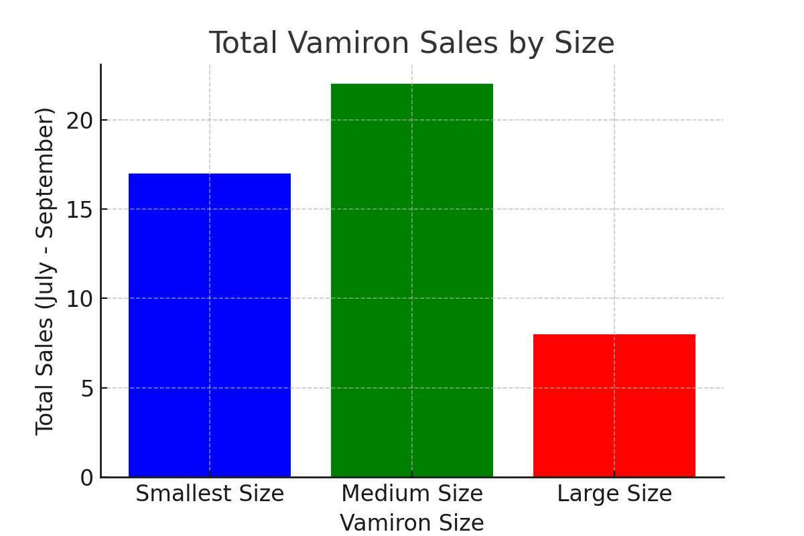

Conclusion:
- The medium-sized Vamiron is the most popular, likely due to a balance between price and quantity.
- The smallest size performed better than the largest, indicating customer preference for affordability over bulk purchasing.
- The large size had the lowest sales, suggesting that customers might not prefer buying in bulk or there is limited market demand for this size.

EXPERIENCE GAINED IN SIWES PLACEMENT
Week 1: Introduction and Learning about some medical terms such as HMO (Health Maintenance Organization).
Week 2: I was taught how to run MS Excel and MS Word and also draw table of the recorded data.
Week 3: I was taught how to input the collected data into Ms Excel and also draw table of the recorded data.
Week 4: Records of sales of goods in the pharmacy.
Week 5: Taking a look at the rate at which the goods are been purchased.
Week 6: I was taught how to draw table of records in Ms Excel, how to merge the lines, how to bold the records and how to add color.
Week 7: I obtained data of sales of vamiron in cartoon by size (small, medium and large) and it was recorded in a new created template in excel.
Week 8: Record of customer that visit the pharmacy to purchase, to complain and make enquiry.
Week 9: I did some analysis of the recorded data within 3 months.

CONCLUSION
After my stay at the SIWES placement, which I was placed in the records department in which I input the daily record in the system, and I was able to carry-out some statistical work by practical, I understand that solving the problem of skill acquisition by graduates of Nigerian technical / vocational education is a reason for the establishment of SIWES. It was planned to be a bridge between educational institutions and industrial employers with the latter providing general and specific occupational skills and knowledge. If the scheme is not adequately implemented it becomes difficult for graduates of the system to secure proper understanding of their choice of study and implementing into occupations or make smooth transition to the labor market world.
Incompetence in workplace is related to the kind or quality of training in the school. To improve on the scheme’s implementation students should be placed in industries relevant to their field s of study. There is need for greater cooperation between industries and educational institutions on how best to implement SIWES programme. It can thus be concluded that SIWES offers the students learning experiences which cannot be directly gained in the class room.

RECOMMENDATION
- All the institutions involved should be organizing orientation courses in collaboration with the ITF for their students prior to their attachment with the attendance made mandatory for the students accepted for SIWES and ITF staff.
- ITF should ensure the regular visitation of the ITF officers to supervising Agencies institutions, employers and students on attachment.
- ITF should be providing insurance cover to students on attachment and improve on paying students and supervisors allowances for motivation.
- The Banks should speed up their action at clearing of cheque issued to avoid unnecessary delay.

