A TECHNICAL REPORT ON
STUDENTS INDUSTRIAL WORK EXPERIENCE SCHEME (SIWES) UNDERTAKEN

AT

INTEGRATED CONCEPTS PARTNERSHIP LIMITED
BY

OLUWABIYI TOBA AYODELE
ND/23/ARC/FT/0004

SUBMITTEDTO

DEPARTMENT OF ARCHITECTURAL TECHNOLOGY AND INSTITUTE OF ENVIRONMENTAL STUDIES
KWARA STATE POLYTECHNIC, ILORIN
ILORIN, KWARA STATE, NIGERIA

IN PARTIAL FULFILMENT OF THE REQUIREMENTS FOR THE AWARD OF NATIONAL DIPLOMA IN ARCHITECTURAL TECHNOLOGY

MARCH, 2025

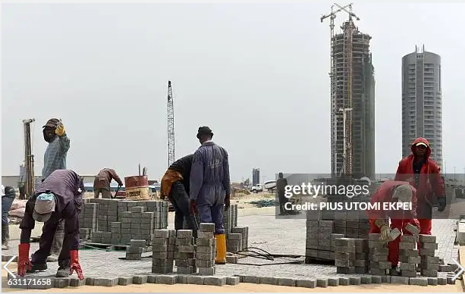
SIWES REPORT

OLUWABIYI TOBA AYODELE
ND/23/ARC/FT/0004

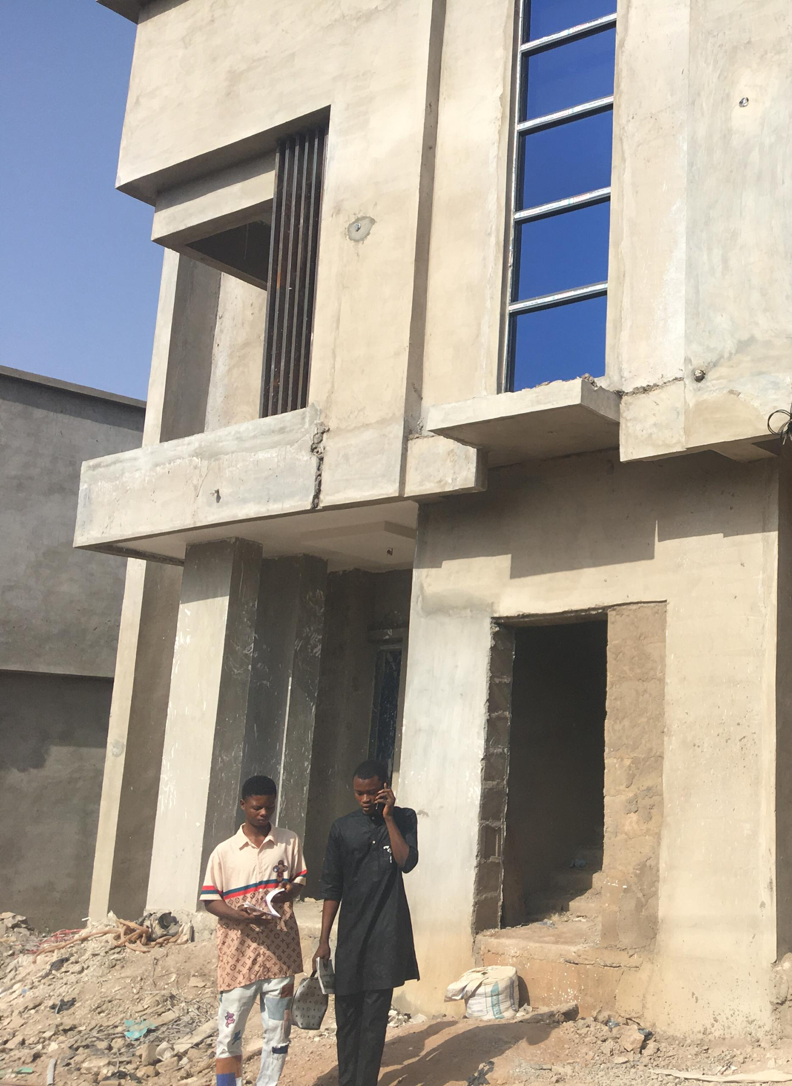

TABLE OF CONTENTS
1.0 CHAPTER ONE
dedication__________________________________________________________4
Declaration__________________________________________________________5
Acknowledgment_____________________________________________________6
Special Recognition__________________________________________________7-8
2.0 CHAPTER TWO
Abstract__________________________________________________________9-10
Introduction______________________________________________________11-12
Establishment______________________________________________________12-15
3.0 CHAPTER THREE
Site Experience ___________________________________________________19-21
Sites Visited _____________________________________________________ 21-22
Construction Processes ____________________________________________ 23-25
4.0 CHAPTER FOUR
Site knowledge __________________________________________________ 26-27
Skill Sets Acquired ________________________________________________28
Projects Worked On _______________________________________________29-30
5.0 CHAPTER FIVE
Summary _________________________________________________________ 31
Problems Encountered _______________________________________________32
Recommendations ___________________________________________________33
References _________________________________________________________34-35

DEDICATION
This report is dedication to God Almighty, for his faithfulness and miracle shown on me before, during and after my SIWES program. I will also like to dedicate this report to my parents Mr. and Mrs. Oluwabiyi and the Director and Industrial Supervisors who stood by me and also help me in many ways during this period of my Siwes and also preparing this report.

DECLARATION
I, OLUWABIYI TOBA AYODELE MATRIC NO ND/23/ARC/FT/0004
NO hereby declare that this student industrial work experience scheme (SIWES) technical report was solely written by me, with guidance of the Architect of Integrated Concepts Partnership International Limited was incorporated under the Company and Allied Matters Decree, 1990 on 7th of January 2010 with RC No 862877.
I also declare that all site pictures attached to this report were taken by me and my fellow IT student on site visits.

STUDENT SIGN DATE

___________________ ______________

SUPERVISOR SIGN DATE
___________________ ______________

H.O.D SIGN DATE
___________________ ______________

ACKNOWLEDGEMENT

I thank God who has seen me throughout my SIWES program and also thank my Industrial based supervisor who guided me through My Industrial training. I also send out my appreciation to my lecturers, friends and Coworkers for their moral support. My special thanks to my wonderful and lovely parents Mr. and Mrs. Saheed who were there for me in terms of care, prayers, financial support and others.

SPECIAL RECOGNITION
Integrated Concepts Partnership International Limited was incorporated under the Company and Allied Matters Decree, 1990 on 7th of January 2010 with RC No 862877
We are a dynamic company dedicated to giving a professional, personal and value for money.
We specialize in up market residential and commercial architecture, construction as well as very successful renovations and alterations, creating interesting designs styled beyond convention, with functional planning and flow to suit the client's budget and life style
A unique service that we are proud to offer is that the client can visualize and understand the project through:
3-D computer model and photo-real images.
Animated video walkthroughs and fly-byes with full color plan
presentations done on computer.
The final product can therefore be viewed at the initial stage. The main advantage of 3-D photo realism is that the completed building can be visualized from any angle and view. It also aids in the selection of materials, colors, finishes and landscaping engineers, builders and other professionals working on the project can see and understand the building from the design stage.
Technical construction details are resolved on the computer generated 3-D model. The photo-real images and videos are a useful tool for marketing purposes for new residential and commercial developments
We have delivered best-in-class construction services to our various clients in a wide variety of markets including but not limited to; corporate, commercial, manufacturing, telecommunication, education, retail, government bodies and agencies, financial institutions and ovic projects
To carry instructions clearly to the actual site work, we offer precise technical construction drawings which include architectural, structural, electrical and mechanical engineering designs. These ensure efficiency, professionalism and environmentally friendly and cost effective approach to our projects
We undergo Master Plan Development for town, estate, industrial layout and campuses from conception to planning and execution
We carry out land and building acquisition, title documentation and perfection, valuation for different purposes. We also develop for sale, private estate and structures for our various clients at tenable and profitable prices

ABSTRACT
The Student Industrial Work Experience Scheme (SIWES) is a pivotal program designed to enhance the practical knowledge and skills of students in technical and vocational disciplines. This report outlines the objectives, methodologies, and outcomes of my SIWES placement at Concepts Partnership International Limited, where I worked for four Month as a interns. The primary aim of the internship was to apply theoretical concepts learned in the classroom to real-world scenarios, thereby gaining hands-on experience in the industry.
During the internship, I participated in various projects related to Site supervision, architectural drawing and lot more, which allowed me to develop essential skills in relevant skills, e.g., project management, teamwork, technical proficiency. The experience provided insights into industry standards and practices, fostering a deeper understanding of the challenges and dynamics within the integrated Concepts Partnership International Limited
Key findings from this experience include the importance of effective communication, collaboration, and adaptability in a professional setting. Additionally, I gained valuable knowledge about specific technologies or methodologies used, which will significantly contribute to my academic and professional growth.
This report concludes with recommendations for future SIWES participants and highlights the necessity of integrating practical experience with academic learning to better prepare students for their future careers.

CHAPTET ONE
1.0 INTRODUCTION

The second semester year-one course is one of the most compulsory courses for undergraduate students in the department of Architecture, same for some other departments in the Kwara State Polytechnic and other higher institutions. Students’ Industrial Work Experience Scheme (SIWES) according to the curriculum of Architecture department, students are expected to spend a period of four months in an establishment where they are granted the opportunity to work as an intern. It exposes the student to architectural office practice in real environments. Acquisition of skill for competence in the execution of practical Architectural projects, safe handling of equipment and avoidance of hazards associated with them, and skill of observation, recording and documentation on construction sites.
The scheme exposes students to industrial based skills necessary for a smooth transition from the class room to the field of work. It affords students of tertiary institutions the opportunity of being familiarized and acquainted to the needed experience in handling machinery and equipment which are usually not available in our institutions. Thus, the participation in SIWES has become a necessary prerequisite for the award of Diploma and Degree certificates in specific disciplines in most institutions of higher learning in the country, in accordance with the education policy of government.
SIWES, or Student Industrial Work Experience Scheme, is a vital component of higher education programs, particularly in technical and vocational fields in Nigeria. It provides students with practical experience in their chosen disciplines, allowing them to apply theoretical knowledge acquired in the classroom to real-world situations.

Objectives of SIWES
Practical Experience: To give students hands-on experience in their field of study, enhancing their understanding of industry practices and standards.
Skill Development: To help students develop professional skills, including teamwork, communication, and problem-solving, which are essential for their future careers.
Industry Exposure: To expose students to the working environment, familiarizing them with the tools, technologies, and methodologies used in the industry.
Networking Opportunities: To allow students to build professional networks that can be beneficial for future employment and career advancement.
Career Guidance: To provide insights into career paths and the realities of working in their chosen fields.

Structure of SIWES
Typically, students participate in SIWES for a specified duration, often between six months to one year, during which they work with an organization relevant to their field. Students are usually required to submit a report detailing their experiences, challenges faced, and skills acquired during their time in the organization.
Overall, SIWES is an essential program that bridges the gap between academic learning and practical application, preparing students for successful careers after graduation.

CORPORATE BACKGROUND
Integrated Concepts Partnership International Limited was incorporated under the Company and Allied Matters Decree, 1990 on 7th of January 2010 with RC No 862877
We are a dynamic company dedicated to giving a professional, personal and value for money.
We specialize in up market residential and commercial architecture, construction as well as very successful renovations and alterations, creating interesting designs styled beyond convention, with functional planning and flow to suit the client's budget and life style
A unique service that we are proud to offer is that the client can visualize and understand the project through:
3-D computer model and photo-real images.
Animated video walkthroughs and fly-byes with full color plan
presentations done on computer.
The final product can therefore be viewed at the initial stage. The main advantage of 3-D photo realism is that the completed building can be visualized from any angle and view. It also aids in the selection of materials, colors, finishes and landscaping engineers, builders and other professionals working on the project can see and understand the building from the design stage.
Technical construction details are resolved on the computer generated 3-D model. The photo-real images and videos are a useful tool for marketing purposes for new residential and commercial developments
We have delivered best-in-class construction services to our various clients in a wide variety of markets including but not limited to; corporate, commercial, manufacturing, telecommunication, education, retail, government bodies and agencies, financial institutions and ovic projects
To carry instructions clearly to the actual site work, we offer precise technical construction drawings which include architectural, structural, electrical and mechanical engineering designs. These ensure efficiency, professionalism and environmentally friendly and cost effective approach to our projects
We undergo Master Plan Development for town, estate, industrial layout and campuses from conception to planning and execution
We carry out land and building acquisition, title documentation and perfection, valuation for different purposes. We also develop for sale, private estate and structures for our various clients at tenable and profitable prices

SERVICES INCLUDE:
1. Planning
2. Design
3. Construction
- Monitoring and Evaluation.
- Project Management.

GOALS AND OBJECTIVES:
Our Objectives is targeted towards high structural strength, stability, and economical service time delivery to ensure that the facilities are functioning and adequately fulfill the purpose for which it is provided.
ORGANIZATION STRUCTURE
Integrated Concepts Partnership International Limited was incorporated under the Company and Allied Matters Decree, 1990 on 7th of January 2010 with RC No 862877
We are a dynamic company dedicated to giving a professional, personal and value for money.
We specialize in up market residential and commercial architecture, construction as well as very successful renovations and alterations, creating interesting designs styled beyond convention, with functional planning and flow to suit the client's budget and life style

Organizational Structure of a Construction Company
Board of Directors:
Oversees overall strategy, governance, and financial health of the company.
Executive Management:
Managing Director/CEO: Responsible for overall operations and strategic direction.
Chief Financial Officer (CFO): Manages financial planning, risk management, and financial reporting.
Chief Operating Officer (COO): Oversees day-to-day operations and project execution.
Project Management Office (PMO):
Project Managers: Lead individual construction projects, managing timelines, budgets, and teams.
Site Managers: Supervise on-site activities and ensure compliance with safety regulations.
Engineering and Design Team:
Civil Engineers: Focus on structural design and analysis.
Architects: Responsible for project design and aesthetics.
Quantity Surveyors: Handle cost estimation and budgeting.
Operations and Construction Team:
Foremen: Oversee on-site labor and operations.
Skilled Laborers and Tradespeople: Perform construction tasks (e.g., carpenters, electricians, plumbers).
Human Resources:
Manages recruitment, employee relations, training, and compliance with labor laws.
Procurement and Supply Chain:
Responsible for sourcing materials, negotiating contracts, and managing supplier relationships.
Safety and Quality Assurance:
Ensures that projects adhere to safety standards and quality regulations.
Marketing and Business Development:
Focuses on acquiring new clients, managing relationships, and promoting the company’s services.
This structure may vary based on the size and scope of the company. For T & G Partners Construction Limited, the specifics could include local adaptations or additional roles depending on their projects and operational focus. If you need further details or have specific roles in mind, let me know
ARCHITECTURAL DRAWING EXPERIENCE
- Introduction to conversion of scale, I was taught how to calculate scale in architectural design my supervisor explained how architect use scale to accurately represent building and structures on paper e.g. important of proper architectural drawing.
- I was ta ught hoe to measure and interpreted scales in drawing and dimension the size of the wall is represented as 225.
- Introduction to garage layout and the dimension, I was taught how to think like an architect in other to dictect any error on the plan.
- Introduction and explanation on how to make use of diagram concept to develop your project
- Introduction to plan, and how to develop a well functionable plan
- I was taught hot to cut section and how to bring out the roof carcass out of the structure
- Introduction to roof design and guideline to follow in other to have an aesthetic roof design
- I was taught how to supervs=ised on site in other to have a workable structure and how to do setting out on site.
- We are giving assignment to draw 2 bedroom floor plan
- Assignment was giving on drawing of section
- Assignment was giving to draw a Elevation plan
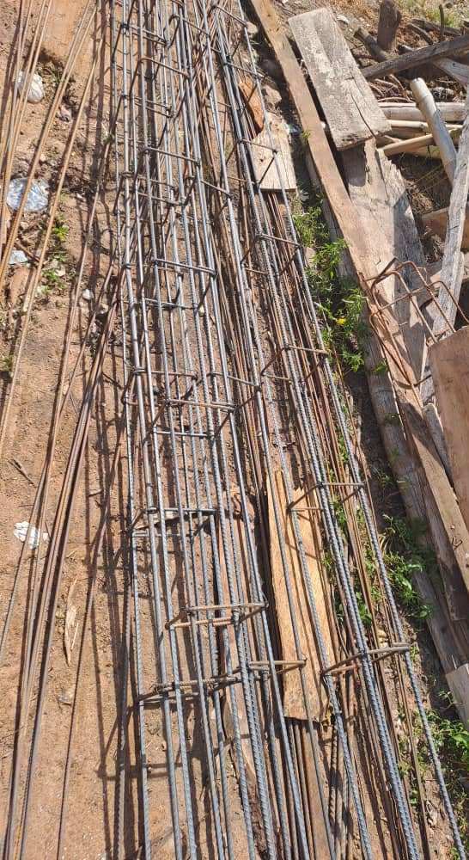
- We are taught how to draw site plan and assignment was given also
- I was taught the sizes of window, door that we have
- I was taking to the site in other to see the pratical of what we have been taught

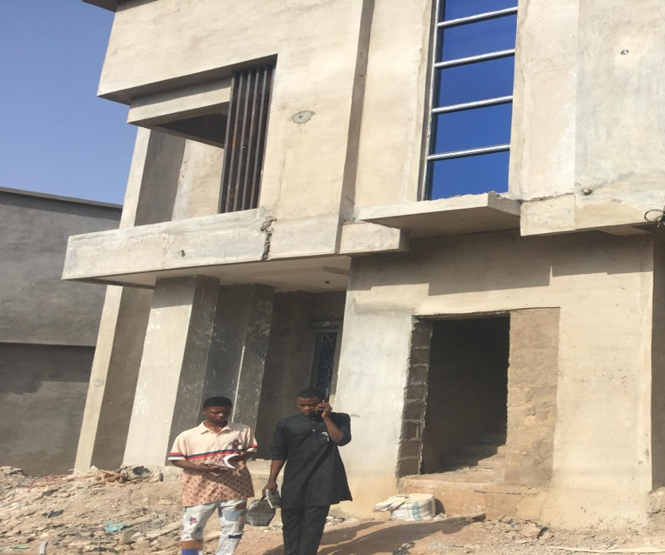
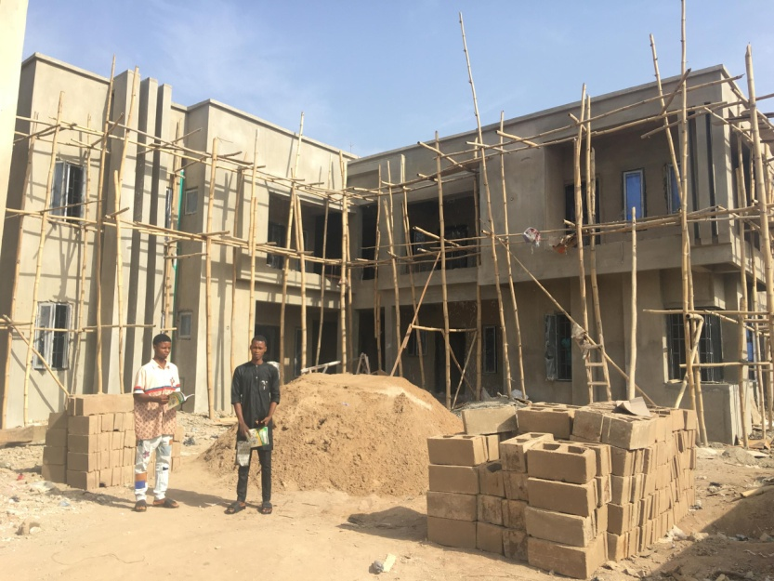
PART OF THE DRAWING CARRIED OUT

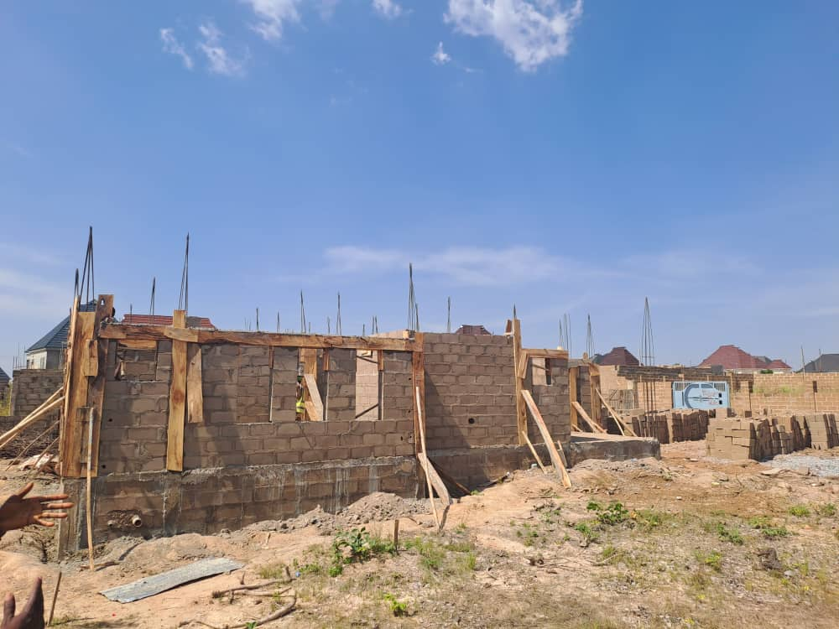
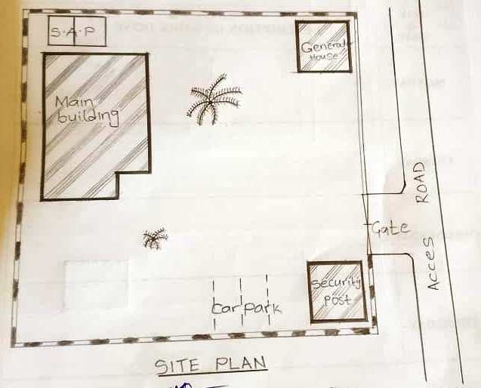

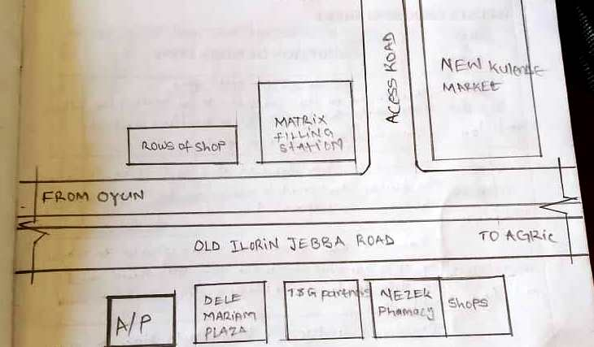
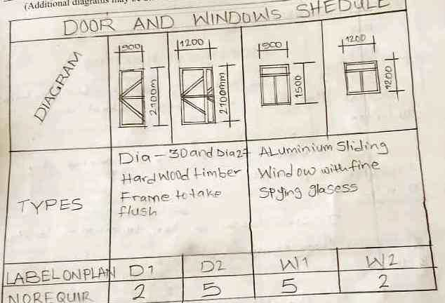

UNITS AND FUNCTIONS
Integrated Concepts Partnership International Limited was incorporated under the Company and Allied Matters Decree, 1990 on 7th of January 2010 with RC No 862877
We are a dynamic company dedicated to giving a professional, personal and value for money.
DESIGN DEPARTMENT
This department is responsible for the preparation of detailed plan of the form or structure of something, emphasizing features such as its appearance, convenience, and efficient functioning. This department utilizes their creative skills with the use of architectural softwares to strategically create plans in form of 2-dimensional drawings and 2-dimensional visualizations for actualization of certain development projects.
Other processes include:
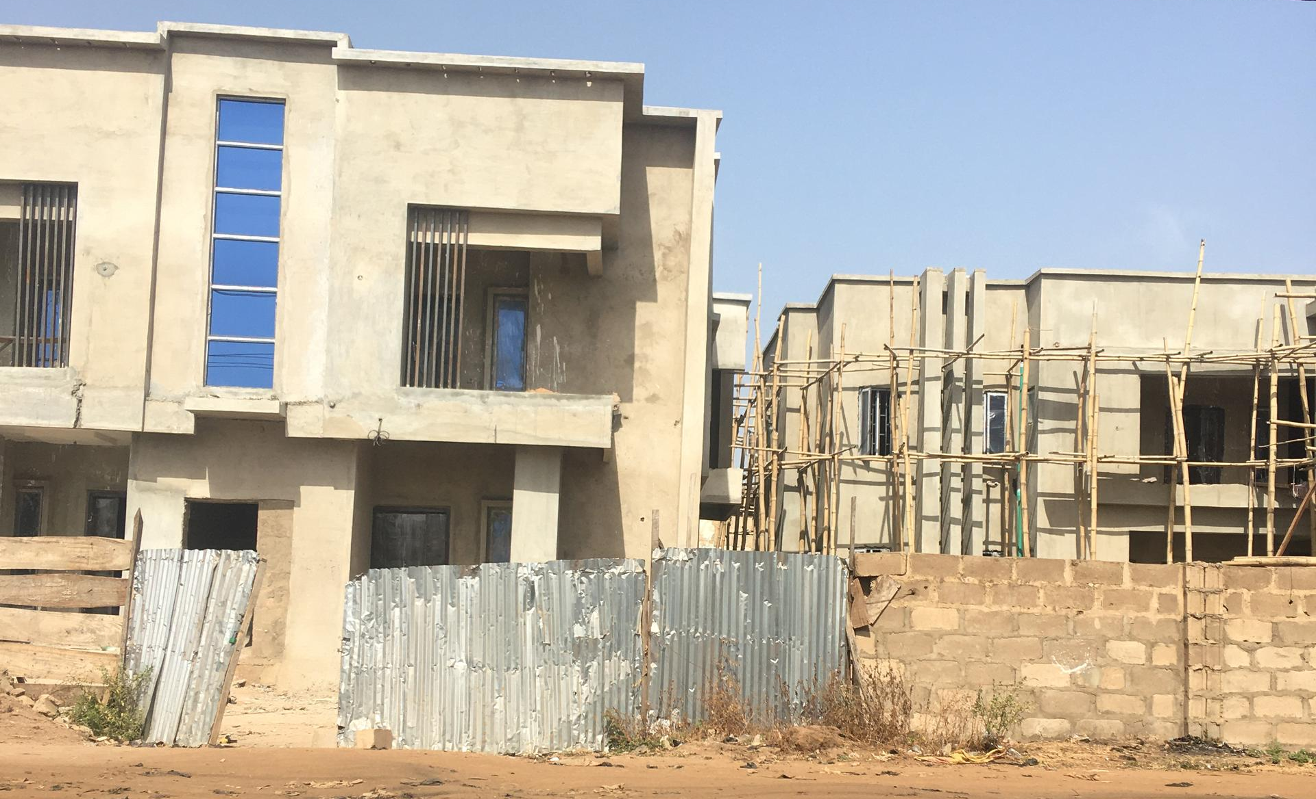

The construction phase of the project brings the dream to life and demands rigor. It involves checking any documents and drawings that the contractor puts forward and ensuring that the works are carried out in conformity with the building contract.
It’s a very important phase in the architect’s scope of works as it is the only way that the architect can ensure that the project gets built as he has designed and developed with the client. It usually requires weekly meeting with minutes by the architect.
Depending on the type of building contract the architect helps coordinate the works with the different trades, making sure that good common practice is respected, standards and regulations are followed. The architect can explain each part of the construction process and makes sure that all the different specialized participants don’t lose site of the big picture. Each month the architect examines any invoices raised by the contractor to ensure that any payment that is requested corresponds to completed works on site.
At the end of the building site phase the architect reviews the works with
the contractors to complete any last details.

HANDOVER OF THE WORKS AND PRACTICAL COMPLETION
At the end of the construction phase the architect assists the client with the handover of the building. In the UK it’s known as practical completion. It involves a formal visit of the works and a report, sometimes with a list of defects or snagging list that is put together by the architect for the client. It’s the moment when the client can list any works that they feel aren’t complete or don’t satisfactorily meet their expectations but only defects in relation to a contract is listed.

AS BUILT DOCUMENTS AND BUILDING USER MANUAL
At the end of the building project the architect will collate for the client all the construction drawings that were used to build the project together with the manuals, certificates and guarantees that apply.

ADMIN DEPARTMENT
This department is responsible for supporting their organization in a variety of ways including bookkeeping, communications, scheduling, data entry, secretarial services and much more. The role of administrator involves a great deal of multitasking. They work with teams, oversee the operations within your company, manage groups,
coordinate with management and engage in planning according to the needs of

This department is responsible for running the accounting and financial activities of the firm. They analyses the economic stability of the company and provide financial information to other departments, enabling these department to make budgeting and investment decisions. They report on costs, productivity, margins and company expenditures.

CHAPTER TWO
SITE EXPERIENCE
Construction starts with planning, design, and financing; it continues until the project is built and ready for use.
The importance of construction to an architect cannot be overemphasized. Nowadays, architecture students learn to design buildings within the walls of the studio. The modern day architecture school problem revolves around most students not knowing the construction process of what they design.
Thus, here is a list of what I have come to gain during the SITE EXPERIENCE of my SIWES The importance of construction to an architect cannot be overemphasized. Nowadays, architecture students learn to design buildings within the walls of the studio. The modern day architecture school problem revolves around most students not knowing the construction process of what they design.
programme:
•
I ACQUIRED SITE-SENSITIVITY:
No matter how many site visits and analysis you make, you could never achieve the same site sensitivity as you would by working on it. As I worked on the site, I fully grasped its nature. This way, I was able to shape my building per site conditions to the tee!
•
I UNDERSTOOD MORE ABOUT MATERIAL APPLICATION:
It shouldn’t come as a surprise that participating in building process boosts one’s understanding of material applications. After all, construction site serves as a perfect platform for exploring the inherent connection between architecture and its materials.
Once you’re a part of the building-making process, you might end up discovering your own sustainable materials that are suitable for construction.

Thus, if given a fair chance on site, architects can not only become proficient in the art of building but also contribute to expanding the possibilities of material applications.
•
IT DEVELOPED MY CRAFT SKILLS:
It is a well-established fact that any hands-on experience is a better teacher than most classrooms. Likewise, working directly on the site would develop one’s trade skills and craftsmanship more than any studio room.
To elaborate further, take an example of an instruction manual. Just like this manual would tell you what to do to make a certain product in steps, your college education teaches us how to make a building. It is not until we start following those steps that we find ways to change the instructions a bit for more efficiency. Similarly, when we craft building not on paper but on a construction site, we can see the impact of your design decisions right away and change those decisions per necessity.
Through this process, I attained a better understanding and appreciation of the efforts it takes to create the desired result.
•
CONSTRUCTION SITE GAVE ME EVEN MORE UNDERSTANDING OF WHY SITE KNOWLEDGE IS PARAMOUNT:
Knowing and doing are two very different things. This is not to imply that the academic part of architectural education is not good enough, rather it’s not sufficient. We, architecture students, have been adding a junction box in our technical drawings for years.
Practical experiences on the site gave me mirages of realization over and over again. I realize that what I’ve been drawing for years had major gaps in construction knowledge. Hence, it is essential that I have construction site experience.
The act of being actively involved in any construction process cannot be overemphasized as it opens the architect’s eyes to things that cannot be fully grasped in the design process.

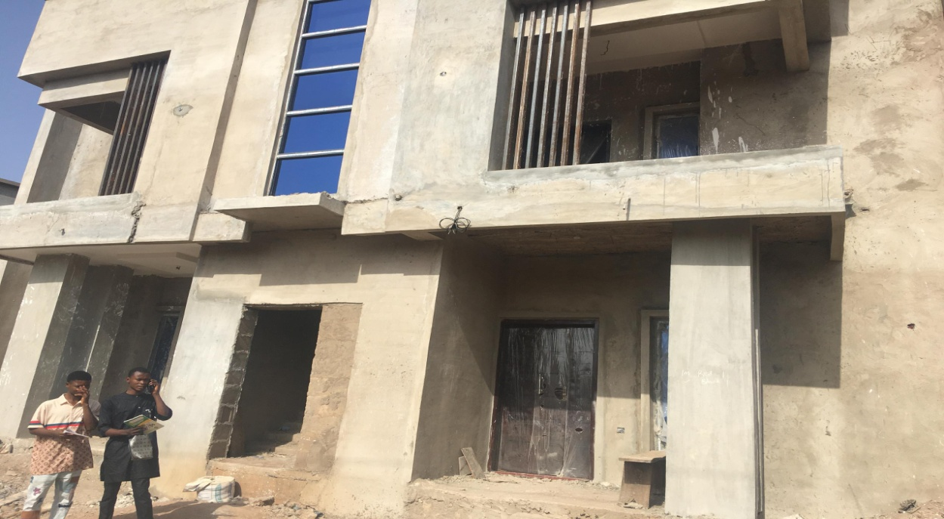
SITE VISITATION

Site pictures found in this chapter were taken by me and my colleague from
sites we visited, as instructed by my establishment of attachment for my SIWES
programme. The buildings were designed and were being supervised us.

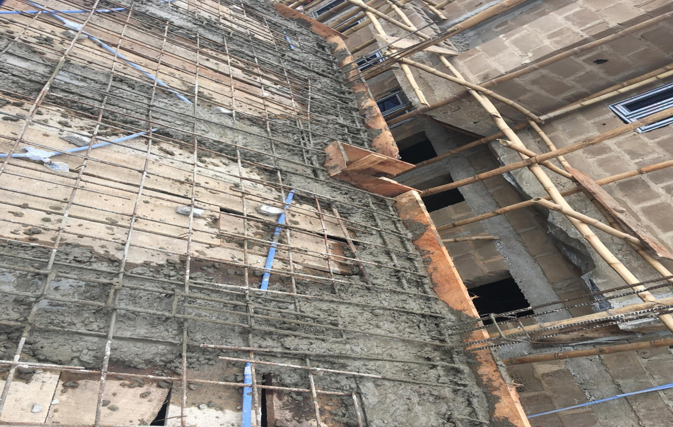
CONSTRUCTION PROCESS

“When walking alone, the architect reviews general progress and also zooms in on
areas that are flagged in their mind: the area that is complicated, the area where there is little tolerance allowed, the area that was supposed to be fixed last week, the area that was problematic on other floors, the area you haven’t seen in a while. The detail level of the observations depends on the phase of construction or special circumstances. Because of phasing, one area may require more detailed observations early because it will not be accessible later.” Unknown The Architect’s work during the construction phase is usually called CA (Construction Administration or Contract Administration).
There are weekly (or biweekly, depending on the size of the project) meetings led by the Owner/ Contractor team that keep the A/E (architect/engineer) team informed about how to prioritize their efforts.

Working with the Architect on sites during the period of my internship, I was able to acquire the following construction processes:
CONSTRUCTION OF CONCRETE WALLS, COLUMN EXTENSIONS
These kinds of wall are built of the mixture of sand, cement, gravel and water in a specific proportion. The right proportion is determined by the intended purpose. However, they have a similar method of construction. This begins by determining the exact position on site which the wall will constructed. The area is then measured and marked out. The marked area is excavated.
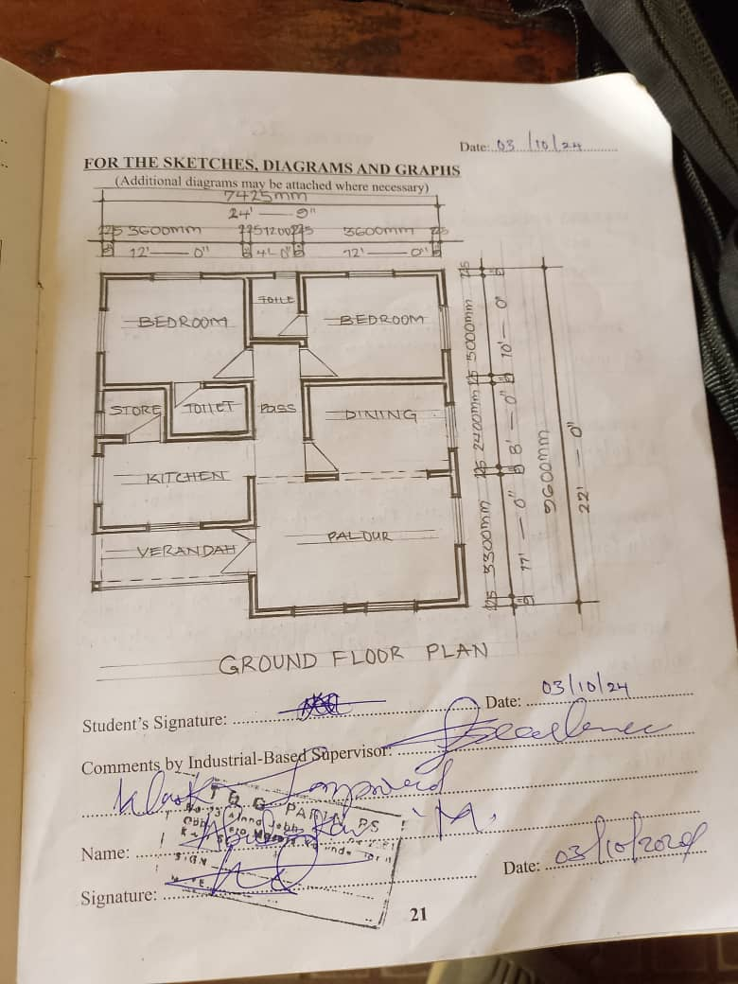
Excavation is either done manually or mechanically. During the excavation, the trench is dug a little wider than the needed region. Then major purpose of the excavation is to give the wall a firm base to prevent any form of overturning. When the trenches are set, construction of formwork begins.

Formworks for In-situ Concrete Work is defined as “A mould or box into which wet concrete can be poured and compacted so that it will flow and finally set to the inner profile of the box or mould.” Formwork can be made using molds out of steel, wood, aluminum and/or prefabricated forms. Formwork is an ancillary construction, used as a mould for a structure. Into this mould, fresh concrete is placed only to harden subsequently. The construction of formwork takes time and involves expenditure up to 20 to 25% of the cost of the structure or even more. These are Temporary structure required to safely support concrete until it reaches adequate strength.
PLASTERING OF WALLS
This is the process by which layers of cement-sand screed is applied to the wall, either on the interior or on the exterior. Cement plastering is commonly used as ideal coating for external and internal surface of wall. Cement plaster is usually applied in a single coat or double coat. Double coat plaster is applied where thickness of plaster is required to be more than 15 mm or when it is required to get a very fine finish.

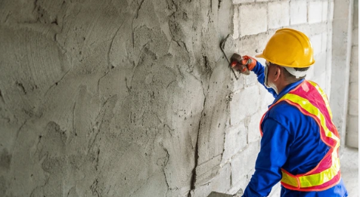

CHAPTER THREE
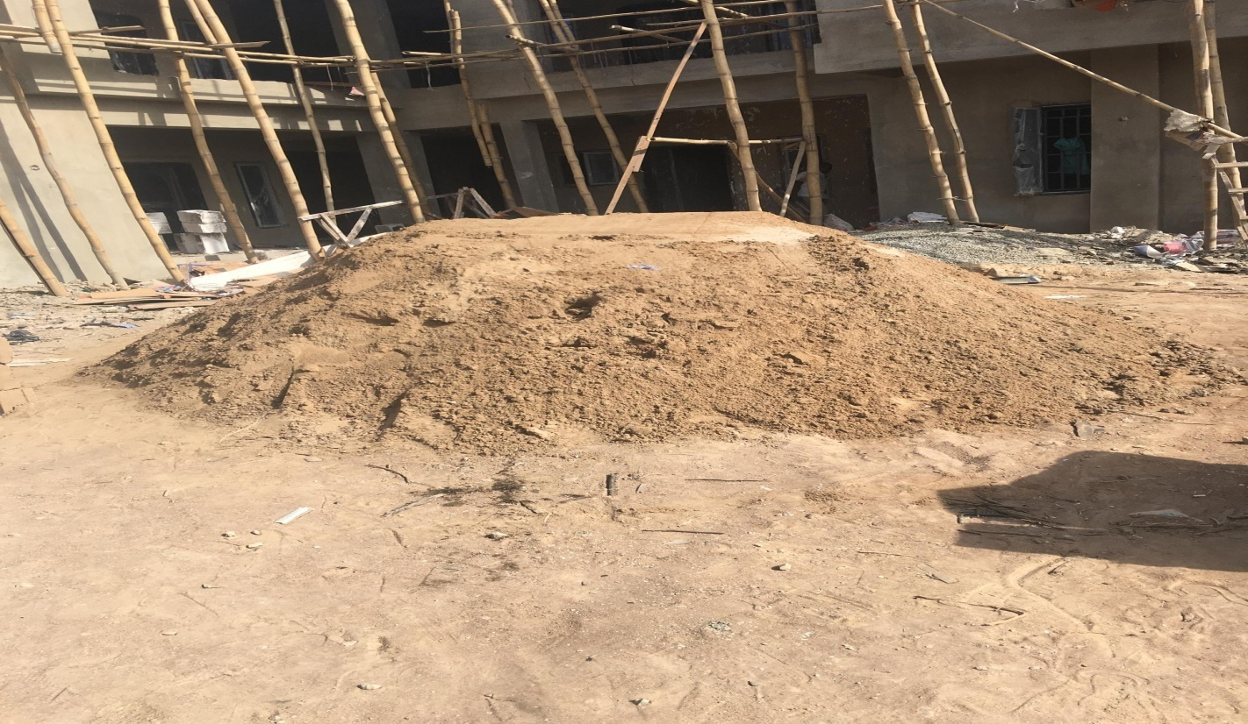
SITE KNOWLEDGE

Construction projects involve the co-ordination of a great number of people, materials and components. Regular inspection is a crucial part of ensuring that the works progress as intended, both in terms of quality and compliance. Inspections will be carried out for a number of different purposes throughout the duration of a project.
The inspection process is separate from the contractor’s own supervision of the works. Inspection is carried out purely to give an independent view of the works either for the client or a third party. Inspection of the construction works will be carried out as they proceed to verify compliance with the requirements of the contract documents.
Site inspectors provide an independent assessment of the works and will generally report to the contract administrator. They keep a site diary, attend construction progress meetings and to produce regular written reports.

SKILLLS SET AQCUIRE
I spent a good time in Integrated Concepts Partnership International Limited was incorporated under the Company and Allied Matters Decree, 1990 on 7th of January 2010 with RC No 862877
, Nigeria. I didn’t just sit down and watch things being done, I paid thorough attention, asked technical questions, and hearkened to important instructions. I was also given a number of projects to work on. All under the guidance of my supervisor. In this course, I started to notice the general improvement in my architectural skills. The acquired skills are so peerless that no amount of lengthy writing can adequately express its extent. Some are explained below:
• Autodesk Revit Architecture
• 3D Studio Max Software
• Sketchup and Other Auxiliary Soft-wares
• Conceptual Development
• Design Development
• Elevation Treatment
• Building Approval

PROJECT WORKED ON
The huge number of the studio works I carried out were majorly based on designing residential and commercial buildings. The major tool used to accomplish my task in the studio were computer aided design software. These software applications aided the precision and accuracy of the designs to a good extent. The software applications include: Autodesk Revit architecture, 3D Studio Max, AutoCAD and other auxiliaries.
During my course of work in studio I got to understand more about designing and space management. I learnt more about flexibility in designing and gleaned some knowledge of how designs are being tackled from the brief to the final presentation to the client. Below are highlights of some of the projects I handled.
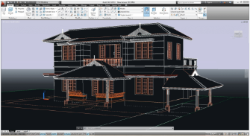

CHAPTER FOUR
SUMMARY
Prior to the commencement of my SIWES programme, I made a list of objectives. These objectives were planned to have all been attained at the end of my programme. They include but not limited to:
• To be able to create plans following all the laws and safety regulation.
• To be able to work towards a particular budget
• To learn new materials and new construction methods
• To improve my material selection
• To be aware of common and innovative construction processes on site
• And to gain additional architectural skills
For the ease of explanation, I have grouped my experience gained into
two
• Site experience
• Studio experience
Out of the number of sites currently under construction, I was given the opportunity to be present on 4. I witness and in some cases, I was instructed by my supervisor to supervise some common and innovative construction processes and material installation.

PROBLEM ENCOUNTERED
Besides the extent of the good outcome of the programme, the experience wasn’t free from hitches. There are some aspects of the scheme that isn’t good enough and requires appropriate attention. These problems were avoided as possible but they proved to be inevitable. This chapter points out a few of these problems, explaining the bad effects they might have, and the assumed causes.
• Difficulty in securing a SIWES placement
• Inadequate orientation
DIFFICULTY IN SECURING A SIWES PLACEMENT
The first major problem faced by myself and most of my colleagues is the difficulty to secure a SIWES placement. We found out that a lot of the firms out there are unwilling to employ interns. This might be caused by the poor performance of the previously employed students. The extent of this problem is huge that most of my counterparts spent for closed to a month searching for a firm that will at least give them audience. I am also not an exception. This almost resulted into frustration and depression.
RECOMMENDATION
In the previous topic, some of the problem faced during my SIWES programme were discussed. These problem requires prompt attention and rectification, as it poses a great threat on the productivity of interns. Urgent attention to these problems will foster the growth of the scheme and improve the willingness of student to participate.
In this section, I will suggest some possible solutions for the university authorities that may reduce or even completely solve some of the problems discussed in the previous chapter.
• Liaising with firms
• Provision of fund
• Introduction of leave
• Elimination of academic distraction

REFERENCE
[1] K. Rishiraj, “10 Reasons Why Practical Knowledge is Much Important Than Bookish Knowledge”, Pulse LinkedIn, 15, November 2018, Accessed on: August 30, 2018, Available: <www.linkedin.com/ pulse/10-reasons-why-practicalknowlwdge-much-important-than-kamir-rishraj>
[2] D. Wygant, “The Importance of Appreciation of Others”, Huffpost Blog, 28, April 2018, Accessed: June 2, 2018, Available on:<m.huffpost.com/us/entry/us_59034a4fe4b03b105b44b7b3/amp>
[3] T. Cheng, “Architectural Models”, Wikipedia, 10, August 2018, Accessed on:
June 4, 2018, Available: <en.m.wikipedia.org/wiki/Architectural_Model>
[4] “What are the 4 Types of Organizational Structure”, HierarchyStructure, 10, January 2018, Accessed: June 10, 2018, Available on: <www.hierarchystructure.com/types-organizationalstructure/>
[5] C. Coastal, “What is Architectural Design”, Cummins-Architure & Design, LP, 2018, Accessed: June 10, 2018, Available on: <cumminshomedesign.com/blog/2018/5/23/WhatisArchitecturaldesign>
[6] M. Von, “Best 3D Architecture/BIM Software of 2018 (many are free)”, All3DP, 5, April 2018, Accessed on: June 12, 2018, Available: <www.google.com.ng/amp/s/m.all3dp.com/1/best-3darchitecture-software/>
[7] L. Marritz, “The All Important Pre-Installation Meeting. How Do They
Work, and Who Should Participate?”, Deep Root blog, 19, October 2011,
Accessed on: August 20, 2018, Available: <www. deeproot.com/blog/blong
entriest/the-all-importamt-pre-installation-meeting-how-do-they-workand
who-should-participate>

