TECHNICAL REPORT ON

STUDENT INDUSTRIAL WORK EXPERIENCE SCHEME (SIWES)

OBSERVED AT

OLUSEGUN OKE LIBRARY
(AUGUST, 2024 – NOVEMBER, 2024)
BY
ADELEKE CHRISTIANAH BOLUWATIFE
(ND/23/LIS/FT/0017)

SUBMITTED TO

THE DEPARTMENT OF LIBRARY AND INFORMATION SCIENCE, INSTITUTE OF INFORMATION COMMUNICATION TECHNOLOGY, KWARA STATE POLYTECHNIC, ILORIN

FEBRUARY, 2025

TABLE OF CONTENT
Title Page 1
Table of content 2
Report Over-view 3
CHAPTER ONE: 4
  - Background 4
1:2 Objectives of SIWES 5
CHAPTER TWO: 6
2:1 Description of the Establishment of Attachment 6
2:2 Location and Brief History of the Establishment 6
2:3 Objective of the Establishment 7
2:4 Organization Structure of the Establishment 8
2:5 Various Department/Unit and their Functions 9
CHAPTER THREE: 11
3:1 Summary of Actual Work Done with a Clear Statement of the 11
Experience Gained During SIWES 14
CHAPTER FOUR: 16
4:1 Description of Equipment Used and their Functions 16
CHAPTER FIVE: 17
5:1 Summary
5:2 Conclusion
5:3 Recommendation

REPORT OVERVIEW
This report provides the details of the experience I gained in various section/division in Olusegun Oke Library. Which include cataloguing, classification, serial, automation, acquisition, reference, humanities, science and technology, and children, which has expose and give me better understanding of what I was taught doing lectures. This report show the detailed information about the establishment which include the history and location and it also give information about the history of SIWES and the objectives.

Chapter one
Introduction
1.1 Background
The Students’ Industrial Work Experience Scheme (SIWES) was initiated in 1973 by the Federal Government of Nigeria under the Industrial Training Fund (ITF) to bridge the gap between theory and practice among products of our tertiary Institutions. It was designed to provide practical training that will expose and prepare students of Universities, Polytechnics, and Colleges of Education for work situation they are likely to meet after graduation. Before the establishment of the scheme, there was a growing concern among the industrialists that graduates of institutions of higher learning lacked adequate practical background studies preparatory for employment in industries. Thus the employers were of the opinion that the theoretical education going on in higher institutions was not responsive to the needs of the employers of labour.
As a result of the increasing number of students’ enrolment in higher institutions of learning, the administration of this function of funding the scheme became enormous, hence ITF withdrew from the scheme in 1978 and was taken over by the Federal Government and handed to National Universities commission (NUC), National Board for Technical Education (NBTE) and National Commission for Colleges of Education (NCCE). In 1984, the Federal Government reverted back to ITF which took over the scheme officially in 1985 with funding provided by the Federal Government. It tends to develop the technology, physical and social skill of our nation, through this, adequate and intelligent student are provide the department involved the actual challenge various discipline before they can be awarded Diploma certificates.
  - AIMS AND OIBJECTIVES OF SIWES
- The program prepares the students for the real-life situations they would face in the career world.
- Provides an avenue for students to acquire industrial skills for experience during their course of study.
- Exposes students to work methods and techniques that may not be available during their course of study.
- Bridging the gap between theory and practice by providing a platform to apply knowledge learned in school to real work situations.
- Enabling an easier and smoother transition from school by equipping students with better contact for future work placement.
- Introduces students to a real work atmosphere so that they know what they would most likely meet once they graduate.

Chapter two
Description AND BRIEF HISTORY of oLUSEGUN OKE LIBRARY
2.1 Description of OLUSEGUN OKE LIBRARY
According to Aina (2004), a library can be described as a place where information materials of different formats are systematically acquired, organized, stored, preserved, and disseminated to users at the appropriate time to meet their information needs. Olusegun Oke Library (OOL) is the main academic library of the Ladoke Akintola University of Technology (LAUTECH), Ogbomoso in Oyo State, Nigeria. It was formerly known as LAUTECH Library and was established in July 1990, some months after the inauguration of the university. It was set up as one of the academic units in the university. Olusegun Oke Library was renamed after Professor Olusegun Oke, the first Vice-Chancellor of the university.
The library serves as the nerve center of academic activities in the Ladoke Akintola University of Technology, Ogbomoso in Oyo State, Nigeria. It houses different sections and units such as the Readers Service Unit, Technical Service Unit, Acquisitions Unit, Serials Unit, Reference Section and Virtual /E-Library. It allows a large proportion of its materials on open access. Hence, it plays the crucial role of providing users with all the materials and services for the continued support of current research academic priorities. It is a complex of libraries comprising the main library and Faculty/College libraries such as the Medical Library; Faculty libraries; departmental libraries and the Olusegun Oke Library Annex. .
2.2 History of OLUSEGUN OKE LIBRARY
Olusegun Oke Library was established in July 1990, after the establishment of the university with the major aim of supporting the vision and mission of the university in the area of teaching, learning and research activities. At inception, it occupied a small space in the building, now referred to as Bookshop and Internal Audit. The OOL has witnessed impressive physical developments, starting from a building that provided 82 seats between 1990 and 1999, to a building complex with 2,400 seats in 2002, comprising various offices, conference room, stores, etc. The library moved to its present site courtesy of the then Vice-Chancellor Prof. A. M Salau, JP. FIN.
The library, in its bid to serve as the university's main hub for all electronic resources and management, established a virtual and electronic library in 2007 and 2012 respectively. The Universal Service Provision Fund (USPF), an arm of the Nigerian Communication Commission, supported the establishment of the full-fledged virtual library and electronic library in the university.
In 2018, library spaces evolved to meet campus needs by the setting up of an Annexe Library referred to as the Olusegun Oke Library Annexe. The aim of the Annexe Library was to meet the academic needs of the medical community. The National Information Technology Development Agency (NITDA) through its commitment to implementing the National Information Technology Policy, assisted OOL Annexe with the Library Software Management System, Ebscohost database and electronic gadgets in March 2018. The maiden edition of the World Book Day (WBD), designated by UNESCO, was marked on March 1, 2018 which was co-sponsored by the library in collaboration with Information Network for the Availability of Scientific Publications (INASP) and OXFORD OXION, England.On August 14, 2024, Dr. (Mrs.)
2.3 STAFFING AND HIERACHY OF OLUSEGUN OKE LIBRARY
The University Librarian (UL) heads the library. The UL is responsible for the day-to-day coordination of the library and is assisted by other librarians who are in charge of the different sections and units. The staffing has three categories: professional, para-professional and non-professional staff. While the professional staff includes those with at least a master's degree in Librarianship, the para-professional staff includes those with a Diploma in Librarianship. On the other hand, the non-professionals in the library include those without any formal library training and qualification in librarianship.

2.4 MAJOR SERVICES RENDERED IN OLUSEGIN OKE LIBRARY
The library renders numerous services to its users and community. The services rendered in the library include but not limited to reference services, research support services, twenty four hours reading room services during examinations, charging and discharging of library materials and user education/orientation. Other services includes; photocopying service, reference services, user-driven acquisition services, technical services, serials, internet services, Virtual /E-Library services, information retrieval and literature search services, selective dissemination of information/ current awareness services amongst others
2.5 location of collection in the main library.
The library holds over 42,000 volumes of print collections and 10 million electronic resources in different databases, relating to almost all fields of knowledge within the community. It has collections in the form of monographs, newspapers, periodicals, magazines, journals, inaugural lecture series, reference books, students' projects, dissertations and theses. OOL acquires volumes of books covering all programs being offered periodically in the university. Currently, the library is subscribed to fourteen different electronic databases.
2.6 ORGANIZATIONAL CHART OF ACADEMIC LIBRARY
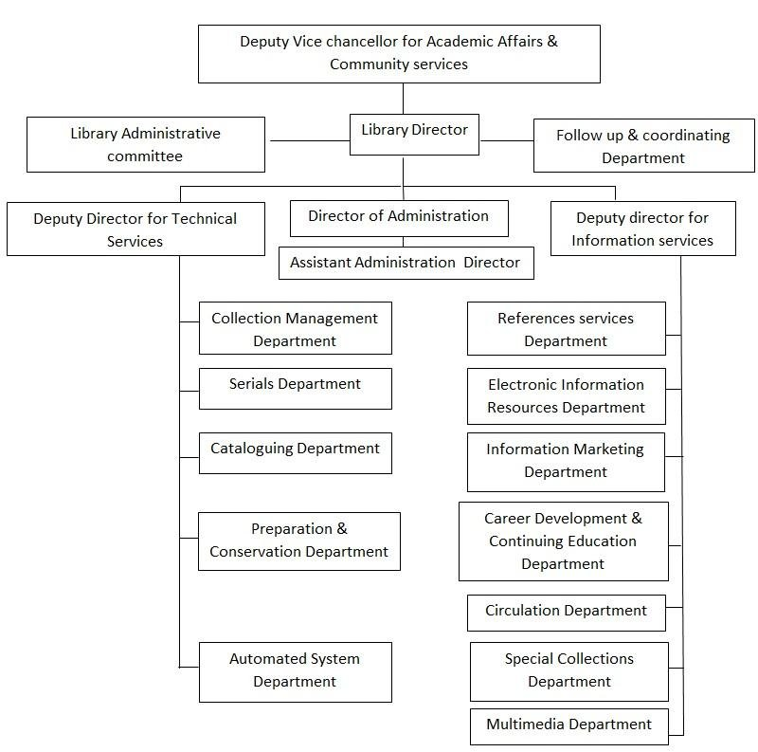
2.6 Division /section
- Technical services
- Readers services
- Electronic support services
2.6.1 Technical services department
They carry out technical activities in the library. It is headed by a deputy university librarian as technical services librarian. The division comprises acquisition, cataloging and classification section, serial and bindery units. The primary responsibility of the division is to coordinate activities taken place in the section.
- Acquisition section: The section is saddled with the responsibility of selection and acquisition of selected material for the university in all formats including digital items and maintaining the necessary records related to acquisitions. The collection development policy of the university is paramount in determining the relevance and quality of material to be acquired. This section requires the processing of information materials before they are made available to users. The acquisition section has various identification stamp used on different information materials. They are the donation stamp, edge stamp, security stamp, accession stamp, purchase stamp, spine stamp, and cancelled stamp.
Information materials are acquired in the library either through purchase, donation or gift.
Routines performed in the acquisition section.
- Collection development i.e. procurement of books through purchase donations, gifts and endowment.
- Keeping records of books purchased.
- Verification of books on order.
- Accessioning and stamping of books purchased.
- Facilitating books purchases between library clientele and publishers for personal use.
- Preparation of list of new arrivals (books).
- Sending orders to vendors.
- Harvesting books selected by department.
- Dispatch books to cataloguing and classification section.
- Receiving gifts and donation from individuals and corporate bodies.
- Cataloging and classification section: this section was directed by ALH T.O AFOLABI. This section involves the process of creating and maintaining bibliographic and authority records of books, serials, recordings (audio and video), cartographic materials which are the properties of Olusegun Oke Library. They adopted an electronic mode of catalog leveraging on online public access catalogue (OPAC). This is the engine room of any library. They provide bibliographical information of materials and materials are assigned subject, location, and class mark referred to as classification.
Classification section: they simply identifies the subject of a new material (subject cataloging) after receiving them from the acquisition section and assigning the classification number to the material. It uses the library of Congress subject heading and after the subject has been determined, it direct the cataloguer to the schedule, after which the location of the material has been determined, then the cutter table will be used to cut the author's name and differentiate a material that has same subject title from one another.
The materials used in classifying materials include,
- Subject heading.
- Schedule.
- Cutter table.
Cataloging section: describes the content of a document on a 3×5 card referred to as descriptive cataloguing. Using the author's name, publishers, pagination note area, subject, accession number and location mark are made available before classification is done for easy retrieval and use. They make use of the library of Congress schemes and the type of cataloging are as follows:
- Descriptive cataloguing
- Subject cataloging
- Cataloguing in publications
- Online cataloging.
Descriptive cataloguing: this can be single entry, double entry, multiple entry, cooperate bodies, edited material, etc. It is the description of an information material on the catalogue card by providing the bibliographic details of the material. The name of the author or title are mostly used as the assess point here.
Subject cataloguing: it focus on the subject content of the material. This content can be gotten from the book back page, introduction page, preface, or the content page, before the subject can be determined.
Cataloging in publication: this is when a book has already been classified and catalogued from publication. And it can be found on the verso page of the material. You only have to transfer the information on the catalogue card.
Online cataloguing: this is the process of transferring the information on the catalogue card to the library software (KOHA).
Routines performed in the catalogue and classification section.
- Catalogue library materials.
- Classify library materials.
- Manually and electronically create and maintain records of the library holdings.
- Label library materials.
- Move the processed library materials to their designated sections. E.g. (circulation, reference, and serial sections).
- Serial section: This section is responsible for keeping new materials that come at regular intervals, which includes; newspapers, journals or periodicals, government annual reports, newsletters, gazette, e.t.c. the catalogue, classify, and make serial materials available to library users. They acquire both local and foreign journals. They take daily statistics of student that make use of the materials both in the morning and in the afternoon. They catalogue and classify their materials before displaying on the shelves for users to have access to them.
Routines of the serial section.
- Procurement of journals, newspapers and magazines through subscription or donations.
- Processing of serial for the use of the clientele
- Arrangements of serial on the shelves
- Making serials available to users on demand.
- Keeping statistics and generate reports of users of serials.
- Displaying current serials.
- Providing current awareness services.
- Recording of daily newspaper.
- Record materials acquired by the library.
- Weeding and recording of obsolete materials from the shelve.
d. Bindery section: a specialized services that focused on general book binding for the library, cutting of the catalogue cards, lamination of papers and documents like certificates and identity cards for the individuals within the polytechnic and beyond.
Routines of the bindery section.
- General book binding for the library, other departments and offices of the university, institute and individuals of the university community and outside.
- Cutting of the catalogue cards for the library and it's clientele use.
- Training of students of library and information science on industrial training (IT) under the SIWES programme to update their practical knowledge in the area of book binding and preservation.
- Lamination of papers and documents like certificate and identify cards for the individuals within the university communities and beyond.
- Mend torn library books and journals.
2.6.2 Readers services division
This division establishes direct contact with the library users. It takes custody of materials that have been processed in the technical service division and makes them available to users in an organized and controlled system. The division coordinates the activities of the sections under it. The sections include circulation section, document section, reference section, and thesis and dissertations section.
- Circulation section: this is one of the public relations section of the library. The head of the section is usually circulation librarian. It processes the registration of new library users, charge and discharging of books out to users. Circulation staff also prepares library bills for damaged, long overdue, or lost materials. They are often responsible for shelving new and returned materials as they frequently provide lost and found services.
Routines of the circulation section.
- Register new library users.
- Charge books out to users.
- Discharge returned books.
- Keeps statistics and generate reports of library users and library materials consulted.
- Display and shelf new books.
- Reshelf used books.
- Consult shelve reading.
- Maintain books on the open shelves.
- Maintain books on reserved and other closed access shelves and keep statistics of usage.
- Shelving of new materials.
- Allocation of carrels to users.
- Handling reserve materials.
- Answering users queries.
- Reference section: this is headed by a reference librarian. The materials are meant for consultation only and are therefore not to be borrowed or taken out of the library. This is also public relations section of the library. Books are freely available on the shelves for consultation and books consulted are to be left on the table for statistical purposes. They are also responsible for reference and referral services. They perform interlibrary loan and lending on behalf of the library. The houses reference materials such as encyclopedia, Dictionaries, biographies, gazette, gazetteers, maps, handbooks, index, almanac, abstract, atlas, etc.
Routines
- Provides answers to reference queries.
- Maintain reference collections on closed shelves.
- Provides answers to directional and non-directional queries.
- Processes inter library requests.
- Teaches clientele how to use special reference materials.
- Maintains statistical and generates reports of reference materials consulted.
- Shelving and shelve reading of reference materials.
- Carrying out interlibrary loan on behalf of the library.
2.6.3 Electronic support service division.
They ensure that all manually handled library services are carried out electronically. It oversees three section namely; automation section, electronic library, and digital library section.
- Automation section: it ensures that all activities that are handled manually should be done on the computer system. This is done to enhance easy retrieval of information and organization of the information materials.
Routine of the automation section.
- they ensures that bibliographic details of all library materials and information about the patrons of the library are carefully uploaded unto the library server by the circulation and technical section of the library.
- They handle all technical challenges that may crop up while inputting bibliographic details of the library into the server.
- Attend to challenges resulting from system upgrading and also maintains server operation.
- They also ensure that the internet connectivity of the library are in order.
- It also serve as the manual way of keeping the library data.
- Digital library section: this section enables users to have access to the institutional repository of the library. It is responsible for the retrospective conversion of library materials to digital format. The make use of the digital machine, computer, ups, etc
Routines of the digital library section.
- This section is responsible for creating, developing and maintaining the institutional repository system, which contains the intellectual properties of the university.
- It is an open access system, which staff and student can access for research, teaching and learning.
- Digitization of both thesis and dissertations
- Uploading of publication of each department on the institutional repository.
- Electronic library: this section directly assists students and staff to use the computer facilities to access the internet, provide wireless internet services and provides access to the subscribed and free databases of the library for their research.
Routines of the electronic library.
- This section develops and implements library programmes for students and staff on the search for qualitative academic e-journal and e-books from the e-library.
- Online dissemination of current resources acquired.
- Retrospective conversion.
- Provision of selective dissemination of information.
- Maintenance and repairs of electronic gadgets.
- Provides on hand training for students on SIWES program.

Chapter three
Description of work done and experience gained.
During my SIWES, I was introduced to various departments, section and staff of the Olusegun Oke Library. I was exposed to the opening hours of the library, the divisions and sections under each divisions. I was also put through on how the library carries out their functions such as user registration, discharging of books, stamping of books, etc. I was posted to the following sections in Olusegun Oke Library.
- Circulation section: I was exposed to how library materials are shelved and re-shelved, how library materials are discharged, how borrowers slip is being filed until the user has returned the borrowed items. The borrowers slip contains three copies which is white and pink. The white is filled according to the accession number of the book, pink according to borrower’s number. The pink copy is the users copy. We were also introduced to the book bank where newly materials and processed materials are kept before shelving. It also contains up to date materials and are used during accreditation.
Experience gained
- I was taught the Charging and discharging of library materials.
- I took part in the Library statistics done at regular intervals of 4 hours, at 10 am and 1 pm.
- Shelving and shelf reading of library materials on daily basis.
- I engaged in the arrangements of newly acquired library materials on the shelf
- Registering of new library users who wants to make use of the information materials in the library.
- I received processed materials from the cataloging and classification section.
- I weeded out dated materials as well as torn materials.
- I engaged in recording of books that are recieved from the catalogue and classification section.
Acquisition section: I was put through on how library materials are acquired. They acquire books, serial materials, newspapers, magazines and non-books. Acquisition is done by the polytechnic management and TETFUND. Acquisition is done by purchase or donation. TETFUND materials are purchased by TETFUND, and the polytechnic committee's also pay for materials being purchased by the polytechnic Stamping and accessioning of library materials is also done by the acquisition section. The stamp used in this section is of 6 as shown and explained in the above diagram. As well as a sample of accessioning register. Accessioning is done by following the previous number in the accession register. I.e. 097962-03 the next number will be 097964- followed by the number of copies of the material acquired by the university. They ensure books bear the necessary stamp before they are moved to the shelf. The register is used to keep information of books as shown below. 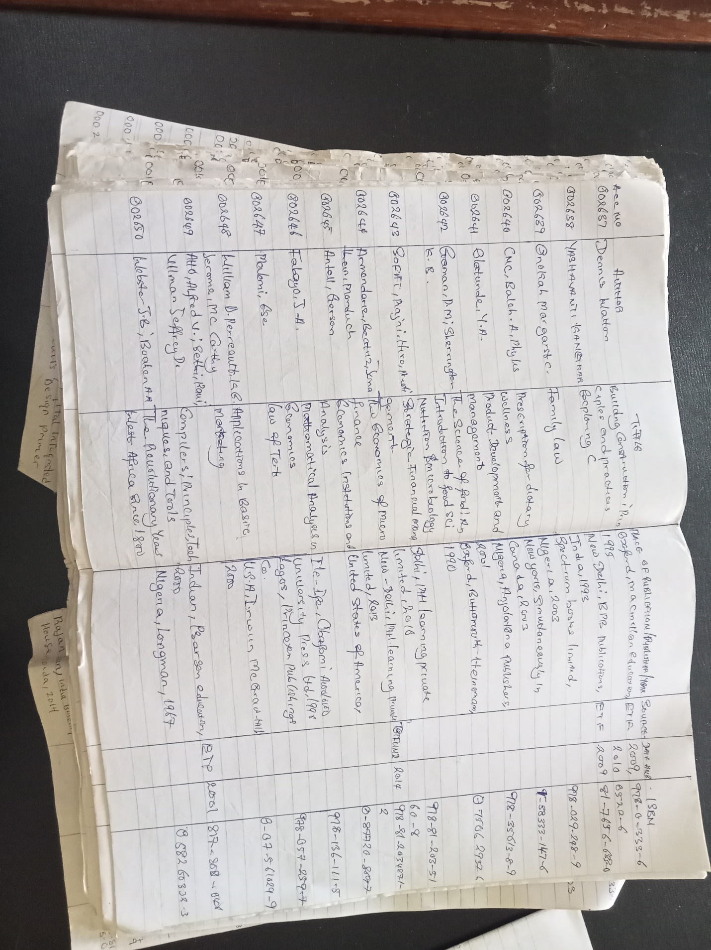Experience gained
- I have learnt the different stamps and their uses.
- I now know how to use the accessioning register to keep bibliographic details of acquired materials.
- The selection of library materials and evaluation is done here.
- Different approaches are used to acquire different materials such as serial materials which is acquired through subscription, books through purchase or donation, etc.
- I administer accession number to newly acquired books.
- Dispatching of processed material to the cataloguing and classification section for further processing.
- Cataloguing and classification section: I was taught on how to catalogue and classify library materials. We were put through on how to describe library materials on the catalogue cards in order for easy retrieval. The University use the library of Congress classification scheme to classify materials and the AACR2 to describe the library materials. Library of Congress (LC), divide knowledge into the 25 alphabets, (a-z) excluding I,O,X,W and Y for future expansion. Catalogue provides the physical description of library materials which is prepared in the following entry: main/author entry, subject or title entry. Example of a card catalogue is shown below.

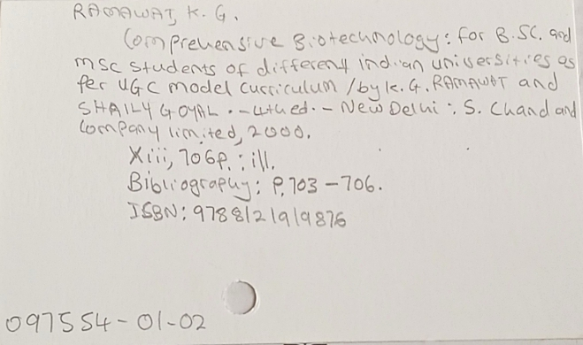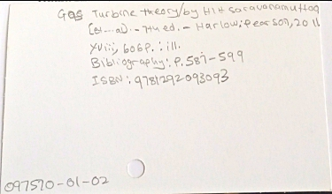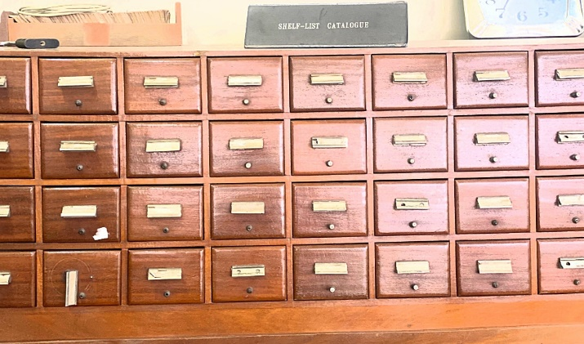
Experience gained
- Classify materials using LC.
- Cataloguing of library materials on the catalogue card.
- Use the AACR2 to describe materials in order of name of author, place of publication, year of publication, etc. for easy retrieval of information materials.
- I engaged in online cataloguing of library materials using the library integrated software KOHA. It is used to input the information on a catalogue card to the online public access catalogue OPAC.
- The different types of catalogue such as descriptive catalogue, subject catalogue and online catalogue practical are learnt in this section.
5. Serial section: I was introduced to the activities carried out in this section. I was taught on how to record newspapers, stamping, stapling, and dispatching of newspaper to the required places. I learnt the different between journal and books as well as the type of journals we have which can either be local or foreign journals. Serials are issued in successive part and are also in volumes. The local journals include; Nigeria journal of social work education, Nigeria journals of clinical and counseling psychology. While the foreign journals include; Canadian journal of economics, senri ethnological studies, etc. .
Experience gained
- Journals are assigned ISSN and are always in volumes. Such as Nigeria journal of clinical and counseling psychology (ISSN : 1118-4035) (vol. 26, may 2018).
- Stamping the necessary pages on the journals.
- Recording of newspaper and other journals.
- Materials here can only be consulted in the library and cannot be loaned out.
- Statistics of users who consult the materials are taken.
6. E- library: I was introduced to the databases that are available in the library which are of two categories, subscribed and non-subscribed databases. I learned how to catalogue inline using the library software KOHA. The operations and activities carried out in this section is to support the patron in order to have free access to any information via the internet. I also have a deep understand on the different between automation and digitization. The subscribed databases are PROQUEST, JSTOR, and the non-subscribed databases are AGORA, HINARI, JSTOR, OARE.
experience gained
- The difference between automation and digitization.
- The difference between subscribed and non-subscribed databases.
- How to assist student search for needed information using that subscribed and non-subscribed databases.

Chapter four
- Equipment used and the details of their usage
- Computers: computers are used for easy accessing of information and are used to enter the information on the card catalogue to the library software Computers can be use in a Library to keep records of books and number of books that are available in the book stalk. It is used to access the databases of the library.
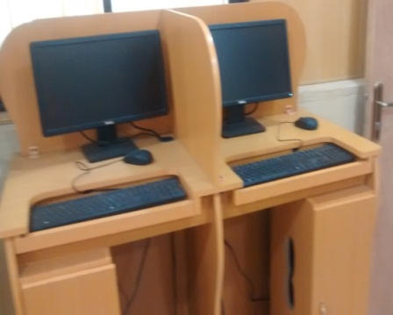
- Card catalogue cabinet: This is used to keep the catalogue cards which entails the details of all the material that has been processed in the library.
- Ups: It is used in the library because of power failure. It enables the operator to save documents before the computer system shut down to avoid loose of data and effort.
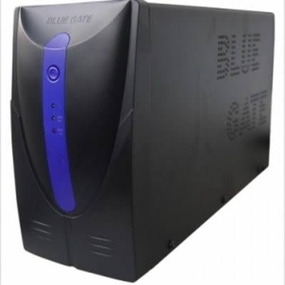

- Library shelf's: This allows the material to be arranged properly in order for easy access by the users and the library staffs.
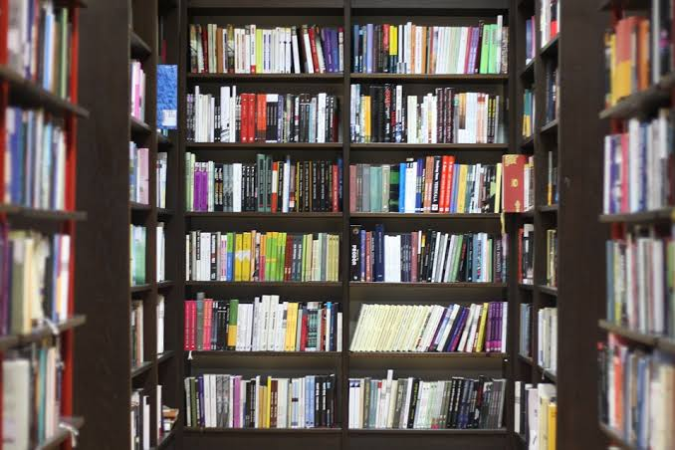
- 3 by 5 Card: this is the card used when cataloguing a book and it is used in cataloguing section by writing the descriptive details of a material in an orderly manner for easy access. After been used to catalogue the material they are kept in a drawer for record use.
- Book End: it used between books to ensure they are well arranged by putting one at the beginning and other at the end of the book on the shelf.
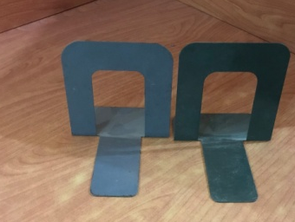
- Stamps: they are used on the information materials that are aquired in the library. It comprises of different stamp such as the date stamp, Security stamp, Edge stamp, identification stamp, Gift stamp, accession stamp and Ownership stamp, stamped on the information material. Accession stamp is for inserting the accession number, Edge stamp display library name and it is stamped on the edge of book, Ownership is to display the means of acquiring the material and Gift stamp is used when the material are donated to the library so the name of the donor can be written on it.
- Library of Congress subject heading and schedule: it list knowledge in an alphabetical order a-z. It is a comprehensive list of all the terms used by the library of congress to describe materials in their collections. It is used at cataloguing and classification section of the library to determine the subject and classify the library materials.
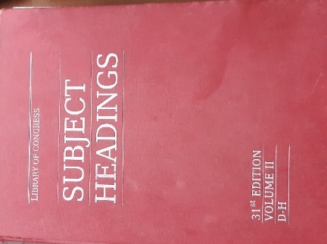

- Cutter table: it is used to determine the author name after a book has been catalogued and classified.

Chapter five
Summary, conclusion and recommendation
5.1 summary
In the course of my attachment at Olusegun Oke Library, I have been taught on how to shelve, re-shelve, catalogue, discharge, acquire, stamping, etc. of library materials. During my course of learning, I observed that the class lectures are theory and are not complete without the SIWES training. There is need to balance the scale between the school system, and the industry in raising the technical literature of the students. I have gained a profound knowledge, practical skills, and understanding partaking to my profession.
5.2 Conclusion
This report covers the experience gathered during the students’ industrial work experience scheme SIWES programme held at Olusegun Oke Library popularly known as LAUTECH Library. I learnt the basic practical and theoretical knowledge that I may not have gotten from the lecture room. It also gives me a feel of what it would be like after graduation, when I start working in a library organization. It is therefore an understatement to conclude that SIWES is of great benefit to students of tertiary institutions. Proper and effective administration of the scheme will go a long way in boosting and enhancing the competencies of the work force of the country.
5.3 Recommendations
Base on my experience during the four months SIWES training, I hereby recommend the following;
- There should be alternative power supply in the library so as to not hinder the study of the student currently studying in the library.
- Experienced staff should be assigned to the students.
- The SIWES coordinator should provide Scheme of what the organization are to teach the students.
- The bindery section should be provided for to enhance the protection of materials.
- There should be proper maintenance of the ICT facilities and training of staff and also back up of data for further use.
- The SIWES officials should invigilate the students at their respective place of attachment to ensure discipline.
- Organization should accept student in order to gain the expected experience.
- Materials should be processed, checked, and dispatched immediately to ensure that the materials are available on the shelf at the needed time.

