

TECHNICAL REPORT
ON
STUDENT INDUSTRIAL WORK EXPERIENCE SCHEME (SIWES)

HELD AT
BALOGUN GAMBARI MICROFINANCE BANK LTD.
NO, 1 OJAGBORO, ILORIN, KWARA STATE

PRESENTED BY
ADEYANJU MARIAM MAYOWA
ND/23/BFN/FT/0021

SUBMITTED TO
DEPARTMENT OF BANKING AND FINANCE,
INSTITUTE OF FINANCE AND MANAGEMENT STUDIES
KWARA STATE POLYTECHNIC, ILORIN

IN PARTIAL FULFILLMENT OF THE AWARD OF NATIONAL DIPLOMA (ND) IN BANKING AND FINANCE
AUGUST – DECEMBER 2024
TABLE OF CONTENT
Title page
Dedication
Acknowledgement
Abstract
CHAPTER 1: INTRODUCTION
1.1 Student Industrial Work Experience Scheme
1.2 Aim of the Study
1.3 The Role of the Industrial Training Fund
1.4 The Scope and Importance of SIWES
1.5 The Role of the Student and the Institution
CHAPTER 2: DESCRIPTION OF WORKPLACE
2.1 Overview of Balogun Gambari Microfinance Bank
2.2 Corporate Information and Track Record
2.3 Background and Establishment
2.4 Organizational Structure and Services
2.5 Vision and Mission of SIWES BGM Bank
CHAPTER 3: SIWES ACTIVITIES AND EXPERIENCE GAINED
3.1 Practical Experience at Balogun Gambari Microfinance Bank
3.2 Challenges Encountered

CHAPTER 4: SUMMARY, CONCLUSION, AND RECOMMENDATIONS
4.1 Summary
4.2 Conclusion
4.3 Recommendations

DEDICATION
This work is dedicated to the Almighty God, for their love, mercies, guidance and protection during and even after this work.
This work is also dedicated to my lovely and caring parents and wonderful brothers and sisters for their love, support and encouragement.

ACKNOWLEDGEMENT
I wish to acknowledge and thank everyone who contributed one way or the other towards the success of my industrial training.
My special thanks goes to the management of and my supervisor for their numerous contribution and effort to make this research a success.
Also my beloved mother and my colleagues for giving me the great opportunity.
I want to say a big thanks to my siblings and my friends for their support and love also my friends for their encouragement and advice.

ABSTRACT
This report presents a comprehensive account of my six-month industrial training under the Student Industrial Work Experience Scheme (SIWES) at Balogun Gambari Microfinance Bank Limited. The report begins by outlining the historical background, objectives, and significance of SIWES, highlighting its role in bridging the gap between academic theories and practical industrial skills. An in-depth description of Balogun Gambari Microfinance Bank is provided, detailing its corporate profile, organizational structure, and the range of financial services it offers, including loans, savings, electronic banking, and deposit services. During the placement, I gained hands-on experience in key areas such as customer verification, credit appraisal, loan processing, disbursement, and monitoring. The report also addresses the challenges encountered during the training and concludes with recommendations for both educational institutions and the host organization to enhance the overall effectiveness of the SIWES program. This experience has not only enriched my practical skills in the financial sector but also affirmed the critical role of microfinance institutions in promoting financial inclusion and economic empowerment.
CHAPTER 1
1.1 STUDENT INDUSTRIAL WORK EXPERIENCE SCHEME
The Students Industrial Work Experience Scheme (SIWES), is a skills Development programme initiated by the Industrial Training Fund (ITF), in 1973 to bridge the gap between theory and practice among students of Engineering and technology in Institutions of Higher Learning in Nigeria. It provides for on-the-job practical experience for students as they are exposed to work methods and techniques in handling equipment and machinery that may not be available in their Institutions.
SIWES was established by ITF in 1973 to solve the problem of lack of adequate practical skills preparatory for employment in industries by Nigerian graduates of tertiary institutions.
The Scheme exposes students to industry based skills necessary for a smooth transition from the classroom to the world of work. It affords students of tertiary institutions the opportunity of being familiarized and exposed to the needed experience in handling machinery and equipment which are usually not available in the educational institutions.
Participation in SIWES has become a necessary pre-condition for the award of Diploma and Degree certificates in specific disciplines in most institutions of higher learning in the country, in accordance with the education policy of government.
Duration – Four months for the Polytechnics.
1.2 AIM OF THE STUDY
The Student Industrial Work Experience Scheme (SIWES) plays a crucial role in bridging the gap between theoretical knowledge acquired in the classroom and the practical demands of the modern workplace. It allows students to immerse themselves in real-world environments, applying their academic learnings to real-life situations.
Practical Application: SIWES provides a platform for students to apply the theoretical concepts they have learned in their academic programs to real-world scenarios. This hands-on experience solidifies their understanding and helps them develop a deeper appreciation for the practical implications of their studies.
Industry Exposure: Through SIWES, students gain valuable exposure to modern technology, tools, and industry processes. They get to witness firsthand how their field of study is applied in the real world, gaining insights into the latest trends and advancements.
Skill Enhancement: SIWES is instrumental in enhancing students' practical skills and preparing them for the challenges of the modern job market. It allows them to develop essential skills such as problem-solving, teamwork, communication, and time management, all of which are highly valued by employers.
IMPORTANCE OF SIWES:
Industry-Academia Collaboration: SIWES fosters a strong relationship between educational institutions, employers, and the Industrial Training Fund (ITF). This collaboration ensures that academic programs are aligned with industry needs, and that students are equipped with the skills and knowledge required by the workforce.
Professional Development: SIWES equips students with practical knowledge and skills that are essential for their professional development. This real-world experience helps them gain confidence, build their resumes, and become more competitive in the job market.
Real-Life Experience: SIWES provides a platform for students to gain valuable real-life experience before entering the workforce. This experience allows them to test their skills, explore different career paths, and gain a better understanding of the industry they are pursuing.
1.3 THE ROLE OF THE INDUSTRIAL TRAINING FUND
The Industrial Training Fund (ITF) was established by the decree 47 of 1971 constitution and charged with the responsibility of promoting and encouraging the acquisition of industrial skills, with the view of generating a collection of indigenous trained manpower, sufficient enough to enhance and meet the needs of the economy so as to promote development. Supervision of students, organizing orientation programs, and disbursing allowances to students are some of the roles played by the industrial training fund in the implementation of SIWES.
1.4 THE SCOPE AND IMPORTANCE OF SIWES
The scheme covers all science and technological based students in monotechnics, polytechnics and universities in Nigeria, resulting in a high population of students which is easily managed because of the public and private industries that partake in the scheme. SIWES enables students acquire industrial know-how in their field of study particularly in technological based courses. It also enables students experience the application of theoretical knowledge in solving real life problems.
1.5 THE ROLE OF THE STUDENT AND THE INSTITUTION
The role of the student is to partake in the program in such a way that he/she will achieve maximum benefit from the program. The student is advised to ask questions, be submissive, and adhere to all the rules and regulations of the organization where he is attached. Identification of placement opportunities, funding of SIWES supervisors and assessment of the student are some of the roles played by the institutions to ensure smooth running of the program.

CHAPTER 2: DESCRIPTION OF WORKPLACE
2.1 OVERVIEW OF BALOGUN GAMBARI MICROFINANCE BANK
Balogun Gambari Microfinance Bank Limited is a licensed Microfinance Bank under the supervision of the Central Bank of Nigeria (CBN). The bank provides an array of financial services including loans, savings, electronic banking, and deposit services. It is strategically focused on serving Small and Medium Scale Enterprises (SMEs), traders, farmers, the underserved, and those seeking high returns on investment.

2.2 CORPORATE INFORMATION AND TRACK RECORD
Licensing and Regulatory Framework: Licensed by the CBN, the bank adheres to the statutory requirements for microfinance institutions in Nigeria.
Business & Financial Track Record: Established as one of the oldest microfinance institutions in Ilorin, the bank is widely recognized as one of the fastest growing in Nigeria. Since its incorporation and licensing in 2007, it has built a strong reputation, recruiting and training over 150 staff and enrolling more than 40,000 microcredit women in Ilorin.
Customer Base: The bank’s diverse customer portfolio includes micro, small, and medium-scale enterprises, various groups, and salary earners, all contributing to a healthy and expanding financial portfolio.

2.3 BACKGROUND AND ESTABLISHMENT

Balogun Gambari Microfinance Bank was initially established by key community stakeholders from Gambari, Ibagun, and Zango Ward 1 to meet the banking needs of the local community.
Inception: The bank commenced operations on June 28, 1994, at its registered office located at 1 Ojagboro Junction, Balogun Gambari Road, Ilorin.
Evolution: Following a successful recapitalization in 2008, the bank transitioned from a community bank to Balogun Gambari Microfinance Bank, aligning its operations to meet the statutory capital requirements while continuing to serve its immediate community and beyond.
Core Focus: The bank is dedicated to promoting a savings habit among the active poor—customers often underserved by conventional banks—and focuses on offering financial services to traders, farmers, and SMEs.

2.4 ORGANIZATIONAL STRUCTURE AND SERVICES

Balogun Gambari Microfinance Bank is managed by an active board comprising professionals from banking, insurance, law, public service, and entrepreneurship. This board brings strong competencies to the bank’s management and operations.
Key Services Offered:
Loans: Tailored for various segments including microcredit, SME financing, and specialized loan products.
Savings & Deposits: Designed to encourage a savings culture among the underserved.
Electronic Banking: Providing modern, digital solutions to enhance customer convenience.
Financial Advisory: Guidance on maximizing returns on investments and managing finances effectively.

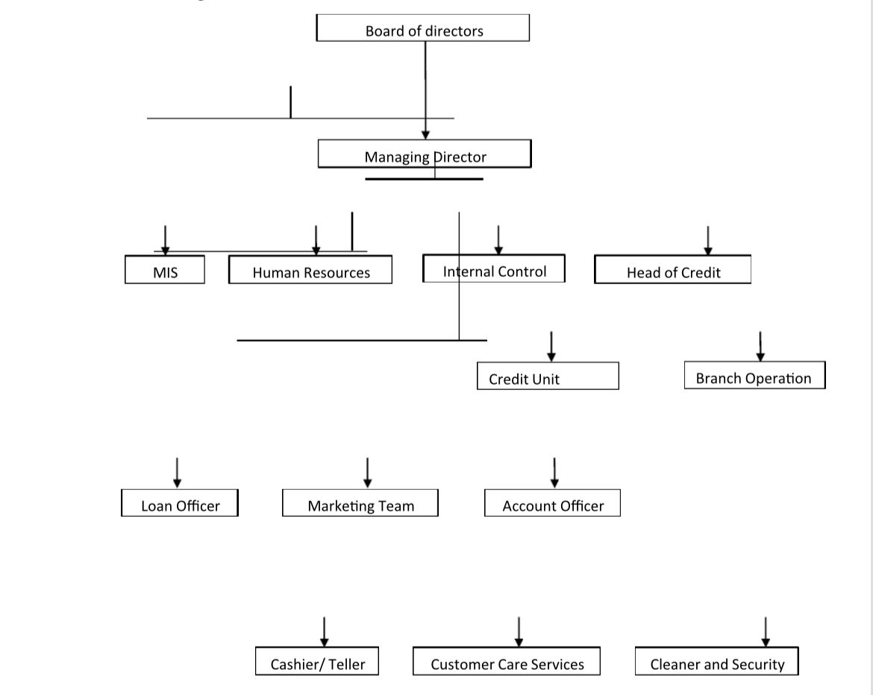

2.5 VISION AND MISSION OF SIWES BGM BANK
Vision
To be the leading Microfinance service provider in Nigeria
Mission
To create a better and thriving financial inclusiveness among the low income group, through provision and access to financial services, while adding value to stakeholders

CHAPTER 3: SIWES ACTIVITIES AND EXPERIENCE GAINED
3.1 PRACTICAL EXPERIENCE AT BALOGUN GAMBARI MICROFINANCE BANK
During my three-month SIWES placement at Balogun Gambari Microfinance Bank, I was exposed to a wide range of activities that provided deep insights into microfinance operations. my practical experiences included:
Customer Onboarding and Verification: Engaging with clients to verify their identities using relevant documentation (such as national IDs, voter cards, and utility bills) in accordance with Know Your Customer (KYC) protocols.
Loan Processing and Appraisal: Participating in the appraisal of loan applications by analyzing customer backgrounds, assessing creditworthiness, and understanding the specific financial needs of micro, small, and medium-scale enterprises.
Account Management: Assisting in the creation and management of customer accounts, including setting up savings, deposit, and loan accounts using the bank’s electronic banking platform.
Disbursement and Monitoring: Learning the procedures for loan disbursement, which included generating repayment plans, executing fund transfers, and monitoring the utilization of disbursed loans to ensure compliance with the intended purpose.
Customer Relationship Management: Observing the bank’s emphasis on nurturing long-term relationships with clients, particularly through personalized advisory services and targeted financial products tailored to the unique needs of the underserved.

3.2 CHALLENGES ENCOUNTERED
My experience also revealed several challenges inherent in the microfinance environment:
Resource Constraints: At times, limited staffing and heavy administrative workloads necessitated that interns take on responsibilities comparable to full-time employees.
Technology Integration: While the bank is progressively adopting electronic systems, some legacy processes still require manual intervention, adding to the administrative burden.
Client Diversity: Serving a broad spectrum of customers—from microcredit women to SMEs—demanded a versatile approach and continual learning to address varied financial needs effectively.

CHAPTER 4: SUMMARY, CONCLUSION, AND RECOMMENDATIONS
4.1 SUMMARY
The SIWES placement at Balogun Gambari Microfinance Bank provided me with an in-depth exposure to microfinance operations. Through active participation in customer onboarding, loan processing, and account management, I gained valuable practical skills that complemented my academic training. The experience underscored the importance of robust financial systems and personalized customer service in driving the success of microfinance institutions.Digital Environment.
4.2 CONCLUSION
My time at Balogun Gambari Microfinance Bank has been both enriching and transformative. The exposure to real-world financial operations has significantly enhanced my understanding of microfinance, confirming my interest in pursuing a career in this dynamic field. The practical skills acquired—ranging from customer verification to loan monitoring—are invaluable assets that will support my future professional endeavors.
4.3 RECOMMENDATIONS
Based on my experience, I propose the following recommendations to further enhance the SIWES program and the operations of Balogun Gambari Microfinance Bank:
For Educational Institutions:
- Enhanced Orientation: Conduct thorough pre-placement orientations to familiarize students with industry expectations and administrative protocols.
- Structured Supervision: Ensure regular monitoring by faculty representatives to provide feedback and support to interns.
For Host Organizations (Balogun Gambari Microfinance Bank):
- Investment in Technology: Accelerate the adoption of digital systems to streamline processes and reduce administrative burdens.
- Capacity Building: Increase staff training initiatives to empower interns and employees with up-to-date skills and industry best practices.
- Strengthen Client Engagement: Enhance customer relationship management strategies to tailor services better and build long-term trust, especially among underserved segments.

