CHAPTER TWO

2.0 BAMBOO FIBRE

2.1 TREATMENTS
Alkali treatment is often applied to change the composition of fibers. Sodium Hydroxide (NaOH) is a common alkali that is used to dissolve the hydroxyl (OH) groups and the closely packed crystalline composition to generate new types of amorphous system structures. It also eliminates fiber components such as hemicelluloses, lignin, waxes, and oils, which enhance the surface harshness of the fiber [P.R.L. Lima, H.M. Santos, G.P. Camilloto, R.S. Cruz, 2017]. Furthermore, the alkali treatment enhances the surface area of the fiber, which facilitates fiber adhesion and interlocking with the blends, causing improved composite strength qualities.
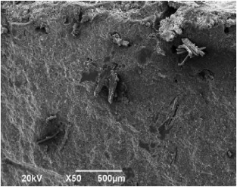
The cement containing 0.5% untreated bamboo fibers displays a collection of distinct strands as shown in Fig. 2, Strong hydrogen bonds between the fibers, which prevent individual fiber dispersion, should be to blame for this. Fibers distributed unevenly would result in surface and bulk defects. The mortar specimens' fracture strength would decrease because of the stress intensity at these faults, which would speed up crack transmission [K. Ghavami, 2005]. The research found that the treatments enhanced the fiber's chemical characteristics, allowing the fiber to better cling to the hydrophobic features of the matrix.

Fig. 2. Fracture surface with 5% untreated bamboo fibers [
M. Li, S. Zhou, X. Guo, 2017].
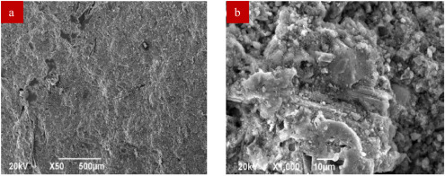
The bamboo fibers have been evenly and finely dispersed throughout the cement as can be seen in Fig. 3a. The mechanical characteristics of the fiber-reinforced mortar would be enhanced by uniformly dispersing treated bamboo fibers to prevent fracture growth. Fig. 3b shows the cement's larger broken surfaces made of bamboo fibers that have been treated with alkali. The treated bamboo fibers are tightly encased in the cement matrix, distributed uniformly throughout the cement matrix without noticeable phase interfaces, and aggregated on the fracture surface. This shows that the bamboo fibers treated with alkali and the cement matrix have stronger adherence. This may be explained by cement precipitating into fiber cavities with a fibril-exposed surface and by an interfacial link forming between the calcium-based cement's hydrated product and the cellulose chains of natural fibers. An hour was spent studying fibers that had been exposed to an alkali solution (5% weight/volume NaOH). The Century fibers ' chemical, mechanical, and physical characteristics were examined and compared (untreated). Results revealed that the elimination of excess amorphous elements by the NaOH treatment increased the surface roughness and crystallinity with a reduction in diameter [K.O. Reddy, K.R.N. Reddy, J. Zhang, J. Zhang, A. VaradaRajulu, 2013]. In research comparing treated and untreated bamboo fibers, it was discovered that the alkali-treated fiber had lost several functional groups including cellulose, hemicellulose, and lignin [M.K. Bin Bakri, E. Jayamani, 2016]. Surplus amorphous components are removed from the Dracaena reflex fiber as a consequence of alkali treatment, and treated fiber has more infrared penetration than untreated fiber [A. Vinod, M.R. Sanjay, S. Suchart, P. Jyotishkumar, 2020].

Fig. 3. Fracture surface with 5% treated bamboo fibers (a) low magnification and (b) high magnification[ M. Li, S. Zhou, X. Guo, 2017].
Additionally, Fig. 3b shows a high incidence of pulled-out treated bamboo fibers that are embedded, and some voids caused by pulled-out treated bamboo fibers that were still adhered to the fracture surface. This suggests that the high length/diameter ratio of alkali-treated bamboo fibers may boost pull-out resistance from cement matrix, increasing energy absorption and dissipation during fracture. Delaying the development and spread of microcracks benefits the cementitious matrix's refinement and enhancement of toughness while preserving greater stiffness because of efficient stress transmission from the brittle matrix to the resilient bamboo fibers.
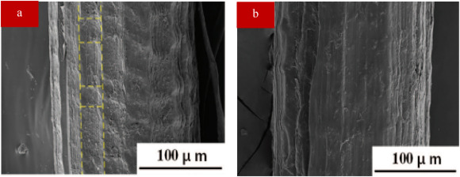
Silane coupling treatment is a useful technique for enhancing the interfacial adhesion between resin and fibers in composites. The term “silane treatment” often refers to a surface treatment that uses a silane coupling agent as a chemical bonding aid to join inorganic and organic materials. Silane treatment is soaking bamboo fibers in a solution of the coupling agent silane. This procedure strengthens the link between the two materials by forming a covalent bond between the fibers and cement matrix. Fig. 4 displays SEM images of bamboo fibers that have been untreated and treated (5% silane). Untreated bamboo fibers are made up of a dense assembly of many fibrils, as shown in Fig. 4a. On the surface, vertical and transverse lines are visible. The surface of the pit, which is encircled by cross sections and vertical lines, is covered with amorphous impurities. After a 5% silane treatment, a thin, uniform coating that covers surface imperfections is seen on the fiber surface (Fig. 4c and d). In certain ways, the film is thought to be the result of siloxane deposition. Additionally, the researchers noted that the silane surface treatment had a positive impact on interfacial bonding and stress transfer between the fiber and matrix, leading to an improvement in mechanical characteristics [
S. Maruyama, H. Takagi, A.N. Nakagaito, 2019].

Fig. 4. (a) Untreated and (b) treated (5% silane) [Q. Wang, Y. Zhang, W. Liang, J. Wang, Y. Chen, 2020].
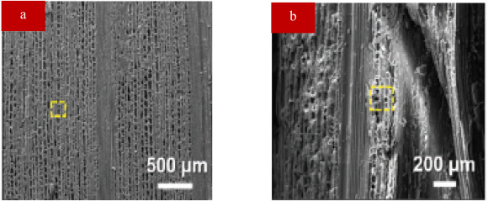
Bamboo fibers are heated to a certain temperature range for a predetermined period during the heat treatment procedure. The bamboo fiber's chemical and physical characteristics are changed throughout the heat treatment process, which enhances its dimensional stability, strength, and durability. Saturated steam heat treatment, which is said to be more cost-effective and environmentally friendly than conventional techniques, is receiving more and more attention in recent years. Besides, mild saturated steam heat treatment has been demonstrated to successfully enhance the physical and mechanical characteristics of bamboo-based materials [L. Song, H. Ren, X. Wang, J. Ma, Y. Li, Y. Li, B. Xu, 2018]. A researcher [X. Han, Z. Lou, C. Yuan, X. Wu, J. Liu, F. Weng, Y. Li, 2022] studied the effects of heating bamboo fibers in two steps with saturated steam (the second heat treatment temperature was 140 °C, 150 °C, and 160 °C, and the second heat treatment temperature was 140 °C, 150 °C, and 160 °C, and the second heat treatment temperature was 1, 2, and 3 h, respectively). The SEM (Fig. 5) findings show that heat-treated samples have smoother parenchyma cell edges and thinner cell walls. The heat treatment also makes the cellulose in the fibers more crystalline, which improves the fiber's stiffness and strength. Additionally, the treatment eliminates the fiber's inherent sugars and starches, making them less vulnerable to insect and fungus attacks.

Fig. 5. (a) Untreated and heattreated bamboo fibers [X. Han, Z. Lou, C. Yuan, X. Wu, J. Liu, F. Weng, Y. Li, 2022].

2.2. FRESH CONCRETE

2.2.1 Slump Flow
The introduction of fibers decreases the fluidity, which may have a detrimental influence on the concrete's workability despite substantial advances in the mechanical qualities of hardened concrete. The fiber can get complicated to blend, set down, and compact fresh concrete [J. Ahmad, M.M. Arbili, A. Majdi, F. Althoey, A. Farouk Deifalla, C. Rahmawati, 2022]. When bamboo fibers were added to the mixture, as indicated in Fig. 6, the slump decreased. As can be observed, adding more bamboo fibers to the fresh mix improved its cohesion and internal resistance while decreasing its flowability [A.N. Ede, O. Oshogbunu, O.M. Olofinnade, J. Jolayemi, S.O. Oyebisi, G. Mark, P.O. Awoyera 2019].

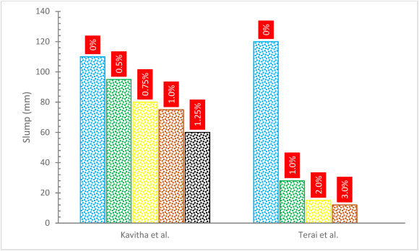

Fig. 6. Slump flow of bamboo fibers reinforced concrete [M. Terai, K. Minami,2012].
The reduction in flowability with fiber is expected to the enhanced surface area of the fibers, more water may be required to cover up them, which reduces the amount of cement paste that can be used for lubrication. Cesare's inclusion reduces concrete fluidity, which may enhance fiber surface area. The fiber also increased the frictional resistance between the fiber and the concrete ingredient, requiring the use of more paste to lessen internal resistance [J. Ahmad, F. Aslam, R. Martinez-Garcia, M.H. El Ouni, K.M. Khedher, 2021]. Though fibers in concrete have numerous benefits, they make freshly formed concrete less floppy [B.P. Hughes, N.I. Fattuhi, 1976 P.K. Mehta, P.J.M. Monteiro, 2017]. A result of the enhanced surface area of fibers is an increase in water consumption. For the components to flow based on mass, there is a requirement for more potential energy since the aggregates and fibers in the mixtures have higher resistance [P. Muthupriya, N. V Manjunath, B. Keerdhana, 2014]. The outcomes are still favorable, and the fibers ' absorption of most of the water in the mixture is what causes the reduced droop [S. Ghosn, N. Cherkawi, B. Hamad, 2020]. Concrete slumps due to hemp fibers, indicating a decrease in workability. The exceptional permeability of hemp fibers, which draws a sizable amount of water for blending, best describes this discovery. The association between porosity and the quantity of fiber consumed is direct [S. Ziane, M.-R. Khelifa, S. Mezhoud, 2020]. The fiber could be made hard to blend, handle, place, and compaction. One of the challenges presented by the fibers-in-mixing procedure is the formation of fiber balls, which results in a lack of uniformity and a decline the concrete performance [A.D. de Figueiredo, M.R. Ceccato, 2015].

2.2.2 Air Content
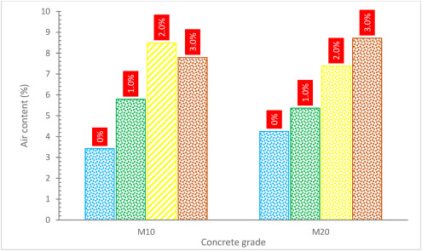
Air fills the area between the fibers and the concrete, and this air already begins to collect as the adhesive surfaces are mixed. The minor interaction between the cement paste [S. Grzesiak, M. Pahn, M. Schultz-Cornelius, S. Harenberg, C. Hahn, 2021] that caused the air cavities is related to how poorly concrete performed. The durability-related characteristics of concrete are negatively impacted by an increased air content [
P. Smarzewski, D. Barnat-Hunek, 2017]. Fig. 7 shows that the fresh mix air content rises when bamboo fibers are added to the mixture. This rise was 4–4.5% for bamboo fibers with a volume content of 3%. The greater air content might be due to the difficulties of compacting concrete with higher fiber concentrations, which results in more entrapped air. According to one research, the quantity of air in the concrete increased as the fiber length decreased, and extra air adverse influence on the slump [M.Z. Bayasi, P. Soroushian, 1992]. It is commonly identified that any kind of fiber reduces concrete flow. Less workable concrete has additional entrapped air, which cannot discharge from the mass due to the mixture's extreme stickiness. Inadequate workability causes an increase in the amount of air in the voids and holes of the capillaries, which has a significant impact on the strength and durability qualities of the concrete [J. Dils, V. Boel, G. De Schutter, 2013].

Fig. 7. Air content of bamboo fibers reinforced concrete [M. Terai, K. Minami, 2012].

2.3 STRENGTH PROPERTIES
2.3.1 Compressive Strength
Fig. 8 and Table 1 depict the concrete compressive capacity with the addition of bamboo fibers. According to one research, bamboo fibers may improve the concrete compressive capacity. Because bamboo fiber lengths remain consistent, the concrete compressive capacity is greatest when the bamboo fibers proportion is 0.26%. As the proportion of bamboo fibers remains steady, the concrete compressive capacity falls with the bamboo fiber's length [X. Zhang, J.Y. Pan, B. Yang, 2012]. According to one research, bamboo fibers significantly limit fracture development by halting the cracks, hence improving compressive strength. The fiber surface pre-treatment also improved the connection between the bamboo and the paste through the interlocking phenomena. This also creates a stitching impact, which increases the energy absorption required to prevent fracture development and transmission [H. Savastano Jr., S.F. dos Santos, M. Radonjic, W.O. Soboyejo, 2009]. The concrete compressive capacity is enhanced by the confinement of the fiber around the cylindrical specimens. Compressive strength is increased by tangential extension that is sustained by compressing and constrained by the fibers. The fiber's strength allows them to withstand strain and shear [J. Ahmad, A. Manan, A. Ali, M.W. Khan, M. Asim, O. Zaid, 2020].
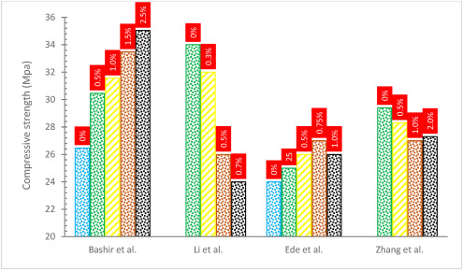

Fig. 8. Compressive strength of bamboo fibers reinforced concrete [A.N. Ede, O.M. Olofinnade, O. Joshua, D.O. Nduka, O.A. Oshogbunu, 2020., M. Li, S. Zhou, X. Guo, 2017., A. Bashir, C. Gupta, M.A. Abubakr, S.I. Abba, 2018 C. Zhang, Z. Huang, G.W. Chen, 2013].

Ref | Range Bamboo fibers addition | Additional information  Table 1. Summary of bamboo fibers reinforced performance | Type of material | Length (mm)B | Slump (mm) | Days | Bamboo fibers | % Change in compressive strength w.r.t control | % Change in tensile strength w.r.t control | % Change in Flexural strength w.r.t control | Conclusions
[M. Li,  S. Zhou,  X. Guo,  2017] | 0–0.7% | Alkali-treated bamboo fibers | Cement | .. | .. | - 14  - 28 | - 0.5% | - −21.8  - −23.5 | - +16.6  - +3.8 | - +20  - +16.2 | Compressive strength declined while tensile and flexural strength increased
[M. Terai,  K. Minami,  2012] | 0–3% | .. | Concrete | 30 | Decline | - 28  - 56 | - 1% | - −20.9  - −20.5 | - +18.1  - +8.3 | - −10.7  - −6.4 | Compressive and flexural strength declined while tensile strength increased
[M. Maier,  A. Javadian,  N. Saeidi,  C. Unluer,  H.K. Taylor,  C.P. Ostertag, 2020] | 0–8% | .. | Mortar | - 0.0072  - 0.0078 | - .. | - 28 | - 4% | - −7.2  - −9.1 | - −6.9  - −23.6 | .. | Compressive and tensile strength declined
[X. Zhang, J.Y Pan, B. Yang, 2012] | 0 to 0.39 | .. | Concrete | - 10  - 30 | - .. | - .. | - 0.26 (kg/m³) | - +26.24  - +6.3 | - +97.2  - +69.2 | .. | Compressive and tensile strength increased
[R. Fujiyama, F. Darwish, M. V Pereira, 2014] | 0–2.0% | .. | Concrete | 45 | .. | 28 | 1% | −8.6 | +40.5 | .. | Compressive strength declined while tensile strength increased
[B. Akinyemi, T. Omoniyi, 2018] | 0–1.5% | Latax = 10% | Mortar | – |  | - 28  - 45  - 60 | - 1.5% | - +183  - +137  - +90 | - +400  - +250  - +200 | - +440  - +150  - +177 | Compressive, flexural, and tensile strength increased
[A.N. Ede, O.M. Olofinnade, O. Joshua, D.O. Nduka, O.A. Oshogbunu, 2020] | 0–1.0% | .. | Self compacting concrete | 50 | Decline | - 14  - 28 | - 0.5% | - +5.5  - +8.3 | - +22.7  - +24.0 | .. | Compressive and tensile strength increased
[A.B. Akinyemi, E.T. Omoniyi, G. Onuzulike, 2020] | 1–1.5% | - Hot water  - Microwave  - Alkali | - Composites | - 20 | - .. | - 7  - 14  - 28 | - 1.5% | - 7  - 14  - 28  - 7  - 14  - 28  - 7  - 14  - 28 | - +20  - +8.3  - −14  - +7.1  - +6.6  - +6.25  - +10  - +30  - +40 | .. | Tensile strength increased
[K. Kumarasamy, G. Shyamala, H. Gebreyowhanse, 2020] | 0–2.5% | .. | Concrete | 50 | .. | - 7  - 14  - 28 | - 2% | - +1.6  - +1.7  - +1.9 | - +9.2  - +11.9  - +3.30 | - +26.5  - +32.3  - +18.7 | Compressive flexural and tensile strength increased
[J.T. Kang, S.H. Park, S.H. Kim, 2014] | 5–30% | Pristine | Composites | .. | .. | .. | 5% | .. | −X. Zhang, J.Y Pan, B. Yang, 2012 | .. | Tensile strength declined
[A. Bashir, C. Gupta, M.A. Abubakr, S.I. Abba, 2018] | 0–2.5% | .. | Concrete | .. | .. | - 7  - 28 | - 2.5% | - +28.7  - +32.3 | - .. | - −53.3  - −34.0 | Compressive strength increased and flexural strength declined
[K.S.Tf. Kala, ] | 0–1.25% | .. | Concrete | 62 | Decline | - 7  - 14  - 28 | - 1% | - +61.9  - +72.3  - +25.0 | - +123.5  - +96.2  - +79.1 | - +91.4  - +55.3  - +57.6 | Compressive, flexural, and tensile strength increased
Ref = Reference.
+ = Increased.
− = decreased

Nevertheless, the research found that the compressive strength decreased at 1.0% fiber content. This may be ascribed to the concrete developing pores because of the high fiber content, which may have impacted the matrix's compactness and aggregate packing. The existence of honeycombs provides an ideal environment for the beginning and growth of microcracks, which causes the sample to fail before its time. However, in samples that included less than 0.75% fiber, the fibers worked as crack arrestors, slowing the spread of any cracks and, as a result, increasing the final strengths [A.N. Ede, O.M. Olofinnade, O. Joshua, D.O. Nduka, O.A. Oshogbunu, 2020]. The concrete compressive capacity was not substantially changed by the inclusion of sisal fiber [R. Fujiyama, F. Darwish, M. V Pereira, 2014].
The matrix's total strength is decreased by the bamboo fibers, causing a greater reduction in strength as the fiber concentration is higher [H. Chen, H. Cheng, G. Wang, Z. Yu, S.Q. Shi, 2015]. According to the results, adding bamboo fibers to concrete does not increase its compression strength but instead causes a minor drop by 3.8% to 9.6% in comparison to ordinary concrete [R. Fujiyama, F. Darwish, M. V Pereira, 2014]. With increasing volume percentages of fibers, the compressive strength of bamboo fibers-reinforced concrete considerably dropped because the fiber's addition lowered the binding tension between the cement matrix and aggregate [M. Terai, K. Minami, 2012]. Additionally, the research found that adding bamboo fibers lowered compressive strength [M. Maier, A. Javadian, N. Saeidi, C. Unluer, H.K. Taylor, C.P. Ostertag, 2020]. This tendency may be due to the bamboo fibers' lower compressive strength and higher elastic modulus than the cement matrix.

2.3.2 Tensile Strength
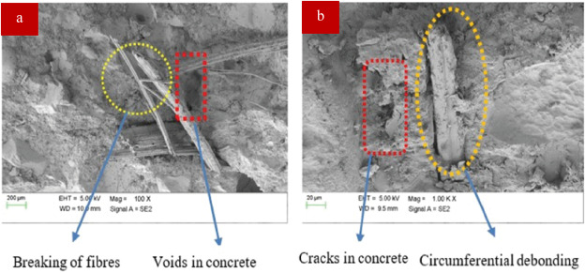
Fig. 9 and Table 1 depict the concrete tensile capacity reinforced with bamboo fibers. According to the study, adding bamboo fibers to concrete boosts its compressive and tensile strengths by 22 and 17%, correspondingly. This improvement results from the fiber's bridging function, which prevents cracks in the hardened mix from spreading [[Y. Haryanto, N.G. Wariyatno, H.-T. Hu, A. Han, B.A. Hidayat, 2021], [Kharabsheh, M.M. Arbili, A. Majdi, S.M. Alogla, A. Hakamy, J. Ahmad, A.F. Deifalla, 2022], [Kharabsheh, M.M. Arbili, A. Majdi, S.M. Alogla, A. Hakamy, J. Ahmad, A.F. Deifalla, 2023]]. As a consequence of the alkali treatment, which eliminated impurities and decreased the proportion of lignin and cellulose, the bamboo's coarser fiber surface morphology contributed to the samples' increased tensile strength. Since the fiber-matrix adhesion was improved because of the rougher surface, the tensile capacity also increased. Because of the surface pre-treatment, bamboo fibers deprivation in the cement, which might have decreased strength, has been dramatically minimized. As a result, the bamboo fibers could provide their maximum performance in reducing fractures in the mortar specimens [B. Akinyemi, T. Omoniyi, 2018]. Increased fiber content only benefits concrete tensile strength at relatively modest fiber doses of up to 1%. Similarly, to this, it was found that the length of the fiber had a substantial impact on the concrete tensile capacity. Longer fibers are more efficient than shorter ones at lower fiber levels of up to 1%. Though, at 1% fiber content, an opposite tendency was seen. At the highest and lowest fiber doses, this behavior is more apparent (i.e. 0.1% and 2.5%) [R.B. Mugume, A. Karubanga, M. Kyakula, 2021]. The results of the experiments show that the low fiber volume has no effect on compressive capacity but considerably improves tensile capacity [R. V Balendran, F.P. Zhou, A. Nadeem, A.Y.T. Leung, 2002].
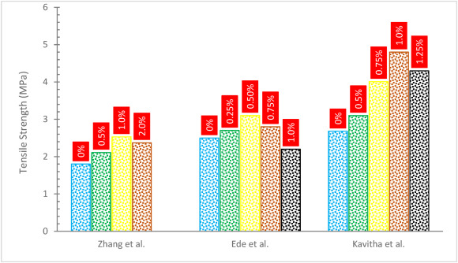

Fig. 9. Tensile Strength of Bamboo fibers Reinforced Concrete [A.N. Ede, O.M. Olofinnade, O. Joshua, D.O. Nduka, O.A. Oshogbunu, 2020,K.S.Tf. Kala, ,R. Fujiyama, F. Darwish, M. V Pereira, 2014].
According to the study, the inclusion of bamboo fibers in concrete at concentrations of 5%, 1%, 1.5, and 2%, respectively, increases the material's split tensile strength by 0.2%, 1.3%, 1.85%, and 3.3%. However, the concrete tensile capacity began to decline after a 2.5% addition of fiber and decreased by 0.43% [K. Kumarasamy, G. Shyamala, H. Gebreyowhanse, 2020]. Bamboo has a unique internal network of sclerenchyma fibers with a tiny lumen and strong secondary walls, which provides it with amazing tensile qualities that allow it to resist the development of fractures. Additionally, the superior aspect ratio of the fibers contributed to the observed enhanced strength when they were introduced, increasing the tangential surface area of the fibers in connection with the paste, and increasing the connection among the cement, paints, and fibers. Furthermore, due to the greater tensile capacity of the fiber, the process of breakage shifts from fracturing fibers to pulling them out of the matrix. In other words, the mechanism is controlled by how well the cement, paint, and fibers stick together [J. Claramunt, M. Ardanuy, J.A. García-Hortal, R.D. Tolêdo Filho, 2011].

2.3.3 Flexural Strength
Fig. 10 and Table 1 depict the concrete tensile strength with the addition of bamboo fibers. A researcher examined the concrete flexural capacity for various bamboo fiber mix amounts, including 0%, 0.50%, 1%, 1.50%, 2.00%, and 2.50%. The concrete flexural capacity improved when associated with traditional concrete when fiber additions are made at a rate of 0.5, 1.0, 1.5, and 2%, but it has reduced at a rate of 2.5% in comparison to other fiber ratios. Similarly, the concrete split tensile capacity with the inclusion of bamboo fibers has improved when associated with normal concrete when bamboo fiber reinforcement is used, but it has reduced when bamboo fiber reinforcement is used at a ratio of 2.5% as opposed to other fiber ratios. A study stated that the concrete flexural capacity has enhanced with the insertion of fiber (up to 2%). The concrete's flexural strength increases by 0.2%, 1.3%, 1.85%, and 3.3% when the fiber is added at rates of 0.5%, 1.0%, 1.5%, and 2.0%, respectively. The flexural strength of the concrete began to decline after a 2.5% addition of fiber and decreased by 0.43% [K. Kumarasamy, G. Shyamala, H. Gebreyowhanse, 2020]. This is due to the fibers ' ability to withstand splitting pressures more cohesively and collectively than the maximum values seen in the control samples. Additionally, the extreme aspect ratio of the fibers contributed to the observed enhanced strength when they were introduced, increasing the lateral surface area of the fibers in connection with the paste. Additionally, due to the superior tensile capacity of the fiber, the process of rupture shifts from fiber breaking to fiber extraction from the blend. This suggests that the mechanism is controlled by the strength of the bonds between the cement and fibers [J. Claramunt, M. Ardanuy, J.A. García-Hortal, R.D. Tolêdo Filho, 2011]. According to studies, polyethylene fiber does not improve the flexural capacity of hybrid composites [C.L. Pereira, F.F. Demarco, M.S. Cenci, P.W.R. Osinaga, E.M. Piovesan, 2003]. Brittle failure is a characteristic of glass fiber [J. Ahmad, R.A. González-Lezcano, A. Majdi, N. Ben Kahla, A.F. Deifalla, M.A. El-Shorbagy, 2022]. However, polyethylene fiber inhibits entirely separating fragmented specimens [F. Sharafeddin, A.A. Alavi, Z. Talei, 2013,O. Zaid, J. Ahmad, M.S. Siddique, F. Aslam, H. Alabduljabbar, K.M. Khedher, 2021]. According to a study, nylon fibers increased flexural strength more effectively than glass fibers [J. Ahmad, O. Zaid, F. Aslam, M. Shahzaib, R. Ullah, H. Alabduljabbar, K.M. Khedher, 2021]. As the percentage of fiber volume grew, the flexural strength improved [J. Ahmad, M.M. Arbili, A. Majdi, F. Althoey, A. Farouk Deifalla, C. Rahmawati, 2022]. This is most likely caused by the fact that the fibers will withstand the stress when the blend splits until the interface connection between the fibers and the blend disintegrates [Y.R. Atewi, M.F. Hasan, E. Güneyisi, 2019].
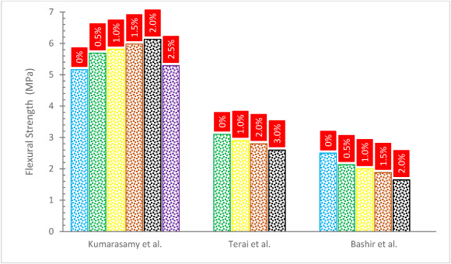

Fig. 10. Flexural Strength of Bamboo fibers Reinforced Concrete [M. Terai, K. Minami, 2012,A. Bashir, C. Gupta, M.A. Abubakr, S.I. Abba, 2018,K. Kumarasamy, G. Shyamala, H. Gebreyowhanse, 2020].
According to research, bamboo fibers' presence also had a significant impact by preventing the spread of these fissures. When compared to the control samples, the ductility attribute that bamboo fibers provided resulted in an improvement in the samples' flexural strength. The fibers were included in the mortar to increase strength, regulate mortar breaking, and change how the material behaves after the blend has fractured by connecting around these fissures and therefore supplying some post-cracking ductility [M.R. Ismail, H.A. Youssef, M.A.M. Ali, A.H. Zahran, M.S. Afifi, 2008]. Paste precipitation into the fibril-exposed surface and the fiber voids may be accountable for the enhanced connection between the bamboo fibers and the blend. The bamboo cellulose chain and the calcium-based, hydrated cement creation later created an interfacial connection. As a result, the composite samples' fracture resistance was significantly increased, and their crack propagation mechanism was reduced.

2.3.4 Failure Pattern
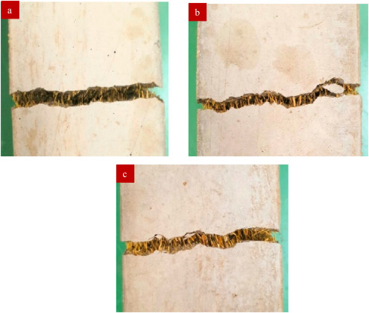
The control mix behaved linearly elastically up to the maximal stress before failing suddenly, completely separating the specimens into two pieces. The bamboo fiber combinations, on the other hand, showed superior post-crack performance, leading to a strain-softening performance, where just one crack appeared in the middle of the prismatic sections. This impact is seen in Fig. 11, where images of the specimens under test obtained after bending tests are displayed for samples with 300-μm fibers. One can see the fibers spanning the formed fissure, which became much more noticeable as the fiber concentration rose from 4 to 8% [J. Ahmad, F. Aslam, R. Martinez-Garcia, M.H. El Ouni, K.M. Khedher, 2021].

Fig. 11. Failure pattern (a) 4%, (b) 6%, and (c) 8% bamboo fibers [M. Maier, A. Javadian, N. Saeidi, C. Unluer, H.K. Taylor, C.P. Ostertag, 2020].
Concrete reinforced with fiber has a better tensile strength than regular concrete because it uses fibers to increase elasticity by postponing the appearance of tension ruptures or avoiding cracks from forming. The effect of fibers is fracture-blocking rather than fracture-restraint. Fiber has a superior influence on tensile capacity than compressive capacity when associated with traditional concrete due to the prevention of fiber cracking (bridging action). Numerous investigations have demonstrated that fibers enhance the tensile capacity of post-cracking behavior. According to research, increasing the concrete strength would be simple if fibers were distributed continuously throughout it without clumping together. The majority of the works demonstrated improvements in concrete strength at reduced fiber contents. Instead, the continually dispersed fibers in the concrete prevent cracks from spreading during testing through bridging, which increases the strength of the concrete [J. Sridhar, R. Gobinath, M.S. Kırgız, 2022].

2.3.5 Load Deflection Curve
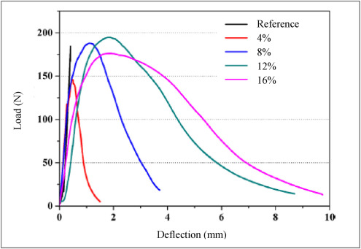
According to Fig. 12, the static rupture of the samples without bamboo fibers is fragile because the load-deflection curve of the reference sample is essentially straight up to the highest position where a sudden crack development occurs with a quick reduction in force. But the load-deflection curve of the composites with bamboo fibers filling exhibits early linearity and later nonlinear feature, and the drop in load after passing the highest load is sluggish, suggesting that the static rupture of the specimens with bamboo is ductile. According to research, adding fibers to concrete has been shown to improve the material's overall deflection and ductility capabilities [H. Wang, A. Belarbi, 2013].

Fig. 2. Load deflection curve of bamboo fibers reinforced concrete [X. Xie, Z. Zhou, Y. Yan, 2019].
Additionally, as the percentage of bamboo fibers increases, so does the deflection of the sample in the load-deflection curves. When the bamboo fibers percentages are 4, 8, 12, and 16%, the specimens' deflection values at failure are about 3.5, 10.5, 19.0, and 22.0 times higher than those of the reference sample without bamboo fibers. The test procedure for the specimens with 0, 4, 8, 12, and 16% bamboo fibers took around 0.8, 3.0, 7.4, 17.4, and 19.5 min, respectively, based on the displacement load ratio of 0.5 mm/min in the bending assessment [X. Xie, Z. Zhou, Y. Yan, 2019]. The post-cracking ductility is enhanced by the fiber's crack-bridging action. In distinction to steel-reinforced slabs, bamboo achieved a strength of 82% while achieving a ductility of 93%, according to the study's findings. As a result, bamboo can serve as a concrete reinforcement alternative to steel, though more research is needed to determine whether or not the mechanical properties can be improved [Y. Haryanto, N.G. Wariyatno, H.-T. Hu, A. Han, B.A. Hidayat, 2021].
According to research, bamboo fibers groups using 300 and 500 μm fibers both showed comparable tendencies, with 8-vol percent combinations showing the greatest peak load and 4-vol percent mixtures the lowest. Additionally, the break may be bridged by the bamboo strands, which caused a strain in all bamboo combinations. Higher fiber content combinations showed more dramatic post-crack behavior [M. Maier, A. Javadian, N. Saeidi, C. Unluer, H.K. Taylor, C.P. Ostertag, 2020]. According to research [M. Li, S. Zhou, X. Guo, 2017], bamboo fibers have a greater fracture toughness and a lower elastic modulus than cement matrix, which causes a little reduction in the elastic modulus and peak stress of bamboo fibers-reinforced cement. Additionally, since alkali-treated bamboo and cement have higher interfacial adhesion, the cement matrix may successfully transmit certain amounts of the imposed external load to the bamboo. As a result of the stress spreading in the treated bamboo, the fragile rupture of oil well cement with a corresponding drop in strength and elastic modulus may be reduced and deformed more effectively. The treated bamboo fiber's pullout along the rapture crack and the capacity of the fiber to sustain post-continuity is related to the greater strain of the stress-strain curves compared to the pure cement. Additionally, a significant rise in the area under the stress-strain curves indicates that alkali-treated bamboo fibers may toughen oil well cement and delay the development of the failure crack. The increase in energy dissipation from crack deflection, fiber debonding, fiber connecting, fiber pull-out, and fiber rupture is linked to the toughening of oil well cement due to the natural fibers ' resistance to fracture [H. Jr Savastano, A. Turner, C. Mercer, W.O. Soboyejo, 2006].

2.3.6 Elastic Modulus
Fig. 13 describes the elastic modulus of concrete reinforced with bamboo fibers. Research also found that air, which begins to gather during the blending activity between the adhesive surfaces, fills the area between concrete and fibers. The little contact between the fiber and the binder is related to the air spaces. The compressive strength of high-performance concrete is lowered by a tiny air volume. Additionally, the larger fiber quantity lowers the volume of the concrete while simultaneously lowering the concrete's compressive strength and elastic modulus [S. Grzesiak, M. Pahn, M. Schultz-Cornelius, S. Harenberg, C. Hahn, 2021].
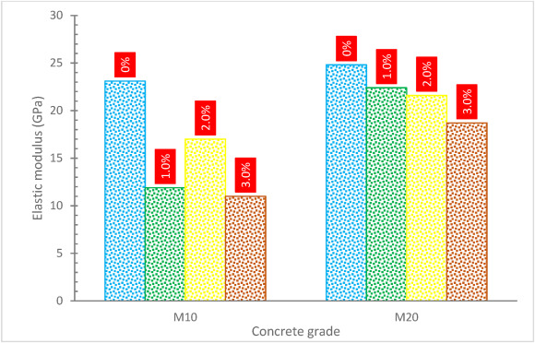

Fig. 13. Elastic modulus of bamboo fibers reinforced concrete [M. Terai, K. Minami, 2012].
The elastic modulus was also shown to decrease with the inclusion of fibers in research. Despite having an increase in strength, the fiber reinforced mixes had an average decrease of 10% [N. Suksawang, S. Wtaife, A. Alsabbagh, 2018]. The possibility that fibers parallel to the load direction might behave as voids is one explanation for the drop in elastic modulus. The consolidation may also be impacted by the inclusion of fibers which would lower the elastic modulus. Additionally, mixes with longer fibers have lower elastic modulus when compared to mixtures of fiber reinforced materials with the same amount of fiber [N. Suksawang, S. Wtaife, A. Alsabbagh, 2018].

2.3.7 Toughness
The toughness of concrete decreased with bamboo fibers as shown in Fig. 14. Furthermore, toughness also depends on fiber size. When compared to the smaller and shorter fibers in the 300-μm batch, thicker and longer fibers, such as those discovered in the 500-μm batch, demonstrated an overall loss in toughness. This is explained by the greater pull-out resistance for fibers with a higher aspect ratio and a higher bridge-carrying capacity for mixes with a larger quantity of fibers [M. Maier, A. Javadian, N. Saeidi, C. Unluer, H.K. Taylor, C.P. Ostertag, 2020]. When relative to 4% bamboo fiber percent blends, the toughness values of the 300-μm fiber samples at 1 mm deformation were 40.0% and 73.3% greater for the 6% and 8% mixes, respectively. According to the evaluation of the 500-μm fiber batch, the toughness of the 8-volume percent and 6% mixes increased by 16 and 47%, correspondingly, in comparison to the 4% blends.

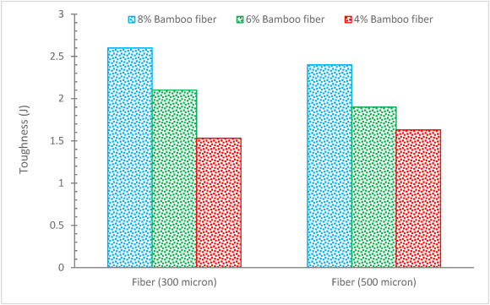

Fig. 14. Toughness of bamboo fibers reinforced concrete [M. Maier, A. Javadian, N. Saeidi, C. Unluer, H.K. Taylor, C.P. Ostertag, 2020].

2.3.8 Impact Resistance
Fig. 15 illustrates the elastic impact resistance of concrete reinforced with bamboo fibers. A study added fiber to concrete to increase its impact resistance (including strength and energy absorption capacity) [H.T. Wang, L.C. Wang, 2013]. According to research [N. Wang, S. Mindess, K. Ko, 1996], the fracture energy absorption capacity of concrete greatly enhanced for fiber volume fractions of 0.5% to 0.75%, and this resulted in the best impact resistance/cost ratio being attained with a hooked steel fiber content of 0.75%. Due to the fiber bridging effect, post-cracking flexural strength rose visibly when steel fibers were added. Comparatively to alkali-resistant (AR) glass fabric-reinforced composites [D. Zhu, M. Gencoglu, B. Mobasher, 2009], composites containing sisal fibers had a more ductile behavior when hit and comparable final impact strength. According to research [R. Perumal, K. Nagamani, 2014], adding 0.5–1.5% of crimped fibers considerably improved the resistance of concrete to repeated impacts, and it was shown that silica fume and fibers interacted favorably. Concrete containing crimped steel fibers had maximum impact strengths that, at first fracture and failure, were 1.51 and 1.79 times greater than those of concrete without fibers. With increasing fiber length, the impact resistance of natural fiber-reinforced slab specimens also rises, which may be a result of the fibers ' interlocking with one another in the cement matrix [G. Ramakrishna, T. Sundararajan, 2005].

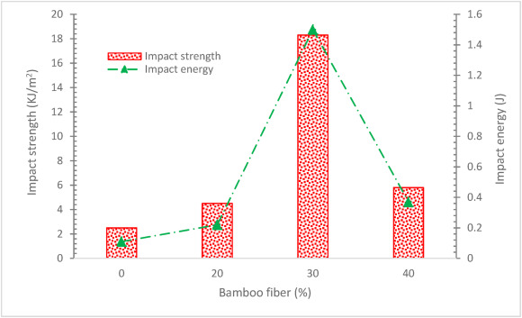

Fig. 15. Impact strength and impact energy of bamboo fibers reinforced concrete [H. Banga, V.K. Singh, S.K. Choudhary, 2015].
Fig. 16 provides the absorbed energy and absorption coefficient of the samples with 12% bamboo fibers. The absorbed energy rises as the impact energy improves. The specimens' respective absorbed energies are 3.82, 9.19, 14.35, 19.30, and 23.16 J for impact energies of 5, 10, 15, 20, and 25 J. When the impact energy is 5, 10, 15, 20, and 25 J, the corresponding absorption coefficients are 0.76, 0.92, 0.96, 0.97, and 0.93, respectively. In contrast, the absorption coefficient exhibits a rise first and subsequently decreases. Concrete reinforced with sisal fiber has excellent impact strength and acceptable tensile and flexural properties. However, the potency was decreased when the 2.0% dose was exceeded [J. Ahmad, F. Aslam, R. Martinez-Garcia, M.H. El Ouni, K.M. Khedher, 2021]. Fibers are used in concrete to increase flexibility by avoiding or delaying the appearance of tension fractures, which results in higher strength. According to research [X. Xie, Z. Zhou, Y. Yan, 2019], adding the right quantity of bamboo fibers may increase cement's toughness, but too many bamboo fibers can produce fiber aggregation and, as a result, cannot increase the composites' maximum flexural strength and impact resistance. According to research, concrete without bamboo fibers has a lower impact strength than material with a 10% fiber loading. However, when the percentage of fiber increases over 10%, the impact strength tends to decrease [I. Widiastuti, H.C. Saputra, S.S. Wisnu Kusuma, B. Harjanto, 2022].

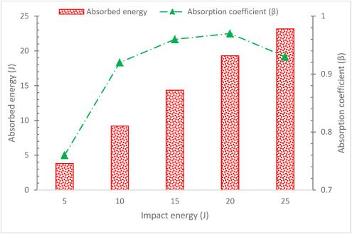

Fig. 16. Impact energy and absorbed energy of 12% bamboo fibers composites [X. Xie, Z. Zhou, Y. Yan, 2019].
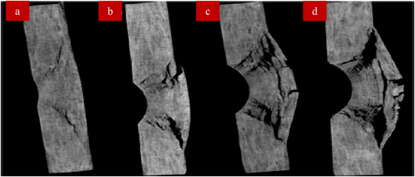
From Fig. 17, the top surfaces of the slabs developed pits of various sizes, and the depth of the pits rises as the impact energy rises. The damaged pattern on the bottom surfaces of the slabs is about spherical when compared to the loss on the top surfaces, and the impact area is larger. Furthermore, when the impact energy rises, the damaged area and size of the matrix fracture grow as well. At an impact energy of 5 J, it is shown in Fig. 17 that the inner specimens have matrix fractures, delamination, and a little degree of fiber breakage. Additionally, the fracture path is adjacent to the edges of the cone, whose top and bottom surfaces match the damaged regions on the top and bottom surfaces of the samples, and the spalling of the slabs is mostly perpendicular to the hammer head's impact direction. The impact loading is transmitted to the next layer via the cement blend and the interlocking between fibers as impact energy increases, leading to more significant debonding and fissures. As a result, the damage to the samples' surfaces is less severe than the delamination region and several fracture

Fig. 17. Computed tomography map of the sample after impact test (a) 5 J, (b) 10 J, (c) 15 J, and (d) 20 J [X. Xie, Z. Zhou, Y. Yan, 2019].

2.4 PERFORMANCE AT ELEVATED TEMPERATURES
Visual examination for color change, cracking, and spalling is often the first step in assessing concrete buildings damaged by fire. When concrete is heated, a color shift from normal to pink or red is often seen. This is helpful because it marks the beginning of a major loss in concrete strength. According to research, there seems to be a minor lightning of color only at 200 °C, and no major color change has happened on the look of concrete without bamboo fibers. Macroscopic cracks progressively start to show up as the temperature rises. The sample becomes unstable around 800 °C and develops many fractures all over the outer surface, along with some spalling. This is connected to the breakdown of the primary geopolymer system chains [A. Celik, K. Yilmaz, O. Canpolat, M.M. Al-Mashhadani, Y. Aygörmez, M. Uysal, 2018]. According to research results [A. Bilodeau, V.K.R. Kodur, G.C. Hoff, 2004], spalling damage may be avoided if propylene fiber concentration is more than 0.1%. To be more specific, the simultaneous addition of 0.025% of each propylene fiber and nylon fiber (for a total fiber content of 0.05%) to specimens that already included both fibers did not result in spalling damage. The reduction in spalling is almost twice as bad when using nylon and propylene fibers together as it is when using just one kind of propylene fiber. Researchers [Y.-S. Heo, J.G. Sanjayan, C.-G. Han, M.-C. Han, 2010] examined several fiber types and concentrations to increase fire resistance without compromising workability. More specifically, the research conducted by the scientists found that nylon fiber outperforms other types of fibers in terms of flowability and fire resistance due to its smaller diameter, hydrophilic characteristics, and short length.
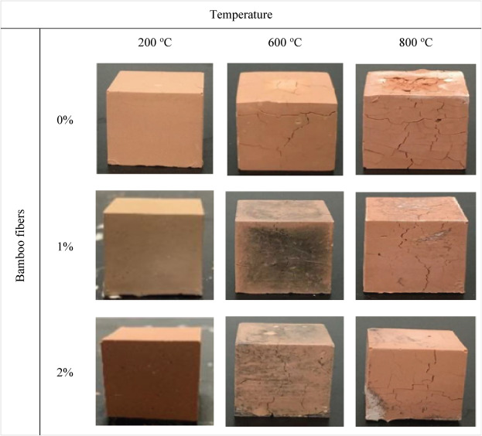
At 600 °C, concrete without bamboo fibers starts to develop fracture networks as shown in Fig. 18. However, considerable cracking did not appear in concrete reinforced with 1% and 2% bamboo fibers until temperatures above 600 °C.

Fig. 18. Visual observation at elevated temperature [X. Zhang, J. Zhang, Z. Zhang, Y. Wu, Y. Zuo, 2023].
Both the concrete reinforced with 1% bamboo fibers and the concrete reinforced with 2% bamboo fibers contain black carbides on their surfaces at 600 °C, but there are none to be seen at 800 °C. At 800 °C, the surfaces of the two samples (concrete reinforced with 1% bamboo fibers and concrete reinforced with no bamboo fibers) exhibit more noticeable fissures, and one corner of the concrete reinforced with 2% bamboo fibers peels off. It is helpful to utilize the color change and fractures as signs of a major loss in mechanical characteristics. This is because the altered look is congruent with a clear decline in strength brought on by heating [N.R. Short, J.A. Purkiss, S.E. Guise, 2001]. Research also found that the emergence of a red hue was significantly accompanied by a decline in compressive strength. Moreover, the concrete's real hues relied on the kinds of cement and aggregate employed in its creation [S.E. Guise, 1997]. The widespread consensus is that when heated to temperatures between 300 °C and 600 °C, concrete made with silicate aggregates (quartz, flint) would become red [N.R. Short, J.A. Purkiss, S.E. Guise, 2001]. In addition, the cement matrix becomes whitish-grey between 600 and 900 °C and takes on a buff hue between 900 and 1000 °C. By visually contrasting concrete impacted by high temperatures with unaffected concrete, temperature-related color changes in building concrete are simple to see. Concrete reinforced with 1% and 2% bamboo fibers exhibits fewer fractures than concrete without bamboo fibers. The tiny gaps created by bamboo degradation within the geopolymer matrix, suggest that bamboo serves a specific function in avoiding high-temperature cracking.
Fig. 19 displays the compressive strength values for benchmark, 1%, and 2% bamboo fibers before and after heating. At room temperature, reference, 1%, and 2% bamboo fibers had compressive strengths of 50.27, 54.31, and 53.86 MPa, respectively. 1 and 2% of bamboo fibers have greater mechanical strength than the reference mix at room temperature. Additionally, the research found that after warming the solid at 800° Celsius for 60 min, compressive strength decreases. Without the fiber, the strength falls by 10% compared to its initial level, and it falls by 18% for every 1% of bamboo fibers added. Because the fibers melt at high temperatures and create holes to let the vapor pressure escape, there is a corresponding reduction in strength [S. Kavitha, T.F. Kala, 2021]. All samples' compressive strength decreases as temperature rises. Compressive strengths of control blend,1%, and 2% bamboo fibers reinforced concrete after treatment at 800 °C were 7.36, 15.39, and 15.92 MPa, respectively, while residual strength rates were 14.64, 28.34, and 29.56%, respectively. The behavior may be caused by the geopolymer's release of water moisture, which causes voids and shrinkage cracks, as well as bamboo's thermal deterioration, which results in the loss of bearing capacity and reduces compressive strength under the microscope [X. Zhang, J. Zhang, Z. Zhang, Y. Wu, Y. Zuo, 2023]. The control mixture's compressive strength was diminished because of the significant internal cracking and spalling. Nevertheless, it was found that the addition of fiber to each specimen of concrete helped maintain residual strength. The fiber-containing concrete sample had a residual compressive strength of more than 40% [G. Lee, D. Han, M.-C. Han, C.-G. Han, H.-J. Son, 2012].
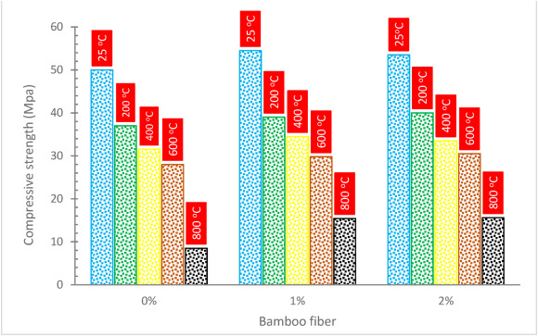

Fig. 19. Compressive strength at elevated temperature [X. Zhang, J. Zhang, Z. Zhang, Y. Wu, Y. Zuo, 2023].

In Fig. 20, SEM micrographs of reference, 1%, and 2% bamboo fibers at 800 °C temperatures are shown. The control samples exhibit extensive microcrack formation and rather significant voids when subjected to high temperatures. The combustion and degradation of bamboo cause certain irregular holes to appear throughout the micro-structure of 1% and 2% bamboo fibers reinforced concrete above 400 °C [X. Zhang, J. Zhang, Z. Zhang, Y. Wu, Y. Zuo, 2023]. A study also claimed that below 400 °C, the hydration products of concrete do not decompose and that the high-temperature vapor pressure is primarily responsible for the deterioration of concrete; above 400 °C, the decomposition of calcium hydroxide, calcium silicate hydrate gel, and calcium carbonate results in a decrease in concrete strength [R.K. Ibrahim, R. Hamid, M.R. Taha, 2012].
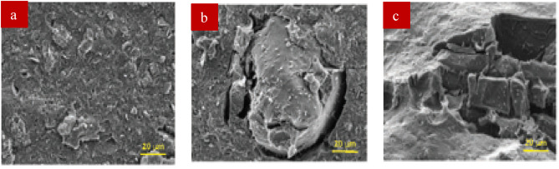
Fig. 20. SEM at 800 °C (a) 0%, (b) 1% and (c) 2% bamboo fibers [X. Zhang, J. Zhang, Z. Zhang, Y. Wu, Y. Zuo, 2023].
The internal vapor pressures produced by bamboo decay may be reduced, which would lessen the likelihood of cracking [X. Zhang, J. Zhang, Z. Zhang, Y. Wu, Y. Zuo, 2023]. The following factors contribute to concrete degradation at high temperatures: high-temperature vapor pressure, temperature stress, differential thermal extension coefficients between aggregate and cement, and thermal disintegration of hydration products [D.L.Y. Kong, J.G. Sanjayan, 2010], the latter of which is the primary factor.

2.5 Durability

2.5.1 Density
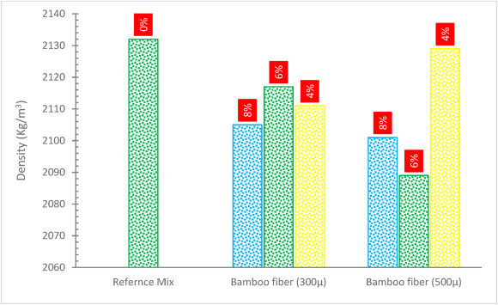
The density of the control mix was 2132 kg/m³, which was somewhat greater than the density of the fiber-containing mixes. As demonstrated in Fig. 21, the inclusion of bamboo fibers had minimal influence on density, demonstrating a drop varying between 0.7 and 2.5%. According to one research, the density of fiber concrete compared to conventional concrete is lowered by 0.07%, 0.43%, and 0.67% for concrete with a w/c of 0.45, and by 0.29%, 0.39%, and 0.53% for concrete with a w/c of 0.45 [J.M. Irwan, N. Othman, K.H. Koh, R.M. Asyraf, S.K. Faisal, M.M.K. Annas, A.M. Shahrizan, 2013]. The gap between the concrete and fibers is occupied with air, which begins to collect during the blending process between the adhesive surfaces. The air spaces are attributed to a little interaction between the cement paste [S. Grzesiak, M. Pahn, M. Schultz-Cornelius, S. Harenberg, C. Hahn, 2021], which lowered the density of the concrete. The presence of hemp fibers causes the concrete to droop, indicating a lack of flowability. This finding is characterized by the exceptional penetrability of hemp strands, which draw a large amount of water for mixing. Porosity is directly related to the quantity of fiber consumed [S. Ziane, M.-R. Khelifa, S. Mezhoud, 2020]. Fresh concrete mixing, handling, placement, and consolidation may be hampered by the fiber. One of the issues presented by the fiber in the mixing process is the formation of fiber balls, which results in a loss of uniformity and a drop in density [A.D. de Figueiredo, M.R. Ceccato, 2015].

Fig. 21. Density of bamboo fiber reinforced concrete [M. Maier, A. Javadian, N. Saeidi, C. Unluer, H.K. Taylor, C.P. Ostertag, 2020].

2.5.2 Shrinkage
Fig. 22 depicts the shrinkage of concrete reinforced with bamboo fibers. Research [Y. Ban, W. Zhi, M. Fei, W. Liu, D. Yu, T. Fu, R. Qiu, 2020] on bamboo-fiber-reinforced cement composites was conducted to propose an explanation for the problem of weak interfacial bonds between bamboo fibers and paste. The original bamboo fibers were changed using three low-price and simple-to-apply treatments: glycerol, aluminate ester, and silane. Natural fibers, such as bamboo fibers, are absorbent, as opposed to synthetic fiber, which is usually solid. This is related to the structure of their fibers. One risk with employing natural fibers in cement composites is that the linked pore structure may assist drying and cause higher shrinkage. The drying shrinkages of the silane combination, the reference blend, the aluminate ester combination, and the glycerol combination were found to be the greatest across all ages. Although the shrinkage of the silane combination was somewhat greater than that of the reference blend (9.0% at 90 days), all mixes demonstrated modest shrinkage strain (less than 350 × 10⁻⁶). This finding also offered indirect proof that the changing chemical used had strong water resistance, preventing water evaporation through the fiber structure. According to one research, effective packing may have contributed to the absence of breakages during contraction and gap size decrease. According to the research detailed, fibers bridged voids and lowered concrete permeability [J. Liu, Y. Jia, J. Wang, 2010].
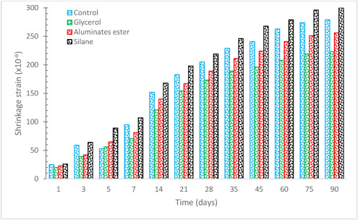

Fig. 22. Shrinkage of bamboo fiber reinforced concrete [Y. Ban, W. Zhi, M. Fei, W. Liu, D. Yu, T. Fu, R. Qiu, 2020].

2.5.3 Water Absorption
Fig. 23 indicates that the rate of water absorption rises approximately linearly for neat (0%) fiber and increases for all percent, with the 40% specimen absorbing the most water. With a lowering percentage, the rate of water absorption falls. This might be because the inclusion of bamboo fibers percent increases the space and cavities in the materials. When the specimens are dipped in water, water enters these areas, causing greater absorption. Another cause might be that bamboo strands absorb water, causing the cloth to soak more water [H. Banga, V.K. Singh, S.K. Choudhary, 2015].
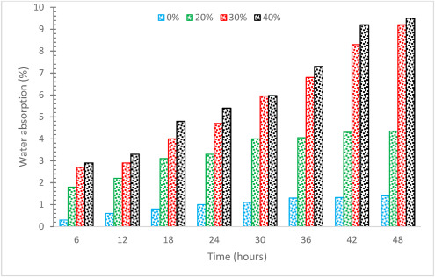

Fig. 23. Water absorption [H. Banga, V.K. Singh, S.K. Choudhary, 2015].
The fibers absorb a large portion of the water in the blends [S. Ghosn, N. Cherkawi, B. Hamad, 2020], which contributes to boosting the water absorption capability. A study [H. Jamshaid, R.K. Mishra, A. Raza, U. Hussain, M. Rahman, S. Nazari, V. Chandan, M. Muller, R. Choteborsky, 2022] looked at the concrete characteristics by using natural cellulosic fibers such as jute, sisal, sugarcane, and coconut. Each natural fiber, with an average length of 30 mm, was combined with a concrete matrix in varied quantities fluctuating from 0.5 to 3% mass. The capacity of water absorption improved with increasing fiber loading % in all-natural fiber-reinforced concrete specimens (jute, sisal, sugarcane, and coconut). The total water absorption capability of natural cellulosic fiber-reinforced concrete ranged from 4.25% to 9.25% when the fiber loading proportion was changed from 0.5% to 3%. Among the several natural fibers employed in this study, coconut and sugarcane fibers showed greater permeability and smaller crystallinity than jute and sisal fibers. As a result, the concrete specimens reinforced with these fibers had a greater water absorption capability.

2.6 MICROSTRUCTURE ANALYSIS
When the externally forced concrete's damage process is taken into account, it is demonstrated that the structure of the concrete failed due to the instigation of microcracks, dispersal of microcracks, rise in extension, connecting between microcracks, and infiltration of chemicals or moisture into the structure, until the microcracks are transformed into macrocracks, resulting in a higher expansion force for a crack which causes deterioration [H. Song, J. Liu, K. He, W. Ahmad].
Concrete that had been treated with 1.5% bamboo fibers had fewer and more erratic pores as shown in Fig. 24. Bamboo fibers made up 1.5% of the concrete's composition to increase its compaction. The fiber prevents the creation of a connection between microcracks and pores in building materials. Since jute fibers exist, dents and links between microcracks are created. The presence of a few micro-sized spaces demonstrated that jute fibers and the cement matrix had a strong connection (Fig. 24). On a micro level, internal and external forces cause the interfacial transition zone (ITZ) surrounding the fiber stack, which is randomly disseminated in the concrete, to collapse. This is similar to how the jute fibers were dispersed in the concrete, but the bamboo fibers were enclosed by the ITZ. The bamboo fibers would not increase the amount of tension concentrated at the fracture [J. Sridhar, R. Gobinath, M.S. Kırgız, 2022]. According to research [X. Xie, Z. Zhou, Y. Yan, 2019], the interfacial contact between the fiber and matrix as well as the energy absorbed when the fibers pulled out of the cement matrix during the bending test is responsible for the enhancement of the bamboo fiber's addition on the fracture toughness. Because of this, specimens with bamboo fibers of 16% or more had increased deflection and fracture toughness. However, compared to deflection and fracture toughness, the effect trend of bamboo fiber content on maximum flexural strength is different. First, when bamboo fiber concentration is 4 wt%, the specimens' maximum flexural strength value drops to 76.6% of the specimen without bamboo fibers [X. Xie, Z. Zhou, Y. Yan, 2019].

Fig. 24. SEM of 1.5% bamboo fibers (a) compressive load and (b) bending load [J. Sridhar, R. Gobinath, M.S. Kırgız, 2022].
Instead, the addition of bamboo fibers-transformed concrete to high-strength concrete served two purposes: it protected the crack's onset, protected the dispersion and connecting of the existence of fractures, and supported a portion of the compressive and flexural strengths through the examination, resulting in strengthened, toughened, and durable concrete in terms of crack and micro-crack (Fig. 24a and b). Nevertheless, it has been noted that the first failure of the concrete was caused by the development of concrete fractures. Grinding and compressing can cause voids to form within the concrete. Breakage of the fiber, caused by the applied stress, was seen (Fig. 24a). The SEM picture of the fractured concrete surface treated with 1.5% bamboo fibers under flexure stress is demonstrated in Fig. 24a. Because fiber-reinforced concrete is flexible and robust, fiber can support greater weight with less distortion. Additionally, it is noted that the link between the fiber and cement blend under flexural stress is deteriorating, resulting in circumferential debonding of the fiber and fracture in the concrete. The relationship between the concrete failure configuration and fiber dispersion demonstrates that pull-out and circumferential delamination generated by applied stresses are the causes of fiber failure [R. Anitha, S. Chitra, V. Hemapriya, I.-M. Chung, S.-H. Kim, M. Prabakaran, 2019]. Research utilizing SEM found that fiber tended to bundle up and flocculate, leading to an uneven distribution of fibers and a decline in bonding strength [B.H. Mohammed, A.F.H. Sherwani, R.H. Faraj, H.H. Qadir, K.H. Younis, 2021]. So, while selecting the fiber quantity and blending concrete, attention must be taken. According to research, fiber improved strength and durability by preventing cracks [J. Ahmad, A. Majdi, A. Al-Fakih, A.F. Deifalla, F. Althoey, M.H. El Ouni, M.A. El-Shorbagy, 2022]. The fiber was able to improve the concrete's structural properties and decrease water absorption thanks to the superior fiber-matrix bonding quality. Since the fiber's surface was wrapped by a tightly bonded cement matrix, it filled the spaces and reduced porosity [J. Ahmad, R.A. González-Lezcano, A. Majdi, N. Ben Kahla, A.F. Deifalla, M.A. El-Shorbagy, 2022].

