


A TECHNICAL REPORT ON SIWES
DONE AT
AL-BULAI NIGERIA CO. IDOFIAN PANLADA
COMPOUND KWARA STATE

By

ABDULWAHEED BASHIRAT
ND/23/PSM/FT/0057

SUBMITTED TO:

DEPARTMENT OF PROCUREMENT AND CHAIN MANAGEMENY
INSTITUTE OF FINANCE AND MANAGEMENT STUDIES
KWARA STATE POLYTECHNIC, ILORIN, KWARA STATE.

ON PARTIAL FULFILMENT ON THE REQUIREMENTS FOR THE AWARD OF NATIONAL DIPLOMA IN CIVIL ENGINEERING TECHNOLGY

AUGUST – DECEMBER 2024

CERFTIFICATION
I hereby certify that this report of Student Industrial Work Experience Scheme (SIWES) was prepared and compiled by ABDULWAHEED BASHIRAT (Matric Number: ND/23/CEC/FT/0057) from the department of PROCUREMENT AND CHAIN MANAGEMENT, INSTITUTE OF FINANCE AND MANAGEMENT STUDIES, KWARA STATE POLYTECHNIC, ILORIN, KWARA STATE for the successful completion of my four (4) months Industrial Training undertaken at AL-BULAI NIGERIA CO. IDOFIAN PANLADA COMPOUND KWARA STATE

DECLARATION
I hereby declare/ascertain that this compressive report was compiled by me (ABDULWAHEED BASHIRAT) and entails precisely what I have done during my SIWES Industrial Training at AL-BULAI NIGERIA CO. IDOFIAN PANLADA COMPOUND KWARA STATE. I withal declare that this report or its content has not been submitted to this or any other institution of learning for the purport of consummating the requisites for the award of any degree or diploma. All citations and sources of information’s and research are pellucidly acknowledged by betokens of references

ABDULWAHEED BASHIRAT…………………………………………………………….

DEDICATION
I would relish dedicating this report to The Almighty God, who has been my ultimate source of bliss, vigor, sapience, good health and sustenance for visually perceiving me through and for the prosperous completion of my SIWES programme in one piece. Would additionally want to dedicate this report to my parents Mr. and Mrs. ABDULWAHEED, my Brother and sibling, who provided for me and the family who accommodate me during my SIWES programme. It is withal dedicated to the AL-BULAI NIGERIA CO. IDOFIAN PANLADA COMPOUND KWARA STATE for all the care, attention and understanding throughout the duration of my SIWES in their reputable department.

ACKNOWLEDGEMENT
I acknowledge the Lord God Almighty. To Him alone be the glory and honor. I am what I am today by His grace, His name be praised forever and ever.
My sincere appreciation also goes to my parent MR & MRS ABDULWAHEED who play the role of a father and a mother and I also thank my siblings and all my colleagues at AL-BULAI NIGERIA CO. IDOFIAN PANLADA COMPOUND KWARA STATE for the support and cooperation during my Student Industrial Work Experience Scheme (SIWES) exercise.
I also want to appreciate my boss MR. AJALA TAJUDEEN, the officer in charge of the SIWES Student in the AL-BULAI NIGERIA CO. IDOFIAN PANLADA COMPOUND KWARA STATE and the Director of Works AL-BULAI NIGERIA CO. IDOFIAN PANLADA COMPOUND KWARA STATE who approved my application letter to do my SIWES exercise with them. My gratitude also go to the whole workers in the AL-BULAI NIGERIA CO. IDOFIAN PANLADA COMPOUND KWARA STATE I pray may the Lord bless you all abundantly. (Amen).

ABSTRACT
This Student Industrial Work Experience Scheme (SIWES) report provides a comprehensive account of my industrial training at a pure water production company. The training aimed to bridge the gap between theoretical knowledge and practical application in the water purification industry.
During my internship, I was exposed to the step-by-step processes of pure water production, including water sourcing, filtration, reverse osmosis, UV sterilization, ozonation, pH adjustment, and packaging. I also learned about the various instruments used, such as sand filters, carbon filters, reverse osmosis (RO) systems, ultraviolet (UV) sterilizers, ozone generators, and automated sachet/bottle filling machines.
Quality control measures, including microbiological testing, total dissolved solids (TDS) monitoring, and pH balancing, were implemented to ensure that the final product met health and safety standards. Proper hygiene, sanitation practices, and regulatory compliance (such as NAFDAC and WHO standards) were also emphasized during the training.
This experience provided valuable hands-on exposure to the water production industry, enhancing my technical skills, problem-solving abilities, and industry knowledge. The training successfully reinforced my academic learning and prepared me for future professional engagements in water purification and industrial processes.

Keywords: SIWES, pure water production, filtration, reverse osmosis, sterilization, packaging, quality control.

TABLE OF CONTENTS
TITLE PAGE i
CERTIFICATION ii
DECLARATION iii
DEDICATION iv
ACKNOWLEDGEMENT v
ABSTRACT vi
TABLE OF CONTENT vii-viii
CHAPTER ONE
- INTRODUCTION 1
  - Background of Study 1
  - Brief history of SIWES 1-2
  - Aims and objectives of SIWES 2
2.0 DESCRIPTION OF INDUSTRY 3
2.1 Industry Overview 3
2.2 Organizational Structure 3
3.0 LITERATURE REVIEW 4
3.1 Production Process of Pure Water 4
3.1.1 Water Sourcing 4
3.1.2 Coagulation and Flocculation (If Needed) 4
3.1.3 Sedimentation 4
3.1.4 Filtration 5
3.1.5 Reverse Osmosis (RO) Purification 5
3.1.6 Disinfection (UV Sterilization & Ozonation) 5
3.1.7 pH Adjustment and Mineralization (If Required) 6
3.1.8 Storage and Quality Testing 6
3.1.9 Packaging and Sealing 6
3.1.10 Labeling and Distribution 6
3.2 Water Quality Control in Pure Water Production 7
3.2.1 Source Water Quality Testing 7
3.2.2 Filtration Control 7
3.2.3 Reverse Osmosis (RO) System Monitoring 8
3.2.4 Disinfection Control (UV & Ozonation) 8
3.2.5 pH Adjustment and Remineralization Control 8
3.2.6 Microbiological and Chemical Testing 8
3.2.7 Storage and Packaging Control 9
3.2.8 Final Quality Control and Compliance 9
3.2.9 Continuous Monitoring and Documentation 9
4.0 INSTRUMENTS USED IN PURE WATER PRODUCTION 10
4.1 Borehole and Submersible Pump 10
4.2 Sand and Carbon Filter 10
4.3 Reverse Osmosis (RO) System 11
4.4 Ultraviolet (UV) Sterilizer 11
4.5 Ozone Generator 11
4.6 ph Meter 12
4.7 Total Dissolved Solids (TDS) Meter 13
4.8 Turbidity 13
4.9 Storage Tanks 13
4.10 Sachet Water Packaging Machine 13
4.11 Bottling Machine 14
4.12 Microbiological Testing Kit 14
5.0 OBSERVATIONS AND RECOMMENDATIONS 15
5.1 Observations 15
5.2 Recommendations 15
5.3 Conclusion 15
5.4 Reference 15
5.5 Appendices 16

CHAPTER ONE
INTRODUCTION

  - BACKGROUND OF STUDY
Student Industrial Work Experience Scheme (SIWES) is one of the Industrial Training Fund (ITF) programmes which were introduced in 1974 due to the in ability of Students in Nigeria University and Polytechnic to meet the practical aspect of their training. That is, the needs to enable student match their theoretical school knowledge with the practical aspect of their training in Industry/Investment.
The program was designed for Students of Tertiary Institution with aims of exposing Students that have acquired theoretical knowledge in the class to the practical exposure and experience. The scheme is a tripartite programmes involving the Students, Tertiary Institutions and the Industry (Employers of Labor). It is funded by the Federal Government of Nigeria and jointly coordinated by the Industrial Training Fund (ITF) And the National University Commission (NUC).
  - BRIEF HISTORY OF SIWES
In recognition of the shortcomings and witnesses in the formation of Graduate, particularly with respect to acquisition of relevant production skills (RPSs), the Industrial Training Fund (which was itself established in 1971 by decree 47) initiated the Student Industrial Work Experience Scheme (SIWES) in 1973. The scheme was designed to exposed student to industrial environment and enable them develop occupational competencies so that they can readily contribute their quota to National Economic and Technological Development after Graduation. Participation in SIWES as becomes a necessary condition for the award of Degrees and Diplomas.
The main thrust of ITF programmes and services is to stimulate human performance, improve productivity and reduce value added production in commerce and Industry.
  - AIMS AND OBJECTIVES OF SIWES
- To help Students prepare for the cooperate world and enhance their curriculum vitae.
- To bridge the gap between theoretical and practical knowledge, thereby given Students the opportunities to apply their knowledge accurately.
- To improve interpersonal relationship skills of the students.
- To provide avenue for students in Nigeria Universities to acquire industrial skill and experience in their course of study.
- To develop skill on practical knowledge.

CHAPTER TWO
2.0 DESCRIPTION OF INDUSTRY
2.1 Industry Overview
The Industry specializes in the production and distribution of sachet and bottled pure water. It ensures high hygiene standards and compliance with regulatory requirements.
2.2 Organizational Structure
The production unit consists of the water treatment department, packaging section, quality control unit, and maintenance department.
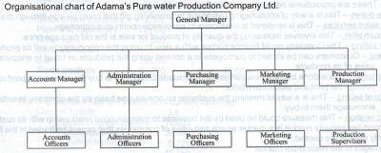

CHAPTER THREE
3.0 LITERATURE REVIEW
3.1 PRODUCTION PROCESS OF PURE WATER

3.1.1. Water Sourcing
- Water is obtained from natural sources such as boreholes, wells, rivers, or municipal supply.
- The raw water is stored in a reservoir or underground tank to stabilize its composition before treatment.

3.1.2. Coagulation and Flocculation (If Needed)
- In cases where water contains high amounts of suspended particles, a coagulant (e.g., aluminum sulfate) is added.
- This process causes small particles to stick together, forming larger particles called flocs, which are easier to remove.

3.1.3. Sedimentation (If Needed)
- The flocs settle at the bottom of a sedimentation tank by gravity, leaving cleaner water on top.
- The clearer water is then directed to the next stage.

3.1.4. Filtration
- Water passes through several layers of sand, gravel, and activated carbon filters to remove particles, bacteria, and organic matter.
- Additional filtration methods include:
  - Microfiltration – removes small particles and bacteria.
  - Ultrafiltration – eliminates viruses and larger molecules.

3.1.5. Reverse Osmosis (RO) Purification
- Water is forced through a semi-permeable membrane at high pressure to remove:
  - Dissolved salts and heavy metals.
  - Bacteria, viruses, and harmful contaminants.
- RO is one of the most effective methods for purifying water.

3.1.6. Disinfection (UV Sterilization & Ozonation)
- UV Sterilization:
  - The water passes through ultraviolet (UV) light, which kills bacteria, viruses, and other microorganisms by destroying their DNA.
- Ozonation:
  - Ozone gas (O₃) is introduced into the water to further disinfect and improve taste.
  - It helps eliminate residual bacteria and odors.

3.1.7. pH Adjustment and Mineralization (If Required)
- In some cases, the pH of purified water needs to be balanced using alkaline minerals like calcium or magnesium.
- Some companies also add essential minerals to improve taste and health benefits.

3.1.8. Storage and Quality Testing
- The purified water is stored in stainless steel tanks or food-grade plastic reservoirs to prevent contamination.
- Quality control tests are conducted to check for:
  - pH Level
  - Turbidity (clarity of water)
  - Total Dissolved Solids (TDS)
  - Microbiological purity (absence of bacteria and viruses)

3.1.9. Packaging and Sealing
- The purified water is transported to the packaging section where it is either:
  - Filled into sachets using an automatic sachet-filling machine.
  - Bottled into plastic containers using a bottling machine.
- The bottles or sachets are then heat-sealed to prevent contamination.

3.1.10. Labeling and Distribution
- The packaged water is labeled with brand details, manufacturing date, and regulatory certifications.
- The final product is distributed to the market for retail and consumer use.

3.2 Water Quality Control in Pure Water Production
Water quality control is essential in pure water production to ensure that the final product meets health, safety, and regulatory standards. It involves several checks, monitoring systems, and laboratory tests to confirm that the water is free from contaminants and safe for consumption. Below are the key aspects of water control in pure water production:

3.2.1. Source Water Quality Testing
Before beginning the treatment process, raw water from boreholes, rivers, or municipal sources must be tested for:
- Turbidity (clarity of water)
- pH Level (acidity or alkalinity)
- Total Dissolved Solids (TDS) (level of dissolved minerals and salts)
- Microbiological Contamination (presence of bacteria, viruses, and fungi)
- Heavy Metals (e.g., lead, arsenic, mercury)
If the source water does not meet safety standards, additional treatments like pre-filtration, sedimentation, and chemical treatment are applied before purification.

3.2.2. Filtration Control
- Sand and carbon filters are monitored to ensure they effectively remove sediments, chlorine, and organic matter.
- Filtration systems are regularly cleaned and replaced to maintain efficiency.
- The flow rate of water through filters is controlled to prevent clogging.

3.2.3. Reverse Osmosis (RO) System Monitoring
- The RO membrane must be checked for efficiency in removing dissolved solids, bacteria, and heavy metals.
- The pressure and temperature of water in the RO system must be controlled to prevent damage to the membranes.
- Regular flushing and replacement of membranes ensure consistent water purity.

3.2.4. Disinfection Control (UV & Ozonation)
- UV Sterilization: The intensity of UV light is monitored to ensure all bacteria and viruses are destroyed.
- Ozonation: The ozone gas concentration is controlled to prevent overuse, which could alter the taste of water.

3.2.5. pH Adjustment and Remineralization Control
- If required, pH levels are adjusted using food-grade minerals to maintain water balance.
- Calcium and magnesium may be added to improve the taste and mineral content.

3.2.6. Microbiological and Chemical Testing
Water samples are regularly tested in a laboratory for:
- Bacteria (E. coli, coliforms, etc.)
- Chlorine levels (to ensure excess chlorine is removed)
- Nitrate, sulfate, and fluoride levels
If any contamination is detected, the entire batch is rejected, and production is halted until the issue is resolved.

3.2.7. Storage and Packaging Control
- Water is stored in sanitized stainless steel or plastic tanks to avoid contamination.
- Automated filling machines are used to ensure hygienic and precise packaging.
- The packaging process is conducted in a clean environment to prevent microbial contamination.

3.2.8. Final Quality Control and Compliance
Before distribution, final checks ensure that:
- pH levels are within acceptable limits (typically 6.5 – 8.5).
- TDS levels are within standards (usually below 100 ppm for pure water).
- Bottles and sachets are properly sealed to prevent leaks and contamination.
- The product meets the standards of regulatory agencies (e.g., NAFDAC, FDA, WHO).

3.2.9. Continuous Monitoring and Documentation
- Regular audits and maintenance are performed on filtration and purification systems.
- Records of test results, maintenance activities, and quality checks are kept for regulatory compliance.
- Employees undergo training on hygiene and best practices in water production.
CHAPTER FOUR

4.0 INSTRUMENTS USED IN PURE WATER PRODUCTION
Below is a list of key instruments used in the production of pure water, their functions, and their importance in the process:

4.1. Borehole and Submersible Pump
- Function: Extracts raw water from underground sources like boreholes or wells.
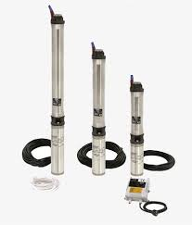
- Importance: Provides a reliable and consistent water source for the purification process.

4.2. Sand and Carbon Filters
- Function:
  - Sand Filter: Removes large particles, dirt, and sediments.
  - Carbon Filter: Removes chlorine, odors, and organic contaminants.
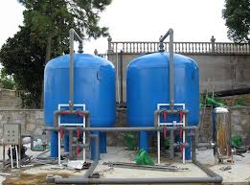
- Importance: Improves the clarity and taste of water while preparing it for further purification.

4.3. Reverse Osmosis (RO) System
- Function: Uses a semi-permeable membrane to remove dissolved solids, heavy metals, and microorganisms.
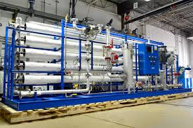
- Importance: Ensures high-quality purification by eliminating impurities and contaminants.

4.4. Ultraviolet (UV) Sterilizer
- Function: Uses UV light to kill bacteria, viruses, and other microorganisms.
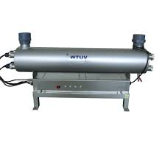
- Importance: Provides an effective, chemical-free disinfection method to ensure microbial safety.

4.5. Ozone Generator
- Function: Produces ozone gas (O₃) that is dissolved in water to kill bacteria, viruses, and improve water freshness.
- Importance: Enhances water safety, removes unpleasant odors, and improves taste.
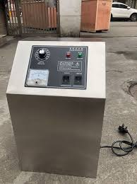

4.6. pH Meter
- Function: Measures the acidity or alkalinity of the water.

- Importance: Ensures water maintains a balanced pH level for safe consumption.

4.7. Total Dissolved Solids (TDS) Meter
- Function: Measures the concentration of dissolved solids in water (minerals, salts, and impurities).
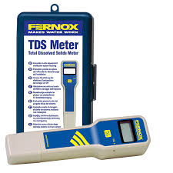
- Importance: Helps determine the effectiveness of the filtration and purification process.

4.8. Turbidity Meter
- Function: Measures the clarity of the water by detecting suspended particles.
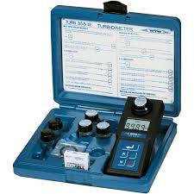
- Importance: Ensures water is visually clear and free from sediments.

4.9. Storage Tanks
- Function: Stores purified water before packaging.
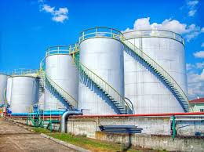
- Importance: Provides a sanitary and contamination-free environment for treated water.

4.10. Sachet Water Packaging Machine
- Function: Automatically fills and seals sachets with purified water.
- Importance: Ensures hygienic, contamination-free packaging with high efficiency.
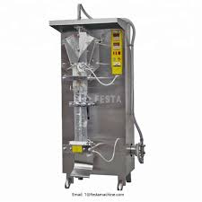

4.11. Bottling Machine
- Function: Fills purified water into bottles and seals them with caps.
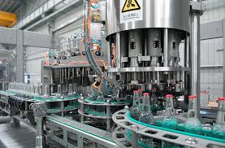
- Importance: Ensures accurate filling and proper sealing of bottled water for distribution.

4.12. Microbiological Testing Kit
- Function: Tests water samples for bacteria and other microorganisms.
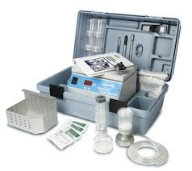
- Importance: Ensures the water is safe for drinking and meets health regulations.

CHAPTER FIVE
OBSERVATIONS AND RECOMMENDATIONS
5.1 OBSERVATIONS
- The company strictly adheres to hygiene and regulatory standards.
- The use of automation has improved efficiency and reduced contamination risks.
- Regular maintenance of machines ensures optimal performance.
5.2 RECOMMENDATIONS
- Regular quality control checks should be emphasized to maintain product safety.
- Staff should undergo continuous training on hygiene and safety practices.
- The company should explore energy-efficient systems to reduce operational costs.
5.3 CONCLUSION
The industrial training provided me with hands-on experience in the production of pure water. I learned the importance of quality control, hygiene, and the use of specialized instruments in ensuring safe and clean water production. This experience has bridged the gap between my academic knowledge and practical industrial applications.
5.4 REFERENCES
- Industry standards for water purification.
- Manuals for water treatment and packaging equipment.
- Health and safety regulations in water production.
5.5 APPENDICES
- Pictures of production processes and instruments.
- Daily activity logs during the SIWES training period.

