

A TECHNICAL REPORT
ON
STUDENT INDUSTRIAL WORK EXPERIENCE SCHEME (SIWES)
HELD AT
KABOLA TECHNOLOGY KARA MARKET

PRESENTED BY
LATEEF HABEEB OPEYEMI
ND/23/COM/PT/0070

SUBMITTED TO:
THE DEPARTMENT OF COMPUTER SCIENCE, INSTITUTE OF INFORMATION COMMUNICATION AND TECHNOLOGY (IICT), KWARA STATE POLYTECHNIC, ILORIN.
IN PARTIAL FULFILLMENT OF THE REQUIREMENTS FOR THE AWARD OF NATIONAL DIPLOMA (ND) IN COMPUTER SCIENCE

SEPTEMBER TO NOVEMBER 2024

DEDICATION
This technical report was dedicated to Almighty God the custodian of wisdom and the giver of knowledge and to my loving family especially to my ever supportive parent.
ACKNOWLEDGEMENT
All praise and adoration goes to one but Almighty God for his infinite mercies over my life and for giving me the power and wisdom to put this piece together. My appreciation and gratitude goes to my beloved parent
Furthermore my profound goes to my HOD and my lecturers in the department. I pray God shall bless you all abundantly.
TABLE OF CONTENTS
Title Page
Dedication
Acknowledgement
CHAPTER ONE
1.1 Introduction
1.2 Definition of SIWES
1.3 Goals and Objectives of SIWES
CHAPTER TWO
2.0 Brief History of the Company
Organizational Structure
2.2 Aims and Objectives of the Organization
CHAPTER THREE
3.1 Reporting on Daily Work Carried Out
CHAPTER FOUR
Challenges and Gains Encounter in Place of Attachment
CHAPTER FIVE
5.1 Conclusion
5.2 Recommendation
CHAPTER ONE
1.1 INTRODUCTION
The practical background of the computer science student industrial work is purposely set up in partial fulfillment of the requirements for the award of National Diploma (ND) in computer science. I fulfilled my compulsory four months industrial training at KABOLA TECHNOLOGY KARA MARKET
The report comprises of my experience, knowledge and my involvement in the job description during the course of my SIWES.
The Student Industrial Working Experience Scheme (SIWES) is a program which express student to practical knowledge industries. Companies sites and government parastatals. The program enables students to adamantine more practical knowledge in their field of studies in relation to their classroom lectures. It also gives strong and bright picture of the technological knowledge. As good want it,
The Industrial Training Fund (ITF) was established in 1971, the nationwide climate of accelerated economic activities of the early 1970’s as manpower development agency of Nigeria, especially to provide services and facilities for the development of skilled manpower, particularly in the industrial and commercial sector of the economy.
The Industrial Training Fund was enabled by decree no. 47 of 8th of October 1971. It was therefore one of the major leverages by which the government hope to transform the economy to Nigerians that would be competent to perform the specialized skills required to manage essential sectors of the national economy.
The scheme is designed to take place outside the school in every different environment rather than the one they are use to student environment. Students are allowed to choose a reputable organization of their choice. The lucky one will have to go in ministries of their place decided but the school SIWES offer, a lots of time students that fall into this categories complain a lots of skills and experienced are lost rather than unlike in private business where more gained.
Student Industrial Work Experience Scheme is a programme organized by Federal Government in conjunction with the aim to break the barrier that exists between practical and theories to enable students to develop more practical.
SIWES can also be defined as an important program organized by the Industrial Training Fund (ITF) in order to impact and promote understanding practical for the experience gained in school. SIWES allows the students to acquire deep knowledge about what is taught in school.
1.2 DEFINITION OF SIWES
SIWES means Student Industrial Work Experience Scheme. It is a course by which students are exposed to practical training in their respective field of study. SIWES is the acceptable skill training programme set up as the requirement for the award of National Diploma (ND) certificate for student studying Electrical Electronic Engineering. Its effort is to bridge the gap existing between theory and practical aspect of engineering and some applied sciences.
1.3 GOALS AND OBJECTIVES OF SIWES
- To enable students to be practically oriented.
- To enable students to handle equipment and machines in their field of study.
- To expose students to challenges to be face in their course of study and their fields after graduation.
- To access the performance of the students in the practical aspects of their course of study.
- To up rise the knowledge of students on their interest in their course of study.

CHAPTER TWO
2.0 BRIEF HISTORY OF THE COMPANY
Kabola Technologic and IT solution was private organization, it obtained and manage by Mr Muritala Kabir

ORGANIZATIONAL STRUCTURE
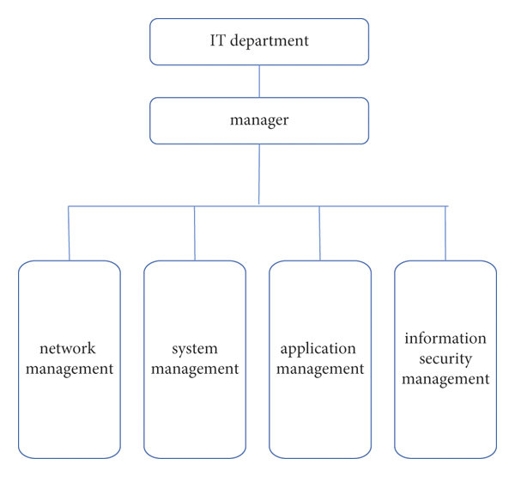

2.2 AIMS AND OBJECTIVES OF THE ORGANIZATION
- To improve efficiency in various processes and operations within an organization. It involves automating repetitive tasks, streamlining workflows, and implementing systems that increase productivity and reduce manual effort.
- To fosters effective communication and collaboration among individuals and teams
- To supports decision-making processes by providing accurate and timely information. It involves collecting, analyzing, and presenting data in a format that aids decision-makers in evaluating options, identifying trends, and making informed choices.
- To implement measures such as firewalls, encryption, access controls, and regular backups to protect sensitive information from unauthorized access, breaches, and data loss.
CHAPTER THREE
3.1 Reporting on Daily Work Carried Out
WEEK 1: I was introduced to all members in the organization and I was given rules and regulation of the organization, Kabola technologic and IT solution was private organization, it obtained and manages by Mr Muritala Kabir.
WEEK 2: I learnt web design encompasses many different skill and discipline in the production and maintenance of websites, web design partially overlaps web engineering in the broader scope of web development
WEEK 3: I was taught website development is also the setup of page application using the HTLM marsh up language ( hyper text markup language) D vs code editor d browse d notepad tt d sublime text d atom (chrome, fire fox, edge, sarfat)
WEEK 4: I was taught HMTL tags are the opening tag () tag the closing tag(1) and they are used to indicate to the browser the elements of the HMTL, HMTL elements are always written starting with opening tag (strong) and a design tag (1 strong)
WEEK 5: I was taught it’s through HMTL is computer in this we are using an inbuilt editor or a browser so no need to follow the steps, in computer you need an editor (eng notepad ++) for typing HMTL code, an operation can only be define as an manufacture and we have a practical
WEEK 6: The (IDOCTYPE HMTL) define the page is HMTL (HMTL): this tag is the root of an HMTL page, this tag contains meta information about the page, this tag can include a title for the documents scripts styles meta information and more
WEEK 7: I was taught how to use H1, H2, H3, H4.H5,H6 it reduce text type size for largest H6 for smallest, the (form) tag is to place the (HMTL) contract it is also used to send form data to the server (styles) it used to define internal style of the web pages the standard way to write this tag is inside an HMTL document then we have practical
WEEK 8: : I learnt how tag is used as containers which can hold different element it can use have any type of HMTL element (table) link, image, dill and e.t.c (tr) tag in HMTL (table row) to start the row (tr) tag is use

CHAPTER FOUR
CHALLENGES AND GAINS ENCOUNTER IN PLACE OF ATTACHMENT
Gains:
- Students gain practical experience with cutting-edge technology and tools, enhancing their technical skills.
- Exposure to real-world projects helps students develop critical skills such as programming, troubleshooting, and project management.
- Students can connect with professionals in the tech industry, which may lead to internships, job offers, or mentorship.
- Working in a technology center allows students to understand industry standards and practices, bridging the gap between theory and practice.
- Students learn to tackle real-life technical challenges, improving their analytical and problem-solving abilities.
Challenges:
- The fast-paced nature of technology can be overwhelming, as students may struggle with unfamiliar tools and systems.
- Balancing multiple projects and deadlines can be challenging, requiring effective time management skills.
- Some students may find a lack of mentorship or supervision, making it difficult to navigate complex tasks.
- Technology centers may face budgetary limitations, which can affect the availability of tools and resources for students.
- Adapting to team dynamics and workplace culture can be a challenge, especially for students new to professional environments.

CHAPTER FIVE
5.1 CONCLUSION
The Student Industrial Work Experience Scheme (SIWES) has contributed to my exposure and training in the field of computer science.
The programme also enabled me to put into practice the knowledge gained in the classroom with the actual industrial experience and to develop a critical and realistic approach to problems and their solutions in the electrical field. Kabola Technology gave me good practical knowledge about my course of study. Also all their staff are so friendly and kind to the extent that one cannot distinguish one person from the others.
5.2 RECOMMENDATION
Under the Kabola Technology has a lot of experience for student that has interest in computer training, IT experience and how to make use of IT tool.
The following should be taken into consideration.
The ITF supervisor and the department supervisor should make it necessary and important to visit student at their various locations. This would enable them to know the problem and state of their students. IT placement is now becoming difficult due to an increase the number of students applying for placement, the school’s ITF unit should take it upon themselves to provide for the students who have not gotten placement.

