

A TECHNICAL REPORT
STUDENT INDUSTRIAL WORKING EXPERIENCE SCHEME
(SIWES)

HELD AT:
XTREME SUPERMARKET NO. 18 OLUWAKEMI STREET ALAPERE KETU LAGOS

PREPARED BY:
ADELEKE HALIMAT GBONJUBOLA
ND/23/PSM/FT/0080

SUBMITTED TO:

DEPARTMENT OF PROCUREMENT AND SUPPLY CHAIN MANAGEMENT
KWARA STATE POLYTECHNIC, ILORIN

IN PARTIAL FULFILLMENT OF THE REQUIREMENTS FOR THE AWARD OF NATIONAL DIPLOMA (ND) IN PROCUREMENT AND SUPPLY CHAIN MANAGEMENT

Sept., Nov., 2024
DEDICATION
I dedicate this technical report to the Almighty GOD, the giver of knowledge, wisdom and who is rich in mercy.

ACKNOWLEDGEMENT
I take this opportunity to express my profound gratitude and deep regards to the creator of heaven and earth, the one who knows the beginning and the end, the alpha and the omega. my sincere gratitude also goes to my guidance Mr. and Mrs. Adeleke for their financial support and word of encouragement during my SIWES Programme and also to those who stood by me during my SIWES programme, thank you all. I also take this opportunity to express a deep sense of gratitude to compliment my supervisor at the place of my attachment for taking his time for my practical knowledge and for his cordially support, valuable information and guidance which helped me in completing my SIWES through various stages may Almighty God bless you abundantly.
TABLE OF CONTENT
Dedication
Acknowledgement
CHAPTER ONE
  - Introduction to SIWES
  - History of SIWES
  - Objectives of the Programme
  - Objectives of Establishment
CHAPTER TWO
2.1 Activities of place of Attachment
2.2. Precaution Taken in the Place of Attachment
2.3 Uses of the Organization Equipment
CHAPTER THREE
Reporting on Work Carried Out
3.1 Reporting on Daily Work Carried Out
CHAPTER FOUR
Challenges and Gain Encounter In Place of Attachment
CHAPTER FIVE
Summary, Conclusion and Recommendations
5.1 Summary
5.2 Conclusion
5.3 Recommendations
CHAPTER ONE
1.1 INTRODUCTION TO SIWES
Students Industrial Work Experience Scheme (SIWES) is a Skills Training Program designed to prepare and expose Students of Universities, Polytechnics, Colleges of Technology, Colleges of Agriculture and Colleges of Education for the Industrial Work situation they are likely to meet after graduation. The Scheme affords Students the opportunity of familiarizing and exposing themselves handling equipment and machinery that are usually not available in their institutions.

1.2 HISTORY OF SIWES
The Students’ Industrial Work Experience Scheme (SIWES) was initiated in 1973 by the Federal Government of Nigeria under the Industrial Training Fund (ITF) to bridge the gap between theory and practice among products of our tertiary Institutions. It was designed to provide practical training that will expose and prepare students of Universities, Polytechnics, and Colleges of Education for work situation they are likely to meet after graduation.
Before the establishment of the scheme, there was a growing concern among the industrialists that graduates of institutions of higher learning lacked adequate practical background studies preparatory for employment in industries. Thus the employers were of the opinion that the theoretical education going on in higher institutions was not responsive to the needs of the employers of labour.
As a result of the increasing number of students’ enrolment in higher institutions of learning, the administration of this function of funding the scheme became enormous, hence ITF withdrew from the scheme in 1978 and was taken over by the Federal Government and handed to National Universities commission (NUC), National Board for Technical Education (NBTE) and National Commission for Colleges of Education (NCCE). In 1984, the Federal Government reverted back to ITF which took over the scheme officially in 1985 with funding provided by the Federal Government.
1.3 OBJECTIVES OF THE PROGRAMME
The specific objectives of SIWES are to:
- Provide placements in industries for students of higher institutions of learning approved by relevant regulatory authorities (NUC, NBTE, NCCE) to acquire work experience and skills relevant to their course of study
- Prepare students for real work situation they will meet after graduation.
- Expose students to work methods and techniques in the handling of equipment and machinery that may not be available in schools.
- Make transition from school to the labour market smooth and enhance students’ conduct for later job placement
- Provide students with the opportunity to apply their knowledge in real life work situation thereby bridging the gap between theory and practice
- Strengthen employer involvement in the entire educational process and prepare students for employment in industry
- Promote the desired technological knowhow required for the advancement of the nation.
1.4 OBJECTIVES OF ESTABLISHMENT
The specific objectives of establishment are to:
- To ensure that stock levels align with sales forecasts to avoid losses from overstocking or stockouts.
- To maintain the right amount of stock to meet customer demand while minimizing holding costs.
- To manage inventory effectively to free up cash that can be used for other business operations.
- To ensure product availability to meet customer needs, thereby improving service levels.
- To implement efficient stock management practices to minimize storage, handling, and obsolescence costs.
- To streamline stock processes to improve productivity and reduce waste.
- To provide data and insights on stock trends to inform business decisions and strategies.
- To identify and mitigate risks related to supply chain disruptions or market changes that could affect stock levels.

CHAPTER TWO
2.1 ACTIVITIES OF PLACE OF ATTACHMENT
The experience, knowledge, skills and exposure acquired during the period of attachment in the industrial exercise cannot be over emphasized. I was exposed to certain areas in my course of study, such as:
- Analyzing Customer Preference
- Customer Behavior
- Customer Relation
- Raw Materials
- Work-in-Progress (WIP)
- Finished Goods
- Maintenance, Repair, and Operations (MRO) Supplies
- Consignment Stock
- Safety Stock
- Cycle Stock
- Seasonal Stock
- Returnable Packaging
2.2. PRECAUTION TAKEN IN THE PLACE OF ATTACHMENT
- Promote the use of eco-friendly materials and processes.
- Conduct frequent audits to ensure inventory accuracy and identify discrepancies.
- Use technology to track stock levels, sales patterns, and reorder points in real time.
- Analyze demand forecasts to avoid overstocking or stockouts.
- Keep a buffer of safety stock to accommodate unexpected demand fluctuations or supply chain disruptions.
- Ensure older stock is sold first to reduce the risk of obsolescence and spoilage.
- Provide training on inventory management best practices to improve handling and reduce errors.
- For perishable items, regularly check expiration dates to minimize waste.
- Ensure that storage areas are secure, organized, and climate-controlled as necessary to protect stock.
- Inspect incoming and outgoing stock to maintain product quality.
- Build strong relationships with suppliers to improve communication and reliability in restocking.
- Develop contingency plans for unexpected events that may disrupt supply chains or inventory management.
2.3 USES OF ORGANIZATION STOCK EQUIPMENT
- Production Efficiency: Stock equipment is essential for manufacturing processes, helping to streamline production and maintain consistent quality.
- Inventory Management: Equipment such as barcode scanners and inventory management software helps track stock levels, facilitating better decision-making and reducing errors.
- Storage Solutions: Shelving, racks, and pallets optimize storage space and improve accessibility to inventory, making retrieval easier and faster.
- Material Handling: Equipment like forklifts, pallet jacks, and conveyor belts assist in the safe and efficient movement of goods within warehouses and production areas.
- Quality Control: Tools and equipment for inspection and testing ensure that products meet quality standards before reaching customers.
- Maintenance and Repairs: Stock equipment includes tools for maintenance and repair tasks, ensuring that machinery and systems are functional and reliable.
- Safety and Compliance: Safety equipment helps protect employees and comply with regulations, reducing the risk of accidents and legal issues.
- Logistics and Distribution: Equipment such as trucks and shipping containers is vital for transporting goods to customers or between facilities.
- Cost Management: Properly maintained stock equipment can reduce operational costs by improving efficiency and reducing waste.
- Employee Productivity: Ergonomic tools and equipment enhance employee comfort and productivity, leading to better performance.

ORGANIZATION STRUCTURE/ORGANOGRAM
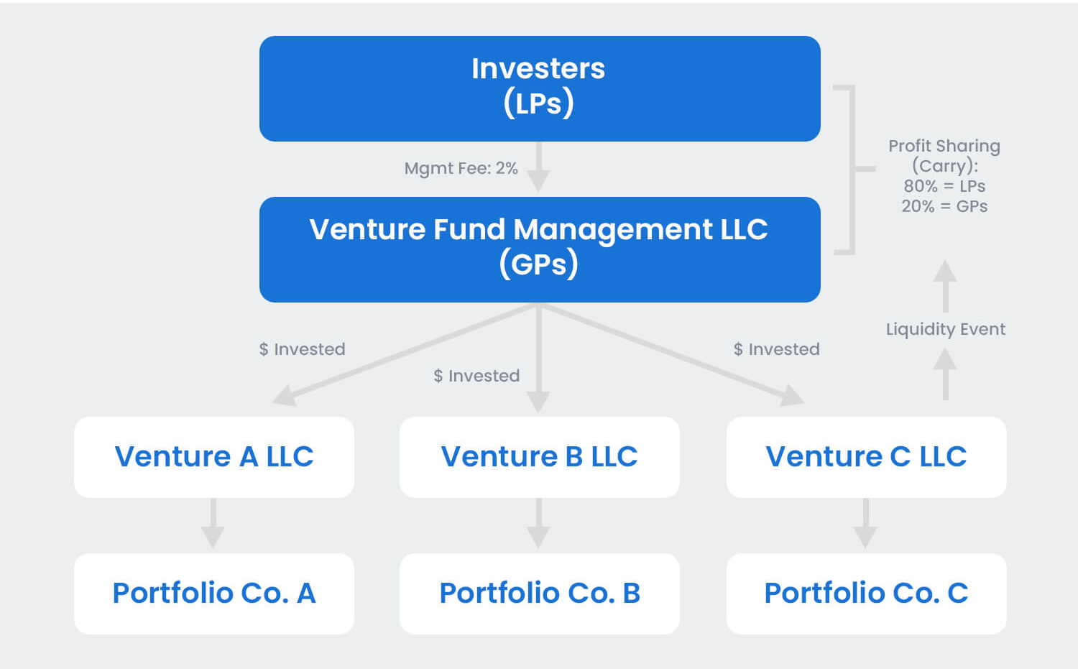
CHAPTER THREE
REPORTING ON WORK CARRIED OUT
3.1 Reporting on Daily Work Carried Out
WEEK 1: I was introduced to all members in the organization and I was given rules and regulation of the organization. Also, I learnt how to analyzed customer preference and customer behavior and their role of e-commerce in modern retail.
WEEK 2: I assisted in the production section, ensuring freshness and quality of items. I also managed to checkout counter during lunch hour
WEEK 3: I learnt about customer service skills related to product selection. I also conduct price check for customers
WEEK 4: I learnt on how to build rapport with customers and ensuring satisfaction. Also, I learnt about front office and how to interact with customers to create a great experience from helping them check-in and creating personality on their interest.
WEEK 5: I practicalized on how to handle and cards and also observing investor audits
WEEK 6: I learnt on how to prepare the final report and how to review all experience
WEEK 7: I learnt about ordering supplies and weekly discussion
WEEK 8: I learnt about the importance of sales service in the industry and also I work as supervisor by assisting the collection of feedback
CHAPTER FOUR
CHALLENGES AND GAIN ENCOUNTER IN PLACE OF ATTACHMENT

GAINS
Practical Experience
Hands-On Skills: I gain practical skills and knowledge about the inventory audit management and assembly processes of organization activities
Real-World Application: I apply theoretical knowledge from their studies in a real-world setting, and enhancing their understanding.
Industry Exposure
Understanding the Market: I learn about market trends, consumer preferences, and competition in industry
Networking Opportunities: Working alongside professionals allows me to build valuable industry connections.
Technical Knowledge
Learning Technology: Exposure to modern technologies used in organization
Quality Control Practices: Understanding quality assurance processes and standards in manufacturing.
Problem-Solving Skills
Real-World Challenges: I encounter and solve practical problems, enhancing their critical thinking and adaptability.
Project Management: Involvement in projects fosters skills in planning, executing, and managing tasks.

CHALLENGES
Adjustment to Work Environment
Workplace Dynamics: Navigating different personalities and team dynamics as been a difficulty.
Learning Curve: I faced a steep learning curve when dealing with complex machinery and processes.
Understanding Technical Jargon: Familiarity with industry-specific terminology.

Time Management
Balancing Responsibilities: I manage their time effectively between work responsibilities and personal commitments.
Meeting Deadlines: The pressure to meet production deadlines can be stressful.
Limited Scope of Work
Repetitive Tasks: I assigned to repetitive tasks, which that has been less engaging.
Pressure to Perform
Expectations: I felt pressure to perform at a high level, which can lead to anxiety.
Feedback and Criticism: Receiving constructive criticism can be challenging, especially for those not accustomed to it.
Safety Concerns
Working with Machinery: I experience inherent risks associated with working in a industrial environment, necessitating careful attention to safety protocols.
CHAPTER FIVE
SUMMARY, CONCLUSION AND RECOMMENDATIONS
5.1 SUMMARY
Organizational stock activities encompass all processes related to the management of inventory within a business. These activities are crucial for maintaining an efficient supply chain, ensuring product availability, and optimizing operational costs. Effective stock management involves various functions, including procurement, storage, inventory tracking, and distribution.
Organizations aim to balance stock levels to meet customer demand while minimizing excess inventory and associated holding costs. Key activities include regular inventory audits, demand forecasting, and the implementation of inventory management systems. By leveraging technology and best practices, businesses can enhance visibility and control over their stock, leading to improved service levels and profitability.
5.2 CONCLUSION
In conclusion, effective organizational stock activities are essential for maintaining a smooth and efficient supply chain. By managing inventory strategically, businesses can not only meet customer demands but also optimize costs and enhance overall productivity. The importance of accurate inventory tracking, regular audits, and the use of technology cannot be overstated, as these practices contribute significantly to minimizing risks associated with stock management.
5.3 RECOMMENDATIONS
- Siwes supervisors should make sure they visit the students in their place of attachment for proper monitoring, improvement and progress for the benefit of the societies as a whole.
- Employees should seek ongoing training and education to stay updated on industry trends and technological advancements.
- Engaging with industry professionals through workshops, trade shows, and online platforms can provide valuable insights and opportunities for career advancement.
- Implement eco-friendly practices, such as reducing water and energy usage, using biodegradable products, and promoting recycling programs to appeal to environmentally-conscious travelers.
- Implement technology solutions that provide real-time tracking and analytics to enhance decision-making.
- Invest in training programs to ensure that employees are well-versed in inventory management techniques and best practices.
- Foster communication and collaboration with suppliers to improve lead times and reliability.

