
A TECHNICAL REPORT ON
STUDENTS INDUSTRIAL WORK EXPERIENCE SCHEME [SIWES]
Held at
ABSOLUTION ELECTRICAL AND SOLAR ENERGY SERVICES
KM 12, Ijoko Road, Akute, Near Lambe Junction, Via Akute, Ogun State
Prepared by:
FALADE IBRAHIM OLAYINKA
ND/23/EEE/PT/0024
SUBMITTED TO
DEPARTMENT OF ELECTRICAL/ELECTRONICS ENGINEERING
INSTITUTE OF TECHNOLOGY (I.O.T)
KWARA STATE POLYTECHNIC, ILORIN

IN PARTIAL FULFILMENT OF THE REQUIREMENT FOR THE AWARD OF NATIONAL DIPLOMA (ND), IN ELECTRICAL/ELECTRONICS ENGINEERING

Sept., – Dec., 2024
DEDICATION
I dedicate this technical report to the Almighty God, the giver of knowledge, wisdom and who is rich in mercy.

ACKNOWLEDGEMENT
I take this opportunity to express my profound gratitude and deep regards to the creator of heaven and earth, the one who knows the beginning and the end, the alpha and the omega, the Almighty God and also to my guides Mr and Mrs FALADE, and to all those who has helped me during my SIWES programme. The blessings, help and guidance given by them, time to time has carry me so this far and shall carry on the journey of life on which I am about to embark. I also take this opportunity to express a deep sense of gratitude to compliment my mentor for his cordial support valuable information and guidance which helped me in completing my SIWES through various stages.
Lastly my deep regard to the best and most inspiring brothers, sisters and friends may Almigthy God continue to bless you all.

TABLE OF CONTENT
Title page
Table of content
Dedication
Acknowledgements
TABLE OF CONTENTS
CHAPTER ONE
1.1 Introduction of Siwes
1.2 History of Siwes
1.3 Aims and Objective of Siwes
1.4 Organization Chart
CHAPTER TWO
2.0 Electrical Tools And Equipment
CHAPTER THREE
3.1 House Wiring
3.2 Different Types Of Electrical House Wiring Systems
3.3 Component In Electrical Distribution Or House Wiring
3.4 Types Of Switch
CHAPTER FOUR
4.1 How To Install a Ceiling Fan
4.2 Electric Distribution Board
4.3 Steps To Install Electrical Distribution Board
4.4 Laying Of Underground Cables
CHAPTER FIVE
5.0 Conclusion
5.1 Recommendation to the Organization Concerning the Siwes Programmed

CHAPTER ONE
1.1 Introduction of Siwes
Student industrial work experience scheme (SIWES) was established by Industrial Training Fund (ITF) in 1973 to solve the inadequacy on practical skills menace in preparation of Nigerian graduates of tertiary institutions for their relevancy in industries while employed.
The program aimed to expose students to industrial based skills necessary for a smooth transition from school to the industry, opportunity for being familiar and exposed to the needed experience in handling machinery. Equipment and responds to challenge in labour market (Company or Industries) which may usually not available in educational institution. At the same time, it also helps the student to promote and encourage the acquisition of skill in industrial and commercial place with a view to meet the need of the economy.
Student industrial work experience scheme (SIWES) has been necessarily required for the award of diploma and degree certificate in specific discipline in Nigeria Institutions of higher learning in accordance with the educational policy.
1.2 History of Siwes
Student Industrial Work Experience Scheme (SIWES) was established by the industrial training fund (ITF) in 1973, to solve the problem of lack of adequate practical skills. it was design by tertiary institution to expose student to the practical skills. It was design by tertiary institution to expose student to the practical aspect of his/her course of study. it involve the attachment of a student organization in line with his or her respective course of the study that can provide the training and experience require in the industry, as these experience and training cannot be obtained in the lecture room but the theoretical knowledge taught in lecture rooms shall be applied by the student in real industrial schemes.
The Industrial Training Fund (I.T.F) was setup under act No:47 of 1971 (as amended up to date) to promote and encourage the "acquisition of skills in industry and commerce with a view to generating a pool of indigenous trained man power sufficient to meet the need of the economy"
1.3 Aims and Objective of Siwes
- It expose student to different work method and techniques in handling equipment machineries that may not be available in the education institution.
- Prepare student for industrial work situation they are likely meet after graduation
- It prepare avenue for student to acquired industrial skills and experience during their course of study
- The scheme exposes student industry based skills which is necessary for smooth transition from classroom to the world of work
1.4 Organization Chart
Manage

Finnace Unit
Secretary

Electrical Unit
Staff
Equipment/Tools Store
Electronics Unit

CHAPTER TWO
2.0 ELECTRICAL TOOLS AND EQUIPMENT
Before you tackle any electrical project, having the proper tools is essential to getting the job done efficiently, correctly, and more importantly, safely! The old saying, use the right tool for the job, couldn’t be more relevant, especially when it comes to electrical work.
Screwdrivers
This is a must have for any electrician. This tool has so many features rolled into one. It has both screwdrivers and nut drivers built in.



Electric Drill
For larger projects, with a lot of drilling required (wood studs, etc.), then an electric drill is more practical.
Knife
knife for stripping the PVC jacket from Romex, stripping large gauge wire, and for many other jobs as well.
Plier
There are many types of pliers use for different purpose A lineman’s plier, a bull nose plier with a wire cutter, and at least 8″or 9″ handles is also an essential part of the electrical tool list. We use these for cutting, bending, twisting wires, etc.
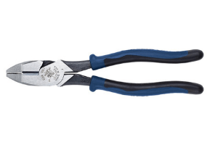

Hammer
Have a good quality, 16oz. claw hammer. You will need this for driving staples, nails, etc.


Tape Measure

Have a good quality, locking tape measure and a 25’length, 1″for measurement

Electrical Tape
Every electrical tool kit should have at least a roll of black electrical tape, and having a few colours like red and blue helps as well for identifying wires, etc.
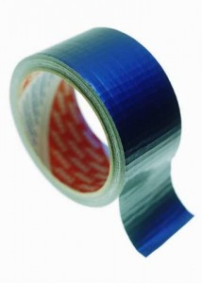

Tool Box or Chest
You need something, even if it’s just a big pail, to keep everything together, and to have a place to put all your tools away. It’s nice to have a good tool box with many compartments to help you keep organized.
Ladders and Step Stools
But you will need the appropriate size for the height you will be working at.
Hacksaw
Critical if working with EMT conduit, flex, etc. If cutting a lot of metal, then an electric reciprocating saw will save you time.
Power Saw or Skill Saw
For cutting studs, blocking and reinforcing boxes, etc.
Wood Chisel
Many uses when working with wood construction.
Conduit Bender
If working with conduit, you will need a hickey bender or any bending tool designed for the conduit you are working with.
Flashlight/Headlam
Is use in some extra light for dark places, or when the power is off while working on existing systems.
Klein Electrician Level.
I use this particular level because it utilizes the rare earth magnets. This thing will stick to anything! It is so useful when installing EMT conduit and installing electrical cabinets. You never have to worry about it dropping and breaking.
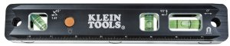

Voltage Detector.
Is use for quickdetermine if a circuit is on or off. I normally use my hand held Klein tester but this one is nice because I can carry it easily on my tool belt.



CHAPTER THREE
3.1 HOUSE WIRING
House electrical wiring is a process of connecting different accessories for the distribution of electrical energy from the supplier to various appliances and equipment at home like television, lamps, air conditioners, etc.
3.2 DIFFERENT TYPES OF ELECTRICAL HOUSE WIRING SYSTEMS
Cleat Wiring: This wiring comprises of PVC insulated wires or ordinary VIR that are braided and compounded. They are held on walls and ceilings using porcelain cleats with groves, wood or plastic. It is a temporary wiring system, therefore making it unsuitable for domestic premises. Moreover, cleat wiring system is rarely being used these days.
Casing And Capping Wiring: It was quite popular in the past but it is considered obsolete these days due to the popularity of the conduit and sheathed wiring system. The cables used in this electric wiring were PVC, VIR or any other approved insulated cables. The cables were carried through the wooden casing enclosures, where the casing was made of a strip of wood with parallel grooves cut lengthwise for accommodating the cables.
Batten Wiring: This is when a single electrical wire or a group of wires are laid over a wooden batten. The wires are held to the batten using a brass clip and spaced at an interval of 10 cm for horizontal runs and 15 cm for vertical runs.
Lead Sheathed Wiring: Lead sheathed wiring uses conductors which are insulated with VIR and are covered with an outer sheath of lead aluminum alloy which contains about 95% lead. The metal sheath gives protection to cables from mechanical damage, moisture and atmospheric corrosion.
CONDUIT WIRING: There are two types of conduit wiring according to pipe installation:
Surface Conduit Wiring: When GI or PVC conduits are installed on walls or roof, it is known as surface conduit wiring. The conduits are attached to the walls with a 2-hole strap and base clip at regular distances. Electrical wires are laid inside the conduits.
Concealed Conduit Wiring: When the conduits are hidden inside the wall slots or chiseled brick wall, it is called concealed conduit wiring. Electrical wires are laid inside the conduits. This is popular since it is stronger and more aesthetically appealing.
Advantages and Disadvantages of Concealed Conduit Wiring System
Advantages
- It is a safe wiring system
- Safe from chemical effects, humidity and other external factors
- No risk of shock
- It is aesthetically appealing
- No risk of wear and tear, fire or damaged cable insulation
- Quite reliable
- Renovations can be easily performed as you can replace old wires easily
Disadvantages
- Expensive as compared to surface conduit wiring
- Changing the location of switches or appliances is difficult
- Installation is complex
- Hard to find defects in the wiring
- Adding additional conduit in future is a tedious task
When the wiring is not done properly or isn’t maintained well, it may lead to dangerous situations such as electrical fires. Therefore, it is important that you take a lot of care while installing electrical wires and cables
THE FOLLOWING TESTS ARE AN ESSENTIAL PART OF THE PROCESSINGS
DEAD TEST:- This is the process of testing completed installations without power supply. The aim is to test the continuity to ensure integrity of the live, neutral and the earth conductors without bridging (short Circuit). Testing the insulation to ensure that there is a high resistance between live and neutral and earth conductors. Testing polarity to ensure all switches and breakers are connected to phase, live conductors.
LIVE TEST- This is the process of testing completed installation with power supply. The aim is to know the load that is connected to each circuit, each phase and entire 415v that is supplied. During this test for earth loop to know the effectiveness of the installation earthing system. Integrity Tests is undertaking by Visual inspection and the use of a multipurpose meter multimeter) or an instrument specifically for recording resistance i.e. an ohmmeter or megger.
3.3 COMPONENT IN ELECTRICAL DISTRIBUTION OR HOUSE WIRING
They are categorized into two which are
- Load
- Switch
An electrical load is an electrical component or portion of a circuit that consumes electric power. This is opposed to a power source such as battery or generator, which produces power. In electric power circuits examples of loads are appliances and light. The term may also refer to the power consumed by a circuit
A switch is an electrical component that can “make or break” an electrical circuit interrupting the current or diverting it from one conductor or another. The mechanism of a switch removes or another. The mechanism of a switch removes or restore the conducting path in a circuit when it is operated.
3.4 TYPES OF SWITCH
- One Way Switch
- Two way switch
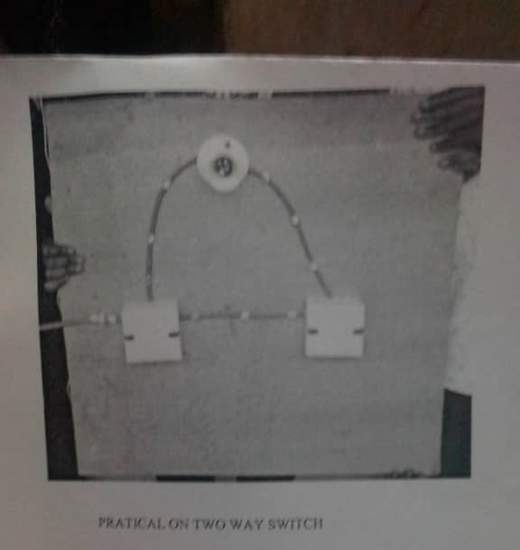
A one way light switch has two terminal which is a common marked as COM or C the common is for the live wire that supplies the input voltage to the switch. The other terminal is marked as Li and is the output to the light fixture.
Diagram of two way switch

CHAPTER FOUR
4.1 HOW TO INSTALL A CEILING FAN
1. Remove the Existing Light Fixture
Make sure electricity to circuit is turned off and carefully remove the glass shade or globe from the old light fixture. Unscrew the retaining nut or screws that hold the fixture to the ceiling. Lower the fixture and disconnect the wires by twisting off the plastic connectors from the ends of the wires.
2. Remove Box and Cut New Hole
Remove the old electrical box from the ceiling. If it's nailed to a joist, pry it free with a flat bar. If it's suspended from a bar, you may have to take off a metal plate to unscrew the box; then pry the bar from the joists. Hold a 1/2-inch-thick pancake box against the ceiling, centered on a joist, and trace around it with a pencil. Cut along the line with a drywall saw.
Tip: Hold a vacuum cleaner wand next to the saw to catch the dust.
3. Attach New Electrical Box
Feed the electrical cable coming from the ceiling through the knockout hole in the pancake box. (Be sure there's a cable connector attached to the knockout hole.) Set the box into the hole cut through the ceiling and press it tight against the underside of the joist. Attach the box to the joist with the two 1 1/2-inch No. 10 hex-head screws provided. Drive in the screws with a drill/driver equipped with a 5/16-inch nut-driver tip. Wrap the cable's bare copper wire around the grounding screw inside the box. Allow the wire end to hang down.
4. Glue on the Ceiling Medallion
Apply a small bead of urethane-based adhesive to the back of the ceiling medallion. Pass the wires through the medallion (above). Center the medallion on the pancake box and press. Fasten it with four 6d finishing nails driven into the joist. Set the nail heads and fill with caulk or spackle.
5. Mount the Ceiling Plate
Hold the fan's metal ceiling plate up to the pancake box and pull the wires through its center hole.
Attach the ceiling plate to the box with two 1 1/2-inch-long 10-32 machine screws.
Tip: If you're going to paint the medallion, do it before installing the ceiling plate.
6. Assemble the Fan Components
- With the fan on the floor, feed the wires coming from the motor through the center of the canopy.
- Set the canopy on top of the motor.
- Next, pass the wires through the hollow down-rod pipe.
- Thread the down-rod pipe into the top of the motor. Use a wrench to tighten the square-head locking screw on the side of the pipe.
Tip: The pipe's threads have a factory-applied coating. Don't remove this coating; it keeps the pipe from unscrewing.
7. Make the Wire Connections
- Hook one side of the canopy onto the ceiling plate.
- Using twist-on wire connectors, join the two green wires to the bare copper wire coming from the cable.
- Join the two white wires.
- Then connect the two black wires.
- Swing the fan up into position against the medallion and secure it with the two canopy screws.
8. Attach the Blades and Lights
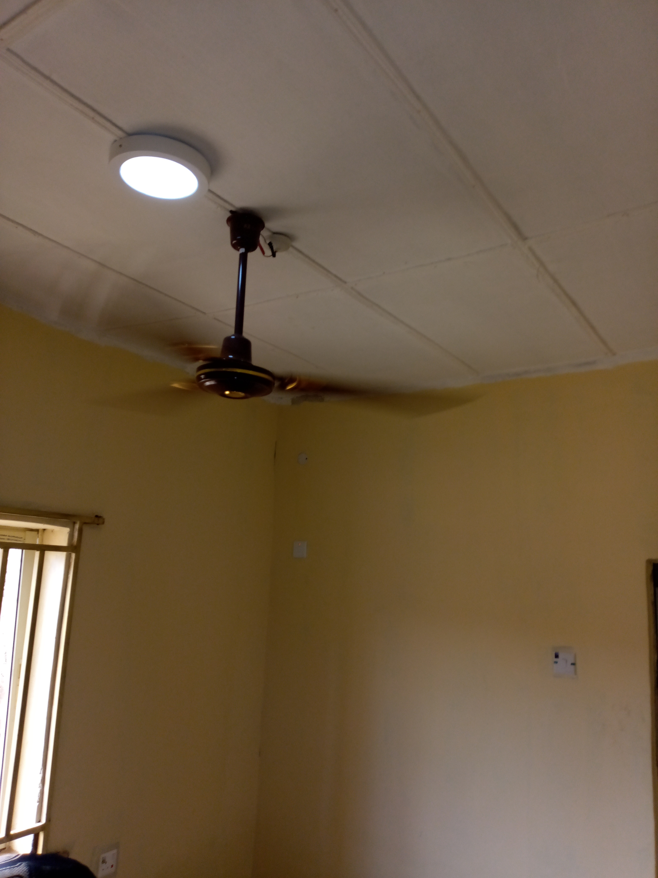
Attach each fan blade to a blade iron (the bracket that holds the blade to the fan). Then, fasten the blade irons to the motor with the screws provided. Plug the fan's light-fixture housing into the wire hanging from the underside of the fan's motor. Install the shades and light bulbs. Screw the plastic holder for the remote control to the wall beside the wall switch.

4.2 ELECTRIC DISTRIBUTION BOARD
A electrical distribution board (or panel board) is a component of an electricity supply system which divides an electrical power feed into subsidiary circuits, while providing a protective fuse or circuit breaker for each circuit, in a common enclosure. Normally, a main switch, and in recent boards, one or more Residual-current devices or Residual Current Breakers with Over current protection will also be incorporated.
Electrical distribution board are sometimes known as:
- Breaker panels
- Fuse box
- Fuse board
- Circuit breaker panel
- Consumer unit, or CU, panel board
The branch distribution boards are used for further distribution of supply to various sub circuits. These are also provided with fuses at the commencement of sub circuit.
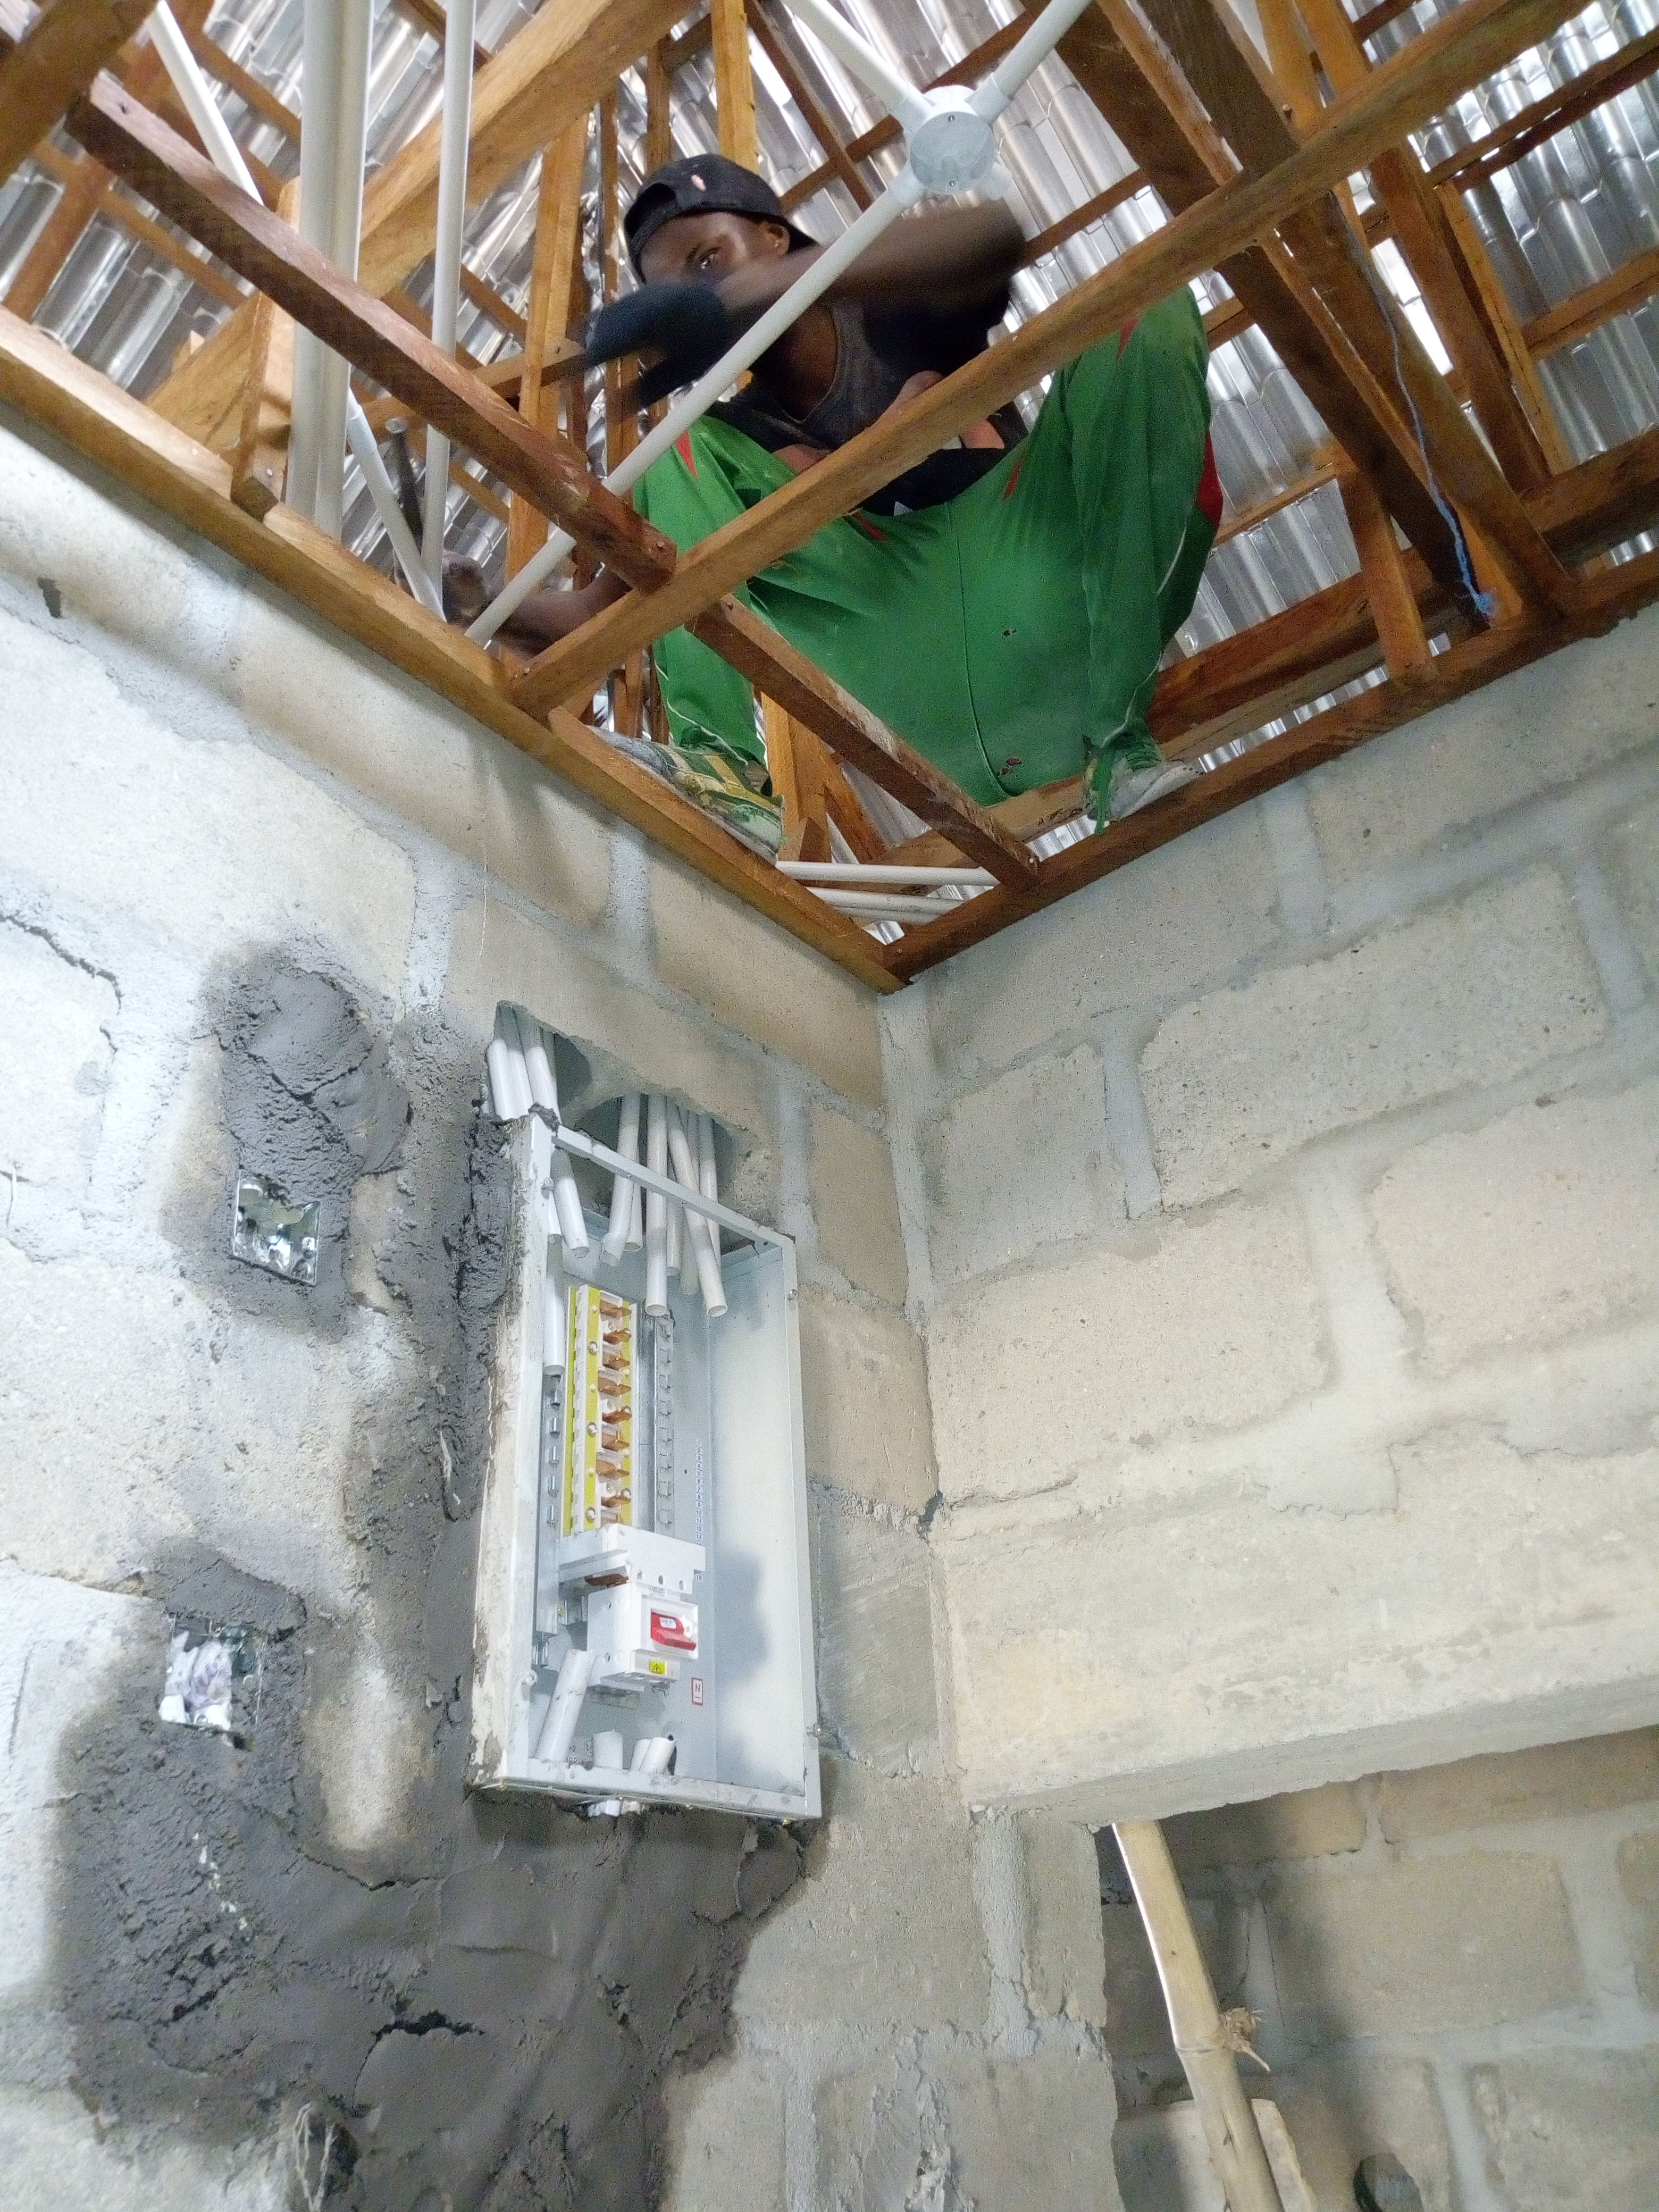

The Electrical Distribution in Distribution Board
The neutral is also further distributed to various sides from the neutral link. One or two spare sub circuits of the same capacity should be provided on each distribution board and branch distribution board for future requirement.
The current rating of circuit, size of fuse element and detail of circuits controlled by each distribution board should also be marked. Strip the wire only enough to make the connection to the main breaker terminal lugs. The black and red wires are the feeder wires in this photo with the black wires being one of the hot feeds and the red wires being the other.
4.3 STEPS TO INSTALL ELECTRICAL DISTRIBUTION BOARD
• You must have to install the feeder pipe at first.
• Install the connector into the panel
• If you’re using metal pipe, place a plastic bushing over the connector threads.
• Level the panel and insert screws through the holes provided in the back of the panel
• Using a tape, pull the electrical feeder wires through the feeder pipe.
• Leave enough wire to get to the opposite side of the panel.
• Bend the two black wires to shape them for easy installation to the main breaker.
• Excess bare wire leaves a safety hazard where the wires can come in contact with other wires and cause a short circuit.
• Connect the neutral wire to the neutral buss. The neutral buss is located on either side of the breakers. It is a silver-colored bar with many smaller screws and connection points
• Connect all of the green and bare copper wires to the ground buss bar.
• If you bend the wires ahead of time, you’ll have a nice, neat wire installation that looks uniform.
• Next, install the circuit feeds to the branch circuit breakers.
• Connect the appropriate sized wire to the correctly rated breaker. Bend the wires so that they keep a neat appearance when the installation is complete.
4.4 LAYING OF UNDERGROUND CABLES
Underground cables are, of course, meant to be installed or laid under the ground. The reliability of underground cable network highly depends upon proper laying of cables, quality of cable joints and branch connections etc. There are three main methods of laying underground cables, which are –
- Direct laying
- Draw-in system
- Solid system.
These three methods are explained below with their advantages and drawbacks.

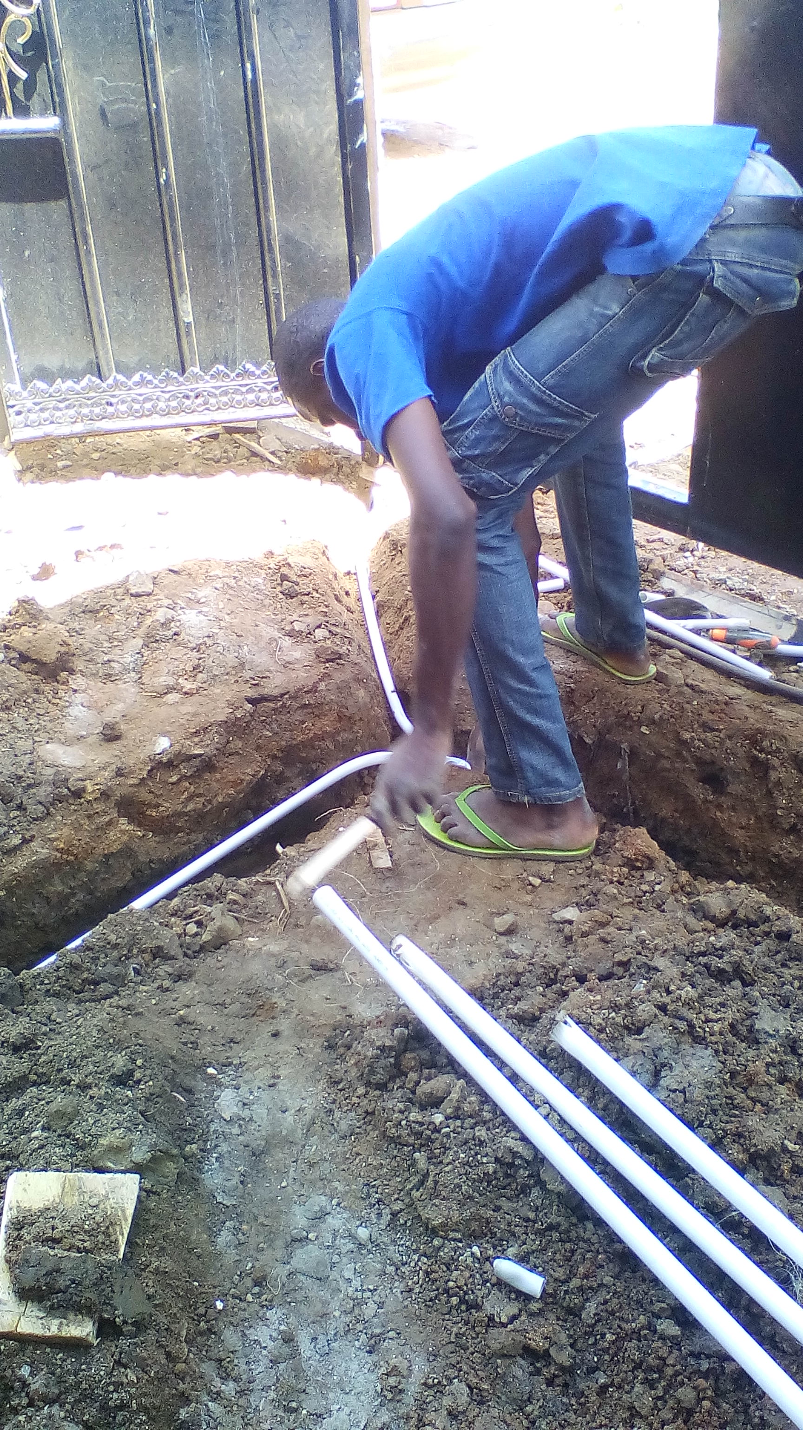

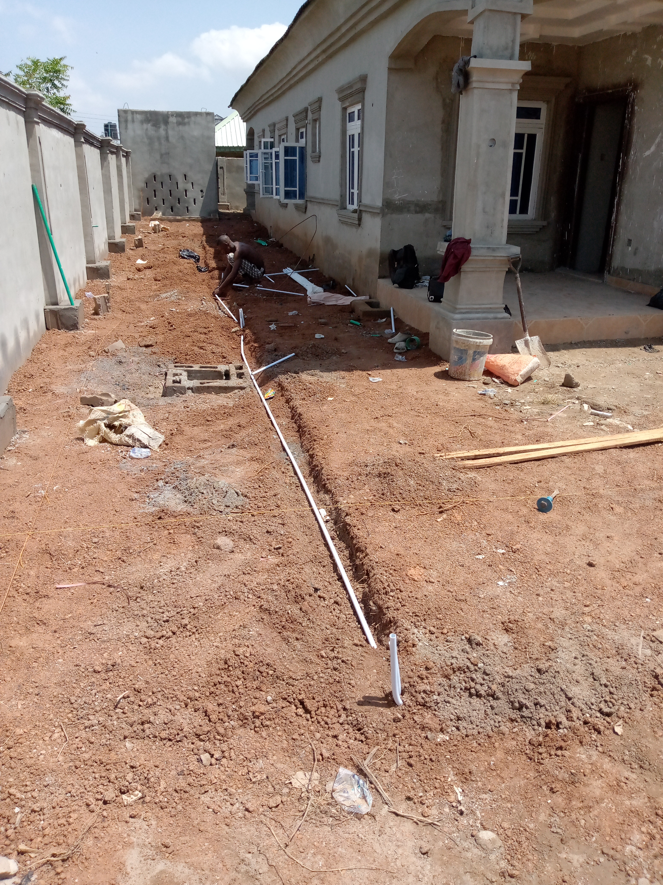

DIRECT LAYING OF UNDERGROUND CABLES
This method is the most popular as it is simple and cheap. The cables to be laid using this method must have the serving of bituminised paper and hessian tape so as to provide protection against corrosion and electrolysis. The direct laying procedure is as follows.
Laying Procedure
- A trench of about 1.5 meters deep and 45 cm wide is dug.
- Then the trench is covered with a 10 cm thick layer of fine sand.
- The cable is laid over the sand bed. The sand bed protects the cable from the moisture from the ground.
- Then the laid cable is again covered with a layer of sand of about 10 cm thick.
- When multiple cables are to be laid in the same trench, a horizontal or vertical spacing of about 30 cm is provided to reduce the effect of mutual heating. Spacing between the cables also ensures a fault occurring on one cable does not damage the adjacent cable.
- The trench is then covered with bricks and soil to protect the cable from mechanical injury.
DRAW-IN SYSTEM
In this method, cast iron or concrete pipes or ducts are laid underground with manholes at suitable positions along the cable route. The cables are then pulled into the pipes from the manholes. Usually, an additional pipe/duct is also provided along with the three cable ducts for carrying relay protection connections and pilot wires. Distance between the manholes should be such that pulling in the cables is easier.

SOLID SYSTEM
In this method, the cable is laid into troughing of cast iron, stoneware, asphalt or treated wood. When the cable is laid into the position, the troughing is filled with a bituminous of asphaltic compound and then covered over. Cables to be laid in this manner could be just lead covered as the troughing provides a good mechanical protection.
This method is very rarely used nowadays as it is more expensive and requires skilled labour and favourable weather conditions

CHAPTER FIVE
5.0 Conclusion
The siwes programmed is an efficient an effective program which as bring much improvement to my field such as welding fabrication, production, and how to know the uses of some tools in the workshop. It is a programmed that bridges the gap between theory and practical aspect, so therefore it has made me to have technical knowledge about what I have learnt theoretically in class.
It is a unique privilege for me to undergo this training, for its enable me to know the service to render as a mechanical engineer. I here appreciate the effort of the federal government and industrial training fund (I.T.F) for improving the technological development of this country.
5.1 Recommendation to the Organization Concerning the Siwes Programmed
I would recommend that the organization should appeal to the federal government to make provision for necessary equipment for the effectiveness of the programme.
I will like to implore the organization to continue in their well accommodative standard.

