

Technical Report
On
STUDENT INDUSTRIAL WORK EXPERIENCE SCHEME (SIWES)

HELD AT
MANDATE SENIOR SECONDARY SCHOOL
Adeta, Ilorin Kwara State
Presented by:
MUSIBAUDEEN RISQIYAH OPEYEMI
ND/23/ACC/PT/0090

Submitted to:
DEPARTMENT OF ACCOUNTANCY, INSTITUTE OF FINANCE AND MANAGEMENT STUDIES
KWARA STATE POLYTECHNIC
P.M.B. 1375, ILORIN

IN PARTIAL FULFILLMENT OF THE REQUIREMENT FOR THE AWARD OF NATIONAL DIPLOMA (ND) IN
ACCOUNTANCY, KWARA STATE
POLYTECHNICS, ILORIN

August – December, 2024
PREFACE
This technical report is written to situate the standard of experience gain by student in the industrial as awareness of continuity at the tertiary level of learning. The technical indulgence of training has been expressed formally in these report required by the constitution of the industrial training office of polytechnic.
This report is divided into five different parts which each part explains the meaning of siwes, major organization, work actually carried out and experienced gain. Even challenged faced, conclusion and recommendation are also involved.

DEDICATION
I dedicate this report to the Almighty Allah, for granting me the privilege to commence this course. Also to my reliable and respectful loving parent: Mr. & Mrs. Musibaudeen for being there for me. I pray may the Almighty Allah reward you abundantly, Amen.

ACKNOWLEDGEMENT
I wish to express my sincere gratitude to Almighty Allah for spearing my life throughout my first year in Kwara State Polytechnic, Ilorin and for making my vision to come to reality. I also thank him for his goodness, mercy and joy throughout my life.
My greatest debt is to my indispensible parent Mr. and Mrs. Musibaudeen for their moral and financial support throughout the duration of my training may Almighty God reward you abundantly.
My special thanks go to the head department and the entire staff of Accountancy department, Kwara State Polytechnic.
My appreciation also goes to the entire staffs of Mandate Senior Secondary School
I also acknowledge the effort of my friends and siblings for their financial, moral and spiritual support throughout my academic pursuit. Also to my SIWES supervisor for his great work.

TABLE OF CONTENT
Title Page
Preface
Dedication
Acknowledgement
Table of content
CHAPTER ONE
1.1 Meaning of SIWES
1.2 Brief history of SIWES
1.3 Aims and Objectives of SIWES
CHAPTER TWO
2.1 History of the Organisation
2.2 The organizational Structure
2.3 Department in the organization
2.4 Interpersonal Relation with the organization
CHAPTER THREE
3.1 Work Actually Carried Out
CHAPTER FOUR
4.1 Experienced Gained
4.2 Challenges Faced
CHAPTER FIVE
5.1 Conclusion
5.2 Recommendation

CHAPTER ONE
1.1 MEANING OF SIWES
SIWES is skill development program designed to prepare students of all institutions for transition from the collage environment to work. Also to promote and encourage the acquisition of skills in industry and commerce with a view of generating a poll of indigenous trained manpower sufficient to meet the needs of the Nigeria economy
It is also described as work experience in a education program in while attending school, while the work experience gives student opportunity to be part of an actual work situation outside the classroom.
1.2 BRIEF HISTORY OF SIWES
The government decrees no 47 of 8th October, 1971 as amended in 1990 highlighted the capacity building resource in industry commerce and government through training and re-training of workers in order to effecting provide the much needed high quality goods and services in a dynamic economy as ours (Jemerigbo 2003) the decree led the establishment of Industrial Training Fund (ITF) in 1973/1974.
The growing concern among our industrialist that graduates of our institution lack adequate practical background studies preparatory for employment in industries, led to the information of student industrial work experience scheme (SIWES) by ITF 1993/1994
The student industrial work experience scheme (SIWES) is a skill training program designed to expose and prepare student of agriculture, technology, environmental science, medical science and applied science for the industrial work situation which they are likely to meet after graduating.

1.3 AIMS AND OBJECTIVES OF SIWES
1. The main aim is the exposing of students to work method and technologies in handing equipment and machinery that may not be available in educational institutions.
2. SIWES provide an avenue for students in institutions of higher learning to acquire industrial skills and experience in their course of study especially in engineering.
3. To strengthen employers involvement in the educational process of preparing students for past graduation work situation.
4. To make transition from school to the world of Work easier and to enhance student contact for later job placement.
5. To provide student an opportunity to apply their knowledge in actual practice
6. Provide opportunity for students to apply their knowledge in real work situation thereby bringing the gain between theory and practical.

CHAPTER TWO
MANDATE SENIOR SECONDARY SCHOOL
Mandate Senior Secondary School, located in adeta Ilorin, Kwara State, Nigeria, has a rich history that reflects the growth of the education sector in the region. It was established in 2010 as a secondary school to provide quality education to the youth of Ilorin and surrounding areas.
VISION AND MISSION
Mission
To provide a comprehensive and quality education that nurtures the academic, social, and emotional growth of students, promoting lifelong learning, leadership, and service.
Vision
To be a center of excellence in education, producing students who are intellectually sound, morally upright, and well-equipped to contribute to the development of their community and the nation at large.

THE ORGANIZATION STRUCTURE AND CHART
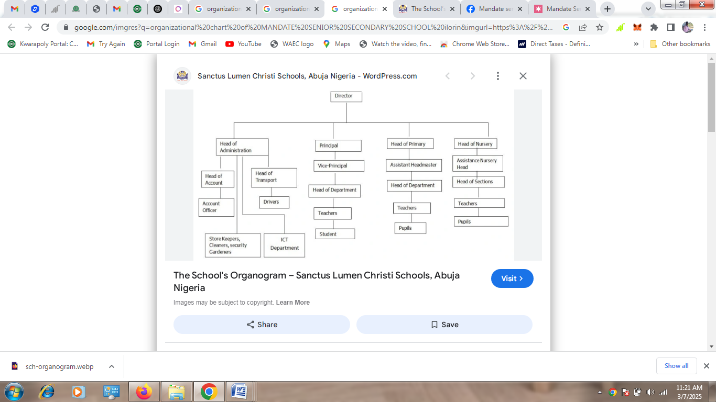
2.3 DIFFERENT DEPARTMENT IN THE ORGANIZATION
- Director administration department:- it consist of admin officers, executive officers, clerical, secretarial, cleaners, drivers and security.
- Director finance and supplies department:- it consists of reconciliation, salary, main accounts
- General manager:- corporate affairs
2.4 INTERPERSONAL RELATION WITH THE ORGANIZATION
There was mutual understanding and love among the staff and the student that did their SIWES programme there because they took all the student like their own children, advising and guiding them to do the right thing at the right time.
High level of discipline was displayed among the student, even though the staffs a make sure that every problem encountered by the student are been tackled and solved out by both the student and staff all in the aspect of bringing about unity and peace.

CHAPTER THREE
3.1 WORK ACTUALLY CARRIED OUT
During my time at Mandate Senior Secondary School, I work as cashier
The duties I carried out as cashier of the school are stated below:
Receiving Payments
- Accepting payments from students, parents, or customers for school-related fees, supplies, or services.
- Processing cash, check, and card payments.
Issuing Receipts
- Providing accurate receipts for payments made, ensuring all details are correct (amount, date, name, purpose of payment).
Balancing the Cash Register
- Counting and verifying cash at the beginning and end of the day to ensure it matches the register's records.
- Ensuring that there are no discrepancies between the amount of money in the register and the recorded transactions.
Recording Transactions
- Keeping detailed and accurate records of all transactions made, including cash, checks, or other forms of payment.
- Ensuring the records are properly documented in the school’s accounting system or ledger.
Maintaining Cash Flow
- Ensuring that there is enough change available in the register to provide accurate returns.
- Managing petty cash and reporting any cash shortages or overages.
Assisting with Fee Collection
- Collecting payments for school fees, event fees, or other student-related costs.
- Ensuring that fees are recorded correctly in the student’s account or database.
Customer Service
- Providing information to students, parents, or staff about payment procedures and due dates.
- Addressing any questions, concerns, or disputes regarding payments or transactions in a professional and courteous manner.
Preparing Reports
- Preparing daily or weekly cash reports detailing all transactions for the day.
- Reporting discrepancies or issues to the supervisor.
CHAPTER FOUR
4.1 EXPERIENCED GAINED
I can actually say I gained a lot from my SIWES Programme by having the opportunity to know my capability on the work I have been taught in school.
Throughout the training, I developed various skills and acquired a deeper understanding of accounting practices in a real-world setting:
- Practical Accounting Skills: I enhanced my skills in financial reporting, bookkeeping, and budgeting. I became proficient in the use of accounting software, which I had not been exposed to in my academic studies.
- Time Management: Working under deadlines, especially when preparing monthly financial reports or reconciling accounts, helped me improve my time management skills.
- Attention to Detail: The need for accurate financial records and proper documentation taught me the importance of attention to detail in accounting.
- Teamwork and Communication: Collaborating with the finance team and other school staff taught me how to communicate effectively in a professional environment and work as part of a team.
4.2 CHALLENGES FACED
During my industrial training, I encountered several challenges, including:
- Time Constraints: There were times when the deadlines for submitting financial reports were tight, which required me to work under pressure.
- Inadequate Resources: The school’s accounting software was not always up to date, which made it difficult to generate reports quickly at times.
- Understanding Specific School Financial Practices: As I had not previously worked in a school setting, understanding the unique financial management practices of the school took some time.

CHAPTER FIVE
CONCLUSION AND RECOMMENDATION

5.1 CONCLUSION
Student Industrial Work Experience Scheme (SIWES) is a good programme for higher institution in the sense that it adds to one’s practical knowledge based on your course of study. As for me SIWES as a course has truly exposed me to face in a growing information world that depend on Business Administration and Management.
5.2 RECOMMENDATION
As a bonafide student of the department of Accountancy of Kwara State Polytechnic and who has undergo industrial training. I hereby make the recommendation that the government should continue funding this programme (SIWES) and pay directly to student after the completion of the programme due to the stress inclined to the programme, in order to serve as encouragement to student that want to increase their practical and technical knowledge.

