

Technical Report
On
STUDENT INDUSTRIAL WORK EXPERIENCE SCHEME (SIWES)

HELD AT
OMOLEWA HOSPITAL & MATERNITY
Hajji Camp Road, Off Gaa-Odota, Ilorin Kwara State
Presented by:
BELLO SHUKURAT AYOMIDE
ND/23/ACC/PT/0181

Submitted to:
DEPARTMENT OF ACCOUNTANCY, INSTITUTE OF FINANCE AND MANAGEMENT STUDIES
KWARA STATE POLYTECHNIC
P.M.B. 1375, ILORIN

IN PARTIAL FULFILLMENT OF THE REQUIREMENT FOR THE AWARD OF NATIONAL DIPLOMA (ND) IN
ACCOUNTANCY, KWARA STATE
POLYTECHNICS, ILORIN

August – December, 2024
PREFACE
This technical report is written to situate the standard of experience gain by student in the industrial as awareness of continuity at the tertiary level of learning. The technical indulgence of training has been expressed formally in these report required by the constitution of the industrial training office of polytechnic.
This report is divided into five different parts which each part explains the meaning of siwes, major organization, work actually carried out and experienced gain. Even challenged faced, conclusion and recommendation are also involved.

DEDICATION
I dedicate this report to the Almighty Allah, for granting me the privilege to commence this course. Also to my reliable and respectful loving parent: Mr. & Mrs. Bello for being there for me. I pray may the Almighty Allah reward you abundantly, Amen.

ACKNOWLEDGEMENT
I wish to express my sincere gratitude to Almighty Allah for spearing my life throughout my first year in Kwara State Polytechnic, Ilorin and for making my vision to come to reality. I also thank him for his goodness, mercy and joy throughout my life.
My greatest debt is to my indispensible parent Mr. and Mrs. Bello for their moral and financial support throughout the duration of my training may Almighty God reward you abundantly.
My special thanks go to the head department and the entire staff of Accountancy department, Kwara State Polytechnic.
My appreciation also goes to the entire staffs of Omolewa Hospital & Maternity
I also acknowledge the effort of my friends and siblings for their financial, moral and spiritual support throughout my academic pursuit. Also to my SIWES supervisor for his great work.

TABLE OF CONTENT
Title Page
Preface
Dedication
Acknowledgement
Table of content
CHAPTER ONE
1.1 Meaning of SIWES
1.2 Brief history of SIWES
1.3 Aims and Objectives of SIWES
CHAPTER TWO
2.1 History of the Organisation
2.2 The organizational Structure
2.3 Department in the organization
2.4 Interpersonal Relation with the organization
CHAPTER THREE
3.1 Work Actually Carried Out
CHAPTER FOUR
4.1 Experienced Gained
4.2 Challenges Faced
CHAPTER FIVE
5.1 Conclusion
5.2 Recommendation

CHAPTER ONE
1.1 MEANING OF SIWES
SIWES is skill development program designed to prepare students of all institutions for transition from the collage environment to work. Also to promote and encourage the acquisition of skills in industry and commerce with a view of generating a poll of indigenous trained manpower sufficient to meet the needs of the Nigeria economy
It is also described as work experience in a education program in while attending school, while the work experience gives student opportunity to be part of an actual work situation outside the classroom.
1.2 BRIEF HISTORY OF SIWES
The government decrees no 47 of 8th October, 1971 as amended in 1990 highlighted the capacity building resource in industry commerce and government through training and re-training of workers in order to effecting provide the much needed high quality goods and services in a dynamic economy as ours (Jemerigbo 2003) the decree led the establishment of Industrial Training Fund (ITF) in 1973/1974.
The growing concern among our industrialist that graduates of our institution lack adequate practical background studies preparatory for employment in industries, led to the information of student industrial work experience scheme (SIWES) by ITF 1993/1994
The student industrial work experience scheme (SIWES) is a skill training program designed to expose and prepare student of agriculture, technology, environmental science, medical science and applied science for the industrial work situation which they are likely to meet after graduating.

1.3 AIMS AND OBJECTIVES OF SIWES
1. The main aim is the exposing of students to work method and technologies in handing equipment and machinery that may not be available in educational institutions.
2. SIWES provide an avenue for students in institutions of higher learning to acquire industrial skills and experience in their course of study especially in engineering.
3. To strengthen employers involvement in the educational process of preparing students for past graduation work situation.
4. To make transition from school to the world of Work easier and to enhance student contact for later job placement.
5. To provide student an opportunity to apply their knowledge in actual practice
6. Provide opportunity for students to apply their knowledge in real work situation thereby bringing the gain between theory and practical.

CHAPTER TWO
OMOLEWA HOSPITAL & MATERNITY
OMOLEWA HOSPITAL AND MATERNITY was incorporated in ILORIN WEST, Nigeria with Registration Number KW12121. It was registered on 17 Feb 2014. Company's registered office address is 1, ALHAJI YUSUF IYANDA STREET, GAA-ODOTA ILORIN, ILORIN WEST, KWARA..
VISION AND MISSION
Mission
Our mission is to provide exceptional healthcare services with a commitment to excellence, compassion, and respect. We strive to meet the medical, emotional, and spiritual needs of our patients, their families, and our community, through a team of highly skilled professionals.
Vision
To be the leading healthcare provider, delivering compassionate, patient-centered care through innovative treatments and advanced medical technology, fostering healthier communities for generations to come.

THE ORGANIZATION STRUCTURE AND CHART
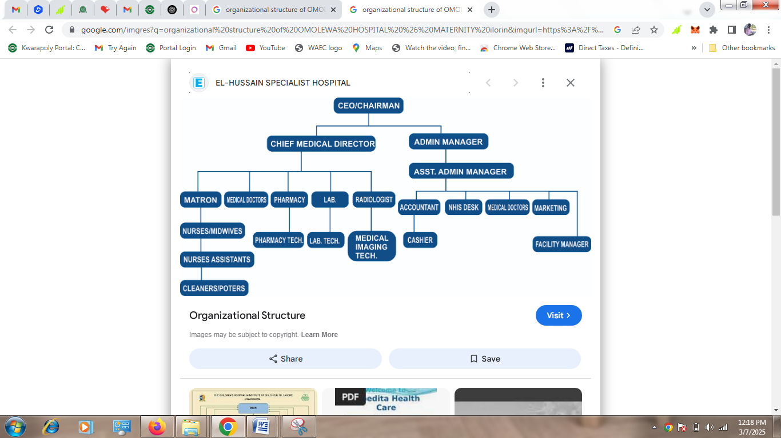
2.3 DIFFERENT DEPARTMENT IN THE ORGANIZATION
- Emergency Department (ED): Provides immediate care for patients with urgent and life-threatening conditions.
- General Medicine: Focuses on the diagnosis and treatment of various non-surgical conditions, including chronic diseases, infections, and acute illnesses.
- Surgery Department: Includes various sub-specialties such as general surgery, orthopedic surgery, cardiac surgery, and neurosurgery.
- Obstetrics and Gynecology (OB/GYN): Specializes in the care of women during pregnancy, childbirth, and postpartum.
- Pediatrics: Focuses on the care of infants, children, and adolescents.
- Includes general pediatric care, pediatric surgery, and neonatal care.
- Radiology: Responsible for diagnostic imaging, including X-rays, MRIs, CT scans, and ultrasounds.
- Laboratory: Provides diagnostic testing for blood, urine, and other bodily fluids.
- Administration: Oversees the overall management of the hospital, including staffing, budgeting, and operations.
- Includes roles in human resources, finance, and general hospital logistics.
2.4 INTERPERSONAL RELATION WITH THE ORGANIZATION
There was mutual understanding and love among the staff and the student that did their SIWES programme there because they took all the student like their own children, advising and guiding them to do the right thing at the right time.
High level of discipline was displayed among the student, even though the staffs a make sure that every problem encountered by the student are been tackled and solved out by both the student and staff all in the aspect of bringing about unity and peace.

CHAPTER THREE
3.1 WORK ACTUALLY CARRIED OUT
Work that actually carried out in my department is recording officer, recording which is the main work of department and almost every staff of the department have different book of record using.
As a siwes student in the department record the file of patient and receipt into the sales book.
As a recording officer some activates I carried out are below:
Processing Payments: This is responsible for receiving payments for services rendered at the hospital, such as patient bills, co-pays, consultation fees, and other charges related to treatment or services.
Issuing Receipts: Once a payment is made, I issues receipts to patients or their families as proof of payment, and ensures the correct amount is recorded in the hospital's financial system.
Billing Assistance: I assist patients with understanding their bills, explaining charges, and answering questions about payments. They may also ensure that the correct billing codes and amounts are applied.
Processing Prepayments and Deposits: For elective surgeries or treatments, the I may collect advance payments or deposits from patients prior to the procedure.
Balancing the Cash Register
- Counting and verifying cash at the beginning and end of the day to ensure it matches the register's records.
- Ensuring that there are no discrepancies between the amount of money in the register and the recorded transactions.
Recording Transactions
- Keeping detailed and accurate records of all transactions made, including cash, checks, or other forms of payment.
- Ensuring the records are properly documented in the school’s accounting system or ledger.

CHAPTER FOUR
4.1 EXPERIENCED GAINED
I can actually say I gained a lot from my SIWES Programme by having the opportunity to know my capability on the work I have been taught in school.
During my placement, I gained several practical skills, which included:
- Accounting Software Proficiency: I became proficient in using hospital accounting software to enter transactions, generate reports, and manage patient billing.
- Financial Record-Keeping: I learned the importance of maintaining accurate and organized financial records for reporting, auditing, and decision-making purposes.
- Communication and Interpersonal Skills: I had the opportunity to interact with different departments, including the medical, administrative, and finance teams, improving my communication and teamwork skills.
- Problem-Solving and Analytical Skills: I encountered challenges such as discrepancies in billing and insurance claims. I learned how to analyze and resolve these issues, ensuring accurate records and smooth operations.
- Understanding Healthcare Financials: I gained an understanding of the unique financial dynamics within a healthcare organization, including patient billing, insurance reimbursements, and managing the costs associated with medical services.
4.2 CHALLENGES FACED
While working at the hospital, I faced a few challenges, including:
- Complexity of Medical Billing: The hospital’s billing system was intricate, especially when dealing with insurance claims, which had multiple variables such as co-payments and deductibles. It took time to familiarize myself with these details.
- Large Volume of Transactions: The hospital handled a high volume of financial transactions, especially during peak periods, which made it challenging to maintain accuracy and speed in processing billing and payments.
- Time Management: Balancing various responsibilities, including record-keeping, invoicing, and assisting with payroll, required effective time management skills, which I developed over time.

CHAPTER FIVE
CONCLUSION AND RECOMMENDATION

5.1 CONCLUSION
Student Industrial Work Experience Scheme (SIWES) is a good programme for higher institution in the sense that it adds to one’s practical knowledge based on your course of study. As for me SIWES as a course has truly exposed me to face in a growing information world that depend on Business Administration and Management.
5.2 RECOMMENDATION
As a bonafide student of the department of Accountancy of Kwara State Polytechnic and who has undergo industrial training. I hereby make the recommendation that the government should continue funding this programme (SIWES) and pay directly to student after the completion of the programme due to the stress inclined to the programme, in order to serve as encouragement to student that want to increase their practical and technical knowledge.

