

A TECHNICAL REPORT AND PRESENTATION
ON
STUDENT INDUSTRIAL WORK EXPERIENCE SCHEME (SIWES)
HELD AT
ABDULGANEEY SULYMAN

DAROSA PROPERTIES AND MANAGEMENT AND CONTRUCTION
No 120 Adeta Street Adewole Illorin Kwara State
SUBMITTED BY:
Abdulganeey sulyman
Nd/23/arc/pt/0005

SUBMITTED TO
DEPARTMENT OF ARCHITECTURAL TECHNOLOGY
INSTITUTE OF ENVIRONMENTAL STUDIES (IES) KWARA STATE POLYTECHNIC, ILORIN
P.M.B 1375, ILORIN, KWARA STATE

IN PARTIAL FULFILMENT OF THE REQUIREMENT OF THE AWRAD OF NATIONAL DIPLOMA (ND) IN ARCHITECTURAL TECHNOLOGY.

August-November 2024
DEDICATION
This SIWES report is dedicated to Almighty Allah the most gracious and merciful. May all in all, who alone is the source of inspiration for sparing my life and also for giving me the opportunity to complete my industrial training. Also to my parent MR. and MRS. ABDULGANEEY.

ACKNOWLEDGEMENT
To Almighty God, I am grateful for the grace and courage He granted me throughout the period of the Industrial Attachment.
Special thanks to my parents MR. and MRS. DULGANEEY for always being there for me especially the trying times when I had challenges with transportation, they encouraged me never to give up.
I also want to express my sincere and profound gratitude to all the staff of Daraso for the good impact they made in my life, both academically and morally throughout the SIWES training. Really appreciate.

TABLE OF CONTENT
Title page
Dedication
Acknowledgement
CHAPTER ONE
1.1 Introduction
1.2 Objectives of Siwes
1.3 purpose of SIWES Unit

CHAPTER TWO
2.1 Location and Historical Background of the Organization
2.2 Organization Chart Of The Organization
CHAPTER THREE

3.1 Land Inspection

3.3 The Floor Plan Of A Two-Bedroom Flat
3.4 Elevation In Architecture

CHAPTER FOUR
Experience gained during Siwes programme
CHAPTER FIVE
5.0 Summary of attachment activities
5.1 Problems encountered
5.3 Suggestion and recommendation

CHAPTER ONE
INTRODUCTION
1.1 BACKGROUND
The student industrial work experience scheme (SIWES) was established in 1973 to solve the problem of lack of adequate practical skills preparatory for employment in industries by Nigerian graduates of tertiary institutions. The scheme exposes students to industry based skills necessary for a smooth transition from the classroom to the world of work. It affords students of tertiary institutions the opportunity of being familiarized and exposed to the needed experience in handling machinery and equipment which are usually not available in the educational institutions.
Participation in SIWES has become a necessary pre-condition for the award of Diploma and Degree certificate in specific disciplines in most institutions of higher learning in the country, in accordance with educational policy of government.
Operators – The ITF, the coordinating agencies (NUC, NCCF, NBTE), employers of labour and the institutions.
Duration – Four months for polytechnic and colleges of education and six months for universities.
Funding – The federal government of Nigeria beneficiaries – undergraduate students of the following. Agriculture Engineering, Technology, Environmental, science, education, medical science and pure and Applied sciences.

1.2 OBJECTIVES
The objectives of SIWES among others include: To provide on avenue for students in institutions of higher learning to acquire industrial skills and experience in their approved course of study.
Prepare students for the industrial works situation which they are likely to meet after graduation.
Expose students to work methods and techniques in handling equipment and machinery in their institutions.
Provide students with an opportunity to apply their knowledge in a real work situation thereby bridging the gap between theory and practices.

CHAPTER TWO
2.1 LOCATION AND BRIEF HISTORY OF THE ESTABLISHMENT
Daraso properties and management and construction is located in the southern part of the state. It is located in Ilorin West Local Government with its headquarter in the emir's market near central mosque Ilorin. It is situated immediately after government high School Ilorin main gate and linking up to university of Ilorin (Mini campus) and Kwara state college of education, Ilorin. The estate is bounded by western reservoir road that links Geri-Alimi and Umar Saro Road Ilorin (Ilorin-Lagos road)
Adeweoie as a planned neighbourhood area comprises of different photo type housing unit categorized into 2 bedrooms bungalows, 3 bedrooms bungalows, 4 bedrooms bungalows and 4 bedrooms manssionattee. Presently the total number of photo type housing units in Daraso Properties and construction Adewole was put at six hundred and twelve ( 12) housing units, he present population of the people at Adewole Estate is about is about fifteen thousand four hundred and eighty. (15,408).
2.2 ORGANIZATIONAL CHART IN THE ESTABLISHMENT

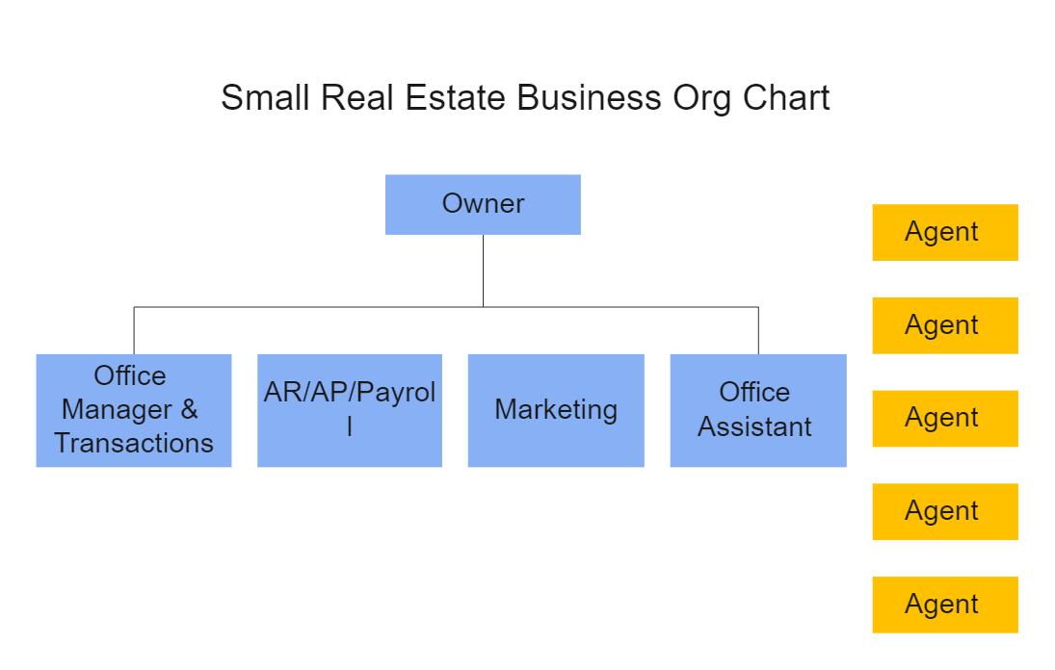

CHAPTER THREE

3.1 SCALE

Scale in architecture refers to the proportion between the size of a building or object and its surrounding environment, as well as the size of its individual parts in relation to each other.

How to Use Scale in Architectural Drawings
Scale is an essential concept in architecture that allows architects, engineers, and builders to represent large structures on paper in a proportional and manageable size. Since buildings are too large to draw at full size, scaled drawings help in planning, designing, and communicating ideas effectively.

1. Understanding Architectural Scale
Scale represents the ratio between the actual size of a building and its representation on paper. It ensures that every component of a structure is drawn to the same proportion as it will be built.
For example, if a drawing is at 1:100 scale, it means that 1 unit on paper = 100 units in real life.

Common Architectural Scales
Scale | Use Case
1:50 | Room layouts, detailed floor plans
1:100 | General floor plans for houses and buildings
1:200 | Site plans and large building layouts
1:500 | Large site developments and urban planning
1:1000 & 1:2000 | City planning and landscape architecture

2. How to Use Scale in Architectural Drawings

A. Choosing the Right Scale
- Select a scale based on the level of detail needed.
- Smaller scales (e.g., 1:1000) cover large areas but show less detail.
- Larger scales (e.g., 1:50) show more detail for specific building parts.

B. Using a Scale Ruler
A scale ruler is a triangular tool used to measure scaled drawings accurately. It has different scale markings for various ratios.
Steps to Use a Scale Ruler:
- Identify the scale used in the drawing (e.g., 1:100).
- Choose the correct side of the scale ruler that matches the drawing’s scale.
- Align the ruler with the object or room you want to measure.
- Read the measurement, then multiply it by the scale factor to get the real-world size.
Example:
- If a wall measures 5 cm on a 1:100 scale, the actual size is 5 cm × 100 = 500 cm (5 meters).

C. Scaling a Drawing Manually
- Decide on a scale based on paper size and required detail.
- Use a calculator to divide real-world dimensions by the scale ratio.
  - Example: A 10m wall at 1:50 scale → 10m ÷ 50 = 0.2m (20 cm on paper).
- Draw using a ruler to ensure precise scaling.

3. Digital Scaling in Architecture
Modern architects use AutoCAD, SketchUp, Revit, and ArchiCAD for digital scaling. These tools allow precise scaling, resizing, and measurement without manual calculations.
How to Use Scale in AutoCAD:
- Set the scale in the drawing settings.
- Use the "Scale" command to resize elements accurately.
- Print drawings at a specific scale using the "Plot" function.

4. Importance of Scale in Architecture
✅ Ensures accurate proportioning of buildings.
✅ Helps in visualizing and communicating designs effectively.
✅ Guides construction teams to follow exact measurements.
✅ Supports urban planning by representing large areas efficiently.
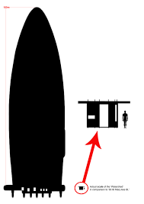
Scale design

3.2 LAND INSPECTION
Land inspection is a critical process in real estate, construction, and agriculture. It involves assessing the physical, legal, and environmental conditions of a piece of land before purchase, development, or investment. Proper land inspection helps avoid disputes, financial losses, and legal complications.

1. Purpose of Land Inspection
Land inspection is conducted to:
✔ Verify ownership and legal documents (to avoid fraud).
✔ Assess topography, soil quality, and drainage for development.
✔ Identify zoning regulations and government restrictions.
✔ Check for accessibility, road networks, and utilities.
✔ Detect environmental risks such as flooding or erosion.

2. Key Aspects to Inspect When Evaluating Land

A. Legal Verification & Documentation
Before inspecting physically, verify:
- Land Title Deed – Confirms ownership and prevents fraud.
- Survey Plan – Defines boundaries and measurements.
- Certificate of Occupancy (C of O) – Confirms government approval.
- Zoning & Land Use Permit – Determines if the land is for residential, commercial, or agricultural use.

B. Physical Inspection of the Land
- Size & Boundaries: Cross-check with the survey plan to ensure accuracy.
- Topography: Identify flat, hilly, or sloped areas (important for construction and drainage).
- Soil Quality: Essential for building foundations, agriculture, or industrial use.
- Flood Risk Assessment: Check for waterlogging, drainage, or signs of past flooding.

C. Accessibility & Infrastructure
- Road Access: Ensure the land has a well-connected road network.
- Electricity & Water Supply: Check for nearby power lines and water sources.
- Drainage Systems: Poor drainage can lead to flooding issues.

D. Environmental & Government Restrictions
- Erosion & Land Stability: Check for signs of erosion, landslides, or unstable soil.
- Government Acquisition Risks: Some lands are earmarked for public projects (e.g., roads, airports) and cannot be developed privately.
- Community & Cultural Considerations: Some lands are tied to traditional or family inheritance, which could lead to disputes.

3. Tools & Professionals Involved in Land Inspection
Tool/Professional | Purpose
Surveyor | Measures land boundaries and provides a survey report.
Soil Test Kit | Determines soil strength for construction.
Land Registry Search | Confirms ownership and legal status.
Drone or GPS Mapping | Provides aerial views of the land.
Environmental Consultant | Assesses flood, erosion, and ecological risks.

4. Steps to Conduct a Proper Land Inspection

Step 1: Research & Documentation Check
✔ Obtain the land title, deed, and survey plan from the seller.
✔ Verify land records at the local land registry.
✔ Confirm zoning regulations and land use policies.

Step 2: Physical Site Visit
✔ Walk the entire land area to verify its size and shape.
✔ Identify flood-prone areas, erosion, and soil conditions.
✔ Ensure the land has road access, electricity, and water.

Step 3: Legal & Government Verification
✔ Check if the land is under government acquisition or dispute.
✔ Confirm with local authorities that the land can be developed.

Step 4: Finalize & Secure the Land Purchase
✔ If the inspection is satisfactory, proceed with the purchase.
✔ Obtain a land purchase agreement, title deed, and receipt.
✔ Register the land with the government to avoid future disputes.

3.3 THE FLOOR PLAN OF A TWO-BEDROOM FLAT
A floor plan is a scaled diagram of a building’s layout, showing the arrangement of rooms, walls, doors, windows, and furniture placement from a top-down perspective. A two-bedroom flat floor plan outlines the design of a living space with two bedrooms, a living room, a kitchen, and bathrooms, ensuring functionality, comfort, and efficient space usage.

1. Key Components of a Two-Bedroom Flat Floor Plan

A. Bedrooms
- Two separate sleeping areas with adequate space for beds, wardrobes, and ventilation.
- Windows for natural light and cross-ventilation.
- Master bedroom (larger, may have an en-suite bathroom).
- Secondary bedroom (smaller, shares a common bathroom).

B. Living Room
- The central gathering space for relaxation and social activities.
- Positioned near the main entrance for easy access.
- Can include dining space if open-plan.

C. Kitchen
- Closed or open-plan layout (open-plan integrates with the living room).
- Placement of cabinets, countertops, and appliances.
- Connection to the dining area or living space for convenience.

D. Bathrooms & Toilets
- One or two bathrooms, including an en-suite bathroom for the master bedroom.
- Common bathroom for guests and the second bedroom.
- Placement of toilet, shower, bathtub, and sink for functionality.

E. Hallways & Circulation Areas
- Walkways connecting different rooms without wasting space.
- Should be wide enough for easy movement.

F. Entryway & Exit Points
- Main entrance leading to the living area.
- Back door (optional) leading to a backyard or utility area.

G. Additional Features
- Balcony or veranda for outdoor relaxation.
- Storage spaces (closets, pantry, or built-in cabinets).
- Utility/Laundry Area (for washing machine and drying clothes).

2. Standard Measurements for a Two-Bedroom Flat Floor Plan
Room | Standard Size (Meters) | Standard Size (Feet)
Master Bedroom | 3.5m × 4.5m | 11.5ft × 14.7ft
Second Bedroom | 3m × 3.5m | 9.8ft × 11.5ft
Living Room | 4m × 5m | 13ft × 16.4ft
Kitchen | 2.5m × 3.5m | 8.2ft × 11.5ft
Bathroom | 1.5m × 2.5m | 4.9ft × 8.2ft
Note: Sizes can vary depending on available land space and design preference.

3. Floor Plan Layout Types for a Two-Bedroom Flat

A. Open-Plan Layout
✔ Living room, dining, and kitchen are combined into a large space.
✔ Increases natural light and airflow.
✔ Best for modern, spacious designs.

B. Closed-Plan Layout
✔ Rooms are divided by walls for privacy.
✔ Best for families or shared apartments.
✔ Provides better noise control between rooms.

C. Rectangular or Square Layout
✔ Simple and cost-effective.
✔ Straightforward circulation from room to room.
✔ Common for apartment buildings and small residential flats.

4. Steps to Design a Two-Bedroom Flat Floor Plan

Step 1: Define the Total Space Available
- Determine the land size and dimensions before drawing.

Step 2: Decide Room Placement
- Place living areas (living room, dining, and kitchen) near the entrance.
- Position bedrooms in private areas for comfort.

Step 3: Allocate Room Sizes
- Assign appropriate dimensions for each room to ensure balance.

Step 4: Draw Walls, Doors, and Windows
- Use a scale (1:50 or 1:100) to maintain accurate proportions.
- Include door swing directions and window placements.

Step 5: Add Furniture & Fixtures
- Indicate bed positions, sofas, dining sets, and kitchen counters.
- Helps visualize how space will be used.

5. Tools Used to Draw a Two-Bedroom Flat Floor Plan
✔ Graph paper & ruler (for manual sketches).
✔ AutoCAD, SketchUp, Revit (for digital architectural drawings).
✔ Online floor plan creators (e.g., RoomSketcher, Floorplanner).

6. Importance of a Floor Plan in a Two-Bedroom Flat
✅ Ensures efficient space utilization.
✅ Helps in construction planning and budgeting.
✅ Improves functionality and aesthetics.
✅ Serves as a guide for furniture placement.
✅ Required for government approvals and permits.
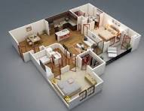
2 bedroom flat apartment
3.4 ELEVATION IN ARCHITECTURE

1. What is Elevation in Architecture
Elevation in architecture is a 2D representation of a building’s exterior or interior as seen from one side. It is a crucial component of architectural drawings, helping builders, engineers, and clients visualize the height, proportions, and external appearance of a structure.
Elevations show details like:
✔ Building height and width
✔ Doors, windows, and other openings
✔ Roof design and materials
✔ Exterior finishes (brick, concrete, glass, wood, etc.)
✔ Landscaping and site features

2. Types of Architectural Elevations

A. Front Elevation (Main Elevation)
- Also known as the "entrance view", it shows the building’s main façade.
- Includes entry doors, windows, roof design, and façade materials.
- First impression of the structure.

B. Rear Elevation (Back View)
- Shows the back side of the building, often less detailed than the front.
- Includes back doors, rear windows, and sometimes a backyard or service areas.

C. Side Elevations (Left & Right Views)
- Shows one side of the building, including roof slope, windows, and exterior materials.
- Used to understand depth and side proportions.
- Important for understanding neighboring structures and ventilation design.

D. Interior Elevation
- Represents inside walls of rooms, showing furniture placement, shelving, built-in units, and wall designs.
- Commonly used in kitchens, bathrooms, and feature walls.

3. Purpose of Elevation Drawings in Architecture
✔ Visualizing Building Appearance – Helps clients and builders understand the final look.
✔ Assisting Construction – Acts as a blueprint for builders to follow.
✔ Approval from Authorities – Used for building permits and regulatory approvals.
✔ Material Specification – Details the types of finishes (wood, stone, glass, etc.).
✔ Proportion & Symmetry – Ensures the building is balanced and aesthetically pleasing.

4. Key Features in an Elevation Drawing
Feature | Description
Walls | Defines the external shape of the building.
Doors & Windows | Shows sizes, styles, and placements for natural light & ventilation.
Roof Design | Displays slope, materials, and gutters.
External Finishes | Indicates textures (brick, wood, glass, stucco, etc.).
Ground Line & Site Features | Includes landscaping, pathways, stairs, and driveways.

5. How to Create an Architectural Elevation Drawing

Step 1: Choose a Scale
- Architectural drawings typically use a scale of 1:50 or 1:100.
- Example: 1 cm on paper = 50 cm in real life.

Step 2: Draw the Building Outline
- Start with a basic rectangular or square shape representing the wall.
- Ensure proportions match the floor plan.

Step 3: Add Doors, Windows, and Roof Details
- Indicate window & door placement, sizes, and styles.
- Show roof pitch, overhangs, and drainage systems.

Step 4: Include Material Textures & Finishes
- Use shading or symbols to show materials like brick, wood, or glass.
- Label exterior colors, cladding, and decorative elements.

Step 5: Dimension and Label All Components
- Mark heights, widths, distances between elements.
- Label features such as "wood cladding," "aluminum window frame," or "concrete finish".

6. Tools Used for Elevation Drawings

Manual Drawing Tools
✔ Graph paper & scale ruler
✔ Pencils, compasses, and T-squares
✔ Shading techniques for material representation

Digital Software for Architectural Elevations
✔ AutoCAD – Industry standard for 2D/3D drafting.
✔ SketchUp – 3D modeling with easy-to-use elevation tools.
✔ Revit – BIM software for detailed elevation and construction planning.
✔ ArchiCAD – Popular for residential and commercial architectural drawings.

7. Difference Between Elevation & Floor Plan
Feature | Floor Plan | Elevation
Perspective | Top-down view | Side/front/rear view
Details | Shows room layout, walls, and furniture | Shows external appearance, doors, windows, and finishes
Use | Interior layout and room sizes | Exterior structure and façade design

8. Common Mistakes to Avoid in Elevation Drawings
🚫 Forgetting Proportions – Always match elevation dimensions with floor plan.
🚫 Omitting Material Details – Specify textures, finishes, and colors.
🚫 Ignoring Roof Slopes & Overhangs – Affects drainage and shading.
🚫 Not Including Ground & Surroundings – Site levels, pathways, and landscaping are essential.

9. Importance of Elevation in Architecture
✅ Ensures proper design aesthetics & functionality.
✅ Helps with planning construction materials & costs.
✅ Enhances building approval process & client understanding.
✅ Essential for structural engineering & roof design accuracy.

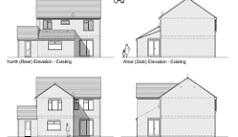
Elevation plan

CHAPTER FOUR
4.1 EXPERIENCE GAINED DURING SIWES PROGRAMME
I was thought how to use scale 1:00, scale 2:100, scale 1:200, scale 1:50, scale1:150, scale1:250.
My experience gained was also include inspection of 10 plot of land also how to draw plan of bedroom plan such as 1 bed room plan, 2 bedroom plan, 3 bedroom plan.
I was also t6hrough how to inspect room and self contain also I was thought how to set paper, how to draw margin.
My experience was include how to draw floor plan, how to draw elevation for both left side and right side elevation.

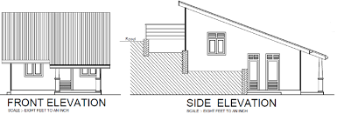
I was also able to draw roof plan of a poultry also draw dimension floor plan of a poultry
I was also gained how to draw section, I was also thought how to draw bubble diagram.
I also draw plan of roof plan of two bedroom flat also roof plan for poultry.
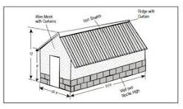
Roof plan for poultry
CHAPTER FIVE
5.0 SUMMARY OF ATTACHMENT ACTIVITIES
This report covers all the activities I partook in during my six months industrial training at Daraso properties and management and construction, No 120, Adeta Street Adewole area Ilorin state . I started it on 24rd April and ended it 24rd September 2018. It was a wonderful experience.
This report has taken to encompass a comprehensive report of the training across the several units.
In conclusion, the SIWES programme has proved invaluable as I know that I am not going back to the classroom the same.
5.1 PROBLEMS ENCOUNTERED DURING THE PROGRAMME
The following are the problems encountered during six months industrial training:
- The main problem encountered during the programme was problem of transportation. It is difficult for students who live in far places to get the organization every working day.
- No allowance or financial benefit was provided for IT students.
- Restriction to some department/offices in the organization.
- Heavy rainfall during wet season which slows down the project works.

5.2 SUGGESTIONS AND RECOMMENDATIONS
- The organization should not just acquire but make use of modern equipment for their operations.
- All institutions or bodies involve in the scheme should make sure that those organizations that have the means to give students allowance or remuneration should do so DURING the programme.
- I would suggest the organization should give more room for potential Surveyors to acquired knowledge and showcase them when the need arises
5.3 CONCLUSION
Student Industrial Work Experience Scheme (SIWES) is a very essential program that must be made compulsory on all students, because it enable students to gain practical experience and more knowledge about what has been taught in school, as their acquired experiences would speak for them in the nearer future.

