

TECHNICAL REPORT ON
THE STUDENT INDUSTRIAL WORKS EXPERIENCE SCHEME (SIWES)

HELD AT

MINISTRY OF AGRICULTURE AND RURAL DEVELOPMENT ILORIN, KWARA STATE P.M.B 1425, OFF OLD JEBBA ROAD, ILORIN, KWARA STATE

PRESENTED BY

WARIS ARIKESOLA AMOO
ND/23/ABE/PT/0019

SUBMITTED TO:
DEPARTMENT OF AGRICULTURAL AND BIO-ENVIRONMENTAL ENGINEERING,
INSTITUTE OF TECHNOLOGY [I.O.T.] KWARA STATE POLYTECHNIC, ILORIN.

IN PARTIAL FULFILLMENT OF THE REQUIREMENT FOR AWARD OF NATIONAL DIPLOMA (ND) CERTIFICATE IN AGRICULTURAL AND BIO-ENVIRONMENTAL ENGINEERING

AUGUST- NOVEMBER 2024

DEDICATION
This report is dedicated to Almighty GOD

ACKNOWLEDGEMENT
My sincere gratitude goes to Almighty GOD the author and finisher of my faith, the one who saw me through, from the beginning to the end of this industrial training exercise. Glory, honour and adoration be unto him.
I thank almighty GOD for his mercy and grace that kept me all through my industrial training period, I appreciate HIM for given me the strength and opportunity to complete this course despite all difficulties and problem encountered during the (SIWES).
My gratitude also goes to the family of Mr & Mrs. WARIS who has contributed immensely, spiritually and financially to the success of this programme, may almighty Allah always remember you for good.
Furthermore, my special greetings go to my colleagues for their support and contributions to the success this report. Finally, I acknowledge all the staff at Ministry of Agriculture and to my supervisor Engr. Sulyman M . Umar May Allah be with them all.

TABLE OF CONTENT
Title page i
Dedication ii
Acknowledgement iii
Table of contents iv
CHAPTER ONE
  - Introduction 1
  - Historical background of SIWES 2
  - Definition of SIWES 2
  - Objectives and goals of SIWES 3
  - Historical background of the company organisation of attachment 3
  - Organisation chart 4
CHAPTER TWO
2.2 Irrigation Section 6
2.3 Types of Irrigation 6
2.4 Agro processing 7
2.5 Objective of Agro processing 7
2.6 Maintenance of Agro processing 7
2.7 Importance of Agro processing 7
2.8 Challenges of Agro processing 8
CHAPTER FOUR
4.0 Farm power and machinery 12
4.1 Types of implement attached to tractor 12
4.2 Daily Maintenance carryout on tractor 13
4.3 The use of multipurpose tractor 17

CHAPTER FIVE
5.0 Conclusion 18
5.1 Recommendations 18

CHAPTER ONE
1.0 INTRODUCTION
The student industrial work experience (SIWES) is a program in Nigeria Institution accepted to improve the practical skills of students and as a partial fulfilment of the requirement for the award of first degree.
The accepted skill training program (SIWES) is expected to bridge the gap existing between the theory and real practical in various fields such as engineering and technology, science, agriculture, medicine, management and other professional educational programs in Nigeria tertiary institution.
Students Industrial Work Experience Scheme (SIWES).
It is aimed at exposing students to machines and equipments, professional work methods and ways of safe-guarding the work area and workers in industries and other organizations. It is funded by the Federal Government of Nigeria and jointly coordinated by the Industrial Training Fund (ITF) and the National Universities and polytechnic Commission (NUPC).
1.1 Historical Background of SIWES
The Students’ Industrial Work-Experience Scheme (SIWES) is a skills development program initiated by the Industrial Training Fund (ITF), in 1973 to bridge the gap between theory and practice among students of engineering and technology in Institutions of Higher Learning in Nigeria. It provides for on-the-job practical experience for students as they are exposed to work methods and techniques in handling equipment and machinery that may not be available in their Institutions.
The scheme was subsequently reviewed by the Federal Government resulting in Decree No 16 of August, 1985 which required that “all students enrolled in specialized engineering, technical, business, applied sciences and applied arts should have supervised industrial attachment as part of their studies”. In the same vein, the ITF was directed by the Federal Government to take charge and resume responsibility for the management of SIWES in collaboration with the supervising agencies, i.e. National Universities Commission (NUC), the National Board for Technical Education (NBTE) and the National Commission for Colleges of Education (NCCE).
1.2 DEFINITION OF SIWES
SIWES: - student industrial work experience scheme may be define as the program that help student in compiling theoretical aspect to practical aspect of studies and uses it in meaningful way and give knowledge of what to be after graduation at their work place.

1.3 OBJECTIVES OF SIWES
- Provide an avenue for students in institutions of higher learning to acquire industrial skills and experience during their courses of study;
- Prepare students for industrial work situations that they are likely to meet after graduation;
- Expose students to work methods and techniques in handling equipment and machinery that may not be available in their institutions;
- Exposure of students to the environment in which they will eventually work, thereby enabling them to see how their future professions are organized in practice
- Enhancing students’ contacts with potential employers while on training.
1.4 HISTORICAL BACKGROUND OF THE ORGANIZATION ATTACHMENT
The Kwara State Ministry of Agriculture and Rural Development in Ilorin, Kwara State. The Department of Agriculture and Engineering service. Was classified as five (4) division as stated below:
i. Farm power and machinery
ii. Farm Structure
iii. Possessing and post harvest
iv. Irrigation and drainage
1.5 ORGANIZATION CHART
The honourable commissioner
Permanent Secretary

DF
DV
DFS
DPRS
DV
DAES

HOD OF PRODUCE
HOD Horticulture
HOD Home -Economic
HOD Engineering
HOD Extension

Pest control
Produce
Irrigation Soil and Water
Mechanical
Section

CHAPTER TWO
Pest
2.0 HISTORY OF MINISTRY OF AGRICULTURE AND RURAL DEVELOPMENT
The Federal Ministry of Agriculture and Food Security (FMAFS), formerly known as the The Federal Ministry of Agriculture and Rural Development (FMARD), was established in 1966 with a clear vision to ensure food security and promote agricultural sustainability in Nigeria.
The idea of Agricultural Development Programmes is an offshoot of the concept of integrated agricultural and rural development. It started in 1972 in Northern Nigerian towns of Gombe and Gusau with two pilot projects assisted by the World Bank.
Akinwumi Adesina was appointed Federal Minister of Agriculture and Rural Development by President Goodluck Jonathan in June 2011. He was succeeded by Audu Innocent Ogbeh who was appointed by President Muhammadu Buhari in 2015.
Industry Consumer Services
Company size 11-50 employees
Headquarters ILORIN, KWARA
Type Privately Held
Founded 2005
2.1 DEPARTMENTS AND THEIR FUNCTIONS
- Poultry: poultry, in animal husbandry, birds raised commercially or domestically for meat, eggs, and feathers. Chickens, ducks, turkeys, and geese are of primary commercial importance, while guinea fowl and squabs are chiefly of local interest.
- Workshop: a small establishment where manufacturing or handicrafts are carried on. 2. : workroom. 3. : a usually brief intensive educational program for a relatively small group of people that focuses especially on techniques and skills in a particular field
- Animal Husbandry: animal husbandry, Controlled cultivation, management, and production of domestic animals, including improvement of the qualities considered desirable by humans by means of breeding. Animals are bred and raised for utility (e.g., food, fur), sport, pleasure, and research. See also beekeeping, dairy farming.
- Farm Mechanization :
- Storage Room: a room or space for the storing of goods or supplies

CHAPTER THREE
3.0 IRRIGATION SECTION
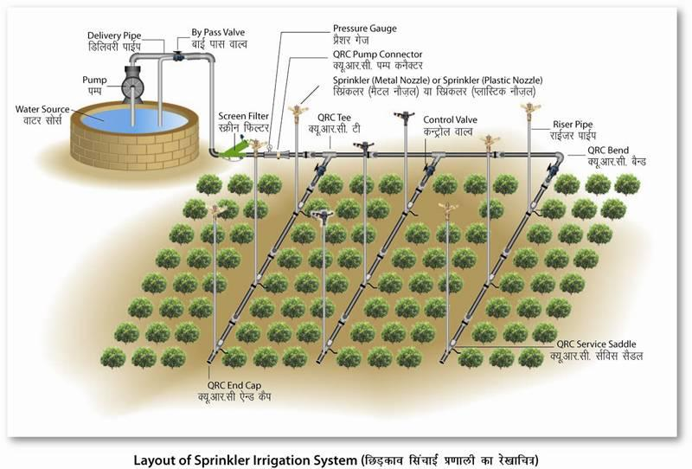
Irrigation soil and water is the artificial ways or process of applying water to crop, to supplement natural rainfall for optimum growth and to have a better crop yield.

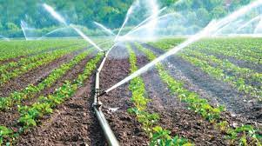

3.1 TYPES OF IRRIGATION
- Surface Irrigation
- Furrow irrigation
- Sub-surface Irrigation
- Basin / check irrigation
- Drip irrigation
- Sprinkler / over head irrigation
3.2 AGRO-PROCESSING
Agro-processing are set of technological activities been carried out for conservation and handling of all agricultural produce and to make it usable as feeds, food, and raw material.
3.3 OBJECTIVE OF AGRO PROCESSING
i. It help as source of revenue generation for government
ii. It help in improvement of farmer income
iii. It increases social economic unemployment, directly or indirectly.
3.4 MAINTENANCE OF AGRO-PROCESSING
- Periodic maintenance
- Corrective maintenance
- Repairs maintenance
- Preventive maintenance
3.5 IMPORTANCE OF AGRO PROCESSING
- it serve as job creation for rural and urban youth
- it enhance agricultural productivity and increased
- it reduce importation of similar or foreign foods and conserve foreign exchange
- it makes food available all years round
3.6 CHALLENGES OF AGRO PROCESSING
- Lack of infrastructural facilities e.g water, road, electricity etc..
- Unavailability of funds (capital)
- Farm constraint (unavailability of farm implement)
- Unpredictable government action

CHAPTER FOUR
4.0 TRACTOR
A tractor is a vehicle specially manufactured to deliver high torque at a lower speed. It hauls a trailer or machinery used in agriculture, construction, and industrial. The tractor is the combination of two words, “traction and motor.” A tractor is used to pull heavy loads for different farming tasks.
There are many agriculture operations performed by farmers, and for each task, the necessary farming machinery and implements are developed. Similarly, according to the farmer’s needs and demand, there are many types of tractors.
Utility Tractor
Compact Tractor
Row Crop Tractor
Industrial Tractor
Garden Tractor
Implement carrier Tractor
Autonomous Tractor
• Utility tractors: This type of tractor is used for farming operations such as plowing and pulling heavy implements.
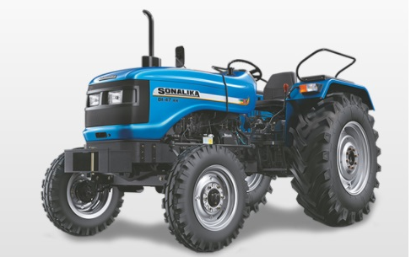

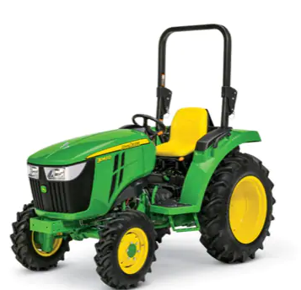
• Compact Tractor: are used in vineyards, fruit yards, and nut yards. They are constructed in a way that the user can sit comfortably and choose the hanging fruits or trim the trees at the same time. The best advantage of compact tractors is they can be adjusted in every space of the yard. Compact tractors come at a smaller size, and it consumes less fuel that saves money.

• Row crop tractor: are used in farms wherein farmers plant crops in a row. These tractors are all around tractors that perform various farming tasks you need to do, Including weed control, leveling, plowing, harrowing, and pulling seed drills

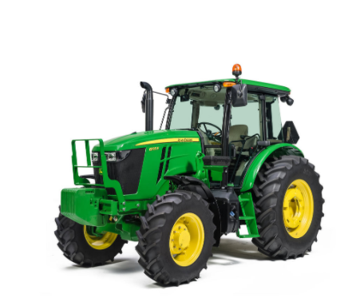

• Industrial tractor: are used in the industry more than agriculture. Formerly, these tractors called tuggers. These tractors mostly used to pull heavy loads and fit the cranes to lifting heavy weights easily.
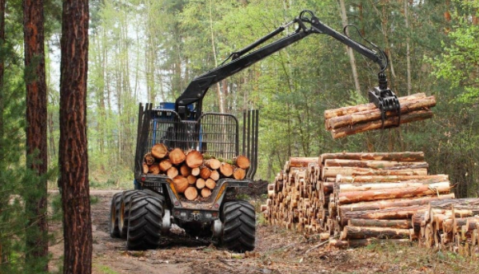

• Garden tractor: come in the engine power range of 1 hp to 20 hp, and they have very small construction size. These tractors mainly used for cutting the grass and making the flower beds in your garden.
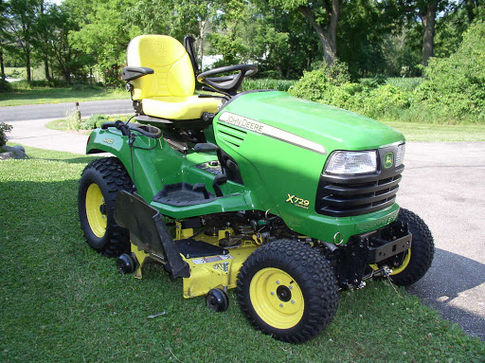

• Backhoe loader: are used for various construction tasks, from digging holes to breaking asphalt. These machines consist of buckets in the back for digging and shovels in the front that can adjusted to your needs.

• Autonomous tractor: are also called driverless or electric tractors that are controlled or operated by artificial intelligence. These tractors could become the wave of the future for agriculture or industry. They utilize the combination of computers, GPS, drone technology, and satellite. Autonomous Tractors avoid the need of human tractor operators.

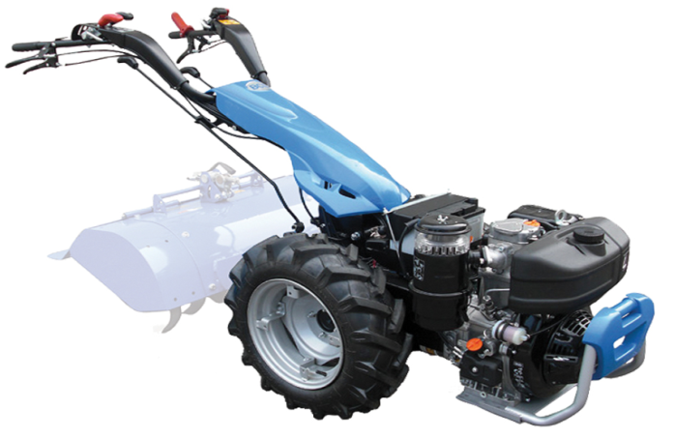
• Two-wheel tractor: are the lighter weight and smaller tractors used for tilling, plowing, and pulling smaller implements such as harvesters, seeding equipment, and trailers. They called walking, single-axle, or walk-behind tractors. These used in small farms and gardens.

4.1 MAIN FUNCTIONS OF TRACTOR ARE
1. To pull various land preparation implements like plough, Harrow, rotavator, cultivator etc using draw bar
2. For planting and seeding precisely
3. For intercultural operations with various implements
4. For harvesting of various crops n forage
5. For threshing, using PTO shaft
6. To pull levelers, trolley, tankers etc using single point linkage
7. It can be use to generate power supply
4.2 Farm power and machinery
Farm Power is an essential input in agriculture for timely field operations for increasing production and productivity of land. Farm power is used for operating different types of machinery like tillage, planting, plant protection, harvesting and threshing machinery
4.3 Types of implement attached to tractors
- Ridger: The, ridge plough is used to split the field into ridges and furrows and for earthing up of crops. Ridge ploughs are used to make broad bed and furrows by attaching two ridge ploughs on a frame at 150em spacing between them
- Rotary Slasher: Rotary Slasher is a sturdy implement which is most suitable for slashing pasture topping and shrubs. It also very well suffices the purpose of maintaining grasslands, road verges and lawn. Rotary Slasher or Slasher allows one to perform the most versatile method of grass cutting i.e. slashing.
- Disc Plough: Ploughs. The disc plough is designed to work in all types of soil for functions such as soil breaking, soil raising, soil turning and soil mixing. It is used to open the new fields and to process the stony areas. It can be used easily at rocky and rooted areas.
- Disc Harrow: A disc harrow is a harrow whose cutting edges are a row of concave metal discs, which may be scalloped or set at an oblique angle. It is an agricultural implement that is used to till the soil where crops are to be planted. It is also used to chop up unwanted weeds or crop residue.
4.4 Daily maintenance carryout on tractor

1. Start with a visual inspection of your small farm tractor.
Check for leaks and worn or loose hoses or cables. Dirt buildups could be a sign of minute leaks. Repair for leaks, big or small, might simply entail tightening or replacing hoses or clamps or tightening drain plugs. Check the glass sediment bowl beneath the fuel filter for water or material. Some tractor models, especially newer ones, have check windows for hydraulic reservoir fluid levels.
This is also a good time to verify that your tractor’s safety features, such as PTO shields, are in place and lights, including hazard lights and turn indicators, are in working order.

2. Check the tractor’s radiator-fluid level.
Gradual loss of fluids over time can be expected in your small farm tractor; however, if a significant amount of additional coolant is needed, it may indicate other, more serious problems, such as coolant leaking into engine oil,

3. Check the fan’s drive belt for wear and tension, and visually inspect the radiator core and grill screen.
Any dirt or debris should be cleared out using air pressure to avoid damaging the fins on the radiator. If your tractor cab is equipped with air conditioning, take a minute to check the condenser, and remove any debris built up around it, as well.

4. Top off the tractor’s fuel tank.
It’s good to have a fresh supply of fuel for the days work, plus you can empty any sediment or water you see in the sediment bowl. It may be necessary to partially drain the tractor’s fuel tank to remove excess water. Fuel should always be fresh—no more than three months in storage, according to Tammel.
Gas tractors using ethanol blends pose another concern. Over time, ethanol in the presence of as little as 4 teaspoons of water per gallon can separate from gasoline and mix with the water. Tammel suggests adding a fuel conditioner to keep components in both gas and diesel fuels stable and in solution.

5. Check the tractor’s oil.
If adding gas required you to start your tractor and drive a short distance to fuel storage, you’re ready to check oil levels. If not, start the engine, and let it warm up before checking the oil. Stop the engine, and give it a few minutes before checking the dipstick or other oil-level indicator. As a final step in daily tractor lubrication, grease joints. Out-of-the-way grease zerks—the small metal fittings for inserting grease into mechanical joints—are easy to miss. When initially compiling your checklist, do a careful count of all fittings, and count them off when you use your grease gun.

CHAPTER FIVE
5.0 CONCLUSION
This SIWES programme has turn out to be more interesting, educative due to the nature of the program itself. I found it interesting and I fully participated in it which in turn yields a successful result, indeed it prepares me for future challenge in my chosen field.

5.1 RECOMMENDATION
The experience I gained during my SIWES program cannot be over emphasized. I was practically oriented, I humbly recommend that the SIWES programme should be made compulsory for students of engineering fields in order to gain more experience in their course of study.

